SUSTAINABLE FOOD SYSTEMS

Chapter Outline (Index)-----
Introduction
Food and Nutrition Security: An Overview
What are Food Systems
Challenges to the dimensions of Food and Nutrition Security
Conclusion
References and Suggested Readings

INTRODUCTION
Concept of Sustainable Development
The term ‘Sustainable Development’ was first coined in 1980 with a very basic notion of ‘conserving earth’s natural resources’ which was an outcome of the World Conservation Strategy. A decade later, in 1987, the World Commission on Environment and Development (WCED) used a multi-disciplinary approach to conceptualize sustainable development as a form of development that meets the needs of the present without compromising the ability of future generations to meet their own needs (Brundtland Commission Report). In 1992, at the United Nations Conference on Environment and Development at Rio de Janeiro, the blueprint for sustainability in the 21st century was laid. The ‘Rio Declaration’ identifies 27 principles of sustainable development, emphasizing the critical links between healthy and productive lives for people and protection and sustainable use of nature and natural resources.
Sustainable development has four key dimensions – society, environment, culture and economy. These four dimensions are closely connected and lack of development in any one of them may affect the sustainability of the others. For instance, for a society to be called as a developed society, it relies on healthy people with adequate access to food and resources, safe drinking water, access to education, access to decent jobs, gender equality, developed infrastructure, and safe environment. If people have adequate food but no access to safe drinking water, or access to education but not decent jobs, then the development is not sustainable. Thus, for development to be sustainable, it must take account of all four dimensions.

Sustainable Development Goals-

The Sustainable Development Goals (SDGs) were adopted by the United Nations in 2015 as a universal call to action to end poverty, protect the planet, and ensure that by 2030 all people enjoy peace and prosperity. There are 17 Sustainable Development Goals, which are as follows:
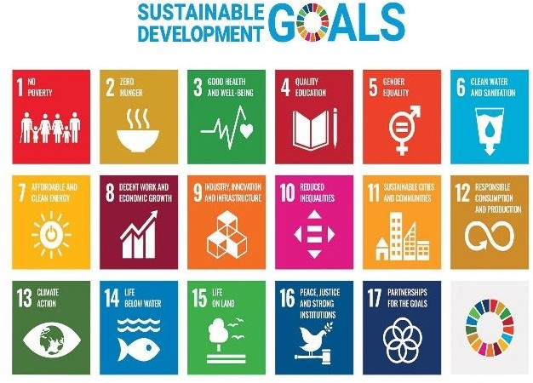
- No Poverty
- Zero Hunger
- Good Health and Well-being
- Quality Education
- Gender Equality
- Clean Water and Sanitation
- Affordable and Clean Energy
- Decent Work and Economic Growth
- Industry,
Innovation and Infrastructure
- Reduced
Inequalities
Figure 5.1 Sustainable Development Goals

- Sustainable Cities and Communities

- Responsible Consumption and Production
- Climate Action
- Life Below Water
- Life On Land
- Peace, Justice and Strong Institutions
- Partnerships for the Goals

The present chapter will focus on the Sustainable Development Goal of ‘Zero Hunger’ (SDG 2). This goal seeks sustainable solutions to end hunger in all its forms by 2030 and to achieve food security. The aim is to ensure that everyone everywhere has enough good-quality and nutritious food to lead a healthy life. Achieving this goal will require better access to food and the widespread

promotion of sustainable agriculture, that is, production practices which don’t over- use or over-exploit our natural resources, especially soils and water (Refer Figure 5.1 for other SDGs).

In a world where we produce enough food to feed everyone, up to 811 million people still go to bed on an empty stomach each night. Acute food insecurity affected 135 million people in 55 countries in 2019. Even more – one in three
suffer from some form of malnutrition. Hunger is the leading cause of death in the world. Our planet has provided us with tremendous resources, but unequal access and inefficient handling leaves millions of people malnourished. If we promote sustainable agriculture with modern technologies and fair distribution systems, we can sustain the whole world’s population and make sure that nobody will ever suffer from hunger again (SDG Goal 2: Zero Hunger). The Zero Hunger Challenge posed by SDG 2 also calls for the following:
  - Zero stunted children under the age of two
  - 100% access to adequate food all year round
  - All food systems are sustainable
  - 100% increase in smallholder productivity and income
  - Zero loss or waste of food

FOOD AND NUTRITION SECURITY: AN OVERVIEW

Food security historically referred to the overall regional, national, or even global food supply and shortfalls in supply compared to requirements. However, despite overall adequacy of food supply, there was an increased observation of insufficient food intake by certain groups. Therefore, the term has later been applied mostly at a community, local, household or individual level (Foster, 1992). According to the accepted definition, adopted at the World Food Summit in 1996, Food Security is achieved when it is ensured that “all people, at all times, have physical, social and economic access to sufficient, safe and nutritious food which meets their dietary needs and food preferences for an active and healthy life”. Food here is defined as any substance that people eat and drink to maintain life and growth, hence includes safe and clean water.

The High-Level Panel of Experts to the Committee on World Food Security (HLPE-CFS), at the global level, is the foremost inclusive and evidence-based international and intergovernmental platform for food security and nutrition (FSN). It has emphasized that the ‘Right to Food’ is central to the definition of food security. In addition to the four dimensions of food security, namely, availability, access, utilization and stability. implied in the above definition, it has added two more dimensions of agency and sustainability .

The period of mid-1990s, started increasingly to emphasize ‘nutrition security’ as an integral part of ‘food security’, given the persistence of a range of micronutrient deficiencies. Nutrition security focuses on both the quantity and quality of food consumption by the household or the individual and on how that food is utilized by the body. The focus on nutrition adds the aspects of caring practices, and health services and healthy environments to the concept, in addition to the quality and diversity of food (Quisumbing, 1995).

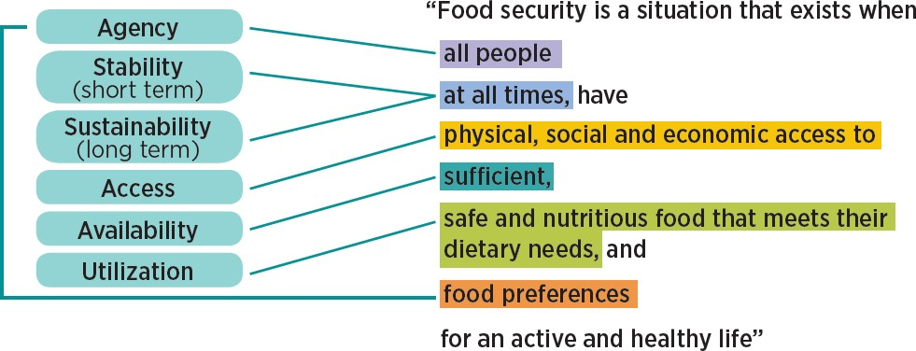
Figure 5.2 Dimensions of Food Security

FOOD SYSTEMS

A food system gathers all the elements (environment, people, inputs, processes, infrastructures, institutions, etc.) and activities that relate to the production, processing, distribution, preparation and consumption of food, originating from agriculture, forestry or fisheries, and the outputs of these activities, including broader socio-economic and environmental outcomes (HLPE, 2017). The food system is composed of sub-systems (e.g. farming system, waste management system, input supply system) and interacts with other key systems (e.g. energy system, trade system, health system). Therefore, a structural change in the food system might originate from a change in another system; for example, a policy promoting more bio fuels in the energy system will have a significant impact on the food system.

Food systems are diverse, ranging from traditional to mixed and modern food systems. While modern food systems are characterized by more diverse food options all year long, and by processing and packaging to extend food’s shelf life, they are not necessarily the healthiest. Policymakers should focus on encouraging the availability and accessibility of diverse and healthy diets, particularly for the marginalized and the most vulnerable. They should aim to limit the consumption of highly processed and nutrient-poor foods by targeting the industries that produce them (e.g. through marketing restrictions, content restrictions and labeling requirements for trans fats and added sugars) as well as the consumers (e.g. through subsidies and taxes, and nutrition education).

Sustainable Food Systems
A sustainable food system (SFS) lies at the heart of the United Nations’ Sustainable Development Goals (SDGs). Adopted in 2015, the SDGs call for major transformations in agriculture and food systems in order to end hunger, achieve food security and improve nutrition by 2030. To realize the SDGs, the global food system needs to be reshaped to be more productive, more inclusive of poor and marginalized populations, environmentally sustainable and resilient, and able to deliver healthy and nutritious diets to all. These are complex and

systemic challenges that require the combination of interconnected actions at the local, regional, national, and global levels. “A food system that delivers food security and nutrition for all in such a way that the economic, social and environmental bases to generate food security and nutrition for future generations are not compromised” means that:
    - It is profitable (economic sustainability);
    - It has broad-based benefits for society (social sustainability); and
    - It has a positive or neutral impact on the natural environment (environmental sustainability).

Drivers of a Sustainable Food System
Food systems can be sustainable only if the interconnectivity and interrelatedness between different parts of the system is ensured. For instance, the progress on SDG 2 – ‘Zero hunger’ has a direct bearing on progress of SDG 3 – ‘Good health and well-being’, and vice versa; similarly, SDG 6 – ‘Clean water and sanitation’, is necessary for food production as well as good nutrition; SDG 12 – ‘Responsible production and consumption’ is necessary to achieve food security and nutrition in a sustainable manner.

A sustainable food system recognizes the complexity of relationships among the systems that support food production, food supply chains, food environments, the behaviors of individual consumers, diets, and nutritional and wider outcomes that feed back into the system. In the past, a narrow focus on agricultural production and agricultural policies, with little attention to the diversity of food system drivers as discussed below, has meant that despite sufficient food production at the global level, many millions remained hungry. Simultaneous focus in a coordinated manner to create the right policies and incentives/disincentives across sectors and levels of the food value chains, from production to consumption, can only ensure the right to food for all.
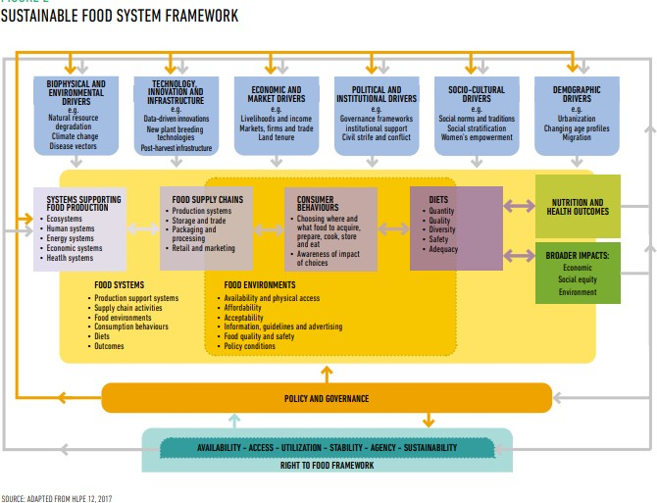

Figure 5.3 Framework of Sustainable Food System

Figure 5.3 illustrates the framework of sustainable food systems. It highlights six main categories of food system drivers including the biophysical and environmental; technology and innovation; economic and market; political and institutional; socio-cultural; and demographic. These are discussed below.

i.) Biophysical and environmental - Food production is heavily dependent on natural resources such as water, land and soil, and ecosystem services like biodiversity, the number of plant and animal species, as well as intra-species variety. All these are critical for food security, diets and nutrition, and serve as the foundation for a sustainable and well managed agriculture system. Climatic conditions such as floods and droughts, impact not only agricultural productivity but also human health. As Devereux notes “Hunger seasons” are most severe when there is also unpredictable rainfall or extreme weather events (2015).

ii.) Technology, innovation and infrastructure - To address the issue of depleting natural resources and build a sustainable food system that protects communities in the events of climatic change, the role of innovation and technology becomes critical. For instance, digital farming is being used by farmers of industrialized countries to improve the efficiency of farm inputs such as energy and agrochemicals. Farmers in less industrialized countries, including small-scale farmers, are also beginning to adopt digital technologies, although there is a knowledge gap in this area and more research is needed to gain a full picture of usage trends (HLPE, 2020).

Infrastructure plays a vital role in today’s context where the produced food moves a longer distance. Developing countries with weak storage infrastructure face restricted ability to translate harvests into food items especially in case of fruits and vegetables. Limited transport infrastructure results in high levels of food losses. Robust infrastructure for storage and transportation can help address food shortages, thereby contributing to food security and safety.

iii.) Economic and market - Global food trade has significant impacts on diets and nutrition of people where food systems and agricultural supply chains are globalized. An expansion of agric-food markets like supermarkets has changed dietary demands, but also relations between countries. For instance, in recent years, food trade has been disrupted owing to growing trade tensions between the world’s two largest economies - China and the United States of America (HLPE, 2020). The global agric-food markets and trade have also faced critiques due to their exclusionary nature, which marginalize small-scale producers and remote areas from the supply chains, by denying them access to such markets.

Another factor which has impacted the food system is the growing financial investments by private entities, which have received both positive and negative responses. On the negative side, it is believed that such financial investment in agricultural commodities has been a key factor driving food price volatility as occurred during the 2008 food price crisis. The impacts of large-scale land acquisitions in developing countries are ambiguous, providing capital for the development of agricultural sector, while also dispossessing local populations.

iv.) Political and institutional - There is a critical role of leadership and governance at regional, national, and global levels for framing a pro-people, and sustainable food security and nutrition policy. However, recent years have seen a decline in public sector investment in agriculture and much of the increased investment in food and agriculture, since the 2007 global food crisis, has been from the private sector (Giller et al., 2017). Much more research is needed on the potential implications of declining public investment for FSN outcomes.

Other political factors impacting food systems are civil strife and conflicts. These lead to chronic food insecurity and malnourishment as food systems are repeatedly put under stress due to unstable food supply chains. Moreover, violent and armed conflict can lead to the destruction of crops, livestock, land and water systems, as well as disruptions in infrastructure and human resources required for food production, processing, distribution and safe consumption.

v.) Socio-cultural - Inequalities based on factors such as geographical location, class, race, gender and caste make certain groups of people more vulnerable and therefore, they become a critical group in food security and nutrition framework. HLPE (2017) identified inequality as an important barrier to agency, access and sustainability in food systems. For instance, rural women face disproportionately high rates of poverty and barriers against accessing productive assets for agriculture, such as land, credit and inputs (FAO, 2017b) which affect their resilience to withstand shocks such as climate-related disasters or increased food prices. Women-headed households are particularly vulnerable and their situation worsens if they belong to already marginalized communities like Dalits and Tribal’s in India.

vi.) Demographic - Population growth and changing demographics put pressure not only on the planet, but also on the sustainability of livelihoods and development. Although population growth rates are declining globally, as countries go through their demographic transition, world population continues to increase. According to FAO (2018f) the food demand is projected to increase, though the extent of increase will depend on consumer food choices and the ability to reduce food losses and waste. Urbanization puts further stress on food systems as people’s demand and dietary needs change. Increased consumption of pre-packaged and processed food and demand for a greater diversity of food in urban areas has not only dictated the kind of foods to be grown by rural producers but also how these foods are traded, processed, distributed and marketed. While urbanization affects diets and nutrition in complex ways, rural to urban migration weakens the capacity of rural communities to produce food, because of the loss of labour in rural areas.

These six broad drivers have social, economic and environmental impacts, reinforcing the interconnected and interrelated nature of our food systems:

Food supply chains are often referred to as food production and distribution networks. These are an important component of food systems, and include all the stages and actors, including private sector businesses, from production to trade, processing, retail marketing, consumption and waste disposal (HLPE 12, 2017). Food supply chains draw on supporting ecological, human, energy and economic systems to produce and distribute food, while also providing livelihoods for those who work at various points in the production-to- distribution continuum.

Food environments consist of ‘food entry points’, namely, personal spaces of acquiring food, personal determinants of food choice and underlying socio- cultural and political factors that shape access, affordability, safety and food preferences. Food environments typically overlap with food supply chains, consumer behaviors and diets. In fact, people are experiencing food and diet transitions due to multiple factors including improved food supply chains, better infrastructure, more accessibility, affordability, and advertising and promotion. People aspire to foods seen as ‘modern’ and often include processed foods such as corn flakes, bread, noodles, pasta, chips etc. which are not necessarily healthy. Unlike these foods, tribal communities in India source food from agriculture, from forests and ponds, local markets and the government’s public distribution system. Though the traditional food of tribal and rural communities presents a diverse plate and is often a ‘balanced’ diet, these foods are seen as ‘backward’, wild (in case of tribal areas) and are discouraged. Therefore, there is a need to recognize the close link between traditional foods, farming practices and cultures and how they modify themselves when in contact with modern food cultures.

Consumer behaviors are the responses of people to food environments and comprise of individual awareness and decisions on where and what foods to acquire, prepare and eat. These are ultimately individuals’ decisions that shape their diets in terms of quantity, quality, diversity, safety and adequacy of food (Downs et al., 2020).

Diets shape outcomes that affect other systems, such as nutritional impacts within populations affecting health, or the climate impacts of diets affecting ecosystems. These linkages create feedback loops that shape the drivers of food system change and the policies that address it (Burlingame, 2019). Well- nourished individuals and communities are key to sustaining food systems, ensuring positive life outcomes and feeding those outcomes back by influencing people’s ability to work and exercise agency within the food system.

Policy and governance systems encompass both formal and informal rules, norms and processes that shape policies and decisions affecting food systems. These could include taxation, import-export policies, land use policies, or perceptions about what constitutes agricultural development or healthy food. The key actors engaged in food governance include public actors, such as governments and intergovernmental organizations, civil society, including non- governmental agencies and social movements, and private sector actors, such as businesses. Food policy and governance seeks to shape food system outcomes, and in the process shape the ways in which drivers of food system change, affect consumer behaviors, and the rules by which supply chain actors operate, amongst others. Food system policy and governance, guided by the principle of the right to food, are most likely to support the six dimensions of food security.

The next section explores various challenges associated with food and nutrition security.

CHALLENGES TO THE DIMENSIONS OF FOOD AND NUTRITION SECURITY

Food systems are sustainable only when they “deliver food security and nutrition for all in such a way that the economic, social and environmental bases to generate food security and nutrition for future generations are not compromised” (FAO, 2018a). Sustainable food systems embody qualities that support the six dimensions of food security. These qualities are: productive and prosperous (to ensure the availability of sufficient food); equitable and inclusive (to ensure access for all people to food and to livelihoods within that system); respectful and empowering (to ensure agency for all people and groups to make choices and exercise voice in shaping that system); resilient (to ensure stability in the face of shocks and crises); regenerative (to ensure sustainability in all its dimensions), and healthy and nutritious (to ensure nutrient uptake and utilization) (FAO, 2018).

In practice, just as the six dimensions of food security are interrelated, so too are these qualities of sustainable food systems deeply interconnected. When food systems embody these qualities in an integrated and holistic way, they are more likely to support the realization of the right to food and to meet the goals of the 2030 Agenda, especially SDG 2 - Zero hunger.

Food availability
India is the second most populous country in the world, hence ensuring adequate food availability is central to the food and nutrition security of its population. Food availability is defined as ‘the availability of sufficient quantities of food of appropriate quality, supplied through domestic production or imports including food aid’. At household level, food availability implies that the household is able to consume the required quantity of food grains. Food availability has two sides, demand and supply. The demand side includes population growth, changing diet preferences and income growth. Food availability or the ‘supply side’ is determined by the level of food production, stock levels and net trade. Poor households are more vulnerable to income and price changes, and supply side changes. There is a constant positive association between the availability of nutritious food and its consumption, according to studies that have looked into the function of food availability in altering dietary intake.

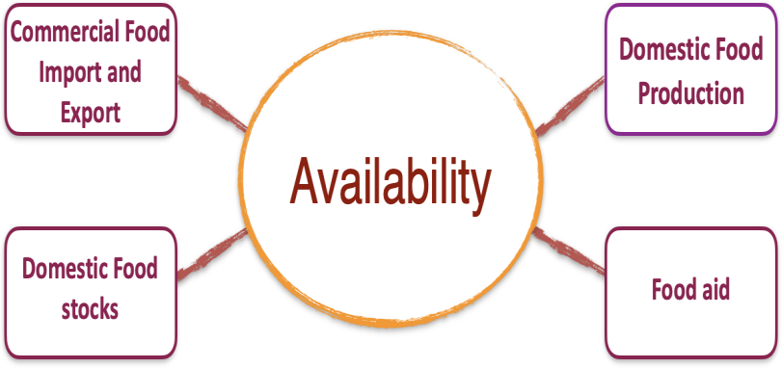

Figure 5.4 Determinants of Food Availability

Figure 5.4 highlights the determinants of food availability which are described as follows:

      - Domestic Food Production: Food production provides the base for food security as it is a key determinant of food availability. For the year 2019, the annual availability of food grains in India was around 179 kg per capita (Statists, 2021). India at present is the world’s foremost producer of milk, pulses, and jute, and ranks second in rice, wheat, sugarcane, groundnut, vegetables, fruit, and cotton production. It is also a major producer of spices, seafood, poultry, livestock, and plantation crops (Kumar, 2005).

      - Commercial Food Import and Export: India has consistently maintained a trade surplus in agricultural commodities over the years and has registered an increase of nearly 7 times in the span of 15 years (from the year 2004-05 to 2020-21). The agricultural export value has increased in marine products, rice (basmati and non-basmati), spices, and sugar. Increasing food export signifies greater domestic food production, thus better food availability. However, the trade data for agricultural products doesn’t automatically signify better outcomes of food related schemes for the poor.

      - Food stocks: Food grain stocking norms refer to the level of stock under central government’s procuring agencies, like FCI (Food Corporation of India), that is sufficient to meet the operational requirement of food grains and exigencies at any point in time. Procurement of rice, wheat and coarse grains over the last five years shows that there is enough stock ensuring food security under the National Food Security Act.

      - Food aid: Food aid refers to the provision of food or cash to purchase food in an emergency or to provide long-term solutions in areas where food scarcity exists, caused by internal (e.g., crop damage) or external factors (import reduced). For example, the United States provides food aid to friendly nations either on concessional or grant terms under the Public Law- 480 scheme.

Factors affecting the availability of food
The above section on the determinants of food availability shows that India as a country has food surplus, enough food stocks, and is an efficient food exporter of various agricultural commodities. However, despite such surplus there are a few bottlenecks (as discussed below) to increasing food availability.

Fragmented land holdings - small and marginal farmers, holding less than 2 hectares of agriculture land, constitute about 86% of all farmers in India. Such small holdings make farming uneconomical.

Finance - only 40% of small farmers have access to institutionalized credit making it difficult for them to increase their productivity (RBI, 2019).

Fertilizers & Pesticides - unscientific use of three macronutrients, Nitrogen (N), Phosphorus (P), Potassium (K), have disbalanced the ratio of N:P:K in soils to 8:3:1 instead of the ideal ratio of 4:2:1, leading to depleted soil quality.

Irrigation - 65% of cultivated area is rain-fed, and with groundwater depleting and irrigation regionally concentrated, water management needs to improve.

Technology and research - Poor adoption of technology in agricultural sector and focus of research more into commercial crops and yields rather than nutrition and diversity pose challenges to productivity.
Distribution and processing of agricultural outputs - lack of infrastructure for storing, cooling, irradiating leads to food losses. For instance, poor road connectivity impacts weight loss in crops like sugarcane, which need to be operated in sugar mills within 24 hours of harvesting for best extraction.
Environmental Concerns - increasing vulnerabilities due to unexpected climatic events viz, flood, drought etc. as well as increasing pest and locust attacks pose environment related challenges to food availability. Loss of a majority of wheat crop in 2021 in Madhya Pradesh was due to untimely rainfall. Government Policy - various government policies such as higher MSP (Minimum support price) for some crops, incentivizes farmers to grow these crops every season without giving time for soil rejuvenation which is possible when farmers grow diverse crops. Similarly, policies relating to trade cartelization where Agricultural Produce Market Committees (APMC) place a ceiling on price realization, or discourage private investment, can end up disadvantaging farmers in terms of paying them less by declaring their produce to be of inferior quality.

Though some government policies as mentioned above hinder food security, during the pandemic year of 2020-21, Government of India took some positive measures to allocate food grains through the National Food Security Act (NFSA) and the Pradhan Mantri Garib Kalyan Anna Yojana (PM-GKAY) schemes. In the PM-GKAY scheme, additional allocation of food grains from the Central Pool at the rate of 5 kg per person per month free of cost for all beneficiaries was provided under the Targeted Public Distribution System (TPDS).

Some other developments by the government, to ensure food security are:

        - Fortification of Rice and Its Distribution - To address the issue of anemia and micro-nutrient deficiency, especially amongst adolescent girls and lactating mothers, and to promote nutrition security in the country, a centrally sponsored pilot scheme on “Fortification of Rice & its Distribution under the Public Distribution System (PDS)” was approved.
        - One Nation One Ration Card - Nation-wide portability of ration card will ensure food availability at any place from any fair price shop (FPS) across the nation. Ordeals regarding food availability for migrant labour, as witnessed during the Covid-19 pandemic, will be minimized.
        - Open Market Sale Scheme - Selling of food grains by government agencies at predetermined prices in the open market. The scheme aims to enhance supply of food grains especially during the lean season.
        - Operation Green - The scheme provides subsidy on transportation of vegetables and horticulture crops to minimize post-harvest loss. This ensures food availability is not hampered because of lack of investment in infrastructure. Oranges from Nagpur can reach Guwahati without worrying about the low shelf life.

Food Access
‘Access to Food’ is an important component for addressing the concern of food insecurity especially during situations of crisis such as the COVID-19 pandemic. The World Food Summit of 1996 defined access to food as having sufficient resources to obtain appropriate foods for a nutritious diet. It is not the lack of production or availability of food that causes hunger, but the lack of ‘access’ that leads to hunger and malnutrition. This access could be physical, social and economic. Physical access includes geographical conditions, infrastructure availability, transportation, and physical condition of the individual. For instance, people in a mountainous region may lack physical access to green leafy vegetables grown in the plains due to lack of transport and storage systems. Economic access takes individual or household income into consideration. Low- income groups and poor people due to financial constraints are unable to afford nutrient rich foods such as milk, legumes, fruits or eggs. Moreover, people with low incomes end up spending a significant proportion of their income on food, making them vulnerable to the risk of food insecurity. Social access to food refers to food that is culturally acceptable or is adaptable by the community. In many societies and communities, customs and cultural practices often dominate the eating and consumption patterns of people. For instance, in many areas, pregnant women aren’t allowed to eat particular foods even if it is available, affordable and nutritious.

Marginalized Groups and Access to Food

Marginalized groups in Indian society, based on multiple discriminations of sex, gender, religion, caste, health status, disability, education or income, or living in remote geographic localities, experience barriers in all three types of access. For instance, at many places, the children of lower caste and tribal communities (SC and ST) are excluded from mid-day meal schemes and other state-sponsored food and nutrition programmes. In other cases, upper caste children have refused to accept the food prepared by a SC service provider in mid-day meal or ICDS schemes.

Contd..

Even the targeted Public Distribution System (PDS) in India is reported to be affected by caste-based discrimination. Studies from the states of Rajasthan, Uttar Pradesh, Bihar, Andhra Pradesh, and Tamil Nadu show that 70% of the fair price shops are located in dominant caste localities and only 17% are located in lower caste localities, affecting physical access. Discriminatory practices followed by the upper caste PDS dealers, such as fixing specific days for distribution to lower caste customers, or providing a slightly lesser quantity for the same price, has affected their accessibility.

The choice of food being largely dependent on caste and religious beliefs, ‘access to food’ has multiple determinants. To ensure the rights and access to food for the vulnerable communities, a holistic and multi-dimensional approach is needed.

Source: Mander & Kumaran (2006); Mamgain & Dilip (2012); Thorat and Lee (2005)

Challenges to ‘access to food’
According to the High-Level Panel of Experts (HLPE-CFS), some of the prominent challenges faced in access to food include:
- Lack of affordability of healthy food
- Food import dependence
- Poverty and precarious livelihoods
- Income inequality
- Uneven quality of food environments
- Gender, class, age and intra-household differences in access
- Weak infrastructure for distribution and access to markets for small scale producers
- Concentration in real markets and increased distance between production and consumption
COVID-19 pandemic and access to food
Access to food has been severely affected due to the ongoing COVID-19 pandemic. To cope with the crisis, people and communities have adhered to various coping mechanisms - from selling assets and livestock, to exhausting all their savings, to migration, and going back to forest foods and products, especially in the case of indigenous communities. Social safety nets of the Government like Public Distribution Systems (PDS) had an important role to play in ensuring access to some food, yet the crisis also exposed the operational and structural dysfunctions in the system. Gender discrimination has further marginalised women in these communities, exposing them to poor health and nutrition outcomes going forward. This pandemic has brought out the urgency of creating a more robust and resilient food system, ensuring access to food for all.

Stability
Stability is typically linked to the vulnerability context and risk factors that can negatively impact food availability or access to food. It requires that food is available to individuals and households at all times, so they have constant access to the food they require. Stability thus, can be defined as having the ability to ensure food security in the event of sudden shocks such as adverse weather conditions, political instability, a health crisis, or economic factors such as unemployment and sudden rise in food prices. Besides these, another type of stability is the ability to ensure seasonal food security by providing a stable supply of healthy and nutritionally diverse foods for all individuals in the off‐ season. Based on this understanding, an individual or household is considered to be food insecure when the food intake is adequate on a day, but inadequate on a periodic basis, risking a deterioration of one’s nutritional status. A sustainable food system should be resilient to ensure stability in the face of above-mentioned shocks, crises and off-seasons.

Utilization
Utilization is the ability of the body to absorb both macro and micro-nutrients from the food consumed. This means that the food should have the required nutrients for the body to be able to absorb those nutrients. There are various factors such as food composition, cooking method, environment factors, food processing methods that determine the nutritive value of the food consumed by the body. For instance, the food consumed by the poor contains more of staple foods which have less of protein, minerals, and vitamins. This leads to a state called as ‘hidden hunger’ where the stomachs are full, but there exist nutrient deficiencies particularly of micro-nutrients like iron or vitamins leading to specific health problems such as anemia, joint pains, night blindness etc. At the same time, food loses its nutritive value due to lack of basic sanitary conditions. This risk is increased by environmental conditions like lack of access to safe drinking water and sanitation that can lead to diarrhea and other water-borne diseases hindering with nutrient absorption.

Food safety methods adopted during processing and packaging of foods is another factor affecting the nutritive value of food. In traditional and mixed food systems, food safety methods are hardly used, there is no testing for their nutritive values, expiry details, or attention to proper cooling and storage. A good example is of small ice cream vendors. In the hot summer, as their ice melts, the ice-creams melt too and are refrozen with a fresh stock of ice. This leads to a deterioration in quality, leading to stomach infections when consumed.

Sometimes, even the lifestyle and busy schedules of individuals have an impact on the quality of food consumed. For instance, during the peak farming seasons of planting and harvesting, when women are often overburdened with both productive and domestic work, they don’t find the time to cook and feed, leading to the lack of nutrition. Then, there are the situations of conflict and post conflict situations that makes the availability of clean and adequate water and sanitation to facilitate food production, preparation and utilization critical.

Sustainability
Sustainability is integral to the concept of food security and is a central idea in policy initiatives such as the SDGs (UN 2019a). Sustainability finds itself based on those practices of food system that respect and protect ecosystems over the long term. It refers to the long-term ability of food systems to provide food security and nutrition in a way that it does not compromise the economic, social and environmental bases that generate food security and nutrition for future generations. However, so far, food interventions have largely worked to ensure short-term stability in terms of food prices, relief measures following disasters and extreme events, rather than longer-term measures. For instance, the excessive use of chemical fertilizers and pesticides that was adopted as a measure to increase crop yields, provided for short-term stability, but led to the decline in the quality of the soil and loss of biodiversity compromising on the natural resources for future generations. Similarly, trade and taxation policies often are not framed keeping in mind the health of future generations, as some of them promote highly processed foods over seasonal and traditional foods adversely impacting health outcomes.

Another aspect which has been a growing concern to sustainability is the decreasing interest of rural youth in agriculture contributing to ‘agricultural stagnation’. Therefore, efforts should be to make food system jobs (like farming, distribution of farm products, marketing of farm products) more attractive to youth economically, intellectually and in terms of social respectability.

In addition to the above concerns, one of the key challenges to the sustainability of food systems comes from climate change, extreme events and seasonality. However, food systems are also responsible for the accelerated pace of natural resource degradation, while at the same time being affected by it. FAO estimates that agriculture, forestry and land-use change generate one-fifth of Green House Gas (GHG) emissions. The contribution of food systems to global Green House Gas emissions is even greater due to the impact of agrochemicals production, transport and storage, and agro-processing and retailing (FAO, 2016a).

Further, new threats such as due to the covid-19 pandemic, which has disrupted livelihoods and food availability, has had serious implications on food systems and food security. The pandemic has unsettled many activities in fisheries, livestock, agriculture, and their supply chains and led to the closure of numerous food processing facilities worldwide. The use of quarantines, bans, restrictions on the movement of goods and people as disease control measures has resulted in significant socio-economic repercussions for livelihoods especially for poor rural farmers, livestock keepers, and capture fisheries from developing nations. Estimates on the economic fallout brought by the COVID-19 pandemic indicate that over half a billion people may be pushed into poverty. Of these, communities in Sub-Saharan Africa, North Africa and the Middle East are expected to be the hardest hit (WIDER, working paper series, 2020).

Agency
HLPE (2020) defines agency as - individuals or groups having the capacity to act independently to make choices about what they eat, the foods they produce, how that food is produced, processed and distributed, and to engage in policy processes that shape food systems. This requires socio-political systems and governance structures that enable the achievement of FSN for all.

However, historically disadvantaged individuals and communities including women, small-scale agricultural producers, indigenous people, pastoralists, fisher folk, vulnerable food system workers, marginalized communities, and oor people in urban areas, often lack agency with respect to food security and food systems, and often experience disproportionate levels of food insecurity. At the same time, other actors (such as donors and large corporations) may have disproportionate agency or power in shaping the way we think about food insecurity – including defining the solutions and influencing the contours of food environments (HLPE 12, 2017; Schuman, 2017).

Further, the increase of corporate role in food systems, concentration of land and resources, and weak governance systems, as well as social inequities are challenges to the exercise of agency. Hence, there is an important role for collectives and groups to challenge social norms and inequities and make their voice heard. However, this also needs the setting up of legitimate spaces and resourcing of such collectives. The Amul cooperative in Gujarat is a good example of collective action to overcome unequal power relations by small producers, especially women. Other factors that present challenges to the dimension of agency are gender and wealth inequities affecting choice and uneven access to information to make informed decisions.

CONCLUSION

We are not on track to meet the SDGs, especially those related to food and nutrition security. To be sustainable, food systems need to address the different dimensions of food security. We need to strengthen our conceptual understanding of the different drivers and processes involved in the food system, and their implications on wellbeing outcomes. Research and documentation, using participatory, people-oriented methods, to understand and support diverse food systems, are needed. This can be accomplished through land reforms, access to institutionalized credit, promoting usage of good quality seeds, fertilizer and pesticides, new and effective methods of irrigation like sprinkle irrigation and drip irrigation, tax reforms, and so on Further, access to food implies having sufficient resources to obtain appropriate foods for a nutritious diet at country, household and individual levels. Measures should be taken to strengthen social protection and governance mechanisms, and ensuring accountability, participation and transparency to assure access to food for marginalized and vulnerable communities.
REFERENCES AND SUGGESTED READINS

Freedman D.A., Vaudrin N., Schneider C. et al. (2016). Systematic Review of Factors Influencing Farmers’ Market Use Overall and among Low-Income Populations. J Acad Nutr Diet,116(7), 1136–1155.

HLPE (2017). Nutrition and food systems. A report by the High-Level Panel of Experts on Food Security and Nutrition of the Committee on World Food Security, Report 12. Rome.

HLPE (2020a). Food security and nutrition: building a global narrative towards 2030. Committee on World Food Security. Report 15. Rome. http://www. fao.org/3/ca9731en/ca9731en.pdf.

HLPE (2020b). Interim Issues Paper on the Impact of COVID-19 on Food Security andNutrition (FSN). Committee on World Food Security. Rome. http://www.fao.org/fileadmin/templates/cfs/Docs1920/Chair/HLPE_En glish.pdf.

Kumar, Dharma (2005). The Cambridge Economic History of India, Volume II:
c. 1757–2003. New Delhi: Orient Longman.

Lucan S.C., Maroko A.R., Sanon O., Frias R., Schechter C.B. (2015). Urban farmers’ markets: accessibility, offerings, and produce variety, quality, and price compared to nearby stores. Appetite.90, 23–30.

Mamgain, Rajendra & Diwakar, Dilip. (2012). Elimination of Identity-based Discrimination in Food and Nutrition Programmes in India. IDS Bulletin. 43. 10.1111/j.1759-5436.2012.00343.x.
Mander, Harsh and Kumaran, M. (2006). 'Social Exclusion in ICDS: A Sociological Whodunit?'. mimeo. New Delhi: Centre for Equity Studies.

McCormack L.A., Laska M.N., Larson N.I., Story M. (2010). Review of the nutritional implications of farmers’ markets and community gardens: a call for evaluation and research efforts. J Am Diet Assoc, 110(3), 399–408.

Dr. Suman Singh, Assistant Professor, Indira Gandhi National Open University Maidan Garhi New Delhi, Pin -110068. Office Context NO.- 011-29573096, Mobile NO. 9170979915, Email Id – sumansingh@ignou.ac.in.

