Management of Ureteric Stone Disease
(Dr Ashi Verma¹, Dr Krishna Kant Singh ², Dr Jitendra Kushwaha ³₎
1.Junior resident, Department of General Surgery, King George’S Medical University, Lucknow
2.Professor, Department of General Surgery, King George’S Medical University, Lucknow
3. Professor, Department of General Surgery, King George’S Medical University, Lucknow

ABSTRACT

Ureteric stone disease is a common problem with rising incidence in the past few decades due to present lifestyle as well as better technology leading to early detection. However, it is also associated with complete cure and can even be prevented with proper measures. Calcium oxalate stones are the most common ones followed by uric acid stones, infection stones(struvite and apatite), calcium phosphate stones and cysteine stones. Patients can be initially asymptomatic or may present in the emergency department with ureteric colic. Detection is done mainly by radiological imaging (X- Ray KUB, IVU, USG-KUB, NCCT KUB) and management ranges from conservative methods including observation and medical expulsive therapy (MET) to interventions including endourological procedures (shock wave lithotripsy, ureterorenoscopy, percutaneous nephrolithotomy) and open surgeries (pyelolithotomy, nephrolithotomy). Certain dietary measures including plenty of water intake, low protein and low sodium diet along with intake of caffeine as well as carbonated water, lemon and orange juice also helps in preventing further stone formation.

INTRODUCTION

Ureteral stones are those lying within the ureter i.e., from ureteropelvic junction (UPJ) to vesicoureteric junction (VUJ). These are always secondary and come into the ureter from the kidneys, the most common being the calcium oxalate stones. The incidence of stone disease has increased to a great extent in the past decades, including both the genders, leading to an increased annual expenditure as well. Intervention methods remove the stones but do not change the course of the disease. Hence, development of preventive measures plays an equally important role as the treatment measures which needs a detailed understanding of the disease.

EPIDEMIOLOGY

Ureteric stones incidence peaks in the 4th to 6th decades of life, similar to renal stone disease. The prevalence of ureteric calculi is 12% in men and 7% in women, being 2-3 times more common in men. A possible reason is higher urinary concentrations of calcium, oxalate and uric acid in men while higher citrate levels in women along with protective effect of estrogens against stone formation. This is also responsible for the bimodal distribution of stone disease in women, demonstrating the second peak just after menopause. Among racial differences, the highest prevalence of stone disease is seen among whites, followed by Hispanics, Asians and African Americans. Hot, arid and dry climates also show a higher prevalence with the highest incidence in the summer months, from July to September due to excessive fluid losses from perspiration and sunlight induced increases in Vitamin D. Occupational risk factors include heat exposure and dehydration leading to increased prevalence in cooks, engineering room personnel, steelworkers and workers at a glass plant. Occupations that limit bathroom access such as taxi drivers and operating room personnel also show increased risk of stones. Individuals with a BMI of more than 30kg/m2 also show higher incidence, the reason being related to metabolic syndrome. The association of obesity with calcium oxalate stone formation is primarily due to increased excretion of promoters of stone formation and with uric acid stone formation is due to urinary pH. Urinary stone disease risk is also increased in hypertensives. Also, hereditary causes for stone disease include cystinuria, type I renal tubular acidosis and primary hyperoxaluria.

PATHOGENESIS

Three main pathways are responsible for stone disease. These are-
- Precipitation of inhibitory factors like citrate, potassium, magnesium and Tamm-Horsfall microproteins by increased concentration of calcium and oxalate.
- Variation in pH my also cause or prevent stone growth, e.g. acidic pH leads to formation of uric acid stones while alkaline pH causes precipitation of calcium phosphate stones.
- Urinary stasis also increases risk of stone formation.

TYPES OF STONES

- Calcium oxalate stones- It is the most common type of stone with the most common metabolic abnormality being hypercalciuria commonly seen in primary hyperparathyroidism. These can be monohydrate as well as dihydrate stones.
- Calcium phosphate stones- seen in two forms, apatite and brushite associated with infection and distal RTA respectively.
- Uric acid stones- commonly seen in patients of gout, after cytotoxic treatment especially in cases of myeloproliferative disorders and in presence of acidic urinary pH.
- Infection stones- include struvite and apatite stones. It occurs due to alkalinization of urine due to urease producing bacterial infections and can grow very large before becoming symptomatic.
- Cystine stones- common in patients of cystinuria. These are very hard stones due to presence of disulphide bonds.

CLINICAL PRESENTATION

Patients may be asymptomatic with stones being detected incidentally (more common in cases of renal calculi) or may present with colicky pain- sudden, acute, intense, agonizing and paroxysmal pain that begins in the renal angle and radiates to scrotum/labia majora, iliac fossa and medial aspect of upper thigh in cases of upper, middle and lower ureteric calculus respectively. Patient rolls around in excruciating sharp pain, writhing or constantly pacing around the examination table. It is often associated with sweating, nausea or vomiting. Also, microscopic, or gross hematuria may be present during episodes of colic.

INVESTIGATIONS

Blood and urine investigations have limited diagnostic value (play role in detecting the etiopathogenesis). Imaging studies play an important role in diagnosis. Plain abdominal radiography (KUB) has a sensitivity in the range of 45-60% for evaluating acute flank pain, its main drawback being its inability to differentiate stone disease from fecoliths and phleboliths. Ultrasonography (KUB) is useful in localizing stones present at the PUJ, the VUJ, in the renal pelvis or calyces. Intravenous urography (IVU) plays role in determining the site, degree and nature of obstruction and has a stone detection rate of 70-90%. However, it can visualize only radio-opaque stones and is associated with risk of nephrotoxicity and contrast reaction, hence replaced with non-contrast enhanced computed tomography (NCCT KUB) which has no similar side effects with higher stone detection rate (sensitivity and specificity being 96% and 100% respectively), is quick to perform and can also detect secondary signs of urinary tract obstruction like uretero hydronephrosis and perinephric stranding. Specificity of helical CT is as high as 100% and can detect stones more than 1 mm in size. CT scan can also visualize radiolucent stones such as uric acid and cystine calculi. However, in patients with little pelvic fat, distinguishing a ureteric calculus from a phlebolith can be challenging. Comet tail sign favors phlebolith while soft tissue rim sign favors ureteric calculi.
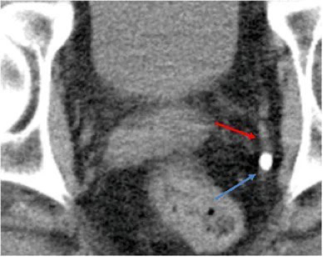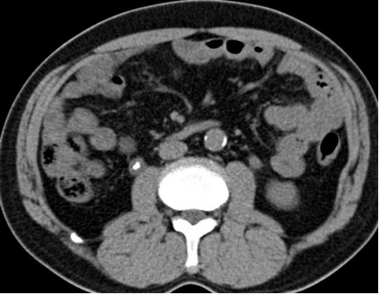
Soft tissue rim sign
Comet tail sign

Ureteroscopy can be used as the last resort - it is diagnostic as well as therapeutic.

MANAGEMENT

The aim of current management algorithm is to achieve maximal stone clearance with minimal morbidity. In many cases, more than one treatment option may be needed. This is based on the balance between invasiveness and morbidity of the procedure versus likelihood of achieving stone free status. Factors that determine optimal treatment include the following-
1. Stone factors: Location, size composition, presence, and duration of obstruction.
2. Clinical factors: Symptom severity, patient’s expectations, associated infections, obesity, coagulopathy, hypertension, and solitary kidney.
3. Anatomical factors: Horseshoe kidney, UPJ obstruction and renal ectopia.
4. Technical factors: Available equipment.

The various aspects of management are-

1. Conservative management-
- Observation/ Wait and watch- Spontaneous passage of ureteric calculi occurs in cases of distal ureteric calculi and stones less than 5 mm within a month in absence of infectious symptoms, intolerable symptoms, or a threat to renal functions.
- Medical expulsive therapy (MET)- It is the first line treatment option for ureteral stones less than 10 mm. The main physiologic reactions thought to slow or prevent ureteral stone passage include ureteral spasm and edema induced by the presence of a calculus. So, an ideal agent would reduce ureteral edema and spasm while preserving peristalsis. The commonly used agents include– Alpha blockers (tamsulosin, doxazosin, terazosin, silodosin), Calcium channel blockers (nifedipine), NSAIDs (indomethacin, ibuprofen, diclofenac), steroids (methylprednisolone) and anticholinergics (tolterodine, oxybutynin). These also play a role in assisting passage of fragments following SWL.

2. Interventional management-
- Shockwave lithotripsy (ESWL)- It is indicated in cases of calculus up to 2 cm in renal pelvis, upper and middle calyx and up to 1 cm in lower calyx. ESWL is done using a lithotripter containing a shock wave generator, a focusing system, a coupling medium and an imaging system. Stone is broken down into smaller fragments using various mechanisms (shear stress, superfocusing, cavitation, squeezing splitting, spall fracture and dynamic fracture). It is absolutely contraindicated in cases of uncorrected coagulopathy and pregnancy and relatively contraindicated in severe renal failure, obese patients (weight > 300 pounds, skin to stone distance >10 cm), skeletal deformities, distal obstruction in ureter, impacted calculus, lower ureteral stone, UTI, hard stones (stone density >1000 HU) such as brushite and cystine and in cases of arterial aneurysm in the vicinity. Factors favorable for ESWL include stone density <900 HU, infundibular length of 3 cm, infundibular width of 5 mm, skin to stone distance <10cm and pre ESWL stenting. Disadvantage of ESWL is that ESWL only fragments making one to wait for stone passage. Steinstrasse is a possible complication wherein a column of stones accumulates in the distal end of ureter, blocking it.
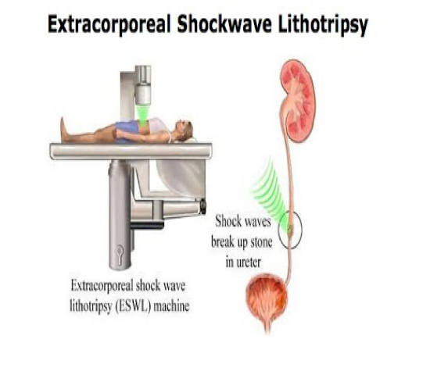
- Ureterorenoscopy (URS)- Semirigid or flexible scopes are used with lithotripter (pneumatic or laser energy device). It is indicated in cases of stones < 10 mm in size with anatomic abnormalities, hard stones (brushite, calcium monohydrate or cystine), in patients with bleeding diatheses or those who are not able to stop anti-coagulation due to other medical co-morbidities. URS is safe and efficacious, has a higher probability of achieving complete stone clearance, especially in cases of distal stones and is a definitive treatment with no waiting for stone passage. However, it is more invasive and requires higher expertise.
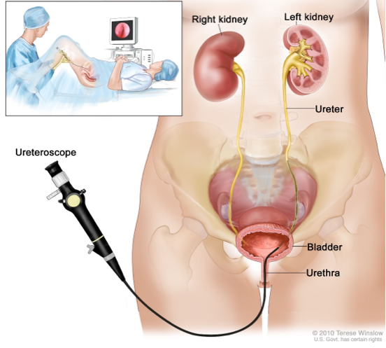
- Percutaneous nephrolithotomy (PCNL)- It is indicated for staghorn calculi, stones >2cm / 1.5cm for lower calyceal stones, stones that are difficult to disintegrate by ESWL (calcium oxalate monohydrate, brushite and cystine), stones refractory to ESWL or ureteroscopy, urinary tract obstruction that requires simultaneous correction, preexisting anatomical abnormality and in obese individuals. It is contraindicated in cases of uncorrected coagulopathy, bleeding diathesis, untreated UTI and pregnancy.
- Open surgery- Pyelolithotomy and nephrolithotomy in used as the last resort in cases of complex and infected stones, large staghorn calculus with anatomic abnormalities.

Pre-treatment ureteral stenting allows easy passage of urine and small fragments of stones and induce passive dilatation of ureter. However, it may lead to pain, infection, hematuria and subcapsular hematoma.

RECENT ADVANCES

- Ureteroscopy has now improved image quality itself with the development of digital ureteroscopes with ‘chip in the tip’ technology. Such systems can be illuminated by LEDs (light-emitting diodes) in the tip of the scope, and an external light source may not therefore be required.
- Significant increases in intra-renal pressure do occur during ureteroscopy (especially during injection of contrast) and these may be associated with complications, including urinary sepsis due to pyelovenous and pyelolymphatic reflux. Hence, through its effect on relaxation of ureteric tone, the use of endoluminal isoproterenol in the irrigation fluid has been shown to reduce pelvic pressure compared with saline irrigation without affecting heart rate or mean arterial blood pressure, offering a potentially useful safety step in ureteroscopy.
- Robotics has made ureterorenoscopy stable, easily maneuverable, and ergonomically superior compared to the conventional method. Also, intra-renal therapeutic maneuvers are also possible, including the complete fragmentation of small stones.

RECOMMENDATIONS TO A PATIENT OF URETERIC CALCULI

General measures-
- Fluid intake: Minimum intake of approx. 3 liters per day
- Daily urine output: 2-2.5 liters per day
- Carbonated water, lemon & orange juice – it increases urinary citrate levels, hence, preventing stone formation.
- Caffeine intake also has been found to decrease urinary stone incidence

Dietary measures-
- Low animal protein
- Low sodium diet
- Combined restriction of sodium and protein reduces stone recurrence by 50%.
- Fruits and vegetables rich diet.
- Avoidance of excess dietary oxalate.
- Dietary calcium avoidance increases stone recurrence risk by increasing intestinal oxalate absorption.

REFERENCES

- Laerum E, Ommundsen OE, Grønseth JE, Christiansen A, Fagertun HE. Oral diclofenac in the prophylactic treatment of recurrent renal colic. A double-blind comparison with placebo. Eur Urol. 1995;28(2):108-11.
- Nicolau C, Claudon M, Derchi LE, Adam EJ, Nielsen MB, Mostbeck G, Owens CM, Nyhsen C, Yarmenitis S. Imaging patients with renal colic-consider ultrasound first. Insights Imaging. 2015 Aug;6(4):441-7. doi: 10.1007/s13244-015-0396-y. Epub 2015 May 21.
- Miller OF, Rineer SK, Reichard SR, Buckley RG, Donovan MS, Graham IR, Goff WB, Kane CJ. Prospective comparison of unenhanced spiral computed tomography and intravenous urogram in the evaluation of acute flank pain. Urology. 1998 Dec;52(6):982-7.
- Mutgi A, Williams JW, Nettleman M. Renal colic. Utility of the plain abdominal roentgenogram. Arch Intern Med. 1991 Aug;151(8):1589-92.
- Worster A, Preyra I, Weaver B, Haines T. The accuracy of noncontrast helical computed tomography versus intravenous pyelography in the diagnosis of suspected acute urolithiasis: a meta-analysis. Ann Emerg Med. 2002 Sep;40(3):280-6.
- Miller OF, Kane CJ. Time to stone passage for observed ureteral calculi: a guide for patient education. J Urol. 1999 Sep;162(3 Pt 1):688-90; discussion 690-1..

