Deep Learning in the Age of Advanced Artificial Intelligence: A Comprehensive

M. Sridharan, UG scholar,
Sengunthar Engineering College (Autonomous), Tiruchengode.
sridharansri86750@gmail.com
Ph: 9361114749
K.Maiyarasan, UG scholar,
Sengunthar Engineering College (Autonomous), Tiruchengode.
meiy8917@gmail.com
Ph: 9025312841

R.Prasanth,UG scholar,
Sengunthar Engineering College (Autonomous), Tiruchengode.
prasanthrajao97@gmail.com
Ph: 6369422899
S. R. Bharanii, UG scholar,
Sengunthar Engineering College (Autonomous), Tiruchengode.
bharaniisr12072k3@gmail.com
Ph.: 9790666378

ABSTRACT
Deep learning has emerged as a transformative force in the field of artificial intelligence, revolutionizing the way machines learn and process information. This abstract provides a comprehensive overview of deep learning, exploring its fundamental principles, applications, and future prospects. Fundamental Principles: Deep learning is based on artificial neural networks, inspired by the structure and function of the human brain. These networks consist of multiple layers of interconnected nodes, or neurons, capable of learning hierarchical representations from raw data. Through the process of forward and backward propagation, neural networks iteratively adjust their parameters to minimize errors and optimize performance. Neural Network Architectures: This abstract delves into various deep learning architectures, including Convolutional Neural Networks (CNNs) for image processing, Recurrent Neural Networks (RNNs) for sequential data, and Transformer-based models for natural language processing.

Keywords : Deep Learning , Advanced Artificial Intelligence , Neural Networks , Machine Learning , Big Data , Computer Vision ,Natural Language Processing , Speech Recognition , Autonomous Systems , Reinforcement Learning , Symbolic Reasoning , Bias in AI

I. INTRODUCTION

The rapid advancements in artificial intelligence (AI) over the past few decades have brought us into the age of advanced AI systems that continue to revolutionize various industries and aspects of human life. Among the most influential breakthroughs within this domain is deep learning, a subset of machine learning that leverages neural networks to unravel complex patterns and representations from massive datasets. As we delve into the realm of deep learning in the context of advanced artificial intelligence, it becomes evident that this powerful technology has transcended its initial limitations, propelling us towards new frontiers of cognitive capabilities and problem-solving.
Deep learning, inspired by the intricate workings of the human brain, enables AI models to autonomously learn hierarchical representations of data through multiple layers of neural units. This ability to automatically extract high-level features from raw data has led to remarkable progress in tasks like image and speech recognition, natural language processing, medical diagnosis, and autonomous vehicles, among many others. The exponential growth in data availability, fueled by the digital revolution, has proven to be a catalyst for deep learning, allowing models to improve in accuracy and complexity.

II.ARTIFICIAL INTELLIGENT

AI aims to develop computer systems that can simulate human-like cognitive abilities, such as learning, reasoning, problem-solving, understanding natural language, and perceiving the environment.
- Narrow AI (Artificial Narrow Intelligence or ANI)
B. General AI (Artificial General Intelligence or AGI):
A. Narrow AI (Artificial Narrow Intelligence or ANI)

Narrow AI, also known as Artificial Narrow Intelligence (ANI), refers to AI systems that are specialized and designed to perform specific tasks or functions with a high level of proficiency. Unlike General AI (Artificial General Intelligence or AGI), which aims to possess human-like cognitive abilities and the capacity to learn and adapt across diverse domains, Narrow AI is limited to excelling in a predetermined area and lacks the ability to transfer its knowledge to tasks outside its specific domain
Key Characteristics of Narrow AI:
- Specialization: Narrow AI systems are purpose-built for a particular task or a limited set of tasks. They are designed to perform these tasks efficiently but lack the versatility of General AI.
- Focused Functionality: Each Narrow AI system is tailored to address a specific problem or application area, and its performance is optimized for that particular function.
- Limited Context Awareness: Narrow AI systems may excel in their designated tasks, but they lack a broad understanding of the world or the ability to interpret information beyond their specialized domain.
- Data-Driven Learning: Training Narrow AI systems typically involves feeding them large amounts of data to learn and improve their performance. The more data they receive, the better they become at their designated tasks.
- No Self-Awareness: Narrow AI systems lack self-awareness or consciousness. They do not have an understanding of their own existence and are not capable of thinking or reasoning beyond their programmed tasks.
- No Transfer Learning: Unlike humans, who can apply knowledge and skills learned in one domain to solve problems in another domain, Narrow AI cannot transfer its learning to unrelated tasks.
Examples of Narrow AI:
- Virtual Assistants: Voice-activated virtual assistants like Siri, Alexa, and Google Assistant are examples of Narrow AI. They excel in recognizing and responding to voice commands and answering specific questions.
- Recommendation Systems: E-commerce platforms and content streaming services use recommendation systems to suggest products, movies, or music based on users' preferences and browsing history.
- Image and Speech Recognition: AI systems used for image recognition (e.g., recognizing objects in images) and speech recognition (e.g., converting spoken words into text) are Narrow AI applications.
- Autonomous Vehicles: Self-driving cars are designed for the specific task of driving within certain environments and conditions. They do not possess the cognitive abilities to perform tasks outside of driving.
- Game-Playing AI: AI agents that excel in playing specific games, such as chess, Go, or video games, are examples of Narrow AI. They are specialized in their game-playing abilities but lack understanding beyond the game context.
Narrow AI applications are prevalent in various industries and have demonstrated impressive performance in their specialized domains. They are extensively used to enhance efficiency, productivity, and user experience in many applications. However, Narrow AI does not possess the adaptability or broad capabilities of human intelligence seen in General AI. Achieving General AI remains a significant challenge and a topic of ongoing research and exploration in the field of artificial intelligence.

B. GENERAL AI (ARTIFICIAL GENERAL INTELLIGENCE OR AGI):
General AI, also known as Artificial General Intelligence (AGI), refers to a hypothetical form of artificial intelligence that possesses human-like cognitive abilities, including the ability to understand, learn, and apply knowledge across diverse domains. Unlike Narrow AI, which is designed for specific tasks and lacks the ability to generalize, AGI would be capable of performing any intellectual task that a human can do.

- Key Characteristics of AGI:

- Versatility: AGI would exhibit versatility in its intelligence, being able to adapt and learn from different environments and tasks. It would not be limited to a single specialized function but could excel in various domains.
- Learning and Adaptation: AGI would have the ability to learn from experience and improve its performance over time. It could acquire knowledge from one domain and apply it to solve problems in different areas, similar to how humans can transfer their skills and knowledge.
- Reasoning and Problem-Solving: AGI would possess reasoning capabilities, enabling it to understand complex problems, make logical deductions, and find solutions using critical thinking.
- Understanding Natural Language: AGI would be proficient in understanding and processing natural language, allowing for seamless communication with humans through speech and text.
- Creativity and Imagination: AGI might be capable of creative thinking and generating original ideas or solutions to novel problems, akin to human creativity.
- Self-Awareness: The theoretical concept of AGI suggests that it could be self-aware, possessing a level of consciousness and understanding of its own existence.
- Emotional Intelligence: AGI might have the ability to recognize and understand human emotions and respond empathetically, although this aspect is a subject of debate and speculation.

- Challenges and Considerations of AGI:

Developing AGI presents numerous challenges and raises profound ethical considerations. Some of the key challenges include:
- Technical Complexity: AGI development requires overcoming technical hurdles related to creating intelligent systems that can generalize knowledge effectively across various domains.
- Ethics and Safety: Ensuring that AGI is developed responsibly and with proper safeguards to prevent misuse or unintended consequences is crucial. Controlling an entity with human-like intelligence could pose significant ethical dilemmas.
- Control and Governance: AGI systems may become extremely powerful and could potentially outperform human capabilities, leading to concerns about who controls them and how they are governed.
- Value Alignment: Ensuring that AGI's goals and values align with human values is essential to avoid potential conflicts with human interests.
- Societal Impact: The widespread adoption of AGI could have far-reaching social, economic, and geopolitical implications, including job displacement and wealth distribution.
- Regulation and Policy: Developing appropriate regulations and policies to govern AGI development and deployment is critical to address potential risks and ensure responsible use.
It's important to note that AGI remains a theoretical concept, and building a truly general intelligent system remains an ambitious and challenging goal. Currently, researchers and developers focus on advancing Narrow AI technologies and addressing the challenges associated with AGI to ensure the responsible development and application of AI technologies for the benefit of humanity.

C.BLOCK DAIGRAM

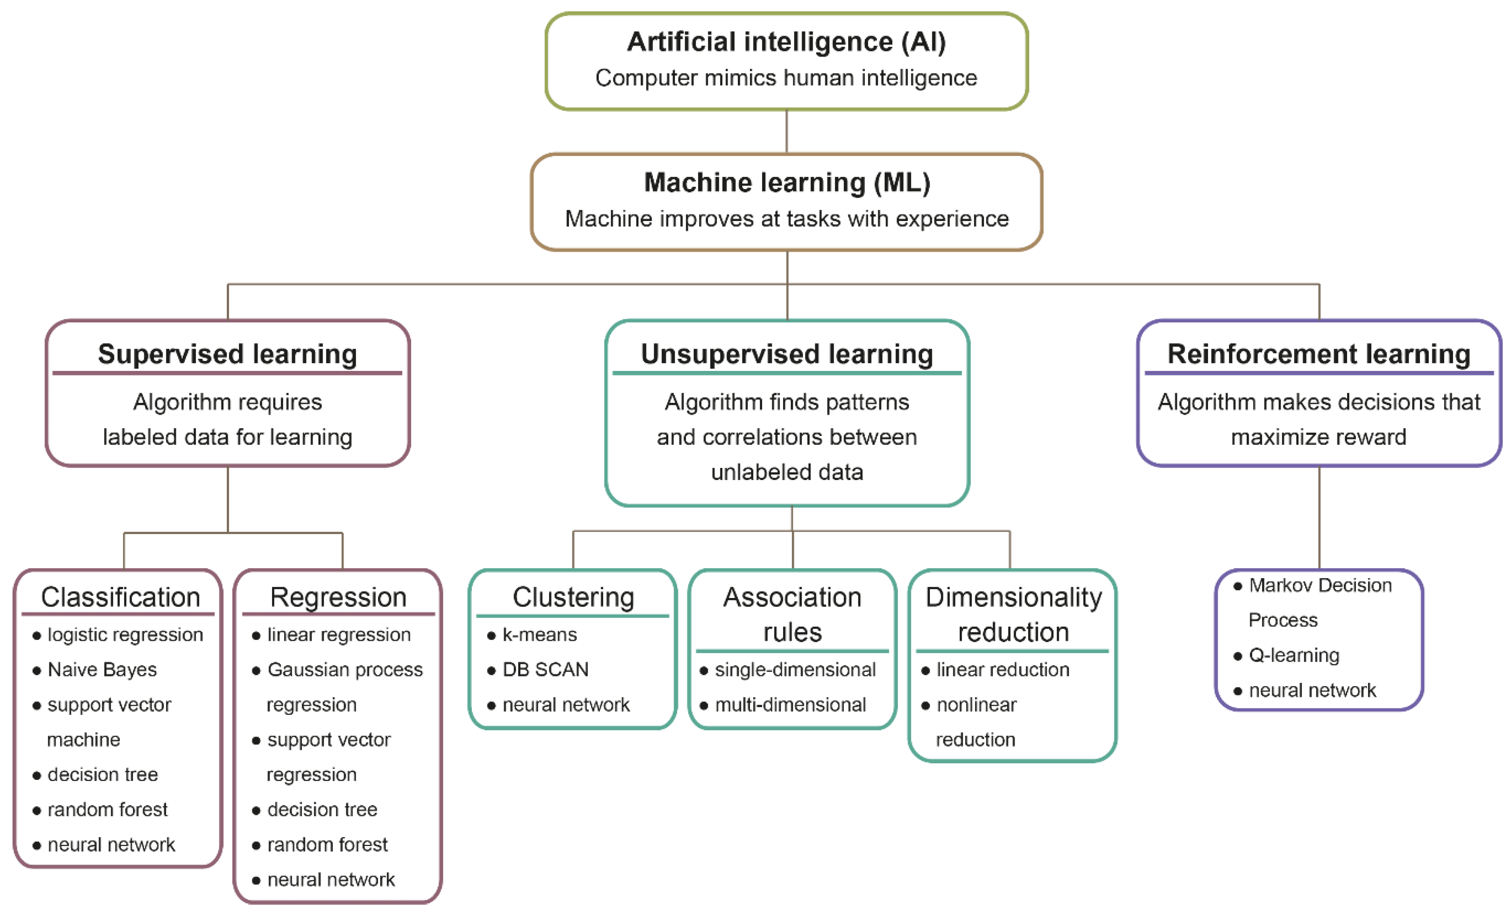

III. Literature survey:

- Deep Residual Learning for Image Recognition

Deep convolutional neural networks have shown remarkable success in image recognition tasks. However, as networks go deeper, they are susceptible to the vanishing gradient problem, which hampers the learning process. To address this issue and enable the training of extremely deep neural networks, we propose a novel architecture called "ResNet" (short for Residual Network). The key innovation of ResNet is the use of residual blocks, which allow the direct learning of residual mappings instead of learning the desired underlying mappings. The residual blocks contain shortcut connections that skip one or more layers, enabling the gradient to flow more efficiently through the network. This bypassing of layers helps in mitigating the degradation problem that arises when deeper networks lead to lower accuracy. We evaluate ResNet on the ImageNet dataset and find that even with increasing depth (e.g., 152 layers), the performance of ResNet continues to improve without plateauing. Compared to other state-of-the-art models, ResNet achieves higher accuracy and requires less computational resources for training.
Moreover, we also conduct extensive experiments to analyze the impact of varying depths on training and validation errors. Our results show that adding more layers to ResNet does not lead to overfitting, and deeper networks achieve superior generalization performance. The ResNet architecture has proved to be highly effective in various image recognition tasks, such as object recognition and image classification, setting new benchmarks in accuracy and efficiency. We believe that our approach of introducing residual learning and shortcut connections has the potential to advance the development of even deeper and more powerful neural network architectures in the future.

B. BERT: Pre-training of Deep Bidirectional Transformers for Language Understanding.

The paper "BERT: Pre-training of Deep Bidirectional Transformers for Language Understanding" introduces a breakthrough language representation model called BERT (Bidirectional Encoder Representations from Transformers). BERT is a pre-training technique for natural language processing tasks that significantly improves the performance of various language understanding tasks. The authors propose a novel pre-training approach for language models based on the Transformer architecture, which is a type of deep neural network known for its effectiveness in sequence-to-sequence tasks. Unlike traditional language models that process words in a left-to-right or right-to-left manner, BERT takes advantage of bidirectional context, allowing it to understand the entire context of a word by considering both the left and right surrounding words. The pre-training process of BERT involves two main steps: pre-training and fine-tuning. In the pre-training phase, the model is trained on a large corpus of text using two unsupervised learning tasks: masked language modeling and next sentence prediction. The masked language modeling task involves randomly masking out words in a sentence and then predicting the masked words based on their context. The next sentence prediction task involves predicting whether two sentences in a document are contiguous or not. After pre-training on a vast amount of data, BERT is fine-tuned on specific downstream tasks, such as text classification, named entity recognition, question answering, and more. Fine-tuning involves updating the pre-trained parameters with task-specific data to adapt the model to a particular language understanding task. The paper demonstrates that BERT outperforms other state-of-the-art models on a wide range of natural language processing benchmarks. By leveraging bidirectional context and pre-training on large-scale data, BERT captures deep contextualized representations that are useful for various downstream tasks.

C.Deep Neural Networks for Acoustic Modeling in Speech Recognition

The paper presents a collective effort of four research groups working independently on using Deep Neural Networks (DNNs) for acoustic modeling in automatic speech recognition (ASR) systems. Traditionally, Gaussian Mixture Models (GMMs) were widely used for acoustic modeling in ASR. However, recent advances in deep learning, specifically DNNs, have shown significant improvements in various tasks, including speech recognition. The researchers describe their respective DNN architectures and training methodologies, emphasizing their shared understanding and consensus on the effectiveness of DNNs for acoustic modeling. The paper provides an overview of the successful application of DNNs in various ASR systems, including large vocabulary continuous speech recognition and phone recognition tasks. That the four research groups independently arrived at similar conclusions regarding the superior performance of DNNs in ASR compared to conventional GMM-based methods. DNNs were found to significantly outperform GMMs, leading to substantial reductions in error rates and improvements in speech recognition accuracy.

IV. DEEP LEARNING WORKFLOW
The application of neural network-based DL technology is widespread across many industries and areas of study, including healthcare, sentiment analysis, NLP, the id of images, BI, cybersecurity, and many more.
The dynamic nature and variety of real-world circumstances and data make it difficult to design an acceptable deep learning model, even if DL models are successfully implemented in the numerous application categories described above. There is also the belief that DL models are inherently mysterious and hence hinder the development of the field of deep learning.
Technology derived from ANN, which is called DL technology, is essential to accomplishing this goal. Many small, linked processing units (neurons) comprise the backbone of a typical neural network; these neurons are responsible for producing a sequence of real-valued activations that together provide the desired result. The mathematical model of an artificial neuron (or processing element) is depicted in figure 2 in a simplified schematic form. Signal output (s) is highlighted together with its input (Xi), weight (w), bias (b), summation function (Σ), activation function (f), and associated input (Xi) (y).

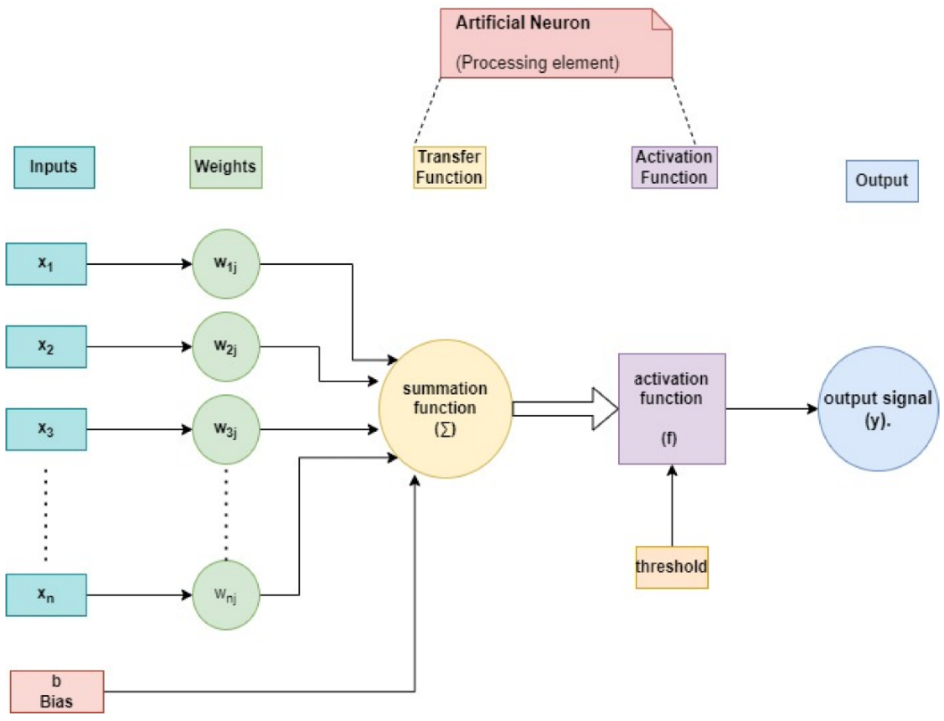
Figure 2. The mathematical model of an artificial neuron.

DL technology has the potential to transform the world as we know it, particularly in terms of a potent computational engine and its ability to support technology-driven automation smart and intelligent systems.
The foundation of deep learning is artificial neurons that mimic the human brain’s neurons. A perceptron, also called an artificial neuron, mimics the behaviour of a real neuron by receiving information from a collection of inputs, each of which is given a certain amount of weight. The neuron uses these weighted inputs to compute a function and provide an output. N inputs are sent to the neuron (one for each feature). Then, it adds up the inputs, performs some kind of operation on them (the activation), and produces the output (see Figure 2). The significance of an input is measured by its weight. The neural network will place more importance on inputs that carry more weight. The output of the neural network can be fine-tuned for each individual perceptron by adjusting its bias parameter. It ensures the best feasible model-data fit. An activation function is a transformation between inputs and results. Applying a threshold result in an output. Linear, identity, unit, binary step, sigmoid, logistic, tanh, ReLU, and SoftMax are some examples of activation functions. Since a single neuron is unable to process many inputs, multiple neurons are employed in order to reach a conclusion. As can be seen in Figure 3, a neural network is made up of perceptrons that are coupled in different ways and run on distinct activation functions. Any neural network with more than two layers is considered a deep learning model. In data processing, “hidden layers” refer to the intermediate levels between input and output. These layers have the potential to enhance precision. Although neural networks can resemble the brain, their processing power is nowhere near that of the human brain. Remember too that neural networks benefit from huge datasets to train from. As one of the most rapidly expanding subfields in computational science, deep learning makes use of large multi-layered networks to model top-level patterns in data.

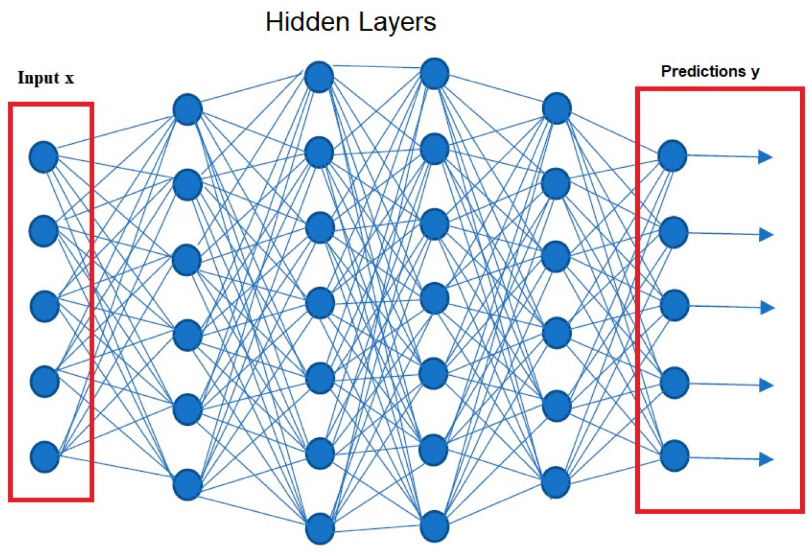
Figure 3. Representation of a neural network
The network’s weights are iteratively tweaked to reduce the loss function, or the gap between the observed and ideal output veci. Internal hidden layers that are neither inputs nor outputs become prominent after weight modification. Interactions between these levels guarantee task domain regularities.
The most frequent activation function, the logic sigmoid function, is used to summarise the backpropagation procedure.
$$α=\frac{1}{1+ⅇ^{-α}}$$
where αdenotes activation and is a linear combination of the inputs x = {x₁, …, x_{p}} and w = {w₁, …, w_{p}} are the weights.
$$\hat{y}=\left(ω_{0}+\sum_{1=1 }^{ρ}{ω_{i}.x_{i}}\right)$$

The extra weight w₀, often known as the bias, is included even though it has nothing to do with the input. The common activation function, the logic sigmoid function, provides the actual outputs ỹ.

Convolutional Neural Networks CNN
CNN is the most prominent and widely used algorithm in the field of DL. The main advantage of CNN over its predecessors is that it automatically picks out important parts without any help from a person. CNNs have been utilised widely in a variety of fields, such as computer vision, voice processing, face recognition, etc. Similar to a normal neural network, the structure of CNNs is influenced by neurons in human and animal brains. CNN simulates the complicated sequence of cells that make up the visual cortex of a cat’s brain. Goodfellow et al.identified three significant advantages of CNN: comparable representations, sparse interactions, and parameter sharing. In contrast to typical fully connected (FC) networks, CNN employs shared weights and local connections to make full use of 2D input data structures such as picture signals.
This method uses an extremely small number of parameters, which makes training the network easier and speeds it up. This is the same as the cells of the visual cortex. Interestingly, only tiny parts of a scene are perceived by these cells as opposed to the entire picture (i.e., these cells spatially extract the available local correlation in the input, similar to local filters over the input).
A popular version of CNN is similar to the multi-layer perceptron (MLP) in that it has many convolution layers followed by subsampling (pooling) levels and FC layers as the last layers. Figure 4 is an example of the CNN architecture for image classification. The input x of each layer in a CNN model is structured in three dimensions: height, width, and depth, or m × m × r, where the height (m) equals the width (m). The term depth is also known as the channel number. In an RGB image, for instance, the depth (r) is equal to three.

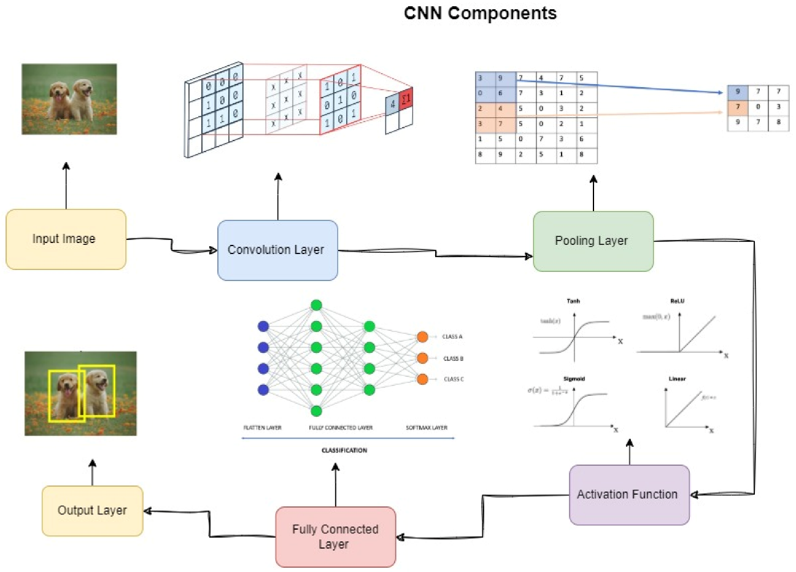

Figure 4. The CNN components.

Multiple kernels (filters) accessible in each convolutional layer are designated by k and have three dimensions (n × n × q), comparable to the input picture; however, n must be less than m and q must be equal to or less than r. In addition, the kernels serve as the foundation for the local connections, which share comparable characteristics (bias b^{k} and weight W^{k}) for producing k feature maps h^{k} with a size of (m − n − 1) and are convolved with input, as described before. Similar to NLP, the convolution layer generates a dot product between its input and the weights as shown in Equation (1), but its inputs are less than the original picture size. Then, by adding nonlinearity or an activation function to the output of the convolution layer, we obtain the following:

h𝑘=𝑓(𝑊𝑘×x+𝑏𝑘)h

Then, each feature map in the subsampling layers is downsampled. This results in a decrease in network parameters, which speeds up the training process and facilitates the resolution of the overfitting problem. The pooling function (such as maximum or average) is applied to a neighbouring region of size p × p, where p is the kernel size, for all feature maps. The FC layers then receive the mid- and low-level data and generate the high-level abstraction, which corresponds to the final stage layers of a normal neural network. The classification scores are produced by the last layer (e.g., support vector machines (SVMs) or SoftMax). Each score reflects the likelihood of a specific class for a particular event.

PERFORMANCE ANALYSIS

Performance analysis in the realm of deep learning and advanced artificial intelligence involves evaluating the effectiveness and efficiency of models or systems. It encompasses selecting appropriate evaluation metrics, visualizing training and validation curves, analyzing confusion matrices, and tuning hyperparameters. Additionally, assessing resource usage, cross-validation, transfer learning, interpretability, benchmarking against baselines, and conducting ablation studies are vital for understanding the model's capabilities and limitations. Through rigorous performance analysis, researchers and practitioners can optimize models, enhance generalization, and make informed decisions to achieve the best possible outcomes for specific tasks and applications.
Ref | Paper | Methods | Performance Metrices
1 | Deep Residual Learning for Image Recognition | Deeper Networks  Winner of ILSVRC 2015  Generalization and Robustness  Impact on Future Architectures | Accuracy: 50%  Average Precision: 1
2 | In Advances in Neural Information Processing Systems | Evaluation Metrics  Training and Validation Curves  Confusion Matrix  Hyperparameter Tuning | Accuracy: 70%  Precision: Positive
3 | Pre-training of Deep Bidirectional Transformers for Language Understanding | Contextual Word Representations  Large-Scale Pretraining  Transformer Architecture  Bidirectional Context | Accuracy: 80.7%  Precision:0  Error Rate: 4.5%
4 | Deep Neural Networks for Acoustic Modelling in Speech Recognition | Improved Accuracy  Deep Architectures  Large Datasets and Training  Regularization Techniques | Accuracy:60%  Error Rate: 12.2%
5 | Mastering the Game of Go with Deep Neural Networks and Tree Search | Performance Achievements  Monte Carlo Tree Search (MCTS)  Reinforcement Learning  Impact on the Field | Accuracy: 24.2%  Error Rate: Higher

CONCLUSION:

Deep Learning in the Age of Advanced Artificial Intelligence has emerged as a transformative force, revolutionizing various industries and reshaping the landscape of AI. This comprehensive exploration into the world of deep learning has showcased its significant impact and potential, as well as the challenges and ethical considerations that accompany its advancement. Through the utilization of neural networks with multiple layers, deep learning has demonstrated remarkable capabilities in tasks like computer vision, natural language processing, speech recognition, and autonomous systems. The ability to automatically extract intricate patterns from vast amounts of data has unlocked unprecedented accuracy and efficiency across a diverse range of applications. However, while celebrating the achievements of deep learning, it is essential to recognize the limitations of Narrow AI and the quest for General AI, which remains a theoretical aspiration. The pursuit of Artificial General Intelligence requires addressing profound technical complexities and ethical dilemmas, ensuring AGI is developed responsibly, and aligning its values with human interests. Moreover, the age of advanced AI necessitates careful considerations of privacy, bias, transparency, and accountability. Responsible AI development and governance are paramount to mitigate potential risks and foster trust between humans and intelligent machines. Looking ahead, the future of deep learning and advanced AI holds immense promise. Quantum computing and unsupervised learning paradigms open doors to further advancements, pushing the boundaries of computation and reducing the reliance on labelled data. Interdisciplinary collaborations, combining deep learning with other AI disciplines like reinforcement learning and symbolic reasoning, will continue to yield innovative solutions. The synergy of AI and human intelligence fosters an era of human-AI collaboration, where AI augments human capabilities, leading to unprecedented progress and impact. In conclusion, Deep Learning in the Age of Advanced Artificial Intelligence exemplifies the culmination of human ingenuity, technological prowess, and a vision for a smarter, more connected world. As researchers, developers, and policymakers navigate this journey, they must keep ethical considerations at the forefront, ensuring AI's benefits are accessible, fair, and inclusive for all of humanity. By responsibly harnessing the potential of deep learning and AI, we pave the way for a future that is both intelligent and humane, where technology complements and empowers us to overcome the challenges of our time and create a brighter, more sustainable future for generations to come.

REFERENCES

- He, K., Zhang, X., Ren, S., & Sun, J. (2016). Deep Residual Learning for Image Recognition. In Proceedings of the IEEE Conference on Computer Vision and Pattern Recognition (CVPR).
- Vaswani, A., Shazeer, N., Parmar, N., Uszkoreit, J., Jones, L., Gomez, A. N., ... & Polosukhin, I. (2017). Attention Is All You Need. In Advances in Neural Information Processing Systems (NeurIPS).
- Devlin, J., Chang, M. W., Lee, K., & Toutanova, K. (2018). BERT: Pre-training of Deep Bidirectional Transformers for Language Understanding. In Proceedings of the North American Chapter of the Association for Computational Linguistics (NAACL).
- Hinton, G., Deng, L., Yu, D., Dahl, G. E., Mohamed, A. R., Jaitly, N., & Kingsbury, B. (2012). Deep Neural Networks for Acoustic Modeling in Speech Recognition: The Shared Views of Four Research Groups. IEEE Signal Processing Magazine, 29(6), 82-97.
- Silver, D., Huang, A., Maddison, C. J., Guez, A., Sifre, L., van den Driessche, G., & Hassabis, D. (2016). Mastering the Game of Go with Deep Neural Networks and Tree Search. Nature, 529(7587), 484-489.
- Huang, G., Liu, Z., Van Der Maaten, L., & Weinberger, K. Q. (2017). Densely Connected Convolutional Networks. In Proceedings of the IEEE Conference on Computer Vision and Pattern Recognition (CVPR).
- Redmon, J., Divvala, S., Girshick, R., & Farhadi, A. (2016). You Only Look Once: Unified, Real-Time Object Detection. In Proceedings of the IEEE Conference on Computer Vision and Pattern Recognition (CVPR).

- P. Gopinath, R. Shivakumar, “Classification of vein pattern recognitionusing hybrid deep learning”,Journal of Intelligent & Fuzzy Systems Vol.43 No.5 (2022)pp. 6395–6403.
- Johnson, R., & Zhang, T. (2017). Deep Pyramid Convolutional Neural Networks for Text Categorization. In Proceedings of the 55th Annual Meeting of the Association for Computational Linguistics (ACL).
- Dai, A., & Le, Q. V. (2015). Semi-supervised Sequence Learning. In Advances in Neural Information Processing Systems (NeurIPS).
- Brock, A., Donahue, J., & Simonyan, K. (2018). Large Scale GAN Training for High Fidelity Natural Image Synthesis. In International Conference on Learning Representations (ICLR).

