**Disruptive Approaches in Pharmacy and Nursing for Preventive Care**

Manmeet Kaur Khanna1*, Hasratjot Singh2, Jasmeen Kaur3, Amanpreet Kaur4

1,2,3,4*University Institute of Pharmaceutical Sciences, Panjab University, Chandigarh, 160014 (India)*

**Abstract**

The professional resonance of Pharmacy and Nursing has recently become patient centric and preventive in practice. This shift has been the result of disruptive technologies and newer approaches providing precision, personalized and compliant treatments to patients. In order to prioritize preventive care and overall wellbeing, it has become imperative to integrate comparable emerging trends. In this chapter, an exploration will be conducted into the intricate concepts of digital health, precision medicine, and cyber-security practices related to these fields, 3D printing, robotics, and the integration of advanced technology. The aim is to effectively address the prevailing issues and offer innovative solutions that are futuristic in nature. This chapter comprehensively provides insights on existing challenges in the fields of nursing, biotechnology, radiopharmaceutical industry and health management followed by the futuristic approaches required for preventive care.

**Keywords**

Preventive Care, Cybersecurity, 3D Printing, Precision Medicine, Radiopharmaceutical Industry

Corresponding Author

Manmeet Kaur

[manmeet0419@gmail.com](mailto:manmeet0419@gmail.com)

**1. Introduction**

The professional domains of Pharmacy and Nursing collaborate closely with diagnostic and care centers in order to deliver comprehensive and integrated healthcare services. Given the increasing susceptibility to pandemics, antimicrobial resistance, and lifestyle disorders, it has become imperative for these domains to simultaneously embrace disruptive technologies in order to guarantee optimal patient care. In the past five years, there has been a notable shift in Pharmacy and Nursing practices, with the emergence of advanced diagnostic techniques ranging from unsystematic diagnosis to point of care diagnostics. Moreover, the concept of "one medicine for all" has evolved into the more sophisticated approach of precision medicine. These recent advancements have significantly impacted the field, paving the way for more tailored and individualized healthcare approaches (Gammal et al., 2021). The epidemiology data also links the pandemic as a cause for increasing vulnerability in population towards communicable and chronic illnesses. This requires an exploration of existing challenges in the field of nursing and pharmacy and implementation of futuristic approaches for preventive and personalized care.

**2. Nursing and Midwifery Approaches**

Nursing as a field of healthcare is the first point of care for patients and has a thoroughly patient centric approach. According to Chiarella et al. future research in nursing and midwifery practices shall put an emphasis on authorized evaluation of the appropriateness, rationality and expiry of capable standards in connection with their manufacturing purpose along with a check on capable domains, constituents and the criteria of conduct to recognize the resemblance and dissimilarity to shed light on nature of advanced practice and specialist nursing and a structured analysis of competency literature to determine the strength of evidence for using skills in setting standards, practicing safely and to increase patient outcomes (Chiarella et.al, 2008). The findings of a latest poll of nurses and midwives regarding the use of competency criteria are also reported in this study. A research by Casey et al. demonstrated that with nurses and midwives working in expert and advanced practice roles as well as participants from other fields like law-making, regulation, plans, apothecary, medicine and education, an illustrative technique was used to interview indispensable stakeholders. It was observed that in order to effectively create and execute the role of advanced practitioners, it is crucial to address elements within the organization and promote harmonious as well as collaborative support and clarify the position (Casey et.al, 2019). It was suggested that nursing service managers must take the initiative in creating plans to strengthen the organizers and get around obstacles for the advancement of responsibilities within the organization.

**2.1 Role of Artificial Intelligence**

Through the research, it was observed that artificial intelligence was majorly put in application in clinical practice and in caring of patient directly as noticed in 115 articles with a percentage rate of 82.14% (O'Connor et.al, 2023). Studies on administration, management and education were less common as they were observed in 21 and 4 articles respectively. It was observed that only 8.714% of studies used the artificial intelligence in practical contexts and claimed to be benefited from it. Datasets of cheap standard that may establish bias, the requirement of clinical evaluation of AI based outcomes, difficulty in privacy and trust and poor artificial intelligence amidst the professions were some of the risks and limits (Crozier et.al, 2012). It was concluded that datasets having information about digital health shall be established in order to aid the trials, utilization and assessment of artificial intelligence in nursing and midwifery.

**2.2 Clinical Coaches in Nursing and Midwifery Practice**

To help nurses and midwives strengthen their clinical skills and practices and to promote an organizational culture of learning and growth, clinical tutors offer educational intrusion at the place where medical care is given. To accomplish their objectives, these clinical tutors employ different supporting coaching techniques to cultivate and develop highly proficient and professional personnel capable of operating in certain clinical settings and expanding their functioning based around the idea of medical care (Faithfull-Byrne et.al, 2017).

**2.3 What Lies ahead in Nursing and Midwifery?**

Through the application of recommended plans listed in the report made by the panel, the panel offers a structure to combine and connect the operations to discuss the concerns arising professionally around the world. By engaging with nurses and midwives all over the world, the report is a blend of the local and international difficulties in order to identify the most urgent health crisis and matters arising professionally in various countries (McCourt, 2005). It is anticipated that improvements in the professional fields covered by the model made by the panel will result in establishment of capacity, practice based on proofs and eventually worldwide health services of superior quality. By concentrating on nurses and midwives as the leaders of this shift, execution plan of the geographical stakeholders can have an influence on the agenda of health worldwide.

Crozier et al. performed a research in order to create enduring resources and activities in a hospital that will help, promote and foster nurses’ and midwives’ research and novel ideas creation. It is well known that globally significant resources are devoted to authorize nurses and midwives to evaluate and cite the papers based on research.

According to Pollock et al. students and practitioners in the fields of nursing and midwifery have a useful and flexible chance to synthesize the available data with the help of scoping review technique which serve as a tool for mapping evidence from many sources and addressing general problems based on research (Pollock et.al, 2021). In these fields, the method of corroboration synthesis has become more and more common and it will undoubtedly stay that way in the future. It is crucial to carry out such reviews properly in alignment with most recent principles based on methodology as such reviews continue to be embraced. An analysis by McCourt demonstrated that investigating established and probabilistic cause and effect linkages as well as testing frequently well-known but untested technology, need the application of experimental methodologies. Although the consequences of interventions, the nature of research questions built culturally or the research based information have received little attention (McCourt, 2005). To deal with these problems, the framework needs to be more nuanced and less linear. A more circular view of knowledge production should take precedence over an uncomplicated hierarchical approach since it captures the complication of the corroboration in a better way.

**2.5 Challenges Faced during Nursing and Midwifery Practices**

Authorities that are not stable and are constantly changing have made it more and more difficult for nurses and midwives to approach the decision-makers and the law making process. WHO suggestions about nursing may find new authorities to be more receptive than the settled authorities. Thus, it is crucial to recognize the inclusion of nurses and midwives in decision-making processes. The need of financing the leadership development among the nurses was also brought into attention by international advisory members especially for those nurses who may be asked to provide information to the makers of laws and policies. The advisory panel also voiced a worry that there is an international human resource shortage in healthcare systems as a result of lack of qualified nurses and midwives, distribution issues and a decline in personnel participation. The advancing age of nurses and midwives is aggravating the issue. According to the international advisory members, a negative perception of nurses and midwives in the society foundational problem that has an impact on a number of interconnected issues, such as choice of career, integrative relationships, insufficient salary, chances of growth and involvement in major policy making decisions. It was suggested that the world health organization shall place nurses and midwives in positions that require exposure to public which would lead to boosting of the reputation and stature of the profession. This would help establish a platform for recognizing the benefaction of nursing and midwifery to health sector on an international level. It was also suggested that the world health organization should communicate the findings via working documents and dissertations and best practices may be found for enhancing the reputation of the profession.

1. **Healthcare Management and Sustainability**

Healthcare management, also called as healthcare administration, is the practice that ensures proper planning, supervision and directions that aid in the smooth running of the healthcare facilities. The healthcare manager needs to ensure that the facility runs smoothly and all the work is being done ethically. The manger must have good communication, organizational and leadership skills (Molero et.al, 2021). Evidence based management can be defined as conscientious, explicit and judicious use of current best evidence in decision making and evidence based medicine means that the physicians must use the medicines for a diagnosis which has been proved over time. It is implemented using six parameters i.e. by translating the given problem into a relevant question and then by searching the answers to the said question (Saviano et.al, 2018). Thirdly, the acquired evidence is judged for reliability followed by combining all the answers collected. The knowledge gained from all the evidences is incorporated into the decision making process and finally the result is evaluated. Practicing EBP aids in providing best care in the healthcare practices and improve the care that can be provided to the patients.

**

***Fig. 1.*** *Six major challenges impact the success of clinical translational development of healthcare biotechnology (Liao et.al, 2023)*

Ethics in healthcare are the guiding principles that help the people in healthcare facilities to have a clear sense of right and wrong and solve the dilemmas in certain situations. There are various challenges faced by the healthcare professionals while doing their jobs. Some of them are privacy of patient, equal treatment and facilities for all, patient safety, conflict of interest etc. In developing countries, it is very difficult as there are limited resources and minimal man power that can assure equal treatment for all (Molero et.al, 2021). Willingly or unwillingly, the healthcare professionals have to sometimes choose between two patients depending upon the prevailing conditions (Saviano et.al, 2018). Ethical guidelines assist the healthcare providers in solving the conflicts. The major areas that are crucial for people working in this field are patient’s confidentiality, relationship with patients, informed consent etc. They even aid a doctor in discussing issues related to physician assisted suicide in the countries where it is legal. This principle of ethics has four key elements:

* Autonomy that is a patient’s right to take decisions related to his/her health;
* Beneficence, doctor’s right to choose the treatment that is most suitable for the patient;
* Non-maleficence means first, do no harm;
* Justice means all patients must be treated equally.

Cyber security in healthcare management is very crucial as in today’s world everything is being digitized and so is the healthcare system. Patient’s confidential data and all the personal information is kept as a digital record which in turn can prove harmful if accessed by the hackers or the people from dark web making the patients victims of cybercrime (Kruse et.al, 2017). This can lead to the disruption of both physical and mental peace. Thus, healthcare managers are required to regularly update their data software, ensure proper data encryption and only authorized access to the digital records.

1. **Biotechnology in Healthcare Systems**

The field of biotechnology is one that is developing quickly and is poised to transform disease detection and treatment, altering the healthcare industry. New biotech paradigms are emerging by utilizing the most recent advancements in molecular biology and genetics, sparking creative efforts to improve human health. The process of converting ground-breaking biotech discoveries into therapeutic applications, however, continues to be a thought-provoking issue. Biotechnology is a multidisciplinary field that develops creative answers to problems in science, technology, and healthcare (Ansari et.al, 2020). This growth has created opportunities for treating serious illnesses including cancer, HIV, and the most recent global COVID-19 pandemic.

Methods like genomic sequencing, proteome analysis, and imaging, helps in creating personalized medicines by using genetic and molecular information to forecast illness likelihood and customize therapies. By enabling developed treatment choices, this strategy improves patient outcomes in terms of safety and efficacy. CRISPR-Cas9 is an example of gene editing, which enables precise DNA modifications to correct disease-causing mutation (Jiang and Doudna, 2017). Through less harmful immune system-activating medicines including CAR-T cell therapy, immune checkpoint inhibitors, targeted therapy, and gene therapy, and nanoparticle-based methods, biotechnology is revolutionizing cancer treatment. These cutting-edge techniques have enormous potential for treating cancer. Additionally, the use of genomes and proteomics for target identification in biotech breakthroughs has a huge impact on drug discovery, resulting in novel treatments for diseases including cancer, Alzheimer's, and Parkinson's. In particular, PCR (Polymerase Chain Reaction) contributes to the prevention of diseases like Hepatitis B and C by acting as a precise DNA amplification technique with diagnostic capability for infections and genetic disorders (Contera et.al, 2020). By utilizing technology, post-1990 genetic discoveries revealed the multigene causes of many diseases, leading to applications like microarrays, a full understanding of disease. The US FDA's Breakthrough Devices Program, which addresses issues of representation disparities, patient outcomes, and barriers impeding the realization of benefits, is an example of regulatory advancements that strive for equitable access to life-saving medical devices (Kadakia et.al, 2023).

In the world of healthcare biotechnology, several challenges shape the path to success However, this raises ethical, legal, and social questions about possible abuse and unexpected consequences (Holford et.al, 2000). Navigating complex regulations involve overcoming obstacles such as demanding trials, long approval processes, and careful pricing. Amid these challenges, competition drives companies to stand out amidst technology advances and market demands. The acceptance of products in the market depends on factors like effectiveness, safety, and quality requiring a strategic approach to succeed, biotech and healthcare companies need to navigate these challenges wisely and bring their innovations to the market effectively.

1. **Radiopharmaceutical Industry**

Radiochemistry is the branch of science that deals with the radioactive elements, their properties and utilization across various fields for the betterment of human kind. Henri Becquerel, Marie Curie, and Pierre Curie discovered radioactivity which in turn contributed for the research and advancements in radiochemistry. This discovery led to the use of various radioisotopes in nuclear medicine, hybrid imaging and scientific research. Nuclear medicine is the scientific branch that deals with the evaluation of body’s anatomy and physiology in order to detect the underlying disease (Beyer et.al, 2017). It employs very little amount of radioisotopes to analyze the functioning of organs and tissues at the molecular level which in turn allows the diagnosis and treatment of various cancers, chronic cardiac and pulmonary diseases. The radioisotopes when injected or ingested by the patients emit electromagnetic waves in the body which by the means of special scanners are detected thus, producing images used in the diagnosis and the treatment of underlying condition. The amount of the radioisotope given for the purpose is so small that it does not produce any side effect when ingested and is readily eliminated once the purpose is served.

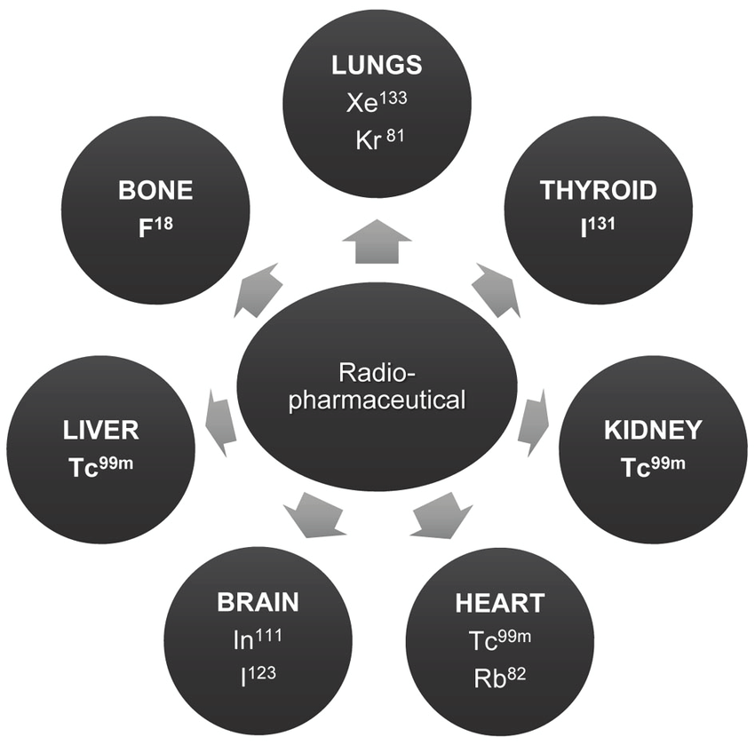

# *Fig 2. Radiopharmaceuticals and their tissue distribution pattern*

Some radioisotopes that decay with alpha or beta radiation are used for the treatment of cancer while others that decay with gamma radiation are used along with some cameras to look up inside the body. Technetium-99m is the most common and important radiopharmaceutical used in the nuclear medicine which is generated by Molybdenum-99 parent and is useful in the imaging of heart and skeleton (Beyer et.al, 2017). Iodine-131 is used for the imaging of thyroid gland. Radioisotopes are used because these are the analogues of the substances or elements which are naturally produced in the body so there is either no adverse reaction or there is very minimal chance of the same. Furthermore, various organs in the body are mapped by using radiopharmaceutical that is absorbed by them and is then scanned via specialized scanners. Various mapping techniques are being used presently which have reliable results and are contributing towards the diagnostic advancements in the healthcare (Ekmekcioglu et.al, 2023).

Diagnostic techniques that utilize radiopharmaceuticals are bringing huge change in the ways medical examinations are done. These include Scintigraphy, SPECT, and PET etc. Scintigraphy is the technique in which 2D images are formed by the gamma radiations emitted by the radiopharmaceutical which are detected by the gamma cameras and are then used for the diagnosis. Single photon emission computed tomography (SPECT) employs various cameras which allows the examiner to inspect the body from its three dimensional image which is formed by the distribution of radiotracer throughout the body. This provides a clear cross section image of body thus, helping in detecting the abnormalities. Positron emission tomography (PET) is similar to SPECT but uses the radioisotopes that decay at a faster rate. It is useful in the management of cancer. Hybrid Imaging is the techniques which combines two or more imaging technologies using software or hybrid cameras which increase the diagnostic specificity to produce more reliable results for example, SPECT/CT or PET/CT (Kraeber-Bodéré, 2014).So, efforts are being made to develop methods that can provide improved diagnosis. For e.g. tumors with low avidity for 18FDG, other 18F-labeled compounds are being proposed (Wheat et.al, 2011)

* 1. **Limitations and Challenges**

Nuclear medicine comes with certain limitations in terms of dose adjustments, patient exposure and safety. One must ensure that the patient and the person himself, both are shielded from radiation source. In developing countries, there are several other setbacks. Local procurement of radio nuclides is very difficult in some third-world countries like (Herrmann and Weber, 2019). There is unavailability of modern and advanced equipment as well as continuous power supply that can keep them running continuously as it is commonly observed that there are power surges and lack of alternate power sources. Nuclear medicine is an advanced science that has enormous potential to revolutionize the field of medicine but there is still a lot of work that has to be done to overcome the challenge so that it can be proved as a boon for human race.

1. **Novel Drug Delivery Systems**

Drug delivery play a crucial role in achieving therapeutic objectives effectively. Innovative methods enveloping drug devices combinations leverage polymer science, pharmaceutics, and molecular biology. Recent advancements introduced various novel drug delivery systems including phytosomes, liposomes, nanoemulsions, microspheres, ethosomes, dendrimers, niosomes and proniosomes (Singh et.al, 2017). Reduced toxicity, enhanced pharmacological efficacy, safety, increased stability, and drug delivery at target site with increased tissue macrophage dispersion are some of the advantages offered by them.

**6.1 Prodrugs: A Strategic Approach**

Prodrugs are the drugs that transform into active chemical entities within the body. Prodrug design has evolved from last-resort strategy to an essential part of drug development. In modern drug discovery, the challenges posed by new chemical entities such as solubility, stability, metabolism, and various barriers for permeation of drug are addressed by prodrug design by using target specific biomolecules furthermore aided by computational simulations. This strategy optimizes new compounds but also upgrade existing drugs due to efficiency gains and cost-effectiveness (Markovic et.al, 2020). Biodegradable polymers, both natural and synthetic, are explored for extended drug release and targeted delivery. Future prospects lie in biocompatible materials and innovative fabrication methods to revolutionize drug delivery and address unmet medical needs. The biopharmaceutics classification system (BCS) plays a crucial role in advancing oral drug delivery methods.

**6.2 Understanding PK/PD for Drug Delivery Systems**

Successful clinical use of drug delivery system relies on understanding mechanism governing pharmacokinetics (PK), biodistribution (BD) and their kinetics. Engineering strategies optimised through PK/BD studies can enhance drug carriers and ADME (Absorption, Distribution, Metabolism and Excretion) processes (Glassman and Muzykantov, 2019). PK analysis holds promise for predicting pharmacodynamic outcomes and improving drug delivery efficacy. By integrating innovative drug delivery methods, prodrug strategies, polymer advancements, classification frameworks and an understanding of PK/PD mechanisms, the therapeutic outcomes and challenges of modern drug development can be enhanced.

**6.3 Challenges and Future Perspectives**

The proliferation of nanotechnology has led to development of diverse nanoparticle systems catering to therapeutic and imaging applications. Within this realm, liposomes and polymeric nanoparticles hold assurance yet their toxicity profiles vary significantly. The biocompatible nature of natural lipids in liposomes enables them to evade immune detection, while in case of synthetic polymeric nanoparticles, their gradual elimination from the bloodstream can lead to organ accumulation. Quantum Dots (QDs) which are used in medical imaging, despite of biocompatible applications they can manifest toxicity due to their inorganic composition (Laffleur and Keckeis, 2020). Likewise, carbon nanotubes & metal nanoparticles like gold, silver and metal oxides, celebrated for their multifarious applications demand careful investigation with attention to factors such as their uptake and clearance in the body. Titanium dioxide nanoparticles display modest toxicity levels but trigger inflammatory responses upon lung tissue exposure. Particularly, stable nanoparticles exhibit diminished cellular toxicity but oxidative transformations could potentially increase their cytotoxicity. In summation, these nanoparticle systems offer substantial potential but it becomes a need for their complete toxicological evaluations before their safe integration in practical applications.

**7. Futuristic Trends and Research Directions**

Healthcare as a dynamic field has to keep evolving through newer techniques and approaches to provide best care possible to the patients. In the field of nursing and pharmacy, both have played a role in both the scientific exploration and practical integration of pharmacogenomics, effectively producing substantial evidence to endorse its incorporation into clinical settings. Notably, extensive research endeavors have successfully identified actionable mutations, which can be specifically targeted, in a substantial proportion of up to 30% within the patient populations of certain comprehensive studies (Rahman et al., 2023).

**7.1 Pharmacogenomics and Personalized Medicine**

Due to the advent of pharmacogenomics, the genetic makeup of patients can be analyzed under PGx testing, which can contain information about the changes in proteins expressing as liver enzymes, necessary for metabolism. The interactions and effectiveness of multiple drug classes depends on the functioning of liver enzymes. This can be analyzed through use of pharmacogenomics in the clinic and hospital practice (Gammal et al., 2021). The implementation of this concept in routinely health checkups and patient data backup can enhance rationale use of drugs in both pharmacy and nursing practice. Through this practice, the healthcare world will be able to shift into the personalized or evidence based medicine. The use of drugs with narrow therapeutic range including warfarin, Abacavir, carbamazepine, tamoxifen and others have been tested for pharmacogenomics biomarkers with positive results (Gammal et al., 2021).

**7.2 Cybersecurity Management**

For the implementation of personalized medicine practices, the patient data and trends require backup and protection. This accounts for the introduction of cybersecurity into the healthcare sector as a practical and futuristic trends. The utilization of digital technologies has significantly enhanced the delivery of patient care, leading to increased efficiency and improved outcomes. The utilization of electronic health records has emerged as an indispensable factor in enhancing diagnostic capabilities and ultimately elevating patient outcomes. An overwhelming majority of healthcare providers, amounting to 75%, have attested to the invaluable role played by EHRs in facilitating the delivery of superior patient care (Kruse et al., 2017). As healthcare providers continue to place greater reliance on technological advancements, the corresponding increase in healthcare cybersecurity threats has become evident. According to Emsisoft, there has been a high incidence of cyberattacks in the recent decade, an alarming exceeding 560 in total (Barnett et al., 2013). These occurred in US in 2020 and led to the concerns on patient safety and data management (Barnett et al., 2013).

**7.3 Point of Care Diagnostics**

The healthcare sector has now been progressing towards the area of patient centric care model, wherein patients are made the first priority (Wang et al., 2021). They are provided with the authority to participate in the decisions made for their treatment and have been involved proactively in understanding the preventive options further in life. The introduction of the point of care diagnostics is one such aspect of healthcare which parties prevention of any disease, rather than treatment. The introduction of point of care diagnostics aims to disrupt the existing model of treatment and recovery over prevention. The typical system includes the physician examination of the patient, test reports and analysis and eventually leading to diagnosis and treatment. This is now aimed to be changed into POCT as a preventive measure on every interaction with pharmacies and nursing staff (Wang et al., 2021).

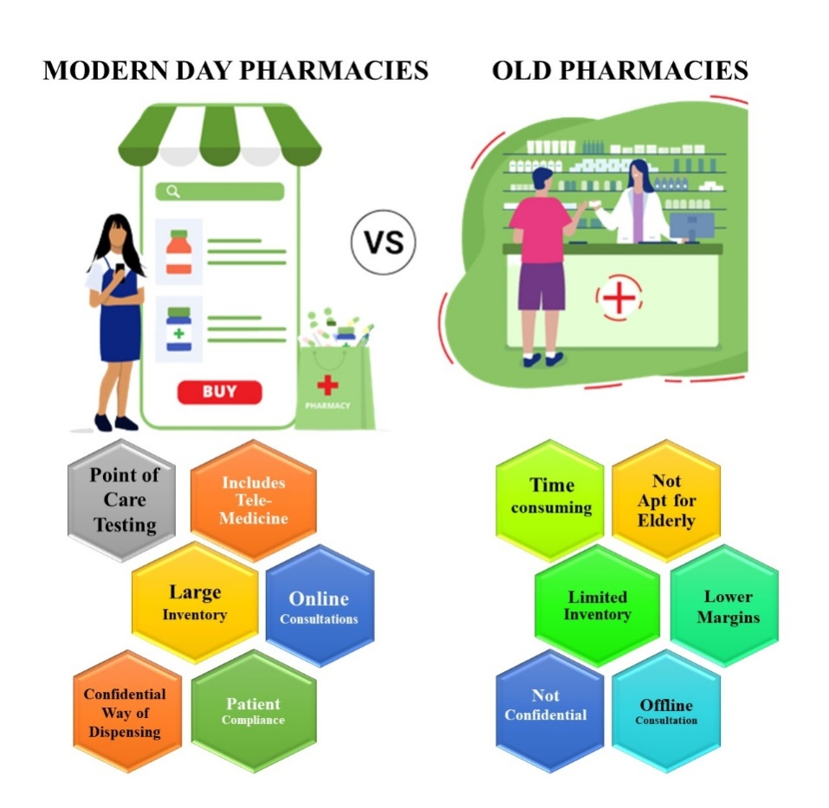

*Fig 3. Recent advances in Modern Day Pharmacies compared to Old Pharmacies*

Any disease or condition identified at the micro level can be treated easily, compared to the serious and chronic treatments. The utilization of point of care techniques facilitates the timely and uninterrupted surveillance of a patient's vital signs during each visit to the pharmacy or nursing station. The integration of point-of-care testing (POCT) into healthcare practices will significantly augment the provision of patient-centric care, thereby reducing the likelihood of missed or delayed diagnostic procedures (Wang et al., 2021). Currently, the healthcare and pharmaceutical sectors are primarily dedicated to the advancement of novel molecules and their delivery methods as shown in Fig 3. However, a forward-thinking trend in these industries is the prioritization of patient-centric prevention.

**7.4 Peptide Receptor Radionuclide Therapy**

The radiopharmaceutical industry is also an essential component of diagnostics and prevention in the healthcare industry. The problems associated with the use, and disposal of radio waste needs a futuristic solution. The utilization of these techniques are specifically helpful in cancer diagnosis and treatment. The futuristic trends in this industry include combination of radioisotopes with the biomolecules to increase the specificity of diagnosis. Some of the newer range of techniques being developed are Peptide Receptor Radionuclide Therapy which can the potential to target neuroendocrine tumors (Bernard-Gauthier et al., 2017). One of the primary obstacles that persists is the need to discern biomarkers, derived from both visualization and molecular data, in order to forecast the response to PRRT and ultimately develop a treatment plan tailored to the individual. The advent of cutting-edge imaging methods, such as the revolutionary PET/MRI and PET/CT scanners, has paved the way for a remarkable enhancement in the realm of comprehensive and seamlessly integrated imaging capabilities (Bernard-Gauthier et al., 2017). By offering comprehensive physiological and functional information, this technology facilitates enhanced visualization of the progression of diseases and the effectiveness of treatment. The convergence of radiomics and artificial intelligence has the potential to facilitate enhanced precision and individualized assessment and therapy planning by leveraging the distinct attributes inherent to the specific medical condition of each patient.

**7.5 Telemedicine and E-Pharmacies**

As the patient centric care has become the main focus of healthcare, there needs to be a comprehensive system to provide telecommunication and telemedicine facilities. The utilization of telemedicine has experienced a significant surge in importance, enabling nurses to administer care from a remote location. This encompasses a range of services such as virtual consultations, the utilization of remote patient monitoring systems, and the effective management of chronic conditions via digital platforms. Such telemedicine facility will enhance the time to time diagnosis and prevention of newer conditions. The patients located far away can get in touch with the best physicians, and the treatment can be connected to the nearby diagnostic centers. The initiatives by government towards telemedicine and Jan Aushadhi Yojana provide a basic system for telemedicine setup (Naithani et.al, 2023). The government hospitals, clinics, diagnostic centers and e-pharmacies require an integrated system PAN India to establish the route of telemedicine. This can keep the nursing and midwifery services connected to the patient and increase patient compliance towards treatment.

**Conclusion**

This chapter has dealt with various aspects of nursing and pharmacy corresponding to the existing problems in the healthcare industry. In the field of biotechnological application, to evidence medicine, the cybersecurity and patient safety has been recognized as the priority. The cybersecurity norms need to be implemented for the practice of pharmacogenomics in the patient-centric healthcare ecosystem. Through the nuances of radiopharmaceutical industry, emerging therapies with radiomics has been discussed. The future is reliant on the trends of artificial intelligence combined with the preventive care to ensure optimum care for the patient. These prospects present its own challenges in the implementation requiring the skilled professionals to develop multifactorial skills corresponding to epidemiology, biomedical engineering and artificial intelligence. The future prospects look bright in terms of patient care and the challenges need to be navigated with prevention as the key.

**References**

Ansari, N., Hussain, A., Kiran, I., Humayun Ajaz, M., Azam, T., & Ghafoor, A. (2020, March 25). Applications of Biotechnological Techniques in Healthcare, Current Advancements and Future Directions. *Scholars International Journal of Biochemistry*, *03*(03), 67–72. <https://doi.org/10.36348/sijb.2020.v03i03.005>

Arnall, J. R., Petro, R., Patel, J. N., & Kennedy, L. (2017). A clinical pharmacy pilot within a Precision Medicine Program for cancer patients and review of related pharmacist clinical practice. *Journal of Oncology Pharmacy Practice*, *25*(1), 179–186. https://doi.org/10.1177/1078155217738324

Barnett, D. J., Sell, T. K., Lord, R. K., Jenkins, C. J., Terbush, J. W., & Burke, T. A. (2013). Cyber Security Threats to Public Health. *World Medical & Health Policy*, *5*(1), 37–46. https://doi.org/10.1002/wmh3.19

Bernard-Gauthier, V., Collier, T. L., Liang, S. H., & Vasdev, N. (2017). Discovery of PET radiopharmaceuticals at the academia-industry interface. *Drug Discovery Today: Technologies*, *25*, 19–26. https://doi.org/10.1016/j.ddtec.2017.09.001

Beyer, T., Freudenberg, L. S., Townsend, D. W., & Czernin, J. (2011). The future of hybrid imaging—part 1: hybrid imaging technologies and SPECT/CT. *Insights into Imaging*, *2*(2), 161–169. https://doi.org/10.1007/s13244-010-0063-2

Casey, M., O’Connor, L., Cashin, A., Fealy, G., Smith, R., O’Brien, D. & Glasgow, M. E. (2019). Enablers and challenges to advanced nursing and midwifery practice roles. Journal of nursing management, 27(2), 271-277.

Chiarella, M., Thoms, D., Lau, C., & McInnes, E. (2008). An overview of the competency movement in nursing and midwifery. Collegian, 15(2), 45-53.

Contera, S., Bernardino de la Serna, J., & Tetley, T. D. (2020, December 9). Biotechnology, nanotechnology and medicine. *Emerging Topics in Life Sciences*, *4*(6), 551–554. https://doi.org/10.1042/etls20200350

Crozier, K., Moore, J., & Kite, K. (2012). Innovations and action research to develop research skills for nursing and midwifery practice: the Innovations in Nursing and Midwifery Practice Project study. Journal of Clinical Nursing, 21(11‐12), 1716-1725.

Ekmekcioglu, O., Terry, S. Y. A., Morbelli, S., Cerci, J. J., Zacho, H. D., Peters, S., Chollet, X. B., & Verzijlbergen, F. (2023). Superfluous, controversial and luxury issues in nuclear medicine. In *European Journal of Nuclear Medicine and Molecular Imaging*. Springer Science and Business Media Deutschland GmbH. https://doi.org/10.1007/s00259-023-06228-x

Faithfull-Byrne, A., Thompson, L., Schafer, K. W., Elks, M., Jaspers, J., Welch, A. & Moss, C. (2017). Clinical coaches in nursing and midwifery practice: facilitating point of care workplace learning and development. Collegian, 24(4), 403-410.

Gammal, R. S., Lee, Y. M., Petry, N. J., Iwuchukwu, O., Hoffman, J. M., Kisor, D. F., & Empey, P. E. (2021). Pharmacists Leading the Way to Precision Medicine: Updates to the Core Pharmacist Competencies in Genomics. *American Journal of Pharmaceutical Education*, 8634. https://doi.org/10.5688/ajpe8634

Glassman, P. M., & Muzykantov, V. R. (2019, March 5). Pharmacokinetic and Pharmacodynamic Properties of Drug Delivery Systems. *Journal of Pharmacology and Experimental Therapeutics*, *370*(3), 570–580. <https://doi.org/10.1124/jpet.119.257113>

Herrmann, K., Veit-Haibach, P., & Weber, W. A. (2019). Driving the future of nuclear medicine. In *Journal of Nuclear Medicine* (Vol. 60, Issue 9, pp. 1S-2S). Society of Nuclear Medicine Inc. <https://doi.org/10.2967/jnumed.119.232264>

Holford, N. H. G., Kimko, H. C., Monteleone, J. P. R., & Peck, C. C. (2000, April). Simulation of Clinical Trials. *Annual Review of Pharmacology and Toxicology*, *40*(1), 209–234. https://doi.org/10.1146/annurev.pharmtox.40.1.209

Jiang, F., & Doudna, J. A. (2017, May 22). CRISPR–Cas9 Structures and Mechanisms. *Annual Review of Biophysics*, *46*(1), 505–529. https://doi.org/10.1146/annurev-biophys-062215-010822

Kadakia, K. T., Rathi, V. K., Ramachandran, R., Johnston, J. L., Ross, J. S., & Dhruva, S. S. (2023, April 10). Challenges and solutions to advancing health equity with medical devices. *Nature Biotechnology*, *41*(5), 607–609. https://doi.org/10.1038/s41587-023-01746-3

Kraeber-Bodéré, F., & Barbet, J. (2014). Challenges in nuclear medicine: Innovative theranostic tools for personalized medicine. *Frontiers in Medicine*, *1*(JUL). https://doi.org/10.3389/fmed.2014.00016

Kruse, C. S., Frederick, B., Jacobson, T., & Monticone, D. K. (2017). Cybersecurity in healthcare: A systematic review of modern threats and trends. *Technology and Health Care*, *25*(1), 1–10. https://doi.org/10.3233/thc-161263

Kruse, C. S., Frederick, B., Jacobson, T., & Monticone, D. K. (2017). Cybersecurity in healthcare: A systematic review of modern threats and trends. In *Technology and Health Care* (Vol. 25, Issue 1, pp. 1–10). IOS Press. https://doi.org/10.3233/THC-161263

Laffleur, F., & Keckeis, V. (2020, December). Withdrawn: Advances in drug delivery systems: Work in progress still needed? *International Journal of Pharmaceutics: X*, *2*, 100050. <https://doi.org/10.1016/j.ijpx.2020.100050>

Liao, C., Xiao, S., & Wang, X. (2023, June). Bench-to-bedside: Translational development landscape of biotechnology in healthcare. *Health Sciences Review*, *7*, 100097. https://doi.org/10.1016/j.hsr.2023.100097

Markovic, M., Ben-Shabat, S., & Dahan, A. (2020, October 29). Prodrugs for Improved Drug Delivery: Lessons Learned from Recently Developed and Marketed Products. *Pharmaceutics*, *12*(11), 1031. <https://doi.org/10.3390/pharmaceutics12111031>

McCourt, C. (2005). "Research and theory for Nursing and Midwifery: Rethinking the Nature of Evidence." Worldviews on Evidence‐Based Nursing 2, no. 2. 75-83.

Molero, A., Calabrò, M., Vignes, M., Gouget, B., & Gruson, D. (2021). Sustainability in healthcare: perspectives and reflections regarding laboratory medicine. *Annals of laboratory medicine*, *41*(2), 139-144.

Naithani, C., Sood, S. P., & Agrahari, A. (2023). The Indian healthcare system turns to digital health: eSanjeevaniOPD as a national telemedicine service. *Journal of Information Technology Teaching Cases*, *13*(1), 67-76.

O'Connor, S., Yan, Y., Thilo, F. J., Felzmann, H., Dowding, D., & Lee, J. J. (2023). Artificial intelligence in nursing and midwifery: A systematic review. Journal of Clinical Nursing, 32(13-14), 2951-2968.

Pollock, D., Davies, E. L., Peters, M. D., Tricco, A. C., Alexander, L., McInerney, P. & Munn, Z. (2021). Undertaking a scoping review: A practical guide for nursing and midwifery students, clinicians, researchers, and academics. Journal of advanced nursing, 77(4), 2102-2113.

Rahman, Md. S., Paul, K. C., Rahman, Md. M., Samuel, J., Thill, J.-C., Hossain, Md. A., & Ali, G. G. Md. N. (2023). Pandemic vulnerability index of US cities: A hybrid knowledge-based and data-driven approach. *Sustainable Cities and Society*, *95*, 104570. https://doi.org/10.1016/j.scs.2023.104570

Saviano, M., Bassano, C., Piciocchi, P., Di Nauta, P., & Lettieri, M. (2018). Monitoring viability and sustainability in healthcare organizations. *Sustainability*, *10*(10), 3548.

Sharma, S., Jain, S., Baldi, A., Singh, R. K., & Sharma, R. K. (2019, January 10). Intricacies in the Approval of Radiopharmaceuticals – Regulatory Perspectives and the Way Forward. *Current Science*, *116*(1), 47. https://doi.org/10.18520/cs/v116/i1/47-55

Singh, N., Joshi, A., Toor, A. P., & Verma, G. (2017). Drug delivery: advancements and challenges. *Nanostructures for Drug Delivery*, 865–886. <https://doi.org/10.1016/b978-0-323-46143-6.00027-0>

Wang, C., Liu, M., Wang, Z., Li, S., Deng, Y., & He, N. (2021). Point-of-care diagnostics for infectious diseases: From methods to devices. *Nano Today*, *37*, 101092. <https://doi.org/10.1016/j.nantod.2021.101092>

Wheat, J. M., Currie, G. M., Davidson, R., & Kiat, H. (2011). An introduction to nuclear medicine. In *Journal of Medical Radiation Sciences* (Vol. 58, Issue 3, pp. 38–45). John Wiley and Sons Ltd. <https://doi.org/10.1002/j.2051-3909.2011.tb00154.x>