Harnessing Nature's Pharmacy: Investigating Traditional Herbal Remedies for Immune Enhancement and Health Promotion

Ritambhara¹, Susmita Shukla^{1*}
¹Applied Plant Biotechnology Research Lab, Centre for Plant and Environment Biotechnology Amity Institute of Biotechnology, Amity University, Noida (U.P), India

Brijesh Shivhare²
Department of Bioscience, Faculty of Science
P.K. University, Shivpuri, Madhya Pradesh
India

ABSTRACT
The immune system is a complex network within the body that defends against a wide range of infections and diseases caused by pathogens. Traditional herbal remedies have been utilized for centuries in various cultures to support and boost the immune system. This research chapter provides an introduction to the concept of immunity and the role of the immune system in protecting the body against various pathogens. The chapter delves into the significance of medicinal plants in promoting immunity and preventing diseases caused by microorganisms. Various traditional herbs, such as Giloy, Ashwagandha, Garlic, Turmeric, Tomato and Ginger, are explored for their potential immunomodulatory properties. Each of these herbs contains bioactive compounds that have been linked to immune-enhancing effects.Lead toxicity was found to be a significant and safe way to reduce lead exposure and combat health issues in the general population. The primary objective of this review article is to provide a summary of lead poisoning identification, sources, and mechanism in light of various toxicological effects on human health. The role of cytokine modulation caused by herbal plants is discussed in detail, highlighting how different herbs can influence the production and regulation of cytokines, which are essential immune system messengers. The chapter emphasizes that these medicinal plants can help balance and enhance the immune response, leading to improved overall health and resistance against infections.Furthermore, the chapter touches upon the potential interactions and side effects of these herbal remedies, suggesting that careful usage and proper dosage are essential for safe and effective immunomodulation. In conclusion, this research chapter presents an overview of various traditional herbs and their potential as immune-boosting agents. The utilization of these herbs in promoting immune health and preventing diseases provides a valuable contribution to the field of immunomodulation research. As more scientific studies explore the efficacy of these traditional remedies, they may offer promising alternatives or complementary approaches to conventional immunomodulatory interventions.

Keywords—Immune System, Traditional herbs, Medicinal plants, Health

INTRODUCTION

The immune system is widely recognized as a very intricate biological mechanism that operates within the human body. During periods of illness, the immune system becomes vulnerable to a wide range of viruses, bacteria, and fungi. The immune system is an integral part of the human body that identifies pathogens by employing specific receptors, resulting in a prompt reaction characterized by the activation of immune cells, cytokines, chemokines, and the secretion of inflammatory mediators. These substances play a role in the regulation and augmentation of the immune system. Numerous studies have demonstrated a significant association between metal toxicity and carcinogenicity, as well as their influence on the normal physiological processes of cells in both human and animal organisms. Metabolic processes are regulated and signaled by a variety of important metals, including zinc, copper, magnesium, lead, selenium, arsenic, iron, and several more. The body's oxidative system is exposed to a notable risk due to the buildup of free radicals caused by lead poisoning (Massage et al., 2007). The clinical presentation of lead poisoning in individuals involves a range of symptoms, including but not limited to headaches, abdominal discomfort, joint pain, raised blood pressure, decreased sperm count, abnormal sperm morphology, and instances of miscarriage, among other manifestations. Exposure to lead has been found to have a notable detrimental impact, specifically causing damage to brain tissue that may have lasting consequences. The consumption of lead has been found to have adverse impacts on the kidneys, liver, and brain in individuals of all ages, including children and adults. In certain cases, it can even result in mortality (Rader et al., 1981).
Restorative plants play a crucial function in mitigating the risk of pathogenic bacterial infections and the subsequent development of related disorders in persons. In the realm of the natural environment, a diverse array of plant species exhibit the capacity to augment and restore the functionality of the immune system, thereby assuming the role of immune modulators. Numerous botanical species are purported to facilitate holistic wellness and bolster the innate immune system, so reinstating bodily homeostasis and providing sustenance to the body's anatomical structures. One may be inclined to postulate that the advantageous and revitalizing properties of these organic treatments could perhaps be ascribed to their influence on the immune system, given that a number of the botanical therapies are thought to augment the body's inherent ability to combat infections. The immunostimulatory activities of several plant-derived chemicals, including proteins, lectins, polysaccharides, and similar molecules, have been well-documented. The usage of plant resources in the management of various human illnesses is acknowledged in Ayurveda and other Indian literary works. There is a substantial body of evidence documenting the immune-modulatory action exhibited by a wide range of plant species. This study investigates the botanical specimens that have exhibited both scientific and clinical data supporting their safe modulatory function [1-4]. An immunomodulator refers to a chemical, whether of biological origin or artificially produced, that possesses the ability to elicit, inhibit, or regulate any of the constituents of the immune system, encompassing both the innate and adaptive facets of the immune response. The immune system is a very complex defense mechanism found in vertebrates, which functions to safeguard them from invading pathogens. The notion of immune system homeostasis pertains to the capacity of the immune response to undergo alterations that encompass the acceptance, manifestation, augmentation, or suppression of any constituent or stage of the immunological response. The compound referred to as an immunomodulator is utilized due to its capacity to exert an affect on the immune system. There exist two primary categories of immunomodulators, distinguished by their respective effects: immunological suppressants and immune stimulators. Immunomodulators, also known as immunological adjuvants, are utilized to selectively control the immune response to antibody components. In the field of veterinary medicine, it is important to acknowledge the presence of a plant-derived component called saponin that is utilized. The term "immunostimulant" encompasses a broad condition characterized by an augmented immune response against both microbial infections and malignancies. Cyclosporin A, a pharmacological compound, is specifically formulated to suppress the activity of T cells, hence functioning as a prophylactic intervention for the prevention of organ transplant rejection. The term "immunomodulation" refers to the broad augmentation of the functionality and efficacy of diverse immune cells, including macrophages, granulocytes, complement, natural killer cells, and lymphocytes. Additionally, it involves the synthesis of diverse effector chemicals produced by cells that have been activated. It is frequently seen in proposals that they assert a wide-ranging effectiveness in delivering protection against a variety of infections, encompassing bacteria, viruses, fungus, and other such entities, along with presenting a viable substitute for traditional chemotherapeutic methods. The present state of our global environment is characterized by a rich abundance of varied life forms. The favorable conditions of an adequate internal heat level and the abundance of nutrients within our environment provide a highly conducive habitat for the expansion of these bacteria. The fundamental role of the human immune system is to protect the body against the harmful effects generated by infectious microorganisms. The idea incorporates both innate (implicit) and adaptive (explicit) immunity. The natural immune system comprises several components, such as natural killer (NK) cells, the complement system, macrophages, antigen presentation cells (APCs), and neutrophils. These several components collaborate to provide a quick and non-specific reaction against alien microbial invaders. In the event that organisms successfully evade the acquired immune response, a vital defense mechanism encompassing humoral and cell-mediated components, the subsequent role of this reaction would be to limit the activities of the invading entities. The specific cytokines released are determined by the type of antigen that is processed and presented by antigen-presenting cells (APCs) to CD4+ T cells, which can include parasites, infections, pathogens, and poisons. The cytokines, in a subsequent manner, determine the differentiation of helper T (TH) cells into either TH1 or TH2 cells, as well as the synthesis of diverse immunoglobulin subtypes by B-cells. The TH1 response encompasses the activation of macrophages, which engage in phagocytosis and subsequent elimination of mycobacteria and parasitic microorganisms. The TH1 pathway is also responsible for the activation of cell-mediated immunity. T-helper 2 (TH2) cells exert an influence on the generation of immunoglobulins and the release of antibodies, hence contributing to the modulation of humoral immunity. CD8+ cytotoxic T lymphocytes are responsible for initiating a process called apoptosis, which is a programmed cell death mechanism. This process is triggered specifically in cells that have been exposed to antigens.

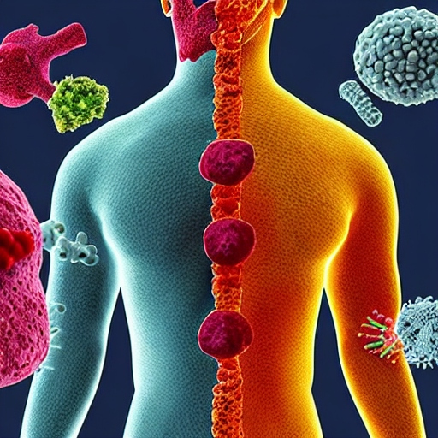
Figure 1 illustrates the intricate and intricate network of cells, tissues, organs, and molecules that comprise the human immune system. This sophisticated system collaboratively functions to safeguard the body from external pathogens, including bacteria, viruses, fungi, and parasites. The fundamental role of this entity is to discern and eradicate detrimental chemicals, while concurrently differentiating them from the body's own viable cells and tissues.

An Overview of Herbal Medicine
Throughout the course of history, traditional tastes and spices have assumed a prominent position in Indian cuisine, serving as potent agents in enhancing immune function. Throughout antiquity, spices and tastes have been acknowledged for their therapeutic properties. Various areas across the globe boast an extensive assortment of more than 80 flavors, with a notable prevalence observed in the Asian continent. India is widely recognized for its significant utilization of a vast array of tastes in traditional medicine. A range of spices, including turmeric, saffron, cloves, cinnamon, carom seeds, ginger, and garlic, are acknowledged for their manifold advantageous properties. Several spices, like as mint, tulsi (Holy Basil), neem leaves, ashwagandha, and giloy, are purported to possess therapeutic properties. Spices and tastes offer distinct benefits owing to their non-intrusive characteristics, in contrast to pharmaceutical drugs that require oral consumption. Given the premise of equal circumstances, it is feasible to incorporate diverse constituents into our fundamental culinary concoctions with the aim of augmenting their flavor and prolonging their shelf life. Ayurveda, an ancient Indian medical system, comprises a wide range of herbs, spices, and roots that are purported to possess innate properties for bolstering the immune system. The discipline of Ayurveda incorporates the use of various tastes and spices to effectively manage chronic health conditions by targeting metabolic abnormalities often known as "toxins". In the realm of Indian cuisine, the inclusion of spices and tastes in a meal has historically been guided by their nutritional advantages and their capacity to fortify the immune system, so conferring safeguard against many ailments and illnesses. A strong and reliable base assists the human body in effectively countering influenza, pathogenic diseases, and bacterial infections. Individuals with weakened immunity are at a heightened vulnerability to illness and tend to manifest more severe symptoms in comparison to individuals with intact immune systems. The importance of a strong and reliable framework is emphasized by its capacity to support a well-balanced way of life. Based on data from the World Health Organization, it can be observed that over 80% of the worldwide population depends on traditional medicine as their main source of primary healthcare, with a special emphasis on South Asia and Europe. According to research investigations, exams have been found to not only enhance the immunological response of the body, but also possess anti-inflammatory properties and demonstrate a considerably lower incidence of unwanted effects.

Figure 2 illustrates the use of three specific herbs and spices, namely garlic, turmeric, and ginger, which serve the dual purpose of enhancing the taste of many culinary preparations and providing a multitude of potential health advantages. The extensive historical utilization of these substances in traditional medicinal practises, together with ongoing scientific investigations, consistently underscore their significance in fostering holistic wellness and upholding a harmonious and nourishing dietary regimen.

Various herbs for enhancing the immune system
To optimize the therapeutic advantages of Ayurveda, the oldest known medical system, a wide range of healthcare practices is necessary. Several extensive studies have been carried out in proximity, uncovering the ability of several chemical constituents, including alkaloids, flavonoids, terpenoids, polysaccharides, lactones, and glycoside derivatives, to elicit changes in immunomodulatory capacities. The objective of this survey is to provide academic support for the utilization of Indian herbal medicines as immunomodulators on a worldwide level, considering their substantial potential and well-documented therapeutic qualities. Throughout the course of human history, it has been apparent that medicinal plants have played a prominent role in the treatment of many maladies, encompassing those induced by insects, parasites, bacteria, and viruses. The observed effects in plants are ascribed to the existence of synthetic chemicals within them, which exhibit similar functionality to traditional pharmaceuticals. Nevertheless, it is crucial to acknowledge that these plants also harbor intrinsic risks, since they hold the capacity to induce detrimental and poisonous consequences. The mitigation of these adverse results can be achieved by the effective management of the plant's raw materials. Ethnobotany is an academic field that encompasses the rigorous investigation of indigenous plant species with the aim of discerning their medicinal properties. This method proves to be a highly efficient strategy for the identification and exploration of prospective pharmaceutical compounds. Based on the data collected during the period of 2015-2016, it has been determined that a total of more than 300 plant species have been recognized for their potential therapeutic attributes (1). A total of 122 plant-derived molecules have been identified as therapeutic agents, with a subset of these compounds being employed in the production of pharmaceutical medications. As an illustration, it is noteworthy that the bark of the willow tree harbors a substantial quantity of salicylic acid, a compound that likewise serves as an active constituent in ibuprofen. The utilization of this bark as a material with analgesic and antipyretic properties has been documented in historical records (2). Moreover, several frequently prescribed pharmaceuticals, including ibuprofen, digoxin, quinine, and opium, are obtained from botanical origins. The utilization of herbal medicine has been prevalent for a significant duration of time. Presently, there is an increasing inclination towards employing these botanical remedies as regulators of the intricate immune system. Several studies undertaken in the area have investigated the occurrence and impacts of diverse chemical substances, including alkaloids, flavonoids, terpenoids, polysaccharides, lactones, and glycoside derivatives. These chemicals have been identified as the causative agents for eliciting alterations in immunomodulatory characteristics. Consequently, there has been an increasing inclination towards the examination of immunomodulators. The advancement of indigenous medicine necessitates the involvement of diverse specialized practitioners who endeavor to modify the complex immune response with the objective of averting infection, as opposed to prioritizing sickness therapy and cure. The objective of this review is to present a comprehensive analysis of several medicinal plants and their immunomodulatory properties, encompassing a wide range of views.

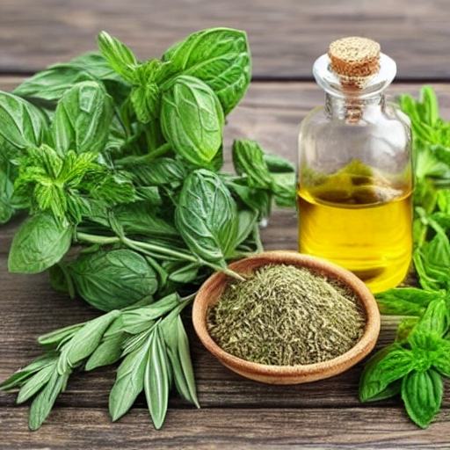
Figure 3: It is noteworthy to acknowledge that although these herbs have been conventionally employed for enhancing immune function, the efficacy of herbs may differ among individuals. It is advisable to seek guidance from a healthcare expert or a skilled herbalist prior to integrating any novel herbs or supplements into one's regimen, particularly if one has preexisting health concerns or is concurrently using drugs. This precautionary measure aims to ascertain the safety and suitability of these additions in accordance with one's individual requirements.

The concept of insusceptibility refers to the state or condition of being resistant or immune
The term "immunity" pertains to the body's intrinsic defence mechanism against a diverse array of diseases and ailments. The immune system, found in vertebrates, exhibits a high level of complexity and advancement. It demonstrates the capacity to produce a diverse range of cells and molecules, enabling it to effectively counteract a broad range of diseases and toxic substances. Immunomodulators are substances that possess the ability to stimulate, augment, or suppress various components or stages of the immune system. There are two distinct categories of immunomodulators that are acknowledged for their therapeutic application: immunostimulatory drugs and immunosuppressant medicines. Immunopharmacology is a modern branch of pharmacology that is dedicated to the examination of immunomodulators [4]. The administration of immunostimulatory drugs, as shown in the context of AIDS, and the utilisation of immunosuppressants to manage an excessive immune response, have the objective of reinstating the regular operation of the immune system and augmenting overall longevity. The utilisation of immunomodulators in combination with antigens is intended to augment the efficacy of the immune system, whereby the immunomodulator acts as a recognised immunological adjuvant [5]. The field of immunology is characterised by its rapid progress in biomedical research, offering considerable promise in the realm of tackling a wide range of diseases and disorders. There exist two alternative approaches to guaranteeing the security of a component. One approach involves the utilisation of a provisional apparatus, which functions as the primary means of protection. The second approach represents a sophisticated and versatile immune response that is distinguished by its intricacy, variety, and ability to retain information [6]. The concept of a diverse immune response also incorporates two distinct forms of immune responses: the humoral immune response, which involves β-lymphocytes, and the cell-mediated cytotoxic response, which is mediated by T-cells. The diverse constituents of the immune system are derived from undifferentiated cells that emerge from the bone marrow in a biological process referred to as hematopoiesis. The individuals in issue have the capacity to undergo cellular differentiation or migrate to peripheral locations as part of their migratory behaviour. In conjunction with a diverse array of immune cells, the immune system relies on the presence of particular chemicals called cytokines to effectively mediate intercellular communication. Cytokines play a crucial role as mediators within the immune system, successfully orchestrating the behaviour and functional responses of the involved cells.
The user's material is insufficient in length to be revised in an academic manner. The regulation of cytokines elicited by botanical plants.
Numerous in vitro and in vivo investigations have been undertaken to examine the influence of natural remedies on cytokines, demonstrating their substantial impacts on a diverse array of cytokines. Cytokines represent a category of soluble extracellular proteins or glycoproteins, including interleukins (ILs), interferons, chemokines, and other others. These molecules assume a pivotal function in both innate and adaptive immune responses. Cytokines are essential for the maintenance of physiological homeostasis through their facilitation of intercellular communication. Cytokines are secreted by diverse nucleated cells in response to tissue damage, thereby triggering an inducible immune response. A substantial body of evidence derived from clinical literature demonstrates a robust correlation between the release of cytokines and the onset of diverse illness states. Cytokines play a significant role in the emergence of mental disorders in diseases that impact the central nervous system. Furthermore, there have been proven instances of abnormal emissions of these chemical messengers. Several neurochemicals, neuroendocrine substances, and neuroimmune factors have been found to display features similar to cytokines. The aforementioned profession has been associated with instances of depression (8), Alzheimer's disease (9), and schizophrenia (10). Numerous social movements, with both positive and negative emotions, stress, and sickness, have been empirically shown to elicit the release of cytokines (11). The existing body of literature pertaining to cardiovascular illnesses emphasises the notable influence of cytokines, which are found in ample quantities within the liver, heart, blood vessels, adipose tissues, and other pertinent tissues. These tissues play a role in the inflammatory characteristics of cardiovascular illnesses. The acknowledgement of the presence and efficacy of cytokines, along with the comprehension of alterations in cytokine manifestation and the examination of their receptors, offer a promising avenue for investigating their viability as targets for therapeutic intervention. A diverse array of pharmacological experts is required to assume the functions of antagonist, agonist, and initiator within the framework of stimulation. In 1986, the Food and Drug Administration (FDA) initiated the investigation of interferon agonist as a potential therapeutic intervention for hairy cell leukaemia. In the context of treating rheumatoid arthritis, there has been a focus on targeting antigens associated with tumour necrosis factor-alpha (TNF-α). Interleukin-1 beta (IL-1β) and tumour necrosis factor-alpha (TNF-α) have garnered significant attention within the realm of periodontal diseases. Potential treatment effects can be achieved in the case of neuroblastomas by suppressing cytokines released from T-helper cells and using IL-2, IL-12, and TNF-α. Cytokines demonstrate a wide range of diverse and pleiotropic attributes, and they also display potential in addressing a variety of illnesses that are not directly related to the immune system. Nevertheless, the administration of interferon has been associated with the manifestation of flu-like symptoms, melancholy, weariness, and various other detrimental consequences in individuals. The aforementioned limitations encountered in the therapeutic strategy pose a substantial impediment for cytokine-based therapy. The identified negative impacts experienced by patients acted as a catalyst for our investigation into the potential of phytotherapy in regulating the expression of cytokines. An instance of a botanical organism is Astragalus membranous, which is alternatively referred to as the "spleen chi tonic." The aforementioned Chinese herb is utilised in the treatment of diverse ailments and disorders that are characterised by the progressive decline of physical health. The concentrated extract obtained from the roots of a botanical specimen has been reported to exhibit a reduction in the levels of interleukin-6 (IL-6) in an in vitro model using human cells [17]. Interleukin-6 (IL-6) is classified as a pro-inflammatory cytokine and is also recognised as a reliable indicator of tissue deterioration [17]. The plant commonly known as garlic, with its scientific name Allium sativum, is extensively utilised in Indian households. Research has revealed that garlic has a range of advantageous characteristics, including anti-inflammatory, hypocholesterolemic, antioxidant, and angiotensin-converting enzyme inhibitory actions. Previous research has demonstrated the efficacy of the intervention in reducing the concentrations of interleukin-1 (IL-1) and interleukin-6 (IL-6). Additionally, the intervention has been found to suppress the production of tumour necrosis factor (TNF) and interleukin-8 (IL-8), while simultaneously enhancing the production of interleukin-10 (IL-10), which functions as an antagonist to pro-inflammatory cytokines [18]. In addition, garlic exhibits antibacterial qualities in conjunction with its anti-inflammatory actions. The possible use of garlic has been proposed as a therapeutic for gastrointestinal infections that trigger a robust immune response. The therapeutic application of IL-10 modulation has also been observed in the management of Alzheimer's disease. Spelman et al. (year) conducted a survey whereby they provided a report on the immunomodulatory characteristics of a diverse array of 18 herbal plants, encompassing Acanthopanax gracilistylus and A. (last name of the second plant). A number of plant species, including sativum, Ananas comosus, Cissampelossympodials, Coriolus versicolor, Curcuma longa, Tinospora cordifolia, and Withaniasomnifera, have been recognised for their potential therapeutic characteristics. Aloe vera, a widely recognised botanical species that flourishes in dry environments, is thought to possess therapeutic benefits for wound healing and burn treatment, which are attributed to its anti-inflammatory characteristics. Prior research has indicated a decrease in levels of TNF-α and IL-6 in diverse animal models [20]. Several locally manufactured drugs have been found to restore balance to different elements of the innate and acquired immune system. It is clear that secondary metabolites derived from plants found in natural products have significant potential as primary candidates for the future development of therapeutic immunomodulators, given the well-established understanding of the diverse immunomodulatory activities exhibited by botanical organisms.

Tinospora cordifolia, commonly referred to as Giloy, is a botanical specimen of considerable importance within the realm of scholarly investigation.
Tinospora cordifolia, known by its common names 'Guduchi' or 'Amrita', has been utilised for an extensive period of time owing to its therapeutic attributes. Numerous research have shown evidence for the hypolipidemic, hypoglycemic, hepatoprotective, antibacterial, anti-inflammatory, anti-osteoporotic, anti-obesity, anticarcinogenic, and antimutagenic characteristics associated with giloy. Numerous research studies have also examined the potential of this compound as an antioxidant. In addition, giloy has demonstrated efficacy in mitigating lead toxicity, treating diabetic foot ulcers, and managing diabetic neuropathy. Moreover, previous studies have examined the impact of giloy on cognitive functions such as learning and memory (21–23). Several models have been employed to investigate the immunomodulatory effects of giloy (24,25). The primary component of giloy, α-D-glucan, has been observed to elicit activation in natural killer cells, B cells, and T cells, while concurrently facilitating the generation of immune stimulatory cytokines (15). Moreover, it has been demonstrated that the administration of giloy extract leads to a decrease in the overall leucocyte count (TLC), as well as the counts of neutrophils and eosinophils, in individuals who are HIV-positive (26). A research investigation was carried out on male Wistar rats, wherein an alcoholic extract of giloy was administered. The results of this study revealed a notable augmentation in white blood cell (WBC) counts, bone marrow cellularity, and serum Ig concentrations. These findings provide more evidence supporting the immunomodulatory capabilities of giloy. (27)
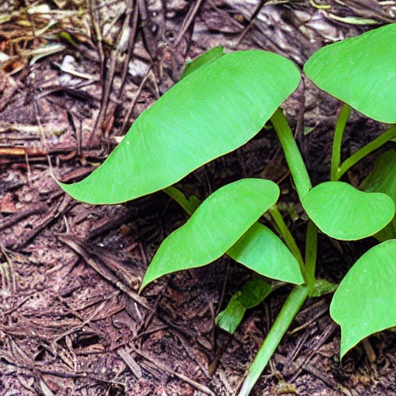
Figure 4 presents Giloy, a herb technically identified as Tinospora cordifolia, which holds significant esteem in traditional Ayurvedic medicine due to its manifold health advantages and its ability to enhance the immune system. Giloy, often referred to as "Guduchi" and "Amrita," is a botanical species indigenous to the Indian subcontinent. Its historical usage as a therapeutic plant spans several centuries.

Ashwagandha (Withaniasomnifera) is a botanical plant commonly used in traditional medicine.
Withaniasomnifera, also known as Ashwagandha, holds a significant position within the Indian Ayurvedic system. It is employed for several types of therapeutic interventions, primarily as a tonic for the nervous system. The term "Ashwagandha" in Sanskrit is associated with the olfactory perception of horses, symbolizing the vigour and potency reminiscent of these animals. Ashwagandha, classified as an adaptogen, belongs to a group of herbs and spices that can regulate the body's stress response, restoring it to its normal levels (28, 29). These spices can enhance our resilience during periods of stress, both physical and emotional, and restore a state of equilibrium. The ashwagandha plant is widely recognized for its various medicinal properties, including its tonic, sexual enhancing, sedative, diuretic, anthelmintic, astringent, thermogenic, and stimulant effects (30-35). Scientific research has indicated that the active compounds known as withanolides, which are abundant in ashwagandha, are responsible for its antimicrobial, antitumor, and immunomodulating properties (36). Additionally, the antioxidants present in ashwagandha play a crucial role in enhancing the immune system. Studies have also demonstrated that the body naturally increases the production of nitric oxide in response to infection, which contributes to the immune-boosting effects of this herb (37, 38)). Ashwagandha has been found to enhance the production of nitric oxide, a molecule responsible for initiating the immune system's macrophage activities and enhancing its ability to engulf foreign cells. Furthermore, Ashwagandha has demonstrated the ability to reduce inflammation by decreasing the levels of C-reactive protein in the body (39). The reduction of chronic inflammation has been found to enhance the functioning of the immune system by promoting the activity of Natural Killer cells, which are integral components of the innate immune system (40). These cells play a crucial role in the elimination of both tumors and virally infected cells. Research has demonstrated that ashwagandha supplementation contributes to an increase in Natural Killer cell activity in human studies.

The figure illustrates that Ashwagandha, a botanical species, has been employed for several centuries within the framework of traditional Ayurvedic treatment, a holistic healing system originating from India. The etymology of its name can be traced back to the Sanskrit terms 'ashva', signifying horse, and 'gandha', denoting smell, due to the pronounced equine fragrance emitted by its roots.
Figure 5 illustrates Ashwagandha, a botanical species scientifically identified as Withaniasomnifera, which holds significant prominence in traditional Ayurvedic medicine and is commonly recognized as the "Indian ginseng" or "winter cherry." This herbaceous plant, characterized by its diminutive stature and yellow blossoms, is indigenous to the Indian subcontinent and is extensively cultivated due to its therapeutic attributes.

The plant species commonly referred to as garlic, scientifically classified as Allium sativum, has been the subject of extensive scientific research.
Allium sativum, a member of the genus Allium, is renowned for its ability to produce organosulfur compounds that exhibit significant biological and pharmacological properties. The separated combinations derived from garlic have been found to possess a diverse array of advantageous capabilities in combating microbial infections, as well as providing cardioprotective, anti-carcinogenic, and anti-inflammatory actions (41-44). In contemporary times, garlic has emerged as a potentially advantageous contender for the preservation of immune system homeostasis. Numerous investigations have been undertaken utilising animal models in order to explore the immunomodulatory properties of various constituents and formulations of garlic (45, 46). The main constituents of garlic consist of S-allyl-L-cysteine sulfoxide, also known as alliin, and derivatives of 𝛾-glutamyl cysteine. The act of crushing or biting garlic leads to the production of a chemical called allicin. The compound known as allicin is considered to be the principal bioactive constituent found in garlic, which is accountable for its characteristic odour and flavour (47). Nevertheless, allicin exhibits instability and undergoes rapid conversion into other sulfur-containing compounds that exhibit therapeutic characteristics. These chemicals have been shown to augment the immunological response of leukocytes in the human body during exposure to viral infections, such as those responsible for the common cold or influenza (48). Aged garlic extract is composed of fructans, more especially fructoligosaccharides, which possess the ability to selectively activate advantageous bacteria within the colon. Consequently, this process leads to the regulation of immunological responses (49).

Turmeric, formally referred to as Curcuma longa, is a perennial herbaceous plant classified under the Zingiberaceae family, commonly known as the ginger family.
Curcuma longa, also referred to as "Indian saffron," is a spice characterised by its yellow-orange hue and distinctive flavour. This spice has a long history of therapeutic usage spanning several millennia (50). This particular flavour is highly acknowledged for its comprehensive understanding and has undergone significant research to explore its potential medicinal benefits. Existing literature has presented empirical support for the therapeutic efficacy of curcumin, the principal constituent of turmeric, across a range of pharmacological domains including antifungal, antiviral, antioxidant, anti-inflammatory, and immune system modulation (51-54). The chemical curcumin has been discovered as the active component responsible for the clinical therapeutic benefits exhibited by turmeric. Moreover, curcumin assumes a substantial function in the modulation of the immune system (55). The exploration of turmeric's possible prebiotic properties has focused on its ability to influence the gut microbiota composition and enhance the gut-immune axis. Moreover, studies have demonstrated that curcumin exhibits the ability to decrease cortisol levels, hence playing a role in the regulation of immune system homeostasis. The relevance of this occurrence is rooted in the existence of cortisol receptors throughout all immune cells, as any deviations in cortisol levels have the potential to impede appropriate immunological reactions (56). The overstimulation of immune cells can give rise to the emergence of several health conditions. Nevertheless, scholarly investigations have also revealed that turmeric exhibits potential in modulating the excessive activation of immune cells (57).

Ashoka, scientifically known as Saraca indica, is a plant of considerable importance within the realm of traditional Ayurvedic medicine. The herbaceous plant under consideration is known for its striking orange blossoms and is native to the Indian subcontinent. It is widely grown for its significant medicinal properties.

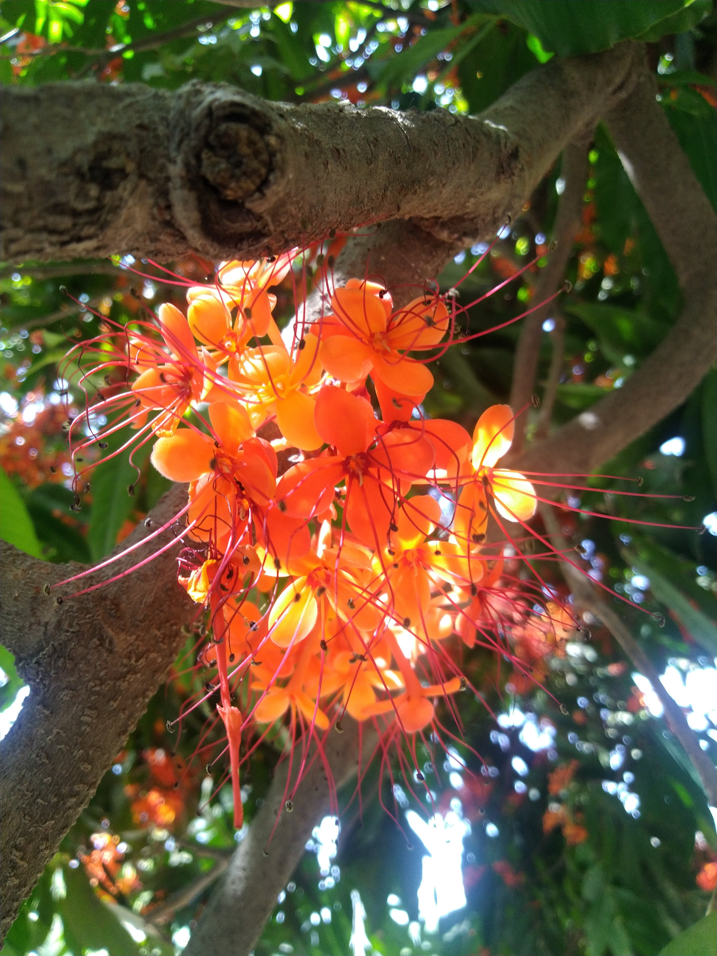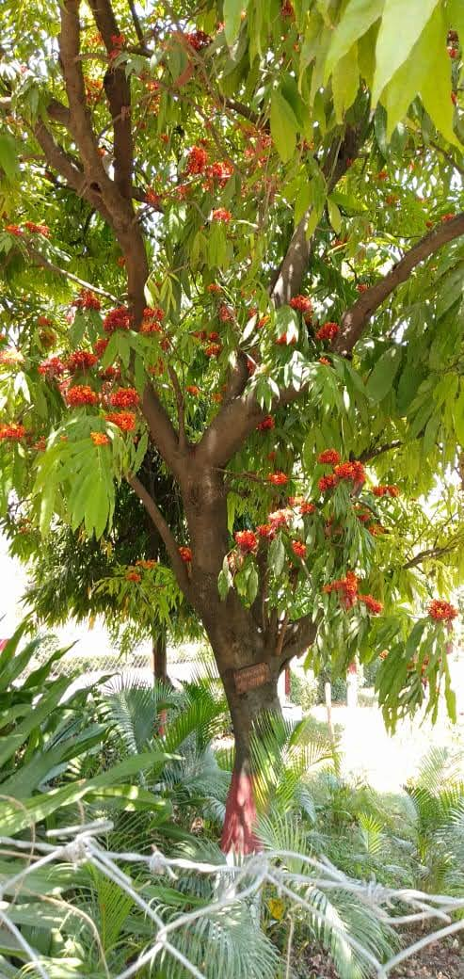
Figure 6: Ashoka, scientifically known as Saraca indica, is a prominent herb in traditional Ayurvedic medicine It is a medicinal plant with orange flowers, native to the Indian subcontinent, and is widely cultivated for its medicinal properties.

Natural commodities, such as vegetables and other consumable plants, assume a pivotal function in the provision of essential minerals and nutrients within the nutritional framework. The inclusion of sufficient amounts of edible plants in one's dietary intake can significantly enhance the levels of essential nutrients and metals inside the human body, hence mitigating the possible risks associated with lead toxicity. Additionally, it is important to acknowledge that edible plants contain a wide range of nutritional supplements, including phytochemicals and dietary protein, which have been shown to offer protection against lead (Pb) toxicity. Garlic, ginger, and onion are extensively utilised in many geographical places as culinary ingredients to enhance flavour, aroma, and taste characteristics on a worldwide level.

Saraca indica (SI) is classified as a member of the Caesalpinaceae family and possesses noteworthy botanical and cultural importance as a sustaining botanical species. Saraca indica (SI) is of considerable importance in relation to conditions such as uterine/ovarian fibroids, diverse ailments, menorrhagia, uterine prolapse, and inflammatory disorders. The main purpose of its use is to enhance the overall health and wellness of the uterus. The prevention of unsuccessful labour during the second trimester is of paramount significance. The variable S exerts significant impacts on both climate patterns and human well-being. The term "indica" denotes a distinct kind of the cannabis plant.

Saraca indica is widely acknowledged as a significant source of natural antioxidants, with its antioxidant effectiveness probably ascribed to the existence of phenolic and flavonoid components in several preparations, including aqueous and ethanolic extracts of S. indica. The term "indica" is being considered, as indicated by the reference cited [58]. The present study revealed the existence of numerous phytochemical elements, such as carbohydrates, flavonoids, saponins, phenols, tannins, glycosides, and steroids, within the leaves, bark, and flowers of the plant species S. The term "indica" denotes a distinct cultivar of the cannabis plant.

Recent research studies have demonstrated that extracts obtained from Saraca indica, in both aqueous and ethanolic forms, show considerable potential in ameliorating the initial damage caused by lead acetate poisoning in hepatic and renal cells. The simultaneous exposure of HepG2 and HEK293 cells to lead acetate and S. indica extract resulted in a statistically significant increase in cellular growth and proliferation (p<0.05). The findings of this study offer persuasive evidence that the potential of aqueous and ethanolic extracts of S.indica as chelators of heavy metals is evident, as they successfully mitigate lead acetate-induced toxicity in HepG2 and HEK293 cells [59].
Ginger, formally referred to as Zingiber officinale, is a spice of considerable global usage. Ginger has historically been utilised in traditional Chinese, Ayurvedic, and Tibb-Unani herbal medicine for the treatment of a diverse range of conditions including catarrh, nausea, mental disorders, gingivitis, toothache, asthma, stroke, constipation, and diabetes. Numerous comprehensive evaluations have been conducted to analyse the medicinal, chemical, and pharmacological characteristics of ginger (60). Extensive evaluation has been conducted on the evidence substantiating ginger's effectiveness as an antioxidant, anti-inflammatory agent, antiemetic substance, and anticancer agent, in addition to its preventive properties against various illness conditions. The key constituent responsible for the pungent fragrance of ginger is the presence of ketones, more especially the gingerols. The gingerols, paradols, sesquiterpenes, shogaols, and zingerone compounds collectively contribute to the robust anti-inflammatory and antioxidant characteristics exhibited by ginger (61, 62). Numerous empirical investigations completed on diverse models have provided evidence that ginger extract possesses the capacity to successfully mitigate inflammation in persons afflicted with ailments such as rheumatoid arthritis, inflammatory bowel disease, asthma, and specific forms of malignancies. A human-based clinical experiment yielded findings indicating that the ingestion of ginger powder led to a notable decrease in the concentrations of inflammatory proteins, including tumour necrosis factor alpha (TNF-alpha) and C-reactive protein (CRP). A separate investigation was conducted on male athletes who were given a daily dose of 1.5 grammes of ginger powder over a duration of six weeks. This study also revealed a significant reduction in the levels of inflammatory markers, such as TNF-alpha, interleukin 6 (IL-6), and interleukin-1 beta (IL-1-beta), in comparison to athletes who were administered a placebo (63-65).

The application of garlic led to a decrease in the buildup of lead (Pb) and a subsequent restoration of immunological markers in both the circulatory system and body tissues (66). Furthermore, garlic is well acknowledged as a therapeutic herb. The treatment of garlic extract has been reported to alleviate the adverse effects of lead-induced brain, liver, renal, and hemolytic damage in rats. The incorporation of these dietary constituents into the diet conferred protection against renal and developmental harm resulting from lead exposure, owing to their similar cellular strengthening properties to those of garlic.

Green tea is commonly used in Asian cuisine and is known for its several health benefits, including its potential to reduce oxidative stress, a condition that has been linked to the onset of diabetes. According to a study (67), the ingestion of green tea has been shown to have a beneficial effect on hepatic function and ameliorate histological changes in the liver.

The tomato, formally referred to as Lycopersicon esculentum in scientific literature, is generally acknowledged for its notable antioxidant characteristics. The efficacy of this intervention in ameliorating renal damage caused by lead exposure has been duly noted in murine models. The phenomenon of tomato plants exhibiting the synthesis of metal-chelating proteins and phytochelatins has been documented in response to their exposure to heavy metal particles. Undoubtedly, the concept that the ingestion of tomatoes through oral means has been supported by empirical data, which demonstrates its efficacy in reducing the accumulation of heavy metals in the hepatic tissues of rats. According to a study conducted by researchers, it was discovered that the ingestion of tomatoes has the potential to effectively restore renal function and mitigate alterations in the activity of antioxidant enzymes in blood plasma (68).

Supplementary Botanical Species for Routine Therapeutic Application
The subject matter under consideration pertains to ginseng, with particular emphasis on its characteristics and applications.
The phrases "Ninjin," "Pannag," and "Panax" can be considered synonymous.
The organic origin of ginseng comprises the desiccated roots of many species belonging to the panax genus, such as Panax ginseng (Korean ginseng), Panax japonica (Japanese ginseng), Panax notoginseng (Chinese ginseng), and Panax quinquefolium (American ginseng).
The plant in question is taxonomically classified within the family Araliaceae.
Taxonomy is a scientific discipline that involves the classification, identification, and naming of organisms based Panax ginseng, belonging to the Araliaceae family, exhibits a distribution range across East Asia and Russia. The species is primarily found in the remote hinterlands of Manchuria and North Korea, although there have been reports of excessive harvesting in several other locations of Asia. The cultivation of the product has been predominantly carried out in Korea, China, and Japan with the main purpose of facilitating trade and utilising it as a medical plant. Panax ginseng, a perennial botanical specimen, exhibits a deciduous growth pattern, featuring leaves that are distinctly separated into five separate lobes. The plant exhibits the characteristic of producing little white flowers, bearing red berries, and possessing a root that is yellowish-brown in colour. The root is employed in a remedial fashion, although diverse amalgamations are present in different sections of the plant.

The figure 7 illustrates that ginseng, a perennial herb, has been employed in traditional medicine for numerous centuries. This plant species is indigenous to the regions of Asia and North America and has been deliberately grown for its therapeutic attributes for a period exceeding 5,000 years.

Panax ginseng is recognised for its possession of triterpene glycosides, often known as ginsenosides, which are considered to be active components. Various bioactive chemicals can be detected in different plant components, encompassing amino acids, alkaloids, phenols, proteins, polypeptides, and vitamins B1 and B2.

The topic being examined pertains to Panax ginseng, a botanical species well recognised as an adaptogen. The term "resilience" encompasses a range of characteristics and impacts on the human body, which collectively enhance the ability to withstand various biochemical and physical stressors. Moreover, there is a prevailing belief that it has the potential to augment levels of energy, foster lifespan, and increase cognitive function. Numerous research have indicated that Panax ginseng may possess immuno-balancing properties via exerting modulatory effects on the hypothalamic-pituitary-adrenal (HPA) axis. The current study aims to examine the augmented functionality of natural killer (NK) cells and heightened phagocytic activity of immune cells subsequent to their exposure to ginsenosides in an in vitro environment. According to a 1999 audit carried out by the World Health Organisation, there is a suggestion that ginseng saponins may possess the capability to decrease blood prolactin levels, hence potentially augmenting male libido in instances of erectile dysfunction. The clinical indications refer to the specific medical conditions or circumstances that warrant the use of a certain diagnostic test, treatment, or intervention. Extensive research has been conducted on Panax ginseng through the utilisation of double-blind, randomised, placebo-controlled trials (RCTs). Ginseng has been a prevalent element within Asian cultures, where it has been utilised for a multitude of objectives, including the management of ailments such as weariness, mental stress, glucose regulation, and the enhancement of libido. Furthermore, there has been a significant focus on the utilisation of Panax ginseng in the domains of disease prevention, glycemic regulation, tiredness management, and immunomodulation within the context of human health and illness. The phenomenon of immunological modulation

Pharmaceutical treatment Blumenthal et al. (year) undertook a comprehensive assessment to investigate the potential botanical interactions involving Panax ginseng and pharmaceutical medications. Their findings, in accordance with the German Commission E, indicate that no recorded interactions between Panax ginseng and pharmaceutical drugs currently exist. Nevertheless, a recent study conducted by Seely et al indicates the need for careful utilisation of Panax ginseng during pregnancy and breastfeeding, even though there is no evidence of any particular teratogenic or chemically disrupting consequences.

Results and Toxicity: Panax ginseng has been found to have low levels of toxicity, since there have been limited instances of documented adverse outcomes when administered in accordance with proper usage guidelines. Elevated dosages and continued use have been linked to the occurrence of adverse outcomes. A range of symptoms has been seen, including hypertension, nausea, diarrhoea, headache, breast soreness, sleeplessness, and skin rash.

Multiple techniques can be utilised for the administration of ginseng root, encompassing oral intake by means of mastication, as well as consumption in the forms of powder, fluid concentration, decoction, or a combination thereof. The sustained utilisation of unprocessed dry root powder, at a dosage of 1-2 grammes per day, can be maintained for a period of up to three months. The suggested daily dose of Panax ginseng, which has been standardised to contain 4% ginsenosides, is 200 mg. The specified quantity ought to be partitioned across many doses, leading to a daily consumption of 8 mg of ginsenosides.

The subject matter under consideration is to licorice, with particular emphasis on its features and characteristics as they pertain to individuals between the ages of 8 and 11.

The botanical entity known as Glycyrrhiza can be referred to alternately as Glycyrrhizae radix or Mulethi. The biological origin encompasses the desiccated, denuded, unhusked root and stolon of Glycyrrhiza glabra. The taxonomic categorization of the family under consideration is Leguminosae.

The user's text lacks academic language and structure. It needs to be rewritten to adhere to The licorice bush, classified as a member of the Fabaceae family, exhibits robust growth in subtropical environments characterised by nutrient-rich soil, attaining a vertical stature ranging from four to five feet. The observed object displays elliptical flyers and clusters of white to purplish flowers that are placed in a consistent and level fashion. The subterranean licorice plant is characterised by its extensive root system, which includes a major taproot and several runners. The primary taproot, which is harvested for its therapeutic properties, exhibits a fragile and fibrous nature, characterised by a vivid yellow hue in its interior.

Dynamic constituents: A number of segments have been derived from licorice, encompassing a water-soluble component that is intrinsically active and accounts for 40-50 percent of the whole dry weight. The aforementioned complex is composed of triterpene saponins, flavonoids, polysaccharides, gelatins, monosaccharides, amino acids, mineral salts, and a variety of other substances.

A number of plant species, such as Neem (Azadirachta indica), Torch ginger (Etlingera elatior), European columbine (Aquilegia vulgaris), and Tossa jute (Corchorus olitorius), have exhibited promising capabilities in alleviating the effects of lead (Pb) toxicity.

Tossa jute, a plant that is frequently consumed as a vegetable and serves as a dietary staple in Eastern Asia and Africa, has been observed to possess significant effects on the restoration of biochemical and haematological parameters. Furthermore, a study conducted by Dewanjee et al. (2013) has demonstrated that it exhibits the ability to decrease the buildup of lead within bodily tissues.

Torch ginger, a botanical species frequently employed in the culinary practises of Malaysia, serves as a prominent illustration of a firmly established nutritional component throughout distinct geographic regions. Haleagrahara et al. (2010) did a study which demonstrated an increase in the levels of enzymes within the oxidative biomarkers and histology of bone marrow.

Curcumin exhibits promising therapeutic potential in the process of chelating toxic metals. Daneil et al. (2004) suggest that there exists the possibility of mitigating neurotoxicity and averting tissue harm. Spirulina and chlorella, two types of algae, have demonstrated the capacity to alleviate the detrimental impacts of lead (Pb) on the brain, kidneys, and liver in animal subjects. However, specific cultivars of these botanical species are frequently utilised in the production of beverages and confectioneries, such as liquorice. Therefore, individuals from populations that are susceptible to heavy metal exposure, and who regularly consume these plants as part of their diet, may potentially experience beneficial results in terms of reducing or eliminating symptoms related to heavy metal poisoning.

Conclusion

In summary, the research chapter explores the significant potential of traditional herbs in augmenting the immune system and promoting general wellness. The immune system plays a critical role in protecting the body from harmful infections, acting as a complex defence mechanism. Throughout the course of history, numerous civilizations have heavily depended on conventional herbal remedies, which have recently garnered attention from contemporary scientific investigations owing to their immunomodulatory properties. The herbs, specifically Giloy, Ashwagandha, Garlic, Turmeric, and Ginger, have exhibited promising immunomodulatory characteristics. Extensive research has been conducted on the immunomodulatory properties of bioactive compounds derived from various plant sources. For example, the presence of ginsenosides in Ginseng, allicin in Garlic, curcumin in Turmeric, and withanolides in Ashwagandha has been linked to immune-enhancing qualities. A diverse array of medicinal herbs are essential in the management of lead-induced harm. India is well acknowledged as a prominent reservoir of different medicinal plants that exhibit a broad spectrum of pharmacological effects. Within the Ayurvedic pharmaceutical system, there exists a preference for the utilisation of botanical extracts over the administration of pure drugs. The Ashoka tree is regarded with great reverence due to its substantial historical and cultural significance. Ashoka exhibits a diverse range of medical applications and is recognised as a non-toxic traditional medicinal herb, frequently utilised in the therapeutic management of many ailments. The activation of immune cells, modulation of cytokine production, and enhancement of innate defence systems of the body have been seen upon the discovery of these herbs. This study highlights the importance of cytokine modulation triggered by herbal plants, as cytokines play a crucial role in immune responses and the regulation of inflammation. Several herbs, including Ginseng, Garlic, and Turmeric, have exhibited the capacity to regulate cytokine levels, thereby promoting a balanced and efficient immune response. However, it is crucial to exercise caution when utilising herbal remedies, as they possess the capacity to interact with specific pharmaceuticals or elicit unfavourable responses in certain individuals. In order to guarantee the secure and effective utilisation of herbal immunomodulators, it is imperative to stick to appropriate dosage recommendations and seek counsel from healthcare practitioners. The discipline of traditional herbal medicine, rooted in historical customs, continues to captivate the attention of the modern scientific community. As further investigation is conducted to explore the immunomodulatory properties of these botanical compounds, they hold the potential to contribute substantial insights and potential therapeutic interventions for enhancing immune response and managing diverse illnesses. The research chapter emphasises the need of incorporating traditional herbal remedies into modern healthcare approaches, with a specific focus on their potential to enhance immune system strength and resilience. As further investigation into these natural agents progresses, their potential to operate as crucial components in strategies targeted at augmenting immune function becomes evident. This potential, in turn, complements established conventional approaches and holds promise for improved outcomes in the field of public health.

REFERENCES

- StanelyMainzen PP, Menon VP, Gunasekaran G. Hypolipidaemic action of Tinospora cordifolia roots in alloxan diabetic rats. J Ethnopharmacol. 1999;64(1):53–57.
- Stanely P, Prince M, Menon VP. Hypoglycaemic and other related actions of Tinospora cordifolia roots in alloxan–induced diabetic rats. J Ethnopharmacol. 2000;70:9–15.
- Puranik N, Kammar KF, Devi S. Anti–diabetic activity of Tinospora cordifolia (Willd.) in streptozotocin diabetic rats; does it act like sulfonylureas?. Turk J Med Sci. 2010;40(2):265–270.
- Bishayi B, Roychowdhury S, Ghosh S, et al. Hepatoprotective and Immunomodulatory effects of Tinospora cordifolia in CCl4 Intoxicated Mature Albino Rats. J Toxicol Sci. 2002;27(3):139–146.
- Shanthi V, Nelson R. Anitbacterial activity of Tinospora cordifolia (Willd) Hook.F.Thoms on urinary tract pathogens. Int J CurrMicrobiol App Sci. 2013;2(6):190–194.
- Patgiri B, Umretia BL, Vaishnav PU, et al. Anti–inflammatory activity of Guduchi Ghana (aqueous extract of Tinospora cordifolia Miers.). Ayu. 2014;35(1):108–110.
- Kapur P, Jarry H, Wuttke W, et al. Evaluation of the antiosteoporotic potential of Tinospora cordifolia in female rats. Maturitas. 2008;59(4):329–338.
- Dhingra D, Jindal V, Sharma S, et al. Evaluation of antiobesity activity of Tinospora cordifolia stems in rats. Int J Res Ayur Pharmac. 2011;2(1):306–311.
- Verma R, Chaudhary HS, Agrawal RC. Evaluation of Anticarcinogenic and Antimutagenic Effect of Tinospora cordifolia in Experimental Animals. J Chem Pharm Res. 2011;3(6):877–881.
- Sharma V, Pandey D. Beneficial Effects of Tinospora cordifolia on Blood Profiles in Male Mice Exposed to Lead. Toxicol Int. 2010;17(1):8–11.
- Purandare H, Supe A. Immunomodulatory role of Tinospora cordifolia as an adjuvant in surgical treatment of diabetic foot ulcers: A prospective randomized controlled study. Indian J Med Sci. 2007;61(6):347–355.
- Nadig PD, Revankar RR, Dethe SM, et al. Effect of Tinospora cordifolia on experimental diabetic neuropathy. Indian J Pharmacol. 2012;44(5):580–583.
- Bairy KL, Rao Y, Kumar KB. Efficacy of Tinospora cordifolia on Learning and Memory in Healthy Volunteers: A Double–Blind, Randomized, Placebo Controlled Study. Iran J Pharmac Therap. 2004;3(2):57–60.
- More P, Pai K. Immunomodulatory effects of Tinospora cordifolia (Guduchi) on macrophage activation. Biol Med. 2011;3(2):134–140.
- Aher VD, Wahi AK. Pharmacological Study of Tinospora Cordifolia as an Immunomodulator. Int J Curr Pharm Res 2010;2(4):52–54.
- Kalikar MV, Thawani VR, Varadpande UK, et al. Immunomodulatory effect of Tinospora cordifolia extract in human immuno–deficiency virus positive patients. Indian J Pharmacol. 2008;40(3):107–110.
- Singh Narender, Bhalla Mohit, Jager PD, et al. An overview of ashwagandha; A rasayan (rejuvenator) of Ayurveda. AfrJ.Tradt Alter. Med. 2011;8(S):208–213.
- Mishra LC, Singh BB, Dagenais S. Scientific basis for the therapeutic use of Withaniasomnifera.(Ashwagandha): A review. Altern Med Rev. 2000;5:334–346.
- Ziauddin M, Phansalkar N, Patki P, et al. Studies on the immunomodulatory effects of Ashwagandha. J Ethnopharmacol. 1996;50(2):69–76.
- Hosny Mansour H, Farouk Hafez H. Protective effect of Withaniasomnifera against radiation–induced hepatotoxicity in rats. Ecotoxicol Environ Saf. 2012;80:14–19.
- Iuvone T, Esposito G, Capasso F, et al. Induction of nitric oxide synthase expression by Withaniasomnifera in macrophages. Life Sci. 2003;72(14):1617–1625.
- Deshpande A, Irani N, Balakrishnan R. Study protocol and rationale for a prospective, randomized, double–blind, placebo–controlled study to evaluate the effects of Ashwagandha (Withaniasomnifera) extract on nonrestorative sleep. Medicine (Baltimore). 2018;97(26):e11299.
- Salman H, Bergman M, Bessler H, et al. Effect of a garlic derivative (alliin) on peripheral blood cell immune responses. Int J of Immunopharmac. 1999;21(9);589–597.
- Reinhart KM, Talati R, White CM, et al. The impact of garlic on lipid parameters: a systematic review and meta–analysis. Nutr Res Rev. 2009;22(1)39– 48.
- Eilat–Adar S, Sinai T, Yosefy C, et al. Nutritional recommendations for cardiovascular disease prevention. Nutrients. 2013;5(9):3646–3683.
- Khatua TN, Adela R, Banerjee SK. Garlic and cardioprotection: insights into the molecular mechanisms. CanadianJPhysiolPharmac. 2013;91 (6),448– 458.
- Fridman S, Sinai T, Zilberg D. Efficacy of garlic based treatments against monogenean parasites infecting the guppy (Poecilia reticulata (Peters) Veterinary Parasit. 2014;203(1–2):51–58.
- Bauer D, Mazzio E, Soliman KF, et al. Diallyl disulfide inhibits TNFα– induced CCL2 release by MDA–MB–231 cells. Anticancer Res. 2014;34(6):2763–2770.
- Park SY, Seetharaman R, Ko MJ, et al. Ethyl linoleate from garlic attenuates lipopolysaccharide–induced pro–inflammatory cytokine production by inducing heme oxygenase–1 in RAW264.7 cells. Int Immunopharmacol. 2014;19(2):253–261.
- Borlinghaus J, Albrecht F, Gruhlke MC, et al. Allicin: chemistry and biological properties. Molecules. 2014;19(8):12591–12618.
- Whitaker JR, Development of Flavor, Odor, and Pungency in Onion and Garlic. Adv Food Res. 1976;22;73–133.
- Nantz MP, Rowe CA, Muller CE, et al. Supplementation with aged garlic extract improves both NK and γδ–T cell function and reduces the severity of cold and flu symptoms: a randomized, double–blind, placebo– controlled nutrition intervention. Clin Nutr. 2012;31(3):337–344.
- Chandrashekar PM, Prashanth KVH, Venkatesh YP. Isolation, structural elucidation and immunomodulatory activity of fructans from aged garlic extract. Phytochemistry. 2011;72(2–3):255–264.
- He Y, Yue Y, Zheng X, et al. Curcumin, inflammation, and chronic diseases: How are they linked? Molecules. 2015;20:9:183–213.
- Ghosh S, Banerjee S, Sil PC. The beneficial role of curcumin on inflammation, diabetes and neurodegenerative disease: A recent update. Food Chem Toxicol. 2015;83:111–124.
- Zandi K, Ramedani E, Mohammadi K, et al. Evaluation of antiviral activities of curcumin derivatives against HSV–1 in Vero cell line. Nat Prod Commun. 2010;5:1935–1938.
- Moghadamtousi SZ, Kadir HA, Hassandarvish P, et al. A review on antibacterial, antiviral, and antifungal activity of curcumin. Biomed Res Int. 2014;2014:186864.
- Sandur SK, Ichikawa H, Pandey MK, et al. Role of pro–oxidants and antioxidants in the anti–inflammatory and apoptotic effects of curcumin (diferuloylmethane). Free Radic Biol Med. 2007;43:568–580.
- Peterson CT, Vaughn AR, Sharma V, et al. Effects of Turmeric and Curcumin Dietary Supplementation on Human Gut Microbiota: A Double–Blind, Randomized, Placebo–Controlled Pilot Study. J Evid Based Integr Med. 2018;23:2515690X18790725.
- Adam EK, Quinn ME, Tavernier R, et al. Diurnal cortisol slopes and mental and physical health outcomes: A systematic review and meta– analysis. Psychoneuroendocrinology. 2017;83:25–41.
- Yu JJ, Pei LB, Zhang Y, et al. Chronic Supplementation of Curcumin Enhances the Efficacy of Antidepressants in Major Depressive Disorder: A Randomized, Double–Blind, Placebo–Controlled Pilot Study. J Clin Psychopharmacol. 2015;35(4):406–410.
- Bode AM, Dong Z. The Amazing and Mighty Ginger. In: Benzie IFF, Wachtel–Galor S, editors. Herbal Medicine: Biomolecular and Clinical Aspects. 2nd edition. Boca Raton (FL): CRC Press/Taylor & Francis; 2011.
- Mashhadi NS, Ghiasvand R, Askari G, et al. Anti–oxidative and anti– inflammatory effects of ginger in health and physical activity: review of current evidence. Int J Prev Med. 2013;4(Suppl 1):S36–S42.
- Da Silveira e Sá Rde C, Andrade LN, de Sousa DP. Sesquiterpenes from Essential Oils and Anti–Inflammatory Activity. Nat Prod Commun. 2015;10(10):1767–1774.
- Reddy AC, Lokesh BR. Studies on spiceprinciples as antioxidants in the inhibition of lipid peroxidation of rat liver microsomes. Mol Cell Biochem. 1992;111(1–2):117–124.
- Zehsaz F, Farhangi N, Mirheidari L. The effect of Zingiber officinale R. rhizomes (ginger) on plasma pro–inflammatory cytokine levels in well– trained male endurance runners. Cent Eur J Immunol. 2014;39(2):174– 180.
- Minghetti P, Sosa S, Cilurzo F, et al. Evaluation of the topical anti– inflammatory activity of ginger dry extracts from solutions and plasters. Planta Med. 2007;73(15):1525–1530.
- Ramalingum N, Mahomoodally MF. The therapeutic potential of medicinal foods. Adv Pharmacol Sci. 2014;2014:354264.
- Dias DA, Urban S, Roessner U. A historical overview of natural products in drug discovery. Metabolites. 2012;2(2):303-36.
- Wadood A, Ghufran M, Jamal SB, Naeem M, Khan A, Ghaffar R, et al. Phytochemical analysis of medicinal plants occurring in local area of Mardan. Biochem Anal Biochem. 2013;2(4):1-4.
- Daniel, S., Limson, J. L., Dairam, A., Watkins, G. M., & Daya, S. (2004). Through metal binding, curcumin protects against lead-and cadmium-induced lipid peroxidation in rat brain homogenates and against lead-induced tissue damage in rat brain. Journal of inorganic biochemistry, 98(2), 266-275.
- Dewanjee, S., Sahu, R., Karmakar, S., & Gangopadhyay, M. (2013). Toxic effects of lead exposure in Wistar rats: involvement of oxidative stress and the beneficial role of edible jute (Corchorus olitorius) leaves. Food and chemical toxicology, 55, 78-91.
- Haleagrahara, N., Jackie, T., Chakravarthi, S., Rao, M., & Pasupathi, T. (2010). Protective effects of Etlingera elatior extract on lead acetate-induced changes in oxidative biomarkers in bone marrow of rats. Food and Chemical Toxicology, 48(10), 2688-2694.
- Sharma, V.; Sharma, A.; Kansal, L. The effect of oral administration of Allium sativum extracts on lead nitrate induced toxicity in male mice. Food Chem. Toxicol. 2010, 48, 928–936.
- Massage AM, Al-Safi SA, Momani IF, Alomary AA, Jaradat QMandAlKofahi AS: Garlic (Allium sativum L.) as a potential antidote for cadmium and lead intoxication: cadmium and lead distribution and analysis in different mice organs. Biol Trace Elem Res 120: 227-234, 2007.
- Mehana, E.; Meki, A.R.; Fazili, K.M. Ameliorated effects of green tea extract on lead induced liver toxicity in rats. Exp. Toxicol. Pathol. 2012, 64, 291–295.
- Salawu, E.O.; Adeleke, A.A.; Oyewo, O.O.; Ashamu, E.A.; Ishola, O.O.; Afolabi, A.O.; Adesanya, T.A. Prevention of renal toxicity from lead exposure by oral administration of Lycopersicon esculentum. J. Toxicol. Environ. Health Sci. 2009, 1, 22–27.
- Shivhare B, Rani R, Pandey M and Kumar R. Antioxidant capacity and metabolic characterization of aqueous and ethanolic extract of Saraca indica, Journal of Pharmacognosy and Phytochemistry, Vol. 12, Issue 1, pp 44-51.
- Shivhare B, Pandey M and Kumar R. Antioxidant potential and in vitro cytotoxicity study of Saraca indica extract on lead-induced toxicity in HepG2 and HEK293 cell lines, Indian Journal of Natural Products and Resources, Vol. 14(1), pp 67-74.

