Simulation Study of The Effect of Water Flooding Pattern on Oil Recovery Using CMG-IMEX

Hirakjyoti Sonowal and Dhrubajyoti Neog
Department of Petroleum Technology, Dibrugarh University, Dibrugarh, India

ABSTRACT
Water flooding is a secondary recovery technique that boosts oil well production by injecting water into a reservoir formation's oil-bearing zone. The displaced oil is physically swept to nearby producing wells by the water from injection wells. For water flooding in the field, there are a variety of injection patterns that can be used. The purpose of the current research is to ascertain how injection patterns affect oil recovery factors. The productivity of the oil and water flooding process has been examined in this study using the CMG-IMEX (Computer Modeling Group) reservoir simulator to examine the effects of various combinations of well designs. The examination of injection patterns with five, seven, and nine spots is taken into account in the current work.

Keywords—water flooding; CMG-IMEX, stimulation; sandstone; recovery factor; sandstone

INTRODUCTION

It is essential to enhance hydrocarbon productivity as effectively and inexpensively as possible due to the rising worldwide demand for oil and gas as well as the rising price of crude oil. Since the majority of the current oil fields are getting close to maturity, secondary recovery techniques are required to boost production from these fields. Because of the ease with which water can be obtained, the simplicity of injection, and the fact that it is less expensive, flooding is the oldest and most commonly used secondary recovery method in these reservoirs. A waterflooding process entails injecting water into the reservoir in order to take out the oil through a porous medium. Successful waterflooding applications yield more oil than the initial stage of recovery. However, a large amount of water is being pumped from many petroleum reserves, making the operation occasionally unprofitable [1].
In order to determine how effective each pattern is at promoting oil recovery after the primary phase of production, the current work will examine the normal 5-spot pattern, the 7-spot pattern, and the normal and inverted 9-spot pattern. The CMG-IMEX (Computer Modeling Group) reservoir simulator was used in the current study to assess the effects of different water flooding patterns on the productivity of oil [2.3].

METHODOLOGY
The IMEX model, which takes into consideration the primary and secondary recovery processes of crude oil production from both conventional and unconventional reservoirs, was employed in the current work. Multiple PVT parameters, rock types, and relative permeability options are all modeled by IMEX. Additionally, CMG provides CMOST, a reservoir engineering tool that automates history matching, sensitivity testing, and reservoir model optimization.
Following is the data referenced in Tables 1, 2, and 3 that will be used in the IMEX model analysis.

Table 1. Reservoir data for simulation

Properties | Value (Field unit)
Reservoir Temperature | 200F
Oil density | 49 lb/ft3
Gas gravity | 0.792
Water phase density | 60.5489 lb/ft3
Formation volume factor | 1.03778
Compressibility of water | 3.3202e-006 1/psi
Viscosity of water | 0.319053 cp
Rock compressibility | 0.000004 1/psi
Reservoir thickness | 150 ft
Porosity of reservoir | 0.2
Top of reservoir | 8000 ft

Table 2. Reservoir Grid Properties

Properties | Value
Number of grid blocks in i-direction | 21
Number of grid blocks in j-direction | 21
Number of grid blocks in k-direction | 5
Block widths in i-direction | 21*500 ft
Block widths in j-direction | 21*500 ft
Total number of grid | 2205

Table 3. Array properties of the grid

Layers | Thickness (feet) | Permeability(mD)
 |  | I | J | K
Layer 1 | 25 | 17 | 100 | 50
Layer 2 | 25 | 68 | 20 | 20
Layer 3 | 25 | 30 | 100 | 80
Layer 4 | 25 | 286 | 50 | 100
Layer 5 | 50 | 64 | 17 | 68

III. EXPERIMENTAL ANALYSIS

Simulation and modelling
The reservoir model is displayed in the current study on a 21x21x5 Cartesian grid, as seen in Fig. 1. Table 2 displays the grid block dimensions (in the x, y, and z directions). For comparison, three distinct flooding patterns—5 spots, 7 spots, and 9 places—were taken into account. Table 4 presents the number of wells and their constraints for different flooding patterns. Table 5 lists restrictions on flow rate and pressure for both the producer and the injection well.

Table 4: Flood pattern with Injection and Production wells
Pattern (Spots) | No. Of Injection Well | No. Of Production Well
5 | 4 | 1
7 | 6 | 1
9 | 8 | 1

Table 5: Flow rate and pressure restrictions

Type Of Well | Constraints | Value
Injector | Bottom hole pressure (max) | 10000 psi
 | Surface water rate (max) | 15000 bbbl/day
Producer | Bottom hole pressure (min) | 3200 psi
 | Surface liquid rate | 25000 bbl/day

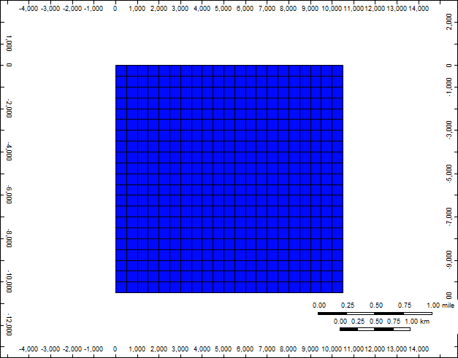

Figure 1: 2D view of the reservoir model

Fig. 2 depicts the 5-spot setup with 4 injectors and 1 producer. Fig. 3 depicts the 7-spot design with six injectors and one producer. Figure 4 depicts the 9-spot design with eight injectors and one producer.

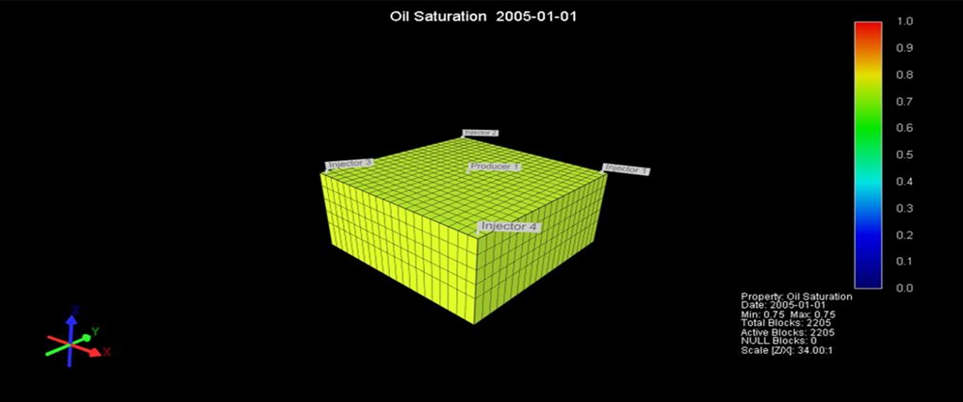
Figure 2: 3D view of normal 5 spot pattern

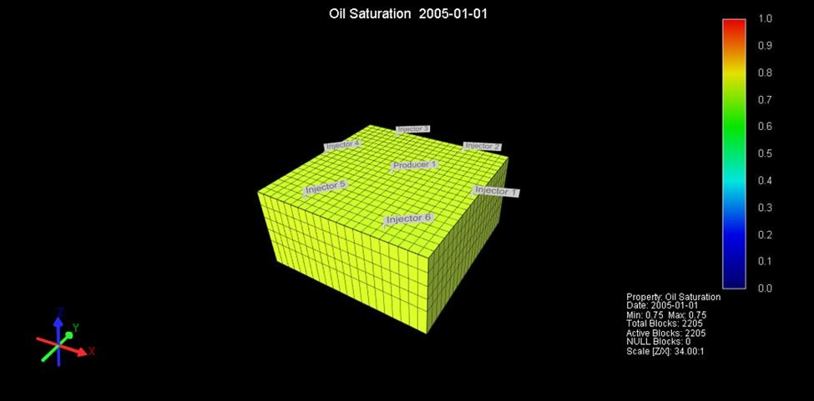
Figure 3: 3D normal view of normal 7 spot pattern

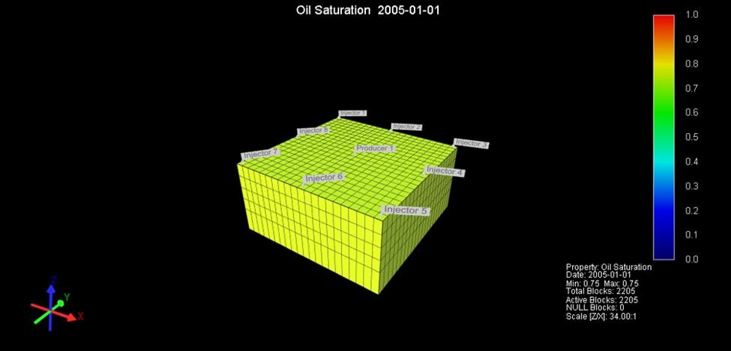
Fig 4: 3D view of normal 9 spot pattern
Figure 4: 3D view of normal 9 spot pattern

IV. EXPERIMENTAL RESULTS

The results of the current study first illustrate the total production for the 5, 7, and 9 spot designs. The effectiveness of the different patterns has also been investigated in response to this water-cut production scenario. According to the results of the current investigation, which were obtained using the 5, 7, and 9 spot patterns, various water cut values were:
Water production in 5 spot patterns = 5.6196 MSTB
Water production in 7 spot patterns = 19436 MSTB
Water production in 9 spot patterns = 18168 MSTB
In all the projected scenarios, oil output is declining while water and gas production are increasing. The results show that compared to the 7-spot and 9-spot patterns, the 5-spot pattern produces less water. This is because 5 spot patterns have fewer injection wells than 7 spot patterns and 9 spot patterns do. Additionally, it can be seen that despite the 9-spot pattern having more water injection wells, the 7-spot pattern has produced more water overall. This is because certain injector wells in the 7-spot design are situated farther away from the producer well. This enables earlier water breakthrough and greater water production by allowing the advancing water front to move more quickly in the producer's direction.
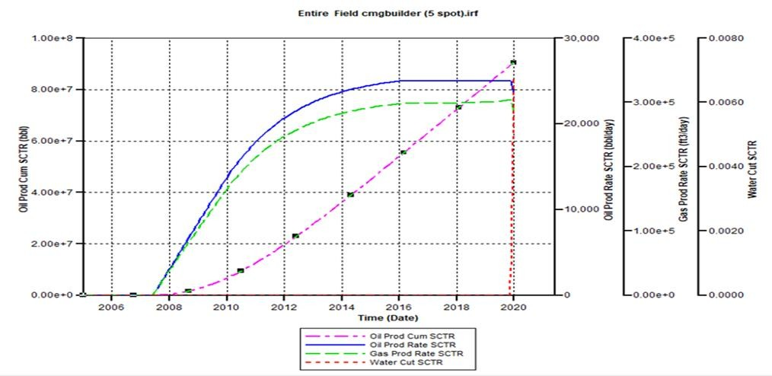

Figure 5: Recovery from 5-spot pattern

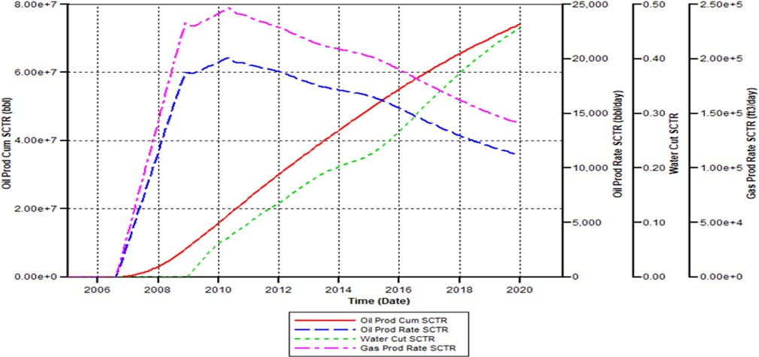
Figure 6: 7-spot pattern

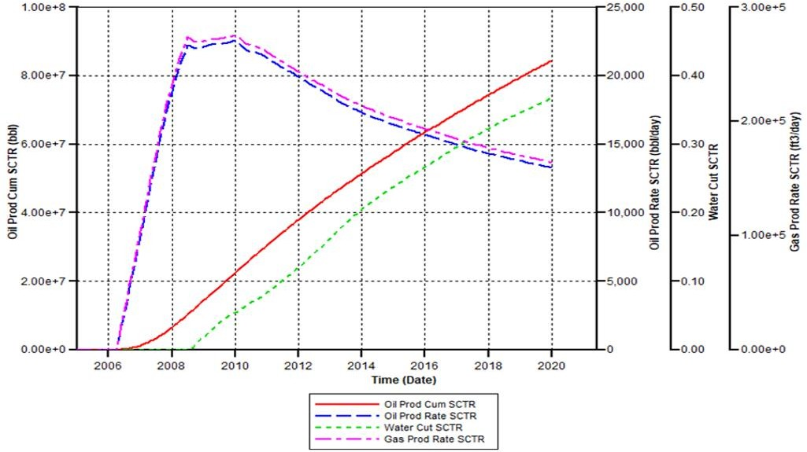
Figure 7: 9-spot pattern

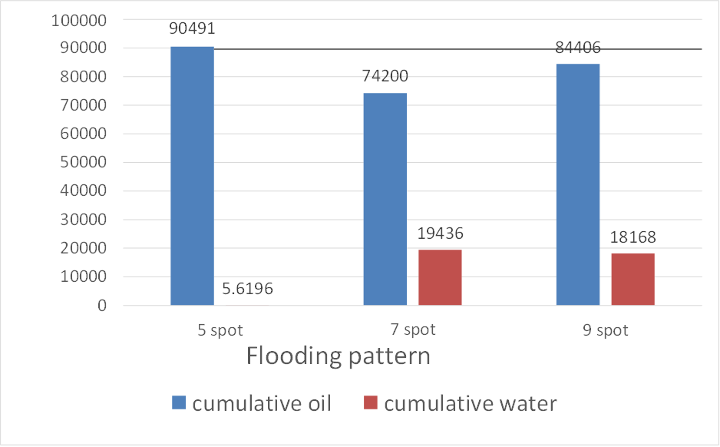

Figure 8: Cumulative production under different flooding pattern

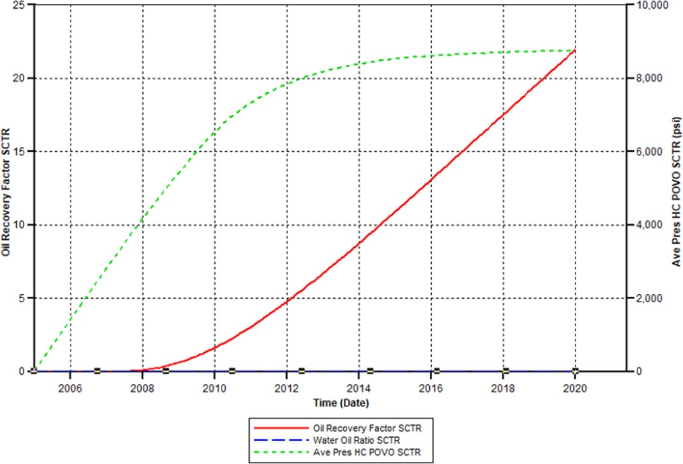

Figure 9: Oil recovery factor under 5-spot pattern

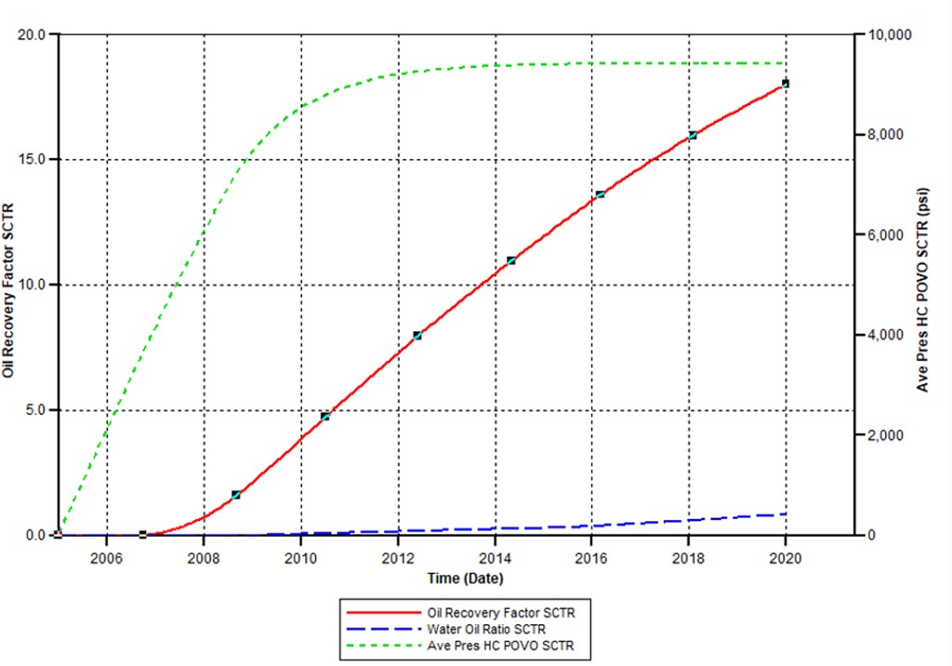
Figure 10: Oil recovery factor under 7-spot pattern

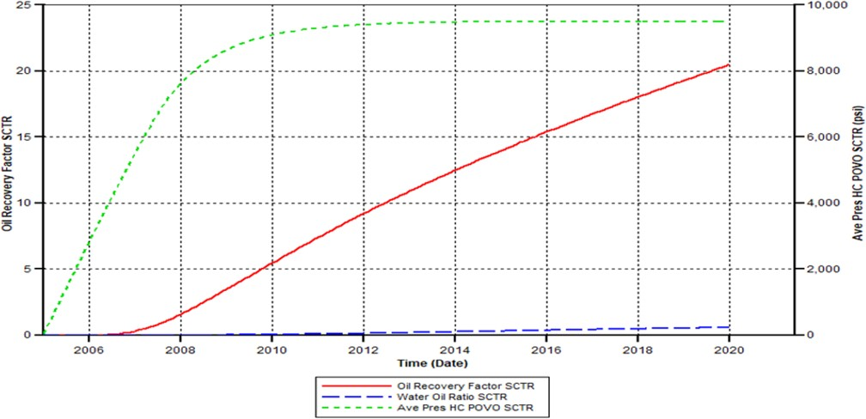
Figure 11: Oil recovery factor under 9-spot pattern

25
21.95
20.47
20
18
15
10
5
0
5 spot
7 spot
9 spot
Flooding Pattern

Figure 11: Comparison of performance of different flooding pattern

According to the aforementioned figures, the 5-spot pattern provides the highest recovery factor (21.95%), compared to the 9-spot pattern (20.47%). The 7-spot pattern, with a recovery factor of 18%, was the least efficient pattern. The traditional 5-spot pattern recovered the most oil because it had just the right amount of injectors to effectively sweep oil from all sides and angles in the reservoir. Although having more injectors should theoretically boost recovery, in this case, having more injectors led to the producers experiencing water breakthrough earlier and experiencing bigger water cuts following breakthrough. The amount of oil produced has decreased as a result.

V. CONCLUSION

The current work investigates how much oil can be produced using a secondary recovery technique called water flooding. To understand productivity, different water flooding patterns were investigated. The numerical simulation investigation was conducted using the CMG-IMEX Computer Modeling Group. Based on three injection patterns, the best recovery factor and cumulative production were obtained from the typical 5-spot injection pattern. The modeling results show that field water cuts significantly rise as soon as water flooding begins and that excessive water output as a result of flooding affects the amount of recoverable oil. When creating the ideal flood pattern, injectors must be positioned in key areas in order to efficiently sweep oil. When more wells are drilled than necessary, recoveries are reduced.

References
[1]. Asadollahi, M. (2012). Waterflooding Optimization for Improved Reservoir Management. Trondheim, Norway: Norwegian
University of Science and Technology (NTNU).
[2]. Sullivan, B. R. (2013). Waterflooding. Austin, Texas: William M. Cobb & Associates, Inc. Dallas, Texas.
[3]. Aziz, K., Settari, A.: Petroleum Reservoir Simulation. Applied Science Publisher Ltd., London (1979)

