The Foundations of Biochemistry

Mrs.Anitha D, Department of Biochemistry,

School of Allied Health Sciences, Vinayka Mission’s Research Foundation – DU,

AVMC & H, Puducherry, India

anithaslims@gmail.com

ABSTRACT

Cell biology is a branch of biology focused on the study of cell structure and function, on how cells form and divide, and how they differentiate and specialize. Cell biology defines both the general properties, common to most cell types, and also dissects the unique features of specialized cells, which allow them to perform different functions.
This section of the Reference Module in Life Sciences includes a variety of articles that span from the molecular components of the cells to the most specialized functions. We treat carbohydrates, proteins lipids and nucleic acids and the molecular aspects underlying their role in both cell structure and functions.

Keywords : Cell biology, prokaryotic, eukaryotic, chromosomes, Metabolism, Anabolic Catabolic, Enzymes, Induced fit model, Lock and Key model, Enzymes substrate binding, chromosomal DNA, Mitochondrial DNA, Ion channels, Clathrin-mediated endocytosis, cytoskeleton
- CELLULAR FOUNDATIONS

- Introduction
You have probably studied the cell many times, either in high school, or in college biology classes. There are many websites available that review both prokaryotic (bacterial and archeal cell types) and eukaryotic cells (protist, fungi, plant, and animal cell types). All cells have some similar structural components, including genetic material in the form of chromosomes; a membrane bound lipid bilayer that separates the inside of the cell from the outside of the cell, and ribosomes that are responsible for protein synthesis. This tutorial is designed specifically from the viewpoint of chemistry. It explores four classes of biomolecules that are also present in all cell types (lipids, proteins, nucleic acids and carbohydrates) and describes in a simplified pictorial manner where they are found, made, and degraded in a typical eukaryotic, animal cell. This cell review focuses on the organelle structures common in eukaryotic cells. Subsequent chapters will concentrate on the structure and function of specific biomolecules.
Let’s think of a cell as a chemical factory which designs, imports, synthesizes, uses, exports and degrades a variety of chemicals (in the case of the cell, these include lipids, proteins, nucleic acids and carbohydrates). It also must determine or sense the amount of raw and finished chemicals it has available and respond to its own and external needs by ramping up or shutting off production. Biochemistry is the branch of science dedicated to the study of these chemical processes within a cell. Understanding these processes can also lend insight into disease states and the pharmacological effects of toxins, drugs, and other medicines within the body. This section will review key structural and functional properties of the cell.
- Metabolism – Synthesis and Degradation
The building and breaking down of life-sustaining chemicals within an organism is known as Metabolism. Overall, the three main purposes of metabolism are: (1) the conversion of food to energy to run cellular processes; (2) the conversion of food/fuel to building blocks for the production of primary metabolites, such as proteins, lipids, nucleic acids, and other secondary metabolites; and (3) the elimination of waste products. These enzyme- catalysed reactions allow organisms to grow and reproduce, maintain their structures, and respond to their environments.
Metabolic reactions may be categorized as catabolic– the breaking down of compounds (for example, the breaking down of proteins into amino acids during digestion); or anabolic – the building up (synthesis) of compounds (such as proteins, carbohydrates, lipids, and nucleic acids). Usually, catabolism releases energy, and anabolism consumes energy.
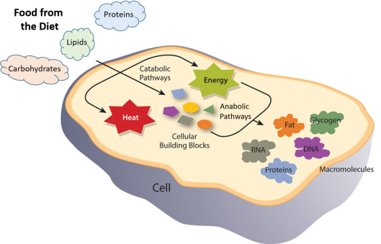
Figure 1 Catabolic and Anabolic Reactions.
Catabolic reactions involve the breakdown of molecules into smaller components, whereas anabolic reactions build larger molecules from smaller molecules. Catabolic reactions usually release energy whereas anabolic processes usually require energy.
The chemical reactions of metabolism are organized into metabolic pathways, in which one chemical is transformed through a series of steps into another chemical, each step often being facilitated by a specific enzyme. Enzymes are crucial to metabolism because enzymes act as catalysts – they allow a reaction to proceed more rapidly. In addition, enzymes can provide a mechanism for cells to regulate the rate of a metabolic reaction in response to changes in the cell’s environment or to signals from other cells, through the activation or inhibition of the enzyme’s activity. Enzymes can also allow organisms to drive desirable reactions that require energy that will not occur by themselves, by coupling them to spontaneous reactions that release energy. Enzyme shape is critical to the function of the enzyme as it determines the specific binding of a reactant. This can occur by a lock and key model where the reactant is the exact shape of the enzyme binding site, or by an induced fit model, where the contact of the reactant with the protein causes the shape of the protein to change in order to bind to the reactant. The catalytic mechanisms, kinetics, and regulatory pathways of enzymes will be studied in detail within this text.
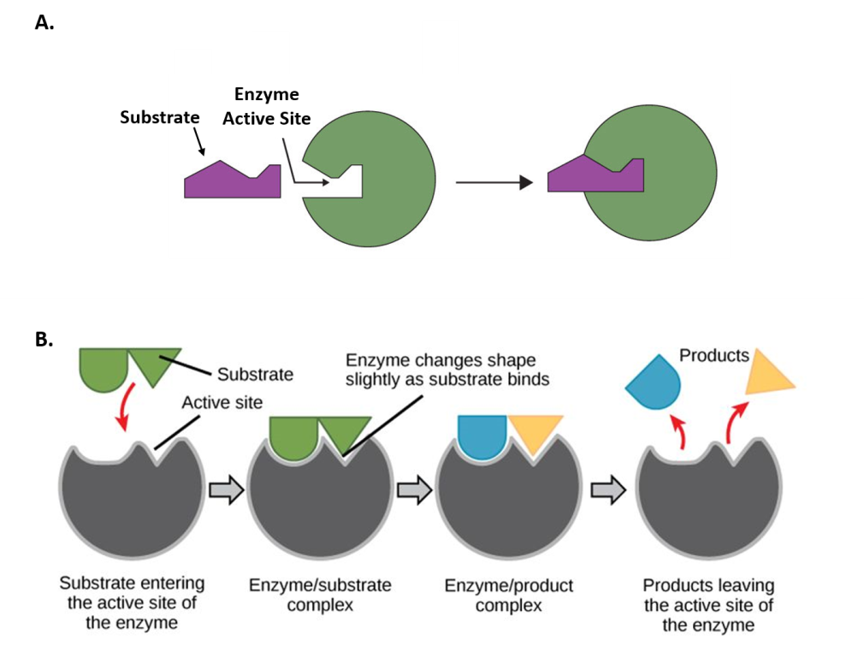
Figure 2 Mechanisms of Enzyme-Substrate Binding. (A) In the Lock and Key Model, substrates fit into the active site of the enzyme with no further modifications to the enzyme shape required. (B) In the Induced Fit Model, substrate interaction with the enzyme causes the shape of the enzyme to change to better fit the substrate and mediate the chemical reaction.
Metabolism is a feature of all cellular life, from the very simplistic prokaryotic cells (Archae and Bacterial cells) to the more complex eukaryotic cells (Fungi, Animal and Plant cells) (Fig. 3). Prokaryotic cells and eukaryotic cells are defined by major differences in size and structural features. Prokaryotic cells are simplistic cells that are approximately 1,000 times smaller than their eukaryotic counterparts. All prokaryotes have a single, circular chromosome located in a nucleoid region of the cell, as well as ribosomes that produce proteins that perform cellular metabolic functions. Prokaryotic cells also contain a plasma membrane and external cell wall structure. Some prokaryotes also have cilia or flagella that aid in locomotion.
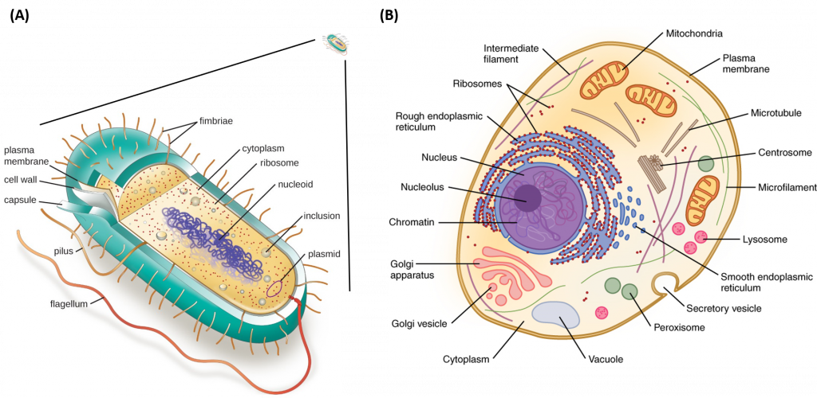
Figure 3 Structures of Prokaryotic and Eukaryotic Cell Types.
Depiction of the relative size of a prokaryotic cell (A) which is approximately 1,000 times smaller than a eukaryotic cell (B). All prokaryotic cells contain a chromosomal DNA that is concentrated in a nucleoid, ribosomes, and a cell membrane-cell wall system. Some prokaryotic cells may also possess flagella, pili, fimbriae, and capsules. Eukaryotic cells are much larger than prokaryotic cells and require the additional compartmentalization of structures into membrane-bound organelles to mediate metabolic functions.
Eukaryotic cells, on the other hand, are much larger and require more compartmentalization to adequately perform metabolic functions. They have a true nucleus surrounded by a complex nuclear membrane that houses multiple, linear chromosomes. Within eukaryotic cells, the metabolic machinery present allows for the construction of membrane-bound organelle structures that help to compartmentalize cellular functions. Therefore, organelles can be thought of as ‘little organs’ within the cell having discrete cellular functions. The figure of the animal cell below (Fig 4) and in the other linked sites based on it was made available with the kind permission of Lillian Torres. Click on the blue hyperlinks for some of the organelles for more detailed information on them.
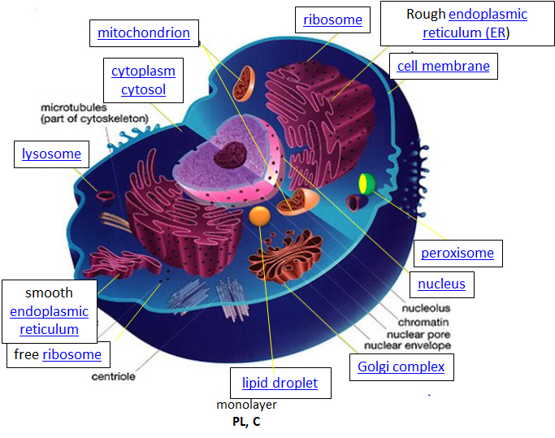
Figure 4 Structure of a Typical Eukaryotic Animal Cell.

- Cellular Design and the Blueprint of Life
The design for a cell mostly resides in the blueprint for the cell, the genetic code, which is comprised of deoxyribonucleic acid (DNA) housed in the cell nucleus and a small amount in the mitochondria (Figure 1.5). Of course, the DNA blueprint must be read out or transcribed into ribonucleic acid (RNA) and then translated to proteins by ribosome structures, which themselves were encoded by the DNA and contain a combination of RNA and protein subunits. The genetic code has the master plan that determines the sequence of all cellular proteins, which then perform almost all other activities in the cell, including enzymatic functions, motility, architectural structure, transport, etc. In contrast to DNA, RNA and protein polymers, the formation of the other two major macromolecules (carbohydrates and lipids) are not driven by such a template but rather by the enzymes that catalyses the synthesis
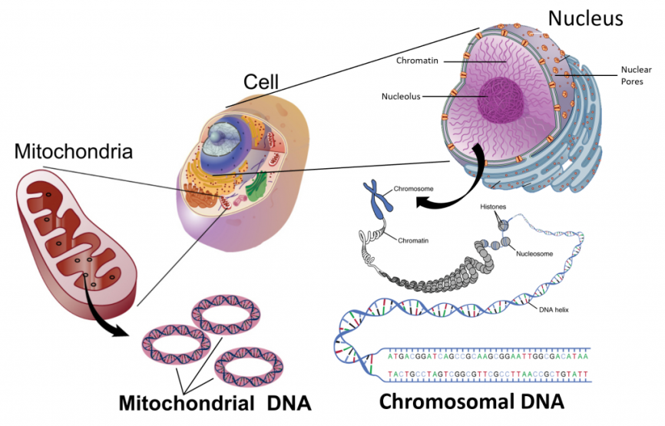
Figure 5 The Blueprint for Life is housed in Deoxyribonucleic Acid (DNA).
Within eukaryotic cell’s DNA is localized to two major places within the cell. The first is the nuclear DNA that forms linear chromosome structures (shown on the right). The second is the circular DNA housed in the mitochondria (shown on the left). The mitochondrial structures replicate independently of the cell and are thought to have originated as prokaryotic symbioses during the early evolution of the eukaryotic cell type.
- Cellular Import and Export of Molecules
Many of the chemical constituents of the cell arise not from direct synthesis but from import of both small and large molecules. The imported molecules must pass through the nonpolar lipid bilayer that forms the cell membrane and in some cases through additional membranes if they need to reside inside membrane-bound organelles. Molecules can move into the cell by two major processes, diffusion or active transport. The process of diffusion moves molecules down their concentration gradient from an area of high concentration to an area of low concentration and does not require an input of energy. Active transport, on the other hand, requires energy to move molecules against their concentration gradient from an area of low concentration to an area of high concentration. Diffusion across the plasma membrane can either be passive or facilitated. In passive diffusion, small, nonpolar molecules (such as CO₂ and O₂) move across the membrane directly across the membrane (Fig 6A). Larger and/or polar molecules move by facilitated diffusion, which requires a channel or carrier protein (Fig 1.6B). Computer simulations of the facilitated diffusion of lactose or water across the membrane are shown at the following links: Animation of lactose diffusion through the LacY protein and Animation of water diffusion through the aquaporin channel, (These animations were created by the Theoretical and Computational Biophysics group at the Beckman Institute, University of Illinois at Urbana-Champaign. These molecular dynamic simulations were made with VMD/NAMD/ Bio Core /JMV/other software support developed by the Group with NIH support.)
Ion channels are specialized channels that allow the flow of ions across membranes. Some are permanently open (nongated) while others open or close depending on the presence of ligands (ligand gated) that bind the protein channel, the physical bending of the protein within the local environment (mechanical gated), or a change in the voltage/charge state (voltage gated) of the local environment of the protein in the membrane. Flow of ions through the channel proceeds in a thermodynamically favoured direction, which depends on their concentration and voltage gradients across the membrane.
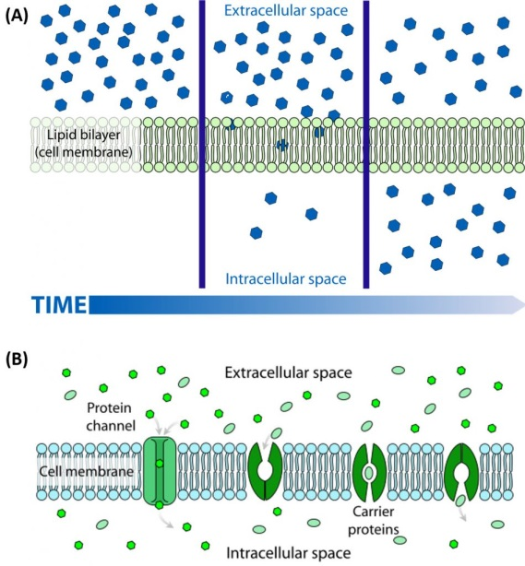
Figure 6 The Process of Cellular Diffusion.
The movement of small, nonpolar molecules across the plasma membrane and down their concentration gradient occurs by passive diffusion (shown in A). Protein channels or carriers are required for the movement of larger and/or polar molecules, such as water, across the plasma membrane (shown in B). Note that diffusion processes will proceed and equalize concentrations of a molecule until a dynamic equilibrium is reached.
Molecules can also move against a concentration gradient in a process called active transport. Active transport requires an input of energy, often in the form of ATP hydrolysis (Fig. 7). When ATP is used as the energy source, this is known as primary active transport. The Na+/K+ ATPase pump is an important example of active transport and works to set up chemical gradients inside and outside of the cell. For the hydrolysis of one ATP molecule, three Na+ are pumped outside of the cell, while two K+ are pumped inside the cell. Proteins that move two molecules in opposite directions are also known as antiporters (Fig 1.7). Other active transport systems can use the energy of a chemical gradient to move other molecules in the same direction. This is known as secondary active transport. An example of a secondary active transporter is the Na+/glucose symporter that uses the energy of Na+ moving down its concentration gradient to move glucose into the cell against its concentration gradient. Note that a symporter is a transporter that moves two molecules in the same direction across the plasma membrane (Fig. 8).
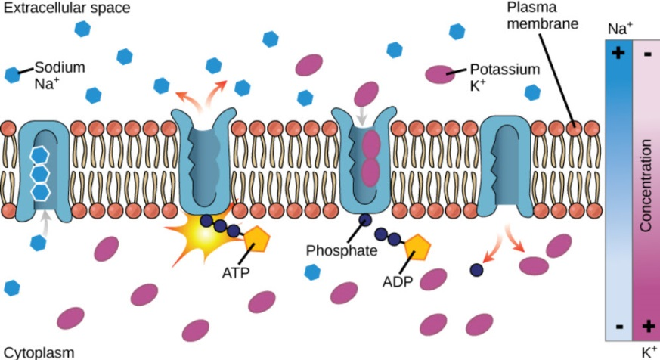
Figure 1.7 The Na+/K+ ATPase Active Transporter.
The Na+/K+ ATPase hydrolyzes ATP to ADP and utilizes the energy released to shuttle three sodium ions outside of the cell and two potassium ions inside of
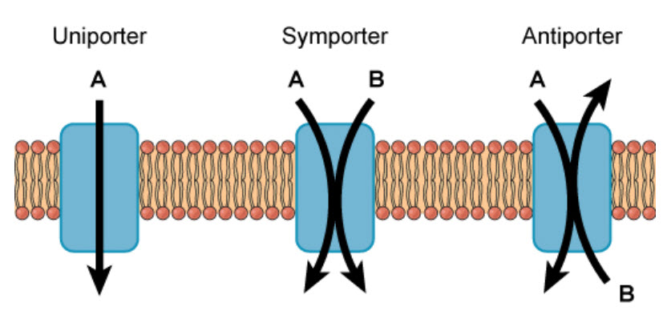
Figure 8 Uniporters, Symporters, and Antiporters.
Channel, carrier and pump proteins can be classified as uniporters if they only move a single molecule across the plasma membrane or as symporters if they move two molecules in the same direction, or as antiporters, if they move two molecules across the membrane in opposite directions.
The pH of the cytosol (the aqueous substance surrounding all the organelles within the cell) is tightly regulated from about 7.0-7.4, depending on the metabolic state of the cell. Some organelles have proton transporters that can significantly alter the pH inside an organelle. For example the pH inside the lysosome, a degradative organelle, is about 4.8. Furthermore, the creation of a pH gradient across the inner mitochondrial membrane is sufficient to drive the thermodynamically unflavoured synthesis of ATP. Gradients of protons and other ions within the cell are mediated by activity of ion channels and ion pumps within the plasma membrane.
Compared to the extracellular fluid, the concentration of potassium ion is higher inside the cell, while concentrations of sodium, chloride and calcium ions are higher on the outside of the cell (see table below). These concentration gradients are maintained by ion transporters and channels and require energy expenditure ultimately in the form of ATP hydrolysis. Changes in these concentrations are integral to the signalling system used by the cell to sense and respond to changes in its external and internal environments, including the firing of an action potential by neurons and muscle contraction within myocytes.
The table below show approximate ion concentrations in the cell.
Table 1.1 Average Cellular and Extracellular Ion Concentrations
Ion | Inside (mM) | Outside (mM)
Na⁺ | 140 | 5
K⁺ | 12 | 140
Cl- | 4 | 15
Ca²⁺ | 1 uM | 2

Some membranes, such as the nuclear and outer mitochondrial membranes, assemble proteins complexes to form large, but regulated pore complexes (Fig 9). Porin proteins are found in mitochondrial membranes while nucleoporins (Nups) are found in the nuclear membrane. Nuclear pores enable the passive and facilitated transport of molecules across the nuclear envelope. Nups form a family of around 30 proteins and are the main components of the nuclear pore complex in eukaryotic cells. Nuclear pores are able to transport molecules across the nuclear envelope at a very high rate. A single pore is able to transport 60,000 protein molecules across the nuclear envelope every minute. Some Nups family members contain repeating sequences of the amino acids phenylalanine (F) and glycine (G) giving rise to FG peptide repeats. These peptide repeats are thought to give specificity and selectivity to the molecules that can pass through the pore complex.
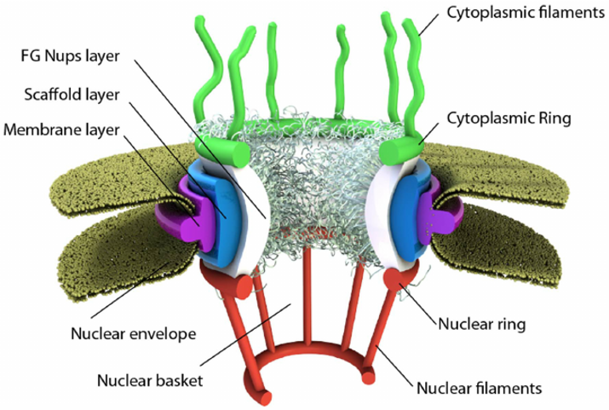
Figure 9 Schematic of the Nuclear Pore Complex.
The pore is anchored to the nuclear envelope by a membrane layer that surrounds the scaffold layer. This scaffold layer provides structure and serves as an anchor for Nups that contain both structured domains as well as highly unstructured domains that are thought to form a barrier that excludes non-interacting molecules while allowing for selective transport of others. This central channel exhibits eight-fold rotational symmetry and has eight cytoplasmic filaments as well as eight nuclear filaments protruding into the cytoplasm and nucleoplasm respectively. The nuclear filaments are bound via a ring, resulting in a basket structure. Pores allow for the selective transport of larger molecules through membrane structures, including molecules such as mRNA.
The transport of molecules can also occur through the processes of exocytosis and endocytosis (Fig 1.10A). Large particles, hormones, and other signalling molecules can be packaged into secretory vesicles within the cells and released into the extracellular matrix through the process of exocytosis. Exocytosis occurs when the secretory vesicle fuses with the plasma membrane causing the contents of the vesicle to be exposed to the outside of the cell. New proteins can also be introduced into the plasma membrane during this fusion process. In the reverse process, called endocytosis, very large particles [for example, Low Density Lipoproteins (LDL) and viruses] can be engulfed into the cell. In this process, the plasma membrane invaginates around the materials to be imported into the cell. This invagination eventually pinches off to form an endosomal vesicle. Endocytosis can occur via three major processes: phagocytosis, pinocytosis, and receptor-mediated endocytosis (Fig 10B).
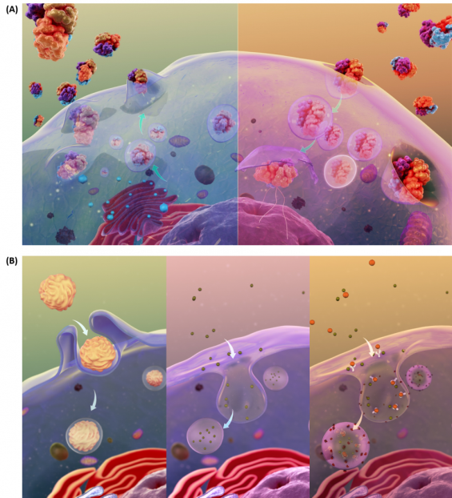
Figure 10 Schematic Representations of Exocytosis and Endocytosis.
In the upper panel (A), exocytosis, depicted on the left hand side, involves the fusing of secretory vesicles with the plasma membrane to release contents and imbed proteins into the plasma membrane. The reverse process, shown in the upper right hand panel (A), involves the formation of endosomal vesicles as particles from the extracellular matrix are engulfed into the cell. The processes of endocytosis can be further subdivided into three types as shown in (B). The left hand panel depicts phagocytosis, or the process by which large particles (≥ 0.5μm) are engulfed by the cell. Pinocytosis, depicted in the lower middle diagram, is known as fluid endocytosis and is the process which small particles suspended in extracellular fluid are brought into the cell. Receptor-mediated endocytosis, also called clathrin-mediated endocytosis, is depicted in the right hand, lower panel and is a process by which cells absorbs metabolites, hormones, proteins – and in some cases viruses – by a receptor-mediated process. This form of endocytosis is strictly mediated by receptors on the surface of the cell.
- Cellular Structure and Support
The “cytoskeletal” architecture of a (with molecular “cables”- and “girder-like” structures) is not dissimilar from a factory (Figure 11).
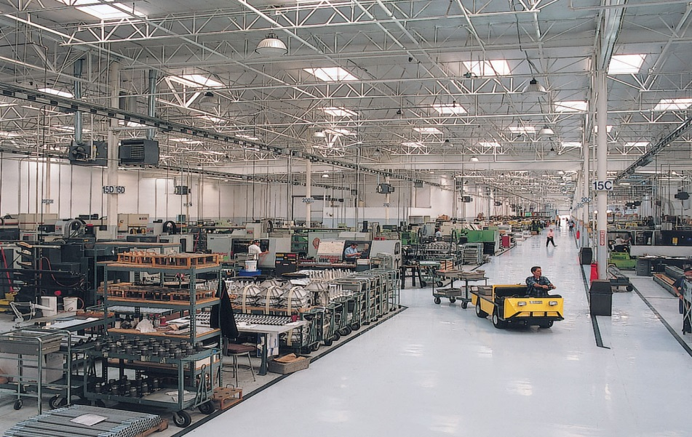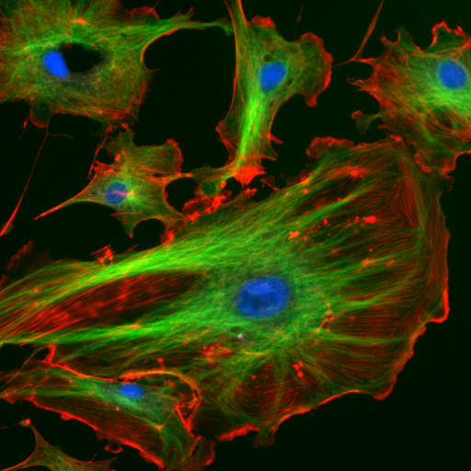
Figure 11 Cellular Architecture
The internal framework of a cell or cytoskeleton is composed of microfilaments, intermediate filaments, and microtubules. These are comprised of monomeric proteins which self-assemble to form the internal architecture. Parts of the cytoskeleton can be seen in Figure 11.
Microfilaments of actin monomers (which are stained with a red/orange fluorophore) and microtubules which offer more structural support made of tubulin monomers (stained green) along with the blue-stained nucleus are shown in the image. Organelles are supported and organized by the cytoskeleton (primarily microtubules). Even the cell membrane is supported underneath the inner leaflet by actin (stained orange) and spectrin microfilaments. Motor proteins like myosin (that moves along actin microfilaments) and dynein and kinesin (that move along tubulin microtubules) carry cargo (vesicles, organelles) in a directional fashion. The cell is not a disorganized collection of molecules and organelles. Rather is a highly organized for optimal chemical production, use and degradation.
Cells have a variety of shapes. Some circulating immune cells must slip through the cells that line capillary walls to migrate to sites of infection. The same process occurs when tumor cells metastasize and escape to other sites in the body. In order to do so, the cell must drastically change shape, a response that requires dissociation of the cytoskeleton polymers into monomers which are available later for repolymerization. The following video shows the mobility and flexibility of a Killer T-Cell as it attacks and kills a cancerous cell.
- The Cell is an Amazingly Crowded Place
In chemistry labs, we typically work with dilute solutions of solute molecules in a solvent. You have probably heard that the body is comprised of 68% water, but the water concentration is obviously dependent on the cellular environment. Solute molecules like protein and carbohydrates are densely packed. Cells are so crowded that the space between larger molecules like protein is typically smaller than that of a single protein. Studies have shown that the stability of a protein is increased in such conditions, which would help keep the protein in the correctly folded, native state. Another consequence of high intracellular concentrations is that it limits the diffusion of molecules throughout the cell, as would be expected from an equilibrium perspective in dilute solutions. Thus, cytoplasmic cellular functions can be highly localized within specific regions of the cell creating unique microenvironments and higher differentiation potential within a single cell, as depicted in Figure 1.12.
Hence the study of biomolecules in dilute solutions in the lab may not reveal the actual complexities of interactions and activities of the same molecule in vivo. Recently investigators have added a neutral copolymer of sucrose and epichlorhydrine to cells in vitro. These particles induced organization of extracellular molecules secreted by cell, forming an organized extracellular “matrix” which induced the organization of the microfilaments on the inside of the cell as well as inducing changes in cell activity. Furthermore, in vitro enzyme activity of a key enzyme in glycolysis dramatically increases under crowded conditions, indicating that metabolic processes are also dependent on spatial arrangement of the cell. Another result of crowding may be the spatial and temporal association of key enzymes involved in specific metabolic pathways, allowing for the coordinated passage of substrates and products within the localized enzyme system.
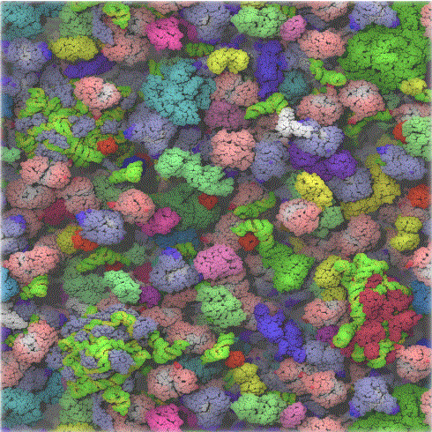
Figure 12: The Crowded Cytoplasm of E. Coli. The computer simulation used 50 different types of the most abundant macromolecules of the E. coli cytoplasm and 1008 individual molecules. Rendering of the cytoplasm model at the end of a dynamics simulation. RNA is shown as green and yellow. This figure was prepared with VMD.
- Cell Components Undergo Phase Transitions to Form Substructures within the Cell.
A perplexing question is how substructures form within a cell. This includes not only the biogenesis of organelles like mitochondria but also smaller particle such as polysaccharides granules, lipid droplets, protein/RNA particles (including the ribosome) as well as the nucleolus of the cell nucleus. It might be easiest to consider this problem using two examples from the lipid world, lipid droplets and membrane rafts. You are very familiar with phase transitions that occur when a sparing soluble nonpolar liquid is added to water. At a high enough concentration, the solubility of the nonpolar liquid is exceeded and a phase transition occurs as evidenced by the appearance of two separate liquid phases. The same process occurs when triglycerides coalesce into lipid droplets with proteins associated on their outside. Another example occurs within a cell membrane when lipids with saturated alkyl chains self-associate with membrane cholesterol (which contains a rigid planar ring system) to form a membrane micro domain called a lipid raft (Figure 13). Lipid rafts are characterized by greater packing efficiency, rigidity and thickness those other parts of the membrane. These lipid rafts often recruit proteins involved in signalling processes within the cell membranes. This process of phase separation is also called liquid/liquid demising as two “liquid-like” substances separate.
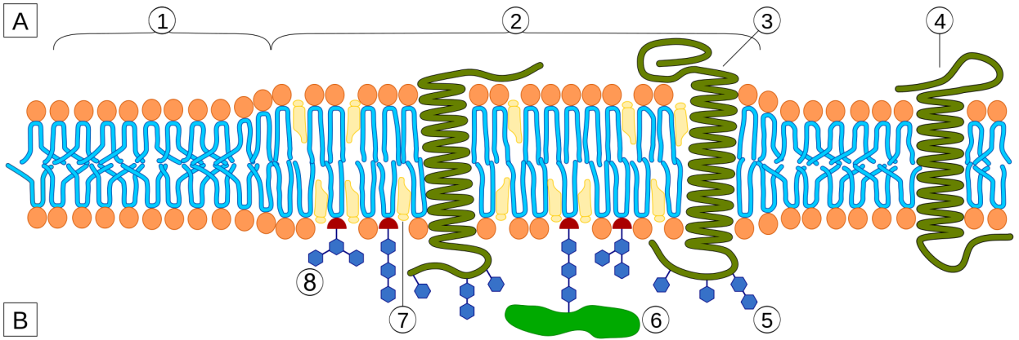
Figure 13 Architecture of a Lipid Raft. Microenvironments, such as lipid rafts, can form within the lipid bilayer of the plasma membrane (A) Depicts the intracellular side of the plasma membrane with section 2 highlighting the lipid raft structural domain. The extracellular side of the membrane (B) contains an abundance of lipids that are modified with sugar functional groups, demonstrating that lipids in the outer leaflet of the plasma membrane can be dramatically different from the population that reside on the inner leaflet. The prevalence and structure of lipid rafts has recently been associated with a number of diseases states including cancer and may contribute to disease progression.

In a similar manner, it appears that proteins that interact with RNA are composed of less diverse amino acid sequences and have more flexible (“more liquid-like) structures allowing their preferential interaction with RNA to form large RNA-protein particles (like the ribosome and other RNA processing structures) in a fashion that mimics liquid/liquid demising. All of these interactions are just manifestations of the various intermolecular forces that can exist between molecules. These include ionic interactions, ion-dipole interactions, dipole-dipole interactions, and London dispersion forces
REFERENCES
- Jakubowski, H. (2017) Biochemistry Online: An Approach Based on Chemical Logic. Retrieved from: http://employees.csbsju.edu/hjakubowski/classes/ch331/bcintro/default.html
- Ahern, K. and Rajagopal, I. () Cells, Water, and Buffers. Chapter in the Online Textbook: Biochemistry Free and Easy, Published on Libretexts through Oregon State University. Retrieved on July 8th, 2019 from: https://bio.libretexts.org/Bookshelves/Biochemistry/Book%3A_Biochemistry_Free_and_Easy_(Ahern_and_Rajagopal)
- Wikipedia contributors. (2020, April 15). Nucleoporin. In Wikipedia, The Free Encyclopedia. Retrieved 16:42, April 19, 2020, from https://en.wikipedia.org/w/index.php?title=Nucleoporin&oldid=951100189
- Wikibooks. (2015) Organic Chemistry. Available at: https://en.wikibooks.org/wiki/Organic_Chemistry.
- Clark, J. (2014) How to Draw Organic Molecules. Available at: http://chem.libretexts.org/Core/Organic_Chemistry/Fundamentals/How_to_Draw_Organic_Molecules

