SIGNIFICANCE OF FISH DISEASES IN RELATION TO AQUACULTURE
Group-5: Priyanka, Shradhanjali, Akankshya & Ankit
Corresponding author mail:pattanaikankit29@gmail.com
INTRODUCTION
Aquaculture has developed into a science and an industry following the declining trend of capture fisheries sector in the last two decades. In order to increase profitability, the culture practices has turned from semi-intensive to intensive systems, leading to indiscriminate increasing of stocking density resulting in increased stress to the animals and consequent incidence of diseases. Disease has now become a primary constraint to aquaculture growth and addressing health questions has therefore become an urgent requirement for sustaining the growth of aquatic animal food production.
Host, Pathogen and Environment Interaction in the Disease Development in Fish and Shellfish and Role of Stress in Disease Development .As could be seen from the classical description of Snieszko in 1970, the incidence of disease is due to the breakdown of the delicate balance between host, pathogen and environment. The host in many cases could resist invasion of most of the pathogens if it is healthy and free from stress. In many of the aquaculture systems however, such a situation rarely exist, as there are a multitude of variables that need to be kept under check for a balanced and optimum requirement of the cultured species. The aquatic environment by itself is highly dynamic and the body functions of fishes which are poikilothermic are controlled by temperature and other water quality parameters. Fish has to continuously adjust to the changing environmental parameters, else it leads to low productivity, reduced weight gain, reduced feed conversion, decreased immunity, reduced natural disease resistance,
A. Bacterial Diseases of Finfish
1. Disease Caused by Gram Negative Bacterial Pathogens
a.1. Infection Caused Due to Bacteria of Aeromonadaceae
There are different species of bacteria belonging to the genus Aeromonas capable of causing disease in fish. The important species are Aeromonas salmonicid - aetiological agent of furunculosis in salmonids and A. hydrophila which main affect tropical fishes. Optimum growth temperature is 22-28°C and some do not grow a 35°C. They occur widely in freshwater and sewage.
a.2. Aeromonas salmonicida
Aeromonas salmonicida is the causative agent of furunculosis in salmonie and related diseases in other species. On commonly used culture media, it often produces a diffusible brown pigment which helps in its identification. A. salmonicie is non-motile and an obligate pathogen of fish with limited survival outside the horizon.
a.3. Furunculosis of Salmonids
Typical furunculosis in salmonids may occur in one of several forms:
Peracute Form in Fingerlings: These fish usually have a dark discoloration and die rapidly without any other premonitory signs. The gross lesions may resemble those observed in the acute form of the disease. Premonitory signs of anorexia occur 2-3 days prior to death. Gross lesions
Acute Form:Include hemorrhage of the liver and splenomegaly.
a.4. Cutaneous Ulcerative Disease of Goldfish
This disease, although it is most common in goldfish, also affects other non- salmonid fishes. It is caused by Aeromonas salmonicida, and the disease is also referred to as "furunculosis". The skin lesions range from whitish discolorations to shallow hemorrhagic ulcers to deep lesions which may expose underlying muscle or bone.
a.5. Motile Aeromonas Septicemia (MAS)
This is the third manifestation of disease caused by Aeromonas sp. This is probably the most common bacterial disease of freshwater fish. This disease has been associated with several members of the genus Aeromonas, including A. hydrophila, A. sobria, A. caviae, A. schuberti, and A.veronii.
P fluorescens can be isolated from the kidney lesions of the affected fish Probably all species of fish are vulnerable to pseudomonas septicemia under adverse environmental condition or when compromised by other factors
b. Diseases Caused by Enterobacteriaceae
b.1 Edwardsiellosis
This disease is also known as emphysematous putrefactive disease (PD) and is caused by Edwardsiella tardo. It is a gram-negative motile rod. Normally this disease occurs in the summer months with an optimum temperature of 30°C. The source of E tarda is presumably intestinal contents of carrier animals
Clinically, lesions are initially observed as 3 to 5 mm red cutaneous fock on the flanks and caudal peduncle. They are caused from fistulas originating deep in the skeletal muscle. There is petechiation and malodorous liquefactive necrosis of the viscera with fibrinous peritonitis. Catfish affected with this disease will continue to eat even if they are severely affected.
The only control is through the use of antibiotics incorporated into the feed. Oxytetracycline and a potentiated sulfonamide are the only drugs currently in use.
b.2 Yersiniosis or Enteric Redmouth (ERM)
Yersinia ruckeril is the causative agent of enteric redmouth disease. The effectiveness of chemotherapy in the treatment of fish diseases largely reflects the method of administration. The various methods advocated are the oral method by means of medicated food, bath and dip procedures and injection.
b.3 Enteric Septicemia of Catfish (ESC)
This is probably the most important bacterial disease of catfish, Ictalurids such as brown bullhead, blue and white catfish. This is a markedly seasonal disease, with outbreaks occurring when water temperatures are in the range of 24-28°C.
b.4.a. V. anguillarum
When the temperature is high with high salinities a condition called red pest out breaks occurs in eels similar to acute vibriosis. Vibriosis occurs in warm weather, when the stocking densities are high and salinities and organic loads are also high. In young fish, mortalities can be 50 per cent or higher. In older fish, infected fish do not feed and normal appearing fish will have necrotic lesions in muscle mass
Brown or Black Spot Disease
It is also called as shell disease, rust disease, burned spot disease, necrosis, etc. Infestation is caused by bacteria belonging to Vibrio, Aeromonas and Pseudomonas Appearance of brownish to black erosion of the carapace, abdominal segments rostrum, tail, gills and appendages. In larval and post larval stages, the affected part shows a cigarette-butt like appearance. The infection is usually initiated at sites of punctures or injuries made from telson or rostrum, cracks on the abdominal segment from sudden flexture of the shrimp body, or from other damage caused by cannibalism. Progressive erosion of these exoskeletal lesions follows upon entry and multiplication of bacterial pathogens.
B. Bacterial Diseases of Shellfish
Commonly reported shrimp pathogenic bacteria are the members of the genus Vibrio. Other bacterial groups include Aeromonas sp., Pseudomonas sp. Flavobacterium and gram positive bacteria like Mycobacterium. Rickettsial and chlamydial diseases have also been reported from shrimps.
Vibriosis
Infections and disease caused by Vibrio spp. have been by far the most numerous of the reported bacterial agents of penaeld shrimp. Vibrio spp. were found to constitute the majority of cultivable bacteria associated with the gut, gills or cuticle of wild or cultured penaeld shrimp. Vibrio spp. are opportunistic pathogens which establish lethal infection as a result of other primary conditions that might include other infectious diseases, extreme environmental stress, wounds etc.
Viral Diseases
- Epizootic Haematopoietic Necrosis (EHN): It is caused by a double-stranded DNA, non-enveloped iridovirus, as causative agents of EHN. Moribund fish have loss of equilibrium, flared opercula and may be dark in colour. Fish may have enlargement of kidney, liver or spleen. There may be focal white to yellow lesions in liver corresponding to areas of necrosis. Acute focal, multifocal or locally extensive coagulative or liquefactive necrosis of liver, haematopoietic kidney and spleen are common.
- Lymphocystis Disease:Lymphocystis disease is caused by iridoviruses in a broad range of fish species. The disease is characterised by the development of macroscopically visible pearl- like or wart-like nodules primarily on body surface but also on internal organs. The infection is chronic, rarely fatal and in most cases is self limiting. However, the infection reduces consumer acceptance of the fish. The disease is diagnosed by the appearance of the nodules but can sometimes be confused with other infections such as "white spot" caused by Ichthyophthirius multifilis.
Diseases Caused by RNA Viruses in Fish
- Infectious Pancreatic Necrosis (IPN)
The disease is caused by a highly contagious virus, infectious pancreatic necrosis virus (IPNV) belonging to the Birnaviridae. It affects both warmwater and coldwater fishes of freshwater and marine environment. IPNV enjoys a wide geographical distribution, reported from America, Europe and Asia. IPN characterized by sudden mortality with a progressive increase in severity. Cumulative mortalities may vary from less than 10 per cent to more than 90 per cent. The virus is also isolated from ornamental fishes in which it causes severe mortality. Affected fish die very quickly.
Viral Disease of Finfish
- DNA Viral Diseases
Koi Carp Herpes virus (KHV): Causes mass mortality in common carp and koi in many countries throughout the world. They may also show hyperactivity loss of equilibrium and disorientation. Morphologically, pale discoloration or reddening of the with rough texture, focal or total loss of epidermis, over- or under-production mucus on the skin and gills, exophthalmia (sunken eyes) and hemorrhages o skin and base of the fins and fin erosion are associated with this infection.
Iridovirus: They have been associated with severe disease and economic loss in fim food fish and ornamental fish, with mortality often reported to reach 50 per or more. Iridoviruses are reported from a number of ornamental fishes such dwarf gourami Colisa lalia, orange chromide cichlid Etroplus maculatus, A lampeye Aplocheilichthys normani and other marine fishes.
Viral Nervous Necrosis (VNN): This disease has been reported in at least 30 fish species, including freshwater and ornamental fishes. The disease has typical characteristics of neurological abnormalities with clinical symptoms like abnormal swimming and whirling.
STRATEGIES FOR HEALTH MANAGEMENT
While the diseases are difficult to be completely removed from aquaculture, it is possible to control them and prevent them from frequent incidences. As the disease in aquaculture is a result of interaction between host, pathogen and environment, controlling all the three factors become important. Keeping the water quality is the most important step in the drive against diseases. Controlling the entry of obligate pathogen to the culture systems and reducing buildup of opportunistic pathogens are also equally important. Protecting the immune status of the host is also important which could increase their resistance of the fish or shrimp to infectious diseases. Apart from proper nutrition, several prophylactic measures are required in achieving disease free aquaculture.
Following methods are suggested by various workers towards controlling the diseases in shrimp farming especially the viral diseases:
- Early and effective detection of pathogens using improved diagnostic methodologies to screen and quarantine infected population to prevent the spread of the pathogens.
- Use of bio secured, closed or semi- closed recycle system with reduced water exchange and increased water-reuse culture systems.
- Maintain good water quality and treat water before use especially for hatcheries. Disinfection with 30 ppm calcium hypochlorite (containing 65 per cent active chlorine) for 12 hours followed by neutralization with soda (Na, S,0,@30 g/m³) and vigorous aeration could be used to treat the incoming water.
- Construct reservoirs for storing water without directly taking from the sea and treat reservoir water (chlorine at the rate of 30 ppm calcium hypochlorite-60 per cent active ingredient) before use in the ponds.
- Bio-security approach for preventing pathogen introduction by screening entry of infected hosts i.e. wild shrimps and non-host biological carriers like crabs, fish or birds in to the ponds and by avoiding the use of inanimate objects contaminated with pathogens. Stray dogs should be kept away from the vicinity of the ponds, as they can also cause spread of virus.
- In case of a disease outbreak, disinfect contaminated water before discharge. Regular treatment of hatchery effluents also should be practiced to prevent contamination of surrounding waters.
- Maintain good pond preparation by drying pond bottom and removing top layer of the sediment. Application of 100 ppm Cao (burnt lime). exposure of pond bottom to sunlight for complete drying and ploughing of the soil are good measures of pond preparation after each harvest.
- Avoid over stocking, optimum stocking density will reduce the stress on the animals and reduce the chances of water quality deterioration
- Production of specific pathogen free (SPF) shrimps and the development of specific pathogen resistant (SPR) strains are two potential approaches. which are of immense use in the broodstock management programmes. SPF animals are produced by selecting animals free of known and detectable pathogens and raising them under controlled and strict sanitary conditions.
- Feed nutritionally balanced diet at the required quantity avoiding excess feed.
- Use of immunostimulants and vaccines to harness the specific and non- specific defence mechanisms of shrimps. This technique has considerable potential for health management in shrimp aquaculture, Biotechnological innovations are being developed in the field of immunostimulants and modulators in an effort to reduce shrimp susceptibility to disease.
PRESENT STATUS OF FISH DISEASE MANAGEMENT IN FRESHWATER AQUACULTURE IN INDIA: STATE-OF-THE-ART-REVIEW:
DISEASE PROBLEMS IN INDIAN AQUACULTURE:
Disease is one of the major constrains to aquaculture and limiting factor for economic and socio-economic development in India and as in many other countries of the world . Some diseases have caused serious damage, not only the livelihood of fish farmers, but also, to the future development of the industry. Many diseases affecting present day aquaculture is resultant of intensification of culture practices without the basic perception of intricate balance between host, pathogen and environment . In India, the increase in aquaculture production particularly in expansion into intensive and semi-intensive methods of production has been coupled by increase in fish and shellfish resulting from high stocking densities and stress conditions that favours the occurrence and spread of infectious diseases . A total loss of one billion US $ was reported due to diseases in shrimp culture. The vertical expansion of fish culture with diversified species and higher stocking density has resulted more frequent occurrence of bacterial, parasitic and viral pathogens, often leading to higher morbidity or mass mortalities and lowered production.
COMMON DISEASES REPORTED IN FRESHWATER AQUACULTURE
India is basically a carp country and indigenous Indian Major Caps (IMC) which include rohu (Labeo rohita), Catla (Catla catla), mrigal (Cirrhinus mrigal), exotic carps like common carp (Cyprinus carpio), grass carp (Ctenopharyngodon idella) silver carp (Hypophthalmicthys molitrix) along with catfishes (Clarius batrachus, Heteropneuestes fossilis, Pangassius spp.) and freshwater prawn Macrobrachium rosenbergii also being widely cultured account for bulk of aquaculture production. In last few years, the exotic catfish Pangasiandon hypophthalamus, and pacu, Piaractus brachypomus, culture are also increasing. Also Tilapia and Pangasius offer opportunities, for cage culture freshwater lakes and reservoirs. Instead of 10 ton per ha, in pond culture system, now a fish production of 3.0 ton in a cage of 6ft × 4ft × 4ft can be achieved. The focus has been on the production of genetically improved tilapia for market of cheap source of proteins.
Bacterial diseases
Bacterial fish diseases are very common and are one of the most difficult health problems to deal with. These bacteria are generally saprophytic in nature and only become pathogenic when fishes are physiologically unbalanced, nutritionally deficient, or there are other stressors, i.e., poor water quality, overstocking, which allow opportunistic bacterial infections to proceed . Bacterial diseases have been frequently encountered in eggs, fry, fingerlings of fish, causing heavy mortality. Occurrence of bacterial diseases was not considered to be a serious problem in our country, as economic losses in fish culture was not known. The incidences of Ulcerative disease (EUS) in various Southeast Asian countries as well as in India, focused tremendous attention on the threat the disease epidemics hold for the farmers. Economic losses of the order of US $ 10 million in Thailand and over 3 $ million in Bangladesh were lessons enough to realize their importance.
Parasitic diseases of fish
The production from culture system is hampered by the infestation of various fish parasites. Compared to other diseases, occurrence of parasitic disease has been the major cause of concern and caused significant setback to freshwater aquaculture in India . Fish parasites multiply rapidly under favourable conditions, there by affecting the health of fishes, often leading to high mortality. Parasites interfere with nutrition of hosts, disrupts metabolism and secretary functions of alimentary canal and damage nervous system.
Fungal diseases of fish
Contrary to bacterial and parasitic diseases, only a few number of fungal species are known to be pathogenic to fish. Mostly these are present in water and under unfavourable conditions, they attack the fish causing skin lesions. Most fungal infections recorded in carp culture are those caused by species belonging to the oomycete fungi, Saprolegnia, Achlya and Aphanomyces. Diseases caused by these fungi are collectively called “saprolegniasis”. These oomycete fungi, are commonly present in aquatic environments, are rarely considered to be primary pathogens. These are often recognized as saprophytic, opportunistic secondary pathogens that readily colonize the damaged tissues infected by bacteria or parasites.
Viral diseases for fish
There are more than 125 different viruses have been identified in fish around the globe and new viruses are being discovered every new date. However, there are only few reports of viral diseases affecting finfish in India. Viral diseases like Cyprinid Herpesvius-2 (CyHV-2), Koi Rana Virus (KIRV), Carp Edema Virus (CEV), Megalocytiviris and Goldfish haematopoietic virus necrosis herpes have been reported in ornamental fish culture [28]. KIRV causing huge mortality of koi Cyprinus carpio was reported in ornamental fishery. In addition, koi sleepy disease caused by CEV was reported in Cyprinus carpio [39]. Report of Viral Encephalopathy and Retinopathy (VER) or Betanoda virus was also reported for a period in seabass farming, although there were no subsequent reports of such disease occurrence in India. There are some reports of occurrence of Tilapia Lake Virus (TILV) in some pockets of tilapia culture in cages and tanks. However, Indian Native Species of Carps (IMC), which is the predominant species is not affected by any of above describes viruses, which is a good sign for Indian aquaculture sector.
PRINCIPLES OF DISEASE DIAGNOSIS AND CONTROL PROGRAMME
The impacts of emerging diseases of aquatic animals have been substantial, adversely affecting livelihood security of millions and have impacted regional or national economies . The most devastating production loss with socioeconomic impacts was that observed in in shrimp aquaculture in India during 1995-1998, which almost led to collapse of shrimp aquaculture industry in India . Development and application of suitable diagnostic and control measures to combat disease occurrence in fish and shellfish culture to control production loss, thus have assumed significance in many aquaculture-producing countries. The most important approach to disease control programme is managing the culture unit to reduce disease predisposing conditions. This is best achieved through the use of realistic stocking densities, preventing the introduction of pathogens into culture systems or hatcheries, maintenance of good water quality parameters, avoiding stress and through the provision of adequate nutrition to cultured animals. Until few years from now, diseases in aquatic organisms were not considered to be a serious problem in our country, as economic losses in fish culture were not known. Recent incidences of various emerging diseases have focused attention in this aspects.
FUTURE SCOPE OF DEVELOPMENT OF AQUACULTURE IN INDIA
Data indicate currently, only an estimated 40% of the available resources in India are in use for aquaculture because of technical and market access issues and there is lot of scope of development of aquaculture. Realizing the immense scope for development of fisheries and aquaculture, the Government of India has restructured the Central Plan Scheme under an umbrella of “Blue Revolution”. The restructured Central Sector Scheme on Blue Revolution called Integrated Development and Management of Fisheries (CSS) approved by the Government provides for a focused development and management of the fisheries sector to increase both fish production and fish productivity from aquaculture and fisheries resources of the inland and marine fisheries sector including deep sea fishing.
OCCURANCE OF DISEASES IN FISH USED FOR EXPERIMENTAL RESEARCH
Several pathogenic microorganisms are responsible for clinical diseases in laboratory animal species and can influence research by confounding experimental results. For this reason, the health surveillance of animals used for research is necessary to maintain an optimal state of health in laboratory animals. It is well known that many infectious agents harm the welfare status or reduce the breeding performance of animals such as rabbit and rodents, which are commonly used in laboratory experiments. There is growing interest in the use of fish as experimental animals for biomedical research, both for human research and for aquaculture purposes. However, little is known about the pathogens of fish compared to mice, rats and rabbits; information regarding pathological surveys or the health status of fish used in experimental trials is scarce. Despite the increasing use of fish in research, the relative dearth of information about fish health reflects inadequate attention to health management of laboratory fishes, including a lack of suitable pathogen control in research institutions.
Species | Used fish | Diseased fish | Pathologies | Effects on research
Danio rerio | 1465 | 24 | Congenital abnormalities | Exclusion
 |  | 8 | Mycobacterium | Severe
 |  | 1 | Schwannoma | None
 |  | 4 | Cartilaginous cysts in the gills | Low
Mugil cephalus | 340 | 4 | Heterophidosis | Low
 |  | 60 | Mycobacteriosis | Severe
Sparus aurata | 323 | 32 | Lymphocystis disease | Medium/severe
 |  | 25 | Cryptocaryon irritans | Mortality
 |  | 23 | Enteromyxum leei | Low
 |  | 1 | Winter Disease | Mortality
 |  | 70 | Ceratomyxa sp. | Low
Dicentrarchus labrax | 296 | 8 | Vibriosis | Severe
 |  | 25 | Pasteurellosis | Severe
 |  | 2 | Amyloodinium ocellatum | Medium
 |  | 58 | Sphaerosporosis | Low
Argyrosomus regius | 80 | 40 | Non-infectious systemic granuloma | None
 |  | 6 | Cryptocarioniasis | Mortality
Dentex dentex | 80 | 0 | None
Cyprinus carpio | 60 | 0 | None
Boops boops | 20 | 0 | None
Tinca tinca | 20 | 0 | None
Anguilla anguilla | 20 | 0 | None
Carassius auratus | 16 | 4 | Myxobolus | Severe
 |  | 3 | Schwannoma | None
 |  | 5 | Mycobacteriosis | Severe
 |  | 1 | Polycystic kidney | Medium
 |  | 15 | Ammonia intoxication | Severe
Poecilia reticulata | 70 | 14 | Mycobacteriosis | Severe
Xiphophorus variatus | 30 | 2 | Mycobacteriosis | Severe
Total number | 2820 | 411

RESULTS FROM THE RESEARCH

Danio rerio
A total of 24 adult zebrafish from transgenic lines raised at CISS showed different congenital abnormalities (cranioschisis attributable to incomplete bone welding of the cranial vault, albinism and microcephaly associated with microphthalmia).
Eight adult male, wild-type zebrafish were affected by Mycobacteriosis and showed serious emaciation and moderate ascites. All specimens were euthanized and processed for histological, immunohistochemical, bacteriological and molecular examinations.
Four adult female, wild-type pond zebrafish, imported from Singapore and acquired for reproduction purposes from the ornamental fish trade before the new EU Directive 63/10, were positive for cartilaginous cysts in the gills during histological examination. On the basis of morphological criteria, the parasites were identified as trematodes belonging to the genus Centrocestus.
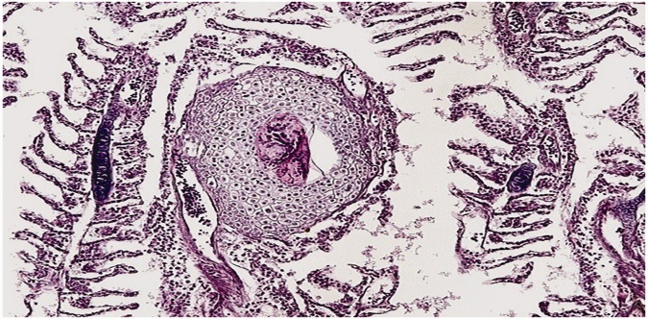
Carassius auratus
A chemical test revealed a concentration of ammonia in the water above the normal level (0.5 mg/L) for 15 goldfish (nine males and six females) that showed symptoms of intoxication (erosions and epidermal bleeding). The fish-tank water was partially substituted and ammonia levels were back to normal in 24 h.A goldfish showing abdominal distension was subjected to radiographic examination, which confirmed the presence of renal cysts.
In four goldfish (one male and three females) that showed white dorsal masses, a cytological examination was carried out after anesthesia. Myxosporidiosis was diagnosed, and the genus Myxobolus was identified. The fish were euthanized after the identification of the parasitic spores.
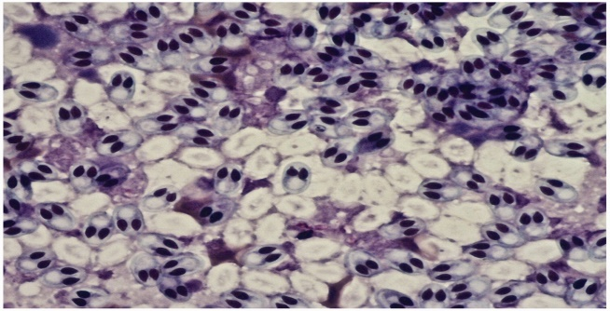
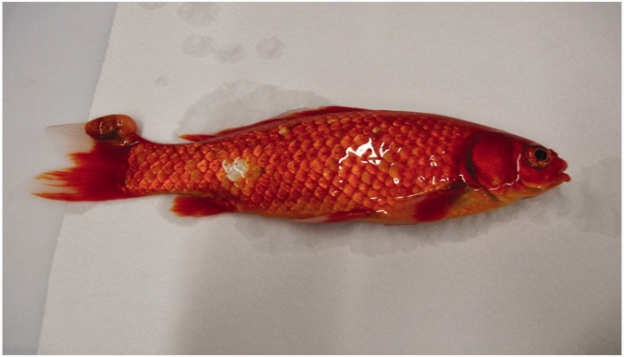

Dicentrarchus labrax
The dinoflagellate Amyloodinium sp. was identified on fresh skin and gill samples analysed from two fish during a post-mortem parasitological examination. Overall, 25 fish died of chronic photobacteriosis with necrotic foci and granulomas in the spleen, liver, kidney and heart due to the presence of Photobacterium damselae subsp. piscicida.
A total of 58 D. labrax were found positive for sphaerosporosis (Sphaerospora dicentrarchi) in the intestine during a post-mortem histopathological examination. Eight seabass that showed signs of acute infectious disease with skin and multi-organ haemorrhages were euthanized. These fish were positive for vibriosis (Vibrio anguillarum) during microbiological examinations.
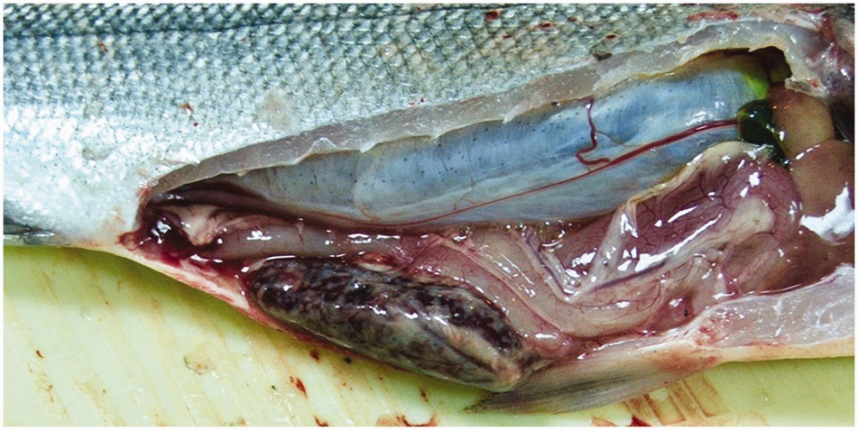
Sparus aurata
After some months of farming, 32 apparently healthy 4-month-old S. aurata juveniles, both males and females, showed the typical clinical signs of lymphocystis virus disease with the appearance of several skin proliferations on the fins, mouth, dorsum and on the lateral side of the body. Three fish per tank were euthanized and autopsied; tissue samples were collected for histopathological and molecular analyses and confirmed the diagnosis of lymphocystis disease (Figure 5) by the presence of viral DNA in all analysed fish.
Cryptocaryon irritans was seen in 25 fish after a partial water substitution with marine water. Mortalities appeared 3 days after the change, and the only obvious macroscopic signs were white spots on the skin of moribund fish.
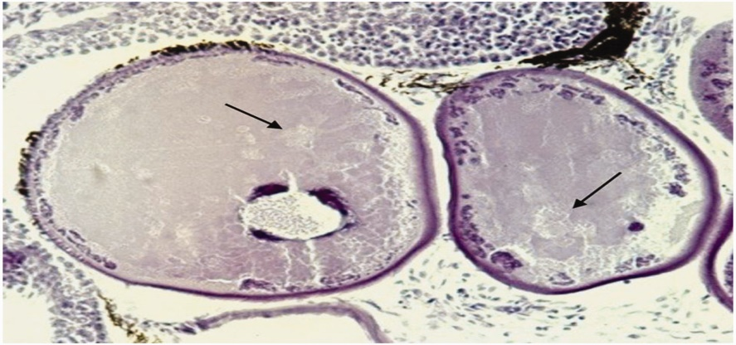
Argyrosomus regius
At histological examination, 40 adult A. regius, both males and females, showed a chronic evolution of granulomas localized in the spleen, liver, kidney, intestine and heart. Six of these subjects died later of severe cryptocarioniasis.
Mugil cephalus
A total 64 wild adult M. cephalus (38 males and 26 females) were positive for zoonotic pathogens. Although no clinical signs were observed, four fish were histologically positive for trematode metacercaria of the genus Heterophyes and 60 were positive for mycobacteriosis.
The genus Mycobacterium was confirmed by immunohistochemistry and microbiological culture, whereas PCR confirmed that the main species was M. fortuitum. Overall, 32 mullet showed lymphocystis disease.
The other fish species (Dentex dentex, Cyprinus carpio, Boops boops, Tinca tinca and Anguilla anguilla) did not show any disease.

