Green Synthesis of Silver Nanoparticlesand their Potential Applications

Rashmi R. Dubey
Department of Chemistry, Kamla Nehru Mahavidyalaya, Nagpur -440024, Maharashtra, India
E-mail: dube.rashmi.rd@gmail.com

W. B. Gurnule
Department of Chemistry, Kamla Nehru Mahavidyalaya, Nagpur- 440024, Maharashtra, India
E-mail: wbgurnule@gmail.com

Swati S. Nagare
Department of Chemistry,
Kamla Nehru Mahavidylaya,
Nagpur-440024, India

Swati G. Burade
Department of Chemistry,
Kamla Nehru Mahavidyalaya,
Nagpur- 440024, Maharashtra, India

Uma S. Purohit
Department of Chemistry, Kamla Nehru Mahavidyalaya, Nagpur- 440024, Maharashtra, India

ABSTRACT
Nanotechnology is a young, developing technology with many uses. The combination of bio sensing platforms and medication delivery systems produced efficient treatment plans for biomedical applications. The outstanding qualities demonstrated by these materials have greatly enhanced these bio sensing and drug delivery systems. It involves the formation and usage of materials with one or more dimensions among 1and 100 nm.
Nowadays, a varied series of physical and chemical procedures are utilised to create nanoparticles (NPs), which pose a risk to human health and the environment. Green nanotechnology, which blends green chemistry with engineering concepts to produce eco-friendly and secure nanomaterials, is used in conjunction with biological techniques to address this problem. Green nanotechnology is used to address problems that have a negative impact on both human health and the environment. However, for medical and biological uses wherever the pureness of NPs is crucial, biogenic reduction of metal precursors to produce corresponding NPs by using phytochemicals found in plants and plants' parts as well as microorganisms is environmentally friendly, less expensive, and free of chemical contaminants. These biological molecules from plants go through a carefully monitored assembling process to make them appropriate for the creation of metal nanoparticles.With regard to pharmaceutical applications with a therapeutic basis as well as applications related to energy and the environment, this study highlights the significance of the green synthesis of metal oxide nanoparticles employing a variety of cutting-edge techniques.
Keywords applications,antimicrobialeffects,bacteria,bioaerosols,biomass,biomolecules,biologicalsynthesis,culture,drug,cytotoxicdelivery,extracellular, greensynthesis, health,intracellular,metal oxide,nanoparticles,phytomining,phytoremedation,supernant,toxicology
I. INTRODUCTION
The antimicrobial properties of silver were well known to our forefathers. In the past, tonsillitis, chronic wounds, acute epididymitis, sepsis and infections have all been treated with silver salt and its colloidal formulations. They also been utilized to prevent baby eye problems. However, once antibiotics were discovered, their use was viewed as being obsolete [2, 3]. Recently, nano silver has made a remarkable comeback. Due to this, enormous determinations were made in nanotechnology, predominantly in the creation of environmentally friendly synthesis techniques for silver nanoparticles (AgNPs), in order to enable the use of nanoparticles in antimicrobial therapy [4].One of the most commercialised nanomaterials today, silver nanoparticles (AgNPs) are used in over 200 goods, including medical apparatus, antimicrobial coatings, photonic devices, molecular diagnostics and textiles, sensors, clothing, textiles, household appliances, conductive inks, home water filters, cosmetics, fillers s, pastes and electronic.[5,6] Owing to the utilisation of non-hazardous, biocompatible, and environmentally acceptable substrates and a moderately simple blend procedure under ambient settings, biological approaches for the production of AgNPs have enormous impact over chemical and physical procedures[7]. Microorganisms and plants are used in the biological method [8]. Although it takes less time, using plant extracts to make nanoparticles results in polydispersed AgNPs because other substances like flavonoids, terpenoids, and polyphenols are needed to reduce silver ions [8,9].Phatogenic synthesis is also influenced by the environment, but if sterile conditions and routine culture maintenance are maintained, microbial production of nanoparticles does not experience these changes. [8] Simple prokaryotic bacteria to complex eukaryotes are entirely utilized in the synthesis of nanoparticles [10]. The key elements that could be taken into account when creating extremely steady and characterised nanoparticles are as follows:
1. Choosing the best organism: To produce nanoparticles, scientists must concentrate on the inborn characteristics of organisms, such as enzyme activity and biological pathways.[11]
2. Ideal circumstances for cell growth and enzyme activity: If the substrate is present in a sub toxic amount, the growth would boost the enzyme's activity [11]
3. Optimal reaction conditions: We must tune the bio-reduction conditions in the reaction mixture while taking into mind the yield and rate in order to manufacture metal nanoparticles on an industrial scale. Biocatalyst concentration, Substance concentration, exposure time, electron donor concentration, mixing rate, temperature, and light all need to be regulated and optimised [12,13]
II. GREEN SYNTHESIS OF SILVER NANOPARTICLES
A. Bacteria mediated synthesis of AgNPs
A natural occurrence in bacterial, fungal, and plant biosystems called biological synthesis of nanoparticles creates nanomaterials with medicinal uses. The buildup of AgNPs inside the cell of Pseudomonas stutzeri AG259 from a silver mine was examined by Klaus and colleagues in 1999 [14]. The ability of bacteria to live in extremely silver-rich environments is the cause of the nanosilver buildup. [14] According on the location, the manufacture of AgNPs by some silver-resistant bacterial strains may take place intracellularly or extracellularly [14]
- Extracellular Synthesis
In the extracellular process, bacterial or fungal cell wall components, organic compounds in the culture media, or microbial enzymes and proteins reduce metal ions for the creation of NPs. Nanoparticles are synthesised extracellular, or outside of the bacterial cell. These nanoparticles have been created utilising cells, culture supernatant, or aqueous cell-free extract. They come in a variety of shapes, including disk-shaped, cuboidal, spherical,, triangular, hexagonal etc. [15]In 100mL of NB medium, Pseudomonas sp. THG-LS1.4 was grown. After one day of incubation at 28°C with an orbital shaker spinning at 120 rpm, the medium was centrifuged to separate the supernatant. The supernatant was combined with a 1mM final concentration of filter-sterilized AgNO3 solution, and then incubated for a further 48 hours at 120 rpm at 28 °C. Visual examination was used to check for changes in the colour of the culture media during the synthesis. Beckman Coulter's Avanti TM J-25 centrifuge, made in the USA, was used to collect the AgNPs at 12,000 g and 25 °C for 10 min. The AgNPs were then carefully washed in water to eliminate any remaining unconverted metal ions or other ingredients. After air drying, the pure nanoparticles were obtained as a powder. [16] Due to the simplicity of recovering nanoparticles from the solution, extracellular techniques of production are preferable to intracellular synthesis.
- Synthesis using biomass
Some bacteria respond to silver salt exposure by producing extracellular AgNPs. (i) Biomolecules secreted into the environment by bacteria aid into decrease of Ag ions to AgNPs, and/or (ii) nanoparticles created inner side the cell are concealed external. Both live (17) and dried (18) bacterial biomass were used in the demonstration of this synthesis. Extracellular AgNps must be subjected to mild sonication in order to adhere to bacterial cell walls.In bacteria, the production of silver-containing nanoparticles such as Ag2S and Ag2O has been reported [19]. However, Muthukkumarasamy et al [21] and Zakiet al [22] show the synthesis of AgPNs from E. coil biomass while they did not observe the development of crystalline AgNPs in the genus Morganella.
- Synthesis by using culture supernant
It has been documented that bacteria cultivated for 24 to 48 hours after exposure to silver-supplemented culture supernatants can synthesise AgNPs. Supernatant is a perfect cause for the decrease of silver ions to AgNPs because it contains organic compounds released by the bacteria during growth and nutrients from the media. On the other hand, it should be noted that AgNPs produced after culture supernatant implant in the organic matrix of medium components, which may impede their characterization, colloidal dispersion, recapture, and, consequently, recognized use. [24]
- Synthesis using cell-free extract
In order to create silver nanoparticles, add 2 mL of pure microalgal extract drop-by-drop into a solution of 100 mL of 1 mM silver nitrate in a 250 mL conical flask. For 10 minutes, the reaction mixture was heated to 60 °C while being constantly mechanically stirred. It was observed that the pH stayed between 4.7 and 5.0 during the reaction and that the decrease of Ag ions into AgNPs was done in less than 10 minutes, demonstrating fast synthesis of AgNPs. The variation in color was identified and nanoparticle creation were observed using a UV-Vis spectrophotometer. The generated silver nanoparticles were centrifuged for 20 minutes at a speed of 15,000 rpm at a temperature of 4 °C; the pellet was collected, and the supernatant was discarded. The pellet was repeatedly cleaned with distilled water to get rid of impurities 90% ethanol to obtain powdered pure AgNPs.[25]
- Synthesis from plants

Phytoextraction, the process by which plants absorb minerals via numerous waters and soil residues, is how plants defend themselves against insects and herbivores. The accumulation of necessary metals to developing crops, as well as the mining of valuable metals from impractical ground sites (phytomining), phytoremediation, and regaining of pollutants, are major applications of phytoextraction. According to studies, the plant gathered metals in the form of nanoparticles. This has sparked attention in using plants as factories to create nanoparticles [26]. Creation of nanoparticles, plants full-grown on the proper metal-enriched substrate have been investigated. Medicago sativa and Brassica juncea have both shown the capacity to accumulate AgNPs. Shankar et al[27] introduced the use of plant broths and/or extracts in the manufacture of nanoparticles.[28] In their research, substances that reduce metal ions remained isolated and employed as decreasing mediators in a synthetic reaction mixture, producing nanoparticles outside of cells.[29]
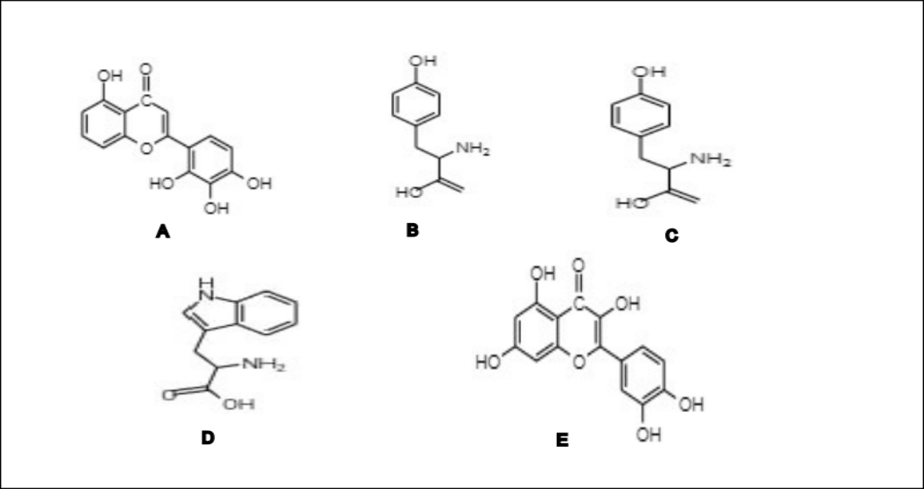
Figure 1:Biomolecules for example amino acids, vitamins, polysaccharides, enzymes, tannins, phenolics, alkaloids, terpenoids, saponins, and proteins are present into extracts and serve as decreasing and stabilising agents [30].

Plant extracts can also produce nanoparticles since they contain sugar. It is commonly known that linear monosaccharide’s like glucose, which include an aldehyde, can function as reducing agents[31] because of the hydrolysis of sucrose, glucose, and fructose in acid. It is generally believed that the process by which sugars produce nanoparticles involves the oxidation of an aldehyde group into a carbonyl group, which in turn causesthe decrease of metal ions and nanoparticlecreation[32]

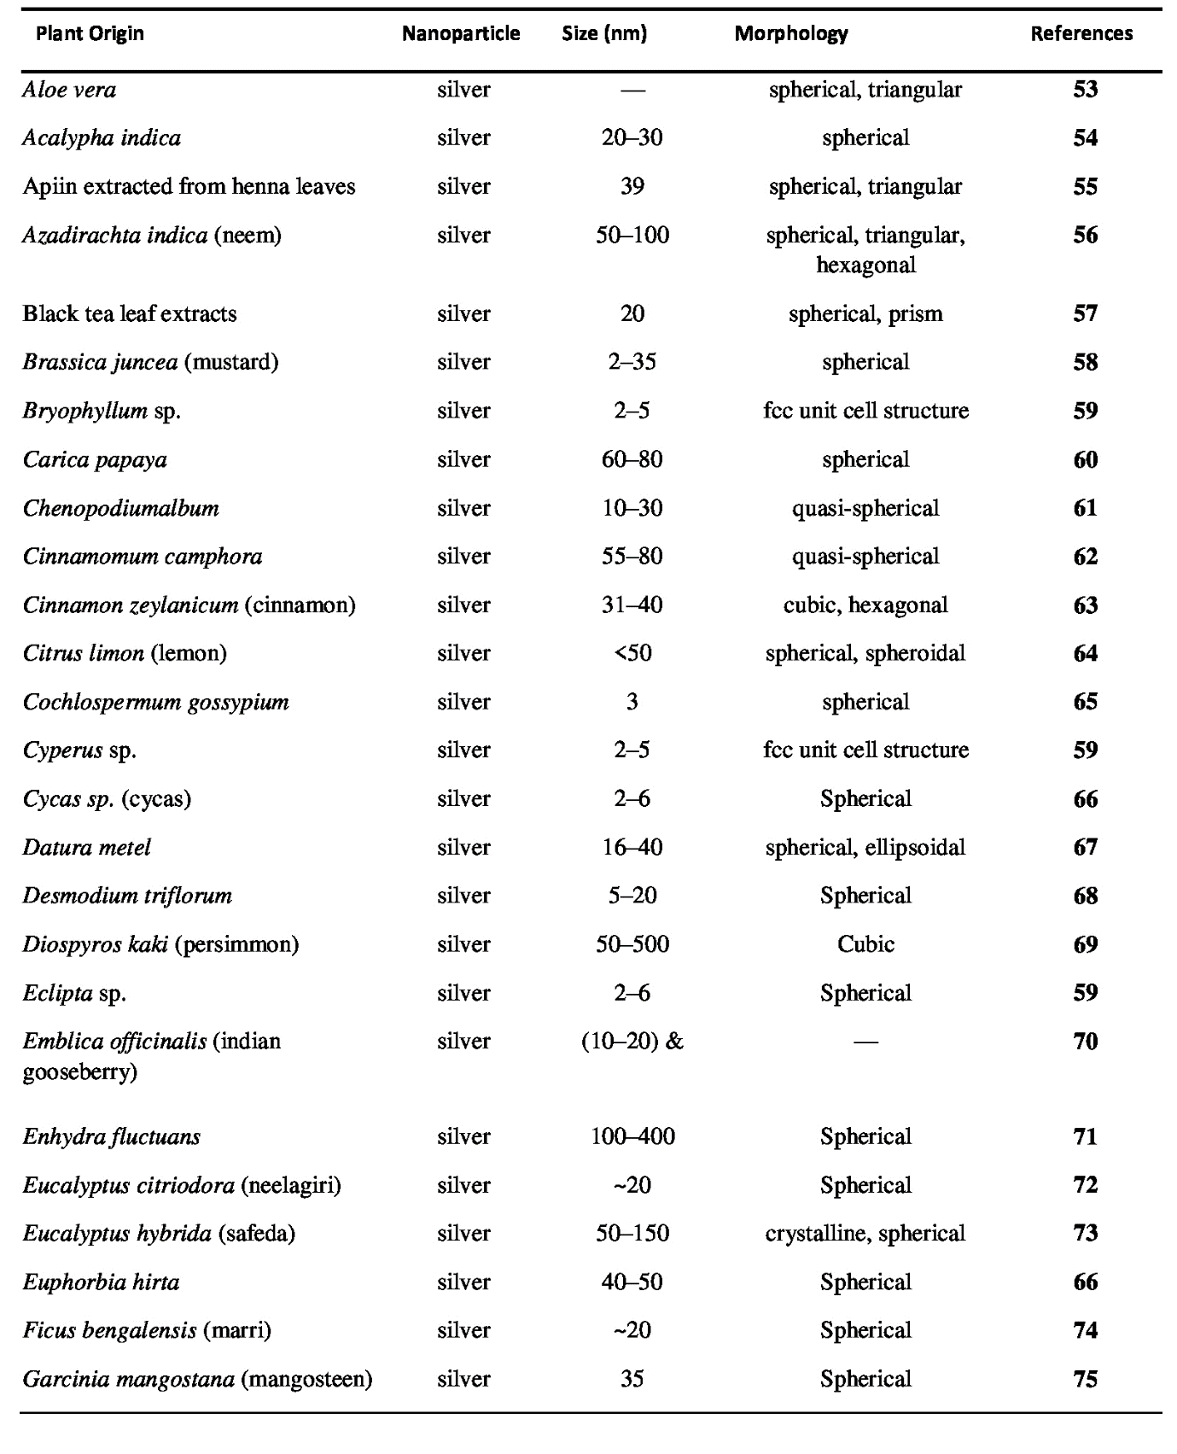
- Intracellular Synthesis
One of the survival techniques used by bacteria to make harmful metal ions benign is the reduction of metal ions to their nano form [32]. Bacterial cells are added to the culture medium containing silver salt and cultivated under the optimal growth conditions to produce intracellular synthesis. Grown cells can also be resuspended in sterile distilled water prior to being treated with silver salt to avoid interfering with medium components. Although Acinetobacter exhibits biocompatibility with its own metal nanoparticles, their cell count is reduced when exposed to the associated metal salt [32]. P. stutzeri [34] revealed the periplasmic deposition of hexagonal and triangular nanoparticles.

III. CHARACTERIZATION OF AGNPS
Understanding and controlling nanoparticle manufacturing and application depend on the characterization of AgNPs; numerous techniques are employed to measure various properties. The morphology of AgNPs is discovered using transmission and scanning electron microscopy (TEM, SEM). The size distribution of AgNPs can be determined using the Zetasizer Nano Series Analyzer. Energy dispersive X-ray spectroscopy (EDS) investigations are carried out using an emission scanning electron microscope with an EDS instrument. By demonstrating the plasmon resonance with the help of X-ray photo electron spectroscopy (XPS), X-ray diffractometry (XRD), Fourier transform infrared spectroscopy (FTIR), and UV-Vis spectroscopy, AgNPs creation is also confirmed. Additionally, XRD is used to determine crystallinity.

- XRD
Information on crystallinity, crystallite size, crystallite orientation, and phase composition can be gleaned from X-ray diffraction data. Both stress measurements and texture analysis benefit greatly from XRD. The ease of sample preparation, speed of measurement, ability to examine mixed phases, and sample purity determination are benefits of XRD. Its disadvantages include the need for uniformly powdered material and peak overlays that produce ambiguous data.[76]

- DLS
An established method for determining the size of particles and molecules is dynamic light scattering. The size of the particles may be estimated because the intensity of the scattered light from laser-illuminated particles varies depending on their size. Size and size therefore DLS can be used to examine the dispersion of particles. Higher sensitivity and improved detection limits are features of the approach.[77] The ability to measure particles as small as 1 nm, analyse data repeatedly, without sample preparation, and with liquid samples are all advantages. Low resolution of polydisperse samples and multiple light scattering are its drawbacks. to ascertain the synthesised nanoparticle's functional group.

- AFM
The surface of nanoparticles may be seen and their surface roughness can be qualitatively measured using atomic force microscopy. It has a very high spatial resolution in three dimensions. A probe is used to scan the sample's surface, and the oscillation amplitude is utilised to calculate the sample's surface properties.
AFM benefits include better resolution than SEM. True atomic resolution is provided comparable transmission electron and scanning tunnelling microscopy.
Single scan image size is one of the restrictions. As opposed to SEM and image artefacts, AFM cannot scan images as quickly.[78]

- SEM
A high-energy electron beam used in the scanning electron microscope scans the sample surface to create a picture. Signals in the form of secondary electrons, back scattered electrons, and distinctive X-rays are produced when an electron beam interacts with a sample's surface and its atoms, providing information on the sample's surface topography, composition, etc.
The two-dimensional imaging capabilities, simplicity of sample preparation, and availability of digital data forms are benefits of SEM. Inadequate sample preparation might cause confusion between artefacts and real data, which is one of its weaknesses. The three most obvious restrictions are size, expense, and upkeep. [79]

- TEM
In TEM, diffraction rather than absorption is the primary mechanism by which the crystalline sample interacts with the electron beam. The orientation of the atoms' locations within a crystal determines the strength of diffraction. As a result, the electron intensity varies, providing information about the crystal structure. Using a TEM micrograph, the distribution of nanoparticles can also be seen.
High quality, intricate, and forceful magnification of element and compound structures are benefits of TEM. Its drawbacks include a cumbersome sample preparation process and a costly approach.[80]

- HRTEM
The high resolution transmission electron microscope (HRTEM) is a TEM imaging mode that enables atomic-scale imaging of samples' crystallographic structures. on HRTEM, the electron wave experiences phase change after interacting with the sample and then interacts with the image wave on the imaging plane. As a result, HRTEM can produce clear images of individual atoms and crystalline flaws. It makes a distinction between amorphous, polycrystalline, and monocrystalline NPs.[81]
- EDX
Combining SEM with this method is employed. Energy Dispersive X-ray (EDX) technology uses X-rays to determine a sample's composition, providing an overall map of the sample. The benefits of EDX include better quality control, assistance with process optimisation, contaminant identification, and higher production output.[82] Its limitations are that qualitative analysis calls for known composition norms and that fluorescence of emitted X-rays limit the precision.

- UV-VIS Spectroscopy
Surface plasmon resonance (SPR), a collective resonance of the conduction electrons in the metal, causes metal nanoparticles to deflect optical light. These nanoparticles exhibit this SPR peak in UV absorption spectra. Nanoparticles' size, shape, and material composition all affect their peak magnitude, wavelength, and spectral bandwidth. UV-Vis spectroscopy has the advantages of being a quick analytical tool, offering extremely high precision and accuracy, being applicable to a large range of chemicals, being able to be employed quantitatively as well as qualitatively, and being able to assess the stability of NP colloidal solutions. If two substances absorb at the same wavelength, the constraint is not wavelength-specific [83].

- FTIR
Information on the proteins and other substances in the mixture that interact with metal ions is provided by Fourier transform infrared spectroscopy. The discovery of functional groups enables the identification of the reducing and capping agents in charge of the synthesis and stability.
The benefits of FTIR include the ability to distinguish between similar components and to identify and detect changes in protein secondary structures. Its drawbacks include overlapping peaks that make it difficult to discern and quantify, as well as better outcomes with solid components[84]

IV. APPLICATIONS OF SILVER NANOPARTICLE
1. The antimicrobial properties of Ag-NPs alongside the growth of E. coli have been reported by Sondi and Salopeck-Sondi [36]. The Ag-NPs have been shown to be an active biocide alongside broad-spectrum bacteria, including both Gram-negative and Gram-positive bacteria [35].
2. Bioaerosols are airborne biological particles such as bacteria, fungus, and viruses that can spread infectious, allergic, or toxic disorders. Particularly, it was discovered that the filters of heating, ventilation, and air conditioning (HVAC) systems accumulated a lot of indoor air bioaerosols. Antimicrobial Ag-NPs have been produced and proposed to be included into air filters to inhibit microbial growth.Ag-coated CNT hybrid nanoparticles (Ag/CNTs) have been produced and their properties have been investigated utilizing aerosol nebulization and thermal vaporization and condensation procedures.
3. In many underdeveloped nations, access to clean drinking water is a crucial social and health issue. In addition to being employed in chem-Ag-NPs, biologically manufactured nanosilver (bio-Ag-NPs) is also used to disinfect water of viruses [38].
4. Ag-NPs were also used therapeutically, mainly to heal burn wounds. For this test, a gel formulation (S-gel) containing Ag-NPs was developed [39].
5. By serving as a reservoir for the gradual release of ionic silver from the surface to the bulk and by preventing growth on the surface itself, Ag-NPs-coated paper may be useful for longer-term food preservation in addition to being used as antimicrobial coatings for household paints, biomedical and therapeutic fields [40].
6. AgNPs' distinct physical, chemical, and biological characteristics have a wide range of exceedingly potential industrial and medical uses. Therefore, AgNps are employed in therapy due to their cytotoxic effects.
7. Infectious disorders instigated through viruses including SARS-Cov, influenza A/H5N1, influenza dengue virus, A/H1N1, HBV, HIV and novel encephalitis viruses have been reported to be developing and remerging more frequently in recent years. These viral infections have a high probability of developing into highly contagious illnesses that harm public health. [51]As previously indicated, Ag-NPs have demonstrated active activity against bacteria and fungus. Ag-NPs' antiviral properties, however, remain a mystery to scientists. There are surprisingly few studies that look into how Ag-NPs affect viruses.[52]

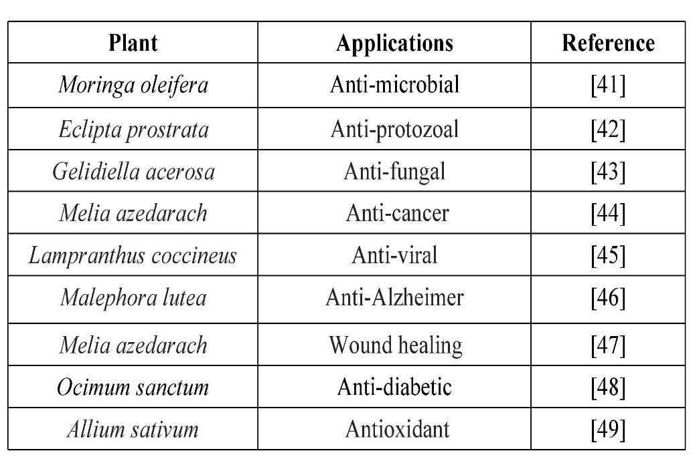
V. CONCLUSION
In conclusion, it can be said that environmentally friendly synthetic methods that make use of bacterial and plant extracts are attractive substitutes for the production of AgNPs. However, morphological features like size and shape need to be precisely controlled in order to create AgNPs with enhanced bioactivities. Utilising concepts and tools from nanoscience and nanotechnology is a good strategy today within the framework of current global priorities. We have observed the interaction of several viral particles with nanomaterials, primarily focused on SARS-CoV-2, and emphasising COVID-19 disease prevention, diagnosis, and therapy as much as possible under the umbrella of nanotechnology. Via permitting initial finding, these progresses will increase the persistence rate of cancer patients. Additionally, these developments being utilized to find the development of cancer and how it responds to treatment, which could help to improve cancer treatment strategies. The field of nanotechnology-based cancer diagnosis has made significant strides, and our comprehension of it has grown significantly. Nanotechnology offers excellent prospects to improve cancer diagnosis, which will ultimately improve the survival rate of cancer patients due to its high sensitivity, specificity, and multiplexed measuring capacity.

REFERENCES:

[1]Sintubin L, Verstraete W, Boon N (2012) Biologically producednanosilver: current state and future perspectives. BiotechnolBioeng 109:2422–2436
[2] Kim, J.S., et al., Antimicrobial effectsof silver nanoparticles. Nanomedicine:
Nanotechnology, Biology and Medicine,2007. 3(1): p. 95-101.
[3] Alexander, J.W., History of the medicaluse of silver. Surgical infections, 2009. 10(3): p. 289-292.
[4] Peng, G., et al., Nanosilver at theinterface of biomedical applications,toxicology, and synthetic strategies, inMetal Nanoparticles for Drug Deliveryand Diagnostic Applications. 2020,Elsevier. p. 119-139.
[5] Lin J, Chen R, Feng S, Pan J, Li Y, Chen G, Cheng M, Huang Z, Yu Y,Zeng H (2011) A novel blood plasma analysis techniquecombiningmembrane electrophoresis with silver nanoparticle-based SERSspectroscopy for potential applications in noninvasive cancer detection.Nanomedicine 7:655–663
[6]Liu C, Yang D, Wang Y, Shi J, Jiang Z (2012) Fabrication of antimicrobialbacterial cellulose–Ag/AgCl nanocomposite using bacteria asversatilebiofactory. J Nanopart Res 14:1084–1095
[7] Shedbalkar U, Singh R, Wadhwani S, Gaidhani S, Chopade BA (2014)Microbial synthesis of gold nanoparticles: current status and futureprospects. Adv Colloid Interface Sci 209:40–48
[8]Salunkhe GR, Ghosh S, Santoshkumar RJ, Khade S, Vashisth P, Kale T, Chopade S, Pruthi V, Kundu G, Bellare JR, Chopade BA (2014)Rapid efficient synthesis and characterization of silver, gold and bimetallic nanoparticles from the medicinal plant Plumbago zeylanicaand their application in biofilm control. Int J Nanomedicine 9:2635–2653
[9] Singh R, Wagh P, Wadhwani S, Gaidhani S, Kumbhar A, BellareJ,Chopade BA (2013)Synthesis, optimization, and characterizationof silver nanoparticles from Acinetobacter calcoaceticusandtheirenhanced antibacterial activity when combined with antibiotics. Int JNanomedicine 8:4277–4290.
[10]H.Korbekandi, S. Iravani and S. Abbasi, Crit. Rev. Biotechnol.,2009, 29, 279–306.
[11]Iravani, S. (2011). Green synthesis of metal nanoparticles using plants. Green Chemistry, 13(10), 2638. doi:10.1039/c1gc15386b
[12]A. Ahmad, P. Mukherjee, S. Senapati, D. Mandal, M. I. Khan, R. Kumar and M. Sastry, Colloids Surf., B, 2003, 28, 313– 318.
[13]H.Korbekandi, S. Iravani and S. Abbasi, Crit. Rev. Biotechnol., 2009, 29, 279–306.
[14] Klaus T, Joerger R, Olsson E, Granqvist CG (1999) Silver-based crystallinenanoparticles, microbially fabricated. Proc Natl Acad Sci U S A96:13611–13614
[15]Oves M, Khan MS, Zaidi A, Ahmed AS, Ahmed F, Ahmad E, SherwaniA, OwaisM, AzamA (2013) Antibacterial and cytotoxic efficacy ofextracellular silver nanoparticles biofabricated from chromium reducingnovel OS4 strain of Stenotrophomonas maltophilia. PLoSOne 8, e59140
[16]Singh, Hina; Du, Juan; Singh, Priyanka; Yi, Tae Hoo (2018). Extracellular synthesis of silver nanoparticles by Pseudomonas sp. THG-LS1.4 and their antimicrobial application. Journal of Pharmaceutical Analysis, S20951779(18)30039X.
[17] MahdiehM, Zolanvari A, AzimeeAS,MahdiehM(2012) Green biosynthesis of silver nanoparticles by Spirulina platensis. Scientia Iranica 19:926–929
[18] Zhang H, Li Q, Lu Y, Sun D, Lin X, Deng X, He N, Zheng S (2005) Biosorption and bioreduction of diamine silver complex by Corynebacterium. J Chem Technol Biotechnol 80:285–290
[19]Debabov VG, Voeikova TA, Shebanova AS, Shaitan KV, Emel’yanovaLK, Novikova LM, Kirpichnikov MP (2013) Bacterial synthesis ofsilver sulfide nanoparticles. Nanotechnol Russ 8:269–276
[20]Parikh RY, Ramanathan R, Coloe PJ, Bhargava SK, Patole MS, ShoucheYS, Bansal V (2011) Genus-wide physicochemical evidence of extracellularcrystalline silver nanoparticles biosynthesis byMorganella spp. PLoS One 6, e21401
[21]Muthukkumarasamy S, Sharadha A, Vignesh S, DhanabalanK,Gurunathan K (2012) Extracellular synthesis of polygonal silvernanoparticles using extract of Escherichia coli ATCC 25922 andits antibacterial activities. Dig J NanomaterBiostruct 7:1419–1426
[22]Zaki S, El Kady MF, Abd-El-Haleem D (2011) Biosynthesis and structuralcharacterization of silver nanoparticles from bacterial isolates.Mater Res Bull 46:1571–1576
[23]Saifuddin N, Wong CW, Yasumira AAN (2009) Rapid biosynthesis of silver nanoparticles using culture supernatant of bacteria with microwave irradiation. J Chem 6:61–70.
[24]Saifuddin N, Wong CW, Yasumira AAN (2009) Rapid biosynthesis of silver nanoparticles using culture supernatant of bacteria with microwave irradiation. J Chem 6:61–70.
[25]Sharma, Gaurav; Jasuja, NakuleshwarDut; Kumar, Manoj; Ali, Mohammad Irfan (2015). Biological Synthesis of Silver Nanoparticles by Cell-Free Extract of Spirulina platensis, Journal of Nanotechnology, 2015, 1–6.
[26] Makarov, V.,et al., “Green”nanotechnologies: synthesis of metalnanoparticles using plants. ActaNaturae (англоязычнаяверсия), 2014.6(1 (20)).
[27] Harris, A.T. and R. Bali, On the formation and extent of uptake of silver
nanoparticles by live plants. Journal of Nanoparticle Research, 2008. 10(4): p. 691-695.
[28] Shankar, S.S., et al., Bioreduction of chloroaurate ions by geranium leavesand its endophytic fungus yields gold nanoparticles of different shapes. Journalof Materials Chemistry, 2003. 13(7): p. 1822-1826.
[29] Shankar, S.S., A. Ahmad, and M. Sastry, Geranium leaf assisted biosynthesisof silver nanoparticles. Biotechnology progress, 2003. 19(6): p. 1627-1631.
[30] Makarov, V., et al., “Green”nanotechnologies: synthesis of metal nanoparticles using plants. ActaNaturae (англоязычнаяверсия), 2014.6(1 (20)).
[31] Ahmed, S., et al., A review onplants extract mediated synthesis ofsilver nanoparticles for antimicrobialapplications: A green expertise. Journal ofAdvanced Research, 2016. 7(1): p. 17-28.
[32] Klaus T, Joerger R, Olsson E, Granqvist CG (1999) Silver-based crystallinenanoparticles, microbially fabricated. Proc Natl Acad Sci U S A96:13611–13614
[33] Wadhwani SA, Shedbalkar UU, Singh R,KarveMS, Chopade BA (2014), Novel polyhedral gold nanoparticles: green synthesis, optimizationand characterization by environmental isolate of Acinetobacter sp.SW30. World J MicrobiolBiotechnol 30:2723–2731
[34] Klaus T, Joerger R, Olsson E, Granqvist CG (1999) Silver-basedcrystallinenanoparticles, microbially fabricated. Proc Natl Acad Sci U S A96:13611–13614
[35] Jones C M and Hoek E M V 2010 J. Nanopart. Res. 12 1531.
[36] Sondi I and Salopek-Sondi B 2004 J. Colloid Interface Sci. 275 177.
[37] Yoon K Y, Byeon J H, Park C W and Hwang J 2008 Environ. Sci. Technol. 42 1251.
[38] De Gusseme B, Sintubin L, Hennebel T, Boon N, Verstraete W, Baert L and Uyttendaele M 2010 4th Int. Conf. on B/ioinform. Biomed. Engin. (Chengdu, China, 18–20 June 2010) pp 1–5.
[39] Jain J, Arora S, Rajwade J M, Omray P, Khandelwal S and Paknikar K M 2009 Mol. Pharm. 6 1388.
[40] Gottesman R, Shukla S, Perkas N, Solovyov L A, Nitzan Y and Gedanken A 2011 Langmuir 27 720.
[41] Ravishankar Rai, V. and A. Jamuna Bai, Nanoparticles and their potential application as antimicrobials. Science against microbial pathogens, communicating current research and technological advances. Formatex, Badajoz, 2011: p. 197-209
[42] Prasad, T. and E. Elumalai, Biofabrication of Ag nanoparticles using Moringa oleifera leaf extract and their antimicrobial activity. Asian Pacific Journal of Tropical Biomedicine, 2011. 1(6): p. 439.
[43] Rajakumar, G. and A.A. Rahuman, Larvicidal activity of synthesized silver nanoparticles using Ecliptaprostrata leaf extract against filariasis and malaria vectors. Acta tropica, 2011. 118(3): p. 196-203.
[44] Vivek, M., et al., Biogenic silver nanoparticles by Gelidiellaacerosa extract and their antifungal effects. Avicenna Journal of Medical Biotechnology, 2011. 3(3): p. 143.
[45] Sukirtha, R., et al., Cytotoxic effect of Green synthesized silver nanoparticles using Melia azedarach against in vitro HeLa cell lines and lymphoma mice model. Process Biochemistry, 2012. 47(2): p. 273-279.
[46] Haggag, E.G., et al., Antiviral potential of green synthesized silver nanoparticles of Lampranthuscoccineus and Malephora lutea. International journal of nanomedicine, 2019. 14: p. 6217-6229.
[47] Youssif, K.A., et al., Anti-Alzheimer potential, metabolomic profiling and molecular docking of green synthesized silver nanoparticles of Lampranthus Novel Nanomaterials 26 coccineus and Malephora lutea aqueous extracts. PLoS One, 2019. 14(11): p. e0223781.
[48] Chinnasamy, G., S. Chandrasekharan, and S. Bhatnagar, Biosynthesis of Silver Nanoparticles from Melia azedarach: Enhancement of Antibacterial, Wound Healing, Antidiabetic and Antioxidant Activities. Int J Nanomedicine, 2019. 14: p. 9823-9836.
[49] Malapermal, V., et al., Enhancing antidiabetic and antimicrobial performance of Ocimumbasilicum, and Ocimum sanctum (L.) using silver nanoparticles. Saudi Journal of Biological Sciences, 2017. 24(6): p. 1294-1305.
[50] Otunola, G.A., et al., Characterization, Antibacterial and Antioxidant Properties of Silver Nanoparticles Synthesized from Aqueous Extracts of Allium sativum, Zingiber officinale, and Capsicum frutescens. Pharmacognosy magazine, 2017. 13(Suppl 2): p. S201-S208.
[51] Coker R J, Hunter B M, Rudge J W, Liverani M andHanvoravongchai P 2011 Lancet 377 599
[52] Elechiguerra J L, Burt J L, Morones J R, Camacho-BragadoA, Gao X, Lara H H and Yacaman M J 2005 J. Nanobiotechnol,3 6.
[53] S. P. Chandran, M. Chaudhary, R. Pasricha, A. Ahmad and M. Sastry, Biotechnol. Prog., 2006, 22, 577–83.
[54] Krishnaraj, E. G. Jagan, S. Rajasekar, P. Selvakumar, P. T. Kalaichelvan and N. Mohan, Colloids Surf., B, 2010, 76, 50–56.
[55] J. Kasthuri, S. Veerapandian and N. Rajendiran, Colloids Surf., B, 2009, 68, 55–60.
[56] S. S. Shankar, A. Rai, A. Ahmad and M. Sastry, J. Colloid Interface Sci., 2004, 275, 496–502.
[57] N. A. Begum, S. Mondal, S. Basu, R. A. Laskar and D. Mandal, Colloids Surf., B, 2009, 71, 113–118.
[58]R. G. Haverkamp and A. T. Marshall, J. Nanopart. Res., 2008, 11, 1453–1463.
[59]A. K. Jha, K. Prasad, K. Prasad and A. Kulkarni, Colloids Surf., B, 2009, 73, 219–223.
[60] N. Mude, A. Ingle, A. Gade and M. Rai, J. Plant Biochem. Biotechnol., 2009, 18, 83–86.
[61] A. D. Dwivedi and K. Gopal, Colloids Surf., A, 2010, 369, 27–33.
[62] J. Huang, Q. Li, D. Sun, Y. Lu, Y. Su, X. Yang, H. Wang, Y. Wang, W. Shao, H. Ning, J. Hong and C. Chen, Nanotechnology, 2007, 18(105), 104.
[63] M. Sathishkumar, K. Sneha, S. W. Won, C.-W. Cho, S. Kim and Y. S. Yun, Colloids Surf., B, 2009, 73, 332–338.
[64] T. C. Prathna, N. Chandrasekaran, A. M. Raichur and A. Mukherjee, Colloids Surf., B, 2011, 82, 152–159.
[65] A. J. Kora, R. B. Sashidhar and J. Arunachalam, Carbohydr. Polym., 2010, 82, 670–679.
[66] A. K. Jha and K. Prasad, Int. J. Green Nanotechnol.: Phys. Chem., 2010, 1, 110–117. 81
[67] J. Kesharwani, K. Y. Yoon, J. Hwang and M. Rai, J. Bionanosci., 2009, 3, 39–44.
[68] N. Ahmad, S. Sharma, V. N. Singh, S. F. Shamsi, A. Fatma and B. R. Mehta, Biotechnol. Res. Int.., 2011, 2011, 454090.
[69] B. Ankamwar, C. Damle, A. Ahmad and M. Sastry, J. Nanosci. Nanotechnol., 2005, 5, 1665–1671.
[70] N. Roy and A. Barik, Int. J. Nanotechnol. Appl.., 2010, 4, 95–101.
[71] S. Ravindra, Y. Murali Mohan, N. Narayana Reddy and K. M. Raju, Colloids Surf., A, 2010, 367, 31–40.
[72] M. Dubey, S. Bhadauria and B. Kushwah, Dig. J. Nanomater. Biostruct., 2009, 4, 537–543.
[73] E. K. Elumalai, T. N. V. K. V. Prasad, J. Hemachandran, S. ViviyanTherasa, T. Thirumalai and E. [74] David, J. Pharm. Sci. Res., 2010, 2, 549–554.
[75] S. Ravindra, Y. Murali Mohan, N. Narayana Reddy and K. M. Raju, Colloids Surf., A, 2010, 367, 31–40.
[76] Y. Tan, D. Sun, H. Yu, B. Yang, Y. Gong, S. Yan, Z. Chen, Q. Cai and Z. Wu, CrystEngComm, 2014, 16, 9657.
[77] Y. H. Lai, S. Koo, S. H. Oh, E. A. Driskell and J. D. Driskell, Anal. Methods, 2015, 7, 7249.
[78] M. Muniz-Miranda, B. Pergolese, A. Bigotto, A. Giusti and M. Innocenti, Mater. Sci. Eng., C, 2007, 27, 1295
[79] S. Rades, V.-D. Hodoroaba, T. Salge, T. Wirth, M. P. Lobera, R. H. Labrador, K. Natte, T. Behnke, T. Gross and W. E. S. Unger, RSC Adv., 2014, 4, 49577.
[80] T. C. Rojas, M. J. Sayagues, A. Caballero, Y. Koltypin, A. Gedanken, L. Ponsonnet, B. Vacher, J. M. Martin and A. Fernandez, J. Mater. Chem., 2000, 10, 715.
[81] M. José-Yacamán, M. Marín-Almazo and J. Ascencio, J. Mol. Catal. A: Chem., 2001, 173, 61.
[82] S. Rades, V.-D. Hodoroaba, T. Salge, T. Wirth, M. P. Lobera, R. H. Labrador, K. Natte, T. Behnke, T. Gross and W. E. S. Unger, RSC Adv., 2014, 4, 49577.
[83] UV/Vis/IR Spectroscopy Analysis of NPs, September 2012, NanoComposix (Nanocomposix.com).
[84] E. M. Moroz, Russ. Chem. Rev., 2011, 80, 293.

