Eco-Materials
Jimmy Mehta¹, Yaman Hooda¹, Sahil Mehta² and Pallav Gupta³
¹ Manav Rachna International Institute of Research and Studies, Faridabad Haryana India
² Electrical and Instrumentation Engineering Department, Thapar Institute of Engineering and Technology, Patiala, India
^{3.}Amity School of Engineering and Technology, Amity University Noida, UP India

- Introduction: Eco materials are a foundation of feasible turn of events, offering a pathway to blend human advancement with natural conservation. These materials, got from sustainable assets or reused parts, essentially lessen asset consumption and ecological debasement. By embracing eco materials in development, fabricating, and regular items, we reduce fossil fuel byproducts, preserve energy, and alleviate biological mischief. Their insignificant effect on indoor air quality, squander decrease potential, and capacity to animate green development by and large add to better conditions and stronger networks. In the excursion toward a supportable future, the reception of eco materials remains as a basic step, cultivating a reasonable concurrence between human necessities and the planet's prosperity.

1.1 Importance of eco materials in sustainable development:
- Resource conservation: The demand for virgin resources is decreased by the use of recycled or renewable materials in the production of eco materials. This promotes the preservation of natural resources such as forests, minerals, and fossil fuels. Reduced
- Environmental Impact: Eco materials are frequently produced with less energy use, less pollution, and fewer emissions. This lessens the damaging environmental effects brought on by conventional material extraction and production methods.
- Energy Efficiency: Many environmentally friendly materials have superior insulation qualities, which can improve a building's energy efficiency. With less need for heating and cooling, there will be less energy use and greenhouse gas emissions.
- Waste reduction: End-of-life considerations are frequently taken into account when designing eco materials. They may be more easily recyclable, compostable, or biodegradable, which will cut down on the amount of waste that is dumped in landfills.
- Better Indoor Air Quality: Eco materials frequently emit fewer volatile organic compounds (VOCs) and are non-toxic, which contributes to better indoor air quality. Buildings should pay special attention to this as poor indoor air quality can have detrimental effects on health.
- Use of environmentally friendly materials that don't harm ecosystems or wildlife contributes to the preservation of biodiversity and the stability of natural ecosystems.
- Mitigation of climate change: Numerous conventional manufacturing and construction processes generate large amounts of greenhouse gas emissions. Environmentally friendly products and methods frequently have lower carbon footprints, which supports international efforts to combat climate change.
- Market demand and reputation: As awareness of environmental issues grows, there is an increasing demand for sustainable products and practices. Businesses that adopt eco materials can enhance their reputation, attract environmentally-conscious consumers, and remain competitive.
- Long term economic benefit: While there might be initial costs associated with adopting eco materials, the long-term benefits, including reduced operational costs (such as energy savings) and potential regulatory advantages, often outweigh these costs.
- Local development: The use of locally-sourced eco materials can support local economies, create jobs, and reduce the carbon footprint associated with transporting materials over long distances.
- Educational Opportunities: Embracing eco materials in construction and manufacturing can serve as an educational opportunity to raise awareness about sustainability and encourage more responsible consumption and production patterns.

1.2 Recycled material from waste:
Definition and significance of recycling in the context of materials: Recycling is a fundamental concept in sustainable materials management that involves the collection, processing, and transformation of discarded materials into new products or raw materials. This report examines the definition and significance of recycling in the context of materials, focusing on its environmental, economic, and social implications.

1.2.1Meaning of Reusing:
Reusing is the most common way of changing over utilized or squander materials into usable items, consequently diminishing the requirement for virgin assets and limiting garbage removal. It includes a few phases, including assortment, arranging, cleaning, handling, and assembling, to create optional materials that can fill in for essential assets in different businesses.
- Asset Protection: Reusing moderate’s regular assets by diminishing the interest for natural substances, like minerals, lumber, and oil. This mitigates the natural effect of asset extraction, including living space annihilation and energy utilization.
- Energy Investment funds: Reusing frequently requires less energy than creating merchandise from unrefined components. For instance, reusing aluminum utilizes around 95% less energy than separating aluminum from bauxite metal, prompting huge decreases in ozone depleting substance discharges.
- Squander Decrease: Reusing redirects materials from landfills and incinerators, broadening the life expectancy of these offices and decreasing the adverse consequences of garbage removal, including groundwater defilement and air contamination.
- Fossil fuel byproduct Decrease: The assembling of items from reused materials produces less fossil fuel byproducts contrasted with utilizing virgin materials. This adds to worldwide endeavors to battle environmental change.
- Monetary Advantages: Reusing enterprises make occupations in assortment, handling, and assembling, subsequently supporting nearby economies. Additionally, reusing can prompt expense reserve funds for organizations by lessening the need to buy costly unrefined substances.
- Innovation: The reusing system drives advancement in materials science and designing, cultivating the improvement of new methods for changing over and using reused materials in clever ways.
- Shut Circle Frameworks: A few materials, similar to specific plastics, can be reused into a similar item more than once, making shut circle frameworks that limit squander age and the requirement for new unrefined components.
- Customer Mindfulness: Reusing advances natural mindfulness among shoppers, empowering dependable utilization and waste administration rehearses.
- Roundabout Economy: Reusing is a foundation of the round economy, where items and materials are planned, created, and used to limit squander age and support nonstop reuse.
- Decreased Environmental Effect: Reusing decreases the ecological effects related with extricating, handling, and moving natural substances, protecting biological systems and biodiversity.
Reusing is a vital component chasing maintainable materials the board. Its multi-layered importance lies in rationing assets, checking energy utilization, limiting waste, encouraging advancement, and supporting monetary development. By reconsidering waste as an important asset, reusing adds to the progress toward an additional economical and regenerative future.

1.2.2 Types of waste materials suitable for recycling:
Cardboard and waste paper: Recycling paper is vital to insure you reduce your environmental impact and to reduce gratuitous general waste. Assiduity and commerce dispose of roughly 12.5 million tonnes of paper and cardboard in the UK each time; most paper is recyclable and can be diverted down from tip spots! Every tonne of recycled paper or cardboard can save up to 17 trees, two boxy yards of tip capacity and 4100 kW/ hours of electricity!
Plastics: The world generates 381 million tonnes of plastic waste annually, and with the quantum of plastic waste set to double by 2034, recovering plastic is vital. There are about 50 different groups of plastics, with hundreds of different kinds. Utmost types of plastic are recyclable, and because of this, they need to be reclaimed to reduce the quantum of waste transferred to tip and help rubbish from ending up in the abysses.
Metals: All grades of non-ferrous and ferrous essence are recyclable for unborn use. Because essence do not lose quality when reclaimed, we can reclaim essence numerous times over. To get an idea of how important energy recycling can conserve, recovering one aluminium drink can saves enough energy to power a TV for around three hours! Before the essence are reclaimed, essence get sorted in our accoutrements recovering installation (MRF), separated into ferrous and non-ferrous types. Ferrous essence includes Iron and Steel; non-ferrous essence include: aluminium, bobby, pristine sword, brass and lead to name but a many.
Electrical and electronic devices: recycling is for the waste of electrical and electronic equipment recycling, which is nearly everything powered by a battery or plug such as computers, mobile phones and TVs. Electronic goods recycling is a specialist part of the waste and recycling industry aiming to prevent electrical items sent to landfill. The Waste Electrical and Electronic Equipment (WEEE) Regulations (2013) became law in the UK on 1 January 2014.
At ISM Waste & Recycling we accept and recycle most WEEE waste, including computers, monitors, TVs, radios, mobile phones and electrical tools.
Wood: Wood is the ultimate renewable material because of its large number of different uses. Wood can be reused as a building material, recycled into mulch for landscaping. Even low-grade wood is useful because we can use it for fuel to generate environmentally friendly energy. According to the Wood Recyclers Association, around 5 million tonnes of waste wood is created in the UK every year, yet considerably less than half of it is recycled. ISM Waste & Recycling can recover all types of uncontaminated timber. Wood grades include timber pallets, timber boxes, floorboards, chipboard, fencing, plywood, furniture etc.
Glass: Glass is 100% recyclable and never loses any purity or quality when recycled, meaning we can recycle it many times over. Glass can take around one million years to fully decompose, which is a big issue for landfill sites getting too full. It is crucial to ensure we recycle as much glass as possible. We can reuse glass repeatedly, and the quality of the material is as good as if it was made new from the raw materials. ISM can recycle various types of glass, which must be suitable for reprocessing. Glass should be as clean and contaminant-free as possible for recycling. Grades include such items as bottles, jars, windows, drinking glasses, computer screens etc. Similar to other recycled materials, recycling glass also saves significant amounts of energy.
Textiles: With the rise of "fast fashion" in recent years, we are buying more clothes than ever and, therefore, we have more waste textiles than ever. It is estimated that more than 1 million tonnes of textiles are thrown away every year in the UK, and at least 50% of the fabrics we throw away are recyclable. It's not just the amount of textiles being sent to landfill that is the issue but also the increased use of raw materials to produce the clothes.
Bricks: We can recycle hardcore rubble into usable materials for many uses in other construction and building projects. Bricks can also be cleaned and reused as "reclaimed bricks" in another building or project to lower costs. Alternatively, we can crush them into brick chips for use as a landscape material). These waste streams come to us on skip wagons from industrial and demolition sites, it is tipped and then crushed to produce various grades of aggregates to be reused on construction sites.

1.2.3 Recycled Materials:
- Recycled aggregates: Aggregates are by-products of other industrial processes, such as concrete from demolition sites. They can often be reconditioned and used again in new construction or manufacturing projects.
- Recycled electronic equipment: It's important to remember that even your waste electrical and electronic equipment can be broken up and reused. Parts can be reconditioned and reused from items like: computers, mobile phones, refrigerators and batteries.
- Recycled glass: Glass can be recycled into a number of useful materials, including:
- bricks, cement and concrete
- 'glass grit', which is used for cleaning
- new glass containers
- fibre glass
- Recycled Material: Making metal from raw materials is expensive and recycling provides a cost-effective and environmentally friendly alternative.
- Recycled organic waste: Organic waste like fruit and vegetable peelings, grass clippings, wood chippings and tea bags can be recycled by:
- composting - organic waste can be recycled into compost which can be used by farms or gardening businesses
- specialist heat processing to make liquid fertiliser and fuel
- Recycled paper: One should aim to buy only recycled paper for use in your business, and make sure you recycle this after use.
- Newspapers and magazines can be recycled into egg boxes and packaging.
- Old photocopies and print-outs can be recycled into high-quality paper.
- Cardboard can be recycled into new cardboard or packaging, or used for animal bedding.

Recycled plastics: Plastic can be recycled into items like containers and plastic bags. Different plastics need to be separated for recycling, and many products are now labelled with a code to aid this process.

Recycled textiles: Material can be recycled into cloth, insulation, or yarn for knitting and weaving. Industrial textile waste such as that from carpets can be reused for weaving, and the croppings can be used for animal bedding.

Recycled tyres: The UK Government is trying to encourage more people and businesses to recycle tyres, which can be shredded to make new rubber, burned as fuel, and used in making and re-treading new tyres.
- Recycled wood: A number of new products can be made from recycling wood, including
- animal bedding
- fuel pellets and fuel chips
- mulch for use in the garden

1.2.4 Case studies showcasing successful recycling initiatives:
The pulp and paper industry (PPI) plays a significant role in the global economy, though it presents a waste disposal challenge due to the generation of substantial waste streams. Among these, paper rejects emerge during the papermaking process and could constitute as much as a quarter of the paper produced. Furthermore, every year, hundreds of millions of tons of paper are manufactured, with a portion ending up in landfills if not incinerated or recycled. Additionally, the PPI's contribution to climate change and global warming through deforestation, water, and air pollution is substantial [1]. As a result, the industry's impact on natural resource sustainability and its negative environmental effects necessitate specific attention.
This analysis concentrates on exploring sustainable methods for repurposing paper waste and rejects from the PPI within the framework of a circular economy. It commences by examining the industry itself and its environmental implications, followed by potential sustainable strategies that can be adopted to enhance papermaking processes and waste management systems, encompassing paper recycling. Existing literature underscores the critical importance of paper recycling, as it has the potential, when properly structured, to substantially reduce greenhouse gas emissions, water and resource consumption, as well as manufacturing expenses [2]. However, concerns have arisen regarding the various chemicals employed to enhance recycling efficiency and the quality of recycled paper. Moreover, the scope of paper recycling is limited to approximately seven cycles. In light of these limitations, this study proceeds to accentuate various sustainable waste management avenues for utilizing paper waste beyond recycling. The focus is on the concept of transforming paper waste and rejects into energy and high-value materials, such as biofuels, biohydrogen, biomethane, heat, nanocellulose, hydrochar, construction materials, and soil enhancements. The advantages and drawbacks of these waste management pathways and their applications are thoroughly debated. This examination underscores that attainable solutions for the sustainable management of paper waste and rejects are viable, albeit necessitating further research and development endeavors.
Building construction material: The integration of solid waste and recycled materials is progressively gaining significance in the realm of construction due to considerations surrounding energy conservation, preservation of natural resources, and environmental well-being. Within the United States, substantial quantities of waste are generated annually, a majority of which is disposed of in landfills, incurring substantial economic and environmental costs. A primary factor contributing to the limited adoption of waste and recycled materials in construction stems from the absence of quantified criteria that provide guidance for their extensive utilization in specific applications [3].
To facilitate the broader use of waste materials in construction, it is imperative to conduct laboratory testing, field assessments, and quantitative analyses with well-defined specifications and quality requirements. Equally vital is the exploration of the compositional and physical attributes of individual solid waste materials to identify any potentially adverse traits. Furthermore, achieving effective and optimal incorporation of specific waste materials necessitates a comprehensive understanding of the traditional materials they can potentially replace or blend with. This entails a focus on aspects such as production methods, material properties, design methodologies, construction applications, and specification guidelines [4]. Performance cements form strong, hard matrix in seconds or minutes or hours depending on the application and address nearly all of the constraints posed by traditional Portland cement.
Table 1: Consumption of Palstic in India
S. No | Year | Consumption (tons)
1 | 1996 | 61,000
2 | 2000 | 3,00,000
3 | 2001 | 4,00,000
4 | 2007 | 85,00,000

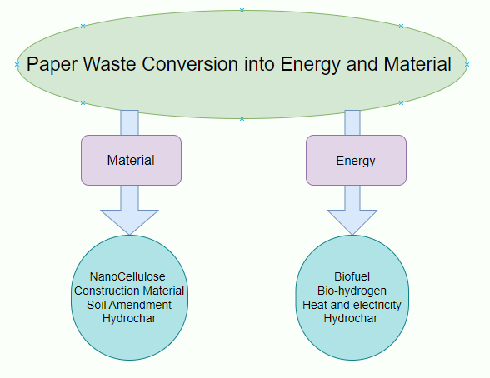
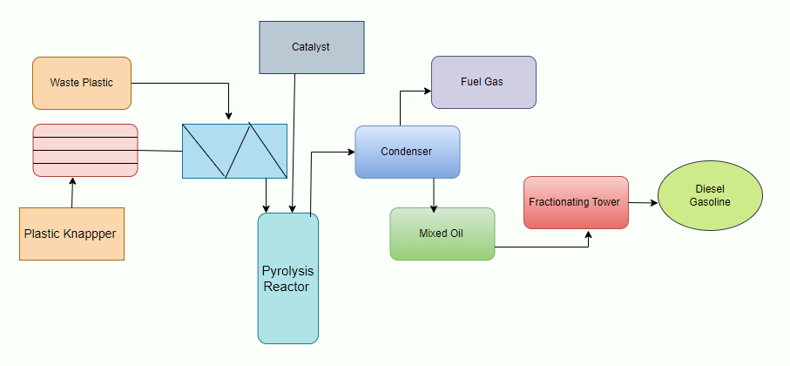
Fig: Pyrolysis Process of generating fuel oil from the waste plastics

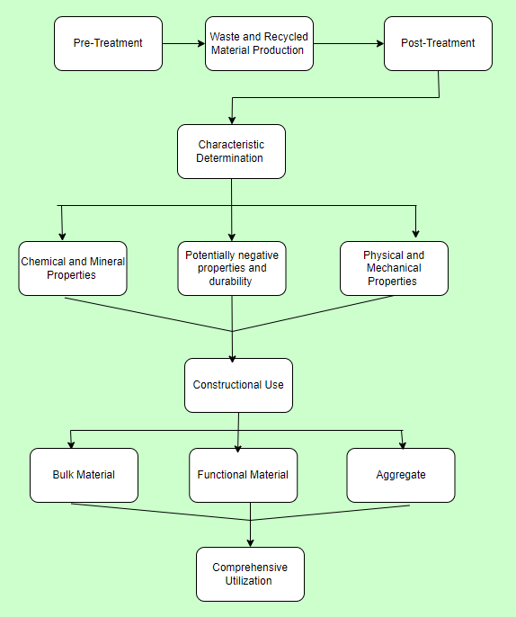
Fig: Conversion Process for application in construction and building

Advantages and Challenges of recycled materials:
- Recycling Serves as Pollution Mitigation: In our contemporary society, all forms of pollution trace their origins back to industrial waste. Consequently, the practice of recycling these industrial byproducts – plastics, cans, chemicals, and the like – assumes a pivotal role in curtailing pollution. The essence lies in the transformation of these waste materials into reusable resources, counteracting the heedless act of their thoughtless disposal.
- Preservation of the Ecosystem Recycling waste materials carries with it a paramount advantage in safeguarding the delicate balance of the natural world. An illustrative case is found in the realm of paper-related goods. The conventional production of such items demands a relentless harvesting of trees to secure the essential raw materials. By opting to recycle paper waste, manufacturers gain access to a novel reservoir of raw materials, thus considerably mitigating the menace of deforestation. This prime example underscores the broader potential of recycling in harnessing other natural resources, channeling them towards productive reuse and thus nurturing the environment
- Mitigation of Global Warming via Recycling: An unequivocal consequence of recycling lies in its direct role in mitigating the perils of global warming and its far-reaching repercussions. The conventional methods of waste disposal, at times, result in chemical reactions between discarded materials, engendering the emission of greenhouse gases like carbon dioxide, sulfur, and nitrogen. These emissions are instrumental in driving climate change and contributing to the overarching concern of global warming.
- Preservation of Vital Resources Without the mechanism of recycling to rely upon, the creation of novel products would hinge solely on the extraction of pristine raw materials from beneath the Earth's surface via mining and extraction processes. Recycling stands as a formidable bulwark against such a scenario, as it champions the safeguarding and preservation of currently available raw materials for prospective utilization. This pivotal approach capitalizes on the existing pool of extracted resources, minimizing the necessity for further extraction. This not only safeguards the future availability of essential resources but also ensures the sustainable and judicious employment of precious assets like minerals, water, and timber.
- Waste Reduction via Recycling Reduces Landfill Burden The transformation of aged and utilized materials into reusable commodities plays a pivotal role in significantly diminishing the potential congestion of landfill sites. This outcome is particularly advantageous due to its contribution to the reduction of both land and water pollution. Landfills, notorious contributors to environmental deterioration, have a significant impact on the degradation of fertile topsoil through erosion. By reducing landfill usage and curbing waste accumulation, the adverse effects on soil quality are mitigated. Furthermore, the redirection of waste away from marine disposal preserves aquatic biodiversity and safeguards oceanic ecosystems.
- Sustainability Anchored in Recycling Practices The practice of recycling ensures the prudent and sustainable utilization of existing resources. This stems from its capacity to counteract the haphazard exploitation of raw materials when they are available in substantial quantities. In response to these imperatives, contemporary governments have taken proactive measures to stimulate recycling initiatives across various strata, encompassing educational institutions, small-scale enterprises, and even international domains.
- Recycling as a Catalyst for Job Creation In addition to its notable environmental benefits, recycling emerges as a catalyst for employment opportunities. The widespread adoption of recycling necessitates the establishment of multiple recycling facilities, triggering a lengthy chain of activities involving collection and transportation. Each stage of this process relies on human labor, thus fostering job creation.
- Diminished Energy Consumption The manufacturing process typically demands substantial energy for the processing of virgin raw materials. Recycling stands as a formidable force in reducing energy consumption, as the energy requirements for recycling are significantly lower compared to the energy-intensive process of working with fresh raw materials. This holds particular significance in extensive production domains like mining and refining. Furthermore, recycling imparts a cost-effective character to the entire production cycle, which proves advantageous for manufacturers.
- Financial Benefits of Recycling: Electronics, discarded water bottles, and various other forms of waste can be converted into a monetary asset when sold. Thus, engaging in the act of selling waste not only contributes to environmental preservation but also yields financial gains. Meanwhile, opting for recycled materials translates into reduced costs, thus facilitating financial savings. Incorporating recycled materials into one's consumption habits generates both economic gains and environmental benefits.
- Catalyst for Environmental Consciousness: Recycling marks the inception of a transformative movement aimed at safeguarding the planet for generations to come. The practice of segregating waste into biodegradable, non-biodegradable, and recyclable categories has sensitized individuals to the importance of recycling while concurrently curbing environmental impact.
- Driving Scientific Progress via Innovation: Scientific strides are instrumental in the creation of products that are less reliant on natural resources, rendering the recycling of a myriad of products more feasible. Cutting-edge sorting technologies can now discern the grade and type of plastics, streamlining processes and reducing landfill contents. Novel polymers can be introduced to polyethylene and polypropylene, resulting in the development of robust plastics that can be easily recycled for a second time.
Disadvantages:
- Challenges of High Initial Investment The cost-effectiveness of recycling is not always assured. Establishing a new waste recycling facility demands a substantial upfront investment. This financial commitment encompasses the acquisition of various utility vehicles, the enhancement of recycling infrastructure, waste and chemical disposal expenditures, as well as community education initiatives through beneficial programs and seminars.
- Unsanitary, Hazardous, and Unsightly Recycling Sites Visiting any waste recycling site frequently unveils conditions that are unsanitary, unsafe, and visually displeasing. The accumulation of diverse waste types creates an environment conducive to the proliferation of disease-causing microorganisms, thereby elevating the risk of spreading infectious ailments. Furthermore, the hazardous chemicals inherent in these wastes pose potential dangers
- Durability Issues with Recycled Products Items fabricated from recycled waste materials may exhibit lower quality and durability. Such products typically originate from discarded materials collected from mountains of other waste, often overused and fragile. Consequently, the durability of products derived from recycled waste tends to be compromised, contributing to their relatively lower cost. Moreover, there is no guarantee that recycling will yield high-quality outputs if the input raw materials are of substandard quality. Some products intended for recycling may face limitations in terms of quality improvement due to the inherent constraints of their original composition.
- Limited Scope of Recycling at Scale Despite its significant role in mitigating pollution, recycling has not garnered widespread adoption and substantial development. Regrettably, recycling remains a modest component in the broader quest for long-term environmental success. While recycling is a prevalent practice in schools and households, its impact has not extended to larger spheres. For instance, its integration into local industries or its comprehensive implementation on a global scale remains incomplete.
- Disparity Between Small-Scale Efforts and Industrial Impact The conservation of trees within educational institutions pales in comparison to the extensive deforestation and oil spills witnessed at industrial levels. The localized recycling efforts within schools and homes stand in stark contrast to the immense ecological impact of large-scale industrial practices.
- Increased Energy Consumption and Pollution The recycling of considerable quantities of waste necessitates a sequence of activities, including transportation, sorting, cleansing, and processing in dedicated facilities. Each of these stages demands energy and may yield by-products that contribute to soil, air, or water pollution. Furthermore, the environmental ramifications extend to the vehicles employed for collecting recyclable materials, as they release airborne toxins into the atmosphere, thereby exacerbating air pollution.
- Generation of Pollutants through Breakdown As waste materials undergo decomposition, the environment can be negatively affected by the emergence of pollutants, including chemical compounds. Toxins and impurities inherent in the original materials, such as lead-based paint or aerosol cans, might persist through the recycling process and find their way into the resulting recycled products. Tragically, the realization of contamination may be delayed by several years. A case in point involves the employment of recycled steel in Taiwanese construction projects, which, unbeknownst to the community, triggered instances of gamma radiation poisoning spanning over a 12-year period.
- Elevated Processing Expenses and Substandard Employment Despite its environmentally friendly nature, recycling frequently grapples with cost inefficiencies. The expenses associated with recycling can be threefold higher than those connected with depositing waste in landfills. Moreover, the recycling process is characterized by its labor-intensive nature. Recycling jobs necessitate a substantial workforce, yet the nature of the work can result in diminished morale and a reduced quality of life for employees, further exacerbated by relatively low remuneration. The bleaching process, in particular, exposes workers to demanding conditions that can jeopardize their health and well-being.

Properties of Recycled Materials:

3.1 Environmental and Economic Benefits of Bio based materials:

Challenges and Innovations:
Employ or Customize Existing Recycling and Treatment Approaches: Utilize or modify established recycling and treatment methods for addressing "future waste" challenges.
Develop and Deploy Recycling and Treatment Technologies Aligned with Set Recycling Targets: Innovate and implement recycling and treatment technologies driven by predefined recycling rates mandated by regulations.
Construct Reuse Strategies, Even for Minimal Waste Reduction: Establish reuse solutions, even if they lead to minor reductions in "future waste" volumes.
Establish Feedback Loops between Recycling and Production Sectors: Introduce mechanisms to share insights from the recycling sector with the production sector, encouraging wider adoption of eco-design methodologies.
Promote Comprehensive Evaluation of Production and Recycling Systems: Encourage the holistic assessment of production and recycling systems linked to specific products or services. This aims to demonstrate the tangible advantages of integrating the eco-design concept.
Implement Incentives to Spur Broader Adoption of Waste Management Alternatives:
Employ drivers like legal mandates, economic incentives, or expanded research initiatives to stimulate the broader implementation of diverse waste management strategies for anticipated "future wastes."

Conclusion
Plastics stand out as one of the most remarkable innovations of our era and have unequivocally lived up to their distinguished repute. Boasting qualities such as lightweight nature, resistance to corrosion and decay, cost-effectiveness, reusability, and an innate ability to conserve natural resources, plastics have rightfully garnered widespread acclaim. Research endeavors centered around plastic pyrolysis, undertaken with varying conditions and catalysts, have been prominently documented. However, a series of ensuing challenges necessitate imminent resolution. These include the imperative scaling up of operations, the reduction of waste handling and production costs, and the optimization of gasoline range products to accommodate an extensive array of plastic blends and waste compositions.
The copious volumes of plastic waste generated can potentially be addressed through meticulously designed methodologies that yield substitutes for fossil fuels. Such an approach, contingent on adequate infrastructure and financial backing, holds a superior stance both ecologically and economically. By devising a proficient process capable of converting waste plastic into hydrocarbon fuel, a financially viable alternative to petroleum, free from polluting emissions, can be realized. This strategy would also effectively tackle the predicament of hazardous plastic waste while concurrently curbing crude oil imports.
The primary challenge pertains to formulating standardized protocols for the post-consumer recycled plastic process and resultant products, alongside embracing advanced pyrolysis technologies tailored to the intricacies of waste plastic. The design of the pyrolysis reactor necessitates adaptability to heterogeneous waste plastic compositions and the facilitation of small and medium-scale production. Furthermore, judicious analysis promises reductions in capital expenditure and operational costs, consequently augmenting the economic feasibility of the entire process.

References:
  - Abushammala, H.; Ghulam, S.T. Impact of Residents’ Demographics on Their Knowledge, Attitudes, and Practices towards Waste Management at the Household Level in the United Arab Emirates. Sustainability 2023, 15, 685.
  - Dori, Y.J.; Tal, R.T. Formal and informal collaborative projects: Engaging in industry with environmental awareness. Sci. Educ. 2000, 84, 95–113
  - Pawar, K.; Rothkar, R.V. Forest conservation & environmental awareness. Procedia Earth Planet. Sci. 2015, 11, 212–215.
  - Miranda Carreño, R.; Blanco Suárez, Á. Environmental awareness and paper recycling. Cellul. Chem. Technol. 2010, 44, 431–449
  - Saphores, J.-D.M.; Nixon, H. How effective are current household recycling policies? Results from a national survey of U.S.households. Resour. Conserv. Recycl. 2014, 92, 1–10.
  - Lizin, S.; Van Dael, M.; Van Passel, S. Battery pack recycling: Behaviour change interventions derived from an integrative theory of planned behaviour study. Resour. Conserv. Recycl. 2017, 122, 66–82.
  - Hameed, M., Ahmadalipour, A., & Moradkhani, H. (2018). Apprehensive drought characteristics over Iraq: results of amultidecadal spatiotemporal assessment. Geosciences, 8(2), 58.
  - White, K.M.; Hyde, M.K. The role of self-perceptions in the prediction of household recycling behavior in Australia. Environ.Behav. 2011, 44, 785–799.
  - Tsai, F.M.; Bui, T.-D.; Tseng, M.-L.; Lim, M.K.; Hu, J. Municipal solid waste management in a circular economy: A data-driven bibliometric analysis. J. Clean. Prod. 2020, 275, 124-132.
  - Cobo, M.J.; López-Herrera, A.G.; Herrera-Viedma, E.; Herrera, F. SciMAT: A new science mapping analysis software tool. J. Am. Soc. Inf. Sci. Technol. 2012, 63, 1609–1630.
  - Bamberg, S.; Möser, G. Twenty years after Hines, Hungerford, and Tomera: A new meta-analysis of psycho-social determinants of pro-environmental behaviour. J. Environ. Psychol. 2007, 27, 14–25

