D. GAYATHRY
Research Scholar,
Department of Computer Science
St. Peter's Institute of Higher Education and Research
Chennai - 600 054, Tamil Nadu, INDIA
gaya200689@gmail.com

Dr. R. LATHA Professor & Head
Department of Computer Science & Applications
St. Peter's Institute of Higher Education and Research
Chennai - 600 054,INDIA
latharamavel@gmail.com

REAL TIME FACE RECOGNITION AND DETECTION USING DEEP LEARNING ALGORITHM

Abstract: Nowadays, face recognition is a reliable and accurate
access control technique which is used along with other biometric methods. Face recognition is a process of recognizing the face sample of particular person from the set of face samples stored in the system. It can be done by converting images into digital binary representation to extract features using various techniques. In this paper, we propose a real time face recognition system which implemented using VGG16 architecture of Convolutional Neural Networks (CNN) and Transfer Learning. Convolutional Neural Networks are special type of deep learning neural networks which mainly used for image classification. OpenCV open-source library is used for image pre-processing. The experimental results indicates that an average accuracy of 97- 99% is achieved and hence this is one of the best methods for face recognition.

Index Terms - Face Recognition, Convolutional Neural Networks, Deep Learning.

- INTRODUCTION
In 21st century, many access control methods are available to ensure security. Most of the methods based on biometrics verification. Face recognition is widely used in public security, daily life, military areas, banks as an access control method for identifying a person. Face recognition system is one of the major applications of computer vision. A facial recognition system is a technology capable of matching a human face from a digital image or a video frame against a database of faces, typically employed to authenticate users through ID verification services. With the development of deep learning, face recognition technology based on CNN (Convolutional Neural Network) has become the main method adopted in the field of face recognition. With the development of convolutional neural networks, the achievements made in various competitions are getting better and better, making it the focus of research. Convolutional neural networks are reliable, accurate and minimizes data pre-processing. In this paper we are using OpenCV open-source library for image pre-processing tasks like face detection, face alignment and face cropping. On the other hand, Convolutional Neural Networks are used for extracting features from images, training, and testing face recognition model. The experiment is carried out by collecting the face samples of 20 persons of age between 20 to 45 years. These 20 persons include 10 male and 10 females. The obtained results are compared with other face recognition techniques. The results proves that the face recognition system using convolutional neural networks has better accuracy than other techniques like PCA (Principal Component Analysis), LDA (Linear Discriminant Analysis), LBP (Local Binary Pattern), Gabor filter, LGBP (Local Gabor Binary Pattern) . The rest of the paper is organized as follows. Section II discuss about previous work and literature survey. In Section III Proposed work consist of overall system architecture and methodology. In Section IV results are discussed in detail. Paper concluded in section V.
- RELATED WORK
In recent years variety of research and methods are discovered to
execute face recognition and to increase accuracy of face recognition system. In authors have implemented face recognition based on convolutional neural network which consist of three convolutional layers, two pooling layers, two fully connected layers and one regression layer. For training and feature extraction Stochastic gradient decent algorithm is used. In authors have proposed the face recognition system using improved CNN with the development of computer vision and artificial intelligence. Author have tested the model for activation function accuracy, dropout layer accuracy and overall system accuracy. In the authors have described face recognition system using deep learning CNN. Authors used triplet loss function to tweak neural network weights. With the help of KNN model classification the overall system accuracy achieved around 95%. In authors have implemented face recognition system with the help of hybrid feature extraction method using CNN-PCA (Convolutional Neural Network - Principal Component Analysis). Histogram equalization method of contrast-brightness adjustment is used to improve facial recognition process. After performing experiment, the accuracy produced by PCA algorithm was in between 90- 96%, on the other hand CNN-PCA method gives accuracy up to 98%. In authors have proposed a face recognition system using CNN with Dlib face alignment. The proposed system mainly focused on face alignment and reduction of False Acceptance Rate (FAR). The face recognition model gives overall accuracy of 96% on Face Recognition Grand challenge (FRGC) dataset. In this paper authors have briefly discussed about development stage of face recognition and different early-stage algorithms like Principal Component Analysis (PCA) and Linear Discriminate Analysis (LDA). Authors also discussed about different artificial features and classifiers including Support Vector Machine (SVM), Adaboost etc. In authors have
implemented a face recognition algorithm for biometric based attendance system. This paper shows accuracy comparison between face recognition algorithms Eigenface and Fisherface provided by OpenCV According to research Eigenface achieves better result than Fisherface. In this paper authors have discussed how Convolutional Neural Network (CNN) work. Authors also discussed about different layers of CNN, their mathematical computations and working with diagrams, data transfer between different layers of CNN. In authors have created image classification model based on simple convolutional neural network. Also, author studied different learning rate methods and optimization algorithms with their parameters for image classification. The proposed model is tested on cipher-10 and MNIST dataset for error rate calculation. In authors have discussed about different face detection techniques like skin likelihood image, skin segmentation etc. and some face recognition techniques.
- PROPOSED WORK

System Overview
The main objective of proposed system to increase accuracy of face recognition system with the help of transfer learning and VGG16 CNN method. The proposed system is an IOT based system having real time face recognition functionality. The proposed architecture of the face recognition system as shown in Figure 1.

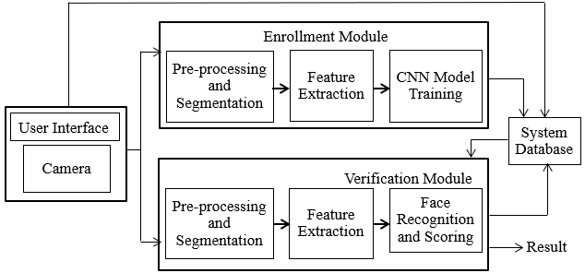
Figure 1: System Architecture

The proposed system is divided into 4 main part User Interface, Enrolment Module, Verification Module and Database. System starts by collecting face samples of users with the help of camera module. In enrolment module, the collected face samples from user are undergo pre-processing and then stored to the train folder. Verification module contains CNN model training and testing. While face recognition user’s face is extracted from continuous stream of video and compare with trained model. Based on CNN model prediction result will be generated.

Methodology
The workflow diagram of proposed system is as shown below. In machine learning data is centralized and important entity. For training of CNN model, we collected data of 20 persons. For each person 30 images were collected for training set and 5 images for validation dataset.

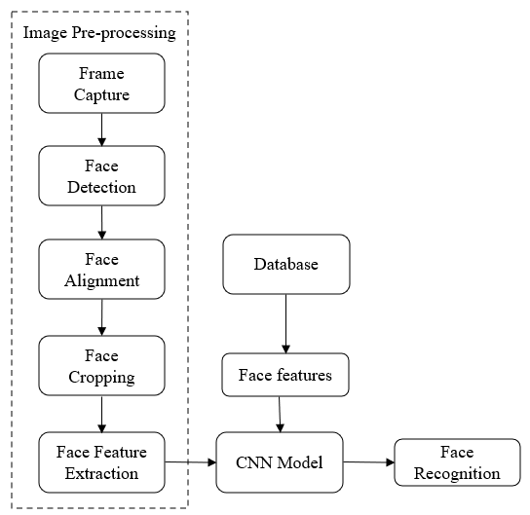
Figure 2: Workflow Diagram

The first step of face recognition system is face detection from a continuous stream of video. Accurate and errorless face detection is very important for greater accuracy of the system. The task of face detection comes under computer vision technology. This is done with the help of pre trained classifier named as haarcascade_frontalface_default.xml. This classifier is trained on tones of images. This classifier detects faces in grayscale images only. Fig.3 Showed the input image and detected face with the help of OpenCV library.

Figure 3: i) Normal image ii) Detected face

Open CV is an open-source library which provides best environment for developing and designing different systems which requires image pre-processing. Usually, not all the detected faces are in properly aligned order. Which creates error in face recognition process. Therefore, the cropped face images must be aligned before feeding them to the neural network to achieve high accuracy in face recognition process. In this process we transform specific set of points from input image into output coordinate system. Output coordinate system based on the concept of nodal points. There are 80 different nodal points on our face which includes eye socket, jawline length, distance between eyes, cheekbone shape, nose width etc. Before feature extraction we must extract particular part of image on which we are going to train CNN model. This includes removal of unwanted part from image and keeping desired aligned face. We are using cropped face image of resolution 224 x 224 for better accuracy. These cropped faces will be stored into the train folder.

The most crucial thing of this system is feature extraction from aligned faces. Feature extraction is done by CNN, because in deep learning CNN are used to work on data having grid-like topology e.g., images. CNN can extract 128-d vectors from aligned faces. It forms digital image which is binary representation of graphical image. This digital image will be used further for model training. We used pretrained VGG16 architecture of convolutional neural network. VGG16 takes input image of size 224 x 224 which contains three channels R, G and B respectively .

On input image process of normalization of RGB values for each pixel performed. It is done by subtracting mean value from each pixel value. After that image is passed to initial two convolution layers of size 3 x 3, which followed by max pooling layer . This stack of layers stores spatial resolution. The feature map of image is generated and passed to the next stack of layers. Generated feature map is of same size as input image. In similar way feature map is passed through different stacks of convolution and pooling layers. At the end there are three fully connected layers. First 2 fully connected layers contains 4096 neurons and last layer act as output layer with 1000 neurons representing 1000 classes. Output of last layer passed to the SoftMax function for normalizing the output and we get normalized feature vectors . Using those VGG16 predict the exact class of the image. In this way cnn model is trained for face recognition.

At the time of face recognition, with the help of OpenCV system detect face in continuous stream of video and extract features from it. This face will be given to cnn model to predict. Finding patterns in extracted pixels of the images is the main goal of Convolutional Neural Networks. This helps CNN to identify targets of the classification. By using those patterns, we can classify our images to their correct classes. Classification is done by passing those patterns from one layer to another layer to find best class which matched to those patterns. Based on prediction the class name is displayed on the face by making a rectangle around detected face in video stream.
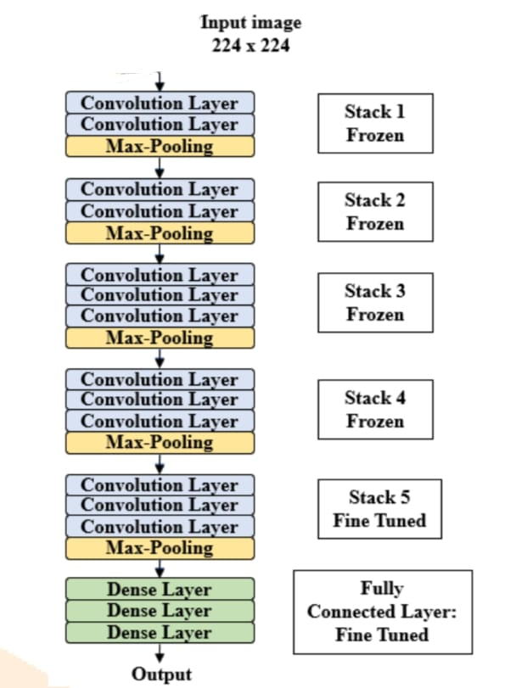

Figure 5: VGG16 Architecture

- RESULT AND DISCUSSION
The overall accuracy of the system is calculated by performing the following experiment: The faces of 20 users were collected and after performing image preprocessing tasks like face detection, face alignment, face cropping the samples are stored into train folder. For each person 30 images are captured. After collecting face samples VGG16 cnn model is trained based on train dataset. The trained model saved for face recognition.
The experiment was performed on 20 users containing 10 male and 10 female. The proposed model is tested in real time. Each user comes in front of camera 5 times. The system detected faces from video stream and predict the name of the user. After the face recognition process experiment results stored for the further evaluation.
The experiment is carried out on NVIDIA Jetson Nano Development kit, which is small, powerful computer to run neural networks.
We used TensorFlow, Keras as deep learning framework. We set batch sizes equal to 32. We used Adam optimizer function.

- Effect of no. of users:
There is considerable impact of number of users on the system. We started with 4 users and increase the no of users up to 20. When there were only 4 users, the accuracy of the system was almost 99%. But after increasing the number of users to the 20 the accuracy of the system decreases to approximately 97%. So, there is slight decrease in the accuracy after increasing no of users.

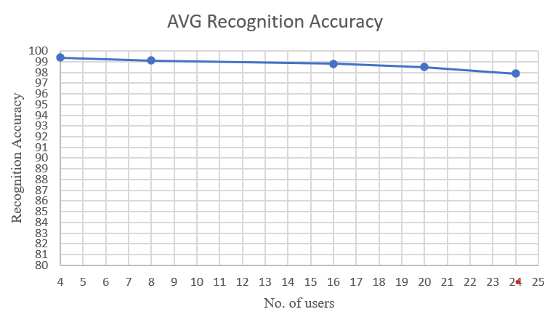

Figure 5: Average Recognition Accuracy

ii )Effect of facial expressions and occlusion:
Small change in face feature can decrease the accuracy of face recognition system. Accuracy may be affected due to expressions like laugh, crying etc. Because expressions lead to change in face geometry. Another factor that affects to the accuracy is occlusion of the face due to face mask, spectacles, earrings. Also, this happens because of hair, mustache, and beard. Due to facial expressions and occlusion of face system fails to identify the person and accuracy of the system decreases.
iii)Effect of other factors:
There are some more important factors which lower down accuracy of face recognition system. Lowresolution images affect the accuracy of the system. Noise present in images of different type like Gaussian, Poisson Speckle etc. This noise performs major role while accuracy calculation. Light and shadow falling on face also reduces the recognition accuracy.

iv)Overall accuracy:

The experimental results of proposed face recognition system also compared with other methods. The following comparison table shows the identification accuracy of different techniques. From the comparison table, it is clear that proposed system gives better accuracy as compared to other methods. VGG16 model with transfer learning gives good accuracy rate.

Table 4.1: Accuracy Comparison

Techniques | Accuracy
VGG16 | 94.4%
Normal CNN | 93%
CNN+PCA | 95%

- CONCLUSION

In this work, a real time face recognition system using VGG16 architecture of CNN is implemented. Also, we used transfer learning methodology to acquire good accuracy. System can detect and identify the face present in continues stream of video. The implementation process includes collection of face samples, image preprocessing, model training and face recognition task. An average recognition accuracy of 97-99 % is achieved as shown in figure 6. Further the proposed system is analyzed based of no. of speakers, effect of light, effect of facial expressions, occlusion, effect of low-resolution images, light, shadow, and noise etc. After performing the experiment, the results shows that system gives better face recognition accuracy up to 20 users. It can be concluded that, VGG16 convolutional networks with transfer learning save a lot of computational power and we can run neural network smoothly on low end devices. Also, it gives high accuracy with less no. of images.

REFERENCES

- T. Guo, J. Dong, H. Li and Y. Gao, "Simple convolutional neural network on image classification," 2017 IEEE 2nd International Conference on Big Data Analysis (ICBDA), 2017, pp. 721-724, doi: 10.1109/ICBDA.2017.8078730.

- K. Yan, S. Huang, Y. Song, W. Liu and N. Fan, "Face recognition based on convolution neural network," 2017 36th Chinese Control Conference (CCC), 2017, pp. 4077-4081, doi: 10.23919/ChiCC.2017.8027997.
- D. Wang, H. Yu, D. Wang and G. Li, "Face Recognition System Based on CNN," 2020 International Conference on Computer Information and Big Data Applications (CIBDA), 2020, pp. 470-473, doi: 10.1109/CIBDA50819.2020.00111.
- M. Heidari and K. Fouladi-Ghaleh, "Using Siamese Networks with Transfer Learning for Face Recognition on Small-Samples Datasets," 2020 International Conference on Machine Vision and Image Processing (MVIP), 2020, pp. 1-4, doi: 10.1109/MVIP49855.2020.9116915.
- M. Owais, A. A. Jalal, M. M. Hassan and A. Shaikh, "Facial Recognition based Attendance System Using CNN and Raspberry Pi," 2020 4th International Symposium on Multidisciplinary Studies and Innovative Technologies (ISMSIT), 2020, pp. 1-5, doi: 10.1109/ISMSIT50672.2020.9254300.
- E. Winarno, I. Husni Al Amin, H. Februariyanti, P. W. Adi, W. Hadikurniawati and M. T. Anwar, "Attendance System Based on Face Recognition System Using CNN-PCA Method and Real-time Camera," 2019 International Seminar on Research of Information Technology and Intelligent Systems (ISRITI), 2019, pp. 301-304, doi: 10.1109/ISRITI48646.2019.9034596.
- S. Sharma, K. Shanmugasundaram and S. K. Ramasamy, "FAREC — CNN based efficient face recognition technique using Dlib," 2016 International Conference on Advanced Communication Control and Computing Technologies (ICACCCT), 2016, pp. 192-195, doi: 10.1109/ICACCCT.2016.7831628.
- L. Li, X. Mu, S. Li and H. Peng, "A Review of Face Recognition Technology," in IEEE Access, vol. 8, pp. 139110-139120, 2020, doi: 10.1109/ACCESS.2020.3011028.
- A. R. S. Siswanto, A. S. Nugroho and M. Galinium, "Implementation of face recognition algorithm for biometrics based time attendance system," 2014 International Conference on ICT For Smart Society (ICISS), 2014, pp. 149-154, doi: 10.1109/ICTSS.2014.7013165.
- S. Albawi, T. A. Mohammed and S. Al-Zawi, "Understanding of a convolutional neural network," 2017 International Conference on Engineering and Technology (ICET), 2017, pp. 1-6, doi: 10.1109/ICEngTechnol.2017.8308186.

