DOSAGE FORM DESIGN
Keshav Kumar, Dr. Rupali Sharma, Dr. Satish Sardana, Mr. Shekhar Sharma
Amity Institute of Pharmaceutical Sciences
Amity University,
Gurugram, Haryana, INDIA

ABSTRACT
Prodrugs are chemically modiﬁed derivatives introduced in therapy due to their advantageous physico-chemical properties (greater stability,
improved solubility, increased permeability), used in inactive form. Biological effect is exerted by the active derivatives formed in organism
through chemical transformation (biotransformation).
Prodrugs are chemically modiﬁed derivatives introduced in therapy due to their advantageous physico-chemical properties (greater stability,
improved solubility, increased permeability), used in inactive form. Biological effect is exerted by the active derivatives formed in organism
through chemical transformation (biotransformation).
Prodrugs are chemically modiﬁed derivatives introduced in therapy due to their advantageous physico-chemical properties (greater stability,
improved solubility, increased permeability), used in inactive form. Biological effect is exerted by the active derivatives formed in organism
through chemical transformation (biotransformation).
Prodrugs are chemically modiﬁed derivatives introduced in therapy due to their advantageous physico-chemical properties (greater stability,
improved solubility, increased permeability), used in inactive form. Biological effect is exerted by the active derivatives formed in organism
through chemical transformation (biotransformation).
Prodrugs are chemically modiﬁed derivatives introduced in therapy due to their advantageous physico-chemical properties (greater stability,
improved solubility, increased permeability), used in inactive form. Biological effect is exerted by the active derivatives formed in organism
through chemical transformation (biotransformation).
The design of dosage forms is a pivotal endeavour within the realm of pharmaceutical sciences, encompassing the intricate interplay between active pharmaceutical ingredients (APIs) and formulation components to achieve optimal therapeutic outcomes. This chapter delves into the multifaceted landscape of dosage form design, exploring the nuanced considerations that underpin the creation of effective, safe, and patient-centric drug delivery systems. Commencing with an introduction to dosage forms, the chapter elucidates the critical role they play in pharmaceuticals, encapsulating a diverse spectrum of solid, liquid, semi-solid, and gaseous entities. Fundamental physicochemical principles governing solubility, dissolution kinetics, and particle characteristics are expounded, providing a foundation for the subsequent design strategies. A comprehensive exploration of drug excipients and formulation components ensues, accentuating their significance in tailoring drug release, stability, and bioavailability. The intricate artistry of solid dosage forms, including tablets and capsules, is deconstructed, encompassing formulation intricacies, compression techniques, and coating methodologies. Liquid dosage forms, from solutions to suspensions, are scrutinized for their formulation challenges and stability considerations, while semi-solid entities such as creams, ointments, and transdermal patches are dissected for their diverse applications. Intriguing forays into parenteral and gaseous dosage forms reveal the precision demanded by injectable solutions, suspensions, and inhalation aerosols. A meticulous evaluation of dosage form attributes is presented, illuminating the role of in vitro dissolution testing, stability studies, and bioavailability assessments. Biopharmaceutics and pharmacokinetics are intricately woven into the narrative, unravelling the influence of dosage form design on drug absorption, distribution, metabolism, and excretion. Nurturing an appreciation for regulatory imperatives, the chapter underscores the alignment of dosage form design with stringent guidelines and standards. Furthermore, emerging trends in the field, including nanotechnology's impact on drug delivery and the advent of personalized medicine, are showcased, offering a glimpse into the evolving landscape of pharmaceutical innovation.
In summation, the "Dosage Form Design" chapter unveils the symphony of art and science that orchestrates the creation of dosage forms, fostering an understanding of the pivotal factors governing their design, development, and evaluation. It stands as a testament to the collaborative efforts of pharmaceutical scientists, chemists, engineers, and regulatory experts in crafting pharmaceutical formulations that optimize therapeutic potential while safeguarding patient well-being.

INTRODUCTION
The "Dosage Form Design" chapter is an important component of pharmaceutical sciences and formulation development. This chapter focuses on the various aspects of designing dosage forms, which are the specific formulations of medications that are administered to patients. The design of dosage forms is crucial to ensure the effective delivery of drugs, patient compliance, stability, and safety. The field of pharmaceutical science is dedicated to improving human health through the development and delivery of effective medications. Central to this endeavor is the design and formulation of dosage forms, which serve as the means by which drugs are administered to patients. The Dosage Form Design chapter is an exploration into the art and science of crafting these specialized drug delivery systems.
In this chapter, we will delve into the intricate world of dosage form design, where pharmaceutical scientists and engineers harness their expertise to create formulations that optimize drug absorption, bioavailability, stability, and patient compliance. It is within these pages that we will uncover the key principles and considerations that underpin the development of tablets, capsules, injections, creams, ointments, and a multitude of other dosage forms.
From the initial concept and selection of suitable excipients to the intricate details of manufacturing processes and quality control, this chapter will illuminate the path that transforms a drug molecule into a safe, effective, and convenient form of medication. Dosage form design not only plays a critical role in the pharmaceutical industry but also has a profound impact on patients' lives by ensuring the right drug reaches the right place in the right amount at the right time.
Join us on a journey through the intricacies of dosage form design, where science meets art, and innovation meets the imperative of improving healthcare worldwide. Whether you are a budding pharmaceutical scientist, a healthcare professional, or simply curious about the fascinating world of drug delivery, this chapter will provide you with valuable insights into the heart of pharmaceutical innovation and patient care.
Here are some key topics that are typically covered in a "Dosage Form Design" chapter:
CHARACTERISTICS OF IDEAL DOSAGE FORM
Dosage forms are pharmaceutical products that involve combination of active drug and non-drug substances, along with other non-recoverable materials. Drug needs to be in the most convenient and proper form, so that it reaches to the desired site of action, which is greatly influenced by the types of dosage form of the drug as on the basis of characteristics and advantage.
Many factors specify the characteristics of an ideal dosage form. Ideal Dosage Form should be:
• Easy and safe to administer
• Easy to handle
• Easy to reproduce and manufacture
• High patient compliance
• Efficacious
• Physically and chemically stable
• Biocompatible
• Economical to the patient
• Maintain its therapeutic activity throughout the shelf life

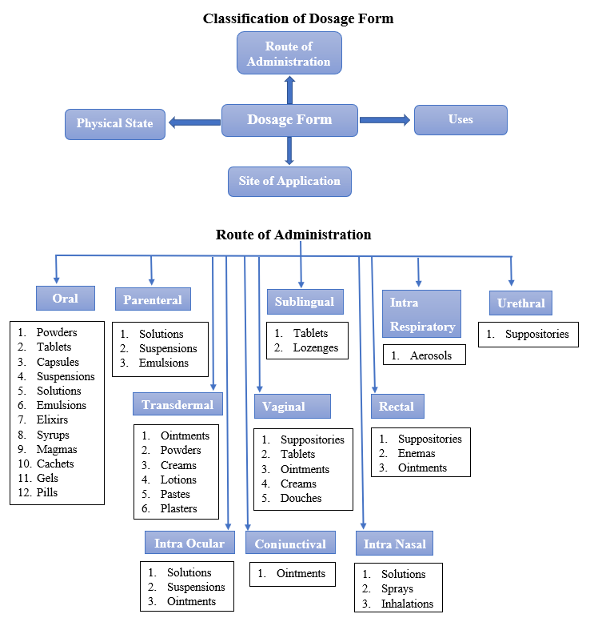

CLASSIFICATION
- Introduction to Dosage Forms:
Definition and importance of dosage forms in pharmaceuticals.
Various types of dosage forms: solid, liquid, semi-solid, and gaseous.

- Physicochemical Considerations:
Solubility and dissolution kinetics of drug substances.
Particle size reduction techniques (milling, micronization) for improving solubility.
Polymorphism and its impact on formulation stability and bioavailability.
- Drug Excipients and Formulation Components:
Role of excipients in dosage form design (binders, fillers, disintegrants, lubricants, etc.).
Compatibility studies to ensure the stability of drug-excipient combinations.
- Solid Dosage Forms:
Tablets: formulation considerations, compression techniques, coating, and tablet disintegration.
Capsules: capsule types, formulation challenges, and encapsulation methods.
- Liquid Dosage Forms:
Solutions, suspensions, and emulsions: formulation considerations, stability, and particle settling.
Syrups, elixirs, and oral drops: sweetness, flavoring, and preservation.
- Semi-Solid Dosage Forms:
Creams, ointments, gels, and pastes: formulation challenges, consistency, and penetration.
Transdermal patches: design considerations, adhesive technologies, and controlled drug release.
- Parenteral Dosage Forms:
Injectable solutions and suspensions: particle size, sterility, and pH considerations.
Intravenous infusion: compatibility with infusion materials and intravenous delivery systems.
- Gaseous Dosage Forms:
Inhalation aerosols: propellants, particle size, and delivery devices.
Gases for medical use: oxygen, nitrous oxide, and their administration methods.
- Dosage Form Evaluation:
In vitro dissolution testing for solid dosage forms.
Stability testing: shelf-life determination and degradation studies.
Bioavailability and bioequivalence studies.
- Biopharmaceutics and Pharmacokinetics:
Factors affecting drug absorption, distribution, metabolism, and excretion.
Importance of dosage form design on drug bioavailability.
- Regulatory Considerations:
Compliance with regulatory guidelines for dosage form development and registration.
Documentation and reporting requirements for clinical trials and marketing approval.
- Emerging Trends in Dosage Form Design:
Nanotechnology and its applications in drug delivery.
Personalized medicine and individualized dosage forms.
Advanced drug delivery systems, such as liposomes, nanoparticles, and micelles.

CONCLUSION
In summary, the "Dosage Form Design" chapter delves into the principles and considerations involved in developing various dosage forms to ensure effective drug delivery, patient safety, and product stability. It's an interdisciplinary field that combines knowledge from pharmaceutics, chemistry, engineering, and regulatory affairs to create pharmaceutical products that meet the needs of patients and healthcare professionals.

REFERENCES
- Garcia Sagredo, K, Guzman, M., Molpereces, J., Aberturas, M.R. (1994) Pluronic copolymers - characteristics, properties and pharmaceutical applications. Pharm. Tech. Europe, 1, 46-56, 2, 38-44.
- Lee, R.L.H. (1985) Aust.J. of Hasp. Pharm., 15, 233 Pagington, I.S. (1987) /3-cyclodextrin: the success of molecular inclusion. Chemistry in Britain, 23, 455.
- Stella, V.J. and Rajewski, R.A. (1997) Cyclodextrins: their future in drug formulation and delivery. Pharm. Res., 14, 556-567. Szejtli, J. (1994) Medicinal applications of cyclodextrins. Med. Res. Rev., 14, 353-386.
- Allen LV Jr, ed. The Art, Science, and Technology of Pharmaceutical Compounding. 3rd ed. Washington, DC: American Pharmacists Association; 2008.
- Allen LV Jr, ed. Suppositories. 1st ed. London, UK: Pharmaceutical Press; 2007.
- Allen LVJR, Popovich NG, Ansel HC, eds. Ansel's Pharmaceutical Dosage Forms and Drug Delivery Systems. 8th ed. Philadelphia, Pa: Lippincott Williams & Wilkins; 2005.
- Anonymous. Remington: The Science and Practice of Pharmacy. 21st ed. Baltimore, Md: Lippincott Williams & Wilkins; 2006.
- Sinko PJ. Marlin's Physical Pharmacy and Pharmaceutical Sciences. 5th ed. Baltimore, Md: Lippincott Williams & Wilkins; 2006.
- USP Pharmacists' Pharmacopeia. 2nd ed. Rockville, Md: United States Pharmacopeial Convention, Inc; 2008:775-779.

e of the eective methods of modern research in the
eld of medicine is the development of prodrugs that have
gained increasingly more importance in current therapy
One of the eective methods of modern research in the
eld of medicine is the development of prodrugs that have
gained increasingly more importance in current therapy
UPDATE
Acta Medica Marisiensis 2016;62(3):356-362 DOI: 10.1515/amma-2016-0032
Prodrug Strategy in Drug Development

Pharmacy, Tîrgu Mureş, Romania
Prodrugs are chemically modiﬁed derivatives introduced in therapy due to their advantageous physico-chemical properties (greater stability,
improved solubility, increased permeability), used in inactive form. Biological effect is exerted by the active derivatives formed in organism
through chemical transformation (biotransformation). Currently, 10% of pharmaceutical products are used as prodrugs, nearly half of them
being converted to active form by hydrolysis, mainly by ester hydrolysis. The use of prodrugs aims to improve the bioavailability of compounds
in order to resolve some unfavorable characteristics and to reduce ﬁrst-pass metabolism. Other objectives are to increase drug absorption,
to extend duration of action or to achieve a better tissue/organ selective transport in case of non-oral drug delivery forms. Prodrugs can be
characterized by chemical structure, activation mechanism or through the presence of certain functional groups suitable for their preparation.
Currently we distinguish in therapy traditional prodrugs prepared by chemical derivatisation, bioprecursors and targeted delivery systems. The
present article is a review regarding the introduction and applications of prodrug design in various areas of drug development.
Keywords: prodrugs, classiﬁcation of prodrugs, drug development, optimization of bioavailability
Received: 01 October 2015 / Accepted: 04 July 2016
Introduction

