# 

# 

# LAMINATES AND VENEERS

Esthetics has been a matter of necessary concern to the dentist. It is predicted that the demand for esthetic dental services will continue to grow, prompted by an increasing population of consumers with more knowledge in esthetic dental care options.

Silicate cements are translucent and were used as anterior permanent esthetic filling material. Silicates have lost popularity due to its many disadvantages like irritation to the pulp, lack of adhesion, high solubility in saliva and it contracts on setting leading to marginal leakage causing discoloration which affects esthetics.

Clinicians have long sought an effective method to replace missing teeth without having to reduce the adjacent teeth as abutments for fixed partial dentures. The advent of dental adhesive systems initiated the concept of bonding a pontic (such as an acrylic resin denture tooth) to the interproximal surfaces of enamel on the tooth adjacent to the space.

The advent of bonding provided the concerned dentist with the means to attach composite resins in their various shades, to the tooth surface in order to create esthetic illusions or to change the color, form and position of anterior teeth.

# Several techniques for fabricating and adapting dental laminates have been developed. Initially, veneering was a technique of bonding composite material directly to the entire labial surface of the tooth.

An esthetic and permanent restorative material that could be placed directly onto the prepared anterior teeth would be an important contribution to dental practice and patient well-being. A material which would have less solubility, sensitivity to desiccation, and brittleness than the silicate cements and having greater dimensional stability than the methyl methacrylate direct filling resins has been in demand for many years.

Dental porcelain has become the most widely used material for the fabrication of crowns in dentistry because of its excellent esthetic properties and its ability to closely duplicate the appearance of natural tooth structure. The crystalline structure of porcelain gives it optical refractive properties similar to those of translucent enamel. Glazed porcelain surfaces being smooth in texture, resistant to wear and discoloration, are also durable.

Laminate veneer restorations have a unique position in today's dental practice. These are conservative restorations, a factor which is especially important for young permanent dentitions and offer impressive esthetics with the ultra-thin porcelain laminate veneers retained with resinous cement. Some indications for their use are restoration of discolored anterior teeth caused by tetracycline staining, fluorosis, developmental malformation, including hereditary hypoplasia, which may be corrected using this technique. Traumatic fractures and non-vital teeth may also be treated by this procedure.

The use of organic surface treatments to improve the union between ceramics and plastics is well established in dentistry. In certain aspects such as the preservation of more tooth structure and the elimination of soluble cement, the etched porcelain restorations may well be superior to the conventionally used ceramic crowns.

Porcelain veneers can be considered to be very much the "State-of-the-art" in cosmetic dentistry because they offer innumerable advantages over any previous form of veneering systems

HISTORICAL PERSPECTIVES

**Buonocore’s** early research on the enamel acid etched technique combined with **Bowen’s** development of resin composite systems provided the clinician with the ability to bond tooth coloured veneering materials to esthetically compromised teeth. This art of veneering teeth has progressed over the past 25 years so that today it can be categorized into two main cements:

1. *Directly fabricated veneers.* These are composite resin materials applied to the tooth freehand by the clinician.
2. *Indirectly fabricated veneers.* These are laboratory fabricated veneers developed on a cast of the patients mouth. This category can be further subdivided according to the materials used: composite and etched porcelain. Furthermore the etched porcelain can be sub classified into conventionally baked porcelain and cast porcelain veneers.

## **DIRECT VENEERS**

**Buonocore's** research of the acid etch technique in 1955, combined with **Bowen's** later use of filled resins, provided the technology enabling mechanical bonding between etched tooth and filled resins (direct bonding). Although these were major breakthroughs in dental research in the early 1960's, less importance was given to esthetics in bonding technology for nearly a decade. This was partially due to the limitations of the self-curing resins which did not allow sufficient working time for the dentist to re-create a labial surface before thecomposite resin chemically cured itself. Not until

the 1970's did the practice of bonding composite resin directly to teeth for esthetic improvement grow in popularity.

The introduction of light-cured composite resins in the early to mid 1970's allowed the dentist greater flexibility. The advantages of visible light-cured composite resins such as greater working time and improved chemistry marked the entry of next generation of esthetic materials. Visible light-cured composite resins were replacing self cured composite resins by the later 1970's and were preferred for esthetic anterior restorations. The fabrication of direct composite veneers are invariably more time consuming and are obviously considerably more complex because of the technique sensitivity and procedural limitations within the confines of the oral cavity. They are dependent on the dentist’s technical skills and artistic ability to create that ultimate result.

The direct form of veneers is mostly indicated when closing small diastemas or repairing fractured teeth. In these situations, the composite veneering material can be bonded to the tooth and readily matched within the confines of the patient’s mouth and blended in so that they are almost unnoticeable.

## **INDIRECT VENEERS**

The idea of restoring teeth for the esthetic purpose became more widely accepted by the dental community as new esthetic restorativetechniques and materials became available. **Faunce** described a one-piece acrylic resin prefabricated veneer as an improved alternative to direct acid-etched bonding. By using a chemical primer applied to the veneer and a composite resin to lute the veneer onto an etched tooth, both a chemical and mechanical bond contributed to the attachment. It was more stain resistant than composite resin veneers, but numerous preformed acrylic resins delaminated at the laminate/composite interface, usually due to the weak chemical bond. Like composite resins they also exhibited poor resistance to abrasion.

The inherent advantage to laboratory fabricated veneers is the anatomical accuracy created by the technician, thus alleviating the chair side artistry required with directly applied veneers. Laboratory formed acrylic resin veneers and laboratory formed microfill resin veneers offer a smooth surface, good masking ability, and very little finishing, if they are completed properly. However their esthetics, strength, and longevity can be surpassed by porcelain laminates.

## **PORCELAIN VENEERS**

**Glazed** porcelain has a long history of use in dentistry as one of the most esthetic and biocompatible materials available, surpassed only by enamel itself. Porcelain's abrasion and stain resistance are excellent and it is well tolerated by gingival tissues. The advent of porcelain labial veneers as a permanent esthetic restoration marked the progression of more than 30 years of dental research in acid-etch, bonding and esthetic restorative techniques.

The concept of acid etching porcelain was cited in the dental literature in 1975 when **Rochette** described the innovative restoration of a fractured incisorwith an "etched silanted porcelain block". In the early 1980's key pioneers in American laminate dentistry were instrumental in the development of porcelain veneers and the associated techniques for their fabrication and placement.

The strength and durability of porcelain laminates will continue to be assessed. Although relatively technique sensitive, the surface texture, color, fluorescence, and overall esthetics of porcelain laminates veneers have been regarded as exceptional. In addition, the ability to adjust final color during placement allows maximum flexibility in final shade adjustment.

## **ADVANTAGE OF PORCELAIN LAMINATES**

Porcelain as a replacement for unaesthetic tooth substance has no peer for the following reasons:

**Color:** This is a dual fold advantage, in that the porcelain offers better inherent color control and a natural look as well as the ongoing stability of these colors within the oral environment.

**Bond Strength**: The bond of the etched porcelain veneer to the enamel surface is considerably stronger than any other veneering system.

**Periodontal Health:** This highly glazed porcelain surface provides less of a depository area for plaque accumulation as compared to any other veneer system, and it appears that some types of porcelain veneers actually deter plaque accumulation.

**Resistance to abrasion:** The wear and abrasion resistance is exceptionally high compared to composite resin.

**Inherent Porcelain Strength:** The veneer itself is rather fragile, but once it is luted to enamel, the restoration develops both high tensile and shear strengths. This is clinically evident by the fact that veneers cannot be "popped" off teeth but actually have to be ground

away using rotary diamonds through to the original tooth surface. The cohesive strength of porcelain is considerably greater than the bond between resin particles and filler in a composite resin. Porcelain can therefore be used to increase the length of any given tooth by extending it over the incisal edge, both because the bond strength to enamel is so much higher and because the actual strength of the porcelain (adhesive and cohesive strengths) is greater.

**Resistance to fluid absorption:** Porcelain absorbs fluids to a lesser degree than any other veneering material.

**Esthetics:** The esthetics is considerably better than any other veneering material because of the ability to control color and surface texture with ceramic. Porcelain can be stained both internally and superficially and has a natural appearance, lending certain vitality. Texture is readily developed on the veneer surface to simulate that of adjacent teeth and can be maintained indefinitely.

## **DISADVANTAGE OF PORCELAIN LAMINATES**

**Time:** The placing of Veneers is technique sensitive and therefore time consuming.

**Reparability:** The veneers cannot be easily repaired once they are luted to the enamel.

**Technique Sensitive:** The process of making veneers is an indirect one, requiring two patient visits.

**Color:** It is difficult to modify color once the veneers are luted in position on the enamel surface.

**Tooth Preparation:** Some tooth preparation may be required to prevent potential problems associated with over contouring.

**Fragility:** The etched porcelain veneers prior to luting are extremely fragile and requires judicious care in its placement.

**Cost:** The dental fee for a porcelain laminate can generally range from the quarter of the fee to even more than the normal fee for an anterior full crown. This should depend on the difficulty of the patient's problem, the time, level of skill, artistic requirements, planning and laboratory costs involved, and finally on whatever "guarantee" you decide to offer the patient regarding length of service and under what conditions you agree to replace or repair the laminates at no additional fee.

## **INDICATIONS**

Dentistry has long sought the ideal restorative material to esthetically alter unattractive smiles. Although porcelain veneers are no panacea, they do offer solutions that are both conservative in nature and esthetically pleasing for the following clinical situations:

### Discoloration

Teeth discolored by tetracycline staining, devitalization and fluorosis, and even teeth darkened with age can benefit by the process. Patients can be given younger brighter-looking smiles.

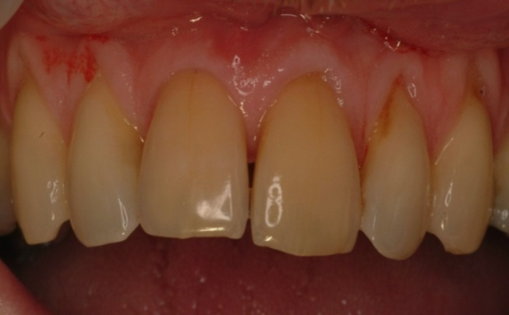

Figure 1: Discoloration

### Enamel Defects

Different types of enamel hypoplasia and malformations can be masked.

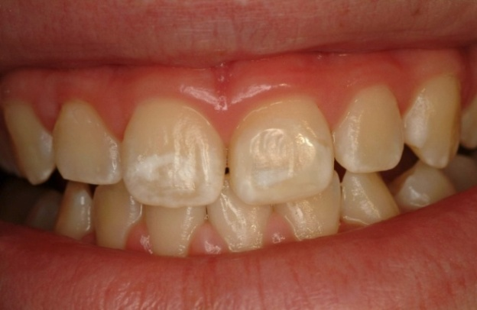

Figure 2: Enamel Defects

### Diastema

Gaps and other multiple unsightly spaces can be closed.

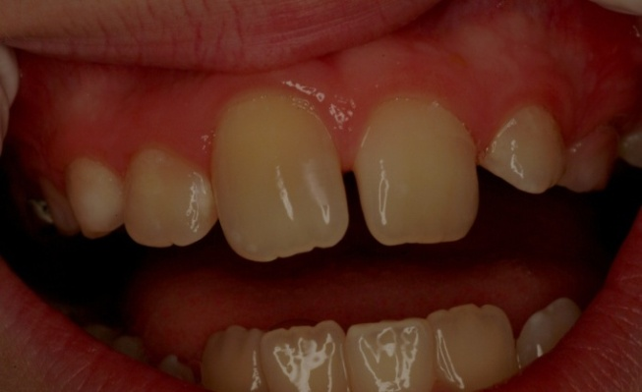

### Malpositioned Teeth

Developing the esthetic illusion of straight teeth where teeth are actually rotated or malpositioned can be accomplished for patients who have relatively sound teeth but do not wish to undergo orthodontics.

### Malocclusion

The configuration of lingual surfaces of anterior teeth can be changed to develop increased guidance or centric holding areas in malocclusions or periodontally compromised teeth.

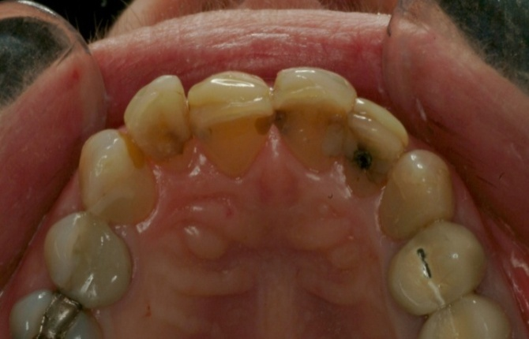

Figure 4: Malocclusion

### Poor Restoration

Teeth with numerous shallow, unaesthetic restorations on labial surfaces can be dramatically restored.

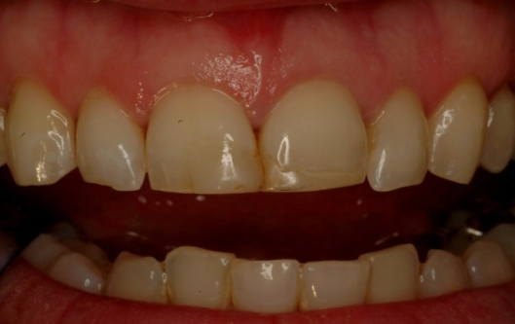

Figure 5: Poor Restoration

### Aging

The ongoing process of aging can result in color changes and wear in teeth. This is often considered unaesthetic to our youth and beauty orientated society. These teeth may be ideal candidates for improvement by bleaching or, in certain situations, bleaching with subsequent veneering.

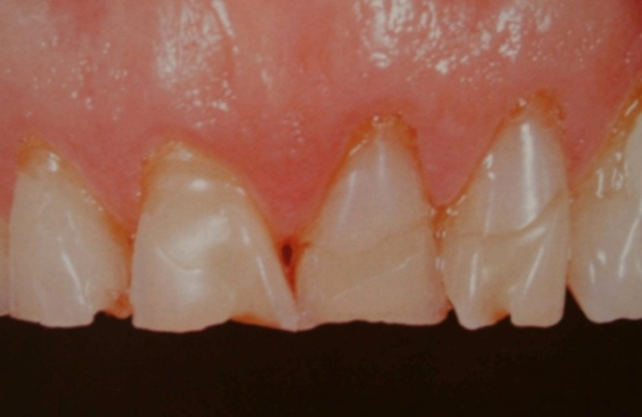

Figure 6: Aging

### Wear Pattern

Porcelain laminates are also useful in those cases that exhibit slowly progressive wear patterns. If sufficient enamel remains and the desired increase in length is not excessive, porcelain veneers can be bonded to the remaining tooth structure to change shape, color, or function.

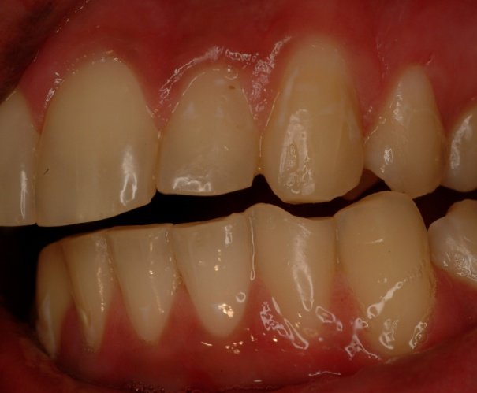

Figure 7: Wear Pattern

### Agenesis of the lateral Incisor

In the problem of the canine erupting adjacent to the central incisor (in those situations where there is a missing lateral incisor) the veneer can be used to develop better coronal form in the canine, thus simulating a lateral incisor. These may have to be combined with veneers on the central incisors to develop a more ideal ratio in the relative proportion of the teeth, because the canine is invariably too wide when positioned adjacent to the central incisor.

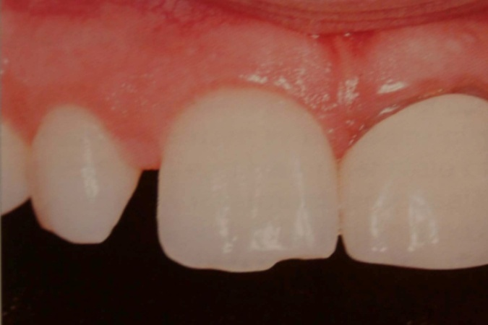

Figure 8: Agenesis of the lateral Incisor

### Teeth Stained with Tetracycline

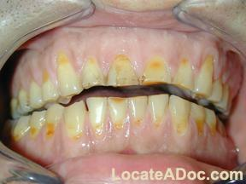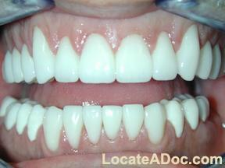

Figure 9: Teeth stained with Tetracycline: before and after

### Enamel Defect

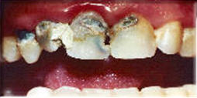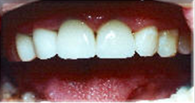

Figure 10: 1. Enamel Defect: before and after

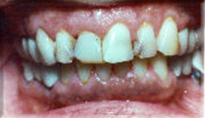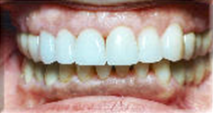

### Diastema

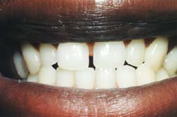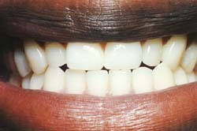

Figure 12: Diastema: before and after

### Malpositioned Teeth

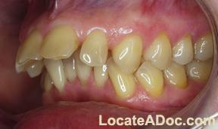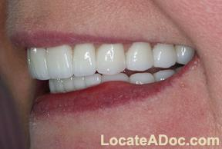

Figure 13: Malpositioned teeth: before and after

### Teeth Showing Wear and Discoloration Associated with Tetracycline Staining

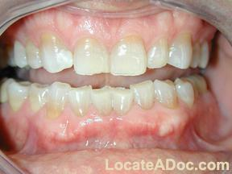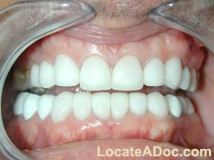

Figure 14: Teeth Showing Wear and Discoloration Associated with Tetracycline Staining: before and after

### Fractured Teeth

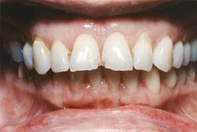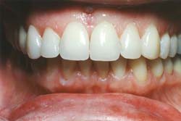

Figure 15: Fractured Teeth: before and after

### Teeth with Spacing in the Interproximal Areas



Figure 16: Teeth with spacing in the Interproximal areas: before and after

## 

## **CONTRAINDICATIONS**

There are no specific contraindications for laminate veneers as opposed to other forms of dental restoration. There are, however, certain considerations to be taken into account:

### Available Enamel

There should be enamel around the whole periphery of the laminate, not only for adhesion but, more importantly, to seal the veneer to the tooth surface. In addition there should be sufficient enamel available for bonding, because bonding to dentin is generally much less retentive than to enamel. If the tooth or teeth are composed predominantly of dentin and cementum, crowning may well be the treatment of choice.

### Ability to Etch Enamel

Deciduous teeth and teeth that have been excessively fluoridated may not etch effectively. They may require special measures to be successful with porcelain laminates.

### Oral Habits

Patients with certain tooth-to-tooth habit patterns, such as bruxism, or tooth-to-foreign-objects habits may not be ideal candidates for veneers. The shearing stress may be too great for the porcelain to withstand.

The system’s inherent strength and long term stability indicate that there are few contraindications to porcelain laminate use, provided discretion is used in case selection and care is exercised in the preparation, fabrication, and placement of veneers.

# 

# ENAMEL REDUCTION

There are different opinions regarding the type of tooth preparation porcelain laminate veneers require. Some clinicians are of the school of thought that little or no tooth reduction is required. Whereas others, at the opposite end of the spectrum advocate a full deep chamfer preparation on labial aspect of the teeth and most or all of the way through the interproximal contact areas.

Both concepts may be correct or incorrect. With each specific cause in hand, just how to approach the preparation should be decided on an individual basis. The philosophy presented in this library dissertation will be biologically based to produce an effective restoration with decreased potential for causing iatrogenic disease. If it is possible to place a veneer without tooth preparation and still develop good esthetic form with no subsequent periodontal changes, it is most ideal. If not, some form of enamel reduction becomes essential.

There is therefore no single answer or ideal way to prepare teeth for porcelain laminates. The decision of whether to reduce enamel should depend on the following biological and technical factors:-

**Esthetics:** If there is no tooth preparation, somewhat larger teeth positioned more labially will result when laminates are placed. In lingually inclined teeth this may be an advantage because the end result will correct the relative position of the teeth and be esthetically more pleasing.

**Relative tooth Position:** If one or more of the teeth are out of line with respect to the others, this will influence the degree of preparation necessary.

**Masking of Tetracycline Stain:** This complex problem requires very specific preparation modifications.

**Marginal Placement:** This should be considered relative to the gingival margin.

**Age:** The age of the patient and the proximity of the pulp to the surface need to be taken into account.

**Attitude:** The attitude of the patient relative to esthetics in general, and tooth reduction in particular, should be determined prior to case presentation since this could modify the expected esthetic results.

**The potential for Periodontal Changes:** The individual patients past periodontal history and tissue susceptibility to bacterial plaque should be reviewed.

**Plaque removal:** The patient should be evaluated for the ability to remove plaque at a porcelain/ tooth interface.

If these restorations are to be esthetic and biologically compatible, they will often necessitate adjustment of the tooth surface. This reduction in enamel can then be replaced with a similar thickness of porcelain, thereby making the end result the same size or, at worst, only slightly larger than the original.

It is extremely difficult for the ceramist to fabricate an accurately fitting laminate to a feather edge finish line, or to work with a thickness much less than 0.3mm. In broad generalities, then the amount of enamel reduction necessary, based on the technicians needs is in the realm of 0.3to 0.6mm or about half the thickness of the available enamel.

## RATIONALE FOR ENAMEL PREPARATION

Enamel preparation may be performed for several reasons:-

1. To provide for an adequate dimension of available space of the porcelain material.
2. To remove convexities and provide for a path of insertion in those situations where either the incisal or the interproximal areas are to be included in the veneer; the best path of insertion is that which will require the least amount of enamel reduction, as modified by esthetic demands of the patient.
3. To provide space for adequate opaquing where necessary and for the composite resin luting agent.
4. To provide a definite seat to help position the laminate during placement.
5. To prepare a receptive enamel surface for etching and bonding the laminate.
6. To facilitate sulcular margin placement in severely discolored teeth.

## ENAMEL REDUCTION PROCEDURE

Enamel reduction should be considered from five distinct aspects:

1. Labial reduction
2. Interproximal extension
3. Sulcular extension
4. Incisal or occlusal modification
5. Lingual reduction

### Labial Reduction

The labial preparation should encompass the amount of reduction necessary to facilitate the placement of an esthetic restoration. Ideally, one would like to replace the same amount of enamel that is removed by the preparation. However, in certain situations such as rotated teeth or teeth in labial-version, it may be advantageous to first bring the offending teeth into alignment with the rest of the arch by reducing their labial contour.

The preparation should remain within the enamel wherever possible and most certainly at the peripheral marginal areas to ensure an adequate seal to enamel.

There may be situations where to facilitate cosmetic alignment, some amount of dentin will be exposed by the preparation of the tooth. This is not that critical if it is limited to only small areas and the margins remain on enamel. Dental bonding provides only a fraction of the bond strength possible with enamel bonding and a less effective seal. Therefore, a good general rule may well be to ensure that over 50% of the preparation is on enamel.

A problem with fresh dentin exposure is the potential of the acidic etching solution and the bonding material itself causing pulpal hyperemia or even necrosis.

#### Depth Guide

To randomly grind away the enamel with no guideline of how much is being removed would be inappropriate. There are several methods to gauge the amount of enamel removed, one of the most effective being the depth cutter diamond. This diamond stone will create horizontal striations or depth-cut grooves on the labial aspect of the tooth. The depth of the cuts is limited by the shank which comes to rest on the surface of the uncut enamel between the striations.

The depth cutting diamond comes in two sizes, one of which would be appropriate for the tooth to be prepared. These dimensions are 0.5 mm reduction for most situation and 0.3 mm for small teeth such as mandibular incisors where the thickness of enamel is considerably less.

The dentist should make a decision on the required amount of reduction, and then select the appropriate depth cutter diamond. Gently draw the diamond bur across the labial surface of the tooth in a mesial to distal direction. This will make depth cuts as horizontal grooves leaving a raised strip of enamel between.

Then remove the remaining enamel to the depth of the original grooves, thereby reducing the tooth the exact amount-no less and no more. Some authors advocate leaving a degree of striation present as a definitive locating system for the laminate placement.

In an alternative method for gauging the amount of enamel reduction that is somewhat more complex, use a no.1 round bur. The depth from the peripheral aspect of the bur to the shank is 0.4mm. Hold the bur at a slight angle so that indentations can be made into the enamel to the depth limited by the base of the shank. Create these indentations randomly ensuring that subsequent reduction to the depth of these indentations will create a uniformly equal preparation on the labial aspect of the tooth. In addition scribe a groove of the same depth following the curvature of the gingival margin. The problems with this type of approach is that these depth cuts can vary depending on the angle the but is held at and the amount of time necessary for this process is considerably greater.

#### Reduction of the Remaining Enamel

Following the creation of the depth cut or striations, the remaining enamel must be reduced to the depth of these initial cuts. The labial reduction should encompass two aspects: (1) the bulk of the reduction should be done with a coarse diamond in order to facilitate added retention and better refraction of the light being transmitted back out though the laminate, and (2) at the marginal area it is desirable to use a fine-grit diamond that will create a definitive, smooth finish line to enhance the seal at the periphery.

The unique Laminate veneer system [LVS] two-grit diamond is specifically designed to do this simultaneously with only one bur. It will rapidly remove coronal enamel with a coarse grit while creating the desired form of finish line with fine diamond grit.

This "two-grit" diamond concept is predicated upon these basic tenets of having a fine, polished finish line and a more coarsely prepared axial wall. The instrument therefore has 1.3mm of fine-grit diamond at the tip and a hybrid mixture of rapidly cutting diamond above. Move the diamond across the labial surface form a mesial to distal direction, following the curvature of the gingiva from the top of the mesial interproximal papillae down to the most apical extent of the free gingival margin and back up to the tip of the distal interproximal papillae. The finish line should be right at the gingival margin is most instances.

Depending on the path of insertion, it may be necessary to remove some extra tooth substance to facilitate a path of insertion from the incisal edge toward the cervical margin. If however, the veneer does not lap the incisal edge it can be placed from the buccal direction and removal of all convexities will not be as critical.

### Interproximal Extension

The margin of the porcelain laminate should generally be hidden within the embrasure area. Depending on the individual form of the tooth, it is usually desirable to extend this margin about half way into the interproximal contact area. Extension of the laminate beyond the mesiobuccal and distobuccal line angle also ensure the wraparound effect with etched resin bonds at right angles to the labial surface for increased bond strength. This is achieved with the same LVS two-grit diamond-moving the margin into thisembrasure area and just lingual to the buccal surface of the interproximal papillae so that it will not be visible from the lateral oblique view or directly from the front.

For the technician it is also useful to have extra reduction in this embrasure area so as to facilitate the addition of porcelain bulk in this region and the strengthening of the laminate around the whole periphery (interproximal areas, the incisal edge, and the cervical region). Fortunately, the interproximal areas have a thicker dimension of available enamel to allow for the slightly more extensive preparation.

#### Treatment of contact Areas

The second aspect of the interproximal extension is dependent upon the type of porcelain laminate fabrication technique to be used. If the platinum foil matrix system is used as opposed to the refractory die technique, work on individual dies will be necessary. The technician will have to section the master cast by swaying from the apical end of the model toward the incisal edge but stopping short of the contact point where the saw blade would damage the teeth. If the contact have been modified it into individual dies, the process will require modifying the contact prior to impression making by passing a very fine, one-sided diamond abrasive strip through the adjacent teeth. The abrasive strip is used in a configuration so that the abrasive side will reshape the contact areas rather than separate them. Thus, a thinner contact in maintained, as measured in a buccoligual dimension.

The contact areas in there models are clearly demarcated and easy, clean snapping apart of this model into dies is facilitated. Dental floss passed through these contact areas should just catch, so that arch integrity and stability are not disturbed.

#### Dentin Exposure

Dentin may be exposed during tooth preparation when dealing with a labially placed tooth that needs to be brought back into harmonious alignment with the rest of the arch. A rotated tooth poses similar problems, as does the clinical situation in which there has been gingival recession when the preparation extends apically beyond the cementoenamel junction onto exposed cementum or dentin.

If the dentinal area exposed is surrounded by enamel to provide a peripheral marginal seal, it can be managed with a dentin bonding agent. This may be conventional dentin bonding agent, a phosphorus ester of the BIS-GMA molecule, or one of the newer systems such as the aluminum oxalates or glutaraldehydes.

If the dentine exposure occurs at the periphery such as the cervical region, it is advisable to prepare a little deeper into this area so that a layer of glass ionomer can be used as a base. This glass ionomer base will bond to the dentin and seal it, as opposed to a dentine bonding agent which may only adhere but not seal effectively. The glass ionomer can subsequently be etched concomitantly with the enamel when placing the veneer, and the composite resin luting agent will then bond to it.

Another typical example of when glass ionomer can be effectively used is cervical erosion. The eroded area already provides the depth necessary for the material. An added advantage in using the glass ionomer in these situations is the anti caries effect offered by the continuous liberation of fluoride ions.

All dentine should be protected from the effects of the enamel etching agents (orthoposphoric acid 30% to 38%). During the enamel etching procedure use a gel form of the acid and confine it solely to the enamel. If in doubt cover the dentine with a film of dentin bonding agent (dentin Adhesit, Vivadent, Tonawanda N.Y) to seal it prior to acid etching.

### Sulcular Extension and Marginal Placement:

At this stage the preparation ends right at the gingival margin. Some authors suggest it be placed just within the sulcus. There is no reason to bury it and try to hide it subgingivally, as with some crown-and bridge procedures. The porcelain with the underlying composite resin will blend in harmoniously with the rest of the tooth without showing a cement line or metal margin. It is not necessary to exceed more than 0.05 to 0.1mm into the sulcus or even to remain supragingival if a dramatic color change is not a high priority.

Sulcular extension and marginal placement are carried out with the two-grit diamond described earlier. Place a narrow gingival displacement cord in the sulcus for about eight to ten minutes to slightly displace the tissue. This system of first developing a preparation line confluent with the gingival margin and then placing a retraction cord prior to refining and extending in into the sulcus ensures (1) access for the diamond, (2) less gingival trauma and (3) direct visualization of the margin during all procedures. Because of the tissue displacement, this refined margin will appear to be supragingival until the effect of the astringent wears off. This sulcular preparation remains a considerable distance from the biologic width so there is little potential for violating it and developing untoward gingival reactions.

The margin must remain at a point where, with regard to tissue displacement, it will once again be visible for finishing of the porcelain laminate and the resin luting agent.

This region of the sulcus also has the least potential for inducing gingival reaction because the sulcular supporting enamel has not been tampered with and the subgingival coronal contour remains the same. It is a much more conservative sulcular extension than any crown-and-bridge preparation where even the all ceramic crown invariably has an opaque cementing medium that has to be hidden below the gingival tissue.

This conservative sulcular preparation also helps ensure that the finish line does not approach the cemento enamel junction, where there may be little enamel thickness left to etch and seal the laminate to. The fine diamond at the tip of the two-grit diamond cuts very slowly, thus reducing the risk of over preparation when entering the sulcus. The diamond merely refines and defines the finish line, and in doing so it moves the finish line from being right at the gingival margin to being 0.2 mm or less into the sulcus.

#### Tetracycline Stained Teeth

Tetracycline-stained teeth present a special problem that necessitates placing the finish line further subgingivally. This is done in a attempt to hide the dark discoloration that tends to show through the marginal tissue. If the enamel is penetrated through to the dentin, it is still important to atleast seal the periphery of the laminate to enamel. The problem with tetracycline stain is that it is usually darkest in the cervical region where there is decreased amount of enamel to cover the stained dentine or for adequate tooth reduction. The tooth also appears darker as the enamel is removed exposing the underlying stained dentin.

#### Finish Line Configuration

The actual configuration of the finish line is somewhat controversial, in that everything from a feather edge through to a rounded shoulder has been advocated.

From periodontal point of view, it would be considerably better to have continuity in form, from the existing enamel extending out over the new veneer: for example, there should be a continuation of the emergence profile so that there is no ledge at the junction of the veneer and the enamel to act as a depository area for microbial plaque. Thus, the finish line should involve some definite reduction to facilitate fabrication of a veneer of sufficient thickness and strength without adding excessive contour to this sensitive region. The nature of the porcelain material and the laminate fabrication technique requires a cervical reduction of at least 0.25mm.

A feather or knife edge finish line is the most conservative preparation but is inordinately complex because of:

1. The difficulty in fabricating porcelain to the required degree of thinness accurately-there is invariably a poor marginal fit or seal.
2. The inevitable increased porcelain thickness subgingivally and resultant potential for gingival problems.
3. Laboratory problems in delineating the exact end of preparation line.

It would appear that the most desired form of finish line is a modified chamfer as created by the two-grit diamond or one of similar shape. This modified chamfer preparation is of nominal depth (±0.25mm) near the cementoenamel junction where the thickness of the enamel decreases rapidly. The sulcular extension should therefore be ultra conservative in that there is an ever decreasing thickness of available enamel as the finish line moves subgingival and approaches the cementoenamel junction.

The preparation of chamfer in this cervical area also aids in sealing the restoration by removing the acid-resistant surface enamel and exposing subsurface enamel which is more readily etched. The modified chamfer as developed by the two-grit diamond seems to be the preparation of choice.

#### Benefits of the Modified Chamfer Finish Line

#### An increased bulk of porcelain at the margin and hence increased strength without over contour.

#### Correct enamel preparation exposing correctly aligned enamel rods for increased bond strength at the cervical margin.

#### A well-defined finish line for the laboratory yet without too great a potential for porcelain sintering shrinkage-increased accuracy of fit.

#### Greater ease for the dentist to obtain a correct gingival finish line after insertion.

#### A definitive stop to aid in seating the laminate in the correct position on the tooth.

#### An accurately fitting restoration with sound marginal seal due to the use of the fine-grit diamond at the tip of the two-grit bur.

### Incisal or Occlusal Reduction:

The fabrication of a porcelain veneer lapping the incisal edge makes placement of the restoration that much easier by virtue of having a definitive stop during seating. The incisal edge gives the clinician a specific relationship from which to evaluate whether the restoration is correctly positioned. This incisal overlap can even be fabricated purely as a positioning device and then later removed once the veneer is bonded in place. This latter type of incisal extension requires no real preparation because the overlap will be ground away following luting and placement of the laminate.

There are times however, when added length may be desirable and in these situations it is necessary to actually prepare the incisal aspect of the tooth. The preparation should be definitive flattening of the incisal edge to create increased enamel width and potential bonding surface for the laminates. The sharp line angles created on the buccal and lingual surface must be rounded, this will again increase the surface area of enamel and prevent the propagation of microcracks in the porcelain.

The reduction should be at least 1mm if it is desired to restore the original length. Simple reshaping of the edge as described above without vertical reduction will suffice if the teeth are to be lengthened.

If the incisal edge is not to be included, it is still useful to increase the amount of horizontal tooth reduction at the periphery of the preparation, the interproximal areas and the incisal edge. This will give the technician extra space to stack porcelain and so develop a thicker periphery for strength. Safer handling at a later stage by the clinician is also facilitated. The incisal edge is thus hollowed out slightly for a dimension of 0.2mm creating this space.

In general, the incisal edge preparation should not end where excursive movements of the mandible will cause shearing stresses across the junction of porcelain laminate and tooth. This potentiates fracture of the porcelain, debonding and ongoing exposure of the composite resin in this crucial area.

### Lingual Reduction

Any reduction of the incisal edge may necessitate some lingual enamel modification so that there is no butt joint at this incisal/lingual junction but rather a rounded chamfer. This modification will help to prevent the porcelain from shearing away from the incisal edge during function. It also ensures (1) increased thickness of porcelain in this critical lingual area that is being used for incising and guidance, (2) enamel bonds at right angles to those on the incisal edge and (3) increased strength.

Excessive buccal convexity of a tooth may make it difficult to overlap the incisal edge and still maintain an incisal path of insertion. An excessive amount of labial tooth structure may have to be removed to facilitate a path of insertion, thereby exposing large amounts of dentin. In these situations the veneer should be designed to rotate about a more rounded incisal preparation in seating it. It is not advisable to compromise and have a butt porcelain joint on the lingual incisal line angle to facilitate a buccal path of insertion. The shearing force will peel this margin open in protrusive movements of the mandible.

Before impressions are made, the preparation is evaluated for the following:

1. Even and adequate overall reduction.
2. Definitive smooth finish line-A modified chamfer is desired.
3. A single path of insertion with no undercuts.
4. Rounded line angles.
5. Modification of the contact areas

The final decision on whether or not to perform enamel reduction remains a clinical chairside decision. It must be based on the following criteria:-

1. The relative position of the teeth in the arch malpositioned and rotated teeth may need reduction to bring them within the confines of the arch.
2. The color of the teeth to be veneered. Darkly stained teeth often require more reduction for opaquing purposes.
3. The propensity for overcontouring to induce gingival problems due to microbial plaque accumulation. If the laminate ends supragingivally it may be considerably easier to maintain this interface plaque free.
4. Partial coverage veneers as in closure of diastema may require little or no preparation.
5. The patients age, relative size of tooth pulp, and psychological approach to tooth reduction.

The dentist should also evaluate the patient and his or her individual expectation. If a patient is apprehensive and unsure than it is wise to perform no reduction, leaving the clinician the option, if necessary, of grinding away the porcelain veneer and repolishing the enamel, thereby returning the patient to a semblance of his or her original state, although this is a most difficult task.

**ENAMEL REDUCTION PROCEDURE**

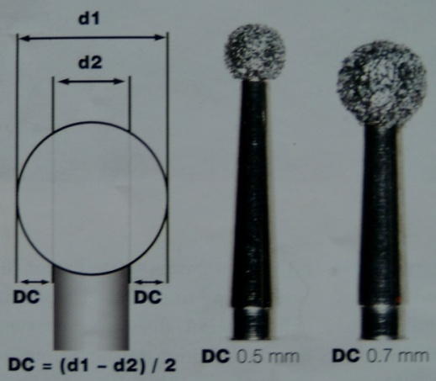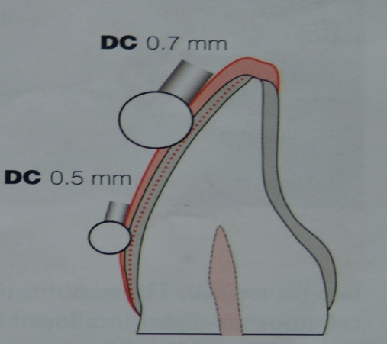

Figure 17: Facial reduction is assisted by two round diamond burs

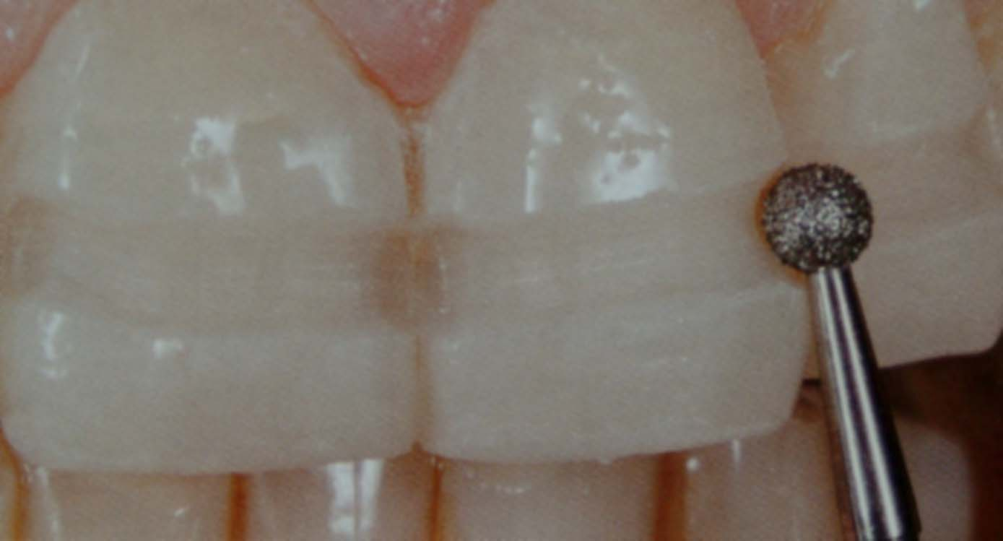

Figure 18: DC 0.7 shaft is placed against the incisal third of the facial surface

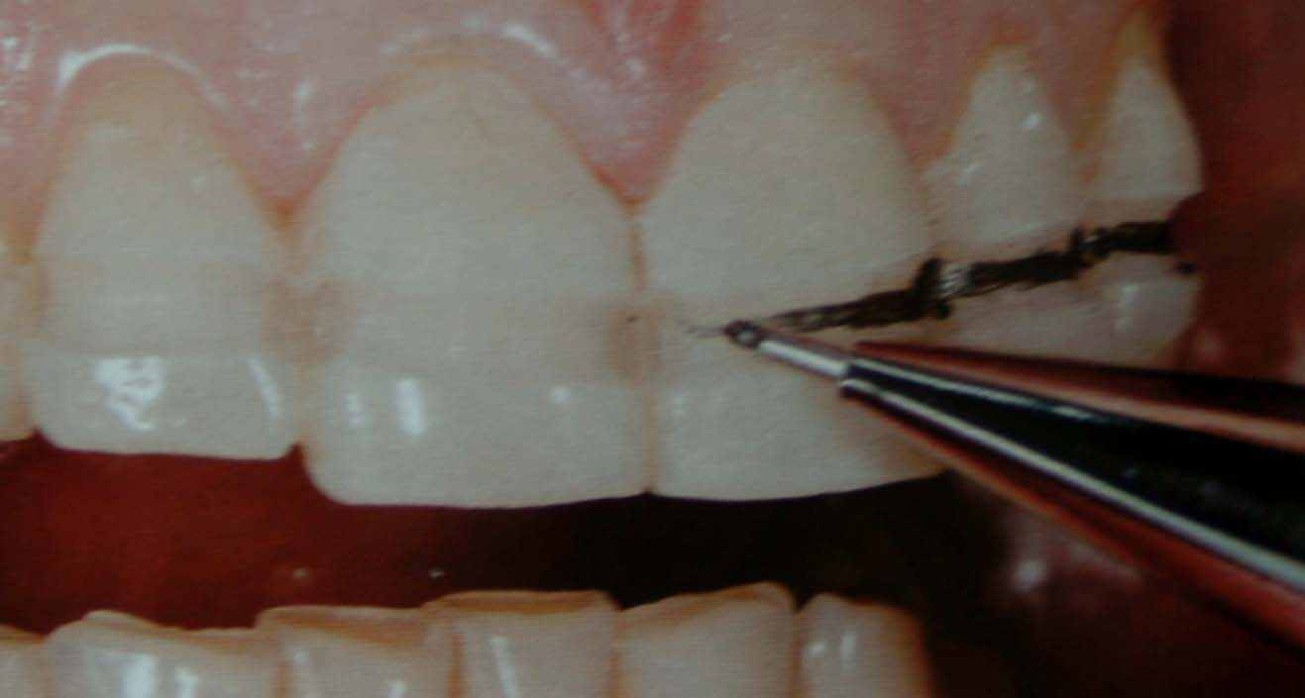

Figure 19; A single horizontal groove is obtained and marked with a pencil

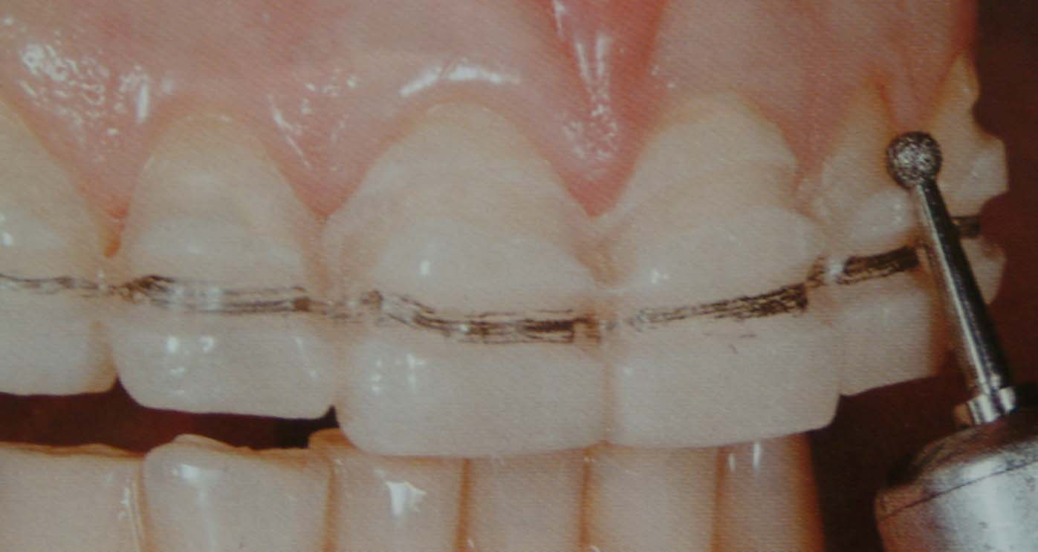

Figure 20: DC 0.5 shaft is placed against the junction of the cervical and middle third of the facial surface and scalloped

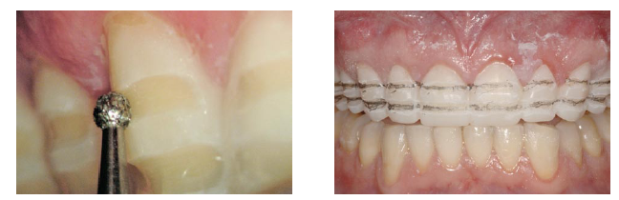

Figure 21: Grooves are marked with pencil

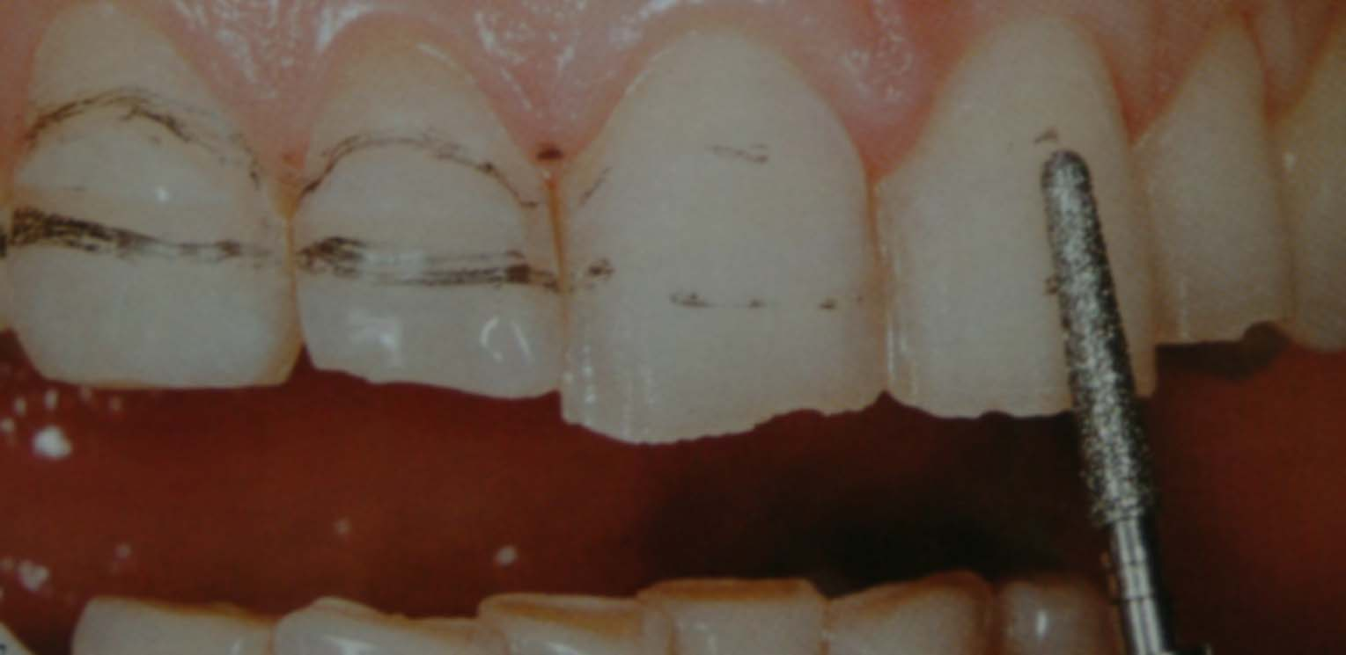

Figure 22: Remaining part of mock-up is removed by using round end tapered burs until the pencil marks are completely removed.

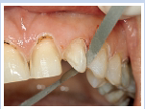

Figure 23: Diamond strips and sandpaper disks are used to smooth contact point and angles

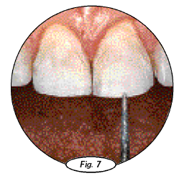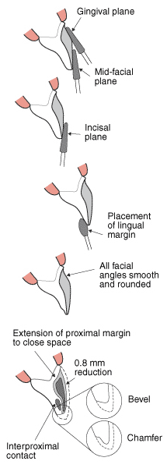

Figure 24: Two grit diamond used to enhance the reduction at the incisal edge to facilitate increased porcelain thickness at the peripheral area.

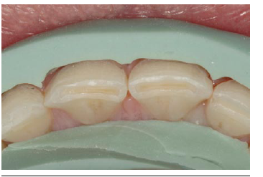

Figure 25: Initial veneer preparation depth with the horizontal putty matrix created from the diagnostic wax up

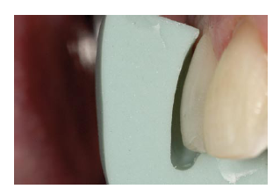

Figure 26: Final axial reduction with the vertical putty matrix created from the diagnostic wax up

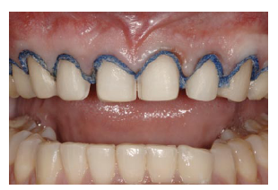

**Figure 27: Final conservative veneer preparations with the retraction cord in place**

**PREPARATION FOR PORCELAIN VENEER**

Extend chamfer to incisal.

Complete gross facial enamel reduction to peripheral margins and depth

Place chamfer lingual to contact area. Avoid undercut to facio-incisal path of draw.

Is existing M-D width suitable and are proximal contacts present?

Place chamfer just labial to proximal contact

Continue margin interproximally to below contact area

Place chamfer at free gingival margin

Is there severe discoloration? (tetracycline)

Place chamfer 0.5-1.0 mm

Below free gingival margin

Place gingival chamfer margin

Prepare labial depth guide cuts for controlled reduction

Determine depth(s) for enamel reduction

Crown ready for veneer preparation

None – minimum

* Root surface

Min.-reg. 0.3-0.5 mm

* Tooth colour = shade
* Linguoversion
* Near CEJ
* Mand incisor gingival half

Reg.-heavy 0.5 – 0.7 mm

* Tooth colour-shade mismatch
* Labioversion
* Mand incisor incisal half

Heavy 1.0 mm

* Functional clearance mand. incisor

# 

# IMPRESSIONS AND TEMPORIZATION

The fabrication of porcelain laminate veneers necessitates some form of a master cast. This cast must be an accurate reproduction of what exists in the mouth, and the impression material should be selected from among those that are used for any crown-and bridge technique. Commonly used materials include polysulfide, polyether, and vinyl polysiloxane elastomeric and hydrocolloid impression materials. Hydrocolloid tends to tear in the unprepared undercut areas below or between the contact areas, therefore an elastomeric materials with greater tensile strength is more desirable. The detail obtained by an alginate impression is probably not of sufficient quality to ensure a precise fit of the laminate.

Prior to deciding upon the type of impression material to be used, the laboratory laminate fabrication technique should be determined. The platinum foil technique uses individual removable dies on a master cast made up of conventional die stone. The die stone can easily be poured into any of the above mentioned impression materials, rendering an accurate reproduction of the tooth preparation. It should be noted though, that for this system the master cast will have to be separated into individual dies. Good delineation of each tooth is ensured if the contact points in the mouth are modified by shaping with an ultra-fine diamond strip, so that dental floss still catches.

In the refractory technique, the die material employed is a phosphate bonded refractory investment. This technique necessitates that one of the elastomeric impression materials such as a vinyl polysiloxane be utilized.

In refractory-technique cases it may be prudent to block out lingual interproximal undercut areas with orthodontic wax. Never do this if the foil technique is being used because the technician will not be able to section the model. In the refractory technique, it may even be adequate to remove the lingual flange of the tray and only take a bucco-incisal impression.

In most situations the impression will be sent to the laboratory so that the technicians can pour up the model themselves. Hydrocolloids necessitate being poured immediately, also because of their nature the laboratory technicians cannot make more than one pour in each impression. The elastomeric material is more advantageous, because it maintains it dimensional stability during travel and can be poured two times or more.

The impression material, either can be utilized in a conventional type of tray or to save time, a combined maxillary/ mandibular bite tray system may be used.

## **IMPRESSION TECHNIQUES**

### Tissue Management

The preparation finish line is right at the gingival margin, delineating the periphery of the laminate. Displace the tissue so that the final finish line can be seen in the sulcus. Tissue displacement is readily accomplished with fine cotton cord impregnated with an astringent agent such as aluminum sulfate. This procedure will displace tissue laterally and provide access to the sulcus thereby allowing the operator to visualize the refinement of the final line within the sulcus.



Gently tuck the retraction cord into the sulcus. Force in excess of 5-grams should not be employed as it would disrupt the integrity of the junctional epithelium. The cord should extend from the interproximal mesial surface around the labial surface and onto the distal interproximal surface. The cord needs to remain in place for some five minutes before being removed to avoid tearing the friable junctional epithelium and precipitating bleeding.

### Impression

The impression material used should be of two viscosities: light and heavy. The tray material should be of the heavy type. The light material should either be syringed into the sulcus or in the case of hydrocolloid, simply be placed over the preparation. This will facilitate the heavy body moving the light body up into the sulcus and embrasures, to pick up the periphery of the preparation. As with any crown-and-bridge medium and more specifically for laminates the impression material should have high tensile strength as well as accuracy. Insert the tray from an oblique buccal direction to make certain all labial and gingival relationships are properly recorded.

### Temporization

Temporization for laminate preparation is usually unnecessary because in most situations, only half of the enamel surface is removed and the dentinal tubules are not exposed. Therefore there should be little or no sensitivity and only minimal esthetic compromise. Also temporary veneers for the most part are undesirable because they may by their very nature cause gingival inflammation.

However in certain situations, temporization may become necessary when teeth have been more extensively reduced to facilitate aligning of the laminates along a preexisting arch. In these situations there may be areas of exposed dentin that require temporary veneers because of sensitivity. There may also be open contacts that potentiate movement of the teeth in the interim between preparation and final insertion of the laminates. Mandibular teeth with incisal reduction should also be prevented from erupting by some form of temporary veneer. Those situations where the reduced teeth are just too unaesthetic for the patient to function adequately also require temporization.

There are four basic techniques for developing the temporary veneers.

#### Direct Composite Resin Veneer

This system involves the placement of a composite resin restorative material directly on the unetched surface of the prepared teeth.

Shape the composite resin while soft with a composite resin placement instrument and then cure it with the respective light. It can then be trimmed with a high-speed handpiece and composite resin finishing burs into the correct form as dictated by the adjacent teeth and occlusion.

In general there is no need to etch the prepared tooth or to use any form of bonding agent in order to maintain the temporary composite resin laminate in place. However, in certain situations it may be necessary to spot etch a small area in the center of the labial surface and use a bonding agent to improve retention. It is essential to ensure that the periphery of the preparation is not involved or compromised by etching. The temporary veneer is removed by prying it away from the tooth or by grinding it away with a high-speed handpiece and diamond stone until fresh enamel is reached. The extra amount of enamel removed is inconsequential and readily compensated for by the omposite resin luting agent. The unetched peripheral composite resin will come off, leaving an uncompromised marginal area.

The direct composite resin system will work nicely for one or two individual units, but it may be too time-consuming when doing four or more laminates.

#### Direct Composite Resin Veneer Utilizing Vacuform Matrix

In this technique, the vacuform matrix is made up on a preoperative plaster cast of the patient's mouth. This cast may be altered and reshaped into a more esthetic form in the laboratory prior to forming the plastic matrix.

Separate the clear vacuform matrix from the cast and trim it. Scallop the area around the gingival margins and cut it short of the soft tissue line and well into the interproximal areas.

Fill the labial aspect of the vacuform with a light-cured composite resin and manipulate the whole complex gently into place on the patient's prepared teeth. The area that has been cut away from the gingival margin allows for manipulation of the soft uncured resin into correct form so that it does not impinge upon the soft tissues and interproximal areas. Then set the composite with the appropriate light-curing unit, and peel the vacuform away from the teeth, leaving the composite resin in place. Trim and shape it to act as the interim temporary veneer using finishing burs and polishing disks.

It is essential to ensure that the composite resin does not impinge upon the tissue in any way, otherwise untoward gingival reactions may occur. Any inflammation of the soft tissues, compromises final seating of the laminates due to crevicular fluid seepage and/or hemorrhage when the tissues are even gently manipulated.

#### Direct Acrylic Veneer

In this technique, instead of utilizing composite resin, methyl methacrylate self-curing acrylic resin is mixed into a soupy state, flowed into the buccal aspects of the vacuform, and allowed to reach the "doughy" stage of curing

Once in this doughy stage, manipulate the vacuform into position over the prepared teeth that have been lubricated to facilitate easy removal. Then manipulate these acrylic resin veneers in the vacuform on and off gently, allowing them to cure but not to engage in any undercuts on the prepared teeth. Remove them from the teeth and take them to the laboratory where they can be trimmed and polished, using the utmost caution not to fracture them. Either cement them into place with a laminate composite resin luting system taking care to remove the extruded excess before light curing or leave them as a removable temporary.

#### Indirect Composite Resin / Acrylic Resin Veneer

These temporary veneers are fabricated in the laboratory on a cast of the prepared teeth. If an in-house laboratory exists, these can be rapidly prepared on a cast of the preparations.

Gently manipulate the matrix and material into position on the cast of the prepared teeth and cure. Trim the matrix and polish it on this cast before separating. Lute in place with any composite resin system.

In none of the above techniques does any acid etching need to be done. Hence, the temporary veneers should peel away readily at the second visit without affecting the ability to subsequently acid etch the enamel. If the temporary veneers need added adhesion, spot etch a small area in the center of the labial surface, using a gel etch for 15 seconds An unfilled resin can then be used to tack the veneer in place. However, in most situations, this is unnecessary.

### Shade Selection

In general, it is advisable to select a shade that is slightly lighter than that desired by the patient. Subtle shade modification is possible using the various composite resin systems. It is somewhat easier to darken any given shade than to lighten it. So in general, select a shade that is higher in value and lower in chroma. Shade selection for laminates varies somewhat from that of conventional crown-and-bridge techniques, where any chosen shade guide tab can be matched by the ceramist. In processing porcelain laminates, the ceramist may well be able to deliver a shade A2 veneer, but once it is luted in place the final color can be very different.

The final color of the restoration will be the combined result of several factors and not only the porcelain shade selected:

* The original tooth color.
* The shade selected for porcelain and amount of opacifier added.
* The color and opacity of the composite resin luting agent.
* The use of resin shade modifiers and characterizers behind the veneers.

**DIRECT COMPOSITE RESIN VENEERS USING HIGH INTENSITY LIGHT SOURCE**





Figure 28: Retracted view of patient’s existing veneers to be placed with porcelain veneers





Figure 29: Recontouring of the gingiva using an electrosurge.





Figure 30: Marginal ledges are filled with a flowable composites and emergence angle is created.



Figure 31: The impression material is injected into the clear tray





Figure 32: Tray is placed into the patient’s mouth





Figure 33: Clear preoperative impression is loaded with the flowable composite





Figure 34: Light curing of prepared tooth using a high intensity light source





Figure 35: Temporary restoration 4 days after the preparation appointment





Figure 36: Soft tissue response showing good marginal adaptation and contour





Figure 37: Postoperative view

**DIRECT COMPOSITE RESIN VENEERS UTILIZING VACUFORM MATRIX**

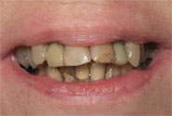

Figure 38: Preoperative view of the teeth to be laminated

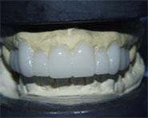

Figure 39: Resin mock-up that serves as a matrix for final contour

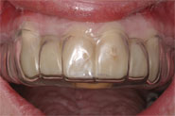

Figure 40: Vacuform matrix is made to simulate desired form of final case

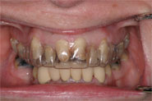

Figure 41: The vacuform matrix is in position on the prepared teeth

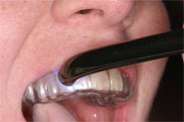

Figure 42: The vacuform matrix in position on the prepared teeth, is filled with composite resin and cured

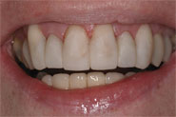

Figure 43: The matrix was removed, revealing the basis of the splint

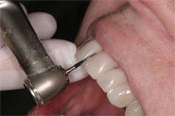 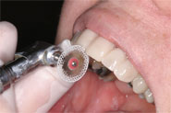

Figure 44: Finishing and polishing done using carbide finishing burs, diamond discs, and abrasive discs

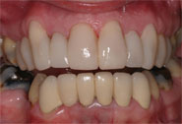

**Figure 45: Completed temporary resin veneers**

Porcelain laminates are thin facings of ceramic porcelain affixed directly to teeth using a composite resin as bonding cement. Porcelain veneers are constructed on refractory dies made from elastomeric impressions unlike composite veneers which are directly fabricated on the patient’s teeth. After etching inner surface of veneer using hydrofluoric acid, addition of coupling agent (organo-silane) prior to bonding chemically augments the mechanical bond and provides ultimate bond strength.

The adhesive porcelain veneers complex has been proven to be very strong in-vitro and in-vivo. The maintenance of esthetics of porcelain veneers in the medium to long term is excellent, patient satisfaction is high and porcelain veneer has no adverse effects on gingival health in patients with an optimal oral hygiene.

The technique combines the durability, esthetics and biocompatibility of porcelain, conservation of tooth structure with facial intraenamel preparations approximately 0.5 mm in depth and the reliability of the acid-etch composite bond. Porcelain veneers will become an “accepted procedure” as it offers “the highest esthetic potential to date for restoration of anterior tooth defects”.