CHAPTER ON ROBOTICS IN INDUSTRIAL AUTOMATION
1.0 INTRODUCTION
Robotics is a very interesting and practical science. The word "Robot" is derived from "Robota," a lowly worker in Czech. Murphy says it first published on January 25, 1921. (2000). Robots can be employed in a variety of settings, including industry, space and underwater research, aiding the disabled, and even providing entertainment. There are several types of robots, including intelligent robots, playback robots, playback robots with fixed sequences, fixed sequence robots with changing sequences, and fixed sequence robots. Niku (2010).
"An intelligent robot is a mechanical creature which can function autonomously". The intelligent robot must be able to deal with situations that are unclear, contradictory, cluttered, and confusing. It is capable of adjusting to all the whims of the outside world and picking up knowledge from its interactions with it. Nehmzow et al, (2012).
Numerous individuals believed that the robot has to be humanoid (human-like). The shapes of the robots in the actual world vary depending on their functions. Murphy (2000). Robot drive systems vary based on the environment in which they are used.
We have always been fascinated with robots. They now frequently appear in our daily lives thanks to their many applications in a variety of industries. They are designed to make our lives more comfortable and to make our work easier.
The term "robot" first gained popularity in the 1950s, when Karl Capek used it to describe the emergence of a dominant race with intelligence on par with humans in Rossum's Universal Robots.
The definition of a robot gets more challenging because they can take many different shapes and have applications in many different sectors. The term "robot" has several different interpretations. Certain of them are:
The Robotics Institute of America's definition of a robot, given in 1979, is that:
“A robot is a multipurpose manipulator that can be reprogrammed to move objects, parts, tools, or specialised devices using a range of programmed motions to perform a number of tasks.”.
Robotics is the field that deals with the investigation and use of robots. Robotics' objective is to closely resemble the natural environment. Although it is just roughly 50 years old, the engineering subject of robotics is finding numerous uses across a wide range of industries.
1.1 THE HISTORY OF ROBOTICS
Many fields are seeing the rise of robots. We hear for them in the news practically daily, whether it's about drone attacks in battle, robots keeping the elderly company in nursing homes, or vehicles that can park or perhaps even drive themselves. It feels like the industry is becoming much more automated when we call a business and get to speak to a computer. Additionally, robots are developing; research is being done to create more sociable robots that can read eye movements and engage in conversation.
The evolution appears to be moving from industrial robots that are restricted to specific locations to machines and systems with increasing levels of autonomy, with science fiction films like Terminator or I,Robot and the singularity—where machines outsmart humans—at the far, more speculative end of the spectrum. What happens when a machine or technological system possesses the property of autonomy? Which philosophical issues are raised? Some of these questions will be examined in this thesis. There isn't a single, agreed-upon definition of autonomy. The ability to act independently and make judgments without the influence of others is a fundamental concept, but definitions change depending on the situation. The definition of autonomy can be fairly strict in philosophical discussions of free will, but it can also refer to things like vacuum cleaners and cars in other contexts, such those involving robots. Additionally, autonomy appears to be gradated. For instance, Volvo will release autonomous vehicles in 2014 that can travel up to 50 kilometres per hour on their own amid "traffic jams." However, when a car is said to be "off on its own," it does not necessarily suggest that the owner is home cooking supper while the car is travelling to pick up the children alone. However, the automobile has some autonomy, and it's easy to believe that this is just the beginning. Growing autonomy is being pursued, especially in the military, where robots are even lethal. Arkin (2009). Although it may seem obvious, there will always be a human "in the loop," assuring us of this.
In this thesis, the phrase "autonomous system" is used to cover a variety of words, including "robot," "artificial agent," and "UAV" (unmanned aerial vehicle). The relevant characteristic for the philosophical questions in the thesis is autonomy, not necessarily the typical robot embodiment. Equally pertinent is an autonomous system built into something we wouldn't classify as a robot. However, because it appears in the literature, the word "robot" is most frequently used. Although there does not appear to be much agreement among roboticists over what constitutes a robot, mobility or independence is an unifying factor Bekey (2012). A computer attached to a printers would qualify as a robot if one were to interpret a robot as, for example, "a computers with sensor devices that enable it to interact with both the external world." Lin and associates (2012).
A higher level of "thinking" or "doing" is necessary to distinguish it from automata, such as thermostats or computers attached to printers. For the definitions of robot and autonomous robot, see Arkin (2009). An automated machine or vehicle that is capable of autonomous perception, thought, and action is referred to as a robot. "A robot that does not require direct manual intervention except for high-level expedition tasking; such an automaton can make its own decisionsconsistent with its objective without demanding direct human authorization, includingdecisions relating the use of lethal force," according to the definition of an autonomous robot. Arkin (2009). Nevertheless, since even a "basic" robot is capable of perception, thought, and action, the distinction appears to depend more on authorization than autonomy.
When referring to computers, the term "thinking" or "reasoning" has a lot of baggage dating back to the "discussion" between Alan Turing, raising the question, "Can Machines Think?" The "Chinese Room" thought experiment by John Searle and Turing (1950) as well as comments on the viability of stronger definitions of computer autonomy are included. However, for the sake of this thesis, Arkin's notion of a robot works quite well. A broad definition involving independence, reasoning, and embodiment will suffice for a philosophical discussion on robots related to topics like ethics and agency, even though it uses concepts that could be viewed as being ambiguous. It is possible to categorise the intriguing philosophical issues surrounding autonomous systems.
The morality of employing autonomous systems is one group of queries. For instance, there are concerns about rights, privacy, safety, and dignity. Should robots take the place of people? What about joblessness? Will the principles of war change if robots take the place of soldiers? Regarding this group of topics, this thesis focuses on the morality of utilising robots in combat. Military robots, some of which are extremely lethal, are the subject of extensive spending. The deployment of autonomous robots in conflict is said to have the potential to change the laws of war. Is it morally acceptable to use UAVs in war? and II: Automatic Robots in War - Marginalization the Ethical Reason for Killing? both address this.
How do we ensure that robots act in the way we want them to, or in an ethical manner, when they are "out on their own?" is a second group of queries. Dodig-Crnkovic and Ürüklü (2011) bring out that it is currently unclear how engineers must also design the technology so that its actions are ethically sound and successful at achieving predetermined goals. In machineethics/machine morality, such as that discussed by Allen et al. (2005, 2006), Wallach and Allen (2009), orroboethics, the solution to the issue is sought. Lin et al (2012). There are two basic strategies: bottom-up, where another robot learns morality much like a kid does, and top-down, where guidelines or an ethical framework are programmed into the robot. This kind of dilemma is covered in paper III, "Robots and the Moral life," which examines one of the obligatory moral theories and applies it to medical robots.
We can learn about ethics by creating artificial moral agents, as suggested by Allet et al. (2006), Coeckelbergh (2012), and Noorman Noorman, who propose that the development of cognitive computers with "built-in" ethics can help understand ourselves and the mechanics of ethical behaviour (2012). "Machine morality seems to have the potential to encourage new lines of inquiry in ethics, much as AI has generated new lines of inquiry in the philosophy of mind. Laboratories for robotics and AI may develop into sites for testing hypotheses of ethical decision-making in artificial systems. Allen & Wallach (2009). Would we want robots to be, say, utilitarians or deontologists? By putting an ethical system into robots, we may ensure their ethical behaviour, which may lead us to "agree" on the kind of morality we want to see in robotic arms or to examine moral theories differently.
Discussions on the significance of emotions among moral agents are one example of the opportunity for a fuller knowledge of the processes of ethical behaviour. The development of autonomous battle robots that can learn and develop based on artificial emotions, such as guilt: Our group has extensive knowledge of maintaining and incorporating emotion into the designs of autonomous systems. It's stated that guilt leads to proactive, positive transformation. Tagney and co. (2007). In this way, guilt might lead to fundamental changes in the autonomous agent's control system, according to Arkin (2009). In terms of making robots at least act compassionately, research is being accomplished on attempt to mimic artificial neural circuits in robots. Lin et al (2012).
A third group of inquiries focuses on agency and accountability, suggesting a possible or potential distinction between autonomous systems and other technology. The concerns in this category lead us into a contentious and perhaps speculative realm, with discussions and recommendations that can occasionally be difficult to stomach. Can an artificial moral actor, for example, exist that is accountable for its own deeds? Or, given that a human is always creating the artificial "agent," is this a "non-question" that can be answered right away, without additional investigation?
Numerous authors, including Dodig-Crnkovic and Ürüklü (2011), Floridiand Sanders (2004), Johnson (2006), Matthias (2004), Stahl (2004), Wallach & Allen, have examined the ethics in autonomous systems and the attribution of blame (2009). Dodig-Crnkovic and Ürüklü think that the ethical implications of autonomous AI have not received enough attention up to this point, in part because of the false belief that intelligent artefacts simply carry out their programming. Dodig-Crnkovic and Türüklü (2011), for instance, or Lin et al (2008). The papers IV and V of this thesis, titled "The Pragmatic Robotic Agent" and "The Functional Morality of Robots," examine agency and accountability in artificial agents.
How can we today deal with something so incredibly uncertain by making the best choices? How can we make the transition from science fiction to what looks plausible in the present?
Singer (2009) asserts that nonscientists' predictions about technology frequently come to pass because they really do not pay heed to what is and is not technically viable. […] Predictions made by scientists frequently exaggerate the good, especially with regard to conflict. For instance, inventors like Franklin, Edison, Nobel, and Einstein believed that their discoveries would put a stop to war. They were knowledgeable about science, but not social science. Both groups have a propensity to ignore how societal development can influence technology and interact with it, producing multiple possible futures rather than just one. Singer (2009).
According to this quotation, interdisciplinary research is crucial for identifying and evaluating potential disruptive technologies' dangers and vulnerabilities in the future.
The CopeTech project, which served as the inspiration for this PhD thesis, adopted this line of reasoning. The CopeTech project aimed to create strategies for dealing with possibly disruptive technologies in the future. This was accomplished by adding co-evolutionary and participative aspects. The foundation for a methodology was created and presented in the paper "Assessing Socially Disruptive Technological Change" (paper VI in this thesis), and it was then further developed and tested in a workshop where the methodology was applied to automated systems, a potentially disruptive technology that the project chose to concentrate on.
According to many, the development of intelligent machines is one the most promising developing technologies (2009). According to Allen et al., the creation of intelligent robots capable of evaluating the consequences of their actions on others and changing their behaviour as necessary may ultimately be the most critical task facing the creators of artificially intelligent computational models (2000).
The fact that future risk and hazard research had not given autonomous systems much consideration was another factor in CopeTech's decision to concentrate on them. This made it a compelling argument for creating a strategy that incorporates co-evolution and participatory aspects; to systematise conversations amongst individuals from many fields who are interested in the future. Paper VII of this thesis, "A co-evolutionary creative injection molding approach for the future of autonomous robot systems but rather potential implications on the care and protection sector," develops the work of CopeTech by laying the foundation for a procedure from Paper VI, contrasting it with other co-evolutionary methods, and using it in the context of autonomous systems.

1.2 SUMMARY OF THE PROBLEM
Robotic job performance will result in a decline of human employment, so the transition should be handled methodically. Robotics advances will reduce the need for many high-end, precise occupations and benefit a number of industries, including agriculture, the military, healthcare, and others. As a result, there will be some harmony between the actual need and demand for robot assistance in the job. Robotics can aid with a variety of activities that are beyond the capacity of humans, and their use in warfare would be very beneficial. Robotics technology has advanced so much, and they are now practically present in every industry and sector, from transportation to healthcare to recreation. The usage of this technology will be criticised by society for displacing regular people from their jobs. But in order to address the concerns raised by this, robots should be utilised for a limited number of tasks, primarily those that humans cannot execute or are not capable of executing.

2.0 MOTIVATION OF ARGICULTURE ROBOTICS
The goal of the last 45 years of industrial robotics has been to address the technological requirements of applied robotics. The sophistication and expansion of application domains have influenced study subjects in the field of computer engineering. The needs of humans have controlled this evolution. The industrial revolution introduced manufacturing robots in the early 1960s to relieve human workers of hazardous and dangerous tasks. Industrial robots needed to be more flexible and intelligent as a result of the later integration of these machines into various manufacturing processes. Lei and co. (2004). Currently, the ageing world we live in and the emergence of new sectors and demands outside of the manufacturing robotic industry (such as cleaning, resulted in making, construction, shipbuilding, and agricultural) need the use of field and service robots to address these needs. Davies (1996).
This study examines robotics in six areas in order to review its development and identify the most representative research strands that are closely connected to practical robotics applications.
- Robot Manipulators
- Mobile Robots
- Biological Inspired Robots
Despite having some common research areas, these three fields have quite different application fields and most common research areas. They have been handled differently in this poll as a result. The study on mobile automation, medical robots, and rehabilitation robots is covered in the subsection on robot manipulators. Other service applications including refuelling, picking, and palletizing are also briefly covered. We look at both land and underwater vehicles when reviewing the research on mobility robots. Since unarmored vehicles are less common, they have not been taken into consideration. Although several other inspired by biological underwater solutions are briefly covered, walking robots but also humanoid robots make up the majority of biologically inspired robots. Despite the contrasts among manipulator robots, mobile robots, and biology inspired robots, field and support robotics is where the three study areas come together today and in the future. Davies (1996) As the First World becomes more modernised, new services are required, which changes how we view robots from an industrial standpoint to a professional and individual viewpoint. The need for new robots made to help and serve humans harkens back to the original beginnings of the robot notion, which have been popularised by speculative fiction since the early 1920s: the robot as a humans servant (see Figure 2.0). A new idea of robot is also brought about by the development of new requirements and markets beyond the traditional market for manufacturing robots. Robotics is consequently creating a new industry with a bright future that will serve people. To serve this new market, conventional mobile and industrial robots are being adapted. As service robot development progressed, research evolved to address the technical requirements of each phase.
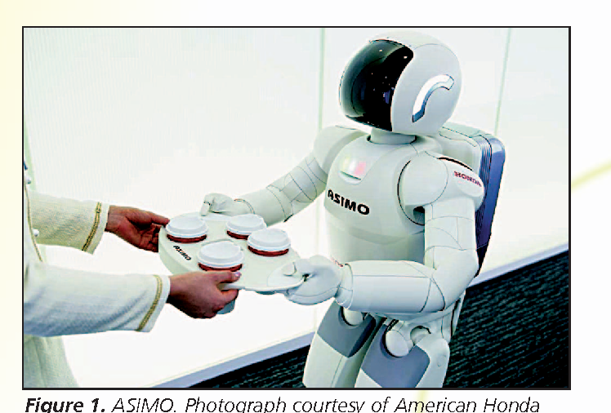
Figure 2.0 ASIMO. Picture provided by American Honda Motor Co.. https://d3i71xaburhd42.cloudfront.net/3ad94298fd25aef2e5873f0ca6ade7eb45a677ef/2-Figure1-1.png
2.1 Robot Manipulators
A robot manipulator, usually referred to as a robotic hand, is a series of rigid limbs that are intended to work together to complete a task. The focus of early designs was on industrial manipulators for activities like palletizing, welding, and painting. The development of society's technological needs and the resulting technological advancements have aided in the rapid expansion of new applications, including those for surgery support, rehabilitation, autonomous refuelling, etc. The domains of robotic arms, medical robots, and therapeutic robots that have attracted a unique, focused study effort are covered in this section.. Zhenyu et al (2002);
2.1.1 Industrial Robots
Industrial robots were originally utilised in manufacturing in the 1960s, and they predominated robotics research up until the 1990s. Due to the automobile sector's market clout and obvious technical requirements, it initially set the standards that industrial robots had to meet. Which areas of research predominated at that time was dictated by these needs. Kinematic calibration was one of those areas. This technique is essential due to the imprecision of kinematic models based on production factors. There are four phases to the calibration procedure. The Denavit-Hartenberg (DH) approach and the product-of-exponential (POE) formulation are at the head of the large family of methods used in the first stage of mathematical modelling. In the literature, the foundations of kinematic modelling are covered in great detail. Craig (1989). In the second stage, direct measurement using sensors is used to determine the discrepancy between the theoretical model and the actual model. The third stage involves identifying the parameters that deviate from their nominal values using optimization techniques after the true position of the robot's end effector has been established. Last but not least, the process of implementing the enhanced kinematic model into the robot is called implementation. Iterative methods must be used in the most difficult circumstances because this procedure will depend on how complicated the machine is. Robot calibration research is still an open question, and there are still suggestions for novel approaches that would simplify the computations involved in the calibration procedure. Lei et al. (2002); Zhenyu et al (2004). Motion planning, in which subgoals are calculated to regulate the accomplishment of the robot's mission, is another crucial research area. There are two categories of algorithms in the literature: implicit methods and explicit methods. Implicit techniques define the robot's desired dynamic behaviour. The potential field algorithm is one implicit technique that appeals to computer scientists. Khatib (1986). The potential field function's local minima can trap the robot far from its intended destination, which is a drawback of this method. Explicit techniques show the robot's path between its starting point and destination. Finding discrete collision-free configuration between the start and target configurations is the main purpose of discrete explicit methods. The two primary groups of algorithms used in these techniques are the cell-decomposition techniques and the road-map methods family, which includes the visibility graph, the Voronoi diagram, the free-way method, and the road-map algorithm Canny (1988). Sharir and Schwartz (1983). On the other hand, continuous explicit methods are essentially open-loop control laws. The main drawbacks of one significant family of techniques, based on optimal-control procedures, according to Bobrow et al. (1985), are their high computational cost and reliance on the accuracy of the robot's dynamic model.
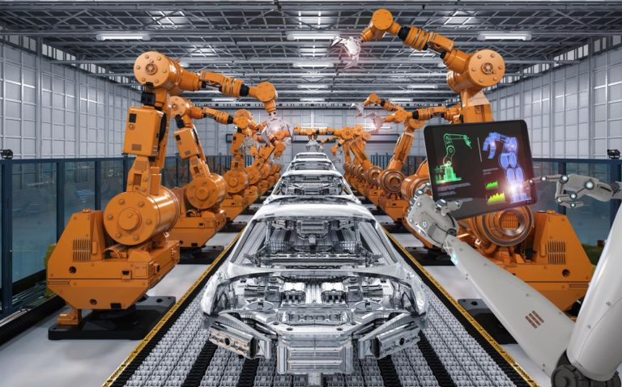
Figure 2.1An illustration of a common industrial robot
https://www.therobotreport.com/wp-content/uploads/2019/08/Industrial-Robot-Sales-Broke-Records-in-2018-768x478.jpg
2.1.2 Medical Robots
Robots have also begun to infiltrate the medical industry in recent years, but not to replace skilled workers like physicians and nurses but to support them in clerical and precise jobs. A promising industry that truly took off in the 1990s was medical robotics. Laboratory robot, telesurgery, surgery training, telehealth, telemedicine and it is, rehabilitation, assistance for the blind and deaf, and hospital robots are just a few of the medical uses that have developed since then. Medical robots help with procedures on heart attack victims and enable millimeter-level prosthetic alterations. Davies (1996)
However, there are significant obstacles to the widespread use of robotics in the medical industry, mostly because of concerns about safety, accuracy, expense, and resistance to adopting this technology. There are many different ways to categorise medical robots, including manipulator design (e.g., kinematics, actuation), autonomy level (e.g., preprogrammed versus mobile robots versus restrained cooperative control), targeted morphology or technique (e.g., cardiac, intravascular, transdermal, laparoscopic, micro-surgical), intended operating environment (e.g., in-scanner, traditional control room (OR)), etc. Despite significant effort and remarkable outcomes, there is still room for research in the field of surgical robotics. Safety is one of the main technical obstacles. Redundancy, minimising excessive speed or power in actuators, thorough design analysis, and numerous emergency stop and checkpoint/restart facilities are some of the fundamental ideas at dispute in Davies (1996). Another important topic that uses roughly the same capabilities as other application sectors is medical human-machine interfaces. Due to the low resolution of newest generation video cameras, optical overlay methods, in which graphic data is superimposed on the surgeon's field of view to augment the information presented, are of interest to surgeons who primarily rely on vision as their primary source of feedback. Since surgeons typically have their hands full, employing voice as an interface has also generated interest. Another potent interface for up with the system applications is force and haptic feedback. Kumar and co. (2000). The employment of political genius systems has been a common theme in both historical and current research on telesurgery. Despite the slaves' limitations in detecting tool-to-tissue forces, these systems are capable of feeding troops and equipment to the surgeon through the master manipulator.
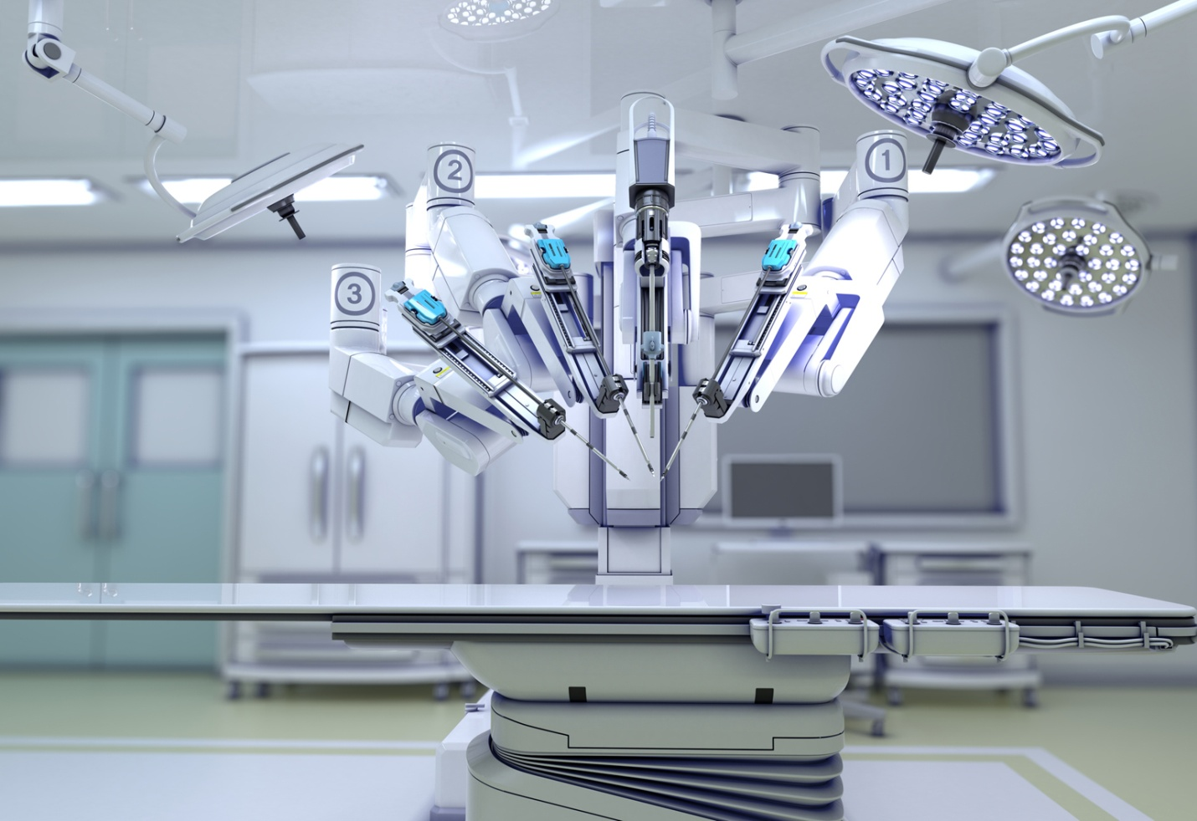
Figure 2.2: A typical medical robots
2.1.3 Rehabilitation Robots
The first commercially effective devices in the field of robotic technology are currently on the market. Activity in this area started in the 1960s, according to Kumar et al. (2000). The term "rehabilitation robot" today can refer to a wide variety of mechatronic devices, from prosthetic limbs to robots that support rehabilitation therapy or provide personal help in medical facilities and residential settings. Examples are Canny (1988) robots for neuro-rehabilitation, power-augmentation orthoses, and therapeutic orthoses. Robotics for rehabilitation is a less developed field than robotics for industry. For reasons of affordability and accessibility, many assistance robotic systems have included an industry robot arm Zhenyu et al (2002). However, these two typical uses have quite distinct requirements for robots. The variations result from the user's participation in rehabilitative applications. In order to deliver speed and accuracy, industrial robots are frequently strong and stiff. No human interaction is allowed because of safety concerns while they run autonomously. For safe user interaction, rehabilitation robots must move more slowly and conform to the user. Rehabilitation robotics therefore resembles service robotics more closely, which unites humans as well as robots in a single activity. It calls for security and special consideration must be given to cyber physical that must be modified for people with disabilities or unskilled users operating a particular programming device. Additionally, it is acknowledged that research & development in robotics should concentrate on creating more adaptable systems for usage in unstructured contexts. The most recent advancements in this field of rehabilitation robotics focus on a variety of subjects, including programming, control, control systems, and human-machine interfaces. Azevedo and co. (2002). This article's "Humanoid Robots" section elaborates on recent findings about human robot interaction.
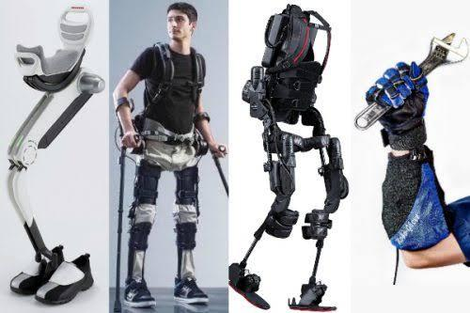
Figure 2.3: Rehabilitation Robots. https://cdn.openpr.com/S/a/Sa21840385_g.jpg
2.2 Mobile Robots
A robotic system that can perform tasks in various locations and is made up of a platform that is moved by locomotive components is referred to as a mobile robot. The region whereby the robot will work is the first consideration in selecting the locomotive system. Aerial, aquatic, or terrestrial can all be used (see Figure 2.4). Propellers or screws are typically used as locomotive systems in aquatic and airborne situations, although benthic legs are also employed. Due to the heterogeneity of terrestrial conditions, selecting a locomotive system is more challenging. Kumar and co. (2000). The typical components of a terrestrial locomotive are wheels, rails, and legs. Robots with mobility have greater operational capabilities and may now be studied in new ways. Some of these problems, like the navigation issue, are universal to all autonomous robots, while others, like the walking gait, are more focused on a particular locomotion technology. Mobile robots had really been placed in the factory by the time autonomous systems were introduced to the production process. Around 1968, automatic guided vehicles (AGVs), which transport tools and move along a predetermined path, made up the majority of the robots. However, the current focus of this research is on autonomous interior and outdoor navigation. Four steps make up autonomous mobile-robot navigation: environment sensing, self-localization, motion planning, and motion generating. For the purpose of mobile robot navigation and motion planning in structured environments, maps or models of the environment can be created through the perception process. However, the robot must navigating in chaotic or dynamic surroundings. Therefore, one of the key uses of artificial intelligence in robots is navigation, which combines learning, thinking, and problem-solving. The primary areas of study in mobile robotics are robot localisation and map creation. Lei et al (2004)
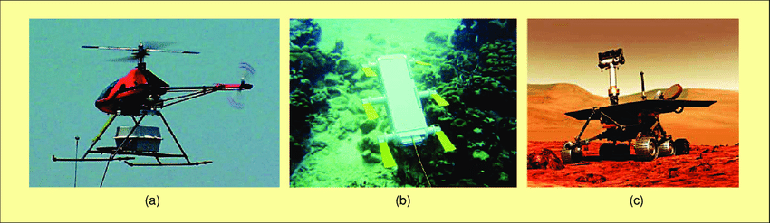
Figure 2.4: Mobile robots in various environment. (a) Aerial mobile robot (b) Aquatic mobile robot (c) Terrestrial mobile robot.
https://www.researchgate.net/profile/Pablo_Gonzalez-De-Santo2/publication/3344813/figure/fig1/AS:670041175494664@1536761673742/Mobile-robots-in-various-environments-a-VAMPIRA-Photograph-courtesy-of-DISAM-UPM.png
2.3 BIOLOGICALLY INSPIRED ROBOTS
A lot of work is being done to harness biological inspiration to create unique types of mobile robots with adaptive mobility systems in addition to the conventional mobile vehicles that move on wheels and tracks (1986). The leg is most likely the physiologically inspired locomotion system that is employed the most frequently. However, some research teams are concentrating on different kinds of locomotion, such the mechanisms utilised by snakes and fish. Due to their wider application, we shall concentrate on walking bots and humanistic robots in this survey. Humanoids and walking robots both employ their legs for locomotion, but their research focuses and service applications are different. Additionally, research on bipedal robotics covers more than just all aspects of mobility; it also include study on other "human" features including communication and emotion display. Therefore, we survey each of them separately..
2.3.1 Walking Robots
The research of mobile robots that move with their legs has received a lot of attention. Walking robots share many of the technological issues common to both industrial robots nor mobile robots since their legs are built on second- and third (DOF) manipulators. The ability to move on their legs gives walking robots benefits over other mobile robots.
- Robots with legs may traverse uneven terrain while keeping their bodies level without jeopardising their stability.
- One of the key benefits of legged robots is their ability to move over obstacles like ditches and stairs.
- Robots with legs can navigate rocky and sand-covered terrain.
- Robots with legs are inherently omnidirectional.
- Robots on legs cause significantly less environmental degradation than those on wheels or tracks.
Legs, however, also present a number of issues of their own. Legged-robot research, in fact, is concerned with all aspects of leg strength and coordination of robot navigation.
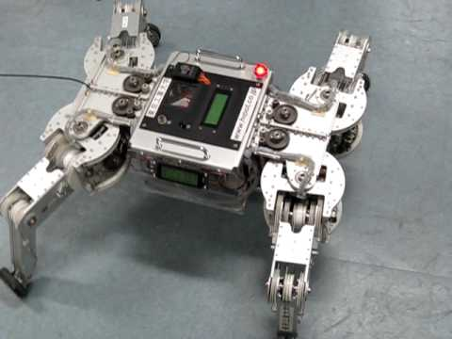
Figure 2.5: Walking Robot. https://i.ytimg.com/vi/i2PUBjzaatY/hqdefault.jpg
2.3.2 Humanoid Robots
Social robots come immediately to mind while talking about simple iterative walking robots. The initial studies with dermato-skeletons, led by Vukobratovic et al. (2002), did not result in actual sentient biped robots until 1967. Davies(1996). At Tokyo's Waseda University, the first control technique biped robot was created in 1972. The robot's name was WL-5. The first creatures were highly simple devices that could only move in a static environment, but further improvements led to really smart, incredibly light, and skilled robotic (see Figure 2.6). Gait synthesis, power steering, and robot design are the three main study areas that have been fueled by these innovative advancements.
Humanoids can generate their gaits using one of two methods. The initial strategy entails creating a gait off-line. Davies (1996). However, this approach is unable to adapt to shifting circumstances. The second kind of technique is an advancement that generates an appropriate gait on a regular basis and figures out the ideal angles for each joint online. Azevedo and co. (2002). Additionally, some effort has been made to lower power usage while walking.
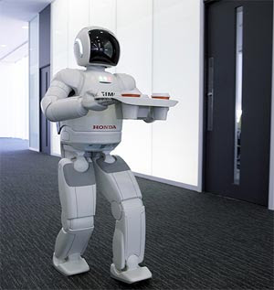
Figure 2.6: Humanoid Robots. https://2.bp.blogspot.com/_V_KZ2xOXXXQ/SVBQ0Q7mzaI/AAAAAAAAAII/QGt70LhVt20/s320/robot.jpg
2.4 LAWS OF ROBOTICS
The "Three Laws of Robotics" by Isaac Asimov are the most well-known sets of laws. Although they were hinted to in a number of his earlier stories, these were first presented in his 1942 short storey "Runaround." What are The Three Laws?:
- A robot may not damage a human or, by doing nothing, permit a human to suffer injury.
- A robot must follow any instructions provided to it by humans unless doing so would violate the First Law.
- As long as it doesn't violate the First or Second Laws, a robot must defend its own existence.

2.5 COMPONENT OF ROBOTICS
- Structure
- Power source
- Actuation
- Sensing
- Manipulation
- Locomotion
2.5.1 Structure
A robot's structure is typically primarily mechanical and is referred to as a kinematic chain. Links (the chain's bones), activator (its muscles), and couplings with multiple degrees of freedom make up the chain.
2.5.2 Power source
- To run the motor and related circuits, a suitable power supply.
- The typical power range is between 3 and 24 volts DC.
- Adapting the 220V AC supply to our machine's requirements is necessary.
- Robots can also be powered by batteries.
- Different motors are used to power robots:-
- DC Motors
- Stepper Motors
- Servo Motors

DC Motors
Robot will remain lighter and more energy-efficient if dc motor is used. Robot costs will remain low because to the use of DC motor. Speed control is yet another crucial element when using DC motors. With the aid of power electronic auxiliary devices, DC motors can be utilised at different speeds and torques, which are not conceivable with AC motors.
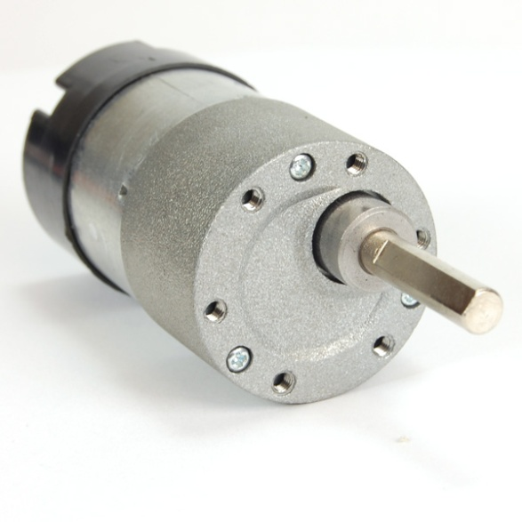
Figure 2.7: DC Motor. https://www.trossenrobotics.com/shared/images/PImages/KIT-MTR-36-06-180-a.jpg
Stepper Motor
DC motors that move in distinct increments are called stepper motors. They have several coils that are arranged into "phases" or collections. The motor will rotate one step at a time by activating each stage in turn.
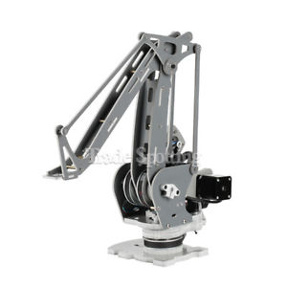
Figure 2.8: Stepper Motor. https://i.ebayimg.com/images/g/VIsAAOSwlnZZt3Zn/s-l300.jpg
Servo Motor
The angular or translational position, velocity, and acceleration can be precisely controlled with a servomotor, which is a rotary actuators or linear actuator. It is composed of a suitable motor connected to a position feedback sensor. Applications for servomotors include robotics, CNC machines, and automated manufacturing.
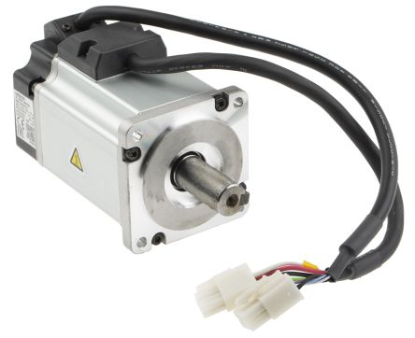.
Figure 2.9: Servo Motor. https://media.rs-online.com/t_large/F1241297-01.jpg
2.5.3 Actuation
Actuators, the components that transform stored energy into movement, are the "biceps" of a robot. Electric motors are the most often used actuators.

2.5.4 Manipulation
- Robots that operate in the actual world need to be able to pick up, alter, destroy, or otherwise affect objects. As a result, a robot's "hands" are refereed to as force sensors, while its arm is talked to as a manipulator.
- Some con artists are:
- Mechanical Grippers
- Vacuum Grippers
Mechanical Grippers
In order to grasp objects with some of its mechanically robust fingers, a robot's end effector uses a mechanical gripper. Two fingers are plenty for holding in the workplace. Depending on the application, you can also utilise more than three fingers.
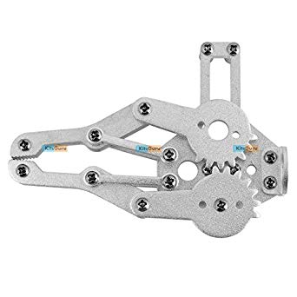
Figure 2.10: Mechanical Gripper. https://images-na.ssl-images-amazon.com/images/I/41DEqvaHYTL._SX342_.jpg
Vacuum Gripper
Robots have vacuum grippers that they utilise to pick up non-ferrous things. It uses vacuum cups, also known as suction cups, as the holding mechanism. If the pieces are clear, flat, and clean, these grippers will offer good handling. It has only one surface for gripping the objects.
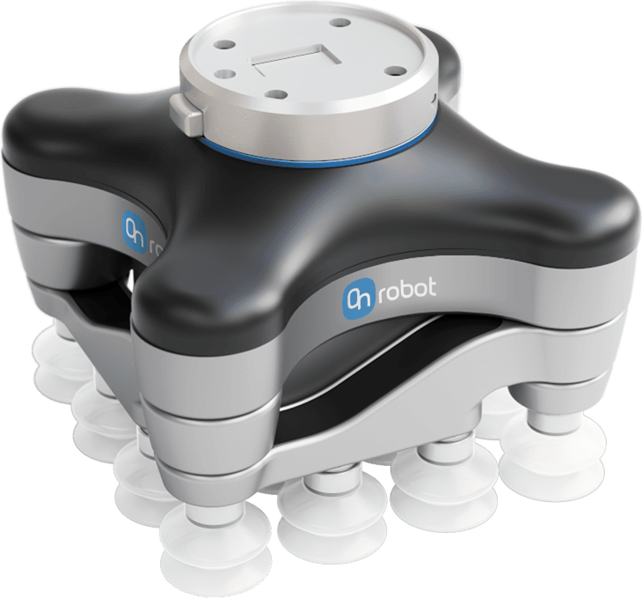
Figure 2.11: Vacuum gripper. https://wiredworkers.io/wp-content/uploads/2019/08/VG10-3.png
2.5.5 Locomotion
- It is worried about how the robot is moving.
- There are various drive kinds in a robot:-
- Differential drive
- Car type
- Skid steer drive
- Synchronous drive
- Pivot drive
- Articulated drive
- Pivot drive
2.6 ROBOTIC MAPPING
Robotic mapping and map-based robot localization are interconnected, therefore research since 1990 has concentrated on finding solutions to both issues at once. Prior to it, topological and metric approaches to mapping were the only options. Metric maps depict the environment's geometric features. Elfes (1987), whereas topological maps use nodes and arcs graphs to depict the connectedness of various locations. Matarie (1990). Metric maps are more precise than topological maps in practise, although more resolution requires more processing. Based on the likelihood of space occupied, metric locations can be discretized. Occupancy-grid mapping is the name given to the resulting mapping techniques. Moravec (1988). The positions and characteristics of objects with simple geometric qualities are preserved, in contrast, in the system of measurement maps of geometric elements. Since 1990, simultaneous localize and mapping has been a prevalent name for robotic mapping (SLAM). While some solutions need multiple passes through the entire set of perceived data, others are cumulative and allow real-time implementation. The location of the robot and the map are estimated using Kalman filters, which are also used to create maps that show the locations of beacons, landmarks, and other objects in the area. Guivant and Nebot from Leonard et al. (1992) (2001). The Lu/Milios method (Lu and Milios, 1997) and, more recently, the dense extended information filter, which is based on the inverse of the based On adaptive filter, are extensions of the algorithms rely on the Kalman filter (EKF). An alternative family of approaches is built on Dempster's Optimism Maximization algorithm, which uses a recursive process to try to discover the most likely map. These methods address the issue of the connection between sensory measurement and actual world objects. Dynamic ecosystems have been the focus of recent research. This is a major issue because non-static situations are where many realistic implementations for robots are found. Although occupancy-grid maps and Kalman-filter methods can both be modified to map dynamic settings by assuming landmarks that migrate slowly over time and, similarly, by decreasing occupancy over time, map production in dynamic environments has not been thoroughly studied. A few algorithms are based on the environment's dynamic. However, there are still a lot of unanswered issues, like how to distinguish between the static analysis parts of the environment and how to depict such information on a map. In Thrun, a comprehensive analysis of mapping techniques is presented (2002). Mobile robots are moving from experimental prototypes to practical uses. Cleaning and housekeeping are two direct service applications for mobile robots, where independent washers and lawn mowers make use of all the expertise in mobile navigation to assist at home. Mobile robots may also be employed as tour guides in museums and as assistants in workplaces, medical facilities, and other public places. These robots address important issues with intelligent navigation, including virtual telepresence, navigation in dynamic situations, and navigation in unmodified surroundings. Another potential use for mobile robot technology is surveillance, and private security firms are starting to show interest in using guard robots in surveillance.
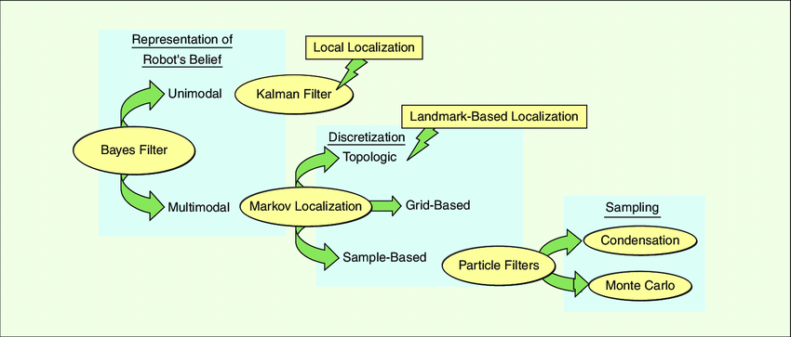
Figure 2.12: Classification of Localization Algorithm. https://www.researchgate.net/profile/Pablo_Gonzalez-De-Santos2/publication/3344813/figure/fig2/AS:670041175502879@1536761673911/A-classification-of-localization-algorithms.png

CONCLUSION AND RECOMMENDATION
4.0 CONCLUSION
The creation of robotic systems to assist humans in hazardous, difficult, or unpleasant work has been the focus of robotics research since the development of the industrial robots in the automobile industry. The demand for flexibility in industrial robots has grown along with task complexity, and robotics research has shifted toward the development of adaptable and intelligent systems. Since 1995, robotics research has expanded into the fields of field and service robotics, where we now have manipulators, mobile robots, and robots that resemble animals with excellent development potential and growing research interest. The initial achievements were surgical robots, and more subsequently, several fields in medical and rehabilitation robotics applications have emerged. Other instances can be discovered, to mention a few, in the domains of housecleaning, refuelling, and museum exhibits.
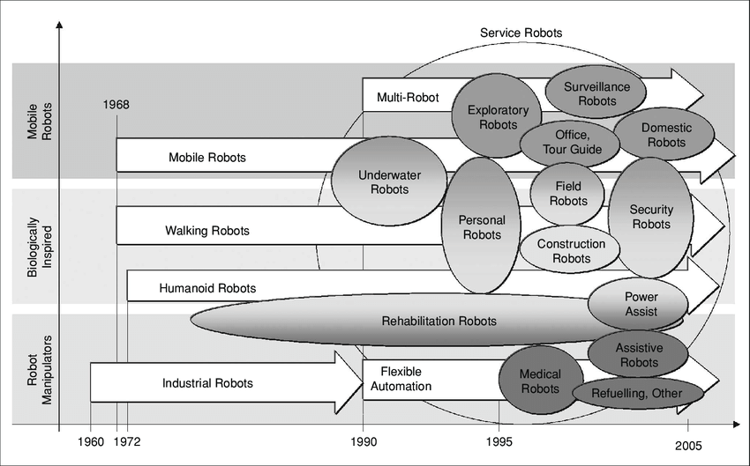
Figure 4.0. Summary of the evolution of robotics over the last 50years.

4.1 RECOMMENDATION
The number of human occupations will decrease as a result of the usage of robots for a variety of tasks. As a result, there will be some balance between the actual need and demand for robot assistance in the job. The advancement of robotics technology should be encouraged by society, since it will benefit both individuals and numerous economic sectors. Robotics can aid with a variety of activities that are beyond the capacity of humans, and their use in warfare would be very beneficial.

REFERENCES
A. Elfes, “Sonar-based real-world mapping and navigation,” IEEE J. Robot. Automation, vol. 3, no. 2 pp. 249–265, Mar. 1987.
Allen, C., Varner, G., Zinser, J. (2000). Prolegomena to any Future Artificial Moral Agent. Journal of Experimental and Theoretical Artificial Intelligence 12(3): 251–261.
Allen, C., Smit, I., Wallach, W. (2005). Artificial Morality: Top-Down, Bottom-Up and Hybrid Approaches. Ethics and New Information Technology 7(3): 149–155.
Allen, C., Wallach, W., Smit, I. (2006). Why Machine Ethics? IEEE Intelligent Systems 21(4): 12–17.
Arkin, R. (1998). Behavior-Based Robotics. Cambridge: MIT Press.
Arkin, R. (2009). Governing Lethal Behavior in Autonomous systems. Boca Raton, FL.: CRC Press.
Asimov, Isaac (1950). I, Robot.
B. Davies, A Discussion of Safety Issues for Medical Robots, In R. Taylor, S. Lavallee, G. Burdea, and R. Moesges, Eds. Computer-Integrated Surgery. Cambridge, MA: MIT Press, pp. 287–296, 1996.
Bekey, G.A. (2012). Current Trends in Robotics: Technology and Ethics. In (eds.)
C. Azevedo, P. Poignet, and B. Espiau, “Moving horizon control for biped robots without reference trajectory,” in Proc. IEEE Int. Conf. Robotics Automation, 2002, pp. 2762–2767.
Coeckelbergh, M. (2012). Can We Trust Robots? Ethics and Information Technology
14(1): 53–60.
Dodig-Crnkovic G. and Çürüklü B. (2011). Robots – Ethical by Design. Ethics and
Information Technology 14(1): 61–71.
F. Lu and E. Milios, “Globally consistent range scan alignment for environment mapping,” Auton. Robots, vol. 4, pp. 333–349, 1997.
H.P. Moravec, “Sensor fusion in certainty grids for mobile robots,” AI
Mag., vol. 9, no. 2, pp. 61–74, 1988.
J. Bobrow, S. Dubowsky, and J. Gibson, “Time-optimal control of robotic manipulators along specified paths,” Int. J. Robot. Rese., vol. 4, no. 3, pp. 3–17, 1985.
J. Leonard, H.F. Durrant-White, and I.J. Cox, “Dynamic map building for an autonomous mobile robot,” Int. J. Robot. Res., vol. 11, no. 4, pp. 89–96, 1992.
J.E. Guivant and E. Nebot, “Optimization of the simultaneous localization and map-building algorithm for real-time implementation,” IEEE Trans. Robot. Automat., vol. 17, no. 3, pp. 242–257, May 2001.
J.F. Canny, The Complexity of Robot Motion Planning, Cambridge, MA: MIT Press, 1988.
J.J. Craig, Introduction to Robotics. Reading, MA: Addison-Wesley, 2nd
ed., 1989
J.T. Schwartz and M. Sharir, “On the ‘piano movers’ problem: 1. The case of two-dimensional rigid polygonal body moving amidst polygonal barriers,” Commun. Pure Appl. Math., vol. 36, pp. 345–398, 1983.
Johnson, D.G. (2006). Computer Systems: Moral Entities but not Moral Agents. Ethics and Information Technology 8(4): 195–204.
L. Zhenyu, C. Yinglin, and Q. Daokui, “Research on robot calibration,” Robot, vol. 24, no. 5, pp. 447–450, 2002.
Lin, P., Abney, K., Bekey, G.A. (2012). Robot Ethics – The Ethical and Social Implications of Robotics. Cambridge, MA.: MIT Press.
Lin, P., Bekey, G.A., Abney, K. (2008). Autonomous military robotics: Risk, ethics and design, a US department of defense office of naval research-funded report. <http://ethics.calpoly.edu/ONR_report.pdf> Accessed May 2013.
Matthias, A. (2004). The Responsibility Gap. Ascribing Responsibility for the Actions of Learning Automata. Ethics and Information Technology 6(3): 175–183.
M.J. Matarié, “A distributed model for mobile robot environmentlearning and navigation,” M.S. thesis, Mass. Inst. Technol., Cambridge, MA, Jan. 1990, MIT AI Lab. Tech. Rep. AITR-1228, May 1990.
M. Montemerlo, S. Thrun, D. Koller, and B. Wegbreit, “FastSLAM: A factored solution to the simultaneous localization and mapping problem,” in Proc. AAAI National Conf. Artificial Intelligence, Edmonton, Canada, 2002, AAAI, pp. 593–598.
Murphy, R. 2000. Introduction to AI robotics. MIT press.
Niku, S. 2010. Introduction to robotics. John Wiley & Sons.
Nehmzow, Ulrich. 2012. Mobile robotics : A practical introduction. London: Praxis.
Noorman, M. (2012). “Computing and Moral Responsibility”. The Stanford Encyclopedia of Philosophy (Fall 2012 Edition), Edward N. Zalta (ed.), URL =http://plato.stanford.edu/archives/fall2012/entries/computing-responsibility/ Accessed May, 2013.
O. Khatib, “Real-time obstacle avoidance for manipulators and mobile robots,” Int. J. Robot. Res., vol. 5, no. 1, pp. 90–98, 1986.
R. Kumar, P. Berkelman, Gupta, A. Barnes, P.S. Jensen, L.L. Whitcomb, and R.H. Taylor, “Preliminary experiments in cooperative human/robot force control for robot assisted microsurgical manipulation,” in Proc. IEEE Int. Conf. Robotics Automation, pp. 610–617, 2000, San Francisco, CA
Stahl, B.C. (2004) Information, Ethics and Computers: The Problem of Autonomous
Moral Agents. Minds and Machines 14(1): 67–83.
Singer, P.W. (2009). Wired for War – The Robotics Revolution and 21st Century Conflict. New York: Penguin Press.
S. Lei, L. Jingtai, S. Weiwei, W. Shuihua, and H. Xingbo, “Geometrybased robot calibration method,” in Proc. IEEE Int. Conf. Robotics and Automation, pp. 1907–1912, 2004
S. Thrun, “Robotic mapping: A survey,” Tech. Rep. CMU-CS-02-111, School Comp. Sci., Carnegie Mellon Univ., Pittsburgh, PA 15213, Feb. 2002.

