A Study of Engine Culture towards Dropping the Probability of Jungle Blazes

Shweta Dhareshwar
Department of Master of Computer Applications
Nitte Meenakshi Institute of Technology
Bangaluru, India
shwetashine.dhareshwar@gmail.com

Adithya Sharavana H
Department of Master of Computer Applications
Nitte Meenakshi Institute of Technology
Bangaluru, India
adithyasharavanah@gmail.com

ABSTRACT
Forest fire prevention is a critical aspect of protecting our natural resources and ensuring the safety of wildlife and communities. Traditional methods of fire prevention have limitations in detecting and predicting fires before they cause irreparable damage. In this report, we propose a novel approach using machine learning to enhance forest fire prevention efforts. By leveraging machine learning algorithms and analyzing relevant data such as oxygen levels, temperature, and humidity, we can develop a predictive model to assess the probability of a fire occurring in a particular area. This model can serve as a valuable tool for governments and authorities to allocate resources effectively and take proactive measures to prevent fires. The research focuses on creating a large dataset by collecting real-life examples of forest fires and their associated parameters. With this dataset, can train a machine learning model to accurately predict the likelihood of a fire outbreak based on the input parameters. By integrating this model into a web or mobile application, can provide real-time fire risk assessments and alerts to users, enabling them to take necessary precautions. The proposed system offers a comprehensive and efficient solution for forest fire prevention, with the potential to be applied on a global scale. By combining machine learning capabilities with preventive measures and community involvement, we can significantly reduce the negative impact of forest fires and safeguard the natural environment.

Keywords— Fire detection,Machine learning

INTRODUCTION

Uncontrolled fires that start in places with combustible vegetation are called forest or wildlife fires. They can be categorized as bush fires, forest fires, or other sorts depending on their size. It is vital to find ways to stop these fires since they pose a serious harm to wildlife. Being able to detect or predict forest fires before they start is one of the biggest difficulties in dealing with them. When a forest fire develops, it becomes very challenging to contain and put it out before it does significant and irreparable harm. In this context, machine learning, an area of research concerned with enabling computers to learn from data and make predictions, can be extremely important. The term "fire prevention" refers to a diverse and intricate array of actions. Physical duties that are part of it include managing forests and fuel loads, maintaining forest roads, safeguarding water sources (by building water tanks, ponds, and fire hydrants), and different operations that put people's safety first. Given that human activity is the primary cause of most fires and that protecting human lives is a high concern in forest fire management, a comprehensive approach is required. All of these elements need to be present and functioning properly for prevention to be effective and efficient.
Forest or wildlife fires pose a significant threat to wildlife, and it is crucial to develop effective solutions to mitigate their impact. One of the main challenges in addressing forest fires is the early detection and prediction of these events, as once a fire starts, it can rapidly escalate and cause extensive, irreversible damage. Machine learning, a field focused on leveraging data to make predictions, can play a vital role in this area. To develop a predictive model for forest fires, it is important to identify and model key parameters that contribute to fire occurrence. The government and appropriate agencies can then use this model to determine the best places to take preventative measures in the event of a fire. By implementing proactive measures based on these predictions, such as increased monitoring, enhanced fire prevention efforts, and resource allocation, the government can minimize the risk and impact of forest fires. This approach allows for targeted and efficient allocation of resources to areas at higher risk, reducing response time and improving overall fire management strategies.
According to Tedim et al., efforts are typically made to raise these threshold levels by implementing technological advancements, better organization, quicker response times, more resources, etc. When firefighting mechanisms are unable to control fires that exceed certain levels of fire behavior, for example, a certain temperature, the temperature of the fire must be raised. However, these initiatives typically involve high costs. This tactic is known as the "firefighting trap" since it focuses on putting out flames while ignoring preventative measures. This phrase describes a short-term management approach that places more emphasis on fixing problems than on preventing them, which frequently has unanticipated negative effects in a professional setting. Because it can temporarily lessen damage, a technique like this might at first glance seem to be effective in controlling forest fires. In the end, though, it falls short of addressing the underlying causes of wildfire risk, leading to the "fire paradox." This problem has been proven to be true, and modern logical thinking emphasizes the necessity to shift the focus from fire concealment to moderation, anticipation, and readiness. Such a policy is more likely to effectively lessen the bad impacts that fire has on society, the economy, and the environment than the existing approach, which focuses exclusively on excluding fires. The phrase "forest fire prevention" refers to all measures performed before a fire to minimize its risk of starting, lessen its propensity for aggressive behavior and quick expansion, and lessen its damage. Preventing fires is a complicated task that requires substantial planning. In addition to physical safeguards like building water tanks, ponds, or fire hydrants, it also encompasses a variety of human-centered activities like maintaining forest routes, regulating fuel loads, and maintaining trees. This is because most fires are started by people, and forest fire management places a great focus on safeguarding people's safety. For prevention to be both effective and efficient, these three components must be combined effective and efficient.
A. Goals
The primary goals of implementing machine learning in this domain include early detection of fire-prone areas, accurate prediction of fire spread patterns, and efficient resource allocation for firefighting efforts. By analyzing various data sources such as oxygen level, Temperature, Humidity level, machine learning models can identify vulnerable regions and provide valuable insights for proactive planning and mitigation strategies. Through this approach, forest fire prevention using machine learning aims to minimize the devastating impact of wildfires, safeguard ecosystems, protect human lives, and preserve valuable natural resources.
B. Motivation
Forest fire prevention can be significantly enhanced through the implementation of machine learning methodologies. By analyzing a variety of data sources such as weather conditions, satellite imagery, historical fire data, and vegetation patterns, machine learning algorithms can identify potential areas of high fire risk. These algorithms can detect patterns and correlations that may be missed by human observers, enabling early identification of vulnerable regions. Additionally, machine learning models can continuously learn and adapt based on real-time data, improving their accuracy and predictive capabilities over time. By integrating these models into fire management systems, authorities can proactively allocate resources, implement targeted prevention measures, and issue timely warnings to communities at risk. By harnessing the power of machine learning, forest fire prevention efforts can be greatly enhanced, reducing the devastating impact of wildfires and protecting both ecosystems and human lives.

LITERATURE REVIEW

Detecting and preventing forest fires is a major issue for many nations. Various techniques have been suggested for keeping track of fire emergence.
A. S. Mahdi et al [1], 2022, demonstrate a survey of computer vision-based fire detection techniques. The recent machine learning models that are used, together with the datasets needed to build upcoming research projects for the wildfire detection system, are the main emphasis of this paper. Additionally, a comparison study is conducted to highlight the advantages and disadvantages of the most important aspects of the present approaches, such as detection accuracy. Alkhatib R et al [2], 2023, explores the application of various machine learning algorithms for forest fire detection and prediction. It discusses the advantages and limitations of algorithms such as decision trees, random forests, support vector machines, k-nearest neighbors, and neural networks. The study emphasizes the importance of feature selection and data preprocessing to enhance model accuracy and efficiency. Abid F et al [3], 2021, reviews various forest fire detection techniques, including image processing, data mining, and machine learning approaches. It provides an overview of different datasets and the performance of algorithms applied to these datasets. A. A. A Alkhatib [4], 2014, conducted a detailed review on Forest Fire Detection Techniques. Chowdary V and Gupta M K [5], 2018, a comprehensive survey of forest fire detection and monitoring techniques. It covers sensor-based approaches, remote sensing, wireless sensor networks, and machine learning algorithms for early fire detection and monitoring. Grari, M et al [6], 2022, in order to detect and predict forest fires using IoT and machine/deep learning, we undertook a comprehensive evaluation of the scholarly literature. The data analysis that was done showed that temperature, humidity, CO, and light are the main factors used to identify and detect forest fires. Additionally, we discovered that the majority of the communication channels used in this situation are based on one of these protocols: WiFi, ZigBee, or GSM.
I. Idrissi et al [7], 2022, developed a technique on Stratified IoT Deep Learning based Intrusion Detection System, which combines the concepts of multidisciplinary approaches of IoT and Deep Learning. M. Grari et al [8], 2022, discovered a methodology for early Wildfire Detection using Machine Learning Model Deployed in the Fog / Edge Layers of IoT. Rajan G V and Paul S [9], 2022, designed an algorithm for Forest Fire Detection Using Machine Learning. Sathish Kumar V. E et al [10], 2023, transfer learning is applied to pre-trained models like VGG16, InceptionV3, and Xception, which enables us to work with a smaller dataset and reduce computational complexity without compromising accuracy. With an accuracy rate of 98.72%, Xception outperformed all other models.

A. Existing System

The detection of a wildfire is primarily dependent upon 3 factors

Oxygen Level: For any fire take place, high oxygen content is required. So higher the oxygen more is the probability of a wildfire taking place

Temperature: Obviously for a fire to take place, heat is favorable. Hence high temperature increases the probability of fire in any region.

Humidity: Obviously Humid weather is unfavorable for a fire, whereas a dry weather is. Therefore, higher the humidity, lower the probability of a fire taking place.

B. Drawbacks Of Existing System

Camera Surveillance: This approach uses drones or camera equipment to survey nearby forest cover for fires. However, the problem is, detection can only be done once a fire is actually started. It is also not economically feasible to cover large forest covers with cameras and drones.

Forest Fire Reservoirs: This is simply creating water supplies near forest covers to extinguish fires early. This is system again only works after a fire takes place and does not help in detection of the forest fire.

C. Proposed System
Machine learning models train on data. So, we take real life examples of forest fires that took place and collect the data prior to the fire taking place, which is publicly available. We have the inputs as oxygen, humidity, temperature, and the output as 0 or 1 based on whether or not a fire took place. On creating a large enough dataset, we can create a trained machine learning model which can successfully predict the probability of a fire taking place in an area given the 3 parameters. Government can in that sense take necessary precautions for areas which high probability of a fire breaking out
D. Benefits of Proposed System
Once we get access to more data the machine learning model accuracy can be further increased
• On a large scale this can be deployed by all forest authorities so that they have a prioritized list of places with places with maximum likelihood of a fire taking place at the top.
• This can be combined with web application to give a nice interface for forest authorities, and this provides a way of smarter patrolling so that forests with greater likelihood of a fire taking place are given maximum patrolling and access to water supply
E. Scope
Forest or wildlife fires pose a significant threat to wildlife, and it is crucial to develop effective solutions to mitigate their impact. One of the main challenges in addressing forest fires is the early detection and prediction of these events, as once a fire starts, it can rapidly escalate and cause extensive, irreversible damage. Machine learning, a field focused on leveraging data to make predictions, can play a vital role in this area. To develop a predictive model for forest fires, it is important to identify and model key parameters that contribute to fire occurrence. The government and appropriate agencies can then use this model to determine the best places to take preventative measures in the event of a fire. By implementing proactive measures based on these predictions, such as increased monitoring, enhanced fire prevention efforts, and resource allocation, the government can minimize the risk and impact of forest fires. This approach allows for targeted and efficient allocation of resources to areas at higher risk, reducing response time and improving overall fire management strategies.

SYSTEM DESIGN

Use Case Diagram
In the Unified Modeling Language (UML), a use case diagram serves as a visual representation of the interactions between users (actors) and a system. It employs specialized symbols and connectors to depict various scenarios, goals, and the scope of the system. By creating an effective use case diagram, teams can discuss and communicate:
Scenarios: A use case diagram illustrates the different situations or scenarios in which the system or application interacts with various entities, including people, organizations, or external systems.
Goals: The diagram showcases the goals that the system or application helps the actors (users) to achieve. These goals can range from simple actions to complex workflows.
Scope: A use case diagram provides an overview of the system's scope, indicating the boundaries and limits of its functionalities and interactions. It defines the extent to which the system interacts with different actors and external systems.
Overall, a use case diagram aids in visualizing and understanding the relationships and dependencies between users and the system. It serves as a valuable tool for requirements analysis, communication, and decision-making during the system development process.
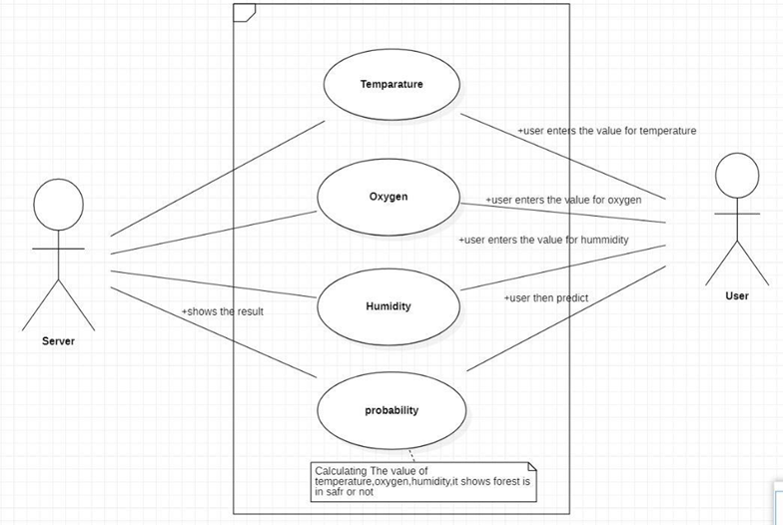

Figure 1: Use Case Diagram

Data Flow Diagram
A data flow diagram (DFD) is a picture that shows how information moves through a system or process. It uses labels and specialized symbols to represent inputs, outputs, storage locations, and the paths that connect them, including rectangles, circles, and arrows. DFDs can range in complexity from straightforward, manually drawn process summaries to intricate, multi-level diagrams that explore the nuances of data management. These diagrams can be used to model new systems or assess current ones. DFDs are useful for visualizing data flow in software and systems, although they might not be as useful for interactive, real-time, or database-oriented systems. For such situations, other diagramming techniques could be more suitable.

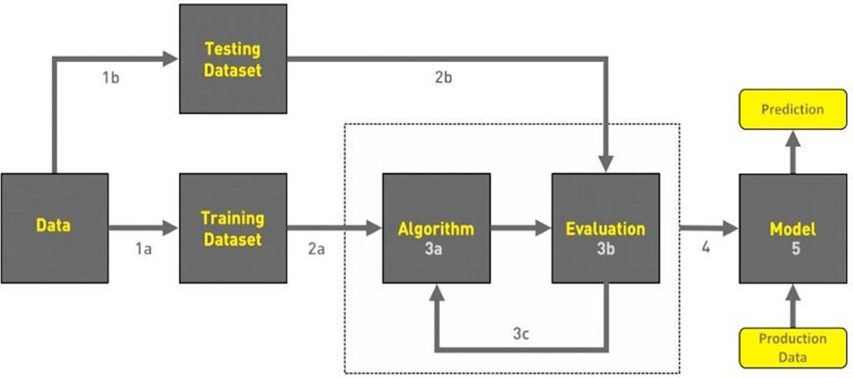

Figure 2: Data Flow Diagram

Class Diagram
In a class diagram, each class is represented with its name, along with its attributes and functions displayed in separate compartments. The diagram provides a clear representation of the structure and organization of the software system. Class diagrams play a vital role in software development as they facilitate the design and implementation of object-oriented systems. They enable developers to model the relationships and interactions between different classes, aiding in the construction of robust and maintainable software systems.
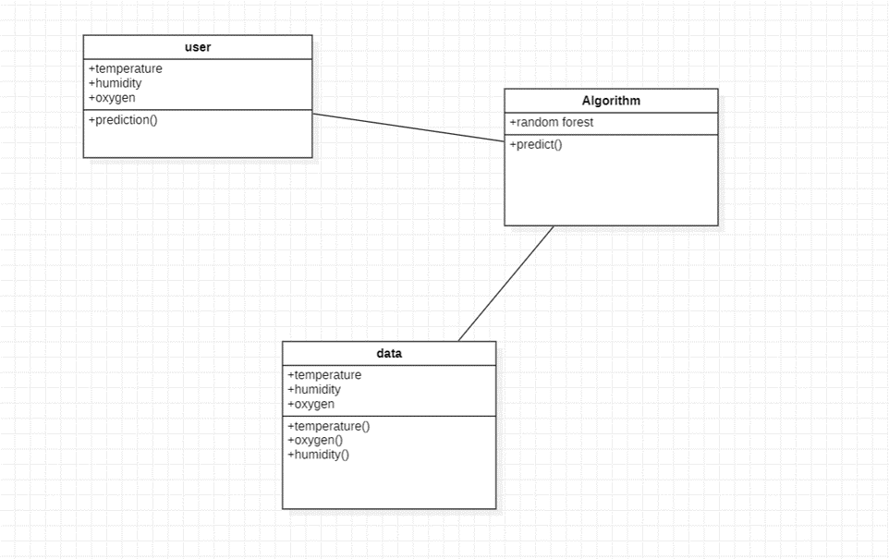
Figure 3: Class Diagram

Architecture Diagram

Machine learning architecture has evolved from a concept to a tangible reality, playing a significant role in the advancement of artificial intelligence. Initially, machine learning focused on pattern recognition. The architecture of machine learning can be categorized into three types based on the algorithms used on training data: Supervised Learning, Unsupervised Learning, and Reinforcement Learning.
The machine learning process involves several key steps within this architecture:
Data Acquisition: This step involves obtaining the necessary data for training the machine learning model. Data can be acquired from various sources such as databases, APIs, sensors, or other data collection methods.
Data Processing: Once the data is acquired, it needs to be processed and prepared for training. This includes tasks like cleaning the data, handling missing values, normalizing or scaling features, and splitting the data into training and testing sets.
Training: The model is trained using the prepared training data. During training, the model learns from the input data and adjusts its internal parameters. This process involves iterations and optimization techniques to improve the model's accuracy.
Evaluation: Once the model is trained, it is evaluated using the testing data to assess its performance and generalization capabilities.

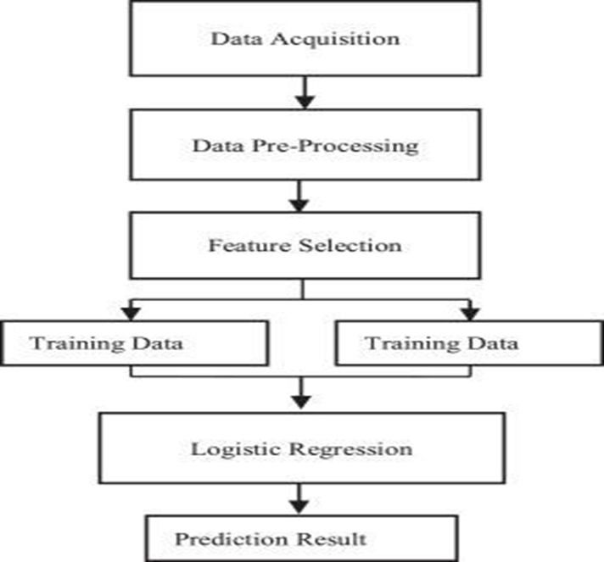

Figure 4: Architecture Diagram

IMPLEMENTATION

Three things are most responsible for a wildfire's detection:
- Oxygen Level: A high oxygen content is necessary for a fire to occur. Therefore, a higher oxygen level increases the probability of a wildfire. In our system, the module allows users to enter the oxygen value to determine if the forest is safe or at risk of a fire.
- Temperature: Heat is a crucial factor for fire ignition. Higher temperatures contribute to an increased likelihood of fire in a region. The temperature module enables users to enter the temperature value to assess the safety of the forest.
- Humidity: Dry weather raises the risk of fire while humid weather is unfavorable. A lower likelihood of a fire is correlated with higher humidity levels. Users of the humidity module can enter a humidity value to assess the forest's safety.
Our proposed system involves training machine learning models on real-life examples of past forest fires. We collect publicly available data prior to the fire occurrence, including inputs such as oxygen, humidity, and temperature, and the output indicating whether a fire took place (0 for no fire, 1 for fire).

Preprocessing: In order to implement a supervised learning algorithm, the first step is to collect a dataset. For the forest fire detection project, data is collected from an environment that resembles forest situations during fire initiation. The data of each node is recorded, and after a certain period, a set of CSV files is generated. Key features required for forest fire detection, such as temperature, humidity, and smoke, are included in the dataset. Two methods were employed to collect the data: creating a dummy dataset by sampling at room temperature and burning leaves, and collecting samples when the fire was stopped.
Web Application: To apply this concept in development, a web application can be created. The web application prompts the user to input three parameters (temperature, humidity, and other relevant factors) to obtain the forest fire probability. Citizens can also use the web application to patrol forests and report any potential dangers to higher authorities. The web application is built using Flask for the backend and HTML/CSS for the frontend.
Learning Algorithm: The forest fire detection problem falls under the category of supervised learning. Three learning models are trained and their accuracies compared:
- Linear Regression
- Logistic Regression
- Support Vector Machine
Based on the comparison, the logistic regression model is chosen for the project because it has the highest accuracy. A machine learning model called logistic regression produces the likelihood that a given input instance belongs to a given class. The output classes in this instance are binary, with "Yes" denoting a high possibility of a forest fire and "No" denoting an unlikely likelihood. A prioritized list of locations can be created using logistic regression, with the areas most likely to experience a forest fire being listed first.

Scenario 1: The user enters the required values for calculating is the forest is in safe or not. The user inputs are Temperature, Oxygen, Humidity, then users predict the forest fire. The output is depicted here when the input conditions are hot weather, high oxygen content, and low humidity.

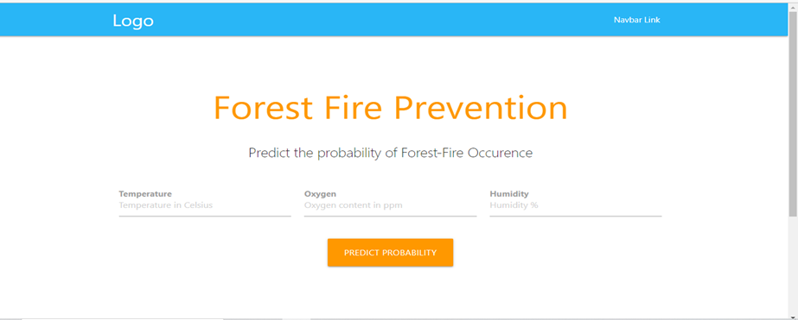
Figure 5: Home Page

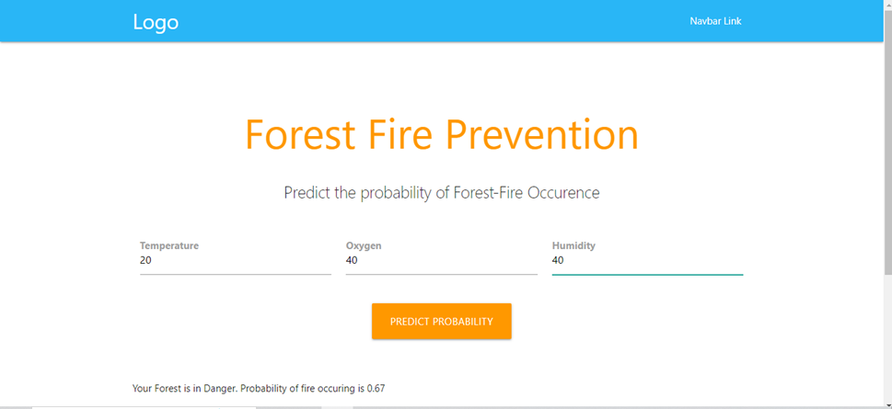

Figure 6: Page to enter the details

Scenario 2: The user enters the required values for calculating is the forest is in safe or not. The user inputs are Temperature, Oxygen, Humidity, then users predict the forest fire. Below is an illustration of the production under hot weather, high oxygen content, and low humidity.

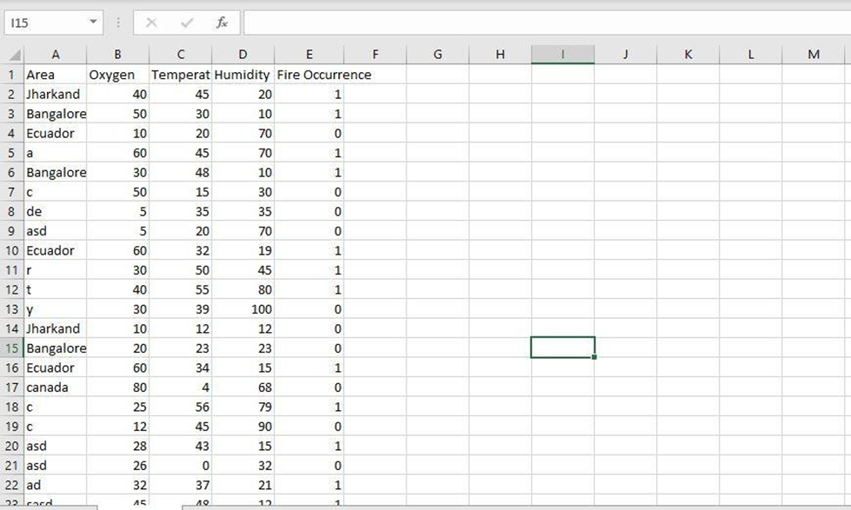

Figure 7: Sample Data Set

CONCLUSION
In conclusion, machine learning can play a significant role in predicting the possibility of forest fires and integrating this model into web or app development can lead to the creation of a global wildfire detection application. However, it is important to acknowledge that such projects require careful planning and execution, especially when dealing with large spatial scales. While it is beneficial to have common approaches and supporting materials at a larger scale, it is equally important to consider local characteristics and involve local communities in fire prevention efforts. This approach can enhance the effectiveness and efficiency of fire prevention initiatives. The lessons learned from this work emphasize the value of investing in fire prevention, employing dedicated individuals, and organizing prevention activities. The cost of these activities could be relatively low compared to the expenses incurred in firefighting efforts, and the long-term results can be significant. Establishing a network to connect and support fire prevention efforts, while monitoring and assessing the outcomes, would help address any weaknesses and lead to impressive results.

FUTURE ENHANCEMENT
The paper has a very broad scope because we want to create a dynamic, adaptable software solution that can be used in many different contexts. By taking into account the unique requirements and characteristics of various regions, we aim to develop a system that can efficiently detect and predict forest fires on a global scale. To ensure widespread accessibility, our application will be designed to be accessible to users worldwide. It can be considering different languages, user interfaces, and accessibility features to make sure that individuals from diverse backgrounds and locations can easily interact with our application. By doing so, we aim to provide valuable fire prevention and detection services to anyone in need, regardless of their location or technical expertise. Since understand the importance of adaptability in addressing the varying requirements and challenges of different regions. The application will be designed to be highly adaptable, allowing for customization and integration with existing systems and resources. This will enable seamless collaboration with local authorities, organizations, and communities, ensuring that the solution can be effectively implemented in different environments. Additionally, we will prioritize scalability, ensuring that the system can handle increasing data volumes and expanding user bases as more areas and users join the platform. Regular updates and enhancements will be incorporated based on user feedback and emerging technologies, ensuring the software remains up-to-date and capable of addressing evolving needs. By focusing on dynamic flexibility, worldwide accessibility, and scalability, we aim to create a comprehensive solution that can make a significant impact in preventing and mitigating the devastating effects of forest fires on a global scale.

REFERENCES

- A. S. Mahdi and S. A. Mahmood, "Analysis of Deep Learning Methods for Early Wildfire Detection Systems: Review," 2022 5th International Conference on Engineering Technology and its Applications (IICETA), Al-Najaf, Iraq, 2022, pp. 271-276, doi: 10.1109/IICETA54559.2022.9888515.
- Alkhatib, R., Sahwan, W., Alkhatieb, A., & Schütt, B. (2023). A Brief Review of Machine Learning Algorithms in Forest Fires Science. Applied Sciences, 13(14), 8275.
- Abid, F. (2021). A survey of machine learning algorithms based forest fires prediction and detection systems. Fire technology, 57(2), 559-590.
- A. A. A. Alkhatib, “A Review on Forest Fire Detection Techniques:,” http://dx.doi.org/10.1155/2014/597368, vol. 2014, Mar. 2014, doi: 10.1155/2014/597368
- Chowdary, V., & Gupta, M. K. (2018). Automatic forest fire detection and monitoring techniques: a survey. In Intelligent Communication, Control and Devices: Proceedings of ICICCD 2017 (pp. 1111-1117). Springer Singapore.
- Grari, M. O. U. N. I. R., Yandouzi, M. I. M. O. U. N., Idrissi, I. D. R. I. S. S., Boukabous, M. O. H. A. M. M. E. D., Moussaoui, O. M. A. R., AZIZI, M., & MOUSSAOUI, M. (2022). Using IoT and ML for Forest Fire Detection, Monitoring, and Prediction: a Literature Review. Journal of Theoretical and Applied Information Technology, 100(19).
- I. Idrissi, M. Azizi, and O. Moussaoui, “A Stratified IoT Deep Learning based Intrusion Detection System,” in 2022 2nd International Conference on Innovative Research in Applied Science, Engineering and Technology (IRASET), Mar. 2022, pp. 1–8, doi: 10.1109/IRASET52964.2022.9738045.
- M. Grari, I. Idrissi, M. Boukabous, O. Moussaoui, M. Azizi, and M. Moussaoui, “Early Wildfire Detection using Machine Learning Model Deployed in the Fog / Edge Layers of IoT,” Indones. J. Electr. Eng. Comput. Sci., 2022.
- Rajan, G. V., & Paul, S. (2022). Forest Fire Detection Using Machine Learning. Forest fire detection using machine learning.
- Sathish kumar, V. E., Cho, J., Subramanian, M., & Naren, O. S. (2023). Forest fire and smoke detection using deep learning-based learning without forgetting. Fire ecology, 19(1), 1-17.

