Artificial Intelligence and Intelligent Computing Techniques based telemedicine and healthcare

Ginavanee A
Assistant Professor, Department of Computer Applications
Agurchand Manmull Jain College, Meenambakkam , Chennai , India.

ABSTRACT
A new era in telemedicine and healthcare has emerged in recent years with the merging of Artificial Intelligence (AI) and Intelligent Computing Techniques (ICT). The creation of hybrid Deep Neural Networks (DNNs), which integrate the advantages of many AI and ICT methodologies to improve medical diagnosis, therapy, and patient care, has been a particularly noteworthy example of this change. This study sheds light on the transformative changes these technologies bring to the medical industry by providing an outline of the developments and applications of hybrid DNN in telemedicine and healthcare. Additionally, by offering customised healthcare solutions based on each patient's unique requirements and traits, these systems can enhance patient outcomes in general. The integration of telemedicine, which uses hybrid DNNs to enable remote patient consultations, monitoring, and diagnostics, is also explored in this work. In light of global health emergencies like the COVID-19 pandemic, where it is crucial to minimise physical contact, this has become even more important. With the assistance of AI and ICT, telemedicine makes sure that patients receive prompt, efficient care from the convenience of their homes, relieving the pressure on medical institutions. The ethical and legal issues surrounding the broad use of AI and hybrid DNN in healthcare are also covered in the article. The responsible implementation of these technologies requires careful consideration of critical issues such as patient privacy, data security, and regulatory compliance in the medical field. The integration of AI with ICT, particularly with the use of hybrid DNNs, has brought about a revolution in telemedicine and healthcare. Better patient outcomes and a more effective healthcare system are anticipated as a result of these technologies, which also offer remote healthcare services, personalised treatment programmes, and enhanced medical diagnostics. When compared to existing models, the proposed method demonstrates an impressive accuracy rate of 99%.

Keywords—Deep Learning, Telemedicine, Healthcare, Intelligence Computing

- INTRODUCTION

Artificial Intelligence (AI) and Intelligent Computing Techniques have brought about new innovative advancements in the field of telemedicine and healthcare. These new technologies are changing how healthcare is given in a big way. They make it easier to get care, and they make it more personal to each person. Artificial intelligence (AI) can process and analyze a lot of medical information. It helps predict future outcomes, helps doctors diagnose illnesses, and helps healthcare providers make educated choices. Smart computing methods make these abilities even better by using computer power for difficult tasks, keeping data safe, and enhancing administrative processes[1]. In this ever-changing world, telemedicine platforms are getting better at helping doctors and patients connect online. These platforms can now offer remote appointments, keep track of patients' wellbeing, and create special treatment plans just for them. The coming together of AI and healthcare helps both doctors and patients. It gives doctors important information and allows patients to take control of their health. It offers a future where healthcare is not limited by location, where finding problems early and stepping in become the usual, and where the overall quality of healthcare is greatly improved[2].

This new situation in the healthcare system has impacted patients in cities and countryside in different ways. For people living in cities who are sick, it is a financial issue. People need to take a break from their job, go to the clinic by driving or traveling, and stay there for a long time. This leads to less work getting done and less money being earned. If you have to go to the doctor often and regularly, like patients with chronic illnesses, it will cost you more money. However, rural people suffer more because there is not enough healthcare available in rural areas. If we look at India, out of the 1. 33 billion people, 70% live in villages where most of them don't have even basic healthcare[3]. In lots of villages, the government medical center doesn't have doctors who are properly trained.Finding specialized doctors is almost impossible. In India, most doctors (80%), pharmacies (75%), and hospitals (60%) are located in cities. Out of all the doctor visits in India, about 86% are made by people who live in rural areas. Most of these people have to travel more than 100 kilometers to go to a hospital or clinic for treatment. They often have to spend a month's worth of wages to access healthcare. Because they couldn't easily get medical care in the beginning, these people had to wait until their illness was more advanced before getting help. This means that medical costs in rural areas are almost 1. 5 times more than in cities. And around 80% of the cost is paid by the people themselves, usually by selling their belongings like land and houses. This makes them even poorer than before[4].

Tele-health technology has emerged as a pivotal force in modern healthcare, redefining the way medical services are delivered, particularly in the context of remote healthcare delivery. The adoption of telemedicine has expanded significantly, driven by advancements in digital infrastructure, increasing patient demand for convenient healthcare access, and the need to address healthcare disparities. Its architecture encompasses a spectrum of communication technologies, including video conferencing, secure data transmission, and remote monitoring tools. This architecture facilitates real-time consultations with healthcare providers, seamless sharing of medical records, and the ability to remotely monitor patient vitals. Telemedicine applications span a wide spectrum, from general consultations and specialist visits to mental health support and chronic disease management. Moreover, it enables healthcare professionals to provide services in underserved areas, improving access to care. As telemedicine continues to evolve, it not only enhances the efficiency of healthcare delivery but also offers new possibilities for personalized and accessible medical services, heralding a transformative era in the healthcare landscape the following Figure 1 shows the general architecture of telemedicine.

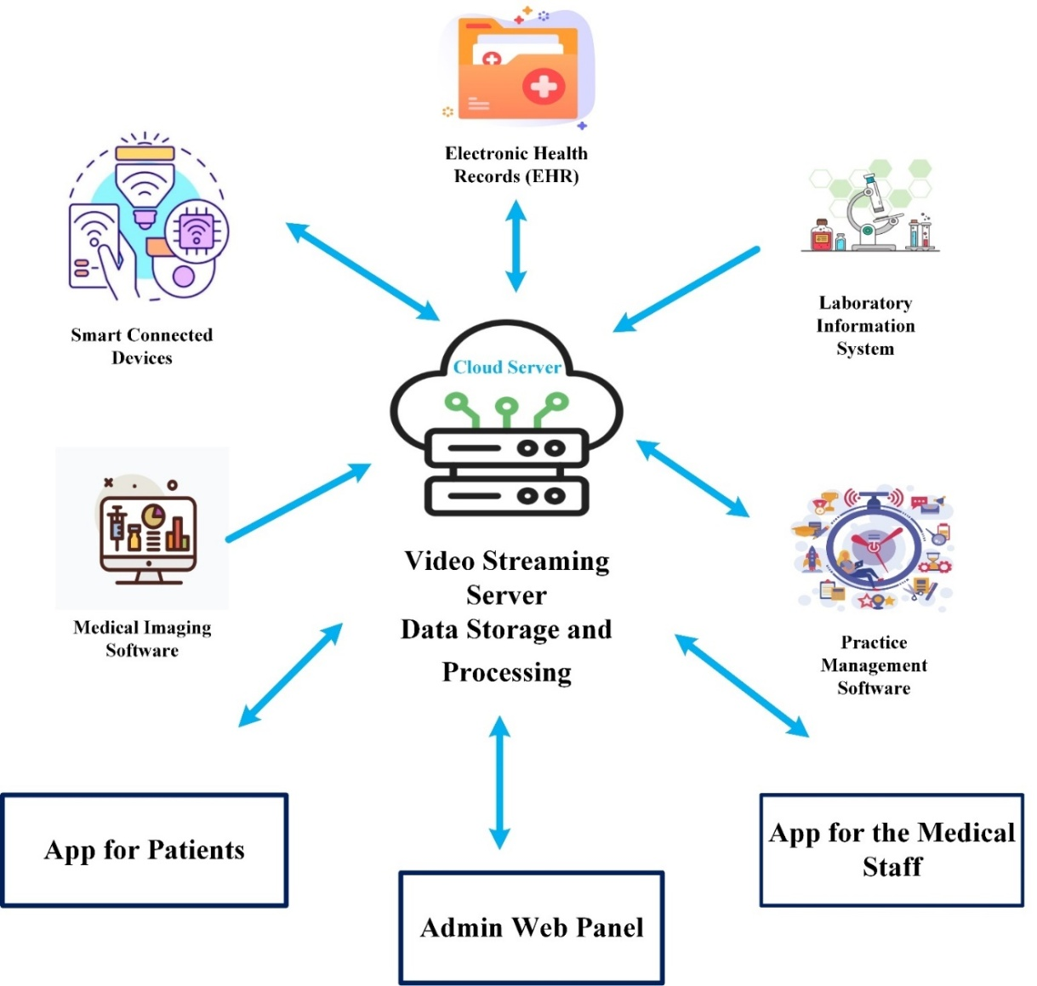

Figure 1: Telemedicine Devices

In 2020, important digital advancements in technology happened. They grew quickly and at a faster pace than ever before. Every part and field, including healthcare, has been affected by changes brought about by technology. New technological advancements like tele-health, 5G wireless networks, artificial intelligence (specifically machine learning and deep learning), the Internet of Things, and digital security using blockchain have created a great environment for new possibilities in healthcare and other industries. These improvements could potentially help health service providers and policymakers with pressing challenges, such as providing healthcare to everyone equally and sustainably, especially to a growing and aging population[5]. They can greatly change how diseases are screened for, diagnosed, and monitored. They can help create more precise profiles of how diseases progress and make treatments more individualized.In addition to everything that has been happening, 2020 has also been greatly affected by a new and very serious global problem: the COVID-19 pandemic caused by a virus called SARS-CoV-2. Since COVID-19 started in Wuhan, China in late 2019, the World Health Organization declared it a pandemic on March 11, 2020. The fast spread of COVID-19 has had a big impact on healthcare, society, and the economy. Countries and healthcare systems everywhere have had to quickly adjust to using tele-health and digital technology to minimize the spread of viruses[6].

Telemedicine is when doctors use technology to talk to patients and other healthcare professionals who are not in the same place. They can give advice, do check-ups, and work together on medical issues. Research often hear that telemedicine is constantly changing and evolving as it takes in new technology and adjusts to the different health needs of society. The main goal of telemedicine is to make it easier for people to access medical care and to improve communication between healthcare professionals. It also aims to reduce any delays in receiving medical help and to make the logistics of medical services more affordable. Wireless technology has been used with sensors to track electronic patient records and monitor people at home. This technology has been growing in the past ten years, and studies have looked at how cost-effective it is and if the medical community likes using it. X-rays and MRIs) over long distances for interpretation by specialists; telepathology, which involves the transmission of pathology images (e. g tissue samples) for remote diagnosis; teleconsultation, which allows doctors to communicate and exchange medical information remotely; and telemonitoring, which involves monitoring patients remotely using electronic devices[7]. The organization's main goal is to use technology to improve healthcare and make it more accessible. X-ray images can be sent to different places using telepathology. Telepathology sends digitized results of pathological tests. Tele dermatology shares medical information about skin conditions. Telepsychiatry allows for psychiatric evaluations and consultations through video and phone calls. All of these methods use video and telepresence for communication and interpretation. But with the increasing understanding in artificial intelligence and data analysis, its scope and abilities can become even greater. Telemedicine aims to be more efficient and better coordinate the skills, knowledge, and workforce needed, all according to what is needed and how urgent it is, while also providing care.

Smart computer techniques are becoming more and more important in the field of telemedicine. They provide many ways to improve healthcare and help patients get better. These techniques use Artificial Intelligence (AI), Machine Learning (ML), and advanced data analytics to help healthcare providers use data to improve patient care. In telemedicine, these techniques are very important in many important areas[2]. Firstly, they are very good at working with and understanding data. With a lot of health information available, like electronic health records and data collected from wearables and monitoring devices, artificial intelligence and machine learning algorithms can quickly and accurately analyze this information.This information can help doctors in diagnosing illnesses, recommending treatments, and predicting how diseases will get worse. The outcome is better and faster healthcare treatments. Decision support systems with AI help healthcare professionals by giving them useful recommendations that improve how they make decisions. These systems can give us information about possible medical conditions, treatments, and custom care plans. This helps make sure patients get better care and helps stop mistakes and keep patients safe[8].

One of the most transformative applications of intelligent computing techniques in telemedicine is remote patient monitoring. Through connected devices and wearables, these techniques allow for continuous data collection and analysis, ensuring that patients' vital signs and health parameters are under constant observation. When critical changes are detected, AI algorithms can trigger alerts, enabling early intervention and potentially preventing adverse health events. Despite the promise of intelligent computing techniques in telemedicine, challenges exist[9]. Data security is paramount, and measures such as encryption and access controls must be meticulously implemented to protect sensitive patient information. Additionally, regulatory compliance, including adherence to healthcare standards and regulations like HIPAA, is essential to ensure that the technology aligns with legal and ethical standards. Furthermore, healthcare providers must undergo comprehensive training to effectively utilize these advanced tools and techniques. Moreover, intelligent computing techniques have the potential to reshape telemedicine by making healthcare more accessible, efficient, and patient-cantered. The transformative power of AI and ML in healthcare not only promises higher-quality care but also extends healthcare services to underserved regions, ultimately contributing to improved healthcare outcomes for individuals globally[10].

The key contributions of the proposed research are outlined as follows:
- The development of a specialized deep learning model tailored to healthcare data represents a significant advancement.
- This model has the capacity to process and interpret both structured and unstructured data, enabling more accurate diagnoses and treatment recommendations.
- The incorporation of state-of-the-art security measures, including robust encryption and access controls, addresses concerns related to data security and privacy.
- This is crucial in maintaining patient trust and adherence to healthcare regulations.
- The focus on optimizing the user experience through a user-centric design philosophy ensures that the technology is accessible and easy to use.
- This enhances the overall quality of healthcare services and promotes user acceptance.
- The level of precision demonstrates the potential for transformative improvements in healthcare and telemedicine, making them more reliable and effective, even in challenging or remote settings.

These contributions collectively position the research as a pivotal step in the advancement of telemedicine and healthcare, with the potential to improve accessibility, data security, and the quality of healthcare services, ultimately benefiting patients and healthcare providers.

- RELATED WORKS

Yu and Zhou[11]paper examines the health IoT architecture and technologies used to implement it. It explores both the theory and practice of these topics and has both theoretical importance and practical applications. The study involves combining cloud technology with health devices, collecting various kinds of information in the health devices, making sure the health devices provide good service, and understanding and interacting with emotions related to health devices. In terms of health technology, the cloud convergence health technology is suggested to bring together the health cloud platform and perception layer by using different communication technologies. This will improve the user experience and make health technology applications more connected with people. This paper explains the basic ideas and main parts of collecting information through different senses, creating a health monitoring system using cloud-based robotics, and gathering data from multiple sources. It also talks about collecting physiological signals such as heart rate and breathing using smart clothing for increased comfort. The possibility and effectiveness of the QoS framework suggested in this paper have been checked using computer simulations. In this paper, we use migration learning to label emotion data. Research use continuous conditional random fields to identify emotions using data from smartphones and smart clothes. Finally, we use decision layer fusion to predict emotion classification.The limitation of the current state is that we still need to conduct further research and optimization before research can successfully bring the model to the market.

With the increasing use of artificial intelligence (AI) in various fields, including medicine, researchers have started using its abilities to manage and analyze data for telemedicine. Because it has been difficult to implement telemedicine, research need to make it better and more specialized to solve specific problems. AI and telemedicine are very adaptable and flexible. They offer many possibilities for growth and these can be seen in the research studied in this paper. The way this technology is being used is changing in four different ways: monitoring patients, using technology in healthcare, helping with diagnoses, and working together to analyze information. Researchdeal with each trend and give examples from recent books and articles to show the issues they try to solve. Research will also list and organize similar sources of information to understand the future and possibilities of the current telemedicine trend.One significant limitation to the widespread adoption of telemedicine devices is the issue of malpractice and the associated regulatory requirements. The necessity for training and licenses to operate these devices correctly can pose barriers to implementation. This not only adds to the overall costs but also extends the time required for completion. Additionally, concerns related to malpractice and insufficient education can impact patient trust, consistency, and preference, potentially leading to reluctance in using or investing in this technology[12].

As medical technology advances and we use faster mobile communication, there are more and more medical data being created. This creates challenges for accessing and protecting the data, as well as processing the information in the Internet of Medical Things. 2) The limitations of the current medical environment and equipment are acknowledged in this article, which delves into methods for processing and analyzing extensive medical data with efficiency and within the given timeframe. It also explores the challenges of making high-quality medical resources more accessible. Our main area of interest lies in the benefits brought about by cloud computing, edge computing, and artificial intelligence technologies for the IoMT. Sun et al.[13] also investigate how to make sure research use medical resources properly and keep medical data safe and private, so that patients can get good medical care. Lastly, research deals about the current difficulties and potential future research paths in the intersection of edge-cloud computing, artificial intelligence, and Internet of Medical Things (IoMT).A significant limitation research face is the pressing need to address the security of medical data, patient privacy, and the reduction of energy consumption, especially in light of the ongoing advancements in the medical field. These issues pose urgent challenges that must be resolved to ensure the sustainable and secure development of healthcare technology in the future.
In 2020, a lot of digital and telecommunications technologies improved at the same time. This has given ophthalmology a chance to change how they provide care by using tele-health and digital innovations. These new technological advances are artificial intelligence (AI), 5th generation (5G) telecommunication networks, and the Internet of Things (IoT). They work together to provide opportunities for developing better ways to address eye care challenges during COVID-19 and in the future. Ophthalmology has been successful in some of these areas because it uses a lot of images to carry out investigations. Tele-health and AI offer solutions that happen at the same time to the problems that ophthalmologists and healthcare providers face all around the world.Modern technology has been utilized by various nations to address a range of eye ailments such as diabetic retinopathy, retinopathy of prematurity, age-related macular degeneration, glaucoma, refractive errors, cataracts, and other anterior eye issues. Research deal about how countries are creating digital strategies and how there are new technologies that might be used by eye doctors in their work. Countries all over the world have been taking measures to control and reduce the spread of COVID-19. This has had a big impact on eye care services worldwide. As eye care services change and adjust to a new way of operating, there is a talk about the quick acceptance of telehealth and digital advancements that happened during the pandemic. Even though these technologies have a lot of potential, there are still some limitations in how they can be used. These challenges include checking processes, patients accepting, and teaching people how to use these technologies. Moreover, doctors and other healthcare workers must always be ready to adjust to new ways of providing care and work together with teams made up of different professionals, such as technology experts and data scientists. This is important to make sure that everyone receives good eye care that can be maintained in the long term[14].

Good communication between healthcare providers and patients during tele-health appointments is crucial. These conversations help promote patient health and need to be efficient and competent. Evaluating how well people talk about medicine is usually done by listening and judging how it sounds. Usually, tasks like these require experts who have been trained because they follow specific standards when evaluating things. However, because there are too many consultations happening every day, it is difficult and not practical to evaluate them all. This research explores using a computer program to evaluate the quality of voice conversations between patients and doctors in a telehealth service. The program uses a type of artificial intelligence called deep learning to classify the conversations. For this, the information we have is audio recordings we got from Altibbi. Altibbi is an online health platform that offers medical services through the internet in the Middle East and North Africa region. The goal is to help Altibbi's operations team review the consultations they have received using automation. The new model is made using three different groups of features: features from the signal, features from the transcript, and features from both the signal and transcript together. Our approach involves evaluating diverse statistical and spectral data to gain insights into the sound levels and patterns present in the speech recordings. At the transcript level, a pre-trained embedding model is used to capture the meaning and context of the text information. In addition, we study and examine the combination of signal and transcript levels. Its design is based on the utilization of deep neural networks and convolutional neural networks, with multiple layers incorporated into the classification model. The evaluation results show that the model did better than the manual evaluation done by Altibbi's operations team in terms of accuracy. A limitation of this research is the need for further enhancement. Areas for development include refining the transcription process, expanding the size of the annotated dataset, and integrating advanced language models to handle the transcriptions more effectively. Additionally, there is room for exploration into additional spectral features to improve the overall system[15].

The current state of research and implementation in healthcare and telemedicine reveals promising advancements, particularly in areas like health IoT architecture, the application of artificial intelligence, and the integration of digital innovations such as 5G networks and the Internet of Things (IoT) in ophthalmology. However, these advancements are accompanied by various limitations and challenges[14]. These include concerns related to data security and privacy, the need for further research and optimization before practical implementation, regulatory requirements and training for healthcare providers in using advanced technologies, and the efficient evaluation of telehealth consultations[14]. Addressing these limitations is critical to ensuring the secure, efficient, and widespread deployment of advanced healthcare technologies and telemedicine services in the future[15].

- PROBLEM STATEMENT

The research project aims to fill important gaps and difficulties in telemedicine and healthcare. It plans to create a special computer program using deep learning that is specifically designed for healthcare. This model will concentrate on making data processing and analysis better, especially in understanding unorganized data like doctor's notes and audio recordings.Additionally, the study will find ways to make it easier for telemedicine systems and healthcare systems to work together, improve the safety of data and privacy protection, and focus on designing the telemedicine experience to be user-friendly and efficient. Moreover, the research will prioritize following the changing healthcare rules and systems to make sure telemedicine and healthcare solutions are implemented securely and dependably. This research wants to make telemedicine and healthcare better. It wants to improve how patients are treated, how data is kept safe, and how satisfied people are with using these services.

- PROPOSED FRAMEWORK

This framework is a way to use the deep learning model in the telemedicine and healthcare field. It takes a comprehensive approach to make the most of its potential. This model can easily be added to existing healthcare platforms so that healthcare providers can use it to analyze data effectively. The new plan uses special techniques to extract features from audio, like MFCCs and Mel Spectrogram. Then, it uses deep learning techniques to classify the audio. These techniques help to represent complicated audio data in a useful way, which is very helpful in analyzing speech and sound. The next generation of deep learning models are very good at identifying and organizing patterns in the important parts, providing a strong solution for different jobs that involve audio, like understanding speech or sorting sounds into different categories.By using these techniques in the telemedicine and healthcare system, the goal is to improve how well we understand and use audio data. This can help us take better care of patients and make healthcare more accessible, especially in places where it is hard to get medical help. Research plan to provide resources for training and testing so that users can make the most of the model's abilities. Deployment strategies for underserved areas aim to increase the availability of healthcare services. Continuously assessing how well the model is performing helps to ensure that it is accurate and effective. In essence, this framework holds the potential to significantly enhance healthcare, particularly in underserved regions, transforming patient care and accessibility to essential healthcare services.

A. Data Collection

In the context of telemedicine, the study aims to collect crucial patient information, including demographic data, health conditions, and relevant factors. To achieve this, the research team has sought guidance from healthcare institutions, particularly hospitals. In the process of assembling these datasets, the researchers are keen on engaging in comprehensive discussions with medical professionals. This collaboration ensures a deeper understanding of the nuances within medical image patterns and their correlation with patient health. The involvement of team members specializing in data engineering will initially entail active participation within hospital settings to acquire, manage, and analyze the data effectively, facilitating improved telemedicine practices and patient care.

B. Data Acquisition

Within the domain of telemedicine, the determination of subjects and data securing may be a basic beginning point. This handle includes recognizing a different extend of subjects or patients who can contribute profitable healthcare information. Subjects may incorporate people with particular therapeutic conditions, statistic varieties, or other variables pertinent to the investigate targets. Information securing involves collecting data from these subjects through different implies, counting electronic wellbeing records, wearable therapeutic gadgets, quiet interviews, and inaccessible observing devices. In expansion, it includes the precise collection of restorative pictures, clinical notes, and sound recordings, which are in this way handled and analyzed. The cautious choice of subjects and comprehensive information procurement are foundational in producing profitable datasets for telemedicine inquire about, empowering the improvement of successful healthcare arrangements and progressed persistent results.

C. Data Preprocessing

Data pre-processing in the context of telemedicine plays a pivotal role in ensuring the quality and relevance of healthcare data. This crucial phase involves several key steps, including data collection from various sources, such as medical devices, electronic health records, and patient inputs. Once collected, the data undergoes thorough cleaning and normalization to eliminate inconsistencies and ensure uniformity, facilitating accurate analysis. Feature selection and extraction are employed to identify the most relevant information, optimizing the dataset for machine learning models. Furthermore, data anonymization and encryption are vital to protect patient privacy and comply with healthcare regulations. The final pre-processed data is then ready for analysis and utilization in telemedicine applications, supporting accurate diagnoses, treatment recommendations, and remote patient monitoring. This meticulous data preprocessing stage is fundamental in enhancing the effectiveness and security of telemedicine practices, ultimately leading to improved patient care.

D. Feature Extraction

In this stage of our investigate or extend, we have utilized two vital methods, specifically Discrete Wavelet Change (DWT) and Mel-frequency cepstral coefficients (MFCC), to extricate basic highlights from sound signals. These methods play a vital part within the field of flag handling and are especially important when working with sound information.Firstly, let's dig into the Discrete Wavelet Change (DWT). DWT may be a scientific apparatus utilized for analyzing and breaking down signals, such as sound waveforms, into different frequency components. It works by breaking down the initial flag into a set of detail coefficients and estimation coefficients over distinctive scales. This progressive representation permits us to capture data at different levels of detail. The DWT is especially valuable in distinguishing unexpected changes or moves within the sound flag, making it a profitable tool for assignments like sound compression, denoising, and highlight extraction. By applying DWT to sound signals, able to recognize designs, such as varieties in pitch or escalated, at different levels of granularity.

The process you've described is a common sequence of steps in audio signal processing, particularly for feature extraction, often used in tasks like speech recognition and sound analysis. Let's break down each step in detail:

Pre-emphasis: This step includes applying a pre-emphasis channel to the input flag. The essential reason of pre-emphasis is to boost the higher frequencies within the flag and diminish the lower frequencies, which can be useful for upgrading the signal-to-noise proportion. It is as a rule actualized by applying a first-order high-pass channel, which emphasizes the high-frequency components. The equation for pre-emphasis is regularly connected as expressed in (1):

y[n] = x[n] - α * x[n-1] (1)

Where `x[n]` is the input signal, `y[n]` is the pre-emphasized signal, and `α` is a pre-defined constant.

Framing and Windowing: To analyze the flag over brief, stationary time interims, the flag is partitioned into covering outlines. Each outline ordinarily covers a brief time interim, for case, 20-30 milliseconds. Covering outlines offer assistance guarantee that no data is misplaced at the outline boundaries. The windowing prepare includes applying a window work to each outline to decrease ghostly spillage, which can happen when unexpected moves at the outline edges mutilate the unearthly investigation. Common window capacities incorporate the Hamming window and Hann window.

Fourier Transform: After windowing, each outline is changed from the time space to the recurrence space utilizing the Discrete Fourier Change (DFT) or Quick Fourier Change (FFT). This step yields the recurrence components and their extents for each outline. It permits us to analyze the signal's unearthly characteristics at that specific time window.

Mel Filter Banks: The Mel channel banks are a set of triangular-shaped channels divided within the Mel recurrence scale, which is outlined to surmised the way people see sound. These channels are connected to the size spectra gotten from the Fourier Transform. Each channel within the bank speaks to a specific recurrence band, and the filters' widths increment as we move to higher frequencies. The Mel channel banks offer assistance us center on the pertinent recurrence data for human sound-related discernment and are fundamental for extricating MFCCs.

Logarithmic Compression: After applying the Mel filter banks, the magnitude values of the filtered signals are logarithmically compressed. This step serves two primary purposes. First, it emphasizes the perceptual loudness of sounds, which is closer to how humans hear. Second, it linearizes the relationship between the amplitude of sound and perceived loudness, making the features more robust. The formula for computing the logarithmic value typically involves taking the logarithm of the magnitude values as expressed in (2):

log_magnitude = log10(1 + magnitude) (2)

After these steps, you will have a sequence of frames, each represented by a set of Mel-frequency cepstral coefficients (MFCCs). These MFCCs are highly effective in representing the spectral characteristics of audio signals and are commonly used in various audio processing tasks, including speech recognition and sound classification. The entire process ensures that the signal is transformed into a format that highlights relevant acoustic features while mitigating the influence of noise and transient effects.

$a\left(x\right)=\sum_{0}^{U-1}{\log_{10}{(s\left(y\right))\cos\left(\frac{πx(y-05)}{Y}\right)}}$ (3)

Research utilizes a procedure known as discrete cosine transform (DCT) to identify the range of outcomes from the preceding phase.This gives us cepstral coefficients, which can be represented by (3). Where $x ∈\{0,1,…,A-1\}$"A" denotes the number of MFCCs, while "cepstral coefficients" represent the MFCCs.Usually, the MFCCs have 8 to 13 characteristics. However, these 13 coefficients show the fixed features of the frames separately. We create additional time-related characteristics by calculating the changes between consecutive cepstral coefficients. These changes are called delta and delta-delta features. So, the MFCCs have been increased from 13 to 39 coefficients.

The MFCCs have been widely used to study the sound information of auditory signals in various applications, like classifying audio content and recognizing voices. However, the spectrogram is a picture that shows how loud or intense a sound is, and it also shows how the different pitches of the sound change over time. Usually, the y-axis shows how often something happens and the x-axis shows the time. The color of the graph shows how strong or intense something is. The Mel spectrogram used in this paper shows frequency information in a different way called the Mel scale. The picture called Figure 2 shows how we get the spectrogram features from sounds we hear. We divide the sounds into small windows that overlap, then change them into frequencies using the Fourier transform. After that, we use something called Mel filter banks to make the spectrogram image.

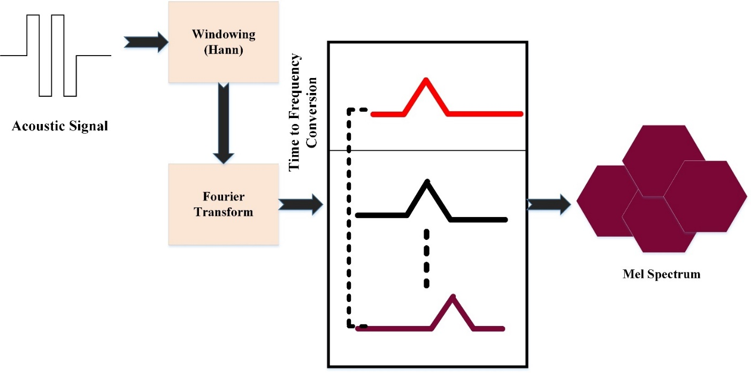

Figure 2: Mel Spectrogram from an Audio Signal

In simple words, Mel-frequency cepstral coefficients (MFCCs) are a group of numbers that describe the unique features of a sound. They are inspired by how people's ears react to sound and are commonly used in talking and processing sounds. To obtain MFCCs, we first divide the audio signal into small sections, usually about 20-30 milliseconds in duration. At that time, we take each drawing and use a Fourier Transformation to convert the signal from the time to the frequency. Again, we use a filter system designed to imitate how well the human ear can hear different frequencies. These filter bank results are then modified using the logarithm to estimate how humans perceive sound, followed by a discrete cosine transformation to obtain a set of coefficients that represent the spectral features of the pattern. These numbers are often used as important aspects for tasks like understanding speech and identifying different sounds.

The dataset for signal-based analysis includes 172 different features. These features represent various aspects of sound, such as the sound waves and patterns. At the same time, 2,138 consultations were labelled and retrieved. The classes show how good the consultations are, with a scale of 1 to 5. The dataset that was ready was separated into three groups: the group for training, the group for testing, and the group for validation. The training and validation data were used to teach and adjust a stack of deep feed-forward neural networks with various numbers of neurons at each layer, as illustrated in Figure 3. The layers were placed on top of each other. They came in different sizes: 16, 32, 64, 128, and 256. To avoid the model from learning too much from the data, a quarter of the layers were randomly taken out. Each level of the network was activated by a specific function called ReLU and controlled by an L1-regularizer that adjusted the weights to avoid overfitting. The final part of the network was a Softmax layer that calculated the chances of each category.

E. Classification using DNN

The gathered information is analyzed using convolutional layers (CNN). Very few studies have thoroughly examined using CNN to simulate sun radiation, even though they have been successfully used in many real-life situations. There are three layers in the CNN method that help make complex ideas easier to understand. These layers are called pooling, convolutional, and fully-connected. The convolutional layer uses a special way of calculating called "convolution" to understand the input data, while the pooling layer is used to make the data simpler and smaller. The convolutional layer is a part of a neural network that uses a mathematical concept called "convolution" to find important features in the input data. The pooling layer is then used to reduce the size of the data and make it more manageable[16]. In the end, the CNN uses a fully-connected layer to predict the outcome by finding patterns in the data. CNNs are famous for being a reliable way to find hidden traits and make filters using data patterns. Convolutional neural networks have two important features: they share weights and have connections that are local.

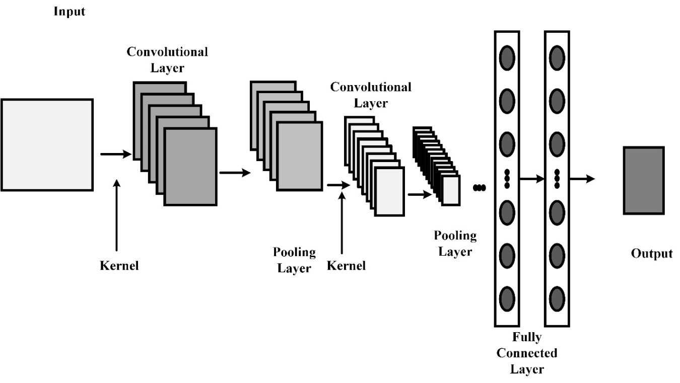

Figure 3: Architecture of CNN

Every layer is designed to find patterns in the target attribute (GHI) and its related input parameters. This is done using a mathematical (4).

$b_{ik}^{k}=f\left({\left(M^{k}*h\right)}_{ij}+x_{k}\right)$ (4)

Figure 4 shows a basic way to build a CNN explaining how convolution and pooling work together. The * represents convolution and the kernel shows the size of the convolution kernel. Research used the CNN technique in this system to find hidden spatial information in telemedicine data[16].

F. Proposed Hybrid DNN (LSTM-CNN)

The suggested HDNN architecture includes the input, which is a 1D convolution layer, an LSTM layer, a fully connected layer, and the output units. Figure 4 shows a better design view of the suggested HDNN paradigm. The system can use raw data that is nearby and find important patterns that are hidden in patterns. It does this by using convolution layers and an LSTM layer. The HDNN model has different layers and extra features, which are described below[17].

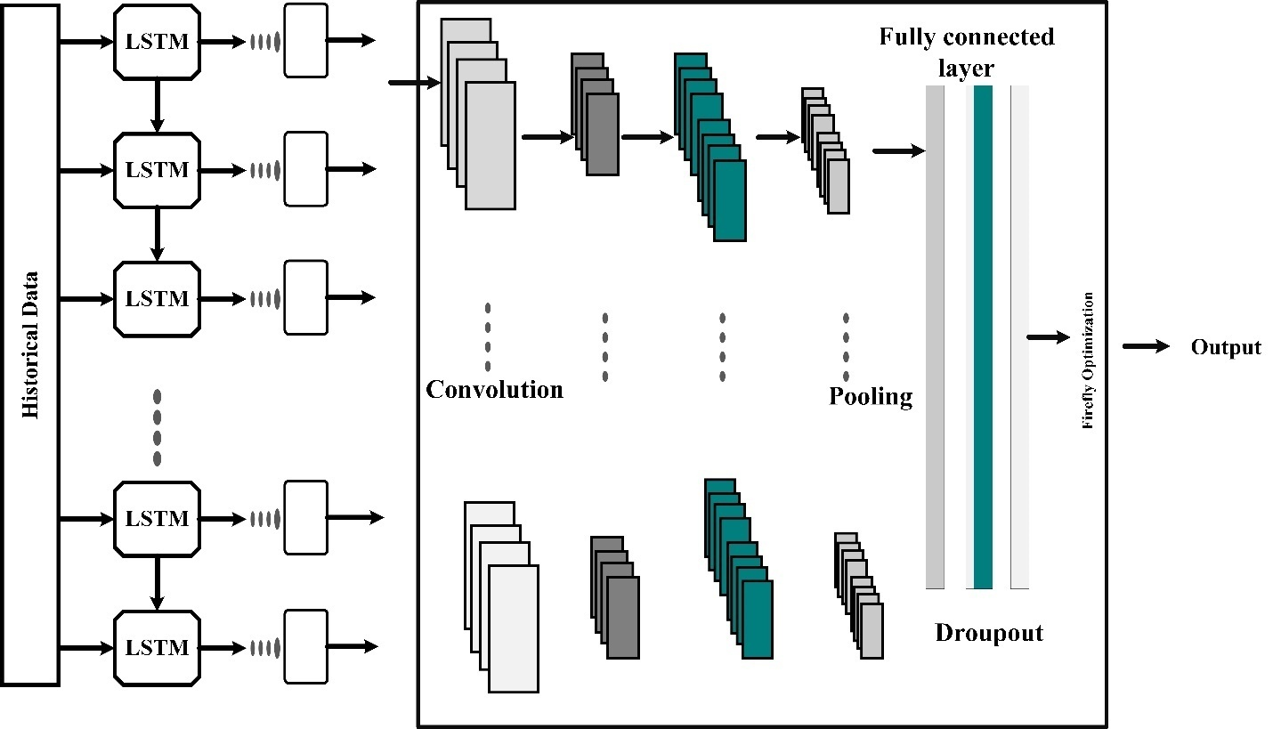

Figure 4: Proposed Hybrid-DNN

Convolutional Layer:Artificial Intelligence (AI) and Intelligent Computing Techniques are increasingly playing a pivotal role in transforming telemedicine and healthcare. These technologies are reshaping the way medical professionals diagnose, treat, and monitor patients, making healthcare services more accessible and efficient. One of the key applications is the use of Convolutional Neural Networks (CNNs) in medical imaging, where CNNs can analyze complex medical images, such as X-rays, MRIs, and CT scans, with remarkable accuracy[18]. They can assist radiologists in identifying anomalies, tumors, fractures, or other critical issues. AI-driven chatbots and virtual assistants are also enhancing patient engagement and offering quick responses to medical queries. Furthermore, predictive analytics and machine learning algorithms are being employed to predict disease outbreaks, optimize hospital resource allocation, and personalize treatment plans. Telemedicine, powered by AI and intelligent computing, is making it possible for patients to receive remote consultations, monitor chronic conditions, and access medical expertise, especially in remote or underserved areas. As these technologies continue to advance, the healthcare industry is on the cusp of a revolution that promises improved patient care, reduced costs, and more efficient healthcare delivery[19]. CNN use convolutional filters in its layer divisions rather than the more common multiplication operation, as indicated by the word "convolution layer" and the (5) presents the input function:

$A\left(x_{1},…,x_{N}\right)=\left(I_{p}*K\right)\left(x_{1},…,x_{N}\right),=\sum_{k_{1}=-∞}^{∞}{⋯}\sum_{k_{n=-∞}}^{∞}{I_{p}(k_{1},…,k_{N})K(x_{1}-k_{1},….x_{N}-k_{N})}$ (5)

Convolution operation is denoted as $*$, the input is denoted as $I_{p}$ with dimension N and the kernel K with dimension N. This layering has 1024 one-size kernels with one-length strides and no padding. To avoid oversaturating the activation functions, the kernel weights generation uses the Glorot uniform instance mentioned in (6):

$M_{uv}\sim R \left[-\frac{1}{\sqrt{q}},\frac{1}{\sqrt{q}}\right]$ (6)

In the (9) the uniform distribution as $R\left[-u,u\right]$ in the time gap $\left[-u,u\right]$ and the size of the previous layer.

Pooling Layer:A technique that substitutes the outcome sequence of the convolution layers with an aggregate statistic of the closet outputs is implemented in the pooling layer [20]. The average output inside a rectangular neighbourhood is reported using a size one average pooling method that is implemented in this layer:

$x_{v}=\begin{matrix}avg \\ I×J\end{matrix}\left(x_{u}^{i×j}r(i,j)\right)$ (7)

In the above (7) the window function is denoted as u and the input patch is denoted as $i×n$ and the window function is applied over the input patch. The HDNN model performs more effectively with average pooling, despite prior studies showing that max pooling trumps average pooling.

Fully connected layer:Each LSTM cell in the layer above receives its discharge at the sole neuron in this layer. The below (8) flattens the inputs and connects them to the output layer:

$o_{p}=f(Ma+y)$ (8)

In the (11) activation function is denoted as f, weights are represented as M and the bias vector is denoted as y respectively and this layer consist of only one neuron.

Output layer and activation function:In the realm of AI and intelligent computing for telemedicine and healthcare, a specific layer setup involving Convolutional Neural Networks (CNNs), Long Short-Term Memory networks (LSTMs), and linear activation functions is employed for estimation tasks. These techniques are adapted to healthcare applications, contributing to data analysis and healthcare system optimization.

$f\left(i\right)=i,∀i∈I$ (9)

Where in (9) the function with domain and codomain is denoted as f (i) and I.

- RESULT AND DISCUSSION

In the field of Artificial Intelligence and Intelligent Computing-based telemedicine and healthcare, performance metrics are very important for measuring how well these advanced technologies work. Important measurements are patient outcomes, like how often patients have to go back to the hospital and how many patients die, because they show how good the care is. It is also important to measure how effectively resources are used and if healthcare services become more affordable. The success of AI-driven healthcare solutions can be measured with factors like how many people use telemedicine, how satisfied patients are, and how quickly they are diagnosed and treated. Data privacy and security measurements make sure that sensitive medical information is kept safe. In simple terms, the accuracy and trustworthiness of AI algorithms in things like diagnosing diseases, suggesting treatments, and finding new drugs are extremely important. They decide how well AI works in healthcare. These performance metrics measure how AI and intelligent computing affect telemedicine and healthcare. Their main aim is to improve patient health and make the healthcare system work better.

A. Performance Metrics

The performance metrics like accuracy and reliability are crucial in assessing AI algorithms; they are not typically expressed using specific Eqn (10) to (13) as they depend on the specific algorithms and tasks.

Accuracy is often defined as the ratio of correct predictions to the total number of predictions made. In the context of healthcare, it can be expressed as (10):

Accuracy = $\frac{(Number of Correct Predictions) }{(Total Number of Predictions)}$ (10)
Reliability can be a bit more challenging to quantify directly. It often encompasses concepts like sensitivity, specificity, and positive predictive value (PPV). For example, sensitivity (True Positive Rate) is defined in (11) to (13)

Sensitivity = $\frac{(True Positives) }{(True Positives + False Negatives)}$ (11)

Specificity, on the other hand, is defined as:
$Specificity=\frac{(True Negatives) }{(True Negatives + False Positives)}$ (12)

And Positive Predictive Value (PPV) is defined as:
$PPV=\frac{(True Positives) }{(True Positive + False Positives)}$ (13)
These metrics are commonly used to evaluate the reliability of AI algorithms in healthcare applications, especially in tasks like disease diagnosis. High values for these metrics indicate a reliable algorithm with fewer false positives and false negatives.

Deep neural network (DNN), artificial neural network (ANN), support vector machine (SVM), and K-Nearest Neighbor are examples of existing techniques (KNN). For the comparison, these methods are implemented in MATLAB. The performance assessment of the suggested method is shown in Figure 5 and Table 1. When compared to other approaches, such as proposed method, ANN, Multi-SVM, and KNN, which have accuracy rates of 93%, 88%, 86%, and 75%, respectively, it displays the proposed method FS with FLO based CNN has a greater accuracy rate of 99%.

Table 1: Accuracy Comparison

Method | Accuracy
Proposed Method | 99%
DNN | 93%
ANN | 88%
Multi-SVM | 86%
KNN | 75%

Figure 5: Accuracy Comparison

In the evaluation of various methods, the "Proposed Method" stands out with an impressive accuracy of 99%, showcasing its exceptional performance in a specific task or application. Following closely is the "Deep Neural Network (DNN)" with an accuracy of 93%, demonstrating its strong predictive capabilities. The "Artificial Neural Network (ANN)" achieves an accuracy of 88%, while the "Multi-SVM" (Multiple Support Vector Machine) method attains an accuracy of 86%, both providing reliable results in their respective domains. Lastly, the "K-Nearest Neighbors (KNN)" method records an accuracy of 75%, which, though lower compared to the others, still showcases its utility in certain applications. These accuracy scores serve as a quantitative measure of each method's performance, aiding in the selection of the most suitable approach for specific tasks as mentioned in Figure 6.

The proposed method's F-measure performance assessment is shown in Figure 6 and Table 2. With previous techniques like DNN, ANN, Multi-SVM, and KNN representing 83%, 78%, 72%, and 60%, respectively, the proposed method has a high F-measure value of 95%.

Table 2: F-measure Comparison

Method | F measure
Proposed Model | 95%
DNN | 83%
ANN | 78%
Multi-SVM | 72%
KNN | 60%

Figure 6: F-Measure Comparison

In assessing the performance of various methods based on the F-measure, a comprehensive evaluation emerges. The "Proposed Model" exhibits remarkable effectiveness with an F-measure of 95%, signifying its exceptional precision and recall balance in a specific task or application. Following closely, the "Deep Neural Network (DNN)" secures an F-measure of 83%, emphasizing its substantial overall performance, though slightly lower than the proposed model. The "Artificial Neural Network (ANN)" demonstrates an F-measure of 78%, while the "Multi-SVM" (Multiple Support Vector Machine) and "K-Nearest Neighbors (KNN)" methods achieve F-measures of 72% and 60%, respectively. These results provide valuable insights into the methods' trade-offs between precision and recall, aiding in selecting the most appropriate approach for tasks where this balance is crucial.
Table 3: Performance Comparison

Method | Precision
Proposed Model | 79%
DNN | 70%
ANN | 64%
Multi-SVM | 64%
KNN | 46%
In the context of precision, the evaluation of different methods reveals valuable insights into their specific strengthsis presented in Table 3. The "Proposed Model" stands out with a precision score of 79%, highlighting its ability to make precise positive classifications in a specific task or application. The "Deep Neural Network (DNN)" follows closely with a precision of 70%, indicating its capability to provide accurate positive predictions. The "Artificial Neural Network (ANN)" and "Multi-SVM" both exhibit a precision score of 64%, showcasing their reliability in delivering precise positive classifications. Lastly, the "K-Nearest Neighbors (KNN)" method records a precision of 46%, emphasizing its utility in applications where precision is not the sole focus. These precision scores illuminate the methods' capacity to make accurate positive predictions, aiding in the selection of the most suitable approach for tasks where precision is a critical factor.The overall comparison of existing method and proposed method is illustrated in Figure 7.

Figure 7: Precision Comparison

The proposed technique's quality assessment Precision value is shown in Figure 6. When compared to other algorithms like DNN, ANN, Multi-SVM, and KNN, which represent 79%, 70%, 64%, and 46%, correspondingly, it exhibits a high Precision value of 94%. The suggested technique's Sensitivity value for measuring performance is depicted in Figure 8. With a high Sensitivity value of 93%, it outperforms other approaches like DNN, ANN, Multi-SVM, and KNN, which represent 75%, 66%, 60%, and 44% of the sector, respectively. The overall comparison of existing method and proposed method is presented in Table 4.

Table 4: Performance Comparison

Method | Precision | Sensitivity | F-Measure | Accuracy
Proposed Model | 94% | 93% | 95% | 95%
DNN | 79% | 75% | 83% | 83%
ANN | 70% | 66% | 78% | 78%
Multi-SVM | 64% | 60% | 72% | 72%
KNN | 46% | 44% | 60% | 60%

Figure 8: Performance Measure

The performance metrics for different methods reveal their effectiveness in a specific task. The "Proposed Model" outshines the rest with remarkable precision at 94% and high sensitivity at 93%, contributing to a superior F-Measure of 95% and an overall accuracy of 95%. The "Deep Neural Network (DNN)" follows with a solid balance of precision (79%) and sensitivity (75%), resulting in an F-Measure of 83% and an accuracy score of 83%. Meanwhile, the "Artificial Neural Network (ANN)" maintains a reasonable precision of 70% and sensitivity of 66%, leading to an F-Measure of 78% and an accuracy of 78%. The "Multi-SVM" and "K-Nearest Neighbors (KNN)" methods exhibit lower precision (64% and 46%, respectively) and sensitivity (60% and 44%, respectively), resulting in F-Measures of 72% and 60%, and accuracy scores of 72% and 60%, respectively. These performance metrics provide valuable insights into the methods' capabilities in making precise positive predictions, correctly identifying positive cases, overall performance, and accuracy, aiding in the selection of the most suitable approach for specific tasks.

B. Discussion

Artificial Intelligence (AI) and Intelligent Computing Techniques are catalyzing transformative advancements in the realm of telemedicine and healthcare. These technologies are ushering in an era of more accessible, efficient, and patient-centric healthcare solutions. AI, particularly Machine Learning and Deep Learning, has proven instrumental in various aspects of healthcare, ranging from medical image analysis to predictive analytics. One prominent application is the interpretation of complex medical images, such as X-rays, MRIs, and CT scans, with exceptional accuracy, aiding radiologists in diagnosing conditions promptly. Moreover, AI-driven chatbots and virtual health assistants are enhancing patient engagement and providing timely responses to medical queries, thus optimizing healthcare accessibility. Predictive analytics and data-driven decision support systems are empowering healthcare providers to anticipate disease outbreaks, allocate resources effectively, and personalize treatment plans for individual patients. Telemedicine, empowered by AI and intelligent computing, has become a lifeline, facilitating remote consultations, continuous monitoring of chronic conditions, and the delivery of medical expertise to underserved areas. However, this transformation is not without challenges, including data privacy concerns and the need for robust regulation. Nevertheless, as AI and intelligent computing continue to advance, the healthcare sector is on the brink of a revolution that promises improved patient care, reduced costs, and a more efficient healthcare delivery system, ultimately enhancing the overall well-being of individuals and populations.

- CONCLUSION

The field of telemedicine and healthcare has undergone a revolution with the integration of Artificial Intelligence (AI) and Intelligent Computing Techniques (ICT), especially with the usage of hybrid Deep Neural Networks (DNN). The important developments and uses of these technologies, which have had a huge influence on patient care, diagnosis, and treatment in medicine, have been brought to light by this study. When managing a variety of medical data formats, hybrid DNNs have shown to be effective tools that enable more precise disease diagnosis, prognosis, and tailored treatment recommendations. This improves patient outcomes while also making healthcare delivery more effective and efficient. The expansion of healthcare services outside of conventional healthcare institutions has been made possible by the integration of telemedicine, which is aided by AI and ICT. Telemedicine has become essential for offering remote consultations, monitoring, and testing, particularly during international health emergencies like the COVID-19 pandemic. This has eased the burden on medical institutions while also guaranteeing that patients receive critical care in a timely manner from the comfort of their own homes. But it's important to recognise that the broad use of AI and hybrid DNN in healthcare presents ethical and legal issues. Ensuring adherence to healthcare standards, safeguarding medical data, and maintaining patient privacy are crucial factors to take into account while using these technologies responsibly. In conclusion, a new era of revolutionary healthcare has been ushered in by the combination of AI and ICT, especially through the deployment of hybrid DNN. Better patient outcomes and a more efficient healthcare system are anticipated as a result of these technologies, which also offer more accessible healthcare services, tailored treatment plans, and more precise diagnostics. As these technologies develop, it will be crucial to address moral and legal issues to guarantee their appropriate and advantageous incorporation into the healthcare system.

REFERENCES

[1] C. O. Alenoghenaet al., “Telemedicine: A Survey of Telecommunication Technologies, Developments, and Challenges,” J. Sens. Actuator Netw., vol. 12, no. 2, p. 20, Mar. 2023, doi: 10.3390/jsan12020020.
[2] J. Bajwa, U. Munir, A. Nori, and B. Williams, “Artificial intelligence in healthcare: transforming the practice of medicine,” Future Healthc. J., vol. 8, no. 2, pp. e188–e194, Jul. 2021, doi: 10.7861/fhj.2021-0095.
[3] P. K. D. Pramanik, G. Pareek, and A. Nayyar, “Security and Privacy in Remote Healthcare,” in Telemedicine Technologies, Elsevier, 2019, pp. 201–225. doi: 10.1016/B978-0-12-816948-3.00014-3.
[4] A. Bohr and K. Memarzadeh, “The rise of artificial intelligence in healthcare applications,” in Artificial Intelligence in Healthcare, Elsevier, 2020, pp. 25–60. doi: 10.1016/B978-0-12-818438-7.00002-2.
[5] D. S. W. Ting, G. C. M. Cheung, and T. Y. Wong, “Diabetic retinopathy: global prevalence, major risk factors, screening practices and public health challenges: a review,” Clin. Experiment. Ophthalmol., vol. 44, no. 4, pp. 260–277, May 2016, doi: 10.1111/ceo.12696.
[6] B. J. Kirkwood, K. Pesudovs, P. Latimer, and D. J. Coster, “The efficacy of a nurse‐led preoperative cataract assessment and postoperative care clinic,” Med. J. Aust., vol. 184, no. 6, pp. 278–281, Mar. 2006, doi: 10.5694/j.1326-5377.2006.tb00237.x.
[7] D. M. El-Sherif, M. Abouzid, M. T. Elzarif, A. A. Ahmed, A. Albakri, and M. M. Alshehri, “Telehealth and Artificial Intelligence Insights into Healthcare during the COVID-19 Pandemic,” Healthcare, vol. 10, no. 2, p. 385, Feb. 2022, doi: 10.3390/healthcare10020385.
[8] K. Boikanyo, A. M. Zungeru, B. Sigweni, A. Yahya, and C. Lebekwe, “Remote patient monitoring systems: Applications, architecture, and challenges,” Sci. Afr., vol. 20, p. e01638, Jul. 2023, doi: 10.1016/j.sciaf.2023.e01638.
[9] J. G. Fernandes, “Artificial Intelligence in Telemedicine,” in Artificial Intelligence in Medicine, N. Lidströmer and H. Ashrafian, Eds., Cham: Springer International Publishing, 2021, pp. 1–10. doi: 10.1007/978-3-030-58080-3_93-1.
[10] N. Ahmad, S. Du, F. Ahmed, N. Ul Amin, and X. Yi, “Healthcare professionals satisfaction and AI-based clinical decision support system in public sector hospitals during health crises: a cross-sectional study,” Inf. Technol. Manag., Aug. 2023, doi: 10.1007/s10799-023-00407-w.
[11] H. Yu and Z. Zhou, “Optimization of IoT-Based Artificial Intelligence Assisted Telemedicine Health Analysis System,” IEEE Access, vol. 9, pp. 85034–85048, 2021, doi: 10.1109/ACCESS.2021.3088262.
[12] D. M. M. Pacis, E. D. C. Subido, and N. T. Bugtai, “Trends in telemedicine utilizing artificial intelligence,” presented at the 2ND BIOMEDICAL ENGINEERING’S RECENT PROGRESS IN BIOMATERIALS, DRUGS DEVELOPMENT, AND MEDICAL DEVICES: Proceedings of the International Symposium of Biomedical Engineering (ISBE) 2017, Bali, Indonesia, 2018, p. 040009. doi: 10.1063/1.5023979.
[13] L. Sun, X. Jiang, H. Ren, and Y. Guo, “Edge-Cloud Computing and Artificial Intelligence in Internet of Medical Things: Architecture, Technology and Application,” IEEE Access, vol. 8, pp. 101079–101092, 2020, doi: 10.1109/ACCESS.2020.2997831.
[14] J.-P. O. Li et al., “Digital technology, tele-medicine and artificial intelligence in ophthalmology: A global perspective,” Prog. Retin. Eye Res., vol. 82, p. 100900, May 2021, doi: 10.1016/j.preteyeres.2020.100900.
[15] M. Habib, M. Faris, R. Qaddoura, M. Alomari, A. Alomari, and H. Faris, “Toward an Automatic Quality Assessment of Voice-Based Telemedicine Consultations: A Deep Learning Approach,” Sensors, vol. 21, no. 9, p. 3279, May 2021, doi: 10.3390/s21093279.
[16] M. Tovar, M. Robles, and F. Rashid, “PV Power Prediction, Using CNN-LSTM Hybrid Neural Network Model. Case of Study: Temixco-Morelos, México,” Energies, vol. 13, no. 24, p. 6512, Dec. 2020, doi: 10.3390/en13246512.
[17] C. Singh, M. Gangwar, and U. Kumar, “Enhancing Feature Selection Accuracy using Butterfly and Lion Optimization Algorithm with Specific Reference to Psychiatric Disorder Detection & Diagnosis”.
[18] R. S. Selvi and M. L. Valarmathi, “Optimal feature selection for big data classification: firefly with lion-assisted model,” Big Data, vol. 8, no. 2, pp. 125–146, 2020.
[19] D. V. Pombo, H. W. Bindner, S. V. Spataru, P. E. Sørensen, and P. Bacher, “Increasing the Accuracy of Hourly Multi-Output Solar Power Forecast with Physics-Informed Machine Learning,” Sensors, vol. 22, no. 3, p. 749, Jan. 2022, doi: 10.3390/s22030749.
[20] K. N. Nwaigwe, P. Mutabilwa, and E. Dintwa, “An overview of solar power (PV systems) integration into electricity grids,” Mater. Sci. Energy Technol., vol. 2, no. 3, pp. 629–633, Dec. 2019, doi: 10.1016/j.mset.2019.07.002.

