FE-based fatigue analysis of unnotched composite laminate using stiffness degradation approach

Pradeep Kumar Sahoo
Structural Technological Division
CSIR- National Aerospace Laboratories
Bangalore, India
Email: pks@nal.res.in

Bikash Kumar Pradhan
Structural Technological Division
CSIR-National Aerospace Laboratories
Bangalore, India
Email: bikashaero.mit29@gmail.com

ABSTRACT
The composites such as carbon fibre reinforced polymer (CFRP)/ glass fibre reinforced polymer (GFRP) composite material are being extensively used in aerospace industries for aircraft primary structural elements. The fatigue evaluation of composites is very complex and challenging. To the authors’ knowledge, no computational tools are available to predict the fatigue life of composites. This project aims to carry out an FE-based fatigue analysis to estimate the fatigue life of GFRP composite aircraft structural elements by performing progressive damage growth analysis (PDGA) based on the stiffness degradation rule up to last ply failures (LPF). A glass fibre-reinforced plastic (GFRP) composite laminate, according to the Chinese standard of materials testing GB/T1447 2005 [1], is considered in the analysis. Two stacking sequences [45/90/-45/0]s and [45/0/0/-45]s are considered. First, the static analyses are conducted on GFRP composite laminate for various applied loads using LPF-based PDGA to determine the static strength of the laminate using Tsi-Wu failure criteria. Then a similar procedure using Tsi-Wu failure criterion is followed for the fatigue analyses to assess the fatigue strength of the laminate with the above two stacking sequences by using S-N data of the unidirectional composites for longitudinal, transverse and shear directions. FEA predicted fatigue strength results are slightly more than the experimental results. This trend may be because the delamination and debonding occurring in the experiment (which is a real scenario) are not considered in FEA. The error %age in fatigue strength for 10³ cycles is of the order of 5% for [45/0/0/-45]s laminates and 7% for [45/90/-45/0]s laminate. This study is essential for evaluating the structural integrity of composite airframe structures.

Keywords: Finite Element Analysis, Glass Fibre Reinforced Polymer, Stiffness degradation, Progressive damage, Last ply failure

INTRODUCTION

The essential material property requirements in aerospace applications are lightweight, high strength, high stiffness, and good fatigue resistance. Composites are the only existing materials that efficiently meet these requirements. The main reason for aircraft structural failure is due to fatigue loading. Therefore, fatigue life evaluation is one of the primary considerations while designing aircraft structures. The aircraft's structural design must meet FAR requirements for certification. An enormous amount of literature exists to evaluate the fatigue life of metallic structures, and the procedure is relatively simple. However, fatigue life evaluation in composites is very complex and is primarily done using tests, and significantly less information is available in the literature, and the procedure is still evolving. Therefore, to fill this gap, this study aims to develop a computational fatigue analysis procedure to predict the fatigue life of composites with various stacking sequences. The finite element (FE) based stiffness degradation approach is used for the analysis.

- Objective and Problem Definition
This project aims to carry out an FE-based fatigue analysis to estimate the fatigue life of composite aircraft structural elements by performing progressive damage growth analysis (PDGA) based on the stiffness degradation rule up to last ply failures (LPF). A glass fibre-reinforced plastic (GFRP) composite laminate, according to the Chinese standard of materials testing GB/T1447 2005 [1], is considered in the analysis. Two stacking sequences [45/90/-45/0]s and [45/0/0/-45]s are considered. First, the static analyses are conducted on GFRP composite laminate for various applied loads using LPF-based PDGA to determine the static strength of the laminate using Tsi-Wu failure criteria. Then a similar procedure is followed for the fatigue analyses to assess the fatigue strength of the laminate with the above two stacking sequences by using S-N data of the unidirectional composites for longitudinal, transverse and shear directions.

Specimen Design
The specimen design shown in Figure 1 [1] had an average thickness of 2.66mm with a fibre volume fraction of 50%, 20mm in width and 127mm in length.
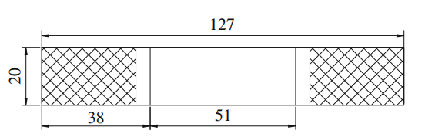
Figure 1: Specimen Geometry (mm)

Material and Specimen: E- glass/ Epoxy
Length: 127mm
Width: 20mm
Thickness: 2.66mm

Material Properties with Composite Layup
Table 1 shows the material properties of E- glass/epoxy that are considered in the analysis. The laminate consists of 8 plies with two different layups [45/90/-45/0] s and [45/0/0-45] s.

Table 1: Material Properties of E-glass/Epoxy [1]
Mechanical Properties | Magnitudes
Longitudinal tensile modulus $E_{11}$ (GPa) | 42.0
Transverse tensile modulus $E_{22}$(GPa) | 11.3
Transverse tensile modulus $E_{33}$ (GPa) | 11.3
Poisson ratio $µ_{12}$ | 0.3
Poisson ratio$µ_{23}$ | 0.4
Poisson ratio $µ_{31}$ | 0.08
Shear modulus $G_{12}$(GPa) | 4.5
Shear modulus $G_{23}$(GPa) | 4.0
Shear modulus $G_{31}$(GPa) | 4.5
Longitudinal tensile strength $X_{T}$ (MPa) | 900
Longitudinal compressive strength $X_{C }$( MPa) | 900
Transverse tensile strength $Y_{T}$( MPa) | 50
Transverse compressive strength $Y_{C}$ (MPa) | 140
Shear strength $S_{12}$ (MPa)

METHODOLOGIES

The FE-based fatigue analysis is carried out through the following five steps: FE modelling, assigning material properties, stress analysis, and applying the failure criterion in conjunction with the stiffness degradation rule. First, the static analyses are conducted on GFRP composite laminate for various applied loads using LPF-based PDGA to determine the static strength of the laminate using Tsi-Wu failure criteria. Then a similar procedure is followed for the fatigue analyses to assess the fatigue strength of the laminate with the above two stacking sequences by using S-N data of the unidirectional composites for longitudinal, transverse and shear directions. The FEA modelling and analyses were carried out using the commercial software ABAQUS. Then FEA stress outputs are post-processed using Tsi-Wu criteria to determine static and fatigue strengths. The detailed procedures are discussed in the following sections.

FE-based Failure Analysis Using ABAQUS
In the present work, the FEA tool ABAQUS is used for carrying out the static and fatigue failure analysis of GFRP composite laminates. The 'CFAILURE' option in the output request form in ABAQUS is considered for the computation of the Tsi-Wu failure index. The fail stress sub-option is chosen for incorporating composite strength parameters in material properties form. Four types of composite failure, such as fibre failure (breakage), Matrix cracking, interfacial debonding and delamination, occur in composites. The S-N data of GFRP composite along the fibre, transverse and in-plane shear directions for stress ratio R=0 have been used to predict composite laminate's fatigue strength-life (S-N) curve [1]. The stiffness degradation rule based on a matrix failure mode is considered for 90⁰ plies, and the fibre-matrix shear failure mode is considered for 45⁰ plies, as shown in Table 2. The range of fatigue life considered is from ${10}^{3}$ to ${10}^{6}$ Cycles. The FE based model and residual strength prediction are considred. [7 – 11].

It may be noted that the strength parameters of UD GFRP composite for ${10}^{3}$, ${10}^{4}$, ${10}^{5} {and 10}^{6}$ Cycles are taken from experimental S-N data shown in Figures 2, 3 and 4. The fatigue analysis of the laminate is carried out, and fatigue strength is obtained by conducting static failure analyses at ${10}^{3}$, ${10}^{4}$, ${10}^{5} {and 10}^{6}$ Cycles. The S-N curve of the composite laminate is generated by plotting the strength obtained for different cycles vs the number of cycles.

Failure Criteria and Material Property Degradation Rule
The laminate failure is assumed to occur when the stress state of a ply in laminate satisfies the Tsi-Wu criterion based on LPF. The Tsi-Wu criterion for ply failure in a composite is shown in the following equations 3.1 to 3.7
F₁σ₁ + F₂ σ₂ ₊ F₁₁ σ₁² ₊ F₂₂ σ₂² ₊ F₆₆ σ₃ ₊ 2F₁₂ σ₁ σ₂ ₌ ₁ 3.1
$F_{1}= \frac{1}{Xt}+\frac{1}{Xc}$ 3.2
$F_{2}= \frac{1}{Yt}+\frac{1}{Yc}$ 3.3
$F_{11}= \frac{-1}{XtXc}$ 3.4
$F_{22}= \frac{-1}{YtYc}$ 3.5
$F_{66}= \frac{1}{s^{2}}$ 3.6
${ F}_{12}=\frac{-0.5}{\sqrt{XtXcYtYc}}$ 3.7

Where σ1, σ2, and σ3 are longitudinal, transverse and shear stresses, respectively.
Xt, Xc are tensile and compressive strength along longitudinal directions.
Yt, Yc, are tensile and compressive strength along transverse directions.
S is the shear strength.

The failed lamina 1st ply until the last ply failure is considered to have stiffness degraded as per the stiffness degradation rules proposed by Camanho et al. [2], as shown in Table 2. The present work assumes the matrix failure and fibre-matrix shear failure mode for stiffness degradation. This failure process, known as a progressive failure, continues until the last ply failure (LPF).

Table 2: Stiffness Degradation Rules of Composite [2]
Failure Mode | Stiffness Degradation Rule
Fibre Failure | 0.07 x All parameters
Matrix Failure | $E_{22}$ = 0.2 $E_{22}$, $G_{12}$ = 0.2$G_{12}$, $G_{23}$ = 0.2$G_{23}$, $µ_{12}$ = 0.2$µ_{12}$, $µ_{23}$= 0.2$µ_{23}$
Fibre Matrix  Shear Failure | $G_{12}$ = 0.2$G_{12}$, $µ_{12}$ = 0.2$µ_{12}$
Delamination | $E_{33}$ = 0.01$E_{33}$ , $G_{12}$ = 0.01$G_{12}$, $G_{13}$ = 0.01$G_{13}$,$µ_{23}$ = 0.01$µ_{23}$, $µ_{13}$ = 0.01$µ_{13}$

S-N Properties GFRP Composite UD Lamina and Failure Criteria of Laminate
Composite laminate failure occurs when the failure index obtained using Tsai -Wu failure criteria is unity using the stiffness degradation rule. The damage is assumed to be arising progressively from the first ply to the last ply failure of the laminate. This model is proposed by Camanho and Matthews [2] and Tserpes et al. [3]. Several other researchers have also used the stiffness degradation approach to predict the failure strength of composites. [4-6]

In the case of fatigue failure, the failure is considered with respect to the number of cycles. In the present work, the number of cycles considered is 10³ to 10⁶ cycles with a stress ratio (R=0).

In the present study, the fatigue strength properties of unidirectional GFRP lamina with respect to longitudinal, transverse and shear directions for 10³, 10⁴, 10⁵, and 10⁶ cycles, as shown in Table 3, are considered as inputs to the fatigue model of composite laminate. These strength data are obtained by digitizing the S-N curves [1] for UD GFRP lamina shown in Figures 2 to 4.

It may be noted that the static failure load procedure has been elaborated in detail in sections 3.1 and 3.2. The fatigue failure load procedure follows a similar approach to the static failure procedure; therefore, the method is not described again. The only difference in fatigue failure analysis is that the failure loads are with respect to the respective number of cycles.

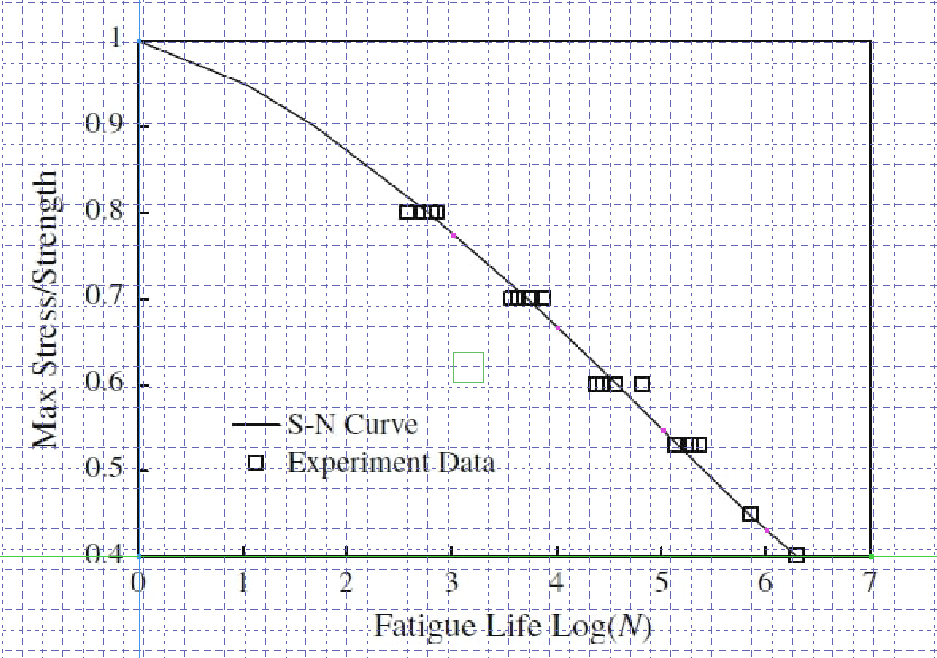
Figure 2: Standard S-N Curve of ${[0]}_{8}$ Laminates [1]

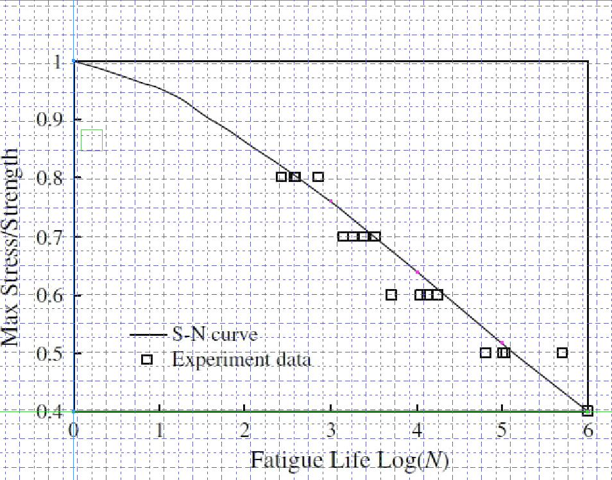
Figure 3: Standard S-N Curve of ${[90]}_{8}$ Laminates [1]
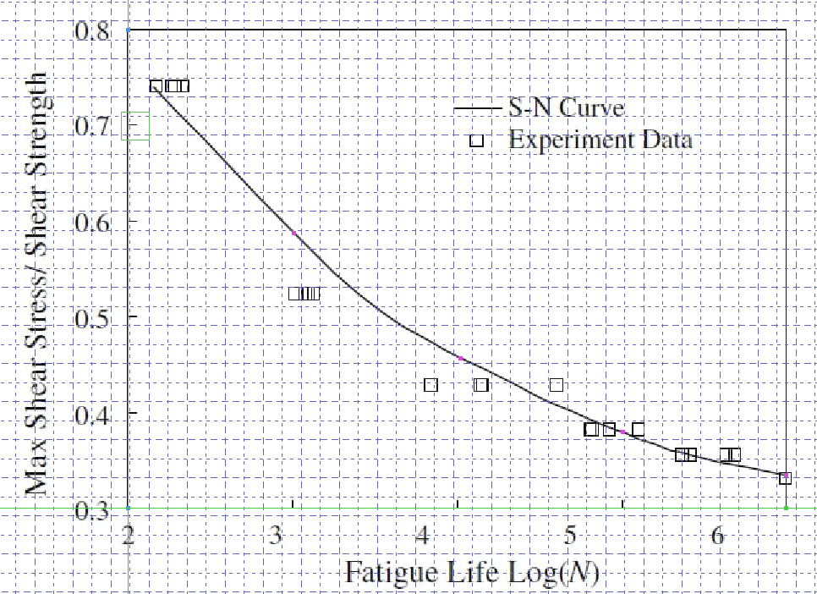
Figure 4: Standard S-N Curve Under in-plane Shear Stress [1]

Table 3: Fatigue Strength Properties of Composite Material with Different Cycles [1]
MATERIAL PROPERTIES
Material Properties | ${10}^{3}$ Cycles | ${10}^{4}$ Cycles | ${10}^{5}$ Cycles | ${10}^{6}$ Cycles
$X_{T}$(MPa) | 696.42 | 598.86 | 491.40 | 386.82
$X_{C}$(MPa) | 696.42 | 598.86 | 491.40 | 386.82
$Y_{T}$(MPa) | 38.00 | 31.91 | 25.91 | 20.00
$Y_{C}$(MPa) | 106.40 | 89.36 | 72.56 | 56.00
$S_{12}$(MPa) | 42.31 | 32.86 | 27.32 | 24.07

The following specimen design in ABAQUS as per the Chinese standard of materials testing standard GB/T 1447 – 2005. The following Fig. 5
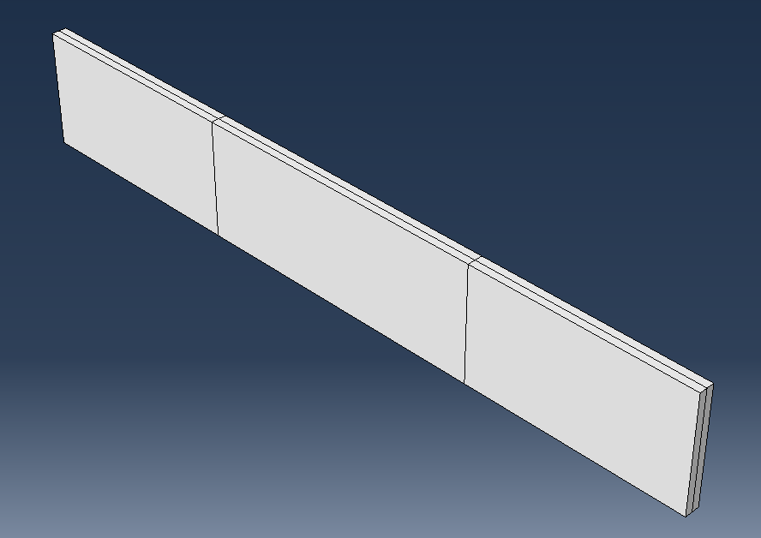
Figure 5: Specimen Modelling using ABAQUS

Stacking Sequence Plots
The stacking sequences considered in this study are [45/90/-45/0]s and [45/0/0-45]s, which are symmetric about the mid-plane of the laminate.

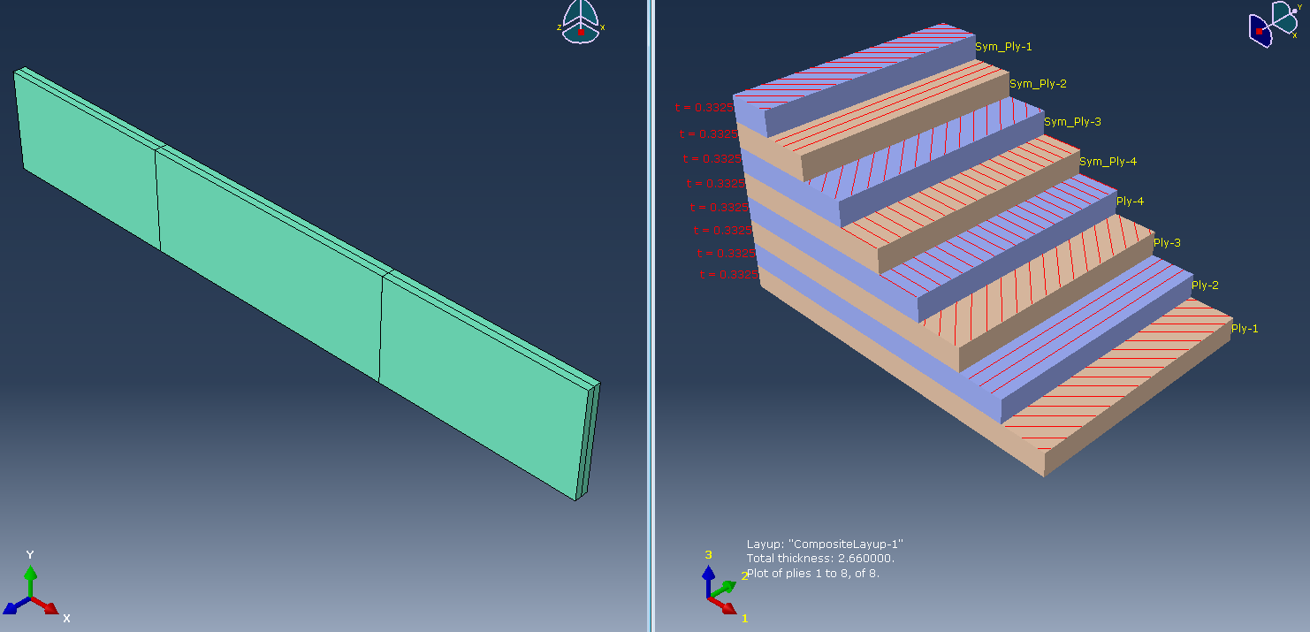
Figure 6: Stacking Plot [45/90/-45/0]s
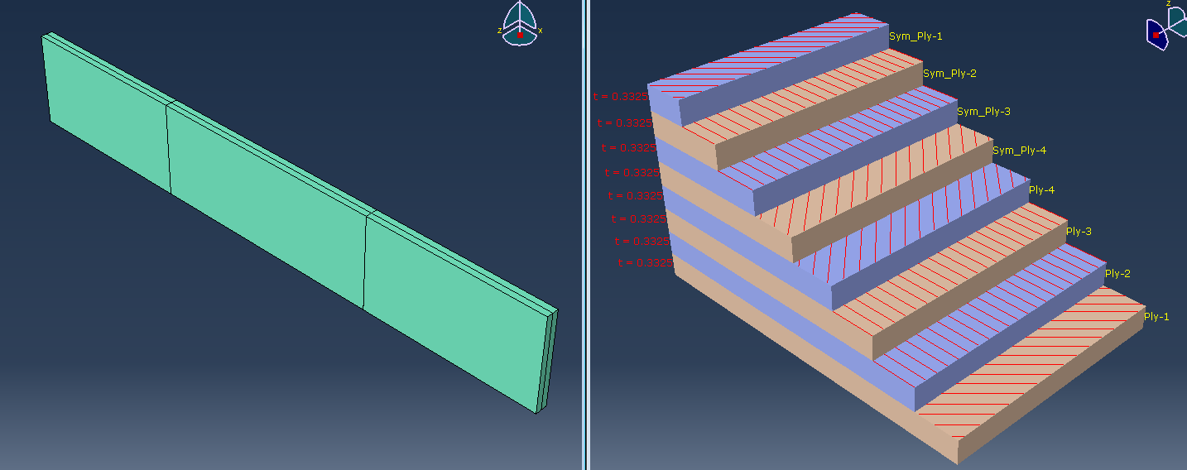
Figure 7: Stacking Plot [45/0/0-45]s
Figures 6 and 7 represent the fibre orientation in each ply for two different stacking sequences of the laminate and show the plot of all the plies.

FE Mesh Convergence Study
Finite element modelling and analysis are carried out using commercial finite element code ABAQUS. Four node shell type quad element (S4R as per ABAQUS element library) is considered in the FE model. S4R is a 4-node, quadrilateral stress/displacement shell element with reduced integration. The finalized mesh is obtained by performing convergence studies.

Figure 8: FE Mesh of Unnotched Composite Laminate

Figure 9: Variation of Stress With Different Element Sizes
The finalized mesh is obtained by performing convergence studies on unnotched composite laminate. Figure 9 above shows the convergence study of unnotched laminate, where the $σ_{xx}$ stress values at $0^{0}$ layer of [45/90/-45/0]s unnotched composite laminate for different element sizes. It is seen that the stress values are almost constant for element sizes 1, 0.5 & 0.25. So, 0.5 element size has been considered for further FEA analysis work.

Table 4: $σ_{xx}$ Stress at $0^{0}$ Layer for Different Element Sizes
Finite Element  Mesh Size | Element  Size | Number of elements | $σ_{xx}$ Stress in MPa at $0^{0}$ layer
Mesh - 1 | 2.0 | 640 | 920.98
Mesh - 2 | 1.5 | 1092 | 921.46
Mesh - 3 | 1.0 | 2540 | 922.13
Mesh - 4 | 0.5 | 10160 | 922.32
Mesh -5 | 0.25 | 40640 | 922.57

Load and Boundary Conditions with MPC
Figures 10 and 11 show the loading and boundary conditions used to simulate the panels under tensile loading. The fixed boundary conditions with all six degrees of freedoms zero (u = v = w = Rx = Ry = Rz = 0) called 'ENCASTER' in ABAQUS were considered in the FE model to simulate support conditions during the test. The other end of the panel was loaded with a tensile point load in ABAQUS.
Figure 10: Interaction of Composite Laminate with MPC
Figure 11: Loading and Boundary Condition for Composite Laminate without Notch
It may be noted that simple fixed boundary conditions can be considered in the model shown in Fig. 11 as against MPC boundary conditions considered in the document. However, the MPC boundary condition with all DOFs as zero in the model is considered similar to the fixed boundary condition. Flow charts for both static and fatigue analyses are shown in Figures 12 and 13, respectively.

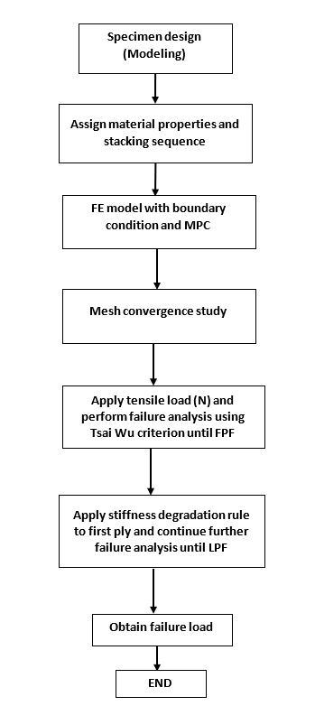
Figure 12: Flow Chart for Static Analysis

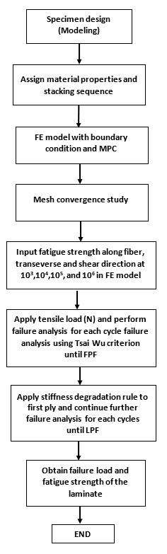

Figure 13: Flow Chart for Fatigue Analysis

RESULTS AND DISCUSSION

Static Failure Analysis of Composite Laminate
Stress analysis is conducted on the composite laminate with different stacking sequences with the loads and boundary conditions described in the previous section. Tables 5 and 6 present failure indices of various plies for different applied loads for two different stacking sequences [45/90/-45/0]s and [45/0/0/-45]s, and Figures 12 and 14 represent them graphically.

Static Failure of [45/90/-45/0]s Composite Laminate
Table 5 represents composite laminate failure index values at various applied loads for different lamina based on the Tsai-Wu failure criterion. When the failure index reaches unity, the respective layer is considered to be failed. Figure 12 shows the failure index Vs applied load graphically.

Figure 14: Failure Index vs Applied Load (N) of [45/90/-45/0]s laminate
Table 5: Static Failure Load (N) Values at Each Layer for [45/90/-45/0]s Composite Laminate
90 ̊ PLY | Applied Load (N) | Failure Index | +/- 45 ̊ PLY | Applied Load (N) | Failure Index | 90 ̊ PLY | Applied Load (N) | Failure Index
 | 2000 | 0.37 |  | 5400 | 0.76 |  | 7500 | 0.41
 | 3000 | 0.55 |  | 6000 | 0.85 |  | 10000 | 0.55
 | 4000 | 0.74 |  | 7000 | 0.98 |  | 13000 | 0.72
 | 5000 | 0.92 |  | 7500 | 1.0 |  | 17000 | 0.94
 | 5400 | 1.0 |  |  |  |  | 22000 | 1.11

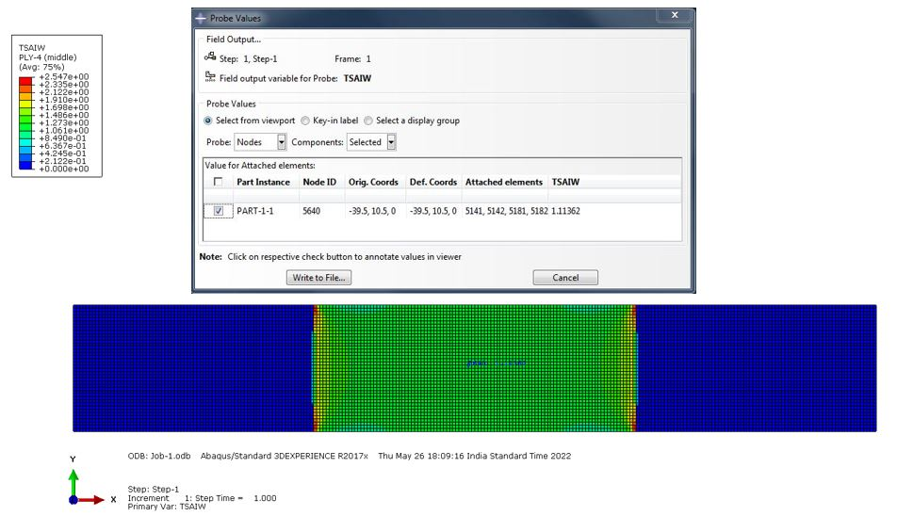
Figure 15: Failure Index Value of 0 ̊ Last Ply Failure using Tsai Wu Rule
The FE-based stiffness degradation method is used to predict the failure load of composite laminate [45/90/-45/0]s. The applied load corresponding to the last ply failure (the last ply fails when the failure index is unity for the last ply) is the failure load and is obtained as 19700N. The 90⁰ ply fails first, and the complete laminate fails when the 0⁰ ply failure occurs, as shown in Figure 13. In FE analysis, for 90⁰ ply failure, the matrix failure mode is assumed, and 45⁰ ply failure fibre-matrix shear failure mode is considered.

Static Failure of [45/0/0/-45]s Composite Laminate
Table 6 represents composite laminate failure index values at various applied loads for different lamina based on the Tsai-Wu failure criterion. When the failure index reaches unity, the respective layer is considered to be failed.

Figure 16: Failure Index vs. Applied Load (N) of [45/0/0/-45]s laminate
Table 6: Static Failure Load (N) Values at Each Layer for [45/0/0/-45]s Composite Laminate
+45⁰/-45⁰ ply | Applied  Load (N) | Failure  Index | 90⁰ Ply | Applied  Load (N) | Failure  Index
 | 5000 | 0.44 |  | 11000 | 0.38
 | 7000 | 0.63 |  | 14000 | 0.48
 | 9000 | 0.82 |  | 18000 | 0.63
 | 10000 | 0.90 |  | 22000 | 0.77
 | 11000 | 0.99 |  | 20000 | 0.7
 |  |  |  | 26000 | 0.91
 |  |  |  | 30000 | 1.05
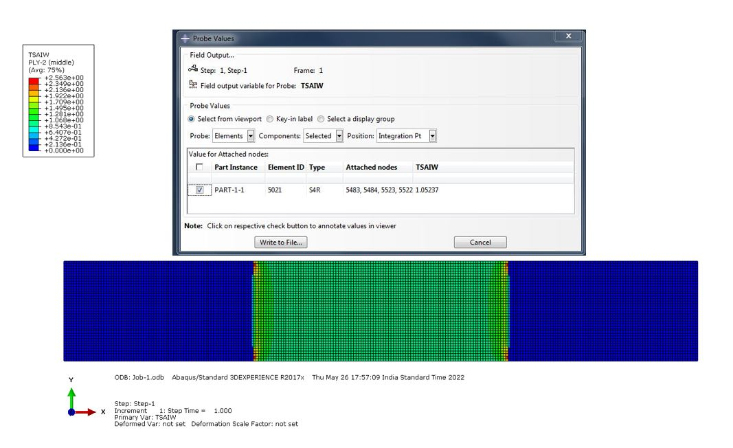
Figure 17: Failure Index Value of 0 ̊ Last Ply Failure using Tsai Wu Rule
The FE-based stiffness degradation method is used to predict the failure load of composite laminate [45/0/0/-45]s. The applied load corresponding to the last ply failure (the last ply fails when the failure index is unity for the last ply) is the failure load and is obtained as 28550N. The 45⁰ ply fails first, and the complete laminate fails when 0⁰ ply failure occurs, as shown in Figure 15. In FE analysis, for 45⁰ ply failure, the fibre-matrix shear failure mode is considered. The first ply failure will occur due to the failure of 45⁰ ply, while the last ply failure will occur due to the failure of 0̊ ply. It is seen from Figures 12 and 14 that the failure indices increase almost linearly with an increase in applied load.

Experimental vs FEA result
The following Figure 16 shows the comparison between the experimental result and the FEA result. The FE-based analysis is done using the stiffness degradation rule.

Figure 18: Error Bar Comparison of Experimental Strength [1] vs FEA Strength

Table 7: Percentage of Error Comparison (Static Test)
Stacking Sequence | Experimental Strength  (MPa) | FEA Strength  (MPa) | % Error
[45/90/-45/0]_{s} | 372 | 370.3 | 0.45
[45/0/0/-45]_{s} | 592 | 545.11 | 7.9

Table 7 above shows the percentage of error between the experimental strength [1] and FEA strength. It is observed from Figure 16 and Table 7 that the experimental strength is slightly more than the FEA strength. This trend is expected since the FE model does not capture the actual stiffness of the real structure.

Fatigue Failure in Composite Materials
This study deals with the fatigue life prediction of unnotched composite laminates with two different stacking sequences [45/90/-45/0]s and [45/0/0/-45]s. The S-N data of GFRP composite along the fibre, transverse and in-plane shear directions for stress ratio R=0 have been used to predict the fatigue strength-life (S-N) curve of composite laminate [1]. The stiffness degradation rule based on a matrix failure mode is considered for 90⁰ plies, and the fibre-matrix shear failure mode is considered for 45⁰ plies, as shown in Table 2. The range of fatigue life considered is from ${10}^{3}$ to ${10}^{6}$ Cycles.

It may be noted that the strength parameters of UD GFRP composite for ${10}^{3}$, ${10}^{4}$, ${10}^{5} {and 10}^{6}$ cycles are taken from experimental S-N data [1] shown in Figures 2, 3 and 4. The fatigue analysis of the laminate is carried out, and fatigue strength is obtained by conducting static failure analyses at ${10}^{3}$, ${10}^{4}$, ${10}^{5} {and 10}^{6}$ Cycles. The S-N curve of the composite laminate is generated by plotting the strength obtained for different cycles vs the number of cycles.

Fatigue Failure of [45/90/-45/0]s Composite Laminate
Figure 17 and Table 8 represent the fatigue life of the FEA and the Experimental results. This graph shows the fatigue life of unnotched composite laminate with stacking sequence [45/90/-45/0]s for different cycles from 10³ to 10⁶ using the stiffness degradation rule and Tsai Wu criterion.

Figure 19: Fatigue Life of [45/90/-45/0]s Laminates
Table 8: Fatigue Failure Load Values at Each Layer for [45/90/-45/0]s Composite Laminate
90⁰ Ply | Number of Cycles | Failure Load (N) | 45⁰ / -45⁰ Ply | Number of Cycles | Failure Load (N) | 0⁰ Ply | Number  of Cycles | Failure Load (N) | Max. Stress (MPa)
 | $${10}^{3}$$ | 3500 |  | $${10}^{3}$$ | 4800 |  | $${10}^{3}$$ | 4000 | 263.15
 | $${10}^{4}$$ | 3200 |  | $${10}^{4}$$ | 4000 |  | $${10}^{4}$$ | 12000 | 225.56
 | $${10}^{5}$$ | 2800 |  | $${10}^{5}$$ | 3200 |  | $${10}^{5}$$ | 9800 | 184.21
 | $${10}^{6}$$ | 2200 |  | $${10}^{6}$$ | 2600 |  | $${10}^{6}$$ | 7600 | 142.85

Table 9: Error Percentage Comparison of Experimental and FEA Fatigue Strength of [45/90/-45/0]s laminate
Fatigue  Life | Max. Stress (FEA)  (MPa) | Max. Stress (Experimental) (MPa) | % of Error
10³ | 263.15 | 245.52 | 7.18
10⁴ | 225.56 | 200.88 | 12.28
10⁵ | 184.21 | 156.24 | 17.90
10⁶ | 142.85 | 126.48 | 12.94

Table 9 represents the error percentage between experimental and FEA fatigue strength of [45/90/-45/0]s laminate In FEA analysis. It is seen that fatigue strength obtained from FEA is more than the experimental results. This trend may be because the delamination and debonding occur in the experiment (which is a real scenario), which is not considered in FEA.

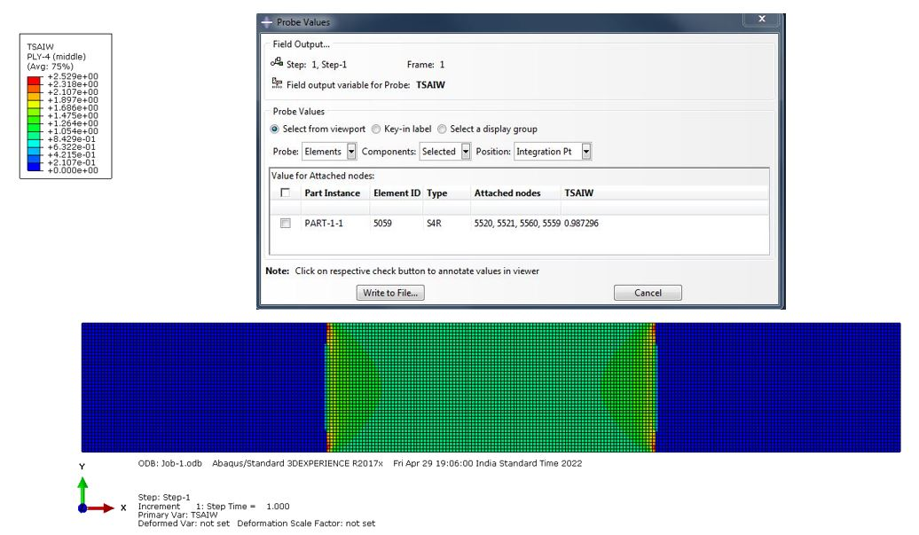
Figure 20: Failure Index Value of 0 ̊ Last Ply Failure at ${10}^{6}$ Cycle using Tsai Wu Rule
Figure 18 represents the failure index plot of composite laminate with stacking sequence [45/90/-45/0]s at ${10}^{6}$ cycle using ABAQUS based on Tsai Wu criteria.

Fatigue Failure of [45/0/0/-45]s Composite Laminate
Figure 19 and Table 10 represent the fatigue life of the [45/0/0-45]s laminate obtained from FEA and the Experiment. This graph shows the fatigue life of unnotched composite laminate with stacking sequence [45/0/0/-45]s for different cycles from 10³ to 10⁶ using the stiffness degradation rule and Tsai Wu criterion.

Figure 21: Fatigue Life of [45/0/0/-45]s Laminates
Table 10 Fatigue Failure Load Values at Each Layer for [45/0/0/-45]s Composite Laminate
45⁰ / -45⁰ Ply | Number of Cycles | Failure  Load (N) | 0⁰ Ply | Number of Cycles | Failure  Load (N) | Max. Stress  (MPa)
 | $${10}^{3}$$ | 7000 |  | $${10}^{3}$$ | 23000 | 432.33
 | $${10}^{4}$$ | 5800 |  | $${10}^{4}$$ | 20000 | 375.93
 | $${10}^{5}$$ | 4800 |  | $${10}^{5}$$ | 16500 | 310.15
 | $${10}^{6}$$ | 4000 |  | $${10}^{6}$$ | 12000 | 225.56
It is observed that +/-${45}^{0}$ plies in the laminate failed first and simultaneously since the failure indices of both the plies reached unity at the same time. It is also observed that +/-${45}^{0}$ plies failed first compared to 0⁰ plies. It is due to the fact that less %age of fibre in +/-${45}^{0}$ plies are participating in transferring load in comparison to 0⁰ plies. The more amount of damage accumulates in +/-${45}^{0}$ plies due to matrix cracking in comparison to 0⁰ ply.

Table 11: Error Percentage Comparison of Experimental and FEA Fatigue Strength of
[45/0/0/-45]s laminate

Fatigue Life  Log (N) | Max. Stress (FEA)  (MPa) | Max. Stress (Experimental)  (MPa) | % of Error
10³ | 432.33 | 408.48 | 5.51
10⁴ | 375.93 | 331.52 | 11.81
10⁵ | 310.15 | 266.4 | 14.10
10⁶ | 225.56 | 189.44 | 16.01

Table 11 represents the error percentage between experimental and FEA fatigue strength of [45/0/0/-45]s laminate In FEA analysis. It is seen that fatigue strength obtained from FEA is more than the experimental results. This trend may be because the delamination and debonding occur in the experiment (which is a real scenario), which is not considered in FEA.
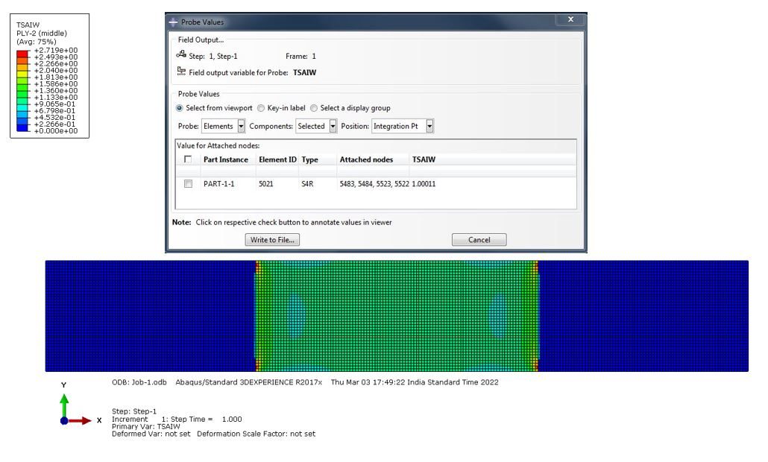
Figure 22: Failure Index Value of 0 ̊ Last Ply Failure at ${10}^{6}$ Cycle using Tsai Wu criterion
Figure 20 represents the failure index plot of composite laminate with stacking sequence [45/0/0/-45]s at ${10}^{6}$ cycle using ABAQUS based on Tsai Wu criteria.

Conclusion
The FE-based computational fatigue analysis has been carried out in the current research work on unnotched GFRP composites using Tsai-Wu failure criteria and compared with the experimental results available in the literature. The work considers two types of GFRP composite laminates with stacking sequences [45/90/-45/0]s and [45/0/0/-45]s, and fatigue lives are predicted using the FEA approach. The FEA stress results are post-processed using Tsai-Wu criteria in conjunction with the stiffness degradation rule to predict the fatigue strength of the composite at various cycles from 10³ to 10⁶ with a stress ratio R=0. The fatigue strengths are plotted against the number of cycles to obtain the S-N curve of the composite laminate. In FEA simulation, matrix cracking is considered in 90⁰ply, whereas fibre matrix shear failure is considered for +/-45⁰ plies in the stiffness degradation rule. The predicted failure strengths are compared with the experimental results and are in good agreement. FEA predicted fatigue strength results are slightly more than the experimental results. This trend may be because the delamination and debonding occur in the experiment (which is a real scenario), which is not considered in FEA. The error %age in fatigue strength for 10³ cycles is of the order of 5% for [45/0/0-45]s laminates and 7% for [45/90/-45/0]s laminate. This study is essential for evaluating the structural integrity of composite airframe structures.
As for the scope and limitations of the work, the method used is mainly limited to FRP composites such as CFRP, GFRP, and Aramid Fiber Reinforced Polymer (AFRP). However, a test program should be conducted using the above composites, where literature data are unavailable to validate and verify this method to the above composites.
As for the future scope of work, strain-based composite failure criteria such as the Tsai-Hill criterion may be used for computational models. The methodologies used in the work can be extended to be used for other types of composites, such as metal matrix composites (MMC) and ceramic matrix composites (CMC).

Acknowledgements
The authors acknowledge the support of the Director NAL for funding the project (No.: S-8-535) titled "Computational Approach to Fatigue and Damage Tolerance Assessment of Aircraft Structures". The support of the Head, STTD, is thankfully acknowledged.

REFERENCES
- Wei Lian, Weixing Yao, "Fatigue life prediction of composite laminates by FEA simulation method", International Journal of Fatigue 32, 2010: 123-133.
- Camanho PP, Matthews FL. "A Progressive Damage Model for Mechanically Fastened Joints in Composite Laminates", Journal of Composite Materials, 33, 1999: 2248-2279.
- Tserpes KI, Labeas G, Papanikos P, et al., "Strength prediction of bolted joints in graphite/epoxy composite laminates", Composites: Part B 33, 2002: 521–529.
- Xiaoqi LI et al., "Tensile properties of a composite-metal single-lap hybrid bonded/bolted joint", Chinese Journal of Aeronautics, 2020 34 (2): 629-640.
- J.A.M. Ferreira et al., "Static and fatigue behaviour of glass-fibre-reinforced polypropylene composites", Theoretical and applied fracture mechanics, 31, 1999: 67-74.
- Arafat I. Khan et al., "Predicting fatigue damage of composite using strength degradation and cumulative damage model", Journal of Composite Science, 2(1), 2018: 1-21.
- PK Sahoo "Strength prediction and fatigue debond growth in bonded joints in metallic and composite structures", 2010: 68-70.
- Robert M. Jones "Mechanics of Composite Materials" Second Edition.
- Jianyu Zhang et al. "A progressive damage analysis based characteristic length method for multi-bolt composite joints", Composite Structures 108, 2014: 915-923.
- PK Sahoo "Finite Element Analysis of Adhesively Bonded Lap Joints", XIV NASAS: Fatigue, Fracture and Ageing Structures, 2006: 330 – 334.
- D. Revuelta “A new approach to fatigue analysis in composites based on residual strength degradation”, Composite Structures 48 (2000) 183 – 186.

