**Induced Systemic Resistance in Foam Cups grown Tobacco plants by Rhizobacteria and Phytoproteins**

Dr. Ashish Kumar Gupta1, Dr. Shalini Srivastava2

1Department of Microbiology, Khwaja Moinuddin Chishti Language University, Lucknow 226013, microashish11@gmail.com

2Department of Botany, University of Lucknow, Lucknow 226007

**INTRODUCTION**

Plant viruses are a known cause of partial to complete crop failure and hence represent a threat to food security. Resistance genes, pesticides and prophylactic measures are generally employed to eliminate these pathogens and protect crops. Alternative strategies to prevent/control virus infection and promote plant growth have been developed in recent years and implemented with some success in the field condition. These novel methods include the modulations of the host’s inherent immune responses through induction of resistance by plant proteins, plant growth–promoting rhizobacteria (PGPR) and systemic acquired resistance by pathogen infection or chemicals. Control of plant pathogens through induction of resistance by antiviral proteins from a few plants such as *Clerodendrum inerme* (CIP-29), *C. aculeatum* (CAP-34) and *Boerhaavia diffusa* (BDP-30) is well known. The resistance inducers from these plants have been purified and characterized (Prasad et al, 1995; Verma et al, 1996; Olivieri et al, 1996; Srivastava et al, 2015). Plant growth promoting rhizobacteria (PGPR) such as *B. subtilis*, *Pseudomonas fluorescens*, *P. putida*, *P. aeruginosa*, etc, colonize the rhizosphere, stimulate growth of plants and exert beneficial effects through direct or indirect methods (Kloepper et al, 1980; Pieterse et al, 1996; Kloepper et al, 2004). Selected PGPR strains induce systemic resistance against bacterial, viral and fungal pathogens in a variety of host plants. These two methods of induction of resistance in susceptible plants can contribute to any integrated pest management program. Highlighting the importance of rhizobacteria in biological control, several commercial formulations of PGPR strains have been developed for use as a foliar spray, soil drench, root dip or seed treatment in conventional agricultural practices. The biochemistry of induced resistance has been dissected to some extent and often there is an accompanying accumulation of defence-related enzymes viz., peroxidase, polyphenol oxidase and superoxide dismutase in the host plants.

Plant extracts with an ability to inhibit viruses in spatially separated tissues have been reported from a number of higher plants. Plant growth promoting rhizobacteria (PGPR) are defined as root colonizing rhizobacteria that exert beneficial effect on plant growth and development. The role of PGPR has been extensively studied as biofertilizers to increase the yield of agronomically important crops. PGPR are free-living, soil-borne bacteria, which enhance the growth of the plant either directly or indirectly. The direct mechanisms involve nitrogen fixation, phosphorus solubilization, HCN production, production of phytohormones, while indirect mechanisms involve production of antimicrobial agents that inhibit the growth of various plant pathogens, competition for nutrients and niches (CNN), and induction of systemic resistance (ISR) in plants against diverse pathogens.

Six bacterial isolates were obtained from rhizospheres of different plants and tested for ISR against plant viruses. The bacterial isolates and CAP-34 (resistance inducing basic protein purified from *C. aculeatum*) were tested for the plant growth promotion on *Nicotiana tabacum* cv. White burley.

**AIMS AND OBJECTIVES**

1. Growth promotion by six bacterial isolates (P1f, PM1, UN1, UN2, H1 and RO2) and CAP-34 on *Nicotiana tabacum* cv. White burley measured as increase in leaf area, plant height and fruit numbers.
2. Antiviral resistance induced by the six bacterial isolates and CAP-34 on *Nicotiana tabacum* cv. White burley measured as nil/reduced visible mosaic symptoms on host plants post tobacco mosaic virus (TMV) challenge.

**MATERIALS AND METHODS**

**Test host:**

*Nicotiana tabacum* cv. White burley seedlings, at 3-4 leaf stage, were transferred from clay pots to a thermacol glass filled with about 200gm of soil. Seedlings were divided into 8 sets, with 10 plants/set. **Preparation of inoculum and treatment of seedlings:**

Prior to transfer, root-dip treatment was administered to seedlings with different bacterial isolates and CAP-34. All six bacterial isolates were incubated for 24 hours at 370C in a shaker incubator in nutrient broth. The 24 hour broth cultures of P1f, PM1, UN1, UN2, H1 and RO2 were used as inoculum. Seedling roots were dipped in the inoculum individually. A set of seedlings was sprayed with purified CAP-34 (20µg/ml). The control set was treated with DW only. Thus a total of eight sets of plants were treated differently. Foliar spray treatment with CAP-34 was repeated thrice at a 3 day interval, whereas the last two treatments with inoculum were administered as a soil drench.

**Measurement of growth promotion:**

The leaf area was measured after the 4th weeks of treatment with the help of Systronics “Leaf Area Meter 211” and growth promotion parameters compared amongst the different sets. Plant growth parameters such as, leaf area, plant height, and fruit yield, were measured after 12 weeks, and data analyzed statistically.

**Assessment of induced antiviral resistance:**

After noting down the growth parameters, the treatments were administered one last time as before, and the plants in all sets were challenge inoculated with TMV 24 hours later. The pattern of development of mosaic symptoms after 14 days of challenge inoculation with TMV was noted.

**RESULTS AND DISCUSSION-**

**Effect of treatment with CAP-34 and bacterial isolates P1f, PM1, UN1, UN2, H1, and RO2 on the growth parameters of *Nicotiana tabacum* cv white burley**

The comparative efficiency of different treatments of rhizobacterial strains and CAP-34 on white burley plants was evaluated for morphological parameters such as leaf area, plant height and fruit number.

**Leaf area*:*** The treated sets had significantly larger leaf area than the control set of plants (Fig 1). The plants in sets P1f and PM1 responded similarly, while the most significant increase in leaf area was seen in set of plants treated with UN2, as determined through Dunnett t test analysis (P=0.000) (Figs. 1 and 2). The P ≤ 0.05 value was calculated through ANOVA.

***Plant Height:*** The treated sets were significantly taller than the control set of plants (P=0.016). The plant sets treated with UN1 and UN2 gave a similar response, while the most significant increase in height was seen in the set treated with PM1 and where the plants received CAP-34 as a foliar spray (as determined through Dunnett t test analysis, P=0.026) (Fig 3A and 4). The P ≤ 0.05 value was calculated through ANOVA.

**Number of Fruits:**

The increase in number of fruits following treatment with rhizobacterial strains and CAP-34 was not statistically significant when a statistical comparison was made between various groups (Fig. 3B)

**Effect of various treatments on induced antiviral resistance against TMV:**

Table 1 represents the status of plants with respect to development of visible mosaic. The set treated with CAP-34 maximally induced resistance against TMV in comparison to all PGPR treatments (Table 1). Representative control plant with visible mosaic symptoms, and a representative healthy plant from CAP-34 treated set are shown in fig.5)

**Fig.1: Effect of rhizobacterial isolates P1f, PM1, UN1, UN2, H1, RO2 and CAP-34 treatments on leaf area** Eight sets of *Nicotiana tabacum cv* white burley plants, with ten plants in each set, were treated with DW, P1f, PM1,UN1,UN2,H1,RO2 and CAP-34. DW-treated plants served as a control set and foliar treatments with CAP-34 were administered thrice, at an interval of three days each, whereas root treatment was administered once prior to planting of seedlings in Thermacol glass, twice thereafter as a soil drench. At the end of 4 weeks, the area of the leaf was measured. The data was analysed statistically using one way ANOVA for comparison of treated sets with the control set and Dunnett t test for multiple comparisons. The P value of leaf area is less than 0.05 for any given treatment, and hence treatment with the bacterial isolates and CAP-34 agents induced a statistically significant increase in leaf area.



**Fig.2: Effect of various treatment on the growth of *Nicotiana tabacum* cv white burley plants.** Plants showed an increase in leaf area after treatment with P1f, PM1, UN1, UN2, H1, RO2 and CAP-34, over the control plants treated with DW.

**(A)**

**(B)**

**Fig.3: Effect of rhizobacterial isolates P1f, PM1, UN1, UN2, H1, RO2 and CAP-34 treatments on plant height and fruit number:** Eight sets of white burley plants, with ten plants in each set, were treated with DW, P1f, PM1,UN1,UN2,H1,RO2 and CAP-34. DW-treated plants served as a control set and foliar treatments with CAP-34 were administered thrice, at an interval of three days each, whereas root treatment was administered once prior to planting of seedlings in Thermocol glass, twice thereafter as a soil drench. At the end of 12 weeks, the number of fruits and height of plants was measured. The data was analysed statistically using one way ANOVA for comparison of treated sets with the control set and Dunnett t test for multiple comparisons. The P value of plant height is 0.016 (<0.05) and hence treatment with the rhizobacterial isolates and CAP-34 induced a statistically significant increase in plant height **(A).** Furthermore, the P value of fruit number of plants is 0.305 (˃0.05) and thus the treatment with rhizobacterial strains and CAP-34 not showed significance result on fruit number **(B).**



**Fig.4: Growth of *Nicotiana tabacum* cv white burley plants treated with P1f, PM1, UN1, UN2, H1, RO2 strains and CAP-34 protein.** Treated plants showed significant increase in height when compared with control plants treated with DW alone.

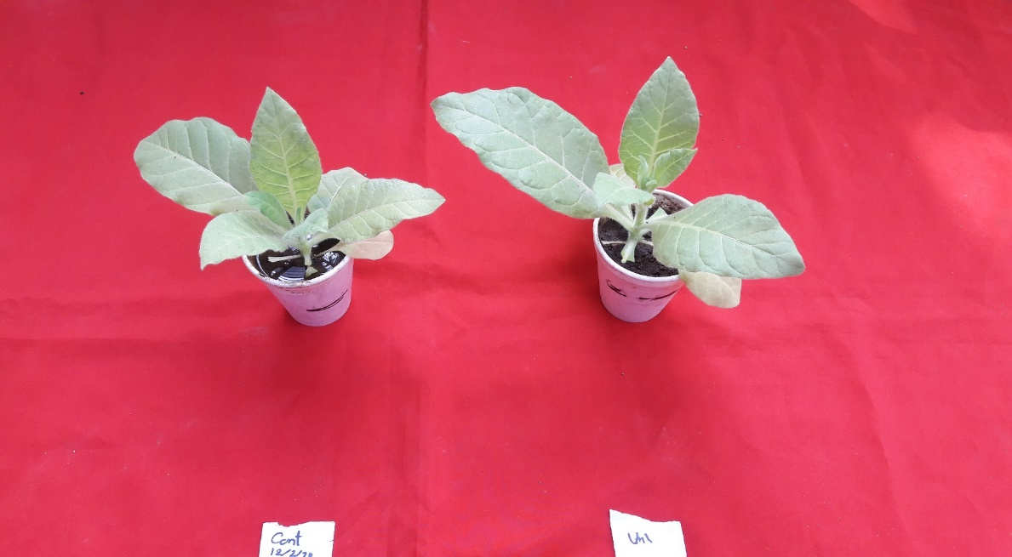

**(a)**

**(b)**

**Fig.5: Induced antiviral resistance against TMV.** *Nicotiana tabacum* cv white burley plants showed visible mosaic due to TMV infection (a) in DW treated set, while resistant plant from the treated sets is symptomless (b).

**Table 1: Effect of Rhizobacterial strains and CAP-34 treatment on the development of mosaic symptoms in plants**

|  |  |
| --- | --- |
| **Treatment** | **No. of plants with visible mosaic** |
| Control | 10 |
| P1f | 7 |
| PM1 | 9 |
| UN1 | 9 |
| UN2 | 8 |
| H1 | 8 |
| RO2 | 7 |
| CAP-34 | 4 |

**CONCLUSION-**

This study is showed the growth promotion activity of rhizobacterial isolates and CAP-34 with their induce systemic resistance ability. The rhizobacterial isolates shows growth promotion activity while the CAP-34 treated plants show growth promotion with high induced resistance against virus.

**References**

Kloepper, J.W., Leong, J., Teintze, M., Schroth, M.N., 1980, Enhanced plant growth by siderophores produced by plant growth-promoting rhizobacteria*. Nature*, 286, 885–886.

Kloepper, J.W., Ryu, C-M., Zhang, S., 2004, Induced systemic resistance and promotion of plant growth by *Bacillus* spp. *Phytopathology*,94, 1259–1266.

Olivieri, F., Prasad, V., Valbonesi, P., Srivastava, S., Ghosal- Chowdhury, P., Barbieri, L., Bolognesi, A., Stirpe, F., 1996, A systemic antiviral resistance inducing protein isolated from *Clerodendrum inerme* Gaertn. is a polynucleotide: adenosine glycosidase (ribosome-inactivating protein). *FEBS Lett*., 396, 132-134.

Pieterse, C.M.J., Van Wees, S.C.M., Hofﬂand, E., Van Pelt, J.A., Van Loon, L.C., 1996, Systemic resistance in *Arabidopsis* induced by biocontrol bacteria is independent of salicylic acid accumulation and pathogenesis-related gene expression. *Plant Cell*, 8, 1225–1237.