The study of dispersion state of Graphene in the Epoxy- Graphene nano composites

Dr Sangeeta Kulkarni Dr Vadiraj B Tangod* Dayanand Lalasangi
Assistant Professor Associate Professor Assistant Professor
Head of Department of Chemistry Head of Department of Physics Head of Department of Physics
Government First Grade College, Government First Grade College for Women’s Government First Grade College
Dharwad-580008 Dharwad-580008 Dharwad-580008
Karnataka.India Karnataka. India Karnataka. India
sangeeta_bk1234@yahoo.com vadirajtangod@gmail.com dayanandlalasangi@gmail.com
*Corresponding author

ABSTRACT

The alternate substitute for traditional epoxy reinforcement with graphene have attracted graphene nano composites in advanced applications. In this paper the dispersion of graphene in to epoxy system by using sonication as well as dispersion states and reaggreation properties have been studied. The reaggreation property was measured by using UV spectroscopy.. The decrease in light transmittance was about 80.6 to 60.3% in liquid epoxy after 10mins. which mainly depends on the sonication time and temperature.

Introduction
The deteriorating unique and exceptional properties of graphene [1]-[2]. which could decrease the purity of graphene was identified from the contamination with other additives required for usefulness of graphene. The covalent functionalization and noncovalent surface modification of graphene can be done by dispersion retaining the original structure and other properties[3] By covering with polymer the dispersion state of graphene surface [4]-[5] can be controlled.
The simplest method to disperse graphene using solvents has been widely applicable. The dispersion of graphene in 1- propanol was showed.by Choi et al. [5] Before curing the dispersion of graphene in solvents suchas acetone [6]-[7], THF [7]-[8], and DMF [9]-[10]. require another step to remove the solvents, which is undesirable due hazardous effects of are expensive and toxic during lengthy processing durations, leading to implications in health and nature[11]-[15].

In this paper effect of dispersion state of graphene and other properties in epoxy, graphene nanocomposites have been studied.

Sample Preparation
The weighed samples of graphene (0.01 mg) were dispersed by mixing with hand for 15 s gently and then sonicated in bath sonicator for uniform dispersion in epoxy system.
For studying the influence of sonication time on the dispersibility the different concentrations such as 0.5 wt% were sonicated for different time intervals (10-50min)at 20°C. The reaggregation properties of the nanocomposites sample(0.5wt%) were studied by sonicating for half an hour and preserving the samples for 10days
The influence of concentration of graphene on the dispersability was studied by preparing samples of various graphene concentration (0.5 to 1.5wt%) in hardener, as well as epoxy-hardner systems The influence of temperature on sonication and the dispersibility of 0.5wt% samples were obtained by sonicating for 20mins at different temperatures(20-60o c)

The reaggregation of graphene in epoxy system was studied by a series of controlled experiments using light transmittance in the UV-visible spectroscopy.
The fixed wavelength of 450 nm were recorded as transmittance for five graphene dispersions versus blank EP and other epoxy graphene nanocomposites The dispersion state of graphene in EP, HD, and EP + HD. were also systematically shown by plotting the graph of transmittance versus sonication time

Results
The high efficiency of dispersion of graphene in polymer matrix was obtained by sonication
The light transmittance of graphene dispersion against sonication time is shown in Figure 1 The graphene dispersion in HD show a decrease in the transmittance within the first 5 mins The lowered light absorbance of graphene aggregates due to shielding effect before sonication. The higher light absorption or lower light transmittance of the graphene aggregates was observed after sonication The decreased in light transmittance was observed for the graphene dispersion is due to high viscosity of epoxy system. The decrease in transmittance was 5 % in EP, 20 % in HD, and 25% for graphene dispersion in other epoxy graphene nanocomposites

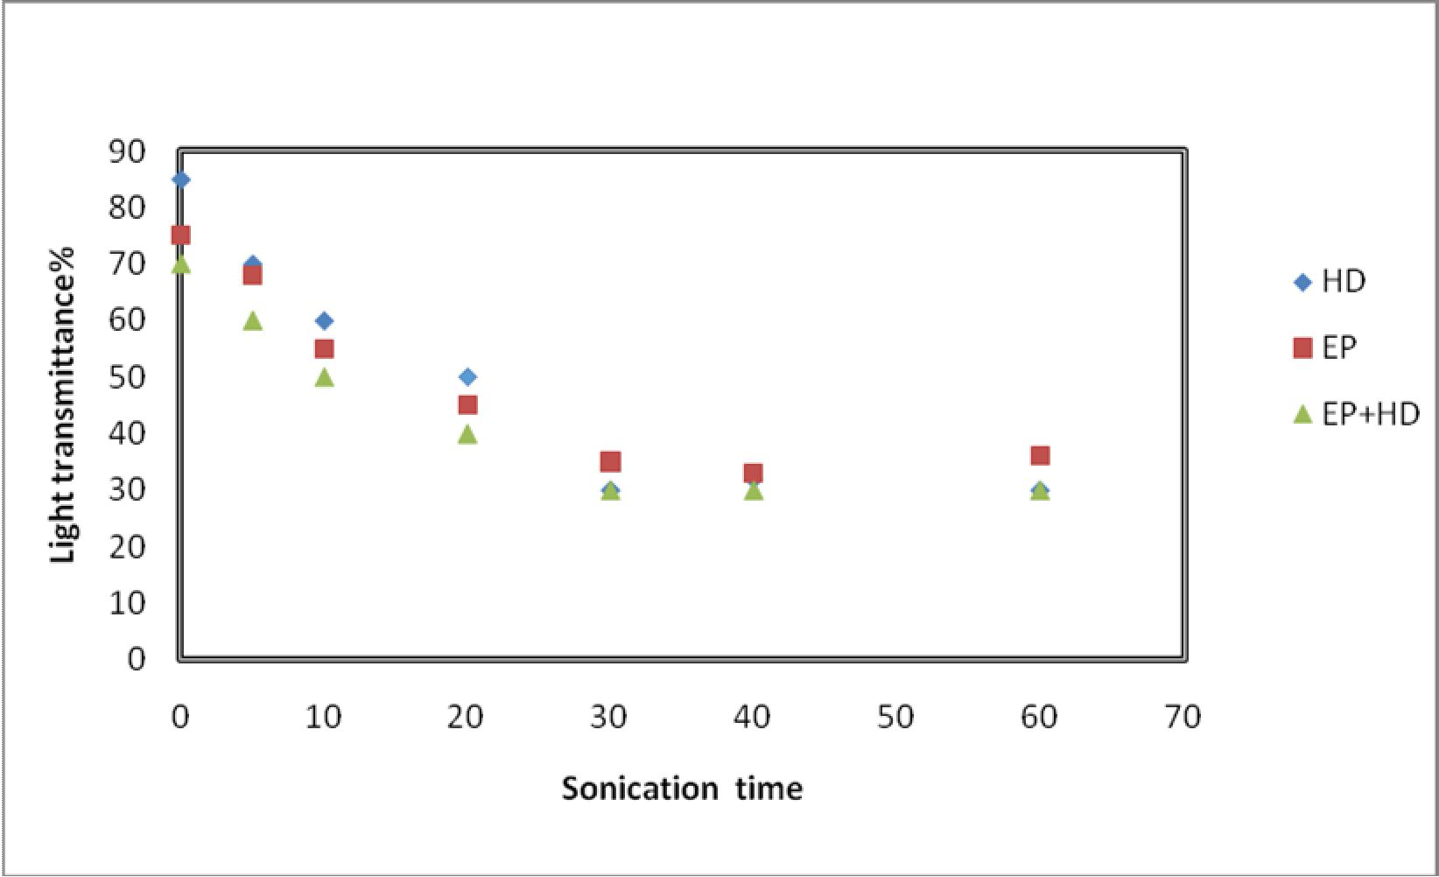

Light transmittance of graphene dispersion against sonication time (graphene concentration: 0.5 wt%).

The curing of epoxy resin mixed with hardener showed non uniform dispersion with lower transmittance. The resin started to cure immediately after mixing liquid resin with hardener. The limited time for graphene dispersion lead to gelling and curing process. The uniformly dispersion of graphene was not depend on. limited time Therefore, it is desirable select epoxy resin with longer curing time for preparing epoxy/graphene nanocomposites.
The light transmittance decreased with the decrease of agglomerate/flake size at low concentration. Figure 2 shows the measured light transmittance against concentration. The light transmittance decreased with increase of concentration
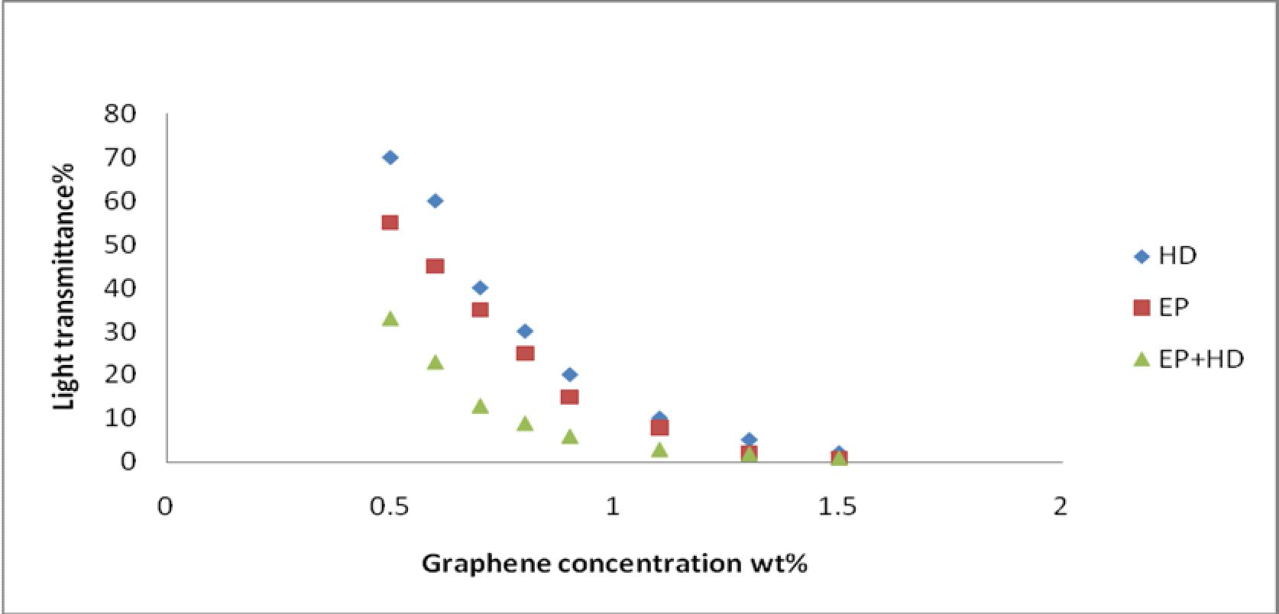
Conclusion
The dispersion of graphene in matrix depends on reaggregation, with the passage of time, for the performance of nanocomposites. The dispersion of graphene significantly contribute to temperature and viscosity. The 0.5 wt% of graphene disperse easily at high temperature in epoxy graphene nanocomposites yielded lower reaggregation profile (size and trend).

Acknowledgement & Conflict of interest
The authors have no conflicts of interest to declare. All co-authors have seen and agree with the contents of the manuscript and there is no financial interest to report. We certify that the submission is original work and is not under review at any other publication

References

[1]. J. Jia, X. Sun, X. Lin, X. Shen, Y.-W. Mai, and J.-K. Kim, “Exceptional electrical conductivity and fracture resistance of 3D interconnected graphene foam/epoxy composites,” ACS Nano, vol. 8, no. 6, pp. 5774–5783.
[2]. Zhu Y., Murali S., Cai W. “Graphene and graphene oxide: synthesis, properties, and applications,” Advanced Materials, vol. 22, no. 35, pp. 3906–3924.
[3]. Hamilton C. E., Lomeda. R., Z. Sun, J. Tour M., and Barron A. R., “High-yield organic dispersions of unfunctionalized graphene,” Nano Letters, vol. 9, no. 10, pp. 3460–3462.
[4]. Zu S.-Z., Zhou D., and Han.-H., “Supramolecular surface modification and dispersion of graphene in water and organic solvents,” Journal of Nanoscience and Nanotechnology, vol. 13, no. 2, pp. 946–953,
[5]. Choi E.-Y., Choi W. S., Lee Y. B., and Noh Y.-Y., “Production of graphene by exfoliation of graphite in a volatile organic solvent,” Nanotechnology, vol. 22, no. 36, Article ID 365601,
[6]. Wang X., Jin,J. and Song M., “An investigation of the mechanism of graphene toughening epoxy,” Carbon, vol. 65, pp. 324–333,
[7]. Li, R Z.. Wang, R. Young J.., “Control of the functionality of graphene oxide for its application in epoxy nanocomposites,” Polymer, vol. 54, no. 23, pp. 6437–6446.
[8]. Liu S., Yan H., Fang Z, and Wang H, “Effect of graphene nanosheets on morphology, thermal stability and flame retardancy of epoxy resin,” Composites Science and Technology, vol. 90, pp. 40–47,.
[9]. Zaman, Kuan H.-C., Meng Q.., “A facile approach to chemically modified graphene and its polymer nanocomposites,” Advanced Functional Materials, vol. 22, no. 13, pp. 2735–2743,
[10]. Meng Q., Jin J., Wang R. “Processable 3-nm thick graphene platelets of high electrical conductivity and their epoxy composites,” Nanotechnology, vol. 25, no. 12, Article ID 125707,
[11]. Chen L., Chai S., Liu K.., “Enhanced epoxy/silica composites mechanical properties by introducing graphene oxide to the interface,” ACS Applied Materials and Interfaces, vol. 4, no. 8, pp. 4398–4404, 2012.
[12]. Zhang Y., Wang Y., Yu J., Chen L., Zhu J., and Hu Z., “Tuning the interface of graphene platelets/epoxy composites by the covalent grafting of polybenzimidazole,” Polymer, vol. 55, no. 19, pp. 4990–5000, 2014.
[13]. Liu F. x, Zhu G., Ren P., Wang Y., and Cui, X. “In situ polymerization of graphene oxide and cyanate ester- epoxy with enhanced mechanical and thermal properties,” Applied Surface Science, vol. 316, no. 1, pp. 549–557, 2014.
[14]. Song S. H., . Park K. Kim H, B. “Enhanced thermal conductivity of epoxy-graphene composites by using non- oxidized graphene flakes with non-covalent functionalization,” Advanced Materials, vol. 25, no. 5, pp. 732–737,. [15]. Hu, D. Kulkarni,D. Choi I., and Tsukruk V. V., “Graphene-polymer nanocomposites for structural andfunctional applications,” Progress in Polymer Science, vol. 39, no. 11, pp. 1934–1972,
[16]. V. Mittal, “Functional polymer nanocomposites with graphene: a review,” Macromolecular Materials and Engineering, vol. 299, no. 8, pp. 906–931, 2014
.

