Hepatoprotective Activity of Aqueous Extract of Sphaeranthus Indicus Against Paracetamol Induced Hepatotoxicity in Rats
*R. Gowri
Faculty of Pharmacy, M. S. Ramaiah University of Applied Sciences, Bangalore 560 054
*Contact Author e-mail: gowrijp@gmail.com

Abstract
From ancient time, medicinal plants are used as source of medicine to treat several diseases. Several Ayurvedic drugs and its formulations are traditionally used to treat several liver diseases. One such important Ayurvedic drug is Munditika or Mundi which has been used to treat various diseases like jaundice, fever, epilepsy, gastric disorders and painful swellings. The accepted source of Munditika is Sphaeranthus indicus Linn. In the present study aqueous extract of whole plant of Sphaeranthus indicus was evaluated for hepatoprotective activity against paracetamol induced hepatotoxicity in rats. Liver toxicity was induced by administration of Paracetamol orally at a dose of 2 g/kg. Protective effect of the extract was assessed by measuring the levels of serum enzymes like SGOT, SGPT, ALP, total protein and total bilirubin. Results of our study showed that administration of aqueous extract of whole plant of Sphaeranthus indicus at 400 mg/kg b.wt showed significant (***P < 0.001) reduction in elevated serum enzyme levels compared to paracetamol induced toxic group, indicating the protective role of Sphaeranthus indicus extract against Paracetamol induced liver toxicity.
Key Words: Sphaeranthus Indicus, Paracetamol, Hepatotoxicity, In Vivo Model

INTRODUCTION
Oxygen derived free radicals plays a major role in the pathogenesis of several degenerative diseases like cancer, diabetes, arthritis, ageing, ischemia, diabetes, parkinson’s syndrome and liver disorders [1]. Reactive oxygen species (ROS) includes superoxide anion (O₂), hydroxyl (OH), hydroperoxyl (OOH), perxyl (ROO), alkoxyl (RO) radicals andReactive nitrogen species (RNS) includes Nitric oxide (NO₂), peroxynitrite (N00⁻), nitrogen dioxide (NO₂). Antioxidants are capable of scavenging these free radicals and preventing the cell from cell damage and peroxidation. Antioxidants are categorized as enzymatic antioxidants and non- enzymatic antioxidants. Several enzymatic antioxidants like Superoxide dismutase, Catalase, Glutathione peroxidase are produced endogenously in the body and several non enzymatic antioxidants are present in several natural sources and include Vitamin – c, Vitamin – E, flavonoids, tannins and carotenoids [2]. Synthetic antioxidants like BHT, TBHQ and BHA are effective but are carcinogenic. Phenolic compounds in traditional medicinal plants have been reported to have several biological activities, including free radical scavenging activity [3]. Currently natural antioxidants are gaining much importance because of their less toxic nature. Hence there is a need to identify and develop natural antioxidants from plant sources to replace synthetic antioxidants for long term safety.
Sphaeranthus indicus Linn is a spreading aromatic herb distributed throughout India especially in plains in damp situation [4]. The plant is extensively used in the treatment of several diseases in both Ayurvedic and Siddha systems of medicine [4,5]. The plant has been reported to contain C- glycoside, 5 - hydroxyl-7-methoxy-6-C-glycosyl flavone (aerial part) [6], sesquiterpene glycoside (Sphaerantholide –
flower) [7], two eudesmanolides namely 7α-
hydroxyeudesmanolide 1 and 2 and two sesquiterpenoids, cryptomeridiol & 4-epicryptomeridiol (whole plant) [8]. Based on the earlier literature on flavonoid content the present study has been proposed to investigate the hepatoprotective activity of whole plant of Sphaeranthus indicus against paracetamol induced liver toxicity.

MATERIALS AND METHODS
  - Collection of Plant Material and Preparation of Aqueous Extract
The whole plant of Sphaeranthus indicus in flowering condition was collected from Chermadevi (paddy fields) region of Tirunelveli district; Tamilnadu in January 2011. The collected plant material was identified and authenticated by Dr. S. N. Yoghanarasimhan, Taxonomist and Research coordinator, M. S. Ramaiah College of Pharmacy, Bangalore. Taxonomic identification was carried out using available literature [9]. A voucher herbarium specimen (No. 043) has been deposited in the Department of Pharmacognosy, M. S. Ramaiah College of pharmacy, Bangalore along with the crude drug specimen. The plant material was thoroughly washed with water to remove the adhering dirt and sandy material, cut into small pieces, shade dried and powdered. Coarse powder was extracted with chloroform water by maceration technique [10, 11]. The extract was filtered and concentrated under reduced pressure by using rotary evaporator. The extract obtained was dark brown colored solid mass with yield of
9.43 % w/w.

Preliminary Phytochemical Screening
The aqueous extract was screened for the presence of various phytoconstituents by adopting standard procedures [10-12].

Animals
Healthy Wistar rats of either sex weighing 170 – 200 g were used for the study. The animals were bred and maintained in the animal house of M. S. Ramaiah College of Pharmacy. Animal house was well maintained under standard laboratory conditions, at room temperature and humidity (60 ± 10%) with 12 h day and night cycle. The animals were provided with standard pellet diet and water ad libitum. The study protocol was approved by the Institutional Animal Ethical Committee (IAEC approval No. MSRCP/P-10/2010).

Acute Toxicity Studies
Acute toxicity study was conducted according to OECD
423 guidelines [13]. Overnight fasted animals were administered a single dose up to the highest dose of 2000mg/kg body weight and observed for any behavioral and neurological changes for first 2 hrs and for any toxic symptoms or mortality for further 14 days.

Assessment of Hepatoprotective activity
Liver damage was induced by administration of Paracetamol orally at the dose of 2 g/kg b.wt [14]. The animals were divided in to 5 groups of 6 animals each. All the treated groups were administered with Paracetamol (2g/kg b.wt. p.o) on 2nd and 3rd day. Group I was considered as normal control and administered 10% Tween
80 (1ml/kg b.w.,p.o) once daily for 5 d. Group II was served as positive control and administered with 10% Tween 80 (1ml/kg b.wt., p.o) for 5 days and Group III was administered with Silymarin (100mg/kg b.wt. p.o) once daily for 5 days. Group IV and V were administered aqueous extract of S. indicus respectively at a dose of 200 & 400 mg/kg, once daily for 5 days. 18 hrs after last treatment, all the animals were anaesthetized with ether anaesthesia for collection of blood from retro-orbital plexus.

Estimation of Biochemical Parameters
The blood was collected from the retro-orbital plexus and the serum was separated by centrifugation at 10,000 rpm for 15 min .The serum was analysed for biochemical parameters like Serum Glutamate oxaloacetate Transaminase (SGOT), Serum Glutamate Pyruvate Transaminase (SGPT),Serum Alkaline Phosphatase (ALP),Serum Total biluribin (TB),total cholesterol and triglycerides by diagnostic kits obtained from Agappe Diagnostic Ltd, Kerala, using autoanalyser (Semi- automatic B4B® ,Analyzer CA-2005).The animals were sacrificed by excess of ether anaesthesia; entire liver was carefully removed and washed with ice cold saline solution. A portion of liver was preserved in 10% neutral formalin for histopathological studies.

Statistical Analysis
Data’s are analyzed by using One Way ANOVA followed by Tukey-Kramer Multiple comparison test. The results are expressed as Mean ± S.E.M. P < 0.001 was considered statistically significant.

RESULTS AND DISCUSSION
The preliminary phytochemical studies confirmed the presence of carbohydrates, Phenolic compounds like tannins & flavonoids, saponins and proteins. Hepatotoxicity was induced by administering paracetamol (2 g/kg). Paracetamol, a widely used analgesic and antipyretic drug, produces acute liver damage at higher doses. Acute paracetamol poisoning is one of the common causes of liver failure in many developed countries [15]. Overdose of Paracetamol causes centrilobular hepatic necrosis which can be fatal. In overdoses, Paracetamol was metabolically activated by Cytochrome P450 enzymes to a reactive metabolite N-acetyl-p-benzo-quinoneimine (NAPQI) that depletes glutathione (GSH). NAPQ1 covalently binds to cellular macromolecules and initiates cell damage [16]. Hepatic cellular damage may result in leakage of enzymes like Serum Glutamate oxaloacetate Transaminase (SGOT), Serum Glutamate Pyruvate Transaminase (SGPT), Serum Alkaline Phosphatase (ALP), which can be measured as indicators of cell damage. Their levels are markedly elevated in hepatitis and other acute liver damage. SGPT level is most commonly used to determine hepatic damage than SGOT [17].
The hepatoprotective activity of aqueous extract of Sphaeranthus indicus at doses 200 and 400 mg/kg were assessed by measuring the level of various liver biochemical parameters like SGOT, SGPT, ALP, TP and TB. Elevated level of SGOT, SGPT, ALP, TC and TG in animals treated with paracetamol is indicative of severe liver necrosis. However treatment with standard drug Silymarin and aqueous extract of Sphaeranthus indicus has significantly decreased the serum enzyme levels indicating the protective effect of Sphaeranthus indicus extract against hepatotoxicity. In our study, animals treated with Silymarin (100mg/kg) and 400 mg/kg of aqueous extract of Sphaeranthus indicus significantly reduced the elevated levels of SGOT, SGPT, ALP (***P < 0.001), when compared with the intoxicated group. However, aqueous extract at dose of 200mg/kg does not show significant reduction of serum enzymes (Table 1 & 2).
Histopathalogical profile of liver of control animals showed normal liver architecture (Fig.1.1), whereas the liver section of animals treated with paracetamol showed distorted liver architecture with more hepatocytes showing degenerative changes and necrosis (Fig.1.2). The liver section of animals treated with aqueous extract showed normal hepatocytes and absence of necrosis (Fig 1.3, 1.4). The above reports confirmed the hepatoprotective effect of whole plant of Sphaeranthus indicus in paracetamol induced hepatotoxicity in rats.

CONCLUSION
The result of the present study clearly indicates that the aqueous extract of Sphaeranthus indicus whole plant possesses potent hepatoprotective activity against paracetamol induced hepatotoxicity, which claims its traditional use as a hepatoprotective agent.

ACKNOWLEDGEMENT
The authors are thankful to Dr. V. Chelladurai for helping in the collection of authentic sample material and also to Gokula Education Foundation, Bangalore for providing facilities to carry out the research work.

REFERENCES

- Cross C.E., (1987) Oxygen radicals and human disease, Annals of International Medicine, 107, pp. 526.
- Ye-Shih Ho, Jean-Luc Magnenat, Mary Gargano, Jin Cao, (1998) The Nature of Antioxidant Defence Mechanisms: A Lesson from Transgenic studies, Environmental Health Perspectives, 106(5), pp. 1219- 1228.
- Mangathayaru K., Sravan K, (2007) In vitro antioxidant studies of the aerial parts of Origanum majoram Linn and Artemesia sieversiana Ehrh, Pharmacognosy Magazine, 3(10),pp. 90-94.
- Yoganarasimhan S.N., (2000) Medicinal plants of India (Tamilnadu) - Vol II, Interline publishing private Ltd, Bangalore.
- Sharma P.C., (2002) Database on medicinal plants used in Ayurveda- V-5, Central council for Research in Ayurveda and Siddha, pp. 251-259.
- Bhuwan B., Yadav S.B., Rakesh K., Tripathi V., (2007) A Novel Flavanoid C-glycoside from Sphaeranthus indicus L.(Family Compositae), Molecules, 12, pp. 2288-2291.
- Shekhani M.S., Muazzam shah P., (1990) An immunostimulant sesquiterpene Glycoside from Sphaeranthus indicus, Phytochemistry, 29(8), pp. 2573-2576.
- Supada R.R., Bhimsen A.N., (1992) 7- HydroxyEudesmanolides from Sphaeranthus indicus, Phytochemistry, 31(9), pp. 3270-3271.
- Gamble J.S., (1921) Flora of the Presidency of Madras, Bishen Singh Mahendra Pal Singh, Vol.II, Dehra Dun, pp. 691.
- Kokate C.K., (1999) Practical Pharmacognosy, Vallabh Prakashan, New Delhi, pp. 107-121.
- Harborne J.B., (1998) Phytochemical Methods, 3rd Edition, Chapman and Hall, London.
- Raaman N., (2006) Phytochemical Techniques, New India Publishing Agency, New Delhi.
- OECD/OCDE, OECD guidelines for testing of Chemical-423, 17 Dec. 2001.
- Nirmala M., Girija K., Lakshman K., Divya T., (2012) Hepatoprotetive activity of Musa paradisica on experimental animal models, Asian Pacific Journal of Tropical Biomedicine, 2(1), pp. 19-24.
- Litovitz T.L., Klein-Schwartz W., Rodgers G.C Jr., Cobaugh D.J., Youniss J., Omslaer J.C., May M.E., Woolf A.D., Benson B.E., (2002) 2001 annual report of the American Association of Poison Control Centers Toxic Exposure Surveillance System, American Journal of Emergency Medicine, 20, pp. 391–452.
- Vermeulen N.P.E., Bessems J.G.M., Van de straat R., (1992) Molecular aspect of paracetamol-induced hepatotoxicity and its mechanism based prevention, Drug Metabolism Review, 24, pp. 24: 367.
- Sharida Fakurazi, Syazana Akmal Sharifudin, Palanisamy Arulselvan, (2012) Moringa oleifera Hydroethanolic Extracts Effectively Alleviate Acetaminophen-Induced Hepatotoxicity in Experimental Rats through Their Antioxidant Nature, Molecules, 17, pp. 8334-8350.

Table 1. Effect of aqueous extract of Sphaeranthus indicus on biochemical parameters in paracetamol induced hepatotoxicity in rats

Groups | SGOT(U/L) | SGPT(U/L) | ALP(U/L) | TP(g/dl)
Normal group | 71.61 ± 5.43 | 35.49 ± 9.96 | 32.56 ± 1.43 | 6.78 ± 0.87
Paracetamol intoxicated | 365.63 ± 29.18 | 125.80 ± 20.93 | 100.42 ± 0.09 | 3.08 ± 0.03
Standard group | 112.21 ± 4.23 *** | 56.85 ± 1.56*** | 39.87 ± 0.18 | 6.18± 0.19***
Aqueous extract ( 200 mg/kg) | 343.37 ± 3.86 | 112.34 ± 17.16 | 76.26 ± 1.71 | 3.45 ± 0.06
Aqueous extract ( 400 mg/kg) | 303.44 ± 13.00*** | 80.43 ± 2.50*** | 69.80 ± 3.24 | 4.23± 0.08***

All values are expressed as mean ± SEM, One way Anova followed by Tukey Kramer multiple comparison test (n = 6). The significance on comparison with control group. ***P < 0.001

Table 2. Effect of aqueous extract of Sphaeranthus indicus on serum levels of Total Bilirubin, TC and TG in paracetamol intoxicated rats

Groups | Total Bilirubin  (mg/dl) | TC (mg/dL) | TG (mg/dL)
Normal group | 0.172 ± 0.002 | 82.06 ±28.53 | 112.2 ± 34.27
Paracetamol intoxicated group | 1.234 ± 0.08 | 318.57 ± 25.35 | 248.35 ± 61.42
Standard group | 0.321 ± 0.032*** | 183.43 ± 5.023*** | 159.07 ± 5.206***
Aqueous extract (200mg/kg) | 1.100 ± 0.176 | 290.95 ± 7.57 | 225.50 ± 2.871
Aqueous extract (400mg/kg) | 0.998 ± 0.156 | 250.14 ± 0.702*** | 215.33 ± 7.17

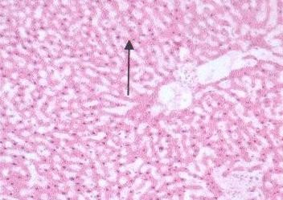
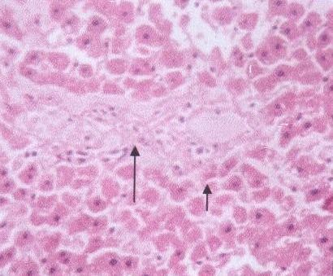
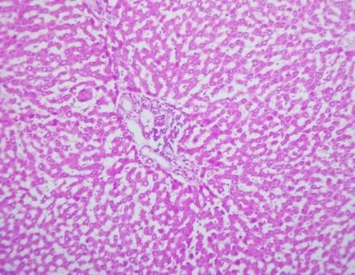
All values are expressed as mean ± SEM, One way Anova followed by Tukey Kramer multiple comparison test (n = 6). The significance on comparison with control group. ***P < 0.001

Fig. 1.1 Normal ( x 100) |  | Fig.1.2 Positive control ( x100)
 |  | 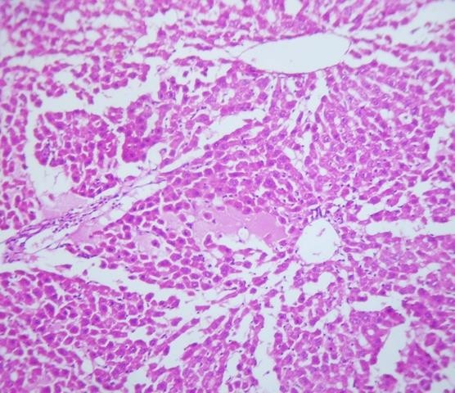
Fig.1.3.S. indicus aqueous extract 400  mg/kg ( x 100) |  | Fig.1.4 S. indicus aqueous extract  200 mg/kg ( x 100)

Fig. 1 Histopathalogical photomicrographs of liver in Paracetamol induced hepatotoxicity

