An Account of Millets: Past, Present and Future
Dr. Ilsa Thakur¹, Dr. Chandni Gupta², Prof. Rashmi Srivastava³, Prof Navneet Sharma⁴, Prof. Ashwani Upadhyaya⁵
¹PG Scholar,² Sr. Lecturer,^{3,4,5}Professor
PG Department of Dravyaguna
Rajiv Gandhi Government Post Graduate Ayurvedic College and Hospital, Paprola, Teh. Baijnath, Distt. Kangra, Himachal Pradesh 176115
ABSTRACT
Cereals are the backbone of present day human diet. India is the world’s second largest producer of major cereals like rice, wheat etc; yet the rank of India in Global Hunger Index 2023 is 107th out of 121 countries; published jointly by Welthungerhilfe and Concern Worldwide since 2006. Millets have been used as food as well as a therapeutic diet in Ayurveda. Since Samhita kala. Millets can be used as a preventive as well as a curative diet in Ayurveda, hence fulfill the main goal of Ayurveda of prevention first then cure. Millets have been staple diet in human history, but over past three decades the consumption of millets as direct food has declined significantly. Hence to revive the demand of millets globally and to decrease the burden on other cereals, the year 2023 has been declared as The International Year of Millet by UNGA. Millets possess an infinite properties because of which Millets are termed as ‘yesterday coarse grains’ and today’s ‘nutri-cereals’^{[1]}. Millets are considered to be ‘future crops’; whose past must be known. Hence, present paper is an attempt to focus on the futuristic trends in Medical sciences on special emphasis to millets. The paper will throw a light on the literary sources of millets in Ayurveda in a chronological order, their properties and uses mentioned in different text along with their use in recent scenario.
KEYWORDS Millets, Kudhanya, Ayurveda, Medoroga, Dhanyavarga, UNGA
INTRODUCTION
India is a country with diverse geographical distribution. From the land of Himalayas, to plain area of Punjab, from plateaus of Telangana to coastal areas of Eastern and Western Ghats, India possess a different land topography with different types of crops and vegetables grown. As in past few years world had faced many problems like climate change, Covid pandemic, food insecurity etc. Millets are emerging as a ray of hope in the society to curb all the problems.
Millets are one of the oldest crops that have been cultivated thousands of years in different parts of the worlds. In Himachal Pradesh, millets are grown in various areas like Finger millet (Ragi) grown in Kullu, Mandi, Kangra and Sirmour districts , Foxtail millet (Kangni) largely grown in Kangra district., Proso millet (Cheenak) is traditional food and food habits in the Gaddi shepherd family of Chamba^{[2]}.
Millets are referred as coarse cereals, external texture which is not smooth. Millets are referred as smart food and are highly nutritious. Millets are rich source of protein, dietary fiber, iron and calcium content. Apart from high nutritious quality millets are turning out to be the global game of attaining sustainable development goals. From sustainable development point of view, millets contribute in curbing the consequences of climate changes, food insecurity, poverty and malnutrition. Millets are climate-resilient crops that can grow with less water and chemical inputs. Millets requires relatively less investments, low quality soils, resource and time than other crops. They can grow even in adverse conditions and are resistant to most of the pest and diseases. So millets can help ensuring economic growth of the farmers and society. Furthermore, millets require fewer resources to grow they can help reduce green house gas emissions and combat climate changes^{[3]}.
After the wave of Covid-19 man has brought significant changes in his lifestyle. However change in eating and dietary habits is one of them. As millets acts as immune modulator , helps prevent the infection and have anti-oxidant properties, the popularity and dietary benefits of millets have been increasing day by day. Millets are powerhouse of nutrients also called as neutri-cereals. Millets have low glycemic index thus have lesser impact on blood glucose level and have good defence in fight against diabetes. Apart from this millets are considered as high energy yielding nourishing food which helps in malnutrition.
As the world is moving towards civilization and advancement, the challenges faced by the society has also been increasing. India is emerging as a superpower since last decade yet the human development index of the country is very poor. India ranks second in child malnutrition incidences, with one third of malnourished children globally being Indian ^{[1].} So there is need to promote the nutritional benefits of millet. To raise the awareness about the benefits and production of millets, 2023 has been declared as international year of millets by UNGA(United Nations General Assembly). Various seminars, workshop and cultural program being held all over the India to showcase the diversity of millets and to create awareness and increase production. India had notified millet as a nutritious cereal in April 2018 and has also been included under the Poshan Mission campaign^{[4]}.
MATERIAL AND METHODS
The current topic was selected based on a literature survey. The literature review was carried out using different Ayurveda texts mainly Nighantus, Charak Samhita, Sushrut Samhita, Ashtaang Hridya, Dravyaguna vigyana Vol III of PV Sharma and databases such as PubMed and Google Scholar as search engines.
MILLETS DESCRIBED IN NIGHANTUS -
Millets are described in Dhanya varg in different Nighantus of Ayurveda text.
DHANWANTARI NIGHANTU (Suwarnadi varga- Dhanyani)^{[5]}
Table 1
S.No | Millets | Synonyms | Properties
1 | Kodrav | Kordush,Udalak,Vankodrav | Sheet virya, grahi, vish-pitta-kaphahar
2 | Niwaara | Taapas, Munibhakat, Prasadak, Arnaydhanya, Rasik | Madhur, Snigdh, Pavitra, Pathya, Laghu
3 | Shayamaka | Trinbeej, Munibhakshay, Gopriy, Sukumar, Raajdhanya, Trinbeejotay | Madhur, kashaye, Snigdh, Laghu, Sheet virya,Vaatvardhak, Kapha-pitta har, Sangrahi, Vishvikaar nashak
4 | Priyangu | Kanguni, Tanguni, Kanguk, Cheenak, Pittandul, Asthisambhandhan, Kanghuni | Madhur, Ruchikarak, Kashayemadhur, Sheet, Vaatvardhak, Pittghan, Dahhar, Bhaganasthibhandhankrit
5 | Yava | JOO, Akshat, Tikshanshuk | Ruksh, Sheet, Guru, Madhur, Sarak, Purishjanan, Vaatvardhak, Shukarjanan, Sathirtakarak, Sathairykar, Mutra-med-pitta-kaphajayet, peenas-swaas-kaas-twagaamyan
6 | Jurna | Jurnah, Yonal, Yaavnaal, Yugandhar | Kapha-pitta har, Shukarvardhak, Mridu, Guru, Shittavirya, Ruksha, Vishtabhi, Apathaya for Guda vikaar.

SODHALA NIGHANTU ^{[6]}
Table 2
S.No | Millets | Properties
1 | Kangu | Ruksha, Hiima, Swaadu, Kashaye, Brihana, Guru, Vaatla, Kapha-pittaghan, Sandhanya, Alapmutarvitt
2 | Kodrav | Badhvinmutar, Vaatla, Lekhan, Laghu, Kashaye, Viashmardi, Pitta-kaphahar, Raktpittashamak, Saparsh sheet, Grahi, Madhur, Ruksha, Sheetal
3 | Uddalaka | Virya ushan, Lekhan, Vaatal, Laghu, Ruksha, Swaadu, Kashaye, Kaphajit, Badhamutravit
4 | Nivara | Shaleshmal, Ruksha, Kashaye, Vaat, Hiim, Lekhan, Badhavinmutar, Swaadu, Pitthar , Laghu
5 | Madhuli | Kapha-pittaghani, Snigdha, Vrishay, Sheetal, Kashaye, Laghu, Swalpmutara, Badhvitt
6 | Shyamaka | Kapha-pittahar, Ruksha, Kashaye, Madhur, Sheet, Vatal, Badhvinnmutar, Laghu, Lekhanatamak
7 | Nandimukhi | Hiim, Swadu, Pathaye, Laghu, Kashaye

MADANPAAL NIGHANTU (Dhanyaadi Varga) ^{[7]}
Describes millets under TRINDHANYAS – Kangu, Shayamak, Niwar, Udaal, Nartak, Vartika, Todparni, Kodrav, Madhulika, Nabdimukhi, Venuyav, Priyangu, Kordush, Gavedhuk, Nal, Naali, Mukunduka, Varika.
Properties of TRINDHANYAS- Laghu, Swaadu, Katupaaka, Vilekhana, Ruksha, Ushna, Malavrodhak, Vaat-pittaprakopaka
Table 3.
S.no. | Millets | Synonyms | Properties
1 | Yava | Shuchi, Tikshanshuk, Nishuk, Atiyav | Kashay,Madhura,Ruksha,Shiat,Pitta-kapha Shamaka, Raktvikara Shamaka  Pathya in vrana just like Tila.  Budhivardhaka, Agnivardhaka, Lekhna, Malavrodhaka, Swarshodhaka, Prameha, Pippasaniwarka  Vaatkaraka, Malvardhaka, Sathirta and Varnkaraka, Picchilla.
2 | Nishpava | Raajshimbi | Pitta-rakta, Mutra and Dhugdhutpadak.  Rechaka, Daahkaraka, Ushna, Guru, Shleshma shopha and Shukrnashaka,
3 | Kanguni | Types-Pittandulika, Kangu, Priyangu,  Karkati, Sitkangu, Musti, Raktkangu, Sothika, Cheenak, Kaakkangu, Shayamaka, Shankanguk, Shaali. | Pitta-shamak, Dhatuposhaka, Bhagansandhanaka, Guru.
4 | Kodrav | Kodo, Kuras, Kodrush, Udaal, Vankodrav | Sheetal, Malavrodhaka, Vishghana, Kapha-pittashamaka.
5 | Niwaar (tinni) | Uttika, Naadi, Munibrihi, Munipriya. | Sheetal, Malbandhak, Pitta Shamaka, Kapha-vata karaka.
6 | Yaavnaal (jwaar, jondhari) | Devdhanya, Juholi, Juhala, Anala | Suswadu, Sheetala, Vaayukaraka, Kapha-pita Nashaka.
7 | Gawedhuka | Karshni, Gojihwa, Aakarshni | Katu, Swaadvi, Krishtanashaka, Kapha Nashaka.

KAEYDEV NIGHANTU ( Dhanyavarga) ^{[8]}
Table 4.
S.No | Millets | Synonyms | Properties
1 | Yava | Sitshuk,Tikshnshuk, Vaajipriya, Shuchi.  Yav without Shuk is known as Atiyav and green Yava is Tokam | Madhur, Kashaye, Ruksha, Balkarak, Vrishya, Shiitvirya, Guru, Mridhu, Varnakarak, Anabhishyandi, Katu Vipaka, Swara- agnideepana, Vranaropaka, Badhmutr, Picchill,Medhya, Vaatmal Evum Sathairyekarak, Vilekhana, Prameha, Trishna, Vaata, Pinasa, Swasa, Kasa, Urusthambha, Kushtha, Charmarog hara.
2 | Priyangu | Pittandulika, Kangu, Durjra. | Bhagan-asthi sandhankrit, Vaatkaraka, Brihana, Guru.  Kanguni is of 4 types- Krishna, Rakta, Shweta, Pitta. Pitta Kanguni is best, Ruksha and Kaphanashaka.
3 | Chinaakprbhitaye | Kaakkangu, Shayamaka, Trinbeejka, Kodrava, Kordusha, Udaalaka, Vankodrava. | Pittnashaka, Sheetala, Vishghana
4 | Nartaka | Malinjaka, Nrityakunda, Nartaka, Nartkundaka | Pittnashaka, Shita- virya.
5 | Niwara | Uddhika, Uddi, Munipriya, Vanbrihi | Same as Nartaka mainly Kapha vardhak.
6 | Yavnaala | Devdhanya, Jurnah, Tuhal, Anila, Taaniyaka, Jurnvika, Tinika, Janhuli. | Madhur, Ruksha, Raktpita-kapha Nashaka, Avrishya, Laghu, Shitvirya Kleda Nashaka, Vaatkaraka
7 | Gavedhuka | Gojihwa, Vaarshika, Karshni | Katu Madhura, Krishtakarak and Kaphanashaka

PRIYA NIGHANTU- ( Dhanyavarga)^{[9]}
Table 5.
S.no | Millets | Properties
1 | Yava | Kashya- madhur, Ruksha, Lekhan, Malprabhutaam, Kaphaja Roga, Prameha, Medhoroghara
2 | Madhulika | Somewhat Madhura, Kashaye-tikta, Laghu, Sheetvirya, Ruksha, Vatvardhaka, Pittta-shamaka.  Jala awashoshni, Ashmari bhedana
3 | Kanghu (kaghuni) | Atiruksha, Guru, Vaatvardhaka, Bhagansandhankara.  Its seeds resemble fruit of Gandhpriyangu that’s why called as Priyangu.
4 | Chinaaka (chiina) | One of Kshudra dhanya.  Properties same as Kanghu.
5 | Shayamaka (sawa) | Ati- ruksha, Shita Virya, Dhatu Shoshaka, vata Vardhaka, Kapha-pitta Shamaka
6 | Kodrav (kodo) | Shiit virya, Ruksha, Vata-vardhaka, Vibhandha karaka, Kapha-pitta Shamaka.
7 | Gavedhuk (gavedhua) | Madhur-katu, Ruksha, Vata-vardhaka, Kapha-shamaka.  Indriyahara, Krishtakaraka.
8 | Niwar (teni) | Grahi, Shita Virya, Laghu,  Grahni and Pramehroghara
9 | Yaavnaal (jwara) | Madhur-kshaye, Shita virya, Ruksha, Shukarnashaka, Jalshoshaka, Vata vardhaka.
10 | Vajaranna(baajda) | Madhur , Ruksha, Ushna Virya.  Dushpachya, Balya, Punshtavnashaka, Kaphahar, vata-pitta Karaka.

MILLETS DESCRIBED IN BRIHATTRAIYE-
Acharya Charaka described Millets under Shookadhanya Varga ^{[10]}
Table 6.
Kordusha | Gavedhuka | Mukunduka | Shivira
Shyamaka | Prashantika | Jhinti, | Utkata
Hastishyamaka | Ambha-shyama | Garguti, | Jurnaha
Neewra | Lohitaanu | Varuka | Yava
Toyaparni | Priyangu | Varaka, | Venuyava

Acharya Shushruta mentioned Millets under Kudhanya Varga ^{[11]}
Table 7.
Kordusha | Udalaka | Gavedhuka
Shyamaka | Priyangu | Varuka
Neewara | Madhulika | Todyaparni
Shantanu | Nandimukhi | Mukunduka
Varaka | Kuruvinda | Venuyava

Acharya Vagbhata has described Millets under Trindhanya which are following^{[12]}
Table 8.
Kangu | Shyamaka
Kodrav | Priyangu
Neewara | Joo

MILLETS DESCRIBED IN PV SHARMA ^{[13]}
Table 9.
Millets | Botanical name | Family | Rasa | Guna | Virya | Karma
Kodrav  (Kodo Millet) | Paspalum scrobiculatum  Linn. | Poaceae | Kashaya  Madhura | Laghu  Ruksha | Shita | Vaatvardhaka  Kapha-pitta Shamaka
Shayamaka  (Barnyard Millet) | Echinochloa frumentacea  Linn. | Poaceae | Kashaya  Madhura | Laghu  Ruksha | Shita | Vaatvarshaka  Kapha-pitta  Shamaka
Kangu  (Itallian millet) (Foxtail millet) | Setaria italic  Linn.Beauv | Poaceae |  | Guru  Ruksha |  | Vaat-kapha Nashaka,  Brihana,  Bhagansandhankaraka,  Beneficially for cattles
Cheenaka  (Common millet) | Panicum miliaceum  Linn. | Poaceae |  | Guru  Ruksha |  | Vaat-kapha  Nashaka, Brihana
Jurna  (Great millet) | Sorghum vulgare Pers. | Poaceae | Kashaya  Madhura | Laghu  Ruksha | Shita | Kapha-pitta Shamaka,  Shukaranashaka, Kaledhara
Madhulika  (Finger millet) | Eleusine coracana Linn | Poaceae | Kashaya  Tikata  Madhura | Laghu  Shita |  | Tridoshshamak, Mainly Pittashamak, Triptikarak
Vajaranna  (Pearl millet) | Pennisetum typhoides  Burm.f.Stapf.&Habbard | Poaceae | Madhura | Ruksha | Ushana | Kapha-vata nashaka,Balya, Punstavhar,  Durjara
Yava  (Barley) | Hordeum vulgare | Poaceae | Madhura  Kahaya | Ruksha  Ishat Guru |  | Kaphashamaka,Vaatvardhak, Purishjanana, Balaya,  Sathariyekrita
Gavedhuka  (Job’s tears)  (Adlay millet) | Coix lacryma | Poaceae | Kahaya  Madhura | Laghu  Ruksha | Shita | Kaphanashaka,  Krishtakaraka

MILLETS DESCRIBED IN VARIOUS AYURVEDIC TEXTS
Table 10.
Millets | Dravyaguna Vigyana  PV Sharma | Charaka  Samhita | Sushruta  Samhita | Ashtanga  Haridya | Dhanvantri  Nighnatu | Shodal  Nighantu | Kaideva  Nighnatu | Madanpala  Nighnatu | Priya Nighnatu
Kodrava | + | + | + | + | + | + | + | + | +
Shyamaka | + | + | + | + | + | + | - | - | +
Kangu | + | - | - | + | - | + | + | + | +
Cheenaka | + | - | - | - | - | - | + | - | +
Jurna | + | - | - | - | + | - | + | + | +
Ragi | + | - | + | - | - | + | - | - | +
Vajaranna | + | - | - | - | - | - | - | - | +
Yava | + | + | - | + | + | - | + | + | +
Gavedhuka | + | + | + | - | - | - | + | + | +
Venuyava | - | + | + | - | - | - | - | - | -
Varaka | - | + | + | - | - | - | - | - | -
Varuka | - | + | + | - | - | - | - | - | --
Priyangu | - | + | + | + | + | - | + | - | -
Niwara | - | + | + | + | + | + | + | + | +
Shantanu | - | - | + | - | - | - | - | - | -
Udalaka | - | - | + | - | - | - | - | - | -

NUTRITIONAL VALUE OF MILLETS-
Table 11.
Nutrient values | Kodo ^{[14]} | Barnyard ^{[15]} | Foxtail ^{[1]} | Porso ^{[1]} | Sorghum^{[1]} | Finger ^{[1]} | Pearl^{[1]} | Barley ^{[1]} | Job’s tears ^{[16]}
Carbohydrates | 58g | 72g | - | - | - | - | - | - | -
Proteins | 8.3g | 10g | 11.7g | 11g | 11g | 7.3g | 14.5g | 11.5gm | 18g
Fat | 1.4g | 3g | 3.9g | 3.5g | 3.2g | 1.3g | 5.1g | 2.2g | 7g
Crude Fiber | 9.0g | 7g | 7g | 9 g | 2.7g | 3.6g | 2.0g | 5.6g | 3g
Calcium | 27 mg | 11mg | 0.01g | 0.01g | 0.04g | 0.33g | 0.01g | 0.04g | 25g
Phosphate | 188mg | 21 mg | 0.31g | 0.15g | 0.35g | 0.24g | 0.35g | 0.56g | -
Pottasium | - | 195mg | 0.27g | 0.21g | 0.38g | 0.43g | 0.44g | 0.50g | -
Iron | 0.5mg | 1.5mg | 32.6g | 33.1g | 50.0g | 46.0g | 74.9g | 36.7g | 5mg
Zinc | - | 1.2mg | 21.9g | 18.1g | 15.4g | 15g | 29.5gm | 23.6g | -
B1 Thiamine | 0.33mg | - | 0.48mg | 0.63mg | 0/.46mg | 0.48mg | 0.38g | 0.44g | 0.28mg
B2 Riboflavin | 0.1mg | - | 0.12mg | 0.22mg | 0.15mg | 0.12mg | 0.22g | 0.15g | 0.19mg
B3 Niacin | 0.2mg | - | 3.70mg | 1.32mg | 4.84mg | 0.30mg | 2.70g | 7.20g | 4.3mg
Phenols | - | - | 106mg | - | 43.1mg | 102mg | 51.4mg | 16.4mg | -

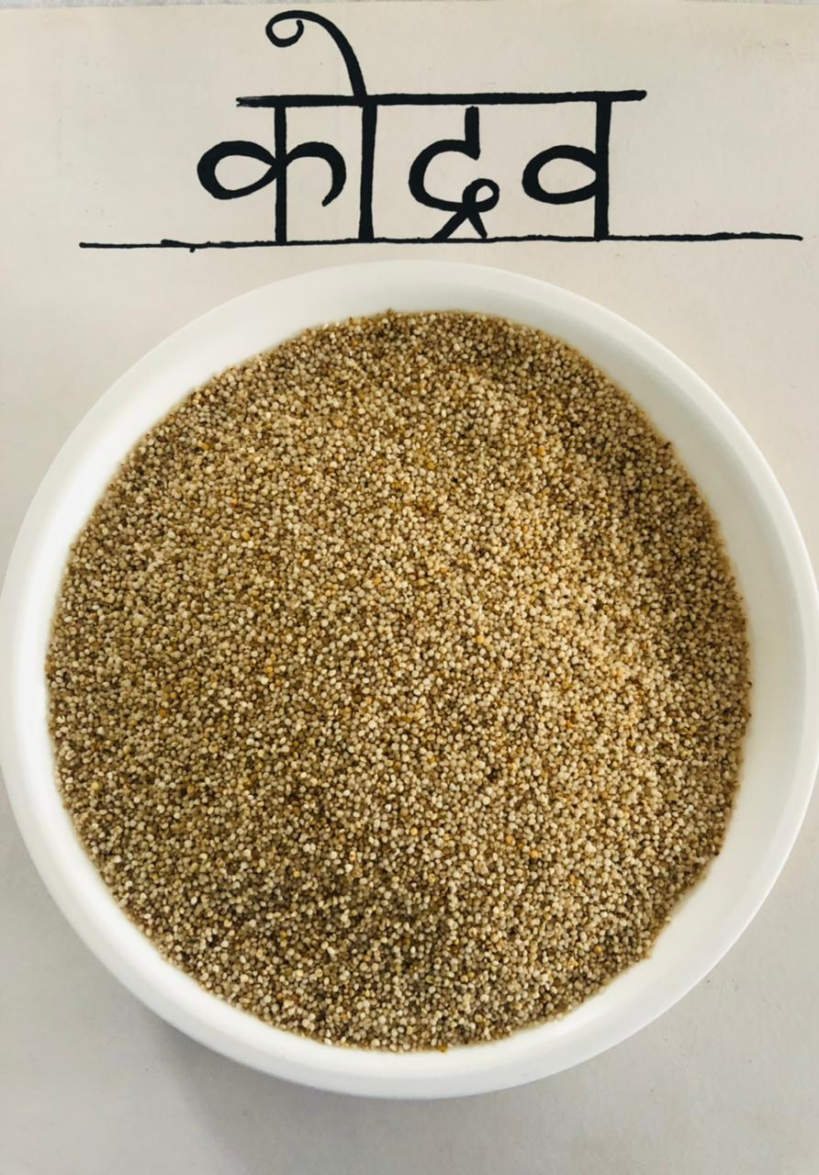 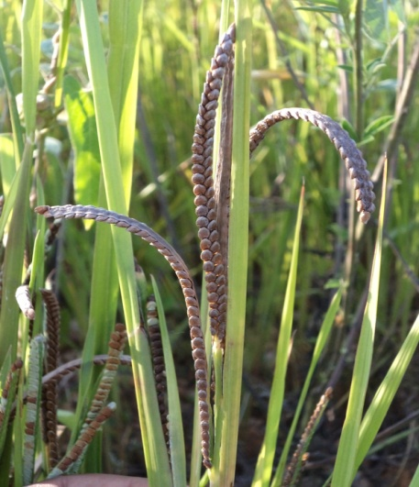 [17]
Fig. 1.Kodrav (Paspalum scrobiculatum Linn.)(Kodo Millet)
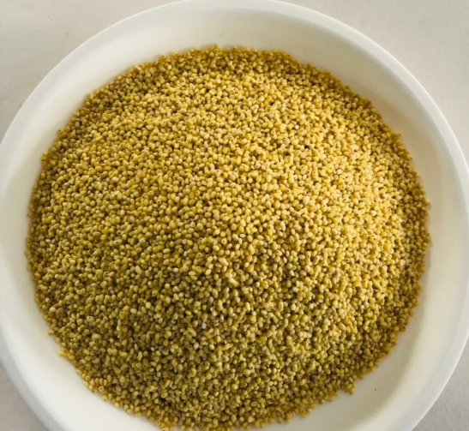 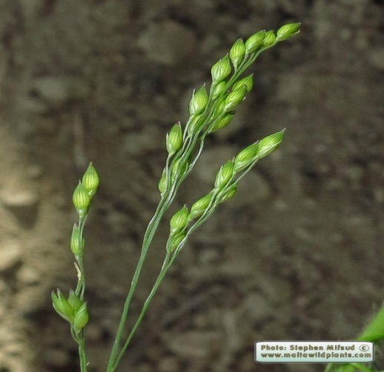 [18]
Fig. 2. Cheenak (Panicum miliaceum Linn.)(Common millet)
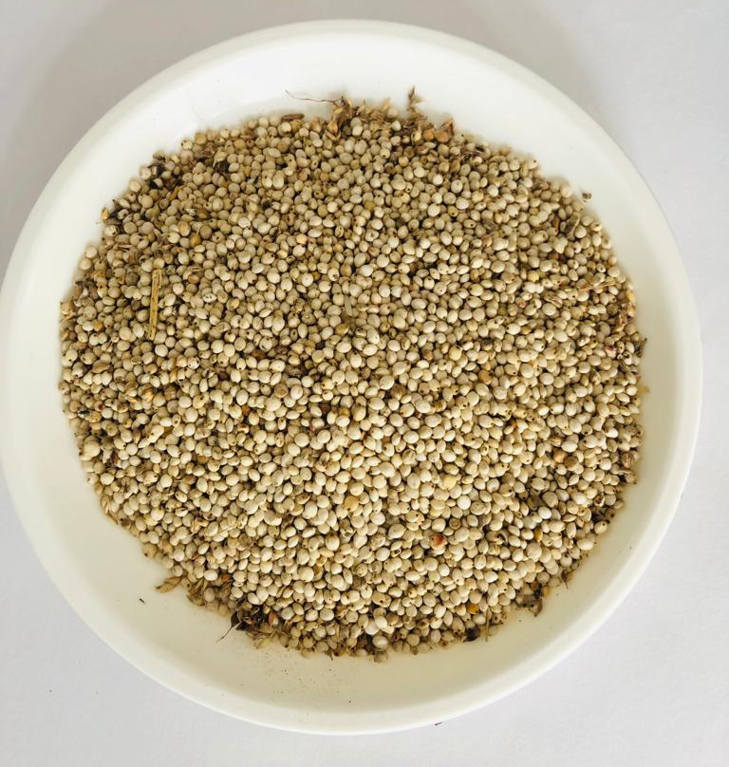 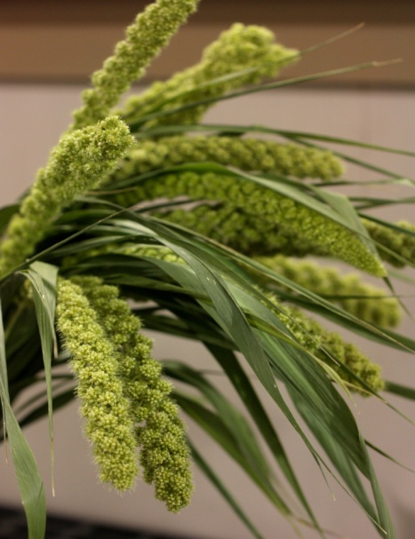[19]
Fig. 3. Kangu (Setaria italic Linn. Beav.) ( Itallian/ Foxtail Millet)
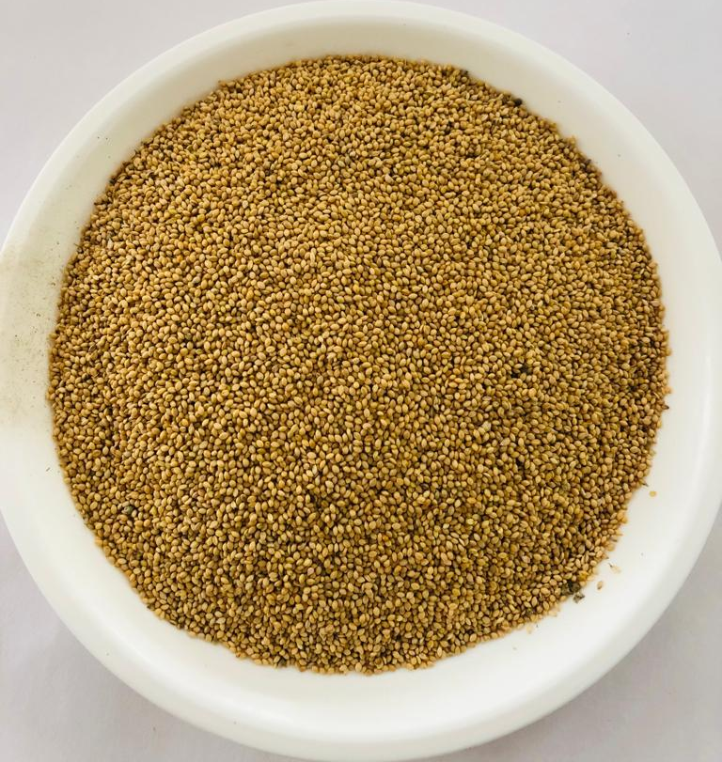 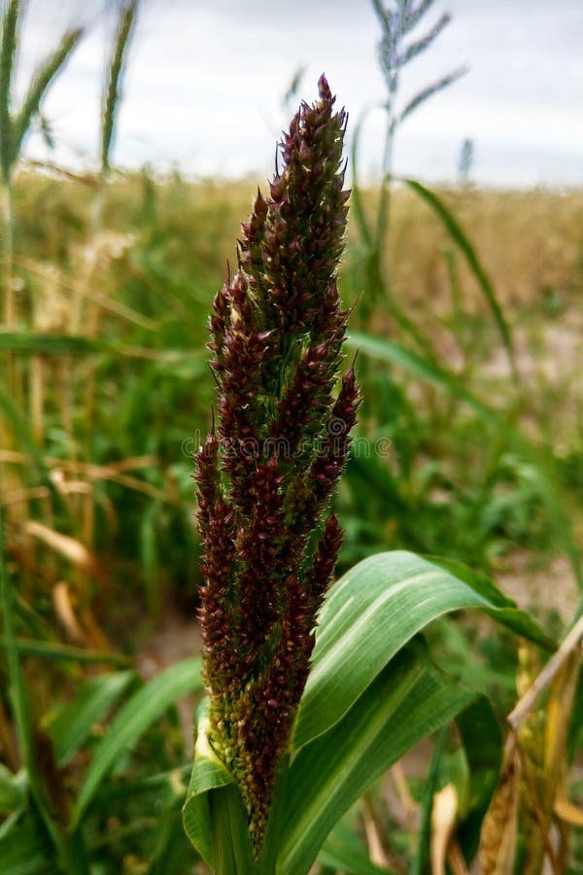[20]
Fig. 4. Shayamak (Echinochola frumentace) (Barnyard Millet)

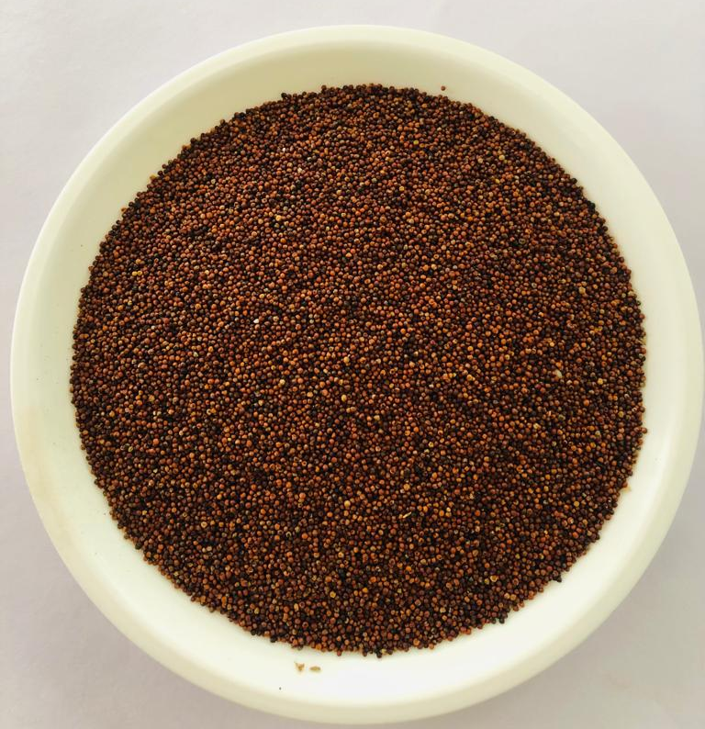 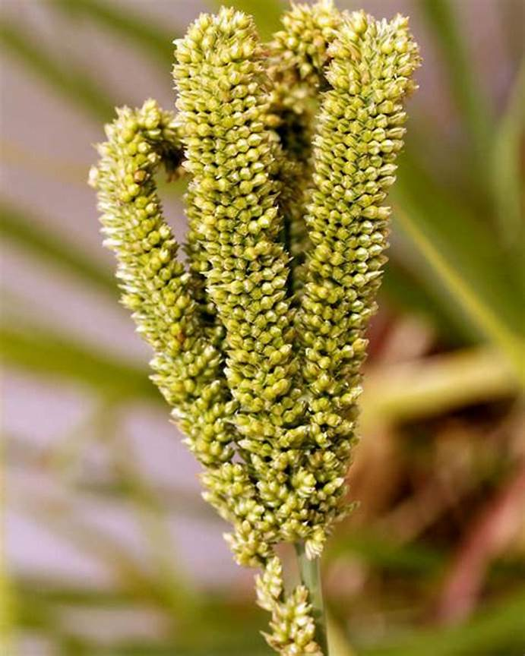[21]
Fig.5. Madhulika/ Ragi (Eleusine coracana Linn.) (Finger Millet)

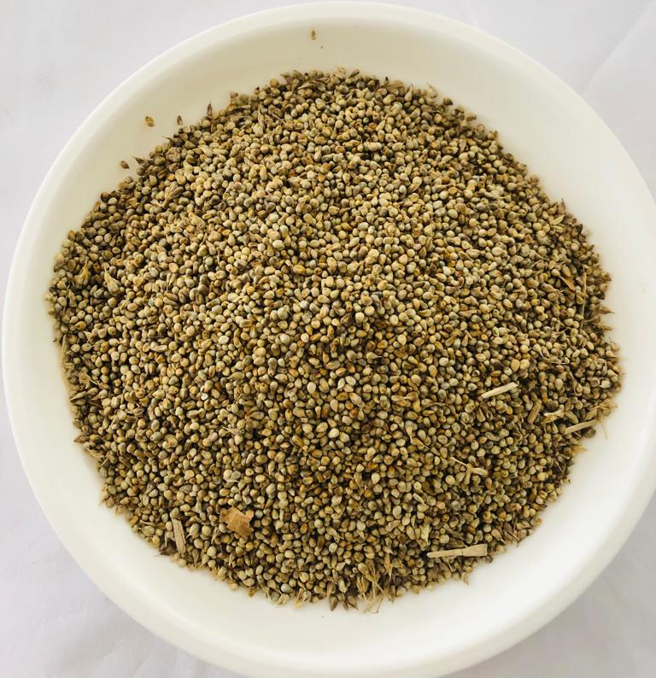 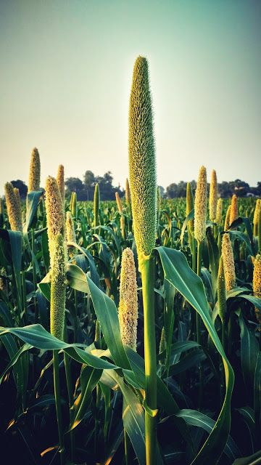[22]
Fig. 6. Bajra (Pennisetum typhoides Burm.f.Stapf.&Habbard) (Pearl Milet)

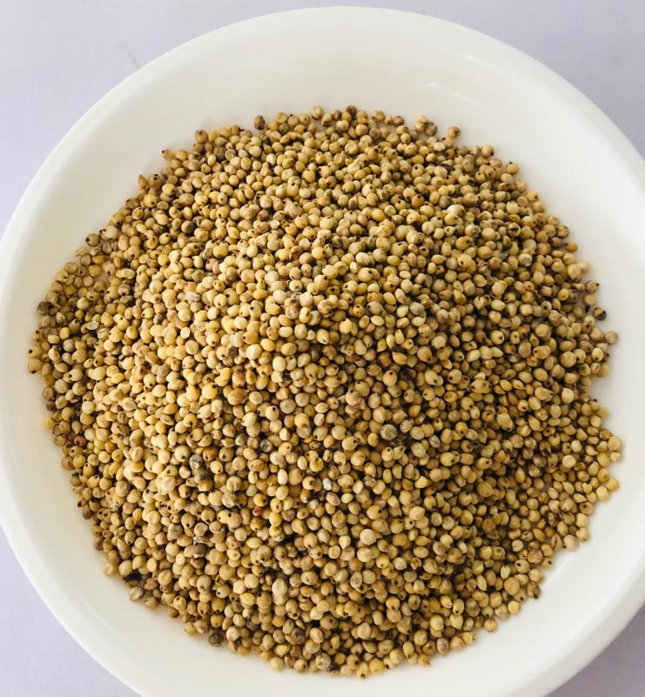 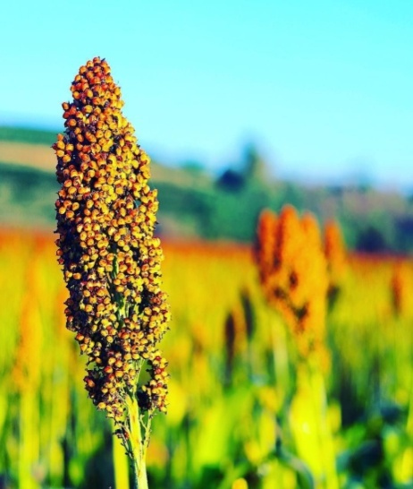 [23]
Fig. 7. Jurna (Sorghum vulgare Pers.) (Great Millet)

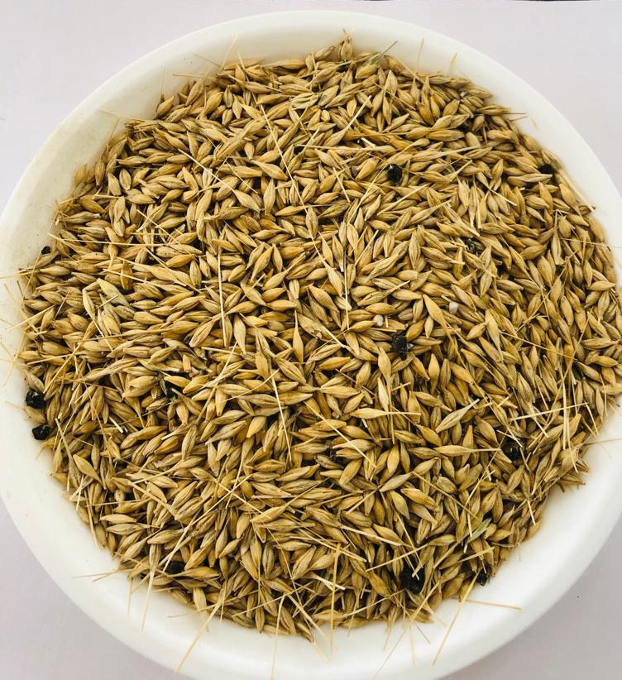 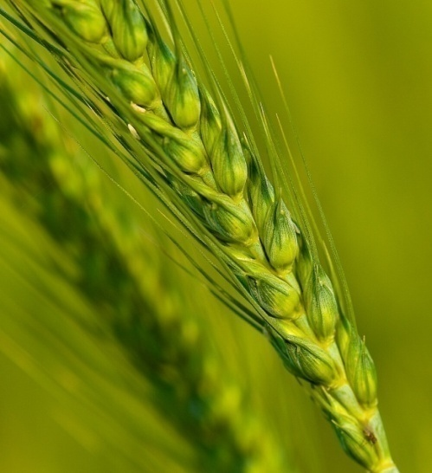 [24]
Fig. 8. Yav (Hordeum vulgare) (Barley)
DISCUSSION
As described in Ayurveda texts millets are beneficial for Kaphaja, Pittaja and Raktaja Roga and as millets aggravates Vata they have to be avoided in such conditions. With this understanding millets are beneficial for Sthoulya, Prameha, Medoroga, Atisaara, Twaga Roga and other Santarpanjanya Vyadhi. Millets should be advised according to individual Jatharagni (digestive power) as they possess Guru and Ruksha properties which makes them difficult for digestion. But millets also possess Lekhana and Kledashoshana properties which makes them helpful in treating Santarpanjanya Vyadhi (disease due to over nourishment of single or multiple tissues).As mentioned in Ayurveda text few millets are Laghu in nature which can be understood as the after effect of digestion they imparts lightness.Though the specific indications of each, millets are not mentioned but looking at their Guna and Karma , indications can be derived.
Kodrava (Kodo Millet) is mainly described as Grahi (absorbs excessive fluids and helps for normal formation of faeces), Baddavitkara (compactness of faeces), Rakta-pitta-kapha Shamaka, Lekhna, Vishamardi (pacifies effects of poison).
According to studies, Kodo millet significantly reduces glycated hemoglobin levels, triggers production of liver glycogen, stimulating instant levels of energy in diabetics, brings down the levels of bad cholesterol, regulate blood pressure, helps in sugar control and celiac disease. Kodo millet is a time tested home remedy for healing external wounds ^{[25]}.
Shyamaka (Barnyard Millet) can be indicated in Atisara (Diarrhea), Grahani (Irritable Bowel Syndrome) , Santarpan Janya Vyadhi (Diseases due to over Nourishment) like Sthoulya (Obesity), Prameha (Diabetes Mellitus), Twaka Roga ^{[26]}.
In a clinical study Ugare et al. (2014), confirmed lower glycemic index in type-2 diabetic group during regular consumption of Barnyard millet ^{[27]}.
Kangu (Foxtail Millet) has Brihmana (Nourishing) , Ruksha (reduces unctuousness), Alpamutra-vitta qualities. It is indicated in Asthi-bhagna (Bone fractures) as it has Bhagna-asthi sthankrit properties.
Foxtail millets are an excellent source of iron and calcium which is why it is indicated in chronic conditions like osteoporosis, arthritis, spondylitis etc. It strengthens nervous system, boosts cardiac health, manages diabetes, build immunity and promotes digestion ^{[28]}.
Cheenaka ( Proso/Common Millet) is Vatta-kapha Hara (Pacifies vatta and Kapha), Brihmana (Nourishing). Shimanuki S et al (2006) ^{[29]} reported that Proso millet has ability in increasing the HDL levels and thus may have strong protective effects against the risk of Coronary Heart Disease development.
Madhulika/Ragi (Finger Millet) is Tripatikaraka (fulfilling), Vrishya (aphrodisiac), Snigdha , Balya (Increases strength), Ashmari-bhedana (removes stone). Ragi contains an amino acid called Tryptophan which lowers appetite and helps in keeping weight in control ^{[33]}.
Kumari PL et al. (2002) ^{[30]} reported that Finger millet have potential against hyperglycemia in Non-insulin dependant Diabetes Mellitus. Srivastava K et al. (2010) ^{[31]} reported Finger millet is storehouse of nutrients.
Jurna/Yavanaala (Great Millet) is Trishnaghna (Pacifies thirst), Raktapitta Shamaka ( Pacifies Rakta and Pitta), Sthoulya ( Obesity), Pacifies Kapha. Shen EL et al.(2015) ^{[32]} reported anti-obese and anti-diabetic activity of Sorghum.
Vajaranna (Pearl Millet) is Balya (Nourishing), Punstavhara, Durjara (difficult for easy digestion). Pearl millet is recommended for curing stomach ulcers. The lignin and phytonutrients in millet act as strong antioxidants thus preventing heart related diseases. Pearl millet contains high concentration of magnesium which helps reduce severity of respiratory problems for asthma patients and is also effective in reducing migraine attacks^{[33]}.
Yava (Barley) is indicated in Peenasa, Shwasa, Kasa, Urusthambha, Kandaroga, Twaga Roga.
This review also enlightens about the contra-indications of Millets. As most of the Millets are Ruksha and Vaata-Vardhaka they should not be advised in Vaata Prdhana Vyadhi like Sandhi-Vata, Shoola, Karshya etc. And due to Durjara (difficult in digestion) property they should not be used in Ajeerna (indigestion), Mandagni ( low digestion power) and Vibandha (Indigestion because of Vata that leads to bloating). In Vata vitiated conditions, Millets have to be used by doing Samskara (Processing) which helps in balancing Vata and eases digestion by soaking Millets in warm water, adding Ghee, Deepan-pachana Dravyas etc. Also the Matra should be regulated wisely and to be consumed in moderate quantities and frequency. As Millets are not included in Nitya Sevaniya Ahara(foods to be used regularly) in Ayurveda they should not be consumed on a daily basis^{[26]}.
CONCLUSION
Millets energy values are similar to staple cereals. Like many other cereals, millets are high in carbohydrate and nutrition, making them useful components of dietary and nutritional balance in foods. They must be considered as today’s nutricereal but in future they have the potential to replace cereals because of their tremendous health benefits. But after considering the above properties of millets in different Ayurvedic literature it can be concluded that millets are not suitable for every individual. In spite of various indications there are some contraindications also. So before suggesting the use of millets proper Prakriti Pariksha and analysis of Jatharagni must be done. Hence millets can be used judiciously after proper Rogi and Rog Pareeksha so that one can utilize proper benefits of millets.
In a clinical study
with human volunteers, Ugare et al. (2014), conﬁrmed a lower
glycemic index (GI) in type 2 diabetic groups during regular
consumption of barnyard millet meal
In a clinical study
with human volunteers, Ugare et al. (2014), conﬁrmed a lower
glycemic index (GI) in type 2 diabetic groups during regular
consumption of barnyard millet meal
In a clinical study
with human volunteers, Ugare et al. (2014), conﬁrmed a lower
glycemic index (GI) in type 2 diabetic groups during regular
consumption of barnyard millet meal
n a clinical study
with human volunteers, Ugare et al. (2014)
REFRENCES-
- N. A. Nanje Gowda,^{1,*} Kaliramesh Siliveru,^{2,*} P. V. Vara Prasad,³ Yogita Bhatt,¹ B. P. Netravati,¹ and Chennappa Gurikar^{1 ;} Modern Processing of Indian Millets: A Perspective on Changes in Nutritional Properties. Foods. 2022 Feb; 11(4): 499 Published online 2022 Feb 9. doi: 10.3390/foods11040499 PMCID: PMC8871339 PMID: 35205975 [PubMed]

- E-Catalogue for export of millets and value added products Himachal Pradesh;Agricultural and Processed food products export development authority;

- Piyush S Girgaonkar ; Millets: The Sustainable Superfood That Can Help Achieve Sustainable Development Goals; in Urban Pulse: Planning, Policies and Development, Environment, TOI April 2023.

- Press Information Bureau (pib.gov.in)

- Sharma P V , Guruprasad Sharma, editor Dhanvantri Nighantu, reprint Varanasi Chaukambha orientalia, 2008 pg no 191-196

- Shodal Nighantu, Prof. (Dr.) Gyanendra Pander, editor Prof.R.R. Dwivedi, reprint Chowkhamba Krishnadas Academy, Varanasi 2009 page no 400-401

- Madanpal Nighnatu, P. Harihar Prasad Tripathi, reprint Chowkhamba Krishnadas Academy, Varanasi 2009 page no 238-240

- Kaiyadeva Nighantu (Pathyaapthya vibhodika), Prof Prya Vrat Sharma, Dr Guru Prasada Sharma, reprint Varanasi Chaukambha orientalia 2009, page no 307-321

- Priya Nighantu, Prof Prya Vrat Sharma, Chaukambha Surbhati Prakshana 2004, page no 204-206

- Acharya Charaka. Sutrasthana, Annapanavidhi Adhyaya. In: Pt. kashinath sastri and Dr. gorakha natha chaturvedi Vidyotani hindi commentary: Chaukhambha bharati academy;2020. P. 460-461

- Acharya Sushruta. Sutrasthana, Annapanavidhi Adhyaya. In Dr. Ambikadutt Shastri Ayurved tatva sandeepika: Chaukhambha Sanskrit Sansthan;2018.p.243-244

- Acharya Vagbhata. Sutrasthana, Annaswaroopavigyaniye. In Hindib commentary by Kaviraja Atrideva Gupta: Chaukjambha Prakashan;2020.p.65-66

- Sharma PV, Acharya Priyvrat Sharma,Vol III,Dhanyavarga, Chaukhambha Bharti Academy;2021,page no 148-167

- Nutritional Value of Kodo Millet: Nutrients Table and Benefits (mysymedia.com)

- What is the Nutritional Value of Barnyard Millet Per 100g? – NutritionFact.in

- Coix Seed (Job’s Tears) - Nutrition Facts & Health Benefits - Health Guide Net

- Kodo Millet facts and health benefits (healthbenefitstimes.com)

- Panicum miliaceum (Millet Plant) : MaltaWildPlants.com - the online Flora of the Maltese Islands.

- Wordpress.com

- Barnyard Millet. Echinochloa Esculentaor Japanese Millet. Nature Stock Image - Image of nature, green: 168310113 (dreamstime.com)

- RAGI - THE FINGER MILLET - FuturO Organic

- (104) Pinterest

- OPINION | Amazing ting: SA must reinvigorate sorghum as a key food before it’s lost (timeslive.co.za)

- Pin on Animal SMALLHOLDING (pinterest.jp)

- Lata Devi, Manthan Chaudhary,Vipul Singh,Rashpal Singh Sarlach; Nutritional Value of Kodo Millet and Its Uses in Indian Food. October 2022 E-ISSN: 2583-1755 ,Volume-1, Issue-11, September, 2022,ResearchGate

- Pooja Hasssan G et al.;An eyeshot on Kshudra Dhanya in Ayurveda;Vol 6.Issue 4.Aug 2021,JAIMS

- Renganathan Vellaichamy Gandhimeyyan, C. Vanniarajan, Karthikeyan Adhimoolam, Jegadeesan Ramalingam; Barnyard Millet for Food and Nutritional Security: Current Statusand Future Research Direction, doi: 10.3389/fgene.2020.00500
Edited by:
Mallikarjuna Swamy,
International Rice Research Institute,
Philippines
Reviewed by:
Atefeh Sabouri,
University of Guilan, Iran
Passoupathy Rajendrakumar,
ICAR-Indian Institute of Millets
Research (IIMR), India
Lohithaswa Hirenallur
Chandappa,
University of Agricultural Sciences,
India
*Correspondence:
Jegadeesan Ramalingam
ramalingam.j@tnau.ac.in
Specialty section:
This article was submitted to
Nutrigenomics,
a section of the journal
Frontiers in Genetics
Received: 05 November 2019
Accepted: 22 April 2020
Published: 23 June 2020
Citation:
Renganathan VG, Vanniarajan C,
Karthikeyan A and Ramalingam J
(2020) Barnyard Millet for Food
and Nutritional Security: Current
Status and Future Research Direction.
Front. Genet. 11:500.
doi: 10.3389/fgene.2020.00500

- [Online].Available from: Foxtail Millet: Nutrition, Health Benefits, Ayurvedic Uses, And Recipes (netmeds.com) [Accessed July 26,2021]

- Shimanuki S, Nagasawa T, Nishizawa N. Plasma HDL subfraction levels increase in rats fed proso-millet protein concentrate. Medical science monitor. 2006 July 1;12(7):PBR221-6

- Kumari PL, Sumathi S. Effect of consumption of finger millet on hyperglycemia in non-insulin dependent diabetes mellitus (NIDDM) subjects. Plant Foods for Human Nutrition. 2002 Sep;57(3):205-13.

- Srivastava K, Sharma AK. Nutraceutical importance of finger millet (Eleusine coracana) for improved human health. European Journal of Plant Science Biotechnology. 2012;6:91-5.

- Shen RL, Zhang WL, Dong JL, Ren GX, Chen M. Sorghum resistant starch reduces adiposity in high-fat diet-induced overweight and obese rats via mechanisms involving adipokines and intestinal flora. Food and Agricultural Immunology. 2015 Jan 2;26(1):120-30.

- B. Dayakar Rao K. Bhaskarachary G.D Arlene Christina G. Sudha Devi Vilas, A. Tonap Nutritional-and-Health-Benefits-of-Millets.pdf (researchgate.net)

fgene-11-00500 June 23, 2020 Time: 13:54 # 1

