**CHAPTER 1**

**INTRODUCTION**

* 1. **GENERAL**

Vapor compression refrigeration system is a system which is used to transfer heat from low temperature reservoir to high temperature reservoir with the help of working fluid, called refrigerant. The household refrigerator is working under the VCR system. The ozone depleting potential (ODP) and global warming potential (GWP) have become the most important criteria in the development of new refrigerants apart from the refrigerants CFCs due to their contribution to ozone layer depletion and global warming. In spite of their high GWP, alternatives to refrigerants CFCs and HCFCs such as hydro fluorocarbon (HFC) refrigerants with the zero ODP and hydro carbon refrigerants (HC) have been preferred for use in many industrial and domestic applications. The problems of the depletion of ozone layer and increase in global warming caused scientists to investigate more environmentally friendly refrigerants than HFC refrigerants for the protection of the environment such as hydrocarbon (HC) refrigerants of propane (R290), isobutene (R600a), Butane(R 600**)**. The need to meet ozone depleting potential (ODP) and global warming potential (GWP) means that it is appropriate continuously to investigate the ways of reducing ozone depleting potential (ODP) and global warming potential (GWP) without compromising COP or increasing the cost of manufacturing engines by using different mixture of hydrocarbon (HC) refrigerants.

**1.2. VAPOR COMPRESSION REFRIGERATION**

The vapor-compression uses a circulating liquid [refrigerant](http://en.wikipedia.org/wiki/Refrigerant) as the medium which absorbs and removes heat from the space to be cooled and subsequently rejects that heat elsewhere.

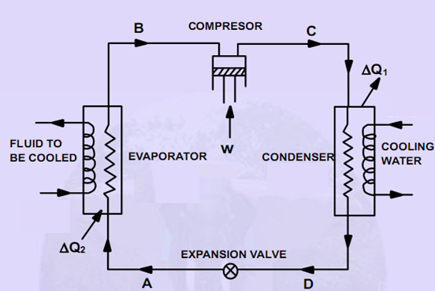

**Figure.1.1 Schematic diagram of vapor compression refrigeration system**

Figure.1.1shows the Schematic Diagram of vapor compression refrigeration system and Figure 1.2 depicts a typical, single-stage vapor compression system. All such systems have four components: a [compressor](http://en.wikipedia.org/wiki/Gas_compressor), a [condenser](http://en.wikipedia.org/wiki/Condenser_(heat_transfer)), a [thermal expansion valve](http://en.wikipedia.org/wiki/Thermal_expansion_valve) and an evaporator. Circulating refrigerant enters the compressor in the thermodynamic state known as a [saturated vapor](http://en.wikipedia.org/wiki/Boiling_point#Saturation_temperature_and_pressure) and is compressed to a higher pressure, resulting in a higher temperature as well. The hot, compressed vapor is then in the thermodynamic state known as a superheated vapor and it is at a temperature and pressure at which it can be [condensed](http://en.wikipedia.org/wiki/Condensation) with either cooling water or cooling air. That hot vapor is routed through a condenser where it is cooled and condensed into a liquid by flowing through a coil or tubes with cool water or cool air flowing across the coil or tubes. This is where the circulating refrigerant rejects heat from the system and the rejected heat is carried away by either the water or the air.

The condensed liquid refrigerant, in the thermodynamic state known as a [saturated liquid](http://en.wikipedia.org/wiki/Boiling_point#Saturation_temperature_and_pressure), is next routed through an expansion valve where it undergoes an abrupt reduction in pressure. That pressure reduction results in the adiabatic [flash evaporation](http://en.wikipedia.org/wiki/Flash_evaporation) of a part of the liquid refrigerant. The auto-refrigeration effect of the adiabatic flash evaporation lowers the temperature of the liquid and vapor refrigerant mixture to where it is colder than the temperature of the enclosed space to be refrigerated.

The cold mixture is then routed through the coil or tubes in the evaporator. A fan circulates the warm air in the enclosed space across the coil or tubes carrying the cold refrigerant liquid and vapor mixture. That warm air [evaporates](http://en.wikipedia.org/wiki/Evaporates) the liquid part of the cold refrigerant mixture. At the same time, the circulating air is cooled and thus lowers the temperature of the enclosed space to the desired temperature. The evaporator is where the circulating refrigerant absorbs and removes heat which is subsequently rejected in the condenser and transferred elsewhere by the water or air used in the condenser.

To complete the [refrigeration cycle](http://en.wikipedia.org/wiki/Refrigeration_cycle), the refrigerant vapor from the evaporator is again a saturated vapor and is routed back into the compressor.



**Figure 1.2 Single stage vapor compression refrigeration system**

a) Schematic diagram b) p-h diagram

1 – Outlet of Evaporator/ Inlet to the Compressor

2 – Outlet of Compressor/ Inlet to Condenser

3 – Point in the Condenser where phase change starts

4 – Outlet of Condenser/ Inlet to Throttling Device

5 – Outlet of Throttling Device/ Inlet to Evaporator

1 – 2: Isentropic Compression

2 – 4: Isobaric Heat Rejection

4 – 5: Isenthalpic Expansion

5 – 1: Isobaric Heat Absorption

The corresponding pressure-enthalpy (p–h) diagram is shown in Figure 1.2(b). In order to simulate the vapor compression refrigerator, a number of assumptions are made. They are (a) steady state operation (b) no frictional pressure drop through pipelines, i.e. pressure changes only through the capillary tube and the compressor (c) heat gains or heat losses from or to the system are neglected (d) no superheating or sub cooling takes place and (e) the compressor has isentropic efficiency of 75%. It must be noted that the above diagrams are either for single component refrigerants or azeotropic mixtures. The T-s diagram for zeotropic mixtures will be discussed at a later stage in the calculations part. However the expressions for various parameters would remain the same. The pressure ratio (PR) is defined as the ratio of the condensing pressure (P2) to the evaporating pressure (P1).

The condensing and evaporating pressures are determined corresponding to the condensation and evaporation temperatures. The condensation temperature is decided by the temperature of the ambient air, whereas the evaporation temperature is determined by the load temperature based on the required freezer air temperature. The performance parameters of the VCR system are Co-efficient of Performance (COP), is the ratio of refrigeration effect (RE) to the work done (W). The energy balance of the evaporator and compressor give refrigeration effect and work done.

**1.3 PURE REFRIGERANTS**

Any substance that absorbs heat through expansion or vaporization may be called a refrigerant. Examples are ammonia, R12, R134a, R22 and hydro carbons etc. A broader definition may include secondary cooling mediums such as brine solutions and cold water. Although HC refrigerants have highly ﬂammable characteristics according to the standards of ASHRAE as a negative speciﬁcation, they have not only several preferable speciﬁcations such as zero ozone depletion potential, very low global warming, non-toxicity, and higher performance than other refrigerant types but also high miscibility with mineral oil and good accordance with the existing refrigerating systems. They are used in many applications with attention being paid to safety of the leakage from the system as for other refrigerants in recent years.

**1.3.1 Chlorofluorocarbon (CFC)**

Since the 1930s, chlorofluorocarbons (CFCs) have been widely used as foam blowing agents, aerosols and especially refrigerants due to their pre-eminent properties such as stability, non-toxicity, non-flammability and thermodynamic properties. In particular, R12 has been predominantly used for small refrigeration units including domestic refrigerator/freezers. Refrigerant R12 has been the most dominant refrigerant for refrigeration industry. However, they also have harmful effect on the earth‘s protective ozone layer. So, they are being regulated internationally by Montreal Protocol since 1989 (UNEP1987). Later, it was also proved that CFCs also contributed significantly to the global warming problem. The global warming potential of R12 is considered to be 8500 times that of CO2 over 100 years. It was thus decided that by 2010, producing and using of CFCs should be prohibited completely all over the world. In consequence, a lot of research has been done to find the suitable eco-friendly replacement of CFCs.

**1.3.2 Hydro Chlorofluorocarbon** (**HCFC)**

The initial alternatives included some hydro chlorofluorocarbons, or HCFCs, but they are likely to be phased out internationally around 2040, because their ozone depletion potentials and global warming potentials are in relative high levels though less than those of CFCs By that time compounds such as HFCs (hydro fluorocarbons)**,** which are benign to the ozone layer, are likely to have replaced HCFCs. As a result, it has become an urgent issue to search and develop CFC and HCFC alternatives. While the presence of single component refrigerants reduces the performance possibilities, the solution appears to lie in using the synthetic mixtures. The search for alternate refrigerants as substitutes for R134a in various refrigeration systems has been an important area of research in the RAC sector. As per the Montreal Protocol, developed countries have already phased out R12 and developing countries like India have to do the same before the end of 2010. None of the alternative refrigerants can be used in the R12 based appliances without making system modifications or technology change (Jung andRadermacher1991). In developing countries the growth of RAC sector has picked up momentum only in the last decade and hence the immediate change of technology may cause setbacks to the RAC sector.

**1.3.3 Hydrocarbon Refrigerants**

It has the advantages of being very economical and easily available in large amounts. They are environmental friendly with zero ozone depletion potential, and they do not cause the greenhouse warming effect. The major limitation is that they are highly flammable substances and must be handled with caution. Also, blends of some refrigerants can be considered as substitutes or alternatives to existing refrigerants. There are an increasing number of scientists and engineers, including environmentalists who believe that an alternative solution, which has been overlooked, may be provided by using hydrocarbons. These provide the possibility of a zero ODP, together with suitable thermodynamic, physical and chemical properties. It is possible to mix hydrocarbon refrigerants with other alternative refrigerants, such as HFC, to replace R134a in domestic refrigerators Alternative refrigerants should have stable thermo physical and chemical properties, good miscibility with lubricants and low inflammability.

The reduction in flammability can be achieved by mixing HCs with HFCs. This process reduces the amount of flammable substance and consequently the flammability risk will be reduced. The global warming potential will be at least two third less when HFCs are used alone. The proposed ternary mixture of HFC/HC used in this study has saturation properties matching with those of R134a. In fact, for the developing countries, meeting all the requirements of various international amendments for environmental protection is quite burdensome.

Furthermore, it is desirable that the designed refrigerants, replace the current refrigerants without any major change in the system equipment. A trade-off point between all these factors has been considered while proposing the mixtures in the present work. The aim of the present investigation is to find substitutes for R134a refrigerators. Using hydrocarbons is an environmentally sound alternative to CFCs/HFCs. The general conclusion is that there is no ideal refrigerant today. Natural refrigerant should be chosen whenever possible for the sake of environment protection. In fact, hydrocarbons are known to have such advantages as low cost, availability, compatibility with the conventional mineral oils. However, their use has been held up in other developed countries mainly due to their high flammability.

The procedures and data presented in this work will be helpful for the replacement/reduction of ozone depleting/green-house warming refrigerants in the future. The point of contention surrounding the phase out of CFCs is to provide substitutes with optimum benefits and performance. In this work, an experimental study, using hydro fluorocarbon/hydrocarbon (HFC/HC) mixtures with suitable proportions, has been carried out to determine the optimum mixture for replacing R134a in existing domestic refrigerator. Non-azeotropic mixtures have some added advantages over single component and azeotropic refrigerants. The alternatives that are proposed in this report mainly comprise of non-azeotropic mixtures of R134a and hydrocarbons.

**1.3.3.1 Propane (R290)**

R290 provides improved performance in terms of discharge temperature and pressure. R290 has a long history in refrigeration. It has been in use since before CFCs were developed and was re-introduced for use in heat pumps after the CFC phase out. Its thermodynamic data, efficiency, and material compatibility are well known. In some countries, appliance manufacturers and food producers began using R290 as a replacement for R404A or R134a in appliances shortly after 2000, due to environmental concerns. The energy efficiency and reliability of the appliance using R290 is expected to be equivalent to or better than that of equipment using R22. Because R290 has no ODP and a very low GWP, assuming that R290 has the same energy efficiency as R22, the environmental impact is reduced. Based on estimated charge sizes and leak rates, emission savings are estimated to be 25 tonnes of R22 per 100,000 appliances.

**1.3.3.2 Isobutane (R-600a)**

Isobutane is used as a [refrigerant](http://en.wikipedia.org/wiki/Refrigerant) in refrigerators started in 1993 when Greenpeace presented the Green freeze project with the German company Foron. In this regard, blends of pure, dry "isobutane" (R-600a) have negligible [ozone depletion potential](http://en.wikipedia.org/wiki/Ozone_depletion_potential) and very low [Global Warming Potential](http://en.wikipedia.org/wiki/Global_Warming_Potential) and can serve as a functional replacement for [R-12](http://en.wikipedia.org/wiki/Dichlorodifluoromethane), [R-22](http://en.wikipedia.org/wiki/Chlorodifluoromethane), [R-134a](http://en.wikipedia.org/wiki/1,1,1,2-Tetrafluoroethane), and other [chlorofluorocarbon](http://en.wikipedia.org/wiki/Chlorofluorocarbon) or [hydrofluorocarbon](http://en.wikipedia.org/wiki/Hydrofluorocarbon)[refrigerants](http://en.wikipedia.org/wiki/Refrigerant) in conventional stationary refrigeration and air conditioning systems.

**1.3.3.3 Butane(R 600)**

In recent years the household compressor manufacturers have reduced the energy losses inside the compressors resulting in a positive effect on the energy consumption in the cabinets. In the following, butane, which is a natural and non-ozone depletion refrigerant, is compared to refrigerants presently used in household compressors.

**1.3.4Tetrafluoroethane (R134a)**

R134a is also known as Tetrafluoroethane (CF3CH2F) from the family of HFC. Tetrafluoroethane first appeared in the early 1990s as a replacement for [dichlorodifluoromethane](http://en.wikipedia.org/wiki/Dichlorodifluoromethane)(R-12), which has ozone depleting properties.

Tetrafluoroethane has been atmospherically modeled for its impact on depleting ozone and as a contributor to global warming. It is an inert gas used primarily as a “high-temperature” refrigerant for domestic refrigeration and automobile air conditioners. These devices began using tetrafluoroethane in the early 1990s as a replacement for the more environmentally harmful [R-12](http://en.wikipedia.org/wiki/Dichlorodifluoromethane). For the past decade, R12 has been replaced with R134a in refrigerators and automobile air conditioners. At present in India more than 80% of the refrigerators are working with R134a. R134a possess favorable characteristics such as zero ODP, non-flammability, stability and similar vapour pressure to that of R12. Earlier studies indicate that the energy efficiency of R134a obtained in actual refrigerators was lower than that of R12.

* 1. **MIXED REFRIGERANTS**

Hydrocarbon such as propane, butane and isobutene mixture is currently used in some parts of the world for domestic refrigerators. These refrigerants have low ODP, low GWP and good efficiency. But the main disadvantage is being extremely flammable. In current scenario the application of Hydrocarbon mixture is increasing considerably in the view of replacing refrigerant R134a as hydrocarbon mixture refrigerants which are more energy efficient, having lower GWP and not having ozone layer depletion potential. Numerous researchers have reported that Hydrocarbon mixture refrigerants are energy efficient and eco- friendly alternative to replace R134a in VCR system.Table 1.1 presents the various properties likemolecular weight, boiling point, critical temperature, explosive limits in air, ODP, GWP of selected alternate refrigerants.

**Table 1.1 Properties of the selected alternate refrigerant mixtures**

|  |  |  |  |  |  |  |  |
| --- | --- | --- | --- | --- | --- | --- | --- |
| **Refrigerant Code** | **Molecular weight** | **Boiling Point 0C (1.01325bar)** | **Critical Temperature 0C** | **Latent heat kJ/kg** | **Explosive Limits in air, % by volume** | **ODP** | **GWP** |
| R12 | 120.93 | -29.8 | 112 | 165.24 | Non-flammable | 0.82 | 8100 |
| R134a | 102.03 | -26.1 | 101.1 | 216.87 | Non-flammable | 0 | 1300 |
| R290  (Propane) | 44.1 | -42.04 | 96.7 | 423.33 | 2.3-7.3 | 0 | 20 |
| R600 (Butane) | 52.13 | -11.73 | 144.7 | 372.25 | 1.8-6.4 | 0 | 20 |
| R600a  (Isobutene) | 58.13 | -11.73 | 134.7 | 364.25 | 1.8-8.4 | 0 | 20 |

* 1. **NON AZEOTROPIC REFRIGERANT MIXTURE**

A non azeotropic refrigerant mixture is made up of two (or more) refrigerants of different volatility and does not act as a pure fluid. When these two refrigerants are used in a vapor-compression cycle, the mixture changes composition as it boils or condenses. As a result of this change in composition a temperature variation occurs during a constant pressure phase-change process.

The magnitude of this temperature variation or "temperature glide" is a function of the properties and relative composition of the mixture constituents. It can be seen that using the non azeotropic refrigerant mixture can reduce heat pump irreversibility and therefore, increase efficiency. The temperature of pure refrigerants is constant in the two-phase region, if the heat source or heats sink temperature varies throughout the heat exchanger. By utilizing the correct non azeotropic mixture, the temperature difference between the refrigerant and the heat source/sink can be reduced, thereby minimizing the irreversibility produced during heat transfer.

**1.6 OZONE LAYER DEPLETION POTENTIAL**

Most commonly refrigerants were CFCs because they were non-toxic, on-flammable but they increase the depletion of ozone layer, ozone layer is a layer which protects the nature from ultra-violate rays. Therefore researchers need to search alternatives of CFCs during this generation HFCs is introduced because they have zero “ODP” which reduces the depletion of ozone layer. Some natural refrigerants like NH3, CO2, HCs, and H2O is also used in this stage. Three points warrant notice. First, refrigerants historically constituted only a minor fraction of total ODS emissions, but most of the same CFCs and some of the HCFCs in common use as refrigerants also were used in much more emissive applications, including as aerosol propellants, foam blowing agents, and solvents. Second and at least comparable in importance to the refrigerant replacements, the environmental concerns prompted major changes in design, manufacturing, installation, service, and ultimate disposal procedures to reduce avoidable refrigerant emissions One of the major challenges posed to the Montreal Protocol is to protect the stratospheric ozone layer and also global warming while ensuring that developing countries are not economically disadvantaged during their transition to new technologies that do not rely on ozone depleting substances (ODS). This is particularly applicable to the refrigeration sector, which accounts for the largest share of ODS consumption in developing countries and touches virtually every person‘s life, directly or indirectly.

**1.7 GLOBAL WARMING POTENTIAL**

The second major environmental impact is GWP, which is due to the absorption of infrared emissions from the earth, causing an increase in global earth surface temperature. While solar radiation at 5800 K and 1360W/m2 arrives the earth, more than 30% is reflected back into space and most of the remaining radiation passes through the atmosphere and reaches the ground. This solar radiation heats up the earth, which approximately as a black body, radiate energy with a spectral peak in the infrared wavelength range. This infrared radiation cannot pass through the atmosphere because of absorption by GHG including the halogenated refrigerants. As a result, the temperature of atmosphere increases, which is called as the global warming.

**1.8 REASONS FOR SELECTING MIXTURE OF R134A AND HC**

The mixture of R134a and hydrocarbon (propane, butane and isobutene) has the following advantages.

* The cooling capacity is near to R-12 and the vapor pressure is appropriate.
* It is naturally occurring and non-toxic.
* Improves the overall efficiency by 10 %.
* The ozone depletion potential and global warming potential are significantly negligible as compared to other refrigerants.
* Environmental friendly
* It does not form acids and thereby eliminates the problem with blocked capillaries.
* Low viscosity and high thermal conductivity that guarantee a good performance of the system.
* As the density is less than lower than CFCs/HFCs, in spite of its flammability, the refrigerant mass requirements are low.

**1.9 OBJECTIVES OF THIS PROJECT**

The main objectives of this project work are as follows:

1. To develop a household VCR system designed to work with R-134a as

an investigation unit to assess the prospect of using mixed refrigerants.

1. Experimental studies in the VCR system with R-134a and identified best

refrigerant mixtures in place of R-134a.

**3.** Comparison of COP for the different refrigerant mixtures and R-134a by

experimental results.

**4**. Comparison of GWP for the different refrigerant mixtures and R-134a.

**5**. Comparison of energy consumption rate of the system when using

different refrigerants mixtures and R-134a by experimental results.

**6**. To suggest the best composition of refrigerant mixture to get the

maximum COP with minimum GWP.

**CHAPTER II**

**REVIEW OF LITERATURE**

**2.1 GENERAL**

Currently popular refrigerants are being phased out due to their damaging effects on ozone layer and global warming. Ban on chloroflorocarbon may have solved the problem of ozone depletion, but another global environmental effect is greenhouse gases and resulting global warming. The refrigerant R134a causes global warming and CFC depletes ozone layer and now these two refrigerants are labeled as greenhouse gases and ought to be replaced. Therefore, a detailed review of various studies on substitutes for R134a in refrigerator are discussed in this chapter. The need for and scope of this research work has been outlined at the end of the chapter.

**2.2 VAPOR COMPRESSION REFRIGERATION SYSTEM**

Richardson and Butterworth (1995) determined the performance of a vapor compression refrigeration system working with propane and a mixture of propane and isobutene. The obtained performance was higher than that obtained from CFC-12 under the similar experimental conditions.

Lee and Su (2002) have conducted performance tests of a domestic VCR system with R600a as the refrigerant. The tests were carried out by varying the input power of the compressor between 230 and 300 W, while the amount of the charged refrigerant was about 150g. The refrigeration temperatures were set at about 4 and −100C. The COP of the system lies between 0.8 and 3.5 in the freezing application, which is comparable with those of the system with R12 and R22 as the refrigerant and the refrigeration capacity increases with the refrigeration loads.

**2.3 PURE REFRIGERANTS**

Nisenoff et al (1996) has studied that R12 is the major contributor to ozone depletion. The new refrigerant, R134a, which is a leading candidate to replace R12 in RAC applications, has been chosen for investigation. To calculate the properties of R134a, a computer program is written, which can be used as a reference for analysis. The results reveal that R12 may be replaced by R134a without any significant loss in the overall performance. It is found that for the same capacity compressor, cooling capacity of R134a is less than that of R12 under the similar operating conditions. Thus, a larger compressor will be required for the same refrigeration capacity with R134a. Besides the values of the ODP and GWP, energy consumption is another important index to be considered in developing a refrigeration system using CFC substitutes.

**2.4 GLOBAL WARMING POTENTIAL**

Lambert Kuijpers (1998) discussed the assessment of the impact of the Montreal and Kyoto Protocol on the developments in the RAC sector related to the use of certain refrigerants or methods. Most of the developed countries have agreed to decrease the gases causing global warming for the commitment period 2008-2012 which varies from 5 to 8%.

Arora C.P (2000) suggested that, the second major environmental impact is GWP, which is due to the absorption of infrared emissions from the earth, causing an increase in global earth surface temperature. While solar radiation at 5800 K and 1360W/m2arrives the earth, more than 30% is reflected back into space and most of the remaining radiation passes through the atmosphere and reaches the ground. This solar radiation heats up the earth, which approximately as a blackbody, are radiating energy with a spectral peak in the infrared wavelength range. This infrared radiation cannot pass through the atmosphere because of absorption by GHG including the halogenated refrigerants. As a result, the temperature of atmosphere increases, which is called as the global warming. During the formulation of Kyoto protocol, countries around the world have voluntarily committed to reduce the GHG emissions. HFC refrigerants have relatively large values of atmospheric lifetime and GWP compared to chlorine based refrigerants.

Calm J.M (2002) investigated that, most commonly refrigerants were CFCs because they were non-toxic, on-flammable but they increase the depletion of ozone layer, ozone layer is a layer which protects the nature from ultra-violate rays. Therefore researchers need to search alternatives of CFCs during this generation HFCs is introduced because they have zero “ODP” which reduces the depletion of ozone layer. Some natural refrigerants like NH3, CO2, HCs, andH2O is also used in this stage.

**2.5 ALTERNATE REFRIGERANT MIXTURES**

One of the major challenges posed to the Montreal Protocol is to protect the stratospheric ozone layer and also global warming while ensuring that developing countries are not economically disadvantaged during their transition to new technologies that do not rely on ozone depleting substances (ODS). This is particularly applicable to the refrigeration sector, which accounts for the largest share of ODS consumption in developing countries and touches virtually every person‘s life, directly or indirectly.

David A et al (1990) suggested that zeotropic blends would influence the refrigeration sector; these are the future long term alternative refrigerants in terms of ODP, GWP and energy efficiency. A zeotrope refrigerant is a mixture of two or more refrigerants. Blending of refrigerants allow the tuning of the most desirable properties of the mixture by varying the mass fraction of the selected components Results shows a 3% increase in performance for a mixture containing 52% R22 and 48% R142b. Analysis indicated that an additional 5% increase in performance was possible by optimizing the motor and compressor design for the refrigerant mixture. A capillary tube is a key component of a small VCR system, such as the household freezer and refrigerator. It is commonly used as the expansion and refrigerant controlling device because of the advantages of simplicity and low cost. It is a long (between 2 to 6 m) drawn copper tube with a very small bore diameter, often less than 1 mm, which connects the exit of the condenser to the inlet of the evaporator. It allows the pressures between the condenser and evaporator to balance during the off cycle, thus reducing the compressor starting torque requirements. The capillary tube size and system charge must be determined to have a compatibility with the compressor to meet the required design conditions with alternative refrigerants.

Kim M.S et al (1994) has experimentally investigated the performance of a heat pump with two azeotropic refrigerant mixtures of R290/R134a and R134a/R600a with the mass fractions of 45%/55% and 80%/20%. The performance parameters of the azeotropes were compared with pure R12, R134a, R290 and R22 at the both heating and cooling conditions with suction-liquid heat exchanger. The COP of R134a/R290 was lower than that of R22 and R290, and R600a/R134a shows higher COP than R12 and R134a. The capacity for R134a/R290a was higher than that for R290 and R22, and R600a/R134a exhibits higher system capacity than R12 and R134a. Experimental results show that the compressor discharge temperatures of the considered azeotropic mixtures are lesser than those of the pure refrigerants i.e., R22 and R12.

Richardson R.N and Butterworth J.S (1995) have reported that if the system is designed such that the saturation pressure is always greater than atmospheric, the risk of a potentially flammable mixture forming within the circuit should not arise. The author investigated the performance of hydrocarbon refrigerant mixture of R290/R600a in a VCR system. It is shown that the 56%/44% mixture has a COP greater than that of R12 throughout the range of temperatures which have been investigated. Mixture of 50%R290 and 50%R600a has very similar saturation characteristics to R12 but COP which would seem to improve with the proportion of R290.

Douglas J.D et al (1999) proposed that flammable refrigerants can be mixed with non-flammable refrigerants to produce a non-flammable mixture. He investigated the alternative refrigerants to R22 with the blends of HFCs and propane (R290). Flammable refrigerants are not cost competitive with non-flammable refrigerants. Results show that the optimal cost of pure propane is about 5% less than that of R22. Propane could be used as a viable alternative if a manufacturer could design a system with a flammability cost of less than about 5%.

Jakobs R and Kruse H (1997) investigated that pure hydrocarbons are not suitable for drop in replacement for existing systems due to mismatch of its saturation properties. It demands changes in the design; especially compressor use of hydrocarbons was restricted due to its flammable properties. The above discussion indicates that a lot of work had been done already and is still continuing to develop and test CFC pure-refrigerant alternatives. These alternatives have a lot of potential, but their total acceptance has not been found out.

Retrofitting of existing R134a in the domestic refrigeration system with alternative refrigerants would be an area of interest to the domestic refrigeration developers. Various alterative refrigerants are available to retrofit the conventional system, but each one has its own merits and limitations. In this context, a new environmental friendly alternative refrigerant mixture is considered to be of much use to the refrigeration sector. Many experimental and theoretical studies have been reported regarding the performance of various alternative refrigerants and their mixtures. In this chapter a comprehensive survey of the existing literature on the performance of alternative refrigerants and their mixtures in refrigeration system has presented.

Hammad M.A and Alsaad M.A (1999) have experimentally investigated the performance parameters of a domestic refrigerator with four proportions of R290, R600 and R600a are used as possible alternative replacements to the R12. The proposed alternative refrigerants have the advantage of being locally available, economical and of an environmentally friendly nature. An unmodified R12 domestic refrigerator was charged and tested with each of the four hydrocarbon mixtures that consist of 100% R290, 75%R290/19.1%R600/ 5.9%R600a, 50%R290/38.3%R600/11.7%R600a and 25%R290/ 57.5%R600/17.5%R600a. The investigated parameters are the refrigeration effect and energy consumption. The results show that the hydrocarbon mixture with 50% R290/38.3% R600/11.7% R600a is the most suitable alternative refrigerant which has COP which is 2.7% higher than the R12.

Mohanraj M et al (2009) also carried experimental investigation to find out a drop in replacement for R134a with the binary mixture of 5.2% R290/54.8%R600a in a 200 liter single evaporator domestic refrigerator. Tests were carried out at different ambient temperatures (24, 28, 32, 38 and 430C); cycle ON/OFF tests was carried out at 320C ambient temperature. The results showed that the HC mixture has lower energy consumption; pull down time and ON time ratio by about 11.1%, 11.6% and 13.2% respectively, with 3.25 to 3.6% higher COP. The discharge temperature of HC mixture was found to be 8.5 to 13.4 K lower than that of R134a. The overall result has proved that the above hydrocarbon refrigerant mixture could be the best long term alternative to R134a.

**2.6 CHARGING OF REFRIGERANT**

The charging of refrigeration systems with hydrocarbon refrigerants is similar to those using halocarbon refrigerants as shown in Figure 2.1 and Figure 2.2. As with all blend refrigerants, hydrocarbon refrigerant blends should also be charged in the liquid phase in order to maintain the correct composition of the blend.



**Figure 2.1 Vacuum Process**



**Figure 2.2 Charging of Refrigerant**

Dmitriyev V.I and Pisarenko V.E (1994) have assessed the optimum refrigerant (R12) charge quantity for domestic refrigerators employing a capillary tube expansion device. The amount of refrigerant charge was found to depend mostly on the volumes of the evaporator and condenser. Experimental measurements were made with different charge quantity and it was concluded that ambient air temperature was not a significant factor. The COP was shown to be more sensitive to overfilling than under filling.

NaerVjacheslav et al (2001) have proposed a rationally based algorithm to evaluate the optimal mass charge into refrigerating machines. The calculated results indicate that the system performance is strongly related to the refrigerant mass charge and a sharp rise in COP is observed during the early stage of refrigerant charge. The COP reaches maximum value for a specified refrigerant charge and shows a slight drop for a further increase of refrigerant charge. Calculated results reveal similar trends to those of experimental data.

Choi J.M and KimY.C (2002) has investigated the effects of refrigerant charge on the performance of a water-to-water heat pump by varying refrigerant charge amount from −20% to +20% of full charge in a steady state, along with cooling mode operation with expansion devices of capillary tube and electronic expansion valve(EEV). The characteristics of the heat pump with an EEV are compared with those with a capillary tube. The capillary tube system is more sensitive to charge as compared with the EEV system. For a wide range of operating conditions the performance of the EEV system was superior to the capillary tube system. The performance of the EEV system can be optimized by adjusting the EEV opening to maintain a constant superheat at all test conditions.

**2.8 SUMMARY OF LITERATURE REVIEW**

The review of literature revealed the following,

* Experiments are conducted to substitute for R134a in a domestic refrigerator with hydrocarbon mixtures of R290, R600 and R600a.
* Hydrocarbon mixtures of R290, R600 and R600a can be substituted for R134a in a domestic refrigerator.
* Changing the mole percentages of the mixtures enables us to reach the desired thermodynamic properties of the fluids.
* Due to difference in saturation properties, pure hydrocarbons are not suitable for drop in replacement for R12 and R134a.
* The factors affecting the performance of vapor compression refrigeration system are, properties of working fluid, mixture proportions of different refrigerants, suction pressure, discharge pressure, pressure ratio, amount of charge filled.
* Flammable refrigerants can be mixed with non-flammable refrigerants to produce a non-flammable mixture.
* Hydrocarbon mixtures can reduce the rate of global warming potential, but there is a problem of flammability.
* Maximum coefficient of Performance obtained by using of hydrocarbon mixtures is 3.08.
* Quantity of Mixed Refrigerant charged is less than R134a as refrigerant.

It is evident from the literature review that the studies on replacement of R134a in VCR system with mixed refrigerants to enhance the coefficient of performance and minimize the Global warming potential are need of the hour.

Therefore, experimental, theoretical and simulation studies on the vapour compression refrigeration system working with mixed refrigerants are carried out with different composition of refrigerant mixtures. The details are discussed in the following chapters.

**CHAPTER III**

**DESCRIPTION OF WORK**

**3.1 GENERAL**

This chapter provides a description of the facilities developed for conducting experimental work on a domestic refrigerator to study the performance with alternate refrigerants. The technique of charging and evacuation of the system is also discussed here. Experimental data collection was carried out in the research laboratory of our institution.

**3.2 EXPERIMENTAL SETUP**

The schematic diagram of the experimental setup is as shown in Figure 3.1. The domestic refrigerator consists of an evaporator, wire mesh air-cooled condenser and hermetically sealed reciprocating compressor. The 165 liters domestic refrigerator of tropical class originally designed to work with R134a is taken for this study. The refrigerator was instrumented with two pressure gauges at the inlet and outlet of the compressor for measuring the suction and delivery pressure, four temperature sensors are mounted to measure the compressor inlet temperature, compressor delivery temperature, evaporator inlet temperature and the freezer temperature. An ammeter is mounted at the inlet of the compressor to measure the power supply. The experimental setup of the test unit and apparatus is shown in the figure 3.2 and figure 3.3.

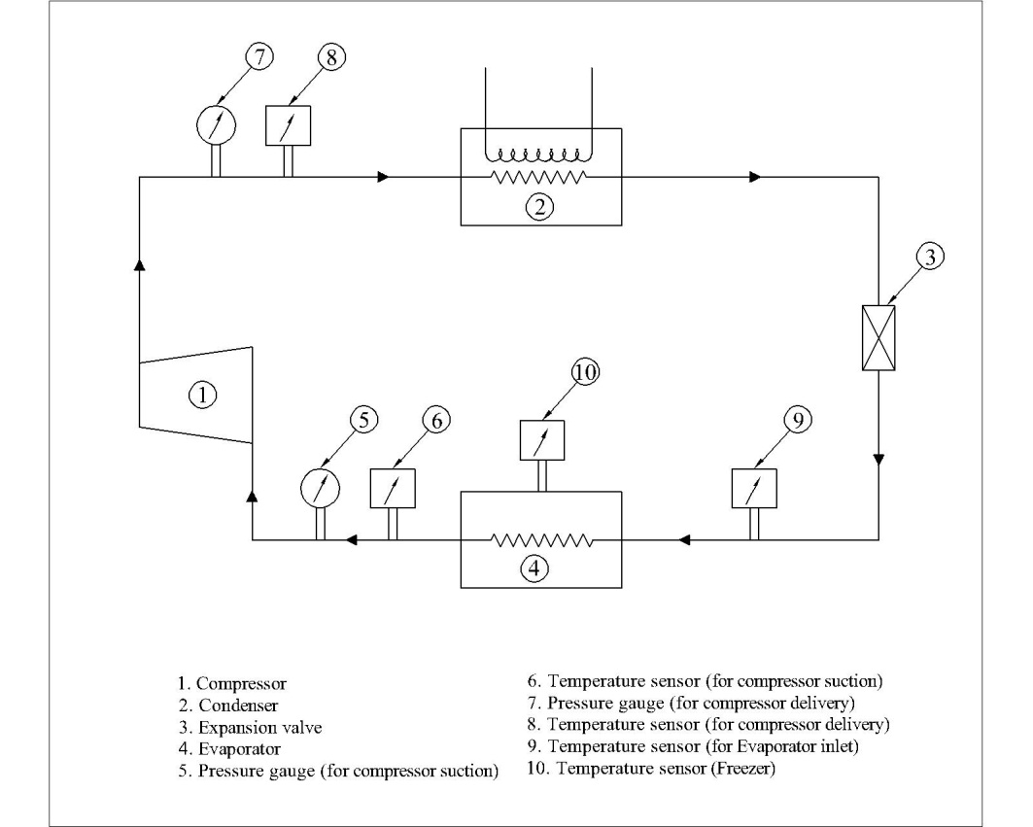 **Figure 3.1 Schematic diagram of the Experimental setup**

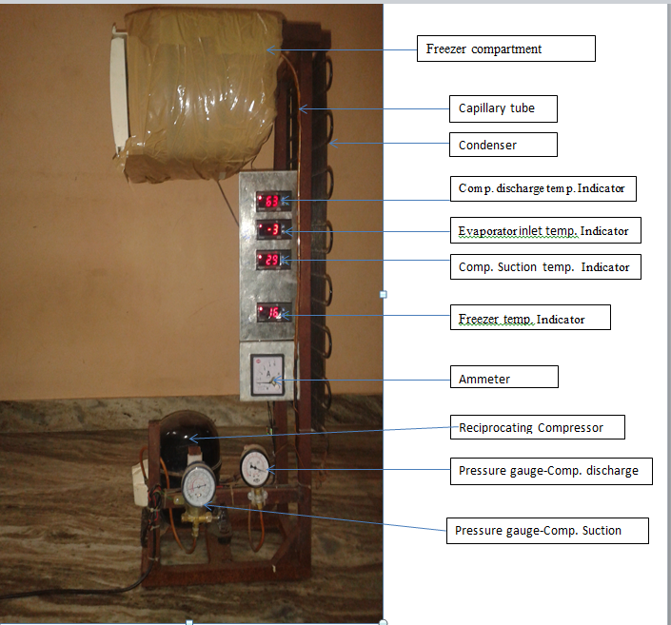

**Figure 3.2 Pictorial view of the experimental setup**

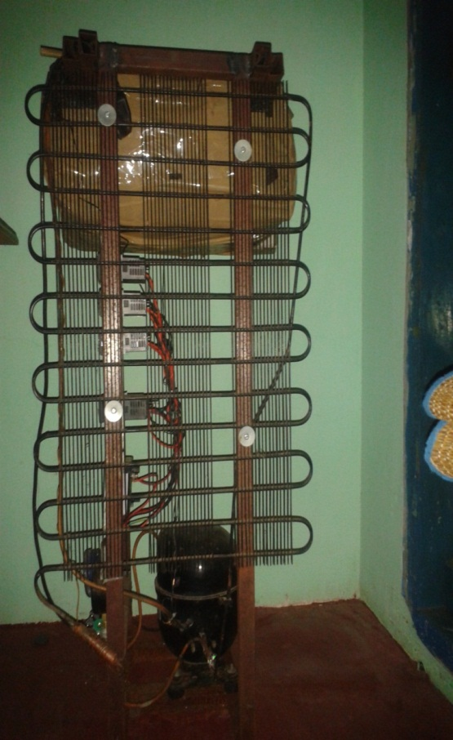

**Figure 3.3 Rear view of the experimental setup**

**3.2.1 Reciprocating Compressor**

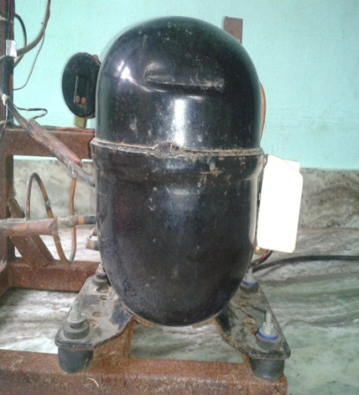

**Figure 3.4 Pictorial view of reciprocating compressor**

**Table 3.1 Specification of the reciprocating compressor**

|  |  |  |
| --- | --- | --- |
| **S.No.** | **Item description** | **Specification** |
| 1. | Make | L.G |
| 2. | Type | Reciprocating |
| 3. | No. of cylinders | One |
| 4. | Refrigerant | R134a&Ref.mixtures |
| 5. | Power supply | 1Φ, 220-240 V |
| 6. | Current | 6Amps (starting) 4.7Amps (running) |
| 7. | Lubricating oil | Poly ol ester |

The pictorial view of the reciprocating compressor is shown in figure 3.4. A reciprocating compressor is a positive displacement machine, where pressure is increased by decreasing the volume of the gas. It is hermitically sealed compressor where the motor and compressor are kept inside in a welded steel dome which cannot be removed easily for internal servicing. The specification of the compressor is given in table 3.1. The compressors are used in the majority of domestic, small commercial and industrial condensing units.

**3.2.2 Capillary Tube**

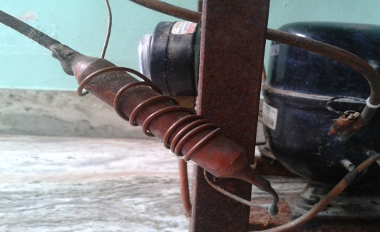

**Figure 3.5 Pictorial view of capillary tube**

The pictorial view of the capillary tube is shown in figure 3.5. The capillary tube is a length of small diameter tubing 1 to 6 m long with the inside diameter generally from 0.5 to 2m.m located ahead of the evaporator. The liquid refrigerant enters the capillary tube and it flows through the tube. The pressure drop occurs due to the friction and acceleration of the refrigerant through the narrow passage. The specification of the capillary tube is given in table 3.2.

**Table 3.2 Specification of the capillary tube**

|  |  |  |
| --- | --- | --- |
| S.No. | **Description** | **Specification** |
| 1. | Material | Copper |
| 2. | Inner diameter | 1.05 ± 0.02 mm |
| 3. | Outer diameter | 2.0 ± 0.05mm |
| 4. | Length | 2.0 ± 0.03m |

**3.2.3 Condenser**

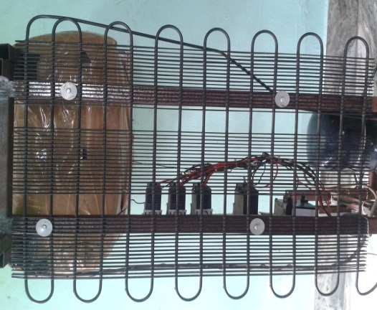

**Figure 3.6 Pictorial view of the condenser**

The pictorial view of the condenser is shown in figure 3.6. The condenser is the component in the refrigeration cycle where heat is removed and rejected. This type of condenser consists of finned tube in which the heat removal is done by air. The specification of the condenser is given in table 3.3.

**Table 3.3 Specification of the condenser**

|  |  |  |
| --- | --- | --- |
| S.No. | Description | Specification |
| 1 | Type | Air cooled |
| 2 | Tube material | Copper |
| 3 | Tube diameter(inner/outer) | 6.15/9.22mm |
| 4 | Outer surface area | 0.0549 m2 |

**3.2.4 Evaporator**

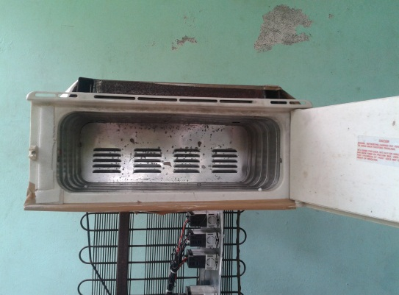

**Figure 3.7 Pictorial view of evaporator**

The pictorial view of theevaporator used in the system is shown in figure 3.7. Evaporator is the heat exchanger in which a refrigerant is evaporated at low temperature and pressure for the purpose of removing heat from the refrigerated space. The evaporator is the component of the refrigerating machine via which heat from the product, medium or space is transferred to the refrigerant for cooling purpose. The specification of the evaporator is given below in Table 3.4.

**Table 3.4 Specification of the evaporator**

|  |  |  |
| --- | --- | --- |
| S.No | Description | Specification |
| 1 | Type | Plate type |
| 2 | Material | Copper and mild steel plate |
| 3 | Length of freezer panel | 900±1 mm |
| 4 | Thickness of freezer panel | 35±1 mm |
| 5 | Passage way surface of panel | 0.537 m2 |
| 6 | Volume of panel | 0.0245m3 |

**3.2.5 Temperature Indicator**

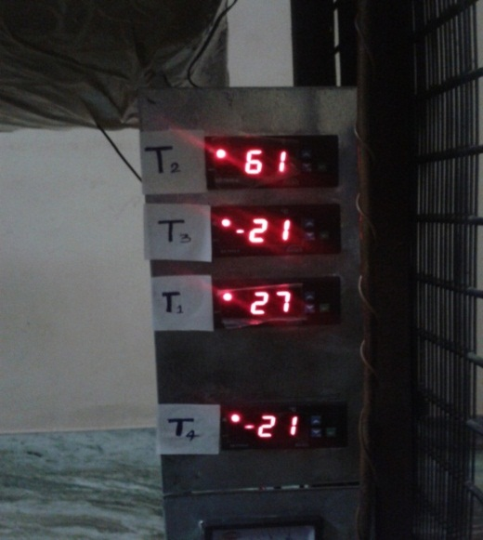

**Figure 3.8 Pictorial view of Temperature Indicator**

The pictorial view of the temperature indicators used in the system is shown in figure 3.8. At various state points on vapour compression refrigeration system is measured by using digital temperature indicator. T1 indicates the compressor suction temperature, T2 indicates the compressor delivery temperature, T3 indicates the evaporator inlet temperature and T4 indicates the freezer temperature. The specification of the temperature indicator is shown in Table 3.5.

**Table 3.5 Specification of the Temperature Indicator**

|  |  |  |  |
| --- | --- | --- | --- |
| S.No | Instrument | Range | Accuracy |
| 1. | Digital type  [‘K’type thermocouple wires] | -50°C to300°C | ± 1 ˚C |

**3.2.6 Pressure Gauges**

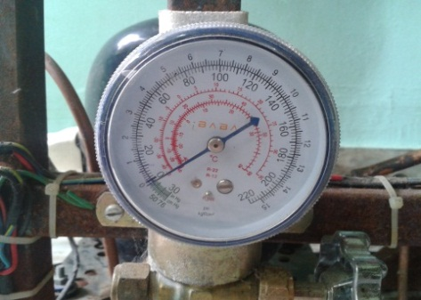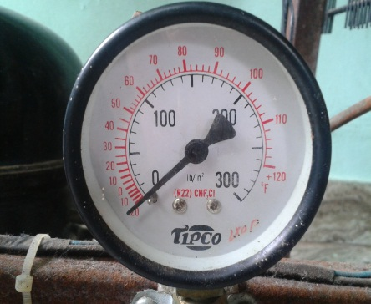

**Figure 3.9(a) Pressure gauge (suction).Figure 3.9(b) Pressure gauge (delivery)**

The pictorial view of the Pressure gauges used in the system is shown in figure 3.9(a) and 3.9(b). The pressure lines of the experimental setup are connected to the pressure gauges, used for measuring compressor suction pressure and measuring compressor delivery pressure. The specification of the pressure gauge is shown in Table 3.6

**Table 3.6 Specification of the Pressure gauges**

|  |  |  |  |  |
| --- | --- | --- | --- | --- |
| S.No | Instrument | Range | Accuracy | Make |
| 1 | Bourdon type gauge (suction) | 0-220kg/cm2 | 0.5 kg/m2 | veve |
| 2 | Bourdon type gauge (delivery) | 0-120 lb/in2 | 1 lb/in2 | Tipco |

**3.2.7 Ammeter**

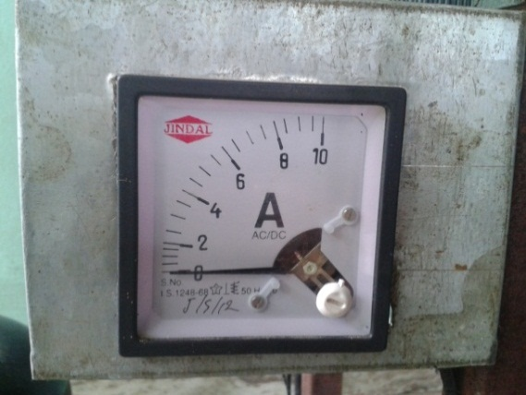

**Figure 3.10 Pictorial view of Ammeter**

The pictorial view of the ammeter which is used in this work is shown in Figure 3.10. A 0-10 amps ammeter is used for measuring the electric current. Ammeter provides an overview of the entire electrical system. The level of current being drawn and the supply current are clearly displayed and the shunt a measurement resistor can be inserted into the measurement point in a matter of seconds, fine connecting cable that runs from the shunt to the gauge is easy to lay without taking up much time. The specification of the ammeter is shown in Table 3.7.

**Table 3.7 Specification of the Ammeter**

|  |  |  |  |
| --- | --- | --- | --- |
| S.No | Instrument | Range | Accuracy |
| 1 | Analog ampere meter | 0/10 A | 0.1% |

**3.3 EXPERIMENTAL PROCEDURE**

The refrigerant mixtures were prepared by a commercial refrigeration company. The mixtures were prepared by four different refrigerants: propane (R290), isobutane (R-600a),butane(R 600**)** and tetrafluoroethane (R134a) in different proportion. Air temperatures in the frozen food storage compartment (freezer) are monitored and recorded continuously. After the refrigerator was run at steady state unloaded condition, the pressure and temperature of the refrigerant at the inlet, outlet of the compressor, temperature at the inlet of evaporator and inside of freezer compartment were recorded. The temperature was monitored and recorded continuously by the digital temperature indicator.

The low temperature, low pressure vapour is compressed by a compressor to high temperature and pressure vapour. This vapour is condensed into high pressure vapour in the condenser and then passes through the expansion valve. Here, the vapour is throttled down to a low pressure liquid and passed on to an evaporator, where it absorbs heat from the surroundings from the circulating fluid (being refrigerated) and vaporizes into low pressure vapour at state B. The cycle then repeats. The electrical energy consumed by the compressor was measured by an energy meter. The refrigerator was charged with 110g of R134a and the base line performance is studied. After completing the base line test with R134a, the refrigerant was recovered from the system and charged with 80g of mixed refrigerant and the performance was studied.

The refrigerant charge requirement with hydrocarbons is very small due to their higher latent heat of vaporization. Pure propane or butane is not suitable as a direct drop in replacement for R134a. However, the saturation properties of the mixture developed by Rauolt's rule, of HC mixture matches closely the saturation properties of R134a.

Therefore, any mixture of R134a/butane/propane/ isobutene at any mole fraction can have saturation properties very close to R134a.To decide the charge quantity density of the liquid refrigerant is an important parameter. Refrigerant charge is a key parameter in a vapour compression refrigeration system that influences the performance of the system. The properties of the mixtures show that the alternative mixtures mixture-1, mixture-2, mixture-3, mixture-4 and mixture-5 have lower liquid density than R134a. For the alternative mixtures the density is 45% to 56% lower than R134a for the considered operating range.

During the experimentation the atmospheric is maintained at 28 ± 2oC. The experimental procedures were repeated and taken the readings by using different mixtures in the same test unit in the various modes. Service port is installed at the inlet of expansion valve and compressor for charging and recovering the refrigerant. The following parameters are calculated based on the observed values.

1. PULL DOWN TIME: It is the time taken by evaporator air temperature to reach required temperature from the ambient temperature.

2. COP: It is calculated by measuring temperature and pressure of entry and exit point of the entire component by digital sensors and pressure gauge.

3. POWER CONSUMPTION: Power consumption is measured with the help of energy meter.

4. SUCTION AND DISCHARGE PRESSURE: Suction and discharge pressure is carried out by measuring pressure at entry and exit of compressor to predict the compressor life.

**3.3.1 Preparation of Refrigerant Mixture**

The proposed ternary mixture of HFC (R134a)/HC (propane, isobutene and butane) in the present study are zeotrope in nature. Hence mixing of the refrigerants, handling and charging should be done carefully. Many guidelines have been reported in the literature regarding procedure and characteristic of the zeotrope mixtures. The five mixtures mixture-1, mixture-2, mixture-3, mixture-4 and mixture-5 were prepared in separate cylinders before they were charged into the system. To control the concentration shifts, the minimum liquid level of the charge quantity in the refrigerant mixture cylinder should not be less than 10% volume while charging the system. Hence the mixture quantity has been prepared sufficiently to maintain the 10% level. To have an accurate quantity the weight of the mixtures were prepared in small cylinders of 1kg capacity. The following are the steps that have been followed by the researcher for preparing ternary mixture

* Initially cylinders were cleaned and flushed with R134a twice.
* Evacuate the cylinder by vacuum pump up to 0.1mbar.
* Cylinders were kept at a low temperature bath while filling to avoid cross contamination and quick transfer of refrigerant.
* Initially cylinders were filled with required quantity of HC, as HC has a lower vapor pressure than R134a .
* Later the required quantity of R134a is filled in to the cylinder.
* Each cylinder was properly labeled to indicate the name and quantity of filled refrigerant mixture.

While charging the refrigerant into the system it was ensure that only liquid has to enter into the system which is done by placing the cylinder in upright down position.

**3.3.2 Charging**

The following additional requirements should be adhered to:-

• Ensure that contamination of different refrigerants does not occur when using charging equipment. Hoses or lines are to be as short as possible to minimize the amount of refrigerant contained in them. It is recommended that cylinders be kept upright and refrigerant is charged in the liquid phase.

• Ensure that the refrigeration system is earthed prior to charging the system with refrigerant.

• Label the system when charging is complete. The label should state that hydrocarbon refrigerants have been charged into the system and that it is flammable. Position the label in a prominent position on the equipment.

• Extreme care should be taken as to not to overfill the refrigeration system. (Note that hydrocarbon charge sizes are typically 40% to 50% of CFC, HCFC and HFC charge sizes).

**3.3.3 Equivalent Charge Quantity of the Mixtures**

The density difference is important when charging the systems. When charging hydrocarbons by weight, only 40% of the R134a charge is used. When charging hydrocarbons by volume, the same volume as for the halocarbon is used. The system should always be charged with liquid refrigerant in case of blends. It is essential that the system should be filled with an exact charge for better performance. HFC/HC refrigerant is zeotropic blends therefore, while charging with mixture, make sure that the refrigerant drawn from the cylinder is in the liquid form. It is recommended that charging should be done by weight using an electronic weighing scale along with charging equipment. As per the refrigerator manufactures recommendation for the given volume of the refrigerator, considering the instrumentation of the system specified quantity of R134a is 100 grams. In the experiment, refrigerant charge is 10% higher due to the presence of instruments and connecting lines etc. To optimize the mixed refrigerant charge, the refrigerator is charged with 80g.

**3.3.4 OBSERVED VALUES**

**3.3.4.1 REFRIGERENT- R134a**

**Table – 3.8 Observed Values of Refrigerant R134a No load condition**

|  |  |  |  |  |  |  |  |  |
| --- | --- | --- | --- | --- | --- | --- | --- | --- |
| **T1**  **°C** | **T2**  **°C** | **T3**  **°C** | **T4**  **°C** | **P1**  **(Kg/cm²)** | **P2**  **(Kg/cm²)** | **Time**  **(min)** | **Ammeter Reading**  **(Amps)** | **Power consumption**  **(watt-hr.)** |
| 26 | 64 | -6 | -4 | 7 | 16.5 | 5.40 | 0.6 | 12.42 |
| 26 | 63 | -8 | -6 | 6 | 16 | 6.00 | 0.6 | 13.8 |
| 26 | 62 | -10 | -8 | 6 | 16 | 6.32 | 0.6 | 14.54 |
| 26 | 62 | -12 | -10 | 5.5 | 16 | 7.15 | 0.6 | 16.45 |
| 26 | 62 | -14 | -12 | 4 | 15.5 | 8.3 | 0.6 | 19.09 |
| 27 | 62 | -15 | -14 | 4 | 15 | 9.0 | 0.6 | 20.7 |
| 27 | 60 | -17 | -16 | 4 | 14.5 | 10.11 | 0.6 | 23.25 |
| 27 | 57 | -18 | -17 | 3.5 | 14 | 12 | 0.6 | 27.6 |
| 27 | 57 | -20 | -18 | 3.5 | 13 | 12.40 | 0.6 | 28.52 |

**Table – 3.9 Observed Values of Refrigerant R 134a with Load1 condition**

|  |  |  |  |  |  |  |  |  |
| --- | --- | --- | --- | --- | --- | --- | --- | --- |
| **T1**  **°C** | **T2**  **°C** | **T3**  **°C** | **T4**  **°C** | **P1**  **(Kg/cm²)** | **P2**  **(Kg/cm² )** | **Time**  **(min)** | **Ammeter Reading**  **(Amps)** | **Power consumption**  **(watt-hr.)** |
| 27 | 65 | -6 | -4 | 8 | 16 | 6.26 | 1.2 | 28.8 |
| 27 | 64 | -8 | -6 | 8 | 16 | 6.52 | 1.2 | 29.99 |
| 27 | 64 | -11 | -8 | 7 | 15.5 | 7.54 | 1.1 | 31.79 |
| 28 | 63 | -12 | -10 | 6 | 15 | 8.56 | 1.0 | 32.81 |
| 28 | 63 | -14 | -12 | 5 | 14.5 | 10.33 | 0.90 | 35.64 |
| 28 | 63 | -16 | -14 | 4 | 14 | 12.28 | 0.8 | 37.66 |
| 28 | 62 | -18 | -16 | 3 | 13.5 | 15.50 | 0.8 | 47.53 |

**Table – 3.10 Observed Values of Refrigerant R134a with load2 condition**

|  |  |  |  |  |  |  |  |  |
| --- | --- | --- | --- | --- | --- | --- | --- | --- |
| **T1**  **°C** | **T2**  **°C** | **T3**  **°C** | **T4**  **°C** | **P1**  **(Kg/cm²)** | **P2**  **(Kg/cm²)** | **Time**  **(min)** | **Ammeter Reading**  **(Amps)** | **Power consumption**  **(watt-hr)** |
| 28 | 67 | -6 | -4 | 9 | 15 | 7.06 | 2.0 | 54.13 |
| 28 | 67 | -8 | -6 | 7 | 14.5 | 8.25 | 1.6 | 50.6 |
| 28 | 66 | -11 | -8 | 6 | 14.5 | 9.29 | 1.4 | 49.86 |
| 29 | 65 | -12 | -10 | 6 | 14 | 11.37 | 1.2 | 52.3 |
| 29 | 65 | -14 | -12 | 5 | 13.5 | 14.44 | 1.0 | 55.35 |
| 29 | 65 | -16 | -14 | 5 | 13.5 | 15.50 | 0.8 | 47.53 |
| 29 | 65 | -18 | -16 | 4 | 13 | 18.53 | 0.7 | 49.72 |
| 29 | 64 | -19 | -18 | 4 | 13 | 22.50 | o.6 | 51.75 |

**Table – 3.11 Observed Values of Refrigerant R134a with load3 condition**

|  |  |  |  |  |  |  |  |  |
| --- | --- | --- | --- | --- | --- | --- | --- | --- |
| **T1**  **°C** | **T2**  **°C** | **T3**  **°C** | **T4**  **°C** | **P1**  **(Kg/cm²)** | **P2**  **(Kg/cm²)** | **Time**  **(min)** | **Ammeter Reading**  **(Amps)** | **Power consumption**  **(watt-hr.)** |
| 27 | 65 | -7 | -4 | 10 | 16 | 5.39 | 1.0 | 20.66 |
| 27 | 64 | -9 | -6 | 9 | 16 | 6.03 | 1.0 | 23.12 |
| 27 | 64 | -10 | -8 | 8 | 15.5 | 6.39 | 0.9 | 22.05 |
| 28 | 63 | -12 | -10 | 7 | 14.5 | 7.27 | 0.9 | 25.08 |
| 28 | 63 | -14 | -12 | 6 | 14.5 | 8.23 | 0.8 | 25.24 |
| 28 | 63 | -16 | -14 | 5 | 14 | 9.20 | 0.8 | 28.21 |
| 28 | 62 | -18 | -16 | 4 | 14 | 11.45 | 0.8 | 35.11 |
| 28 | 60 | -19 | -18 | 4 | 13 | 12.37 | 0.7 | 33.19 |

**Table – 3.12 Observed Values of Refrigerant R134a with load4 condition**

|  |  |  |  |  |  |  |  |  |
| --- | --- | --- | --- | --- | --- | --- | --- | --- |
| **T1**  **°C** | **T2**  **°C** | **T3**  **°C** | **T4**  **°C** | **P1**  **(Kg/cm²)** | **P2**  **(Kg/cm²)** | **Time**  **(min)** | **Ammeter Reading**  **(Amps)** | **Power consumption**  **(watt-hr.)** |
| 26 | 64 | -8 | -4 | 10 | 16 | 5.53 | 1.6 | 33.92 |
| 26 | 63 | -10 | -6 | 9 | 15.5 | 6.28 | 1.4 | 33.7 |
| 26 | 63 | -13 | -8 | 8 | 15.5 | 7.05 | 1.2 | 32.43 |
| 26 | 62 | -14 | -10 | 8 | 15 | 8.01 | 1.0 | 30.71 |
| 26 | 62 | -15 | -12 | 6 | 15 | 9.18 | 0.8 | 28.15 |
| 27 | 62 | -16 | -14 | 6 | 14.5 | 10.30 | 0.8 | 27.64 |
| 27 | 60 | -18 | -16 | 5 | 14 | 13.38 | 0.8 | 40.73 |
| 27 | 60 | -19 | -18 | 4 | 14 | 14.07 | o.7 | 47.76 |

**3.3.4.2 REFRIGERENT- MIXTURE-1**

(5%R134a/47.5%R290/ 47.5%R600a/5% R600)

**Table-3.13 Observed Values of Refrigerant Mixture -1 No load condition**

|  |  |  |  |  |  |  |  |  |
| --- | --- | --- | --- | --- | --- | --- | --- | --- |
| **T1**  **°C** | **T2**  **°C** | **T3**  **°C** | **T4**  **°C** | **P1**  **(Kg/cm²)** | **P2**  **(Kg/cm²)** | **Time**  **(min)** | **Ammeter Reading**  **(Amps)** | **Power consumption**  **(watt-hr.)** |
| 25 | 62 | -8 | -4 | 12 | 16 | 5.51 | 0.4 | 8.45 |
| 25 | 61 | -10 | -6 | 11 | 16 | 6.18 | 0.4 | 9.48 |
| 25 | 60 | -13 | -8 | 10 | 15.5 | 6.49 | 0.4 | 9.95 |
| 25 | 60 | -14 | -10 | 9 | 15 | 7.26 | 0.4 | 11.13 |
| 25 | 60 | -15 | -12 | 8 | 14.5 | 8.13 | 0.4 | 12.47 |
| 25 | 60 | -16 | -14 | 7 | 14 | 9.0 | 0.4 | 13.8 |
| 27 | 58 | -18 | -16 | 6 | 13.5 | 10.0 | 0.4 | 15.33 |
| 27 | 57 | -19 | -18 | 6 | 13.5 | 12.26 | 0.4 | 18.8 |
| 27 | 57 | -21 | -20 | 6 | 13 | 13.05 | 0.4 | 20.01 |

**Table –3.14 Observed Values of Refrigerant Mixture -1 with load1 condition**

|  |  |  |  |  |  |  |  |  |
| --- | --- | --- | --- | --- | --- | --- | --- | --- |
| **T1**  **°C** | **T2**  **°C** | **T3**  **°C** | **T4**  **°C** | **P1**  **(Kg/cm²)** | **P2**  **(Kg/cm²)** | **Time**  **(min)** | **Ammeter Reading**  **(Amps)** | **Power consumption**  **(watt-hr.)** |
| 27 | 65 | -6 | -4 | 16.5 | 17.5 | 6.40 | 1.1 | 26.99 |
| 27 | 64 | -8 | -6 | 15.5 | 17 | 7.21 | 1.1 | 30.4 |
| 27 | 64 | -11 | -8 | 14.5 | 16.5 | 9.03 | 1.0 | 34.62 |
| 28 | 63 | -12 | -10 | 13.5 | 16 | 11.10 | 1.0 | 42.55 |
| 28 | 63 | -14 | -12 | 11.5 | 15.5 | 12.21 | 0.9 | 42.12 |
| 28 | 63 | -16 | -14 | 10 | 15 | 14.0 | 0.8 | 42.93 |
| 28 | 62 | -18 | -16 | 9.5 | 13.5 | 15.12 | 0.7 | 40.57 |
| 28 | 60 | -19 | -18 | 9 | 13.5 | 17.45 | 0.6 | 44.74 |
|  | 65 | -20 | -20 | 9 | 13 | 20.05 | 0.5 | 38.43 |

**Table – 3.15 Observed Values of Refrigerant Mixture -1 with load2 condition**

|  |  |  |  |  |  |  |  |  |
| --- | --- | --- | --- | --- | --- | --- | --- | --- |
| **T1**  **°C** | **T2**  **°C** | **T3**  **°C** | **T4**  **°C** | **P1**  **(Kg/cm²)** | **P2**  **(Kg/cm²)** | **Time**  **(min)** | **Ammeter Reading**  **(Amps)** | **Power consumption**  **(watt-hr.)** |
| 28 | 65 | -6 | -4 | 16 | 18 | 6.37 | 1.7 | 41.51 |
| 28 | 65 | -8 | -6 | 14.5 | 17.5 | 7.46 | 1.5 | 42.9 |
| 28 | 65 | -11 | -8 | 14 | 16.5 | 8.56 | 1.5 | 49.22 |
| 28 | 64 | -12 | -10 | 13.5 | 16 | 10.11 | 1.1 | 42.63 |
| 27 | 64 | -14 | -12 | 12 | 15.5 | 12.20 | 1.1 | 51.44 |
| 27 | 64 | -16 | -14 | 10 | 15.5 | 13.27 | 0.9 | 45.78 |
| 27 | 63 | -18 | -16 | 9.5 | 15 | 14.26 | 0.6 | 32.8 |

**Table – 3.16 Observed Values of Refrigerant Mixture - 1 with load3 condition**

|  |  |  |  |  |  |  |  |  |
| --- | --- | --- | --- | --- | --- | --- | --- | --- |
| **T1**  **°C** | **T2**  **°C** | **T3**  **°C** | **T4**  **°C** | **P1**  **(Kg/cm²)** | **P2**  **(Kg/cm²)** | **Time**  **(min)** | **Ammeter Reading**  **(Amps)** | **Power consumption**  **(watt-hr.)** |
| 28 | 66 | -8 | -4 | 16 | 17 | 5.18 | 0.9 | 17.87 |
| 28 | 64 | -10 | -6 | 15 | 16.5 | 5.24 | 0.9 | 18.08 |
| 28 | 66 | -13 | -8 | 14 | 16 | 6.28 | 0.8 | 19.26 |
| 27 | 65 | -14 | -10 | 13 | 15 | 7.14 | 0.8 | 21.9 |
| 27 | 64 | -15 | -12 | 12 | 14.5 | 8.59 | 0.7 | 23.05 |
| 27 | 64 | -16 | -14 | 11.5 | 14 | 10.12 | 0.7 | 27.16 |
| 27 | 63 | -18 | -16 | 10 | 13.5 | 12.25 | 0.6 | 28.18 |
| 27 | 62 | -19 | -18 | 9 | 13 | 16.1 | 0.6 | 37.03 |

**Table – 3.17 Observed Values of Refrigerant Mixture- 1 with load4 condition**

|  |  |  |  |  |  |  |  |  |
| --- | --- | --- | --- | --- | --- | --- | --- | --- |
| **T1**  **°C** | **T2**  **°C** | **T3**  **°C** | **T4**  **°C** | **P1**  **(Kg/cm²)** | **P2**  **(Kg/cm²)** | **Time**  **(min)** | **Ammeter Reading**  **(Amps)** | **Power consumption**  **(watt-hr.)** |
| 28 | 67 | -8 | -4 | 16 | 17.5 | 6.04 | 1.5 | 34.73 |
| 28 | 66 | -10 | -6 | 15.5 | 16.5 | 6.59 | 1.3 | 32.84 |
| 28 | 66 | -13 | -8 | 14.5 | 16 | 7.35 | 1.2 | 33.81 |
| 28 | 65 | -14 | -10 | 13 | 16 | 9.05 | 1.0 | 34.69 |
| 28 | 65 | -15 | -12 | 12 | 15.5 | 11.27 | 0.7 | 30.24 |
| 27 | 65 | -16 | -14 | 10 | 15 | 15.07 | 0.6 | 34.66 |
| 27 | 64 | -18 | -16 | 9 | 14.5 | 16.45 | 0.6 | 37.84 |

**3.3.4.3 REFRIGERANT- MIXTURE-2**

(15%R134a/40%R290/ 40%R600a/5% R600)

**Table – 3.18 Observed Values of Refrigerant Mixture- 2 No load condition**

|  |  |  |  |  |  |  |  |  |  |
| --- | --- | --- | --- | --- | --- | --- | --- | --- | --- |
| **T1**  **°C** | **T2**  **°C** | **T3**  **°C** | **T4**  **°C** | **P1**  **(kg/cm²)** | **P2**  **(Kg/cm²)** | | **Time**  **(min)** | **Ammeter Reading(Amps** | **Power consumption**  **(watt-hr.)** |
| 26 | 62 | -8 | -4 | 13 | 17.5 | 5.50 | | 0.5 | 10.54 |
| 26 | 62 | -10 | -6 | 12 | 16.5 | 6.12 | | 0.5 | 11.73 |
| 26 | 61 | -13 | -8 | 11 | 16 | 6.34 | | 0.5 | 12.15 |
| 26 | 61 | -14 | -10 | 10 | 15.5 | 7.20 | | 0.5 | 13.8 |
| 26 | 60 | -15 | -12 | 9 | 15 | 8.03 | | 0.5 | 15.39 |
| 26 | 60 | -16 | -14 | 8 | 14.5 | 8.95 | | 0.5 | 17.15 |
| 26 | 58 | -18 | -16 | 7 | 14 | 9.44 | | 0.5 | 18.09 |
| 26 | 57 | -19 | -18 | 6 | 13.5 | 12.12 | | 0.5 | 23.23 |

**Table- 3.19 Observed Values of Refrigerant Mixture- 2 With Load1 condition**

|  |  |  |  |  |  |  |  |  |
| --- | --- | --- | --- | --- | --- | --- | --- | --- |
| **T1**  **°C** | **T2**  **°C** | **T3**  **°C** | **T4**  **°C** | **P1**  **(Kg/cm²)** | **P2**  **(Kg/cm²)** | **Time**  **(min)** | **Ammeter Reading**  **(Amps)** | **Power consumption**  **(watt-hr.)** |
| 25 | 62 | -8 | -4 | 17 | 18 | 6.37 | 1.2 | 29.3 |
| 25 | 61 | -10 | -6 | 16 | 17 | 7.28 | 1.1 | 30.7 |
| 25 | 60 | -13 | -8 | 15 | 16.5 | 9.00 | 1.0 | 34.5 |
| 25 | 60 | -14 | -10 | 14 | 16 | 11.02 | 0.9 | 38.02 |
| 25 | 60 | -15 | -12 | 13 | 15.5 | 12.18 | 0.9 | 42.02 |
| 25 | 60 | -16 | -14 | 12 | 15 | 14.07 | 0.8 | 43.15 |
| 26 | 58 | -18 | -16 | 10 | 14 | 16.20 | 0.7 | 43.47 |
| 26 | 57 | -19 | -18 | 9 | 13.5 | 19.40 | 0.6 | 44.62 |
| 27 | 57 | -21 | -20 | 8.5 | 13 | 20.20 | 0.5 | 38.72 |

**Table-3.20 Observed Values of Refrigerant Mixture -2 With Load2 condition**

|  |  |  |  |  |  |  |  |  |
| --- | --- | --- | --- | --- | --- | --- | --- | --- |
| **T1**  **°C** | **T2**  **°C** | **T3**  **°C** | **T4**  **°C** | **P1**  **(Kg/cm²)** | **P2**  **(Kg/cm²)** | **Time**  **(min)** | **Ammeter Reading**  **(Amps)** | **Power consumption**  **(watt-hr.)** |
| 25 | 62 | -8 | -4 | 17 | 18 | 7.08 | 1.7 | 46.14 |
| 25 | 61 | -10 | -6 | 16 | 17.5 | 7. 47 | 1.5 | 42.95 |
| 25 | 60 | -13 | -8 | 14.5 | 17 | 8.20 | 1.5 | 47.15 |
| 25 | 60 | -14 | -10 | 13.5 | 16 | 10.00 | 1.1 | 42.17 |
| 25 | 60 | -15 | -12 | 12.5 | 15.5 | 12.20 | 1.1 | 51.44 |
| 25 | 60 | -16 | -14 | 10 | 15.5 | 13.21 | 0.9 | 45.57 |
| 26 | 58 | -18 | -16 | 9.5 | 15 | 15.13 | 0.6 | 34.8 |
| 26 | 57 | -19 | -18 | 8 | 15 | 17.31 | o.6 | 39.81 |
| 27 | 57 | -21 | -20 | 8 | 14 | 19 | 0.6 | 43.7 |

**Table-3.21 Observed Values of Refrigerant Mixture -2 With Load3 condition**

|  |  |  |  |  |  |  |  |  |
| --- | --- | --- | --- | --- | --- | --- | --- | --- |
| **T1**  **°C** | **T2**  **°C** | **T3**  **°C** | **T4**  **°C** | **P1**  **(Kg/cm²)** | **P2**  **(Kg/cm²)** | **Time**  **(min)** | **Ammeter Reading**  **(Amps)** | **Power consumption**  **(watt-hr.)** |
| 25 | 62 | -8 | -4 | 12 | 16 | 5.51 | 0.8 | 16.9 |
| 25 | 61 | -10 | -6 | 11 | 16 | 6.18 | 0.8 | 18.95 |
| 25 | 60 | -13 | -8 | 10 | 15.5 | 6.49 | 0.8 | 19.9 |
| 25 | 60 | -14 | -10 | 9 | 15 | 7.26 | 0.8 | 22.26 |
| 25 | 60 | -15 | -12 | 8 | 14.5 | 8.13 | 0.7 | 21.82 |
| 25 | 60 | -16 | -14 | 7 | 14 | 9.0 | 0.7 | 24.15 |
| 26 | 58 | -18 | -16 | 6 | 13.5 | 10.0 | 0.6 | 23 |
| 26 | 57 | -19 | -18 | 6 | 13.5 | 12.26 | 0.6 | 28.2 |
| 27 | 57 | -21 | -20 | 6 | 13 | 13.05 | 0.6 | 30.02 |
| 27 | 56 | -22 | -21 | 6 | 13 | 13.53 | 0.6 | 31.12 |

**Table-3.22 Observed Values of Refrigerant Mixture -2 With Load4 condition**

|  |  |  |  |  |  |  |  |  |
| --- | --- | --- | --- | --- | --- | --- | --- | --- |
| **T1**  **°C** | **T2**  **°C** | **T3**  **°C** | **T4**  **°C** | **P1**  **(Kg/cm²)** | **P2**  **(Kg/cm²)** | **Time**  **(min)** | **Ammeter Reading**  **(Amps)** | **Power consumption**  **(watt-hr.)** |
| 27 | 66 | -8 | -4 | 17.5 | 18 | 6.26 | 1.5 | 36 |
| 27 | 65 | -10 | -6 | 16 | 17 | 7.42 | 1.4 | 39.82 |
| 27 | 65 | -13 | -8 | 14.5 | 16 | 8.27 | 1.3 | 41.21 |
| 27 | 65 | -14 | -10 | 13 | 16 | 9.45 | 1.0 | 36.23 |
| 27 | 64 | -15 | -12 | 12.5 | 15.5 | 12.54 | 0.8 | 38.46 |
| 27 | 63 | -16 | -14 | 11 | 15.5 | 15.25 | 0.7 | 40.92 |
| 28 | 63 | -18 | -16 | 9 | 15 | 17.34 | 0.6 | 39.88 |
| 28 | 62 | -19 | -18 | 9 | 15 | 20.08 | o.6 | 46.18 |
| 28 | 62 | -21 | -20 | 8.5 | 14.5 | 21.15 | 0.5 | 40.54 |
| 28 | 62 | -22 | -21 | 8.5 | 14.5 | 22.10 | 0.5 | 42.36 |

**3.3.4.3 REFRIGERENT- MIXTURE-3**

(20%R134a/37.5%R290/ 37.5%R600a/5% R600)

**Table-3.23 Observed Values of Refrigerant Mixture -3 No Load condition**

|  |  |  |  |  |  |  |  |  |
| --- | --- | --- | --- | --- | --- | --- | --- | --- |
| **T1**  **°C** | **T2**  **°C** | **T3**  **°C** | **T4**  **°C** | **P1**  **(Kg/cm²)** | **P2**  **(Kg/cm²)** | **Time**  **(min)** | **Ammeter Reading**  **(Amps)** | **Power consumption**  **(watt-hr.)** |
| 25 | 61 | -8 | -4 | 12 | 16 | 5.51 | 0.5 | 10.56 |
| 25 | 61 | -10 | -6 | 13.5 | 18 | 5.30 | 0.5 | 10.16 |
| 26 | 61 | -13 | -8 | 12.5 | 17 | 5.37 | 0.5 | 10.29 |
| 26 | 61 | -14 | -10 | 11,5 | 16.5 | 6.12 | 0.5 | 11.73 |
| 26 | 60 | -15 | -12 | 10.5 | 15.5 | 6.58 | 0.5 | 12.61 |
| 26 | 60 | -16 | -14 | 10 | 15.5 | 7.36 | 0.5 | 14.11 |
| 26 | 58 | -18 | -16 | 9 | 14.5 | 8.35 | 0.5 | 16 |

**Table-3.24 Observed Values of Refrigerant Mixture- 3 With Load1 condition**

|  |  |  |  |  |  |  |  |  |
| --- | --- | --- | --- | --- | --- | --- | --- | --- |
| **T1**  **°C** | **T2**  **°C** | **T3**  **°C** | **T4**  **°C** | **P1**  **(Kg/cm²)** | **P2**  **(Kg/cm²)** | **Time**  **(min)** | **Ammeter Reading**  **(Amps)** | **Power consumption**  **(watt-hr.)** |
| 25 | 62 | -8 | -4 | 17 | 18 | 6.37 | 1.1 | 26.86 |
| 25 | 61 | -10 | -6 | 16 | 17 | 7.28 | 1.0 | 27.91 |
| 25 | 60 | -13 | -8 | 15 | 16.5 | 9.00 | 0.9 | 31.05 |
| 25 | 60 | -14 | -10 | 14 | 16 | 11.02 | 0.9 | 38.02 |
| 25 | 60 | -15 | -12 | 13 | 15.5 | 12.18 | 0.8 | 37.35 |
| 26 | 60 | -16 | -14 | 12 | 15 | 14.07 | 0.8 | 43.15 |
| 26 | 58 | -18 | -16 | 10 | 14 | 16.20 | 0.7 | 43.47 |
| 26 | 57 | -19 | -18 | 9 | 13.5 | 19.40 | 0.6 | 44.62 |
| 27 | 57 | -21 | -20 | 9 | 13.5 | 19.55 | 0.6 | 44.97 |
| 27 | 56 | -22 | -21 | 9 | 13 | 20.28 | 0.6 | 46.64 |

**Table – 3.25 Observed Values of Refrigerant Mixture-3 With Load2 condition**

|  |  |  |  |  |  |  |  |  |
| --- | --- | --- | --- | --- | --- | --- | --- | --- |
| **T1**  **°C** | **T2**  **°C** | **T3**  **°C** | **T4**  **°C** | **P1**  **(Kg/cm²)** | **P2**  **(Kg/cm²)** | **Time**  **(min)** | **Ammeter Reading**  **(Amps)** | **Power consumption**  **(watt-hr.)** |
| 25 | 62 | -8 | -4 | 17 | 18 | 7.08 | 1.7 | 46.14 |
| 25 | 61 | -10 | -6 | 16.5 | 17.5 | 7.27 | 1.5 | 41.8 |
| 25 | 60 | -13 | -8 | 15 | 17 | 8.40 | 1.5 | 48.3 |
| 25 | 60 | -14 | -10 | 14 | 16.5 | 9.37 | 1.1 | 39.51 |
| 25 | 60 | -15 | -12 | 13 | 16 | 12.10 | 1.1 | 51.02 |
| 25 | 60 | -16 | -14 | 12 | 15.5 | 13.06 | 0.9 | 45.06 |
| 26 | 58 | -18 | -16 | 10 | 15.5 | 14.46 | 0.6 | 33.26 |
| 26 | 57 | -19 | -18 | 9 | 15 | 17.11 | o.6 | 39.35 |
| 27 | 57 | -21 | -20 | 9 | 15 | 17.10 | 0.6 | 39.33 |
| 27 | 56 | -22 | -21 | 9 | 15 | 7.27 | 0.5 | 13.93 |

**Table-3.26 Observed Values of Refrigerant Mixture-3 With Load3 condition**

|  |  |  |  |  |  |  |  |  |
| --- | --- | --- | --- | --- | --- | --- | --- | --- |
| **T1**  **°C** | **T2**  **°C** | **T3**  **°C** | **T4**  **°C** | **P1**  **(Kg/cm²)** | **P2**  **(Kg/cm²)** | **Time**  **(min)** | **Ammeter Reading**  **(Amps)** | **Power consumption**  **(watt-hr.)** |
| 25 | 62 | -8 | -4 | 15 | 16 | 5.68 | 0.8 | 17.42 |
| 25 | 61 | -10 | -6 | 14 | 16 | 6.22 | 0.8 | 19.07 |
| 25 | 60 | -13 | -8 | 13.5 | 15.5 | 7.12 | 0.8 | 21.83 |
| 25 | 60 | -14 | -10 | 12 | 14 | 7.72 | 0.8 | 23.67 |
| 25 | 60 | -15 | -12 | 11 | 14 | 9.20 | 0.7 | 24.69 |
| 25 | 60 | -16 | -14 | 10 | 13.5 | 10.64 | 0.7 | 28.55 |
| 26 | 58 | -18 | -16 | 9 | 13.5 | 13.19 | 0.6 | 30.34 |
| 26 | 57 | -19 | -18 | 8 | 13 | 17.13 | 0.6 | 39.4 |
| 27 | 57 | -21 | -20 | 15 | 16 | 5.68 | 0.6 | 13.06 |
| 27 | 56 | -22 | -21 | 14 | 16 | 6.22 | 0.6 | 14.31 |

**Table-3.27 Observed Values of Refrigerant Mixture- 3 With Load4 condition**

|  |  |  |  |  |  |  |  |  |  |
| --- | --- | --- | --- | --- | --- | --- | --- | --- | --- |
| **T1**  **°C** | **T2**  **°C** | **T3**  **°C** | **T4**  **°C** | **P1**  **(Kg/cm²)** | **P2**  **(Kg/cm²)** | **Time**  **(min)** | **Ammeter Reading**  **(Amps)** | **Power consumption**  **(watt-hr.)** | |
| 25 | 62 | -8 | -4 | 16 | 17.5 | 7.10 | 1.5 | 40.83 |
| 25 | 61 | -10 | -6 | 15 | 16.5 | 7.22 | 1.3 | 35.98 |
| 25 | 60 | -13 | -8 | 14 | 16 | 8.26 | 1.2 | 38 |
| 25 | 60 | -14 | -10 | 12 | 16 | 9.25 | 1.0 | 35.46 |
| 25 | 60 | -15 | -12 | 11 | 15.5 | 12.35 | 0.7 | 33.14 |
| 25 | 60 | -16 | -14 | 9 | 15 | 15.26 | 0.6 | 35.1 |
| 26 | 58 | -18 | -16 | 8 | 15 | 17.17 | 0.6 | 39.49 |
| 26 | 57 | -19 | -18 | 8 | 14 | 19.31 | o.6 | 44.41 |
| 27 | 57 | -21 | -20 | 7.5 | 14.5 | 20.10 | 0.5 | 38.53 |
| 27 | 56 | -22 | -21 | 7.5 | 14.5 | 21.22 | 0.5 | 40.67 |

**3.3.4.4 REFRIGERANT- MIXTURE-4**

(30%R134a/32.5%R290/ 32.5%R600a/5% R600)

**Table-3.28 Observed Values of Refrigerant Mixture- 4 No Load condition**

|  |  |  |  |  |  |  |  |  |
| --- | --- | --- | --- | --- | --- | --- | --- | --- |
| **T1**  **°C** | **T2**  **°C** | **T3**  **°C** | **T4**  **°C** | **P1**  **(Kg/cm²)** | **P2**  **(Kg/cm²)** | **Time**  **(min)** | **Ammeter Reading**  **(Amps)** | **Power consumption**  **(watt-hr.)** |
| 25 | 62 | -8 | -4 | 12 | 16 | 5.61 | 0.5 | 10.75 |
| 25 | 61 | -10 | -6 | 12 | 16 | 6.21 | 0.5 | 11.9 |
| 26 | 61 | -13 | -8 | 10.5 | 15.5 | 6.54 | 0.5 | 12.54 |
| 26 | 61 | -14 | -10 | 9 | 15 | 7.51 | 0.5 | 14.39 |
| 26 | 60 | -15 | -12 | 8.5 | 14.5 | 8.34 | 0.5 | 15.99 |
| 26 | 60 | -16 | -14 | 7 | 14 | 9.13 | 0.5 | 17.5 |
| 26 | 58 | -18 | -16 | 6.5 | 13.5 | 10.14 | 0.5 | 19.44 |
| 26 | 57 | -19 | -18 | 6 | 13.5 | 12.27 | 0.5 | 23.52 |
| 27 | 57 | -21 | -20 | 6 | 13.5 | 13.20 | 0.5 | 25.3 |
| 27 | 56 | -22 | -21 | 6 | 13,5 | 14.10 | 0.5 | 27.03 |

**Table-3.29 Observed Values of Refrigerant Mixture- 4 With Load1 condition**

|  |  |  |  |  |  |  |  |  |
| --- | --- | --- | --- | --- | --- | --- | --- | --- |
| **T1**  **°C** | **T2**  **°C** | **T3**  **°C** | **T4**  **°C** | **P1**  **(Kg/cm² )** | **P2**  **(Kg/cm²)** | **Time**  **(min)** | **Ammeter Reading**  **(Amps)** | **Power consumption**  **(watt-hr.)** |
| 25 | 62 | -8 | -4 | 16 | 17 | 7.06 | 1.1 | 29.77 |
| 25 | 61 | -10 | -6 | 15 | 16.5 | 7.52 | 1.1 | 31.71 |
| 25 | 60 | -13 | -8 | 14 | 16. | 9.22 | 0.9 | 31.81 |
| 25 | 60 | -14 | -10 | 13 | 15.5 | 11.25 | 0.9 | 38.81 |
| 25 | 60 | -15 | -12 | 11 | 15.5 | 12.48 | 0.9 | 43.06 |
| 25 | 60 | -16 | -14 | 10 | 15 | 14.27 | 0.8 | 43.76 |
| 26 | 58 | -18 | -16 | 9 | 13.5 | 16.40 | 0.7 | 44.01 |
| 26 | 57 | -19 | -18 | 6 | 13.5 | 12.26 | 0.7 | 32.9 |
| 27 | 57 | -21 | -20 | 6 | 13 | 13.05 | 0.6 | 30.02 |
| 27 | 56 | -22 | -21 | 6 | 13 | 13.53 | 0.6 | 31.12 |

**Table – 3.30 Observed Values of Refrigerant Mixture -4 with load2 condition**

|  |  |  |  |  |  |  |  |  |
| --- | --- | --- | --- | --- | --- | --- | --- | --- |
| **T1**  **°C** | **T2**  **°C** | **T3**  **°C** | **T4**  **°C** | **P1**  **(Kg/cm² )** | **P2**  **(Kg/cm²)** | **Time**  **(min)** | **Ammeter Reading**  **(Amps)** | **Power consumption**  **(watt-hr.)** |
| 25 | 62 | -8 | -4 | 16 | 17 | 7.31 | 1.7 | 47.64 |
| 25 | 61 | -10 | -6 | 15 | 16.5 | 8.21 | 1.6 | 50.53 |
| 25 | 61 | -13 | -8 | 14.5 | 16.5 | 9.25 | 1.5 | 53.19 |
| 25 | 61 | -14 | -10 | 13 | 16 | 10.33 | 1.3 | 51.48 |
| 25 | 61 | -15 | -12 | 12 | 15.5 | 12.50 | 1.2 | 57.5 |
| 25 | 60 | -16 | -14 | 10 | 15.5 | 13.39 | 1.0 | 51.33 |
| 26 | 58 | -18 | -16 | 9 | 15 | 15.36 | 0.8 | 47.1 |
| 26 | 58 | -19 | -18 | 8 | 15 | 17.56 | o.6 | 40.39 |
| 27 | 58 | -21 | -20 | 8 | 14.5 | 18.31 | 0.6 | 42.11 |
| 27 | 58 | -22 | -21 | 8 | 14.5 | 19.21 | 0.6 | 44.18 |

**Table –3.31 Observed Values of Refrigerant Mixture -4 with load3 condition**

|  |  |  |  |  |  |  |  |  |
| --- | --- | --- | --- | --- | --- | --- | --- | --- |
| **T1**  **°C** | **T2**  **°C** | **T3**  **°C** | **T4**  **°C** | **P1**  **(Kg/cm² )** | **P2**  **(Kg/cm²)** | **Time**  **(min)** | **Ammeter Reading**  **(Amps)** | **Power consumption**  **(watt-hr.)** |
| 25 | 62 | -8 | -4 | 15.5 | 17 | 5.48 | 0.9 | 18.91 |
| 25 | 61 | -10 | -6 | 14 | 16 | 6.32 | 0.9 | 21.8 |
| 25 | 60 | -13 | -8 | 13.5 | 15.5 | 7.43 | 0.8 | 22.79 |
| 25 | 60 | -14 | -10 | 12 | 15 | 7.34 | 0.8 | 22.51 |
| 25 | 60 | -15 | -12 | 11.5 | 14.5 | 9.38 | 0.7 | 25.17 |
| 25 | 60 | -16 | -14 | 10 | 14.5 | 10.59 | 0.7 | 28.42 |
| 26 | 58 | -18 | -16 | 9.5 | 14 | 13.32 | 0.6 | 30.64 |
| 26 | 57 | -19 | -18 | 8 | 13 | 17.20 | 0.6 | 39.56 |
| 27 | 57 | -21 | -20 | 8 | 13 | 18.30 | 0.6 | 42.09 |
| 27 | 56 | -22 | -21 | 8 | 13 | 19.20 | 0.5 | 36.8 |

**Table – 3.32 Observed Values of Refrigerant Mixture- 4 with load4 condition**

|  |  |  |  |  |  |  |  |  |
| --- | --- | --- | --- | --- | --- | --- | --- | --- |
| **T1**  **°C** | **T2**  **°C** | **T3**  **°C** | **T4**  **°C** | **P1**  **(Kg/cm² )** | **P2**  **(Kg/cm²)** | **Time**  **(min)** | **Ammeter Reading**  **(Amps)** | **Power consumption**  **(watt-hr.)** |
| 25 | 62 | -8 | -4 | 16 | 18 | 6.56 | 1.5 | 37.72 |
| 25 | 61 | -10 | -6 | 15.5 | 17.5 | 7.23 | 1.4 | 38.8 |
| 25 | 60 | -13 | -8 | 14 | 17 | 8.36 | 1.2 | 38.46 |
| 25 | 60 | -14 | -10 | 13 | 16 | 9.27 | 1.1 | 39.09 |
| 26 | 59 | -15 | -12 | 11 | 15.5 | 12.25 | 0.8 | 37.37 |
| 26 | 59 | -16 | -14 | 9 | 15.5 | 15.29 | 0.7 | 41.03 |
| 26 | 58 | -18 | -16 | 9 | 15 | 17.21 | 0.6 | 39.58 |
| 26 | 57 | -19 | -18 | 6 | 13.5 | 18.26 | o.6 | 41.98 |
| 27 | 57 | -21 | -20 | 6 | 13 | 19.05 | 0.6 | 43.82 |
| 27 | 56 | -22 | -21 | 6 | 13 | 20.53 | 0.5 | 39.35 |

**3.3.4.5 REFRIGERANT- MIXTURE-5**

(40%R134a/27.5%R290/ 27.5%R600a/5% R600)

**Table – 3.33 Observed Values of Refrigerant Mixture- 5 No Load condition**

|  |  |  |  |  |  |  |  |  |
| --- | --- | --- | --- | --- | --- | --- | --- | --- |
| **T1**  **°C** | **T2**  **°C** | **T3**  **°C** | **T4**  **°C** | **P1**  **(Kg/cm² )** | **P2**  **(Kg/cm²)** | **Time**  **(min)** | **Ammeter Reading**  **(Amps)** | **Power consumption**  **(watt-hr.)** |
| 25 | 62 | -8 | -4 | 11.5 | 16 | 5.53 | 0.5 | 10.6 |
| 25 | 61 | -10 | -6 | 12 | 16 | 6.51 | 0.5 | 12.48 |
| 25 | 61 | -13 | -8 | 11 | 15.5 | 6.34 | 0.5 | 12.15 |
| 25 | 60 | -14 | -10 | 10 | 15 | 7.51 | 0.5 | 14.39 |
| 25 | 60 | -15 | -12 | 9 | 14.5 | 8.44 | 0.5 | 16.18 |
| 26 | 60 | -16 | -14 | 7 | 14 | 9.33 | 0.5 | 17.88 |
| 26 | 58 | -18 | -16 | 6.5 | 13.5 | 10.44 | 0.5 | 20.01 |
| 27 | 57 | -19 | -18 | 6 | 13.5 | 12.47 | 0.5 | 23.9 |
| 27 | 57 | -21 | -20 | 6 | 13 | 13.10 | 0.5 | 25.11 |
| 27 | 56 | -22 | -21 | 6 | 13 | 14.30 | 0.5 | 27.41 |

**Table – 3.34 Observed Values of Refrigerant Mixture- 5 with load1 condition**

|  |  |  |  |  |  |  |  |  |
| --- | --- | --- | --- | --- | --- | --- | --- | --- |
| **T1**  **°C** | **T2**  **°C** | **T3**  **°C** | **T4**  **°C** | **P1**  **(Kg/cm² )** | **P2**  **(Kg/cm²)** | **Time**  **(min)** | **Ammeter Reading**  **(Amps)** | **Power consumption**  **(watt-hr.)** |
| 26 | 63 | -8 | -4 | 16 | 17 | 7.06 | 1.1 | 29.77 |
| 26 | 63 | -10 | -6 | 15 | 16.5 | 7.58 | 1.0 | 29.06 |
| 26 | 62 | -13 | -8 | 14 | 16.5 | 9.22 | 0.9 | 31.81 |
| 26 | 62 | -14 | -10 | 13 | 15.5 | 11.22 | 0.9 | 38.71 |
| 26 | 62 | -15 | -12 | 11 | 15.5 | 12.48 | 1.0 | 48.98 |
| 26 | 60 | -16 | -14 | 10 | 15 | 14.27 | 0.8 | 43.76 |
| 27 | 59 | -18 | -16 | 9 | 13.5 | 16.40 | 0.7 | 44.21 |
| 27 | 58 | -19 | -18 | 8 | 13 | 18.0 | 0.7 | 48.3 |
| 27 | 57 | -21 | -20 | 8 | 13 | 19.10 | 0.6 | 43.93 |
| 28 | 56 | -22 | -21 | 8 | 13 | 20.10 | 0.6 | 46.23 |

**Table – 3.35 Observed Values of Refrigerant Mixture -5 with load2 condition**

|  |  |  |  |  |  |  |  |  |
| --- | --- | --- | --- | --- | --- | --- | --- | --- |
| **T1**  **°C** | **T2**  **°C** | **T3**  **°C** | **T4**  **°C** | **P1**  **(Kg/cm² )** | **P2**  **(Kg/cm²)** | **Time**  **(min)** | **Ammeter Reading**  **(Amps)** | **Power consumption**  **(watt-hr.)** |
| 26 | 63 | -8 | -4 | 17.5 | 18 | 7.41 | 1.8 | 51.13 |
| 26 | 63 | -10 | -6 | 16 | 17.5 | 8.32 | 1.6 | 51.03 |
| 26 | 62 | -13 | -8 | 16 | 16.5 | 9.35 | 1.5 | 53.76 |
| 26 | 62 | -14 | -10 | 14 | 16 | 10.58 | 1.4 | 56.78 |
| 26 | 62 | -15 | -12 | 11 | 16 | 12.86 | 1.2 | 59.16 |
| 27 | 60 | -16 | -14 | 10 | 15.5 | 13.78 | 1.0 | 52.82 |
| 27 | 59 | -18 | -16 | 10 | 155 | 15.23 | 1.0 | 58.38 |
| 27 | 58 | -19 | -18 | 9 | 15 | 16.21 | o.7 | 43.69 |
| 28 | 58 | -21 | -20 | 9 | 15 | 18.10 | 0.6 | 41.63 |
| 28 | 57 | -22 | -21 | 9 | 15 | 19.20 | 0.6 | 44.16 |

**Table-3.36 Observed Values of Refrigerant Mixture -5 with load3 condition**

|  |  |  |  |  |  |  |  |  |
| --- | --- | --- | --- | --- | --- | --- | --- | --- |
| **T1**  **°C** | **T2**  **°C** | **T3**  **°C** | **T4**  **°C** | **P1**  **(Kg/cm² )** | **P2**  **(Kg/cm²)** | **Time**  **(min)** | **Ammeter Reading**  **(Amps)** | **Power consumption**  **(watt-hr.)** |
| 25 | 62 | -8 | -4 | 15 | 16 | 5.58 | 0.9 | 19.25 |
| 25 | 61 | -10 | -6 | 14.5 | 16 | 6.22 | 0.9 | 21.46 |
| 25 | 60 | -13 | -8 | 13.5 | 15.5 | 7.10 | 0.8 | 21.77 |
| 25 | 60 | -14 | -10 | 13 | 14.5 | 7.64 | 0.8 | 23.43 |
| 25 | 60 | -15 | -12 | 12 | 14.5 | 9.38 | 0.7 | 25.17 |
| 26 | 59 | -16 | -14 | 10 | 14 | 10.59 | 0.7 | 28.42 |
| 26 | 58 | -18 | -16 | 9 | 14 | 13.29 | 0.7 | 35.66 |
| 26 | 57 | -19 | -18 | 8 | 13 | 17.21 | 0.6 | 39.58 |
| 27 | 57 | -21 | -20 | 8 | 13 | 18.50 | 0.6 | 42.55 |
| 27 | 56 | -22 | -21 | 8 | 13 | 20.10 | 0.5 | 38.53 |

**Table-3.37 Observed Values of Refrigerant Mixture -5 with load4 condition**

|  |  |  |  |  |  |  |  |  |
| --- | --- | --- | --- | --- | --- | --- | --- | --- |
| **T1**  **°C** | **T2**  **°C** | **T3**  **°C** | **T4**  **°C** | **P1**  **(Kg/cm²)** | **P2**  **(Kg/cm²)** | **Time**  **(min)** | **Ammeter Reading**  **(Amps)** | **Power consumption**  **(watt-hr.)** |
| 26 | 62 | -8 | -4 | 17 | 18.5 | 6.36 | 1.6 | 39.01 |
| 26 | 61 | -10 | -6 | 16 | 16.5 | 7.12 | 1.4 | 38.21 |
| 26 | 61 | -13 | -8 | 15 | 16 | 8.16 | 1.3 | 40.66 |
| 26 | 61 | -14 | -10 | 13 | 16 | 9.05 | 1.2 | 41.63 |
| 25 | 61 | -15 | -12 | 11 | 15 | 12.05 | 0.9 | 41.57 |
| 26 | 60 | -16 | -14 | 9 | 15.5 | 15.21 | 0.8 | 46.64 |
| 26 | 58 | -18 | -16 | 8 | 15 | 17.11 | 0.7 | 45.91 |
| 26 | 58 | -19 | -18 | 8 | 14 | 19.41 | o.6 | 44.64 |
| 27 | 57 | -21 | -20 | 7.5 | 14 | 20.40 | 0.6 | 46.92 |
| 27 | 56 | -22 | -21 | 7.5 | 14 | 21.25 | 0.6 | 48.88 |

**Table 3.38 Performance of R134a refrigerant**

|  |  |  |  |  |
| --- | --- | --- | --- | --- |
| **Sl. No** | **Temperature**  **T3(°C)** | **Refrigeration Effect** | **Work done**  **( KJ/ kg )** | **COP** |
| 1 | -4 | 126 | 52.4 | 2.38 |
| 2 | -8 | 125 | 52.1 | 2.39 |
| 3 | -12 | 125 | 55 | 2.27 |
| 4 | -16 | 128.4 | 56.2 | 2.28 |
| 5 | -18 | 130.6 | 56.8 | 2.29 |

**Table 3.39 Performance of Refrigerant Mixture- 1**

|  |  |  |  |  |
| --- | --- | --- | --- | --- |
| **Sl. No** | **Temperature**  **T3 (°C)** | **Refrigeration Effect** | **Work done**  **( KJ/ kg )** | **COP** |
| 1 | -4 | 241.92 | 86.4 | 2.8 |
| 2 | -8 | 240.2 | 86.1 | 2.79 |
| 3 | -12 | 242.6 | 86.3 | 2.81 |
| 4 | -16 | 246.4 | 87.9 | 2.8 |
| 5 | -18 | 249.2 | 88.5 | 2.81 |

**Table 3.40 Performance of Refrigerant Mixture- 2**

|  |  |  |  |  |
| --- | --- | --- | --- | --- |
| **Sl. No** | **Temperature**  **T3 (°C)** | **Refrigeration Effect** | **Work done**  **( KJ/ kg )** | **COP** |
| 1 | -4 | 230.8 | 71.7 | 3.22 |
| 2 | -8 | 231.2 | 72 | 3.21 |
| 3 | -12 | 231.7 | 72.2 | 3.21 |
| 4 | -16 | 234.4 | 72.8 | 3.22 |
| 5 | -18 | 237.4 | 73.1 | 3.24 |

**Table 3.41 Performance of M-3 refrigerant**

|  |  |  |  |  |
| --- | --- | --- | --- | --- |
| **Sl. No** | **Temperature**  **T3 (°C)** | **Refrigeration Effect** | **Work done**  **( KJ/ kg )** | **COP** |
| 1 | -4 | 214.46 | 72.7 | 2.95 |
| 2 | -8 | 216.81 | 73 | 2.97 |
| 3 | -12 | 217.7 | 73.3 | 2.97 |
| 4 | -16 | 220.06 | 73.6 | 2.99 |
| 5 | -18 | 221.7 | 73.8 | 3 |

**Table 3.42 Performance of M-4 Refrigerant**

|  |  |  |  |  |
| --- | --- | --- | --- | --- |
| **Sl. No** | **Temperature**  **T3 (°C)** | **Refrigeration Effect** | **Work done**  **( KJ/ kg )** | **COP** |
| 1 | -4 | 192.94 | 67.7 | 2.85 |
| 2 | -8 | 194.01 | 67.6 | 2.87 |
| 3 | -12 | 195.07 | 67.5 | 2.89 |
| 4 | -16 | 201.44 | 67.6 | 2.98 |
| 5 | -18 | 203.1 | 68 | 2.98 |

**Table 3.43 Performance of M-5 Refrigerant**

|  |  |  |  |  |
| --- | --- | --- | --- | --- |
| **Sl. No** | **Temperature**  **T3 (°C)** | **Refrigeration Effect** | **Work done**  **( KJ/ kg )** | **COP** |
| 1 | -4 | 179.03 | 62.6 | 2.86 |
| 2 | -8 | 178.35 | 62.8 | 2.84 |
| 3 | -12 | 182 | 63.2 | 2.88 |
| 4 | -16 | 182.7 | 63 | 2.9 |
| 5 | -18 | 183.4 | 63.2 | 2.9 |

**3.3.6 Model calculations**

**3.3.6.1For R134a at no load**

1. Refrigeration effect = h1-h3  [KJ/Kg]
2. Work input = h2 –h1  [KJ/Kg]
3. C.O.P = h1-h3  / h2 –h1

T1 = 27OC T2 =57 OC T3 = -18 OC

at T1 = 27OC from refrigerant table,

h1  =hf1  +x1 hfg1

hf1 =236.93 KJ/Kg

hg1 =413.45 KJ/Kg

hfg1= hg1- hf1

hfg1=413.45-236.93

hfg1=176.52 KJ/Kg

h1=236.93 +(0.56 x176.52)

h1=335.78 KJ/Kg

at T2 = 57OC from refrigerant table,

h2  =hf2  +x2 hfg2

hf2 =282.65 KJ/Kg

hg2 =425.99 KJ/Kg

hfg2= hg2- hf2

hfg2=425.99-282.65

hfg2=143.34 KJ/Kg

h2=282.62 +(0.62 x143.34)

h2=371.52 KJ/Kg

at T3 = -18OC from refrigerant table,

h3 =hf3  +x3 hfg3

hf3 =176.39 KJ/Kg

hg3 =387.89 KJ/Kg

hfg3= hg3- hf3

hfg3=387.39-176.39

hfg3=211.5 KJ/Kg

h3=176.39 +(0.36 x 211.5)

h3=253.94 KJ/Kg

C.O.P = h1-h3 /h2 –h1

C.O.P = (335.78-253.94)/(371.52-335.78)

= 2.29

C.O.P =refrigeration effect /work input

Refrigeration effect = h1-h3

= 130.6 KJ/Kg

work input = h2 –h1

= 56.8 KJ/Kg

**3.3.6.2 For Mixture-1 at no load**

1. Refrigeration effect = h1-h3  KJ/Kg
2. Work input = h2 –h1  KJ/Kg
3. C.O.P = h1-h3  / h2 –h1

T1 = 27OC T2 =58 OC T3 =-18 OC

at T1 = 27OC from refrigerant table,

h1  =hf1  +x1 hfg1

hf1 =271.05 KJ/Kg

hg1 =602.64 KJ/Kg

hfg1= hg1- hf1

hfg1=602.64-271.05

hfg1=331.59 KJ/Kg

h1=271.05 +(0.54 x331.59)

h1=450.11 KJ/Kg

at T2 = 58OC from refrigerant table,

h2  =hf2  +x2 hfg2

hf2 =359.57 KJ/Kg

hg2 =627.88 KJ/Kg

hfg2= hg2- hf2

hfg2=627.88-359.57

hfg2=268.31 KJ/Kg

h2=359.57 +(0.61 x268.31)

h2=523.24 KJ/Kg

at T3 = -18OC from refrigerant table,

h3 =hf3  +x3 hfg3

hf3 =155.94 KJ/Kg

hg3 =553.88 KJ/Kg

hfg3= hg3- hf3

hfg3=553.88-155.94

hfg3=397.94 KJ/Kg

h3=155.94 +(0.22 x 397.94)

h3=244.61 KJ/Kg

C.O.P = h1-h3  / h2 –h1

C.O.P =(450.11-244.61)/(523.24-450.11)

=2.81

C.O.P =refrigeration effect /work input

Refrigeration effect = h1-h3

= 249.2 KJ/Kg

work input = h2 –h1

= 88.5 KJ/Kg

**CHAPTER IV**

**RESULTS AND DISCUSSIONS**

**4.1 GENERAL**

This project works deals with the mixed refrigerant (hydrocarbon mixtures of isobutene, propane, butane) in order to assess their feasibility for replacing R-134a in domestic refrigeration systems by comparing their relevant parameters. The experiment was conducted based on the standard methods without modifying the components of the refrigerator. The distributions of temperature in the frozen food storage compartment in the refrigerator, energy consumed by compressor, refrigerant temperature and pressure at the inlet and outlet of the compressor were continuously recorded and discussed in detail. This project work was carried out in the following nine modes.

1. Conducting experiments with R134a and alternate refrigerant mixtures
2. Performance of R134a with different load condition

**3.** Performance of refrigerant mixtures with different load conditions

**4.** Comparison of co-efficient of performance for R134a and different mixed refrigerants

**5**. Comparison of refrigeration effect for the refrigerant mixtures and R134a

**6.** Comparison of specific work for the refrigerant mixtures and R134a

**7.** Comparison of global warming potential for different refrigerant mixtures

**8**. Comparison of energy consumption rate of the system when using different refrigerants mixtures and R-134a

**9**. Suggestion of best composition of refrigerant mixture with maximum

COP and minimum GWP.

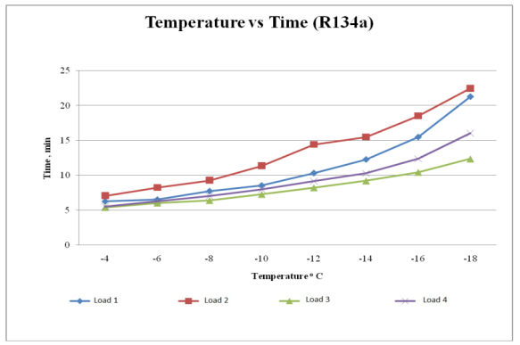

**Figure 4.1 R134-a at Different load conditions.**

Figure 4.1 shows the observed values for R134a at different load conditions of.Load1,Load2,Load3 and Load4. In this observation,

At Load1 condition,-4◦c reaches at 6.26 min, -6◦c reaches at 6.52 min,

-8◦c reaches at 7.54 min, -10◦c reaches at 8.56 min ,**-**12◦c reaches at10.33 min,

-14◦c reaches at12.28 min,-16◦c reaches at 15.50 min and -18◦c reaches at 21.30 min

At Load2 condition, -4◦c reaches at 7.06 min, -6◦c reaches at 8.25 min,-8◦c reaches at 9.29 min, -10◦c reaches at 11.37 min ,**-**12◦c reaches at14.44min,-14◦c reaches at15.50min,-16◦c reaches at 18.53 min and -18◦c reaches at 22.50 min

At Load3 condition, -4◦c reaches at 5.39 min,-6◦c reaches at 6.03 min,-8◦c reaches at 6.39 min, -10◦c reaches at 7.27 min ,**-**12◦c reaches at8.23min,-14◦c reaches at9.20min,-16◦c reaches at 11.45 min and -18◦c reaches at 12.37 min

At Load4 condition, -4◦c reaches at 5.53 min,-6◦c reaches at 6.28 min,-8◦c reaches at 7.05 min, -10◦c reaches at 8.01 min ,**-**12◦c reaches at 9.18min,-14◦c reaches at 10.30 min,-16◦c reaches at 13.38 min and -18◦c reaches at 14.07 min

Based on the above graph, we observe Load3 and Load 4 are suddenly reaching the best cooling effect. When loading the Load1and Load 2 lowest temperature was observed in maximum time.

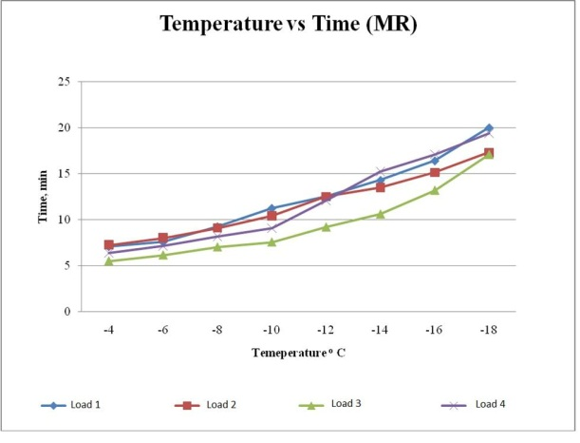

**Figure 4.2 Mixed Refrigerant-1 at Different load conditions.**

Figure 4.2 shows the observed values for mixed refrigerant-1 at different load condition. Of Load1,Load2,Load3 and Load4. From this observation,

At Load1 condition, -4◦c reaches at 6.40 min,-6◦c reaches at 7.21 min,-8◦c reaches at 9.03 min, -10◦c reaches at 11.10 min ,**-**12◦c reaches at 12.21 min, -14◦c reaches at 14.20 min,-16◦c reaches at 15.12 min and -18◦c reaches at 20.05 min

At Load2condition, -4◦c reaches at 6.37 min,-6◦c reaches at 7.46 min,-8◦c reaches at 8.56 min, -10◦c reaches at 10.11 min ,**-**12◦c reaches at 12.20 min, -14◦c reaches at 13.27min,-16◦c reaches at 14.26 min and -18◦c reaches at 16.49 min

At Load3condition, -4◦c reaches at 5.18 min,-6◦c reaches at 5.24 min,-8◦c reaches at 6.28 min, -10◦c reaches at 7.14 min ,**-**12◦c reaches at 8.59 min, -14◦c reaches at 10.12 min,-16◦c reaches at 12.25 min and -18◦c reaches at 16.1 min

At Load4condition, -4◦c reaches at 6.04 min,-6◦c reaches at 6.59 min,-8◦c reaches at 7.35 min, -10◦c reaches at 9.05 min ,**-**12◦c reaches at 11.27 min, -14◦c reaches at 15.07 min,-16◦c reaches at 16.45 min and -18◦c reaches at 19.15 min

Based on the above graph, a smart observation was found in the loading of Load3,Load4 and Load1,Load2 at the up and down the cooling effect

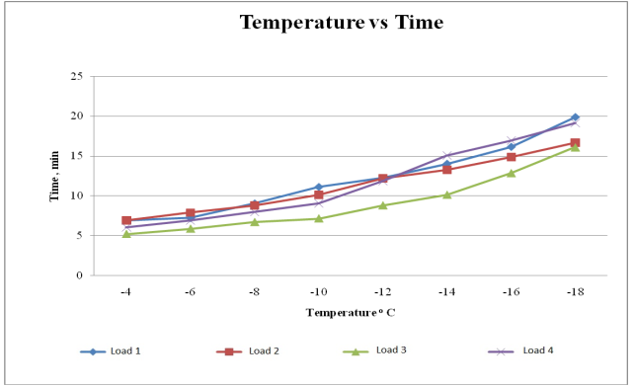

**Figure 4.3 Refrigerant Mixture -2 at Different load conditions.**

Figure 4.3 shows the observed values for mixed refrigerant-2 at different load conditions of Load1,Load2,Load3 and Load4. From this observation,

At Load1 condition, -4◦c reaches at 6.37 min,-6◦c reaches at 7.28 min,-8◦c reaches at 9.00 min, -10◦c reaches at 11.02 min ,**-**12◦c reaches at 12.18 min, -14◦c reaches at 14.07 min,-16◦c reaches at 16.20 min and -18◦c reaches at 19.40 min

At Load2 condition, -4◦c reaches at 7.08 min,-6◦c reaches at 7.47 min,-8◦c reaches at 8.20 min, -10◦c reaches at 10.00 min ,**-**12◦c reaches at 12.20 min, -4◦c reaches at 13.21min,-16◦c reaches at 15.13 min and -18◦c reaches at 17.31min

At Load3 condition, -4◦c reaches at 5.51 min,-6◦c reaches at 6.18 min,-8◦c reaches at 6.49 min, -10◦c reaches at 7.26 min ,**-**12◦c reaches at 8.13 min, -14◦c reaches at 9.0 min,-16◦c reaches at 10.0 min and -18◦c reaches at 12.26 min

At Load4 condition, -4◦c reaches at 6.26 min,-6◦c reaches at 7.42 min,-8◦c reaches at 8.27 min, -10◦c reaches at 9.45 min ,**-**12◦c reaches at 12.54 min, -14◦c reaches at 15.25 min,-16◦c reaches at 17.34 min and -18◦c reaches at 20.08 min

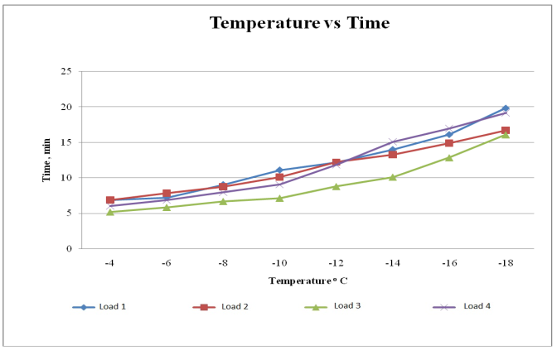Based on the above graph, a smart observation was found in the loading of Load3,Load4 and Load1,Load2 at the up and down the cooling effect

**Figure 4.4 Refrigerant Mixture -3 at Different load conditions.**

Figure 4.4 shows the observed values for mixed refrigerant-3 at different load conditions of Load1,Load2,Load3 and Load4. From this observation,

At Load1 condition, -4◦c reaches at 6.37 min,-6◦c reaches at 7.28 min,-8◦c reaches at 9.00 min, -10◦c reaches at 11.02 min ,**-**12◦c reaches at 12.18 min, -14◦c reaches at 14.07 min,-16◦c reaches at 16.20 min and -18◦c reaches at 19.40 min.

At Load2 condition, -4◦c reaches at 7.08 min,-6◦c reaches at 7.27 min,-8◦c reaches at 8.40 min, -10◦c reaches at 9.37 min ,**-**12◦c reaches at 12.10 min, -4◦c reaches at 13.06min,-16◦c reaches at 14.46 min and -18◦c reaches at 17.11min

At Load3 condition, -4◦c reaches at 5.68 min,-6◦c reaches at 6.22 min,-8◦c reaches at 7.12 min, -10◦c reaches at 7.72 min ,**-**12◦c reaches at 9.20 min, -14◦c reaches at 10.64 min,-16◦c reaches at 13.19 min and -18◦c reaches at 17.13 min

At Load4 condition, -4◦c reaches at 7.10 min,-6◦c reaches at 7.22 min,-8◦c reaches at 8.26 min, -10◦c reaches at 9.25 min ,**-**12◦c reaches at 12.35 min, -14◦c reaches at 15.26 min,-16◦c reaches at 17.17 min and -18◦c reaches at 19.31 min

Based on the above graph, a smart observation was found in the loading of Load3,Load4 and Load1,Load2 at the up and down the cooling effect

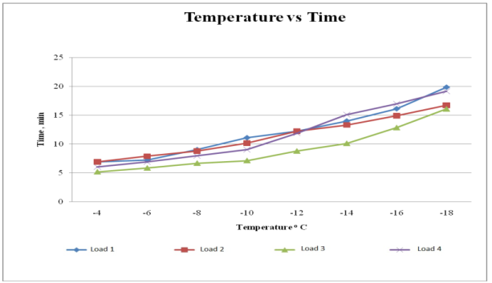

**Figure 4.5 Refrigerant Mixture -4 at Different load conditions.**

Figure 4.5 shows the observed values for mixed refrigerant-4 at different load conditions of Load1,Load2,Load3 and Load4. From this observation,

At Load1 condition, -4◦c reaches at 7.06 min,-6◦c reaches at 7.52min,-8◦c reaches at 9.22 min, -10◦c reaches at 11.25 min ,**-**12◦c reaches at 12.48 min, -14◦c reaches at 14.27 min,-16◦c reaches at 16.40 min and -18◦c reaches at 19.26 min. At Load2 condition, -4◦c reaches at 7.31 min,-6◦c reaches at 8.21 min,-8◦c reaches at 9.25 min, -10◦c reaches at 10.33 min ,**-**12◦c reaches at 12.50 min, -4◦c reaches at 13.39min,-16◦c reaches at 15.36 min and -18◦c reaches at 17.56min

At Load3 condition, -4◦c reaches at 5.48 min,-6◦c reaches at 6.32 min,-8◦c reaches at 7.43 min, -10◦c reaches at 7.34 min ,**-**12◦c reaches at 9.38 min, -14◦c reaches at 10.59 min,-16◦c reaches at 13.32 min and -18◦c reaches at 17.20 min

At Load4 condition, -4◦c reaches at 6.56 min,-6◦c reaches at 7.23 min,-8◦c reaches at 8.36 min, -10◦c reaches at 9.27 min ,**-**12◦c reaches at 12.25 min, -14◦c reaches at 15.29 min,-16◦c reaches at 17.21 min and -18◦c reaches at 18.26 min

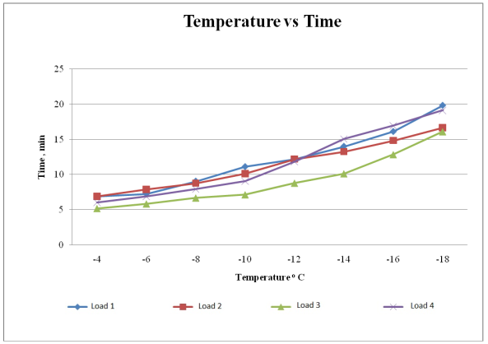 Based on the above graph, a smart observation was found in the loading of Load3,Load4 and Load1,Load2 at the up and down the cooling effect.

**Figure 4.6 Refrigerant Mixture -5 at Different load conditions**

Figure 4.6 shows the observed values for mixed refrigerant-5 at different load conditions of Load1,Load2,Load3 and Load4. From this observation,

At Load1 condition, -4◦c reaches at 7.06 min,-6◦c reaches at 7.58 min,-8◦c reaches at 9.22 min, -10◦c reaches at 11.22 min ,**-**12◦c reaches at 12.48 min, -14◦c reaches at 14.27 min,-16◦c reaches at 16.40 min and -18◦c reaches at 18.0 min

At Load2 condition, -4◦c reaches at 7.41 min,-6◦c reaches at 8.32 min,-8◦c reaches at 9.35 min, -10◦c reaches at 10.58 min ,**-**12◦c reaches at 12.86 min, -14◦c reaches at 13.78 min,-16◦c reaches at 15.23 min and -18◦c reaches at 16.21 min

At Load3 condition, -4◦c reaches at 5.58 min,-6◦c reaches at 6.22 min,-8◦c reaches at 7.10 min, -10◦c reaches at 7.64 min ,**-**12◦c reaches at 9.38 min, -14◦c reaches at 10.59 min,-16◦c reaches at 13.29 min and -18◦c reaches at 17.21 min

At Load4 condition, -4◦c reaches at 6.36 min,-6◦c reaches at 7.12 min,-8◦c reaches at 8.16 min, -10◦c reaches at 9.05 min ,**-**12◦c reaches at 12.05 min, -14◦c reaches at 15.21 min,-16◦c reaches at 17.11 min and -18◦c reaches at 19.41 min

Based on the above graph, a smart observation was found in the loading of Load3,Load4 and Load1,Load2 at the up and down the cooling effect

**Figure 4.7 R134a& Mixed Refrigerant-1 at no load condition**

Fig 4.7 shows the observed values for R134a and mixed refrigerant at no load condition. From this observation,

For R134a, -4◦c reaches at 5.40 min,-6◦c reaches at 6.0 min,-8◦c reaches at 6.32 min, -10◦c reaches at 7.15 min ,**-**12◦c reaches at 8.3 min, -14◦c reaches at 9.0 min,-16◦c reaches at 10.11 min and -18◦c reaches at 12.0 min,-20◦c reaches at 15.87 min and -22◦c reaches at 18.23 min

For Mixed Refrigerant-1, -4◦c reaches at 5.89 min,-6◦c reaches at 6.0 min,-8◦c reaches at 6.75 min, -10◦c reaches at 7.89 min ,**-**12◦c reaches at 8.21 min, -14◦c reaches at 9.23 min,-16◦c reaches at 10.0 min and -18◦c reaches at 12.0 min,-20◦c reaches at 14.89 min and -22◦c reaches at 16.0 min

Based on the above graph Mixed Refrigerant-1 attains lowest temperature at minimum time duration compared with R134-a

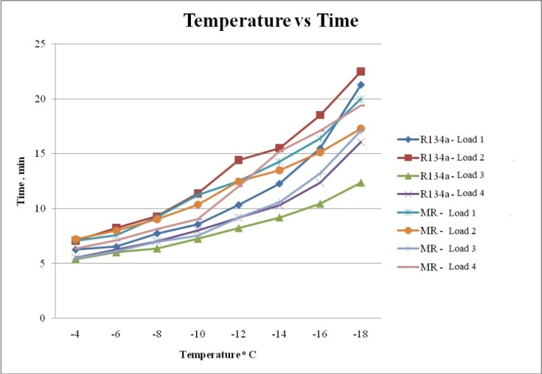

**Figure 4.8 R134a & Refrigerant Mixture 1– Different load conditions.**

Fig 4.8 shows the observed values for R134a and mixed refrigerant-1 at different load condition of Load1,Load2,Load3 and Load4..From this observation,

**For R134a** at Load1 condition, , -4◦c reaches at 6.26 min,-6◦c reaches at 6.52min,-8◦c reaches at 7.54 min, -10◦c reaches at 8.56 min ,**-**12◦c reaches at 10.33 min, -14◦c reaches at 12.28 min,-16◦c reaches at 15.50 min and -18◦c reaches at 21.30 min

At Load2 condition, -4◦c reaches at 7.06 min,-6◦c reaches at 8.25 min,-8◦c reaches at 9.29 min, -10◦c reaches at 11.37 min ,**-**12◦c reaches at 14.44 min, -14◦c reaches at 15.50 min,-16◦c reaches at 18.53 min and -18◦c reaches at 22.50 min

At Load3 condition, -4◦c reaches at 5.39min,-6◦c reaches at 6.03 min,-8◦c reaches at 6.39 min, -10◦c reaches at 7.27 min ,**-**12◦c reaches at 8.23 min, -14◦c reaches at 9.20 min,-16◦c reaches at 11.45 min and -18◦c reaches at 12.37 min

At Load4 condition, -4◦c reaches at 5.53 min,-6◦c reaches at 6.28 min,-8◦c reaches at 7.05 min, -10◦c reaches at 8.01 min ,**-**12◦c reaches at 9.18 min, -14◦c reaches at 10.30 min,-16◦c reaches at 13.38 min and -18◦c reaches at 14.07 min

**For Mixed Refrigerant-1,** at Load1 condition, , -4◦c reaches at 6.40 min,-6◦c reaches at 7.21 min,-8◦c reaches at 9.03 min, -10◦c reaches at 11.10 min ,**-**12◦c reaches at 12.21 min, -14◦c reaches at 14.0 min,-16◦c reaches at 15.12 min and -18◦c reaches at 17.45 min

At Load2 condition, -4◦c reaches at 6.37min,-6◦c reaches at 7.46 min,-8◦c reaches at 8.56 min, -10◦c reaches at 10.11 min ,**-**12◦c reaches at 12.20 min, -14◦c reaches at 13.27 min,-16◦c reaches at 14.26 min and -18◦c reaches at 16.49 min

At Load3 condition, -4◦c reaches at 5.18 min,-6◦c reaches at 5.24 min,-8◦c reaches at 6.28 min, -10◦c reaches at 7.14 min ,**-**12◦c reaches at 8.59 min, -14◦c reaches at 10.12 min,-16◦c reaches at 12.25 min and -18◦c reaches at 16.1 min

At Load4 condition, -4◦c reaches at 6.04 min,-6◦c reaches at 6.59 min,-8◦c reaches at 7.35 min, -10◦c reaches at 9.05 min ,**-**12◦c reaches at 11.27 min, -14◦c reaches at 15.07 min,-16◦c reaches at 16.45 min and -18◦c reaches at 19.15 min

Based on the above graph, we observe a drastic change of while using a mixed refrigerant compared with R134a

**Figure 4.9R134a &Refrigerant Mixture - 1 at no load**

Fig 4.9 shows the graphical representation of observed values for R134a and mixed refrigerant-1 at no load condition. From this observation,

for R134a, -4◦c reaches when the initial pressure comes at 7kg/cm2 and final pressure comes at 16.5 kg/cm2, -6◦c reaches when the initial pressure comes at 6kg/cm2 and final pressure comes at 16 kg/cm2, -8◦c reaches when the initial pressure comes at 6kg/cm2 and final pressure comes at 16 kg/cm2, -10◦c reaches when the initial pressure comes at 5.5kg/cm2 and final pressure comes at 16 kg/cm2, -12◦c reaches when the initial pressure comes at 4kg/cm2 and final pressure comes at 15.5 kg/cm2, -14◦c reaches when the initial pressure comes at 4kg/cm2 and final pressure comes at 15 kg/cm2, -16◦c reaches when the initial pressure comes at 4kg/cm2 and final pressure comes at 14.5 kg/cm2, -18◦c reaches when the initial pressure comes at 3.5kg/cm2 and final pressure comes at 14 kg/cm2, -20◦c reaches when the initial pressure comes at 3.5kg/cm2 and final pressure comes at 13 kg/cm2

for Mixed Refrigerant-1, -4◦c reaches when the initial pressure comes at 12kg/cm2 and final pressure comes at 16 kg/cm2, -6◦c reaches when the initial pressure comes at 11kg/cm2 and final pressure comes at 16 kg/cm2, -8◦c reaches when the initial pressure comes at 10kg/cm2 and final pressure comes at 15.5 kg/cm2, -10◦c reaches when the initial pressure comes at 9 kg/cm2 and final pressure comes at 15 kg/cm2, -12◦c reaches when the initial pressure comes at 8kg/cm2 and final pressure comes at 14.5 kg/cm2, -14◦c reaches when the initial pressure comes at 7kg/cm2 and final pressure comes at 14 kg/cm2, -16◦c reaches when the initial pressure comes at 4kg/cm2 and final pressure comes at 14.5 kg/cm2, -18◦c reaches when the initial pressure at 6 kg/cm2 and final pressure at 13.5kg/cm2 and -20◦c reaches when the initial pressure comes at 6 kg/cm2 and final pressure comes at 13 kg/cm2

Based on the above graph compressor work less when the system attains lowest temperature when the mixed refrigerant-1 used as a Refrigerant in the Refrigerator instead of R134a

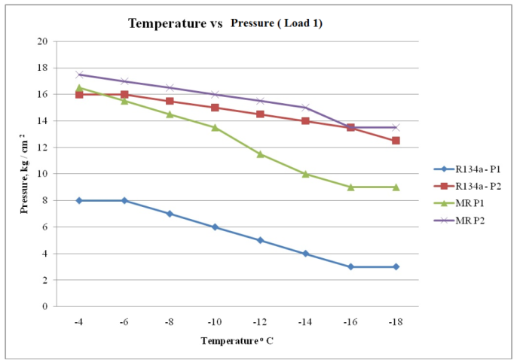

**Figure 4.10 R134a &Refrigerant Mixture - 2 at Load 1 condition**

Fig 4.10 shows the graphical representation of observed values for R134a and mixed refrigerant-2 at load1 condition. From this observation,

for R134a, -4◦c reaches when the initial pressure comes at 8kg/cm2 and final pressure comes at 16 kg/cm2, -6◦c reaches when the initial pressure comes at 8kg/cm2 and final pressure comes at 16 kg/cm2, -8◦c reaches when the initial pressure comes at 7kg/cm2 and final pressure comes at 15.5 kg/cm2, -10◦c reaches when the initial pressure comes at 6kg/cm2 and final pressure comes at 15 kg/cm2, -12◦c reaches when the initial pressure comes at 5kg/cm2 and final pressure comes at 14.5 kg/cm2, -14◦c reaches when the initial pressure comes at 4kg/cm2 and final pressure comes at 14 kg/cm2, -16◦c reaches when the initial pressure comes at 3kg/cm2 and final pressure comes at 13.5 kg/cm2 and -18◦c reaches when the initial pressure comes at 3.5kg/cm2 and final pressure comes at 14 kg/cm2.

for Mixed Refrigerant-1, -4◦c reaches when the initial pressure comes at 16.5kg/cm2 and final pressure comes at 17.5 kg/cm2, -6◦c reaches when the initial pressure comes at 15.5kg/cm2 and final pressure comes at 17 kg/cm2, -8◦c reaches when the initial pressure comes at 14.5kg/cm2 and final pressure comes at 16.5 kg/cm2, -10◦c reaches when the initial pressure comes at 13.5 kg/cm2 and final pressure comes at 16 kg/cm2, -12◦c reaches when the initial pressure comes at 11.5kg/cm2 and final pressure comes at 15.5 kg/cm2, -14◦c reaches when the initial pressure comes at 10kg/cm2 and final pressure comes at 15 kg/cm2, -16◦c reaches when the initial pressure comes at 9.5kg/cm2 and final pressure comes at 13.5 kg/cm2 and -18◦c reaches when the initial pressure comes at 9 kg/cm2 and final pressure comes at 13.5kg/cm2 .

Based on the above graph compressor work less when the system attains lowest temperature when the mixed refrigerant- 2 used as a Refrigerant in the Refrigerator instead of sole (R134a) Refrigerant.

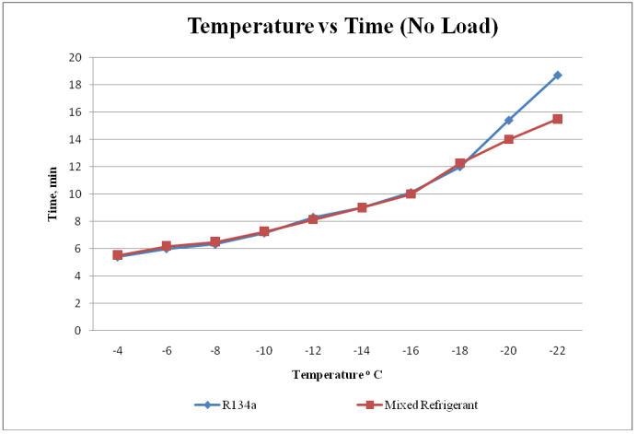

**Figure 4.11 R134a &Refrigerant Mixture -2 at no load condition.**

Fig 4.11 shows the observed values for R134a and mixed refrigerant-2 at no load condition. From this observation,

For R134a, -4◦c reaches at 5.40 min,-6◦c reaches at 6.0 min,-8◦c reaches at 6.32 min, -10◦c reaches at 7.15 min ,**-**12◦c reaches at 8.3 min, -14◦c reaches at 9.0 min,-16◦c reaches at 10.11min and -18◦c reaches at 12.0 min,-20◦c reaches at 12.40 min and -22◦c reaches at 18.23 min

For Mixed Refrigerant-2, -4◦c reaches at 5.50 min,-6◦c reaches at 6.12 min,-8◦c reaches at 6.34 min, -10◦c reaches at 7.20 min ,**-**12◦c reaches at 8.03min, -14◦c reaches at 8.95 min,-16◦c reaches at 9.44 min and -18◦c reaches at 12.12 min,-20◦c reaches at 14.0 min and -22◦c reaches at 15.92 min

Based on the above graph Mixed Refrigerant-2 attains lowest temperature at minimum time duration compared with sole (R134a) Refrigerant.

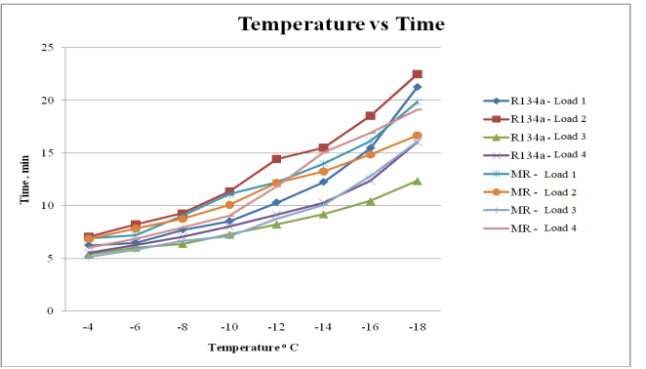

**Figure 4.12 R134a & Refrigerant Mixture -2 at Different load conditions.**

Fig 4.12 shows the observed values for R134a and mixed refrigerant-1 at different load condition of Load1,Load2,Load3 and Load4..From this observation,

**For R134a** at Load1 condition, , -4◦c reaches at 6.26 min,-6◦c reaches at 6.52min,-8◦c reaches at 7.54 min, -10◦c reaches at 8.56 min ,**-**12◦c reaches at 10.33 min, -14◦c reaches at 12.28 min,-16◦c reaches at 15.50 min and -18◦c reaches at 21.30 min

At Load2 condition, -4◦c reaches at 7.06 min,-6◦c reaches at 8.25 min,-8◦c reaches at 9.29 min, -10◦c reaches at 11.37 min ,**-**12◦c reaches at 14.44 min, -14◦c reaches at 15.50 min,-16◦c reaches at 18.53 min and -18◦c reaches at 22.50 min

At Load3 condition, -4◦c reaches at 5.39min,-6◦c reaches at 6.03 min,-8◦c reaches at 6.39 min, -10◦c reaches at 7.27 min ,**-**12◦c reaches at 8.23 min, -14◦c reaches at 9.20 min,-16◦c reaches at 11.45 min and -18◦c reaches at 12.37 min

At Load4 condition, -4◦c reaches at 5.53 min,-6◦c reaches at 6.28 min,-8◦c reaches at 7.05 min, -10◦c reaches at 8.01 min ,**-**12◦c reaches at 9.18 min, -14◦c reaches at 10.30 min,-16◦c reaches at 13.38 min and -18◦c reaches at 14.07 min

**For Mixed Refrigerant-2,** at Load1 condition, , -4◦c reaches at 6.37 min,-6◦c reaches at 7.28 min,-8◦c reaches at 9.0 min, -10◦c reaches at 11.02 min ,**-**12◦c reaches at 12.18 min, -14◦c reaches at 14.07 min,-16◦c reaches at 16.20 min and -18◦c reaches at 19.40 min

At Load2 condition, -4◦c reaches at 7.08 min,-6◦c reaches at 7.47min,-8◦c reaches at 8.20 min, -10◦c reaches at 10.00 min ,**-**12◦c reaches at 12.20 min, -14◦c reaches at 13.21 min,-16◦c reaches at 15.13 min and -18◦c reaches at 17.31 min

At Load3 condition, -4◦c reaches at 5.51 min,-6◦c reaches at 6.18 min,-8◦c reaches at 6.49 min, -10◦c reaches at 7.26 min ,**-**12◦c reaches at 8.13 min, -14◦c reaches at 9.0 min,-16◦c reaches at 10.0 min and -18◦c reaches at 12.26 min

At Load4 condition, -4◦c reaches at 6.26 min,-6◦c reaches at 7.42 min,-8◦c reaches at 8.27 min, -10◦c reaches at 9.45 min ,**-**12◦c reaches at 12.54 min, -14◦c reaches at 15.25 min,-16◦c reaches at 17.34 min and -18◦c reaches at 20.08 min

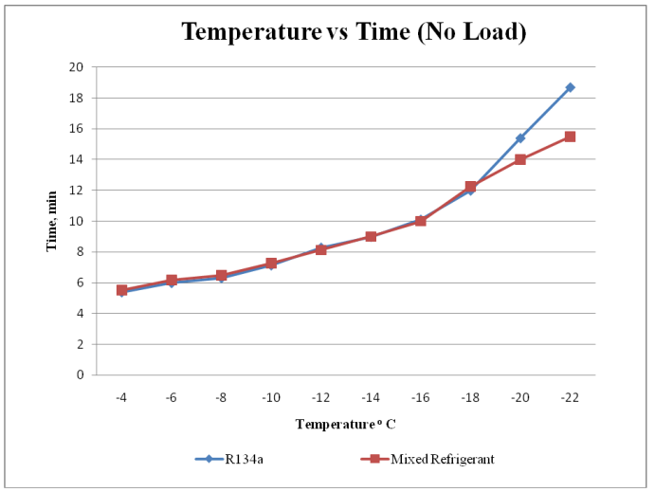 Based on the above graph, we observe a drastic change of while using a mixed refrigerant-2 compared with sole( R134a.)Refrigerant.

**Figure 4.13R134-a & Refrigerant Mixture -3 at no load**

Fig 4.13 shows the observed values for R134a and mixed refrigerant-3 at no load condition. From this observation,

For R134a, -4◦c reaches at 5.40 min,-6◦c reaches at 6.0 min,-8◦c reaches at 6.32 min, -10◦c reaches at 7.15 min ,**-**12◦c reaches at 8.3 min, -14◦c reaches at 9.0 min,-16◦c reaches at 10.11min and -18◦c reaches at 12.0 min,-20◦c reaches at 12.40 min and -22◦c reaches at 18.23 min

For Mixed Refrigerant-3, -4◦c reaches at 5.51 min,-6◦c reaches at 5.30 min,-8◦c reaches at 5.37 min, -10◦c reaches at 6.12 min ,**-**12◦c reaches at 6.58 min, -14◦c reaches at 7.36 min,-16◦c reaches at 8.35 min and -18◦c reaches at 9.21 min,-20◦c reaches at 11.20 min and -22◦c reaches at 13.53 min

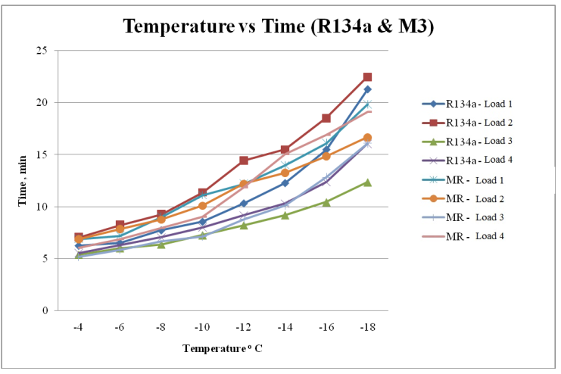 Based on the above graph Mixed Refrigerant-3 attains lowest temperature at minimum time duration compared with sole (R134a) Refrigerant.

**Figure 4.14 R134a &Refrigerant Mixture – 3 with Different load conditions**

Fig 4.14 shows the observed values for R134a and mixed refrigerant-1 at different load condition of Load1,Load2,Load3 and Load4..From this observation,

**For R134a** at Load1 condition, , -4◦c reaches at 6.26 min,-6◦c reaches at 6.52min,-8◦c reaches at 7.54 min, -10◦c reaches at 8.56 min ,**-**12◦c reaches at 10.33 min, -14◦c reaches at 12.28 min,-16◦c reaches at 15.50 min and -18◦c reaches at 21.30 min

At Load2 condition, -4◦c reaches at 7.06 min,-6◦c reaches at 8.25 min,-8◦c reaches at 9.29 min, -10◦c reaches at 11.37 min ,**-**12◦c reaches at 14.44 min, -14◦c reaches at 15.50 min,-16◦c reaches at 18.53 min and -18◦c reaches at 22.50 min

At Load3 condition, -4◦c reaches at 5.39min,-6◦c reaches at 6.03 min,-8◦c reaches at 6.39 min, -10◦c reaches at 7.27 min ,**-**12◦c reaches at 8.23 min, -14◦c reaches at 9.20 min,-16◦c reaches at 11.45 min and -18◦c reaches at 12.37 min

At Load4 condition, -4◦c reaches at 5.53 min,-6◦c reaches at 6.28 min,-8◦c reaches at 7.05 min, -10◦c reaches at 8.01 min ,**-**12◦c reaches at 9.18 min, -14◦c reaches at 10.30 min,-16◦c reaches at 13.38 min and -18◦c reaches at 14.07 min

**For Mixed Refrigerant-3,** at Load1 condition, , -4◦c reaches at 6.37 min,-6◦c reaches at 7.28 min,-8◦c reaches at 9.0 min, -10◦c reaches at 11.02 min ,**-**12◦c reaches at 12.18 min, -14◦c reaches at 14.07 min,-16◦c reaches at 16.20 min and -18◦c reaches at 19.40 min

At Load2 condition, -4◦c reaches at 7.08 min,-6◦c reaches at 7.27min,-8◦c reaches at 8.40 min, -10◦c reaches at 9.37 min ,**-**12◦c reaches at 12.10 min, -14◦c reaches at 13.06 min,-16◦c reaches at 14.46 min and -18◦c reaches at 17.11 min

At Load3 condition, -4◦c reaches at 5.68 min,-6◦c reaches at 6.22 min,-8◦c reaches at 7.12 min, -10◦c reaches at 7.72 min ,**-**12◦c reaches at 9.20 min, -14◦c reaches at 10.64 min,-16◦c reaches at 13.19 min and -18◦c reaches at 17.13 min

At Load4 condition, -4◦c reaches at 7.10 min,-6◦c reaches at 7.22 min,-8◦c reaches at 8.26 min, -10◦c reaches at 9.25 min ,**-**12◦c reaches at 12.35 min, -14◦c reaches at 15.26 min,-16◦c reaches at 17.17 min and -18◦c reaches at 19.31 min

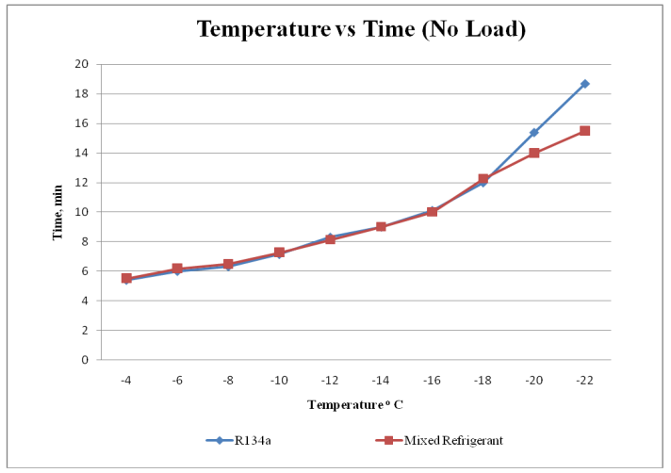 Based on the above graph, we observe a drastic change of while using a mixed refrigerant-3 compared with sole( R134a.)Refrigerant

**Figure 4.15 R134-a and Mixed Refrigerant -4 at no load**

Fig 4.15 shows the observed values for R134a and mixed refrigerant-4 at no load condition. From this observation,

**For R134a**, -4◦c reaches at 5.40 min,-6◦c reaches at 6.0 min,-8◦c reaches at 6.32 min, -10◦c reaches at 7.15 min ,**-**12◦c reaches at 8.3 min, -14◦c reaches at 9.0 min,-16◦c reaches at 10.11min and -18◦c reaches at 12.0 min,-20◦c reaches at 12.40 min and -22◦c reaches at 18.23 min

**For Mixed Refrigerant**-**4**, -4◦c reaches at 5.61 min,-6◦c reaches at 6.21 min,-8◦c reaches at 6.54 min, -10◦c reaches at 7.51 min ,**-**12◦c reaches at 8.34 min, -14◦c reaches at 9.13 min,-16◦c reaches at 10.14 min and -18◦c reaches at 12.27 min,-20◦c reaches at 13.20 min and -22◦c reaches at 14.10 min

Based on the above graph Mixed Refrigerant-4 attains lowest temperature at minimum time duration compared with sole (R134a) Refrigerant.

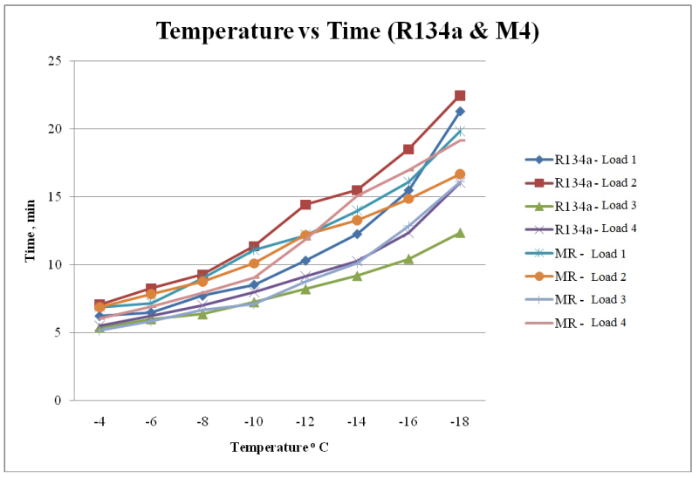

**Figure 4.16 R134a & Refrigerant Mixture -4 with Different load conditions**

Fig 4.16 shows the observed values for R134a and mixed refrigerant-1 at different load condition of Load1,Load2,Load3 and Load4..From this observation,

**For R134a** at Load1 condition, , -4◦c reaches at 6.26 min,-6◦c reaches at 6.52min,-8◦c reaches at 7.54 min, -10◦c reaches at 8.56 min ,**-**12◦c reaches at 10.33 min, -14◦c reaches at 12.28 min,-16◦c reaches at 15.50 min and -18◦c reaches at 21.30 min

At Load2 condition, -4◦c reaches at 7.06 min,-6◦c reaches at 8.25 min,-8◦c reaches at 9.29 min, -10◦c reaches at 11.37 min ,**-**12◦c reaches at 14.44 min, -14◦c reaches at 15.50 min,-16◦c reaches at 18.53 min and -18◦c reaches at 22.50 min

At Load3 condition, -4◦c reaches at 5.39min,-6◦c reaches at 6.03 min,-8◦c reaches at 6.39 min, -10◦c reaches at 7.27 min ,**-**12◦c reaches at 8.23 min, -14◦c reaches at 9.20 min,-16◦c reaches at 11.45 min and -18◦c reaches at 12.37 min

At Load4 condition, -4◦c reaches at 5.53 min,-6◦c reaches at 6.28 min,-8◦c reaches at 7.05 min, -10◦c reaches at 8.01 min ,**-**12◦c reaches at 9.18 min, -14◦c reaches at 10.30 min,-16◦c reaches at 13.38 min and -18◦c reaches at 14.07 min

**For Mixed Refrigerant-4,** at Load1 condition, , -4◦c reaches at 7.06 min,-6◦c reaches at 7.52 min,-8◦c reaches at 9.22 min, -10◦c reaches at 11.25 min ,**-**12◦c reaches at 12.48 min, -14◦c reaches at 14.27 min,-16◦c reaches at 16.40 min and -18◦c reaches at 12.26 min

At Load2 condition, -4◦c reaches at 7.31 min,-6◦c reaches at 8.21 min,-8◦c reaches at 9.25 min, -10◦c reaches at 10.33 min ,**-**12◦c reaches at 12.50 min, -14◦c reaches at 13.39 min,-16◦c reaches at 15.36 min and -18◦c reaches at 17.56 min

At Load3 condition, -4◦c reaches at 5.48 min,-6◦c reaches at 6.32 min,-8◦c reaches at 7.43 min, -10◦c reaches at 7.34 min ,**-**12◦c reaches at 9.38 min, -14◦c reaches at 10.59 min,-16◦c reaches at 13.32 min and -18◦c reaches at 17.20 min

At Load4 condition, -4◦c reaches at 6.56 min,-6◦c reaches at 7.23 min,-8◦c reaches at 8.36 min, -10◦c reaches at 9.27 min ,**-**12◦c reaches at 12.25 min, -14◦c reaches at 15.29 min,-16◦c reaches at 17.21 min and -18◦c reaches at 18.26 min

Based on the above graph, we observe a drastic change of while using a mixed refrigerant-4 compared with sole( R134a.)Refrigerant.

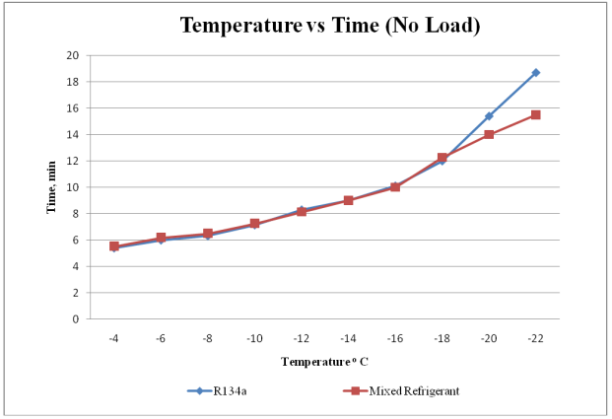

**Figure 4.17 R134a & Mixed Refrigerant- 5 at no load condition.**

Fig 4.17 shows the observed values for R134a and mixed refrigerant-5 at no load condition. From this observation,

**For R134a**, -4◦c reaches at 5.40 min,-6◦c reaches at 6.0 min,-8◦c reaches at 6.32 min, -10◦c reaches at 7.15 min ,**-**12◦c reaches at 8.3 min, -14◦c reaches at 9.0 min,-16◦c reaches at 10.11min and -18◦c reaches at 12.0 min,-20◦c reaches at 12.40 min and -22◦c reaches at 18.23 min

**For Mixed Refrigerant**-**5**, -4◦c reaches at 5.53 min,-6◦c reaches at 6.51 min,-8◦c reaches at 6.34 min, -10◦c reaches at 7.51 min ,**-**12◦c reaches at 8.44 min, -14◦c reaches at 9.33 min,-16◦c reaches at 10.44 min and -18◦c reaches at 12.47 min,-20◦c reaches at 13.10 min and -22◦c reaches at 14.30 min

Based on the above graph Mixed Refrigerant-5 attains lowest temperature at minimum time duration compared with sole (R134a) Refrigerant.

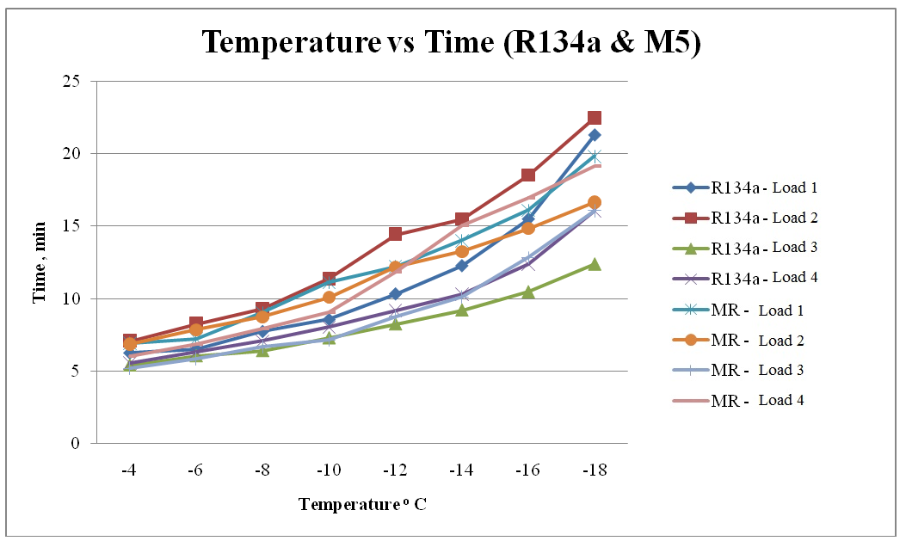

**Figure 4.18 R134a & Mixed Refrigerant -5 with Different Load conditions.**

Fig 4.18 shows the observed values for R134a and Mixed refrigerant-5 at different load conditions of Load1,Load2,Load3 and Load4..From this observation,

**For R134a** at Load1 condition, , -4◦c reaches at 6.26 min,-6◦c reaches at 6.52min,-8◦c reaches at 7.54 min, -10◦c reaches at 8.56 min ,**-**12◦c reaches at 10.33 min, -14◦c reaches at 12.28 min,-16◦c reaches at 15.50 min and -18◦c reaches at 21.30 min

At Load2 condition, -4◦c reaches at 7.06 min,-6◦c reaches at 8.25 min,-8◦c reaches at 9.29 min, -10◦c reaches at 11.37 min ,**-**12◦c reaches at 14.44 min, -14◦c reaches at 15.50 min,-16◦c reaches at 18.53 min and -18◦c reaches at 22.50 min

At Load3 condition, -4◦c reaches at 5.39min,-6◦c reaches at 6.03 min,-8◦c reaches at 6.39 min, -10◦c reaches at 7.27 min ,**-**12◦c reaches at 8.23 min, -14◦c reaches at 9.20 min,-16◦c reaches at 11.45 min and -18◦c reaches at 12.37 min

At Load4 condition, -4◦c reaches at 5.53 min,-6◦c reaches at 6.28 min,-8◦c reaches at 7.05 min, -10◦c reaches at 8.01 min ,**-**12◦c reaches at 9.18 min, -14◦c reaches at 10.30 min,-16◦c reaches at 13.38 min and -18◦c reaches at 14.07 min

**For Mixed Refrigerant-5,** at Load1 condition, , -4◦c reaches at 7.06 min,-6◦c reaches at 7.58 min,-8◦c reaches at 9.22 min, -10◦c reaches at 11.22 min ,**-**12◦c reaches at 12.48 min, -14◦c reaches at 14.27 min,-16◦c reaches at 16.40 min and -18◦c reaches at 18.0 min

At Load2 condition, -4◦c reaches at 7.41 min,-6◦c reaches at 8.32 min,-8◦c reaches at 9.35 min, -10◦c reaches at 10.58 min ,**-**12◦c reaches at 12.86 min, -14◦c reaches at 13.78 min,-16◦c reaches at 15.23 min and -18◦c reaches at 16.21 min

At Load3 condition, -4◦c reaches at 5.58 min,-6◦c reaches at 6.22 min,-8◦c reaches at 7.10 min, -10◦c reaches at 7.64 min ,**-**12◦c reaches at 9.38 min, -14◦c reaches at 10.59 min,-16◦c reaches at 13.29 min and -18◦c reaches at 17.21 min

At Load4 condition, -4◦c reaches at 6.36 min,-6◦c reaches at 7.12 min,-8◦c reaches at 8.16 min, -10◦c reaches at 9.05 min ,**-**12◦c reaches at 12.05 min, -14◦c reaches at 15.21 min,-16◦c reaches at 17.11 min and -18◦c reaches at 19.41 min

Based on the above graph, we observe a drastic change of while using a mixed refrigerant-5 compared with sole( R134a.)Refrigerant.

**Figure 4.19 R134a & Refrigerant Mixure- 1at load condition**

Fig 4.19shows the observed values of COP for R134a and mixed refrigerant-1 at different temperatures. From this observations,

Cop of Refrigerator when R134a is used as a refrigerant at -4◦c is 2.38,at -8◦c is 2.39, at -12◦c is 2.27,at -16◦c is 2.28 and at -18◦c is 2.29

Cop of Refrigerator when Mixed Refrigerant-1 is used as a refrigerant at -4◦c is 2. 8,at -8◦c is 2.79, at -12◦c is 2.81,at -16◦c is 2.8 and at -18◦c is 2.81.

Based on the above graph COP of the Mixed Refrigerant-1 shows more COP in every temperature compared to Refrigerant R134a.

**Figure 4.20R134a & Refrigerant Mixure- 2 at load condition**

Fig 4.20shows the observed values of COP for R134a and mixed refrigerant-2 at different temperatures. From this observations,

Cop of Refrigerator when R134a is used as a refrigerant at -4◦c is 2.38,at -8◦c is 2.39, at -12◦c is 2.27,at -16◦c is 2.28 and at -18◦c is 2.29

Cop of Refrigerator when Mixed Refrigerant-2 is used as a refrigerant at -4◦c is 3.22,at -8◦c is 3.21, at -12◦c is 3.21,at -16◦c is 3.22 and at -18◦c is 3.24.

Based on the above graph COP of the Mixed Refrigerant-2 shows more COP in every temperature compared to Refrigerant R134a.

**Figure 4.21R134a & Mixure- 3at load condition.**

Fig 4.21 Shows the observed values of COP for R134a and mixed refrigerant-2 at different temperatures. From this observations,

Cop of Refrigerator when R134a is used as a refrigerant at -4◦c is 2.38,at -8◦c is 2.39, at -12◦c is 2.27,at -16◦c is 2.28 and at -18◦c is 2.29

Cop of Refrigerator when Mixed Refrigerant-3 is used as a refrigerant at -4◦c is 2.95,at -8◦c is 2.97, at -12◦c is 2.97,at -16◦c is 2.99 and at -18◦c is 3.

Based on the above graph COP of the Mixed Refrigerant-3 shows more COP in every temperature compared to Refrigerant R134a.

**Figure 4.22 R134a & Mixure -4 at load condition**

Fig 4.22shows the observed values of COP for R134a and mixed refrigerant-2 at different temperatures. From this observations,

Cop of Refrigerator when R134a is used as a refrigerant at -4◦c is 2.38,at -8◦c is 2.39, at -12◦c is 2.27,at -16◦c is 2.28 and at -18◦c is 2.29

Cop of Refrigerator when Mixed Refrigerant-4 is used as a refrigerant at -4◦c is 2.85,at -8◦c is 2.97, at -12◦c is 2.87,at -16◦c is 2.89 and at -18◦c is 2.98.

Based on the above graph COP of the Mixed Refrigerant-4 shows more COP in every temperature compared to Refrigerant R134a.

**Figure 4.23 R134a & Mixture -5 at load condition**

Fig 4.23shows the observed values of COP for R134a and mixed refrigerant-5 at different temperatures. From this observations,

Cop of Refrigerator when R134a is used as a refrigerant at -4◦c is 2.38,at -8◦c is 2.39, at -12◦c is 2.27,at -16◦c is 2.28 and at -18◦c is 2.29

Cop of Refrigerator when Mixed Refrigerant-5 is used as a refrigerant at -4◦c is 2.86,at -8◦c is 2.84, at -12◦c is 2.88,at -16◦c is 2.9 and at -18◦c is 2.9.

Based on the above graph COP of the Mixed Refrigerant-5 shows more COP in every temperature compared to Refrigerant R134a.

**Figure 4.24Temperature vs Refrigeration effect**

Fig 4.24 shows the observed values for R134a and different mixtures for temperature vs Refrigeration Effect. From this observations,

R134a given the Refrigeration Effect of 125.21KJ/Kg at all temperatures like -4°C,-8°C,-12°C,-16°C and -18°C.

Mixed Refrigerant1 given the Refrigeration Effect of 241.92 KJ/Kg,240.2 KJ/Kg,242.6 KJ/Kg,246.4 KJ/Kg and 249.2 KJ/Kg at -4°C,-8°C,-12°C,-16°C and -18°C respectively.

Refrigerant Mixture-2given the Refrigeration Effect of 230.8 KJ/Kg,231.2 KJ/Kg,231.7 KJ/Kg,234.4KJ/Kg and 237.4 KJ/Kg at -4°C,-8°C,-12°C,-16°C and -18°C respectively.

Mixed Refrigerant3 given the Refrigeration Effect of 214.46.KJ/Kg,216.8 KJ/Kg,217.7 KJ/Kg,220.06 KJ/Kg and 221.7 KJ/Kg at -4°C,-8°C,-12°C,-16°C and -18°C respectively.

Mixed Refrigerant4 given the Refrigeration Effect of 192.94 KJ/Kg,194.0 KJ/Kg,195.07 KJ/Kg,201.44 KJ/Kg and 203.1 KJ/Kg at -4°C,-8°C,-12°C,-16°C and -18°C respectively.

Mixed Refrigerant5 given the Refrigeration Effect of 179.03 KJ/Kg,178.3 KJ/Kg,182 KJ/Kg,182.7 KJ/Kg and 183.4 KJ/Kg at -4°C,-8°C,-12°C,-16°C and -18°C respectively.

Based on the graph we can identify that Mixture 1 has more refrigeration effect for the corresponding temperature than basic refrigerant and other mixtures.

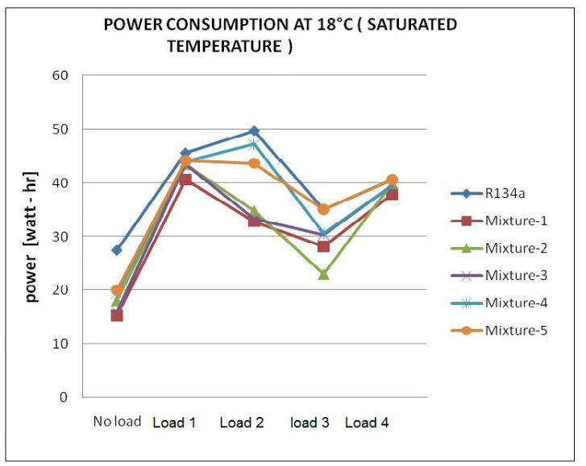

**Figure 4.25 Power consumption vsVarious loads**

Figure 4.25 shows the graph between Power required vs Various Loads.

Of R134a and various mixtures. From this graph,

R134a have the power consumption of 28.52 watt-hr at no load condition,48.9 watt-hr at load1 condition,51.75 watt-hr at load2 condition,33.19 watt-hr at load3 condition and 47.76 watt-hr at load4 condition.

Mixed Refrigerant1 have the power consumption of 20.75 watt-hr at no load condition,38.62 watt-hr at load1 condition,34.5 watt-hr at load2 condition,34.69 watt-hr at load3 condition and 40.44 watt-hr at load4 condition.

Mixed Refrigerant2 have the power consumption of 24.92 watt-hr at no load condition,40.44 watt-hr at load1 condition,36.7 watt-hr at load2 condition,31.12 watt-hr at load3 condition and 42.36 watt-hr at load4 condition.

Mixed Refrigerant3 have the power consumption of 25.93 watt-hr at no load condition,46.64 watt-hr at load1 condition,13.93 watt-hr at load2 condition,14.31 watt-hr at load3 condition and 40.67 watt-hr at load4 condition.

Mixed Refrigerant4 have the power consumption of 27.03 watt-hr at no load condition,31.12 watt-hr at load1 condition,44.18 watt-hr at load2 condition,36.8 watt-hr at load3 condition and 39.35 watt-hr at load4 condition.

Mixed Refrigerant5 have the power consumption of 27.41 watt-hr at no load condition,46.23 watt-hr at load1 condition,44.16 watt-hr at load2 condition,38.53 watt-hr at load3 condition and 48.88 watt-hr at load4 condition.

From the graph it is observed that Refrigerant R134a consumes more power for the Refrigeration Effect for various loads. Mixture 2 consumes less power for the refrigeration effect compared to other refrigerant mixtures and R134a.

**CHAPTER V**

**CONCLUSION**

This work investigated an ozone friendly, energy efficient, user friendly, safe and cost-effective alternative refrigerant for R-134a in domestic refrigeration systems. After the successful investigation on the performance of mixed refrigerants the following conclusions can be drawn based on the results obtained. This experimental investigation carried out to determine the performance of a domestic refrigerator when a mixture of propane/butane/isobutene/ R134a is used as a possible replacement to the traditional refrigerant R134a.

The only drawback of HC blend is the flammability. The drawbacks of using R134a and HC blend with respect to GWP and flammability can be overcome by mixing the R134a and HC blend with an appropriate mass fraction. So, that the final mixture leads to decreased GWP due to less mass fraction of R134a, instead of 100% pure R134a and decreased flammability effect due to mixing of flammable refrigerant with non-flammable refrigerant. With these advantages final ternary mixture which is obtained with the composition of 30%R134a/32.5%R290/ 32.5%R600a/5% R600 will be environment friendly alternative refrigerant. In the present work, investigations have been successfully made to use ternary mixture of R134a/R600/R290/R600a. An improvement in energy efficiency of the new mixture has also been demonstrated in this work.

The performance parameters investigated are the refrigeration effect, the evaporator temperature and the coefficient of performance (COP). The refrigerator worked efficiently when mixed refrigerant was used as refrigerant instead of R134a. The evaporator temperature reached -21°C with COP value of 3.20 and an ambient temperature of 30°C in the mixture-2(15%R134a/40%R290/ 40%R600a/5% R600) is used as alternate refrigerant to the traditional refrigerant R134a. The results of the present work indicate the successful use of this mixed refrigerant as an alternative to R134a in domestic refrigerators. The co-efficient of performance for the mixed refrigerant is comparable with the co-efficient of performance of R-134a. The domestic refrigerator was charged with 100g of R-134a and 80g of mixed refrigerant. This is an indication of better performance of mixed refrigerant as refrigerants. The following conclusions can be elicited from our investigation

**1.** Every mode of mixed refrigerant yields higher COP than R-134a. Especially for mixture-2 the COP obtained is 3.20, but for R134a it is only 2.39.

**2.** From using the mixed refrigerant in domestic refrigerator, freezer temperature obtained is -21°C, but for R134a it is only -18°C.

**3**. The GWP of R134a is 1300, but for the mixed refrigerant GWP is very low at mixture-1 (84) and increasing when the percentage of the R134a increases.

**4**.Power Consumption is low when using the mixed refrigerant that of using R134a as refrigerant. For example at -180c saturated temp for no load condition the power consumption is 27.5 watt-hr for R134a, but for mixed refrigerant-2 it is only18.09 watt-hr.

**5**. As per the refrigerator manufactures recommendation for the given volume of the refrigerator, charge quantity of R134a is 100 grams. In the experiment, refrigerant charge is 10% higher due to the presence of instruments and connecting lines etc. But in case of mixed refrigerant, the refrigerator is charged with 80g.

**CHAPTER VI**

**REFERENCES**

[1] Stocker W.F. and Jones J.W (2006), “Refrigeration and Air-Conditioning”, 2nd Edition, McGraw- Hill, pages 260-634.

[2] Fatouh M and El Kafafy M (2006), “Assessment of propane/commercial butane mixtures as possible alternatives to R134a in domestic refrigerators’, Energy Conversion and Management , Volume 47, Pages 2644–2658.

[3] ShamsulHoda Khan and Syed Zubair M (2001), “Thermodynamic analyses of the CFC-12 and HFC-134a refrigeration cycles”, Energy, Volume 18, Issue 7 Pages 717-726.

[4] UNEP (1987), “Montreal protocol on substances that deplete the ozone

Layer”, final act, New York, United Nations Environmental Program.

[5] Bilal Akash A and Salem Said A (2003), “Assessment of LPG as a possible “alternative to R-12 in domestic refrigerators”, Energy Conversion and Management, Volume 44, Issue 3, Pages 381-388

[6] Senthil Kumar K. and Rajagopal K (2007), “Computational and experimental investigation of low ODP and low GWP HCFC-123 and HC-290 refrigerant mixture alternate to CFC-12”, Energy Conversion and Management, Volume 48, Issue 12, Pages 3053-3062

[7] Jung D.S and Radermacher R (1991), “Performance simulation of single-evaporator domestic refrigerators charged with pure and mixed refrigerants”, International Journal of Refrigeration, Vo1ume 14, July, pages 223-232

[8] Mohanraj M, Jayaraj S and Muraleedharan C (2008), “Comparative assessment of environment-friendly alternatives to R134a in domestic refrigerators”, Journal of Energy efficiency, Springer Links, Volume 1, Number 3 , Pages 189-198

[9] Qiyu Chen and Prasad R.C (1999), “Simulation of a vapor-compression refrigeration cycles using HFC134A and CFC12”, International Communications in Heat and Mass Transfer, Volume 26, Issue 4, Pages 513-521

[10] Tashtoush B, Tahat M and Shudeifat M.A (2002), “Experimental study of new refrigerant mixtures to replace R12 in domestic refrigerators”, Applied Thermal Engineering, Volume 22, Issue 5, Pages 495-506

[11] Sattar M.A, Saidur R and Masjuki H.H (2007), “Performance Investigation of Domestic Refrigerator Using Pure Hydrocarbons and Blends of Hydrocarbons as Refrigerants”, Proceedings of World Academy of Science, Engineering and Technology, Volume 23, ISSN 1307-6884,pages 223-228

[12] SomchaiWongwises and Nares Chimres (2005), “Experimental study of hydrocarbon mixtures to replace HFC-134a in a domestic refrigerator”, Energy Conversion and Management, Volume 46, Issue 1, Pages 85-100

[13] Fatouh M and El Kafafy M (2006), “Assessment of propane/commercial butane mixtures as possible alternatives to R134a in domestic refrigerators”, Energy Conversion and Management , Volume 47, Pages 2644–2658

[14] Hammad M.A and Alsaad M.A (1999), “The use of hydrocarbon mixtures as refrigerants in domestic refrigerators”, Applied Thermal Engineering, Volume 19, Issue 11, Pages 1181-1189

[15] Agarwal R.S (1997), “Safe Handling of Hydrocarbon Refrigerants, Manual for Good Service Practices and Retrofitting of MAC”, ECOFRIG Publication.