RECENT ADVANCES IN ROOT CANAL SEALERS

ABSTRACT
Chief objective of endodontic therapy is obturation with an dimensionally stable, inert and compatible sealer of prepared root canal system which will deliver a hermetic seal by binding to all walls of the canal. Its use is of significance as a three-dimensional seal of the canal space is achieved with the help of sealer during obturation of the canal ⁴. Fundamental obturation material, such as gutta-percha points, slides in and become fixed in the canal as sealer functions as a luting agent and lubricant during obturation. New advancements have been used to develop sealers that have much better properties and are biocompatible with the dentin. Bioceramic sealers have changed the face of endodntics. The present review focuses on the recently introduced sealers and discussion regarding its properties.
Keywords: Root canal sealers, NanoSeal-S, ThermaSeal Plus Ribbon, BIO-C SEALER, NeoSEALER Flo

INTRODUCTION
Aim of Endodontic treatment is to retain clinically compromised tooth, thereby preserving its physiological position with form and function. It has become prevalent due to better and predictable success rate of endodontic procedures ¹. Various crucial factors like appropriate instrumentation, cleaning and shaping, obturation, and finally the post-endodontic restoration is attributed to success of ideal root canal treatment ². An essential purpose of endodontic therapy is obturation of the prepared root canal system with a dimensionally stable, inert and biologically compatible material and avert the microbial entity and any future predilection of re-infection, thus provide a three dimensional fluid tight seal. Numerous materials have been used in root canal therapy but the universally accepted “gold standard” for the obturating materials is gutta-percha ^{3.} In order to achieve three-dimensional sealing of the canal space, sealer is an exceptionally important component of the root canal ⁴.They are used as a thin tacky paste which functions during obturation as a luting agent and lubricant, permitting the core obturation material, such as gutta-percha points or other rigid materials, to slide in and become fixed in the canal. Sealer with the obturating material synergistically forms a hermetic seal ⁴. Recently, numerous unique root canal sealers were introduced under several commercial names. Addition of various agents helps to attain tissue-remineralization and antibacterial properties refining the bioactivity characteristics and biocompatibility of sealers ⁵. Knowledge about properties and features of an endodontic sealer is important to determine the finest choice and application for each clinical case. Although limited materials are proficient enough to trade GP on multiple parameters, research continues to find replacements that may seal well and mechanically support compromised roots by establishing monoblock, This reduces bacterial ingress pathways and support the root to some extent ².
NanoSeal-S ⁶
NanoSeal-S (FIG 1) is a cold flowable polydimethylsiloxane based, antimicrobial root canal sealer fortified with nano silver which is self-curing. Nano silver increases the anti-bacterial effectiveness and acts as a preservative. Composition includes polydimethylsiloxane, silicone oil, nano silver, nano zirconium dioxide, platinum catalyst and excipients. It enlarges by 0.2% to give a tight seal. Nanoparticles that are rod-shaped active can go into accessory canals and infiltrate the dentinal tubules to confirm all the spaces are successfully sealed. Micro-silver particles are dispersed equally in the sealer and in chemical form and so it will not cause corrosion or color changes.
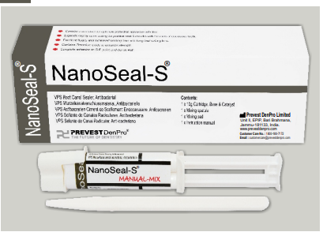
FIG 1: NanoSeal-S
ThermaSeal Plus Ribbon Root Canal Sealer ⁷
ThermaSeal Plus Ribbon root canal sealer is a dual paste system consisting of epoxy-amine resin with self-adhesive and long lasting sealing nature. Paste A which is amber in color consist of Bisphenol-A epoxy resin, Calcium tungstate, Zirconium oxide, Silica, Iron oxide pigments, Bisphenol-F epoxy resin. Paste B having a white color consist of Zirconium oxide, Calcium tungstate, Dibenzyldiamine, Silica, Aminoadamantane, Tricyclodecane-diamine, Silicone oil. Advantges include high Radiopacity , low Micro-Leakage, high dimensional stability , low shrinkage, low expansion, low Solubility, excellent sealing properties, self-adhesive properties, biocompatibility .
BioRoot RCS ⁸
BioRoot RCS (FIG 2) is the newest endodontic mineral based root canal sealer containing tricalcic silicate ingredients aiding from both Active Biosilicate Technology and Biodentine. It is a hydraulic tricalcium silicate based cement suggested for cold lateral condensation root filling or single cone technique. The powder is composed of povidone and zirconium dioxide, tricalcium silicate, and the liquid consist of calcium chloride, polycarboxylate and water. It carries on the sealing process in presence of moisture. Dentin is mineralized by hydroxy-apatite formation. It has microleakage resistance over warm obturation technique. BioRoot RCS crystalizes within dentinal tubules creating a 3-dimensional seal and leakage-free obturation. Its high pH (>11) creates a favorable alkaline environment. Pure mineral formulation will not stain teeth. Resin-free and monomer-free nature ensures zero shrinkage. Eugenol-free nature makes it compatible with all bonding systems. Pronounced flowability plugs auxilliary canals. Appropriate for use in cold single cone or cold lateral condensation and permits quick insertion of the gutta-percha points in permanent tooth.
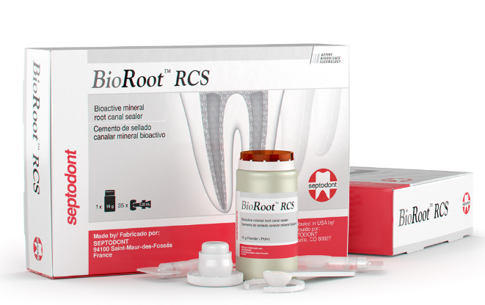
FIG 2: BioRoot RCS
GuttaFlow Bioseal ⁹
GuttaFlow bioseal is a cold filling silicone-based sealer comprising bioactive glass and gutta percha powder. Gutta percha with bioactive glass forms crystals of hydroxyapatite on the surface. GuttaFlow is a 2-in-1 cold filling (obturater and sealer in one) obturation system that is used for the obturation of root canals. Composed of Polydimethylsiloxane, Platinum catalyst, Gutta-percha powder, Silver (preservative), Zirconium dioxide, coloring agent and Bioactive glass ceramic. GuttaFlow also demonstrations exceptional adhesion to the gutta-percha point (masterpoint) in addition to to the dentine wall and does not require condensation as it expands on its own.
BIO-C SEALER ¹⁰
BIO-C SEALER (FIG 3) is a ready-to-use bioceramic endodontic cement that is ready-to-use. Its easy to apply on the canal, shortening the procedure with good time saving. It promotes a biological seal in addition to the physical seal provided by the expansion of cement by the formation of an intermediate layer of mineralization. It consists of Tricalcium Aluminate, Tricalcium Silicate (C3 S), Calcium Oxide, Dicalcium Silicate (C2 S), Silicon Oxide, Zirconium Oxide, Iron Oxide and Polyethylene Glycol. Its Radiopaque and has pH of 12. The interaction of BIO-C SEALER with moisture and tissue fluids discharges active ions that interact with the inorganic and organic matrix of the dentin, encouraging the development of an intermediate area, called the Mineral Infiltration Zone. This zone of mineral infiltration in the dentin delivers an excellent biological seal, diminishing likelihoods of bacterial infiltration.
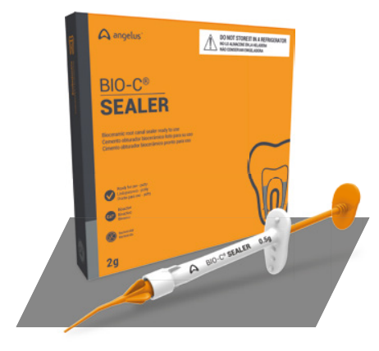
FIG 3: BIO-C SEALER
CeraSeal ¹¹
CeraSeal is a calcium silicate-based root canal sealer which delivers optimum biocompatible environment in the root canal. Due to its excellent sealing ability and biocompatibility its considered next generation bioceramic-sealer. Its composed of Calcium silicates, thickening agent, zirconium oxide. Calcium silicate creates CSH (Calsium Silicate Hydrate) gel and CAH (Calcium Aluminate Hydrate) gel by absorbing the moisture from tissues in the root canal and crystallization of Calcium Hydroxide (Ca(OH)₂). It is antimicrobial and highly biocompatibile ascribed to the presence of Calcium Hydroxide (Ca (OH)₂)'s plus its high pH. Its volume remains same and so it does not expand or shrink in the root canal.
AH Plus Bioceramic Sealer ¹²
AH Plus Bioceramic Sealer (FIG 4) is a root canal sealer conforming to ISO 6876 which does not require any pre-mixing as its packged in a pre-loaded syringe and is set by absorbing moisture from the root canal surroundings. The sealer may be used alone or in combination with gutta-percha obturating cones, injected gutta-percha material or core-carriers master cones. It’s composed of Tricalcium silicate, Lithium carbonate , Zirconium Dioxide, and Dimethyl sulfoxide. Sealer does not discolor the tooth as its free of Bismuth Oxide and guarantees a confident smile. Retreatability is decent as its can be removed even after setting with a hand file or NiTi file. It delivers an perfect environment for hydroxyapatite formation allowing the way for the body’s self-healing process.
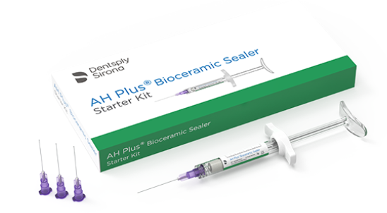
FIG 4: AH Plus Bioceramic Sealer
NeoSEALER Flo ¹³
NeoSEALER Flo is a bioactive bioceramic sealer easy to handle, promotes hydroxyapatite formation which supports the healing process. Unlike conventional sealers, neosealer Flo is resin-free, biocompatible, antimicrobial, dimensionally stable comprising of particularly inorganic fine powder of tricalcium/dicalcium silicate in an organic medium. It releases calcium and hydroxide ions from the MTA, encouraging hydroxyapatite development on the MTA surfaces to enhance sealing and support healing. High pH to promote osteogenic response.
EDGE BIOCERAMIC SEALER ¹⁴
Edge BioCeramic Sealer (FIG 5) consist of a unique resin-free formula making it very biocompatible and hydrophillic. Contrasting conventional sealers, Edge Bioceramic Sealer does not shrink and therefore it does not have to be compacted. It is radiopaque, aluminum-free and insoluble material based on a calcium silicate composition, which necessitates the presence of water to set and harden. It consist of Tricalcium silicate, Zirconium oxide, Dicalcium silicate and Calcium hydroxide. EdgeBioCeramic has high push-out bond strength and forms a close-fitting seal in the root canal thereby decreasing the likelihood of bacterial recolonization. Its Radiopaque and hydrophilic.

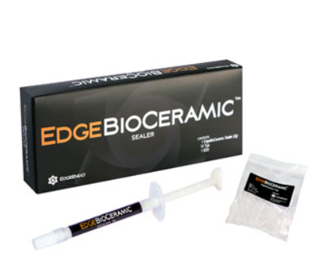

FIG 5: Edge BioCeramic Sealer

CONCLUSION
All these years, there has been an evolution of sealers used in the root canal, starting from conventional Zinc oxide eugonel to the current sealers like epoxy-resin based sealer, and to the modern bioceramic sealers, which have the fondness to transform the way sealers have been used in the near future ². However till today, no sealer has been presented to be completely suitable for clinical usage. Innovative endodontic root canal sealers described in the recent literatures exhibits encouraging biological features in comparison to conventional ones ³. Bioceramic sealers are more biocompatible and better accepted by the root canals. Few of them are even able to promote osteoblastic differentiation. Further in vitro and in vivo studies should be performed to approve the sustainability of recently available sealers, for their clinical use, as more investigations would help us to illuminate the mechanisms causative to the witnessed beneficial results ⁵.

REFERENCE
- Cohen S, Burns Richard C. Text book of pathways of pulp: Obturation of cleaned and Shaped Root Canal System. 2002, the Mosby Company, 8th Edition; 293-95
- Tyagi S, Mishra P, Tyagi P. Evolution of root canal sealers: An insight story. Eur. J. Gen. Dent. 2013;2(03):199-218.
- Mishra P, Gupta S, Nikhil V, Jaiswal S, Raj S. Root canal sealers: A review. Indian J of Conserv Endod. 2020:15;3(3):69-74.
- Abu Zeid ST, Alamoudi RA, Mokeem Saleh AA. Impact of Water Solubility on Chemical Composition and Surface Structure of Two Generations of Bioceramic Root Canal Sealers. Appl. Sci.2022;12(2):873.
- Özdemir O, Kopac T. Cytotoxicity and biocompatibility of root canal sealers: A review on recent studies. J. Appl. Biomater. Funct. Mater. 2022;20:22-25.
- NanoSeal-S [pamphlet]. India: PREVEST DENPRO LIMITED; 2016
- Ribbon® Root Canal Sealer [pamphlet]. Germany: Tulsa Dental Specialties DENTSPLY International, Inc; 2016
- BioRoot™ RCS [pamphlet]. France. SEPTODONT; 2016
- GuttaFlow® bioseal [pamphlet]. Germany. Coltène/Whaledent Ltd; 2016
- BIO-C® SEALER [pamphlet]. Brazil: Angelus dental; 2018
- CeraSeal [pamphlet]. Korea. Meta Biomed Co., Cheongju; 2020
- AH Plus® Bioceramic Sealer [pamphlet]. USA. DENTSPLY TULSA Dental; 2021
- NeoSEALER Flo [pamphlet].USA: Avalon biomed, Texas: 2021
- Edge BioCeramic [pamphlet].USA: Edge Endo: 2022

Author: Dr. Aiswarya Ajith
Guide: Dr. Rajan Dhawan
Co-Guide: Dr. Kirti Makan

