Birds damage to horticultural crops

Kiran*¹, Dharambir Singh¹, Amit Kour¹, Renu Yadav¹ and Rahul Kumar²
¹Department of Zoology and Aquaculture, CCS Haryana Agricultural University, Hisar-125004, Haryana, India
²Assistant Professor of Zoology, College of Agriculture, Bawal, CCS Haryana Agricultural University, Hisar-125004, Haryana, India
*Corresponding author
E-Mail: kiranyodha3@gmail.com

ABSTRACT:

Frugivorous birds impose tremendous costs on tree fruit growers by direct consumption of fruits and grower efforts to control birds. An essential step to reduce damage caused by birds is the identification of species responsible for damage and quantification of damage. Parakeets, Bulbuls, Mynas, Crows, Koel and barbet etc. are frugivores bird species which inflict damage to fruit crops. Rose-ringed Parakeet is the worst pest which causes significant damage to fruit crops. Factors such as food availability, field sizes, fields near roosting sites, crop or orchard characteristics, fruit characteristics and climatic factors influence the ability of the birds to damage the crop plants. This chapter provides an overview of factors responsible for bird damage and the employment of eco-friendly manual scaring practices for management.
Keywords: Birds, Crop, Damage, Horticulture, Management techniques

INTRODUCTION

Agroecosystems constitute 38% of the globe's terrestrial surface and are among the most productive ecosystems on earth (Foley et al. 2011). Agricultural landscapes provide a unique home for a wide range of animals, including invertebrates, amphibians, reptiles, birds and mammals in addition to several ecosystem services. Birds are an essential component of the biotic community in agro-ecosystems and provide several services such as seed dispersers, pollinators, scavengers, depositors of nutrients, insect pest controllers and rodent predators (Sekercioglu 2012). Birds are regarded as bioindicators of overall biodiversity in agricultural areas due to the variety of ecological functions they perform (Kiran et al. 2022). Changes in land use patterns, which usually result in the loss of natural habitats like forests, grasslands, and wetlands, have forced many birds to rely on man-made habitats and agricultural crops. Birds started destroying agricultural crops in their quest for sustenance. Some of these birds, which are well adapted to feed on agricultural crops, have increased enormously in number and become pests (Baral et al. 2019). Many species cause significant damage to agriculture directly through granivory or frugivory or indirectly by eating natural enemies of crops (Schackermann et al., 2014; Martin et al., 2013). It's worth mentioning that, 05 out of 1000 bird species (or 2.1 % ) have been documented to damage fruit crops in India. Birds damage fruit by directly consuming it, which lowers its quality while rendering it more vulnerable to diseases and pests (Lindell et al. 2012). The most severe damage to mature crops was caused by the foraging activities of bird species such as Ploceus philippinus, Lonchura spp. and Corvus splendens which resulted in a 55% decrease in crop yield. Birds such as Acridotheres tristis, Acridotheres fuscus, Sturnus pagodarum, Corvus splendens and Pycnonotus leucotis devastate grapes vineyards in Himachal Pradesh, India which in turn lowers the quality of grapes (Patyal and Rana 2006). In addition to these bird species, the Psittacula krameri, which wreaks havoc on standing grain crops, fruit orchards and vegetable crops is the most widespread and destructive bird from an agricultural perspective (Kushwaha and Roy 2004). Hence, it is vital to implement different strategies to control birds. This chapter discusses strategies for preventing birds from causing harm to horticultural crops.

Frugivores bird species

Parakeet, Bulbuls, Mynas, Crows and Koel several species are frugivores. In Karnataka Red billed magpies, White-cheeked bulbuls, Red-vented bulbuls and Slaty headed parakeets caused 20 % damage to apples, apricot and peach; 14-33 % damage to guava by Rose-ringed Parakeet and Small green barbet; and considerable damage by Bulbuls also recorded (Chakravarthy 1993; Toor 1982; Simwat and Sidhu 1973). Toor (1982); Sandhu and Dhindsa (1995) recorded in Punjab grape losses ranged from 19 % to 60 % due to Bank myna and Indian myna and 36 % damage caused by Common crow, Jungle crow, and Barbet in Karnataka (Prasad and Verghese 1985).
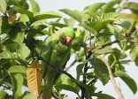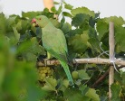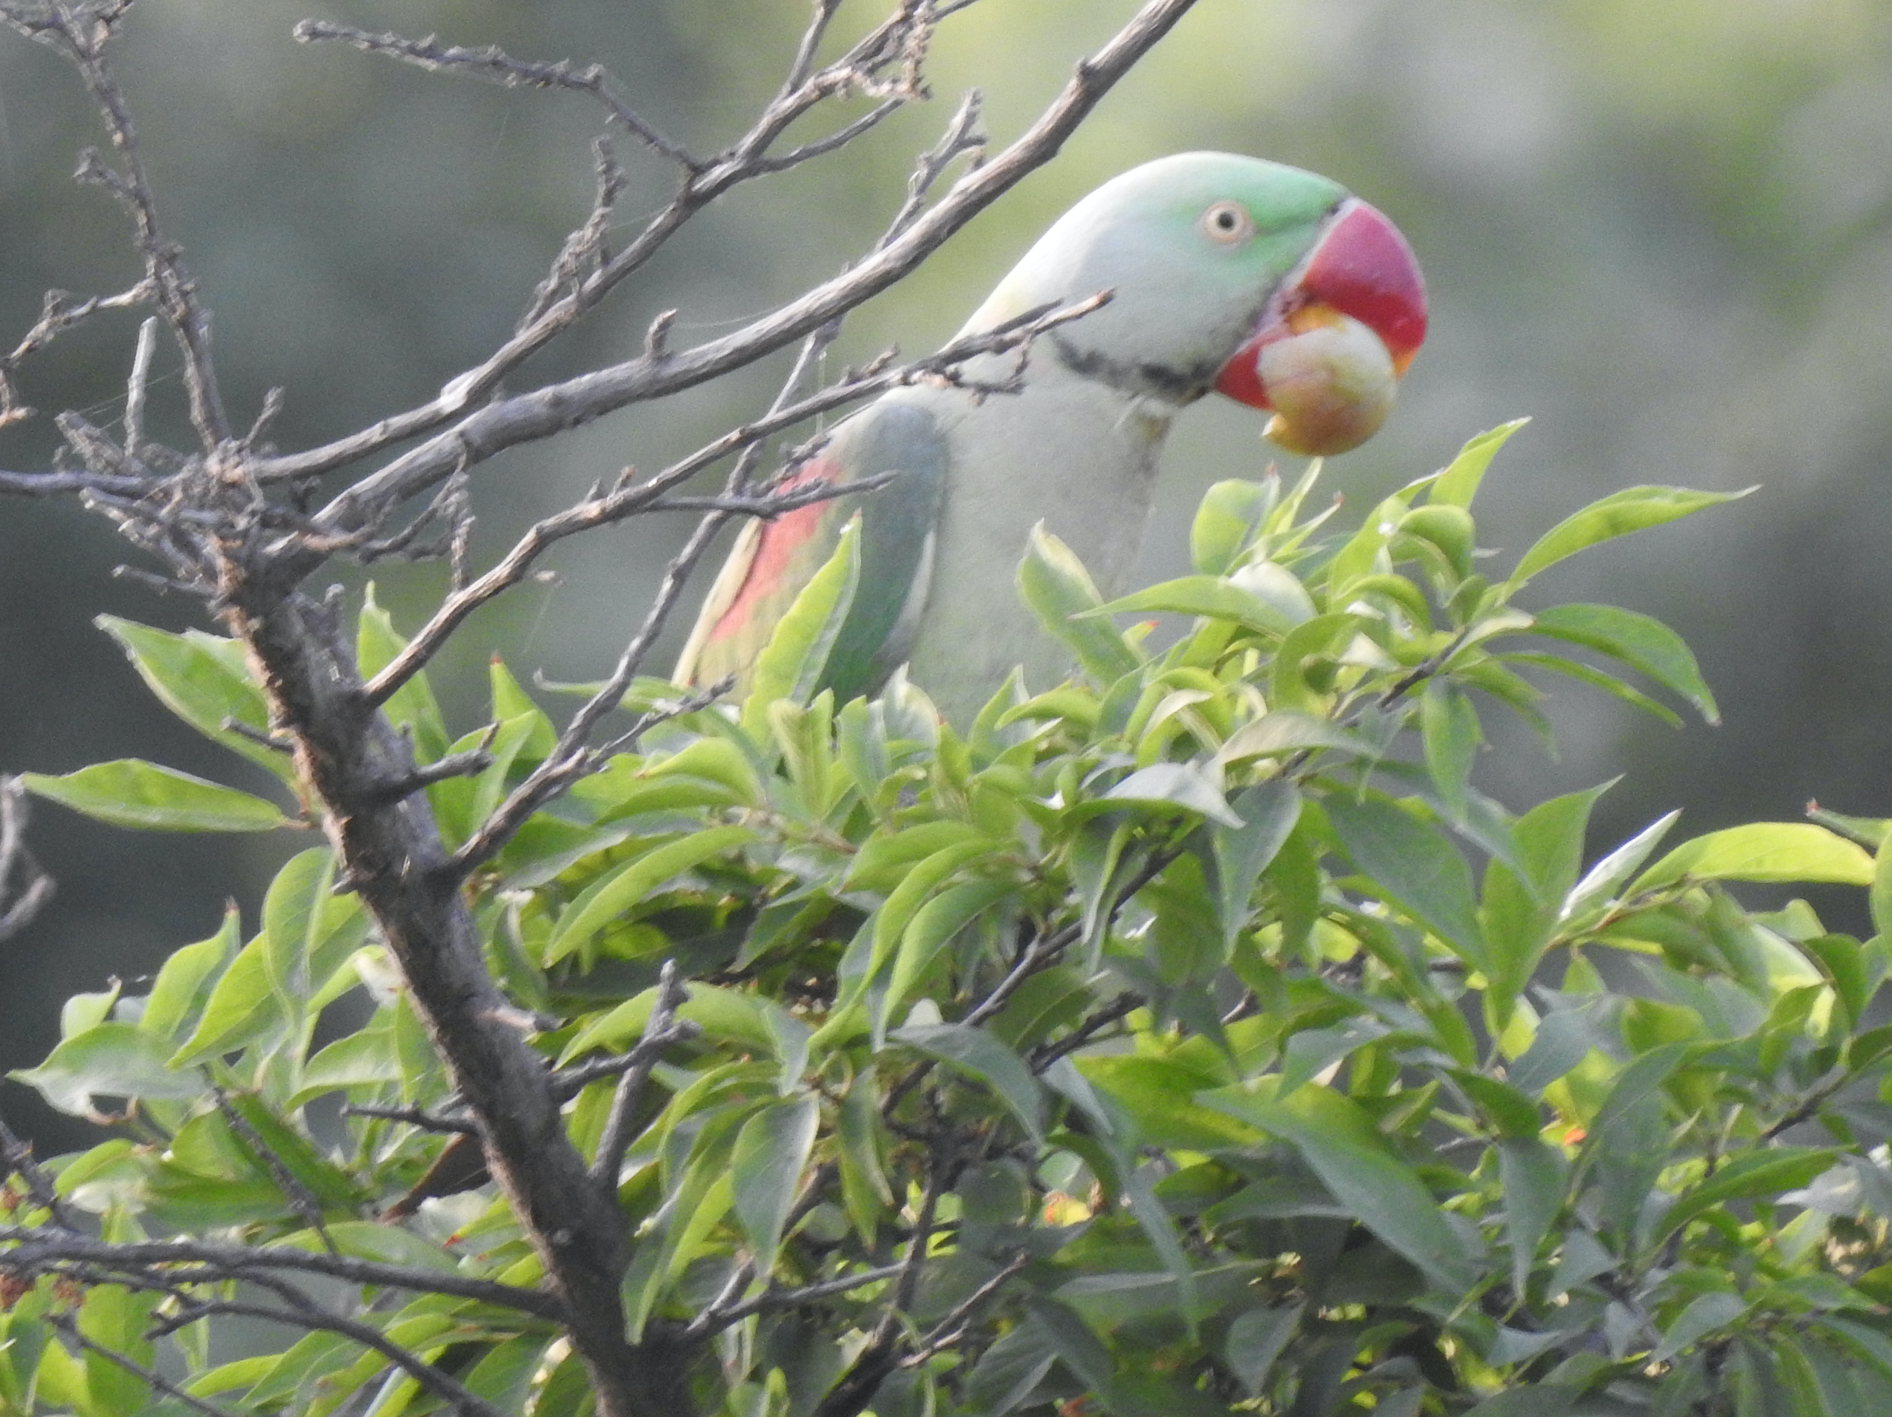

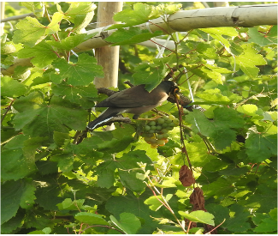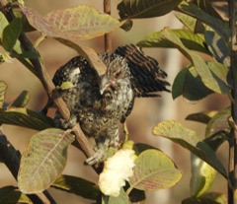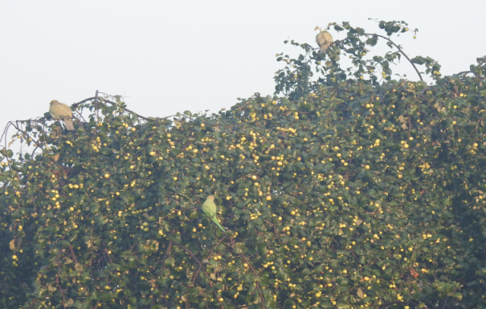

Figure 1: (A) and (B) - Damage to guava and grape fruit by Rose-ringed Parakeet (C) - Damage to plum fruit by Alexandrine Parakeet (D)- Damage to grape fruit by Common Myna (E) - Damage to guava fruit by Asian koel (F) - Damage to Indian ber fruit by Rose-ringed Parakeet and Yellow-footed Green-pigeon @ Kiran.

The Rose-ringed Parakeet, Common crow and Sparrow cause 21.2 % damage to peaches (Mann 1986; Toor and Ramzan 1974). The Blossom-headed parakeet causes up to 80 % damage to apples (Narang and Chandel 1995). Considerable damage also causes to orange fruit by the Jungle crow and Golden-fronted chloropsis whereas the Common crow causes serious damage to sapota (Verghese 2006; Chakravarthy 1993). The estimated damage of 10-30 % was seen in pomegranate by Rose-ringed Parakeet, Coppersmith barbet, Small green barbet and Mynas. The damage caused to pineapple by Jungle crow was reported 22%. Green barbet damage to papaya and Rose-ringed Parakeet damage to mango have also been observed (Toor 1982).

Table 1: Extent of damage caused by birds to horticultural crops

Scientific Name | Stage of crop | Extent of damage | Frugivorous birds
Phoenix dactylifera | Ripening | 0.1-1% | Rose-ringed Parakeet, Common myna, Bank myna, Brahminy myna, House crows and White throated Munia
Vitis sp. | Ripening | 2-27% | Rose-ringed Parakeet, Red-vented Bulbul, Purple sunbird, Common myna, Asian koel and Golden orioles etc.
Psidium guajava | Ripening | 3-5% | Rose-ringed Parakeet, Red-vented Bulbul, Small green barbet and House crow etc.
Mangifera indica | Ripening | 3-10% | Rose-ringed Parakeet
Carica papaya | Ripening | - | House crows, Red-vented Bulbul, Small green barbet, Brahminy myna and Koel
Punica granatum | Ripening | 2-20% | Rose-ringed Parakeet, Red-vented Bulbul, House crow and Jungle crow
Pyrus sp. | - | - | Mainly parakeets; occasionally crows and bulbuls
Zizyphus sp. | - | - | Mainly bulbuls occasionally barbets, crows and parakeets
Source - (Sridhara 2016)

Factors influencing damage

Food accessibility
The population of nuisance birds is significantly influenced by the availability of food. The majority of birds are quite mobile and can fly great distances in search of food or nesting grounds. For pest bird populations to be reduced food availability must be restricted (Smith 1991; Feare 2004).
Fields close to roosting or breeding areas
Fields close to roosting or breeding areas are more vulnerable to bird damage. Birds can build their nests in the trees, shrubs or reeds that surround the fields. They render crops more vulnerable to bird infestations since they will continue eating nearby crops (Mofokeng and Shargie 2016).
Field size
The extent of bird damage to fruit crops can also be influenced by field size. The size of a field or orchard can influence bird behaviour. Here are some examples of how field size cause bird damage:
- Bird habitat proximity: Larger fields or orchards near natural bird habitats, such as woods, marshes, or water bodies are susceptible to more bird damage. Birds from these surrounding habitats may be attracted to the concentrated food supply by the ease with which they may access the fruit crops (Johnson et al. 1989).
- Isolation: Smaller fields that are separated and bordered by other land uses (e.g., urban areas, non-agricultural lands) may be less affected by bird damage. Because birds are less likely to fly far from their habitats in search of food, fruit orchards in isolated regions may be less prone to damage (Johnson et al. 1989).
- Crop diversity: Monoculture fruit crops in larger fields provide a significant and stable food supply for birds. If local bird populations enjoy the fruit crop, they are more likely to focus their foraging efforts in that region, resulting in more damage (Manikowski and Da Camara Smeet 1979).
Fruit Characteristics
The severity of bird damage varies according to fruit characteristics such as fruit size, maturity and sugar content, pulpiness colour and fruit height etc. (Snow 1970).
- Fruit size: Larger fruits are more enticing to birds since they provide an enormous food supply. Birds may quickly find out and consume larger fruits, increasing the probability of damage.
- Fruit colour: Birds are attracted to brightly coloured fruits, particularly red, orange, and yellow colours. These colours indicate ripeness and serve as a visual cue for birds to locate food. As a result, fruits with bright colours may be more vulnerable to avian damage (Wheelwright and Janson 1985).
- Fruit ripeness: As fruits mature, their sugar content rises, making them more enticing to birds seeking high-energy foods. Overripe or rotting fruits may attract birds as a result of fermentation, causing additional damage (Sorensen 1983).
- Fruit texture: Soft, fleshy fruits are easier for birds to peck and eat. Fruits with thin skins or that split readily are more susceptible to avian damage.
- Fruit availability: The availability of fruits is crucial. If a fruit harvest overlaps with a bird species migratory or breeding season, there may be an increased risk of damage as birds seek food for themselves and their offspring.
Climatic factor
Long-term climatic changes can have a considerable impact on bird numbers and behaviour. Birds feed most frequently in the early morning and late afternoon. Other bird species, on the other hand, may not eat until later in the morning, so they may spend the morning doing anything else. The abundance of insects and the weather are two other factors that affect bird richness or foraging behaviours. In a vineyard, for example, the diversity of birds is highest during and shortly after rains (Tracey et al. 2007).

Eco-friendly management methods

Bird scare tactics discourage birds from specific locations, such as agricultural fields and orchards, where their presence might cause damage. These strategies endeavour to create an unpleasant or hazardous environment for birds, encouraging them to avoid the location. Farmers often employ various management techniques to prevent bird damage. The following are some examples of effectively used management techniques:
Visual scare devices: Devices that frighten birds visually are known as visual scare devices.
- Scarecrows: Scarecrows are human-like figurines that are positioned in orchards or fields to resemble a potential threat.
- Reflective tape or strips: Shiny objects that emit light flashes to scare away birds (Arora et al. 2023).
- Balloons or inflatable predators: Inflatable predators that resemble large balloons (such as owls or snakes) and move with the wind might be viewed as a danger (Tracey et al. 2007).
Auditory Scare Devices: Devices that use sound or noise to scare away birds are known as auditory scare devices.
- Propane cannons: Equipment that intermittently fires or explodes loudly.
- Bird distress call devices: Devices that emit distress calls or predator sounds to scare off birds (Khan et al. 2013).
Predator Decoys: Statues or cutouts of natural predators, such as owls, hawks, or snakes are placed near the target location to create an illusion of imminent danger.
Scare Tactics: The presence of humans or persistent disturbance in the vicinity might dissuade birds. The use of fireworks or other pyrotechnic devices that produce loud and visual disruptions.
Netting
The most effective approach is netting. It prevents the entry of birds into the orchard . Due to the massive area of crops that need to be covered, it is one of the most expensive strategies for repelling birds (Rivadeneira et al. 2018).
Use of alternate crops
Every orchard should have a boarder fence area to plant some crops to divert the attention of birds from the main crops (Sridhara 2016).
Habitat manipulation
Persistent disruption to depredatory breeding sites in and surrounding cultivated areas will encourage the birds to leave breeding grounds and relocate to another location that provides better quality feed or shelter through lure crops or sacrificial crops (Rivadeneira et al. 2018).

CONCLUSION

Birds cause significant damage to fruit crops, posing a substantial challenge to farmers and orchard owners. The impact of bird damage on fruit crops includes reduced yield, lower fruit quality, economic losses, increased labour and resource costs for crop protection measures. Various bird species, such as Parakeet, bulbul, myna, crows, and barbet are known to be particularly problematic. To mitigate the damage caused by birds, farmers employ a range of eco-friendly management techniques including netting, scare devices, and the use of loud noises or predator decoys which helps in reducing bird damage.

REFERENCES

Arora, S., Kaur Kler, T., Kaur, G. and Kaur, N. (2023). Depredatory Bird Damage Assessment and Its Management Techniques in Guava. Erwerbs-Obstbau, 1-5.
Baral, S. S., Swarnkar, R., Kothiya, A. V., Monpara, A. M. and Chavda, S. K. (2019). Bird repeller–a review. International Journal of Current Microbiological Applied Science, 8: 1035-1039.
Chakravarthy, A.K. (1993). Vertebrate pest management. Final report of ICAR ad-hoc project, University of Agricultural Sciences, Bangalore, India.
Feare, C. J. (1991). Control of bird pest populations. In Bird Population Studies. Perrins, C. M., Lebreton, D. D. and Hirons, G. J. M. (eds), pp. 463–478.
Foley, J. A., Ramankutty, N., Brauman K. A., Cassidy E. S., Gerber J. S., Johnston M., Mueller N. D., O’Connell C., Ray D. K., West P. C., Balzer C., Bennett E. M., Carpenter S. R., Hill J., Monfreda C., Polasky S., Rockstrom J., Sheehan J. and Sieber S. (2011). Solutions for a cultivated planet. Nature, 478: 337–342.
Johnson, D. B., Guthery, F. S. and Koerth, N. E. (1989) Grackle damage to grapefruit in the lower Rio Grande Valley. Wildlife Society Bulletin, 17: 46– 50.
Khan, H. A., Javed, M., Tahir, A. and Kanwal, M. (2013). Limiting the rose-ringed parakeet (Psittacula krameri) damage on guava (Psidium guajava) and mango (Mangifera indica) with an ultrasonic sound player in a farmland of Faislabad, Pakistan. African Journal of Agricultural Research, 8(49): 6608-6614.
Kiran, Singh, D., Kour, A., Dahiya, P. and Delu, V. (2022). Community composition and status of avian diversity at Campus and Agricultural landscapes of Chaudhary Charan Singh Haryana Agricultural University, Hisar (Haryana). Journal of Applied and Natural Science, 14(4): 1130-1140.
Lindell, C. A., Eaton, R. A., Lizotte, E. M. and Rothwell, N. L. (2012). Bird consumption of sweet and tart cherries. Human-Wildlife Interactions, 6(2): 283-290.
Manikowski, S. and Da Camara-Smeets, M. (1979). Estimating bird damage to sorghum and millet in Chad. The Journal of Wildlife Management, 43(2):540-544.
Mann, G. S. (1986). House sparrows (Passer domesticus Linn.) causing severe damage to peach buds in residential areas at Ludhiana, Punjab. Tropical Pest Manage, 32(1): 43.
Martin E. A., Reineking, B., Seo, B., Steffan-Dewenter, I. (2013). Natural enemy interactions constrain pest control in complex agricultural landscapes. Proceedings of the National Academy of Sciences, 110: 5534–5539.
Mofokeng, M. A. and Shargie, N. G. (2016). Bird damage and control strategies in grain sorghum produciton. International journal of agricultural and environmental research, 2(4): 264-269.
Narang, M. L. and Chandel, J. S. (1995). Preliminary studies on bird damage to apple orchards in Himachal Pradesh (Abstract). Environment and birds, Secretariat Box 45, Srinagar, Garhwal, U.P., India.
Patyal, S. K. and Rana, R. S. (2006). Bird damage to Kinnow fruits in Himachal Pradesh and evaluation of management techniques against them. Pest Management and Economic Zoology, 14: 157-61.
Prasad, V. G. and Verghese, A. (1985). Birds as pests of horticultural crops. Bulletin of Entomology, 26: 94-96.
Rivadeneira, P., Kross, S., Navarro-Gonzalez, N. and Jay-Russell, M. (2018). A review of bird deterrents used in agriculture. In Proceedings of the Vertebrate Pest Conference (Vol. 28, No. 28).
Kushwaha, S. P. S. and Roy, P. S. (2002). Geospatial technology for wildlife habitat evaluation. Tropical ecology, 43(1): 137-150.
Sandhu, P. S. and Dhindsa, M. S. (1995). Orchard birds – a review. (Abstract). In: Environment and birds. Abstracts. Secretariat, Box 45, Srinagar, Garhwal, U. P, India. 57.
Schaackermann, J., Weiss, N., Von-Wehrdren, H., Klein, A. M. (2014). High trees increase sunflower seed predation by birds in an agricultural landscape of Israel. Frontiers in Ecology and Evolution, 2: 35.
Şekercioglu, C. H., Primack, R. B. and Wormworth, J. (2012). The effects of climate change on tropical birds. Biological conservation, 148(1): 1-18.
Simwat, G. S. and Sidhu, A.S. (1973). Studies on the control of house crow (Corvus splendens Viellot) through poison baiting. Journal of Research: Punjab Agricultural University, 10(2): 216-219.
Smith, G. C. (1991). The Silver Gull: Problems, Biology and Management for the Sydney-Wollongong region. NSW National Parks and Wildlife Service and the Water Board and Waste Management Authority, Sydney.
Snow, D.W. (1971). Evolutionary aspects of fruit-eating by birds. Ibis, 113: 194–202.
Sorensen, A. E. (1983). Taste aversion and frugivore preference. Oecologia, 56: 117-120.
Sridhara, S. (2016). Vertebrate pests in agriculture. Scientific Publishers.
Toor, H. S. and Ramzan, M. (1974). A study on bird pests of grapes. Punjab Horticultural Journal, 14: 46-48.
Toor, H. S. (1982). Problem birds and their management in Punjab. In: Management of problem birds in aviation and agriculture.(Eds.): Agarwal, R.A. & Bhatnagar, R.K. Indian Agricultural Research Institute, New Delhi, India.151-158.
Tracey, J. P., Mary, B., Hart, Q., Saunders, G. and Sinclair, R. (2007). Managing bird damage to fruit and other horticultural crops.
Verghese, A. (2016). Frugivorous birds and their management. In: Vertebrate pests in Agriculture. Published by Scientific publishers, Jodhpur, 63-74.
Wheelwright, N. T. and Janson, C. H. (1985). Color of fruit displays of bird-dispersed plants in two tropical forests. American Naturalist, 126: 777-799.

