Global Uptick in Crowdfunding: A Lifeline in the Covid-19 Era and the Regulations Protecting Investors
Deepthi Rapeti*, D. Madhu Sudhan Reddy
*Corresponding Author Email: deepthirapeti3@gmail.com

ABSTRACT

Crowdfunding is one of the most popular ways to raise finances for any design, cause or for helping any existent in need. With the onset of Covid, It had observed to rise in Crowdfunding conditioning across the globe which includes small juggernauts to help people get oxygen and medical help to large finances similar to PM Cares. In utmost authority, restrictions apply to who can fund a new business and how important they're allowed to contribute. Analogous to the restrictions on barricade fund investing, these regulations are supposed to cover simpleminded or non-wealthy investors from putting too much of their savings at threat. Blockchain is the best way provide better to provide maximum features like track transactions, distribution of data, and so on,.
Keywords
Blockchain, Crowdfunding, Decentralize, Network, Ethereum
- INTRODUCTION
Blockchain [1] is a decentralized, unchangeable database that makes it easier to track assets and record transactions in a corporate network. An asset may be physical (such as a home, car, money, or land) or intangible (intellectual property, patents, copyrights, branding). In a Blockchain network, practically anything of value may be recorded and sold, lowering risk and increasing efficiency for all parties.
All network users have access to the distributed ledger's immutable record of transactions thanks to distributed ledger technology. Transactions are only recorded once using this shared ledger, preventing the duplication of effort seen in conventional corporate networks. A contemporary fundraising technique that has grown in popularity recently is crowdfunding. It entails soliciting money from a sizable number of individuals for a project or commercial enterprise, usually using an Internet form. By using this technique, people or organizations may connect with a large number of potential donors who can make modest financial contributions to the initiative.
Crowdfunding [2] has become an increasingly popular financing model that allows entrepreneurs, startups, and individuals to raise funds for their projects, causes, and creative endeavours. However, traditional crowdfunding platforms have several limitations, including high fees, lack of transparency, and limited access to investors.
Blockchain technology has emerged as a game-changer for the crowdfunding industry, offering a decentralized and transparent platform that enables secure and efficient fundraising. By leveraging Blockchain, crowdfunding platforms can eliminate intermediaries, reduce costs, and provide a more open and transparent investment environment for both investors and project creators.
The purpose of the crowdfunding platform powered by Blockchain [3], as described in the report, is to create a decentralized and transparent fundraising environment for individuals, startups, and entrepreneurs to raise funds for their projects. The platform aims to provide a more efficient, cost-effective, and accessible alternative to traditional crowdfunding platforms by leveraging Blockchain technology. The report highlights several limitations of traditional crowdfunding platforms, such as high fees, lack of transparency, and limited access to investors. The Blockchain-powered crowdfunding platform aims to address these limitations by eliminating intermediaries, reducing costs, and providing a more open and transparent investment environment for both investors and project creators.
The platform will leverage Blockchain technology to create a secure and transparent fundraising ecosystem, with features such as smart contracts, digital wallets, and tokenization. Smart contracts will automate the investment process, eliminating intermediaries and reducing costs. Digital wallets will enable secure storage and transfer of funds, while tokenization will provide investors with the opportunity to invest in fractional ownership of projects.
The overall purpose of the Blockchain-powered crowdfunding platform [4] is to democratize the fundraising process, enabling individuals and startups to raise funds more efficiently and providing investors with access to innovative projects and investment opportunities. The objective of crowdfunding powered by Blockchain is to create a decentralized and transparent fundraising ecosystem that leverages Blockchain technology to offer a more efficient, cost-effective, and accessible alternative to traditional crowdfunding platforms.
The key objectives of a crowdfunding platform powered by Blockchain are:
- To eliminate intermediaries: Blockchain technology can enable direct peer-to-peer transactions between project creators and investors, eliminating the need for intermediaries such as banks or crowdfunding platforms. This can reduce costs and increase efficiency.
- To increase transparency: Blockchain technology enables a transparent and secure ledger of transactions, providing investors and project creators with a clear view of the funding process. This can increase trust and transparency in the fundraising process.
- To reduce fees: Traditional crowdfunding platforms charge high fees for their services, which can eat into the funds raised by project creators. By eliminating intermediaries and automating the fundraising process with smart contracts, Blockchain-powered crowdfunding platforms can significantly reduce fees.
- To increase access to funding: Traditional crowdfunding platforms often have limitations on the amount of funds that can be raised, and project creators may have difficulty accessing investors outside of their network. Blockchain-powered crowdfunding platforms can offer a global network of investors, increasing access to funding for project creators. To provide fractional ownership: Tokenization on the Blockchain can enable fractional ownership of assets, allowing investors to invest in small portions of projects. This can enable more people to invest in innovative projects and ideas.
Engaging early adopters: Those who support crowdfunding projects are frequently early adopters who are eager to test out new goods and services before they are made accessible to the general public. Project makers may develop a devoted client base and gather insightful input to enhance their products by interacting with these early adopters.
Overall, the objective of crowdfunding powered by Blockchain is to create a more efficient, transparent, and accessible fundraising ecosystem that benefits both project creators and investors.

EXISTING SYSTEM
Before the emergence of crowdfunding, the traditional process [5] of financing projects, businesses, and creative endeavors was mainly through bank loans, venture capital, or personal savings. These traditional methods of financing were often difficult for startups, small businesses, and individuals to access, as they typically required a track record of success or significant collateral. In addition to these traditional financing methods, there were also a few alternative financing options available, such as grants, donations, and sponsorships. However, these options were often limited in scope, and the selection process was often competitive and time-consuming.
Crowdfunding emerged as an alternative financing model [6] in the early 2000s, enabled by the growth of the internet and social media. Crowdfunding platforms such as Kickstarter, Indiegogo, and GoFundMe provided a way for project creators to raise small amounts of money from a large number of individuals, typically via an online platform. The emergence of crowdfunding disrupted the traditional financing process by enabling project creators to access funding from a global network of individuals without the need for a track record of success or significant collateral. Crowdfunding also provided a way for investors to access innovative projects and ideas that they may not have otherwise had access to.
Overall, the traditional financing process before crowdfunding [7] relied mainly on bank loans, venture capital, personal savings, grants, donations, and sponsorships. Crowdfunding emerged as a disruptive alternative to these traditional financing methods by providing a more accessible, efficient, and democratic fundraising model.
Drawbacks:
- The traditional financing process was often inaccessible
- Traditional financing could lack transparency
- The traditional financing process often limited access
- Traditional financing often involved a lengthy approval process, with extensive due diligence, paperwork, and meetings required.
- Traditional financing options such as bank loans and venture capital often came with high fees and interest rates, which could be difficult for startups and small businesses to afford.
- LITERATURE REVIEW

Blockchain for Supply Chain Management [8] examines the current state of research on the use of Blockchain technology in supply chain management (SCM). The authors analyzed a total of 87 articles published between 2016 and 2020 to identify the potential benefits and challenges of using Blockchain in SCM. Blockchain technology is a decentralized digital ledger that has the potential to disrupt a variety of industries. Potential benefits of Blockchain technology, such as improved security, transparency, and efficiency. They also highlight its potential to enable new business models, such as decentralized autonomous organizations.

The study found that Blockchain [9] has the potential to enhance supply chain visibility, traceability, and security, while also reducing costs and increasing efficiency. Specifically, the technology can be used to improve inventory management, reduce the risk of counterfeit products, and streamline supply chain processes. However, the authors also identified several challenges and limitations associated with the use of Blockchain in SCM, such as the need for interoperability and standardization across different Blockchain platforms, as well as the potential for regulatory and legal issues.

The review concludes with recommendations for future research in this area, including the need for more empirical studies to evaluate the effectiveness of Blockchain in SCM, as well as the exploration of new applications and use cases for the technology. Despite these challenges, the literature on Blockchain highlights its potential to disrupt traditional business models and create new opportunities for innovation. As noted in the study [10], Blockchain technology has the potential to revolutionize the financial industry by enabling secure and transparent transactions without the need for intermediaries. Overall, this literature survey provides valuable insights into the potential of Blockchain technology in improving supply chain management, as well as the challenges that must be addressed in order to fully realize its benefits.

This paper [11] provides an overview of the challenges and potential future applications of Blockchain technology. The author first explains the basics of Blockchain technology, including its decentralized and secure nature, and how it can be used to create a tamper-proof and transparent record-keeping system.

The paper then discusses the current challenges of the technology, including issues related to scalability, interoperability, and regulation. For example, the author notes that current Blockchain systems are not yet capable of handling the transaction volume required for mainstream adoption, and that interoperability between different Blockchain networks remains a challenge. Despite these challenges, the author argues that the potential future applications of Blockchain technology are vast and varied. These include use cases in areas such as finance, supply chain management, and healthcare, among others.
One area where Blockchain technology could have a significant impact, according to the author, is in reducing the risk of fraud and corruption in various industries. By creating a tamper-proof and transparent record-keeping system, Blockchain could help increase accountability and prevent fraud. The author also discusses the potential impact of Blockchain on the job market, noting that while some jobs may be eliminated as a result of Blockchain automation, new jobs will also be created in areas such as Blockchain development and maintenance.
Overall, the paper provides a comprehensive overview of the challenges and potential future applications of Blockchain technology, highlighting both its strengths and weaknesses.
This paper [12] provides an overview of the current state of Blockchain technology, its applications, and challenges. The authors begin by discussing the basics of Blockchain technology, including its decentralized nature and use of cryptography. They then provide an overview of the different types of Blockchain, such as public and private, and their respective advantages and disadvantages. Next, the authors survey the various applications of Blockchain technology, including cryptocurrency, supply chain management, and voting systems. They also discuss emerging applications, such as decentralized identity management and smart contracts. For each application, the authors provide examples and highlight the benefits of using Blockchain technology.
The authors [13] then discuss the challenges and limitations of Blockchain technology, including scalability issues, security concerns, and regulatory challenges. They also discuss the need for interoperability between different Blockchain networks and the importance of educating the public and policymakers about the technology.
Finally, the authors conclude by stating that while there are challenges to be overcome, the potential benefits of Blockchain technology are vast and could fundamentally change the way we do business and interact with each other.
Blockchain technology has the potential to revolutionize the way we store and manage data, offering a secure, transparent, and decentralized alternative to traditional centralized systems. While the technology is still in its early stages, it has already been applied in a variety of industries, from finance to supply chain management. As the technology continues to mature, it is likely that we will see even more applications emerge, with the potential to transform the way we live and work."
Blockchain technology has become increasingly popular due to its potential to revolutionize various industries, including finance, healthcare, and supply chain management. The use of Blockchain in these areas can provide increased security, transparency, and efficiency in transactions. This has led to a significant amount of research being conducted on the topic, with many studies focusing on the potential benefits and drawbacks of implementing Blockchain in various applications.
One such literature survey was conducted by authores [14], who explored the potential use cases of Blockchain technology in various industries. They identified several key areas where Blockchain could be beneficial, including supply chain management, financial services, and healthcare. In the area of supply chain management, the authors found that Blockchain technology could provide increased transparency and traceability, reducing the risk of fraud and counterfeiting. This is particularly important for industries such as food and pharmaceuticals, where the safety and authenticity of products are crucial.
In the financial services industry, the authors noted that Blockchain could provide increased security and efficiency in transactions, reducing the need for intermediaries and the associated costs. They also highlighted the potential use of Blockchain for peer-to-peer lending and remittances, which could provide increased access to financial services for underserved populations. In the healthcare industry, the authors found that Blockchain technology could provide increased security and privacy in patient records, while also facilitating the sharing of information between healthcare providers. They also noted the potential use of Blockchain for clinical trials, where the transparency and immutability of the technology could help to prevent fraud and ensure the accuracy of data. It concluded that Blockchain technology has the potential to revolutionize various industries, providing increased security, transparency, and efficiency in transactions. However, they also noted that there are several challenges that must be addressed, including scalability, interoperability, and regulatory concerns. One limitation of this literature survey is that it was conducted in 2018, and since then, there have been significant developments in the field of Blockchain. Nevertheless, the study provides a comprehensive overview of the potential use cases of Blockchain technology and highlights the need for further research to address the challenges associated with its implementation.
This literature survey [15] aims to investigate the potential use of Blockchain in public procurement, an area that has been identified as a prime candidate for the implementation of Blockchain technology. The authors conducted a systematic review of the literature, analyzing 39 peer-reviewed articles and conference proceedings published between 2014 and 2019. The survey identifies various use cases of Blockchain in public procurement, including transparency in supplier selection, contract management, payment systems, and tracking of goods and services. The review also highlights the opportunities and challenges associated with the adoption of Blockchain in public procurement.
One of the main opportunities [16] identified is the potential for Blockchain to increase transparency and reduce corruption in the procurement process. Blockchain can enable a secure and transparent record-keeping of transactions, allowing for greater accountability and traceability of funds. Additionally, Blockchain can help automate certain procurement processes, reducing the need for manual intervention and saving time and costs.
However, the survey also identifies several challenges that need to be addressed before Blockchain can be widely adopted in public procurement. These include legal and regulatory barriers, interoperability issues between different Blockchain networks, and the need for technical expertise to develop and maintain Blockchain systems.
The survey [17] also includes a case study of the implementation of Blockchain in the public procurement process in different locations. The study found that Blockchain technology improved transparency and reduced the time and costs associated with procurement processes.
Overall, the survey concludes that Blockchain has significant potential to improve the public procurement process by increasing transparency, reducing corruption, and improving efficiency. However, there are several challenges that need to be addressed before the technology can be widely adopted in this area.

PROPOSED SYSTEM
The proposed system for the traditional financing process is a crowdfunding platform powered by Blockchain technology. This platform aims to eliminate many of the limitations of the traditional financing process by creating a decentralized, transparent, and accessible fundraising ecosystem.

BLOCKCHAIN

Crowdfunding is latest method by contribute many individual with small amount from various parts of world. It is different from traditional funding which is usually from bank, very few individuals. Fig 4.1 depicts about difference of traditional and crowdfunding.

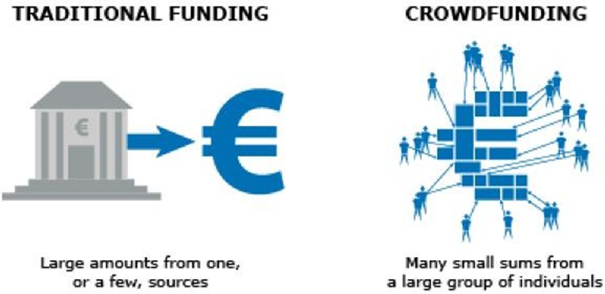
Fig 4.1: Differences Between Traditional Funding VS Crowdfunding

The key features of the proposed system include:
Decentralized platform: The proposed crowdfunding platform is built on a decentralized Blockchain network, which eliminates the need for intermediaries such as banks or crowdfunding platforms. This can reduce costs and increase efficiency by enabling direct peer-to-peer transactions between project creators and investors.
Transparency: The Blockchain technology enables a transparent and secure ledger of transactions, providing investors and project creators with a clear view of the funding process. This can increase trust and transparency in the fundraising process by allowing stakeholders to verify transactions in real-time.
Lower fees: By eliminating intermediaries and automating the fundraising process with smart contracts, Blockchain-powered crowdfunding platforms can significantly reduce fees. This can enable project creators to retain more of the funds they raise and offer investors a more cost-effective investment opportunity.
Access to global network: The proposed crowdfunding platform can offer a global network of investors, increasing access to funding for project creators. This can enable individuals and small businesses to access funding opportunities that were previously unavailable to them.
Fractional ownership: The tokenization of assets on the Blockchain can enable fractional ownership of assets, allowing investors to invest in small portions of projects. This can enable more people to invest in innovative projects and ideas.
Overall, the proposed system for the traditional financing process offers a more efficient, transparent, and accessible fundraising ecosystem that benefits both project creators and investors. It leverages the power of Blockchain technology to create a decentralized and democratized funding model that eliminates many of the limitations of the traditional financing process.

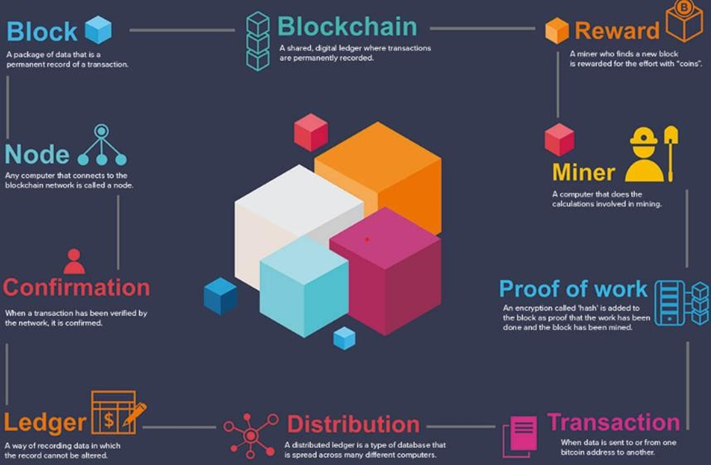
Fig 4.2: Blockchain Technology

Fig 4.2 gives the entire technical perspective of Blockchain technology. Tools that developers may employ to create apps that communicate with the Blockchain include application programming interfaces and software development kits. Developers may access the Blockchain and carry out actions like reading and writing data to the ledger thanks to APIs, which offer a set of instructions. Developers may include Blockchain technology into their apps by using pre-built code libraries known as SDKs.
A block in a Blockchain is a group or collection of information. The information is added to the block in a Blockchain, by connecting it with other blocks in chronological order and creating a chain of blocks linked together. Let’s take the example of Google spreadsheet or MS Excel (Windows). This spreadsheet is shared among different computer networks, where everyone has a copy. The spreadsheet contains data and information of transactions made by individuals. Anyone with a copy can access that spreadsheet but no one can edit or change it. This is how the Blockchain works. It uses blocks, whereas spreadsheet works with “rows” and “columns”.
Blockchain is a distributed digital ledger technology that is used to securely record transactions and store data in a decentralized manner. A Blockchain is essentially a database that is maintained by a network of computers, or nodes, that work together to validate and record transactions.
In a Blockchain, each block contains a cryptographic hash of the previous block, creating an unbreakable chain of blocks, hence the name Blockchain. Once a block is added to the Blockchain, it cannot be modified or deleted, ensuring the integrity of the data stored in it. Blockchain technology is often associated with cryptocurrencies like Bitcoin, but its potential applications go far beyond just financial transactions. It can be used in a variety of industries, including supply chain management, healthcare, real estate, and more, to create transparent, secure, and tamper-proof systems.

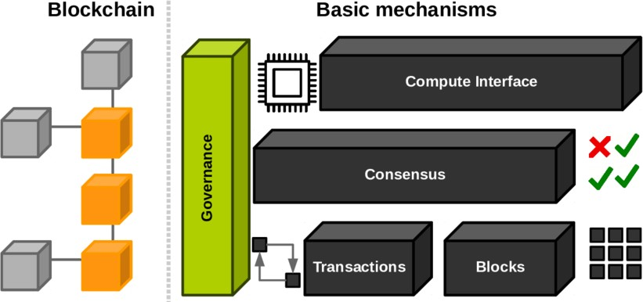
Fig 4.3: Mechanisms of Blockchain

Fig 4.3 gives the basic mechanism of Blockchain. It is a decentralized and immutable digital ledger technology that underpins the crowdfunding platform. In the context of crowdfunding, Blockchain technology enables the creation of a decentralized fundraising ecosystem that removes the need for intermediaries such as banks or crowdfunding platforms. Instead, transactions between project creators and investors are recorded on a distributed network of nodes, providing transparency and security to the crowdfunding process.
The most well-known use of Blockchain technology is in the cryptocurrency Bitcoin, but Blockchain has a wide range of potential applications beyond just digital currencies. It can be used for everything from tracking the supply chain of products to managing digital identities and voting systems.
One of the key features of Blockchain technology is its security. Because the data is stored across a network of computers, rather than in a central location, it is much more difficult to hack or corrupt. Additionally, each block in the chain is linked to the previous block, creating a permanent and unbreakable record of all transactions. This makes it very difficult to tamper with or alter the data stored on the Blockchain.
Blockchain is best known for being the underlying technology behind cryptocurrencies such as Bitcoin, but its potential applications go far beyond that. It can be used for a wide range of purposes, from supply chain management and digital identity verification to voting systems and property rights management.
Crypto assets, such as Bitcoin and Ethereum [18], are decentralized digital currencies that operate on Blockchain technology. Unlike traditional currencies, cryptocurrencies are not backed by a central authority or government. Instead, they rely on cryptographic algorithms and decentralized networks to ensure their security and integrity.
Factors that can influence the value of cryptocurrencies and securities include:
      - Market demand: The price of cryptocurrencies and securities is often influenced by market demand, which can be affected by factors such as supply and demand, economic conditions, and investor sentiment.
      - Regulation: The regulatory environment surrounding cryptocurrencies and securities can have a significant impact on their value. Changes in regulations or government policies can impact the market by affecting investor confidence and creating uncertainty.
      - Technology advancements: The advancement in technology can impact the performance of cryptocurrencies and securities. For example, the development of faster and more efficient Blockchain technology can increase the usability and value of cryptocurrencies.
      - Competition: Competition in the cryptocurrency and securities markets can impact their value. New and innovative products that offer better features and functionality can take market share away from existing products.
      - Security breaches: Security breaches can have a major impact on the value of cryptocurrencies and securities. High-profile hacks and data breaches can erode investor confidence and cause significant price fluctuations.
      - Ledger: It is a file that is constantly growing.
      - Permanent: It means once the transaction goes inside a Blockchain, you can put up it permanently in the ledger.
      - Secure: Blockchain placed information in a secure way. It uses very advanced cryptography to make sure that the information is locked inside the Blockchain.
      - Chronological: Chronological means every transaction happens after the previous one.
      - Immutable: It means as you build all the transaction onto the Blockchain, this ledger can never be changed.

To understand the operation or workflow of block chaining, consider some transactions among three clients namely, A, B and C. The first block of the chain is called the “Genesis Block”. Genesis blocks may also be called “Block 0” or “Day-Zero Block”. Each client initially has some balance amount, for example, client A has five coins, client B also has five coins, whereas client C has ten coins. The nonce is a 32-bit random or pseudo-random arbitrary number assigned by the miner to each block in order to ensure old communication is not replayed. Furthermore, it can be used as an initialization vector cryptographic hashing function.

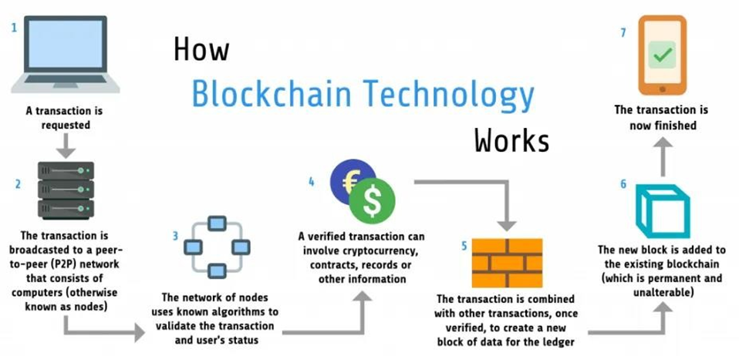

Fig 4.4: How Blockchain works

Fig 4.4 deals the process of Blockchain technology. To understand the operation or workflow of block chaining, consider some transactions among three clients namely, A, B and C. The first block of the chain is called the “Genesis Block”. Genesis blocks may also be called “Block 0” or “Day-Zero Block”. Each client initially has some balance amount, for example, client A has five coins, client B also has five coins, whereas client C has ten coins. The nonce is a 32-bit random or pseudo-random arbitrary number assigned by the miner to each block in order to ensure old communication is not replayed. Furthermore, it can be used as an initialization vector cryptographic hashing function.
The sign n -1 value for genesis block is 0, because sign n denotes the hash value of the previous block, which is none for the genesis block. When we move to block 1, sign n will be considered for block 1 and will have the hash value of the previous block (block 0), same will be for the next block and so on. Furthermore, genesis block contains transactions, as shown in the figure below:
Here, user A transferred one coin to user B. Similarly, user B transferred four coins to user C. Now, user A has four coins, user B has two coins, and user C has fourteen coins.

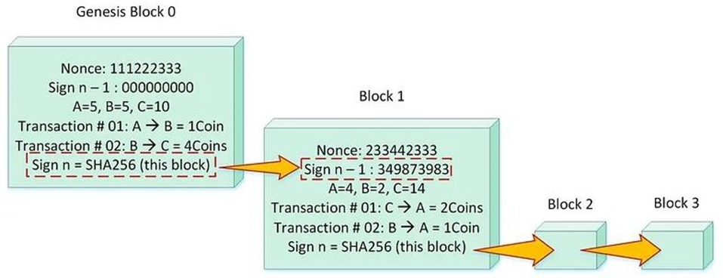

Fig 4.5: Blockchain Transactions

Fig 4.5 gives the flow of transactions from Block to Block by taking various updates of information. The hash value for the genesis block will be calculated by using the SHA-256 algorithm to ensure the integrity of the block. Now, moving to block 1, “Nonce” value and “Sign n -1” value is to be calculated for this block. Sign n -1 value will require the SHA-256 value of the previous block (Block 0). Transactions are saved in this block in the same way as previous block. At last, SHA-256 value is calculated for this block and in the same way, the chain continues.

ARCHITECTURE OF BLOCKCHAIN
Blockchain architecture [19] refers to the design and structure of the Blockchain network. It comprises several components that work together to create a secure, transparent, and decentralized platform for transactions and data storage. The distributed ledger is the foundation of a Blockchain, which maintains a transparent record of all transactions on the network. The ledger is distributed across a network of nodes, with each node having a copy of the ledger.
Consensus mechanism is another crucial component of the Blockchain architecture. It is a process by which nodes on the network agree on the validity of transactions and the addition of new blocks to the Blockchain. There are different consensus mechanisms used in various Blockchain networks, such as Proof of Work (Pow), Proof of Stake (PoS), and Delegated Proof of Stake (DPoS). Each consensus mechanism has its strengths and weaknesses, and the choice of mechanism depends on the specific requirements of the Blockchain network.
Finally, the network is the infrastructure that enables communication and interaction between nodes on the Blockchain. It is divided into two main components: the peer-to-peer (P2P) network and the application layer. The P2P network is responsible for communication and data sharing between nodes, while the application layer provides an interface for developers to create Dapps on the Blockchain.

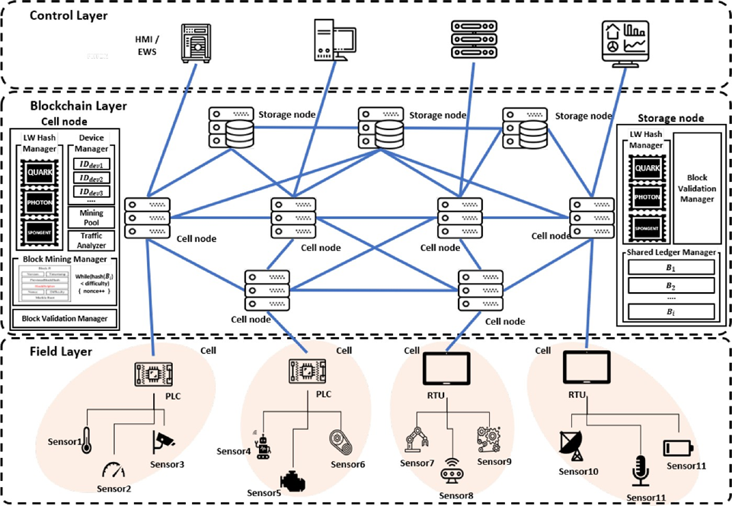
Fig 4.6: Architecture of Blockchain

Fig 4.6 deals architecture of Blockchain with levels of the process. Overall, the architecture of a Blockchain is designed to provide a secure, transparent, and decentralized platform for transactions and data storage. Its unique features, such as the distributed ledger, consensus mechanism, smart contracts, and network infrastructure, ensure that transactions on the Blockchain are accurate, secure, and tamper-proof. The Blockchain architecture provides an innovative solution to the challenges faced by traditional centralized systems, making it a valuable technology for various industries.
Blockchain is a digital ledger technology that allows for secure, transparent, and decentralized transactions without the need for a central authority or intermediary. It consists of a distributed database that records transactions in a series of blocks that are linked together in a chain. Each block in the chain contains a cryptographic hash of the previous block, creating an immutable record of all the transactions that have ever occurred on the Blockchain. This makes it virtually impossible to alter or delete past transactions, ensuring the integrity of the Blockchain.
Blockchain is best known for being the underlying technology behind cryptocurrencies such as Bitcoin, but its potential applications go far beyond that. It can be used for a wide range of purposes, from supply chain management and digital identity verification to voting systems and property rights management[20].
Blockchain transactions involve the transfer of digital assets or data across a decentralized network of computers, also known as nodes. These transactions are verified, validated, and recorded on the Blockchain ledger, ensuring transparency, security, and immutability.
The following steps outline the general process for how Blockchain transactions are done: Initiating the Transaction: The sender creates a transaction and broadcasts it to the network. The transaction includes the recipient's address, the amount to be transferred, and any other relevant information.
Verification and Validation: The transaction is verified and validated by nodes on the network. This involves checking that the sender has sufficient funds to complete the transaction and that the transaction meets other criteria specified by the Blockchain protocol. The validation process differs depending on the consensus algorithm used by the Blockchain network.
Creating a Block: Once the transaction is validated, it is added to a block along with other validated transactions. The block is then broadcast to the network for further validation.
Consensus: Network participants must agree on the contents of the block, which is achieved through a consensus algorithm. The most common consensus algorithms used in Blockchain networks are Proof of Work (PoW) and Proof of Stake (PoS).
Adding to the Blockchain: Once consensus is reached, the block is added to the Blockchain ledger. The ledger is updated with the details of the new block, including the timestamp, block number, and transaction details.
Confirmation: The recipient is notified of the transaction and can confirm the receipt of the funds. The transaction is considered complete and cannot be reversed or modified without consensus from the network.
Overall, Blockchain transactions involve a decentralized network of nodes that validate and record transactions on a transparent and immutable ledger. The process ensures that transactions are secure, transparent, and irreversible, making Blockchain an attractive option for various industries, including finance, supply chain management, and identity verification.
- CONCLUSION
Because Blockchain technology is so appealing, it has already gained widespread usage. Given that almost every business uses some form of agile record keeping, it is reasonable to anticipate that this technology will be used in a variety of applications, some of which are hinted at in our earlier article. Others are either in development or have not yet been found, such as the potential for a smart city. Moreover, because this technology is peer-to-peer and every stakeholder has access to their own block of the ledger. Our "Crowdfunding Platform powered by Blockchain" project is finished, operational, and live. Traditional crowdfunding techniques have long been plagued by fraud and a lack of transparency. That is a preventable issue, and we think we have a workable solution in place that can put an end to these persistent issues. The goal of having a transparent, anti-fraud, decentralized platform has mostly been accomplished. In order to make the crowdfunding process transparent and foster trust among people, our initiative has addressed the flaws in traditional crowdfunding platforms. As a result, individuals may donate their money to worthy organizations without worrying about being scammed.
- FUTURE RECOMMENDATION
Future research might offer light on any security risks that are not yet known as technology develops. Blockchain has become extremely popular across almost all industries, from banking and healthcare to education and city planning. More regulation: Although crowdfunding has grown in popularity recently, there have been problems with fraudulent campaigns and other factors. As a result, crowdfunding platforms may be subject to further regulation in order to safeguard investors and provide better accountability and transparency.
There is opportunity for new niche platforms that target certain audiences or sectors, even if the market has been dominated by large crowdfunding sites like Indiegogo and Kickstarter. For instance, there may be crowdfunding sites dedicated to helping women-owned businesses or initiatives with a social impact.
Increasing the focus on equity crowdfunding: In exchange for their contribution, backers who use equity crowdfunding obtain shares of the firm. We could see additional platforms that are only focused on in the future.

REFERENCES
- Yaga, Dylan, Peter Mell, Nik Roby, and Karen Scarfone. "Blockchain technology overview." arXiv preprint arXiv:1906.11078 (2019).
- Deng, L., Ye, Q., Xu, D. et al. A literature review and integrated framework for the determinants of crowdfunding success. Financ Innov 8, 41 (2022). https://doi.org/10.1186/s40854-022-00345-6
- Menon, Arjun and Kadam, Kaustubh and Kumar, Pranav and Shah, Subash Kumar, Decentralized Crowdfunding Using Blockchain (January 15, 2023). Available at SSRN: https://ssrn.com/abstract=4324640 or http://dx.doi.org/10.2139/ssrn.4324640
- Ashari, Firmansyah. (2020). Smart Contract and Blockchain for Crowdfunding Platform. International Journal of Advanced Trends in Computer Science and Engineering. 9. 3036-3041. 10.30534/ijatcse/2020/83932020.
- https://www.businessnewsdaily.com/4134-what-is-crowdfunding.html
- Salim, M., & Kassim, S. (2019). Viability of Crowd funding as an Alternative Funding Mechanism for Youth Entrepreneurs. International Journal Academic Research in Business and Social Sciences, 9(12), 374–383
- Emerging Trends in Blockchain Technology and Applications: A Review and Outlook
- Agrawal, Ajay & Catalini, Christian & Goldfarb, Avi. (2014). Some Simple Economics of Crowdfunding. Innovation Policy and the Economy. 14. 63-97. 10.1086/674021.
- Chang, A.; El-Rayes, N.; Shi, J. Blockchain Technology for Supply Chain Management: A Comprehensive Review. FinTech 2022, 1, 191-205. https://doi.org/10.3390/fintech1020015
- Blockchain Technology: Principles and Applications
- Zetzsche, Dirk Andreas and Buckley, Ross P. and Arner, Douglas W. and Barberis, Janos Nathan, From FinTech to TechFin: The Regulatory Challenges of Data-Driven Finance (April 28, 2017). New York University Journal of Law and Business, Forthcoming, European Banking Institute Working Paper Series 2017 - No. 6, University of Hong Kong Faculty of Law Research Paper No. 2017/007
- Habib, G.; Sharma, S.; Ibrahim, S.; Ahmad, I.; Qureshi, S.; Ishfaq, M. Blockchain Technology: Benefits, Challenges, Applications, and Integration of Blockchain Technology with Cloud Computing. Future Internet 2022, 14, 341. https://doi.org/10.3390/fi14110341
- Makridakis, S.; Christodoulou, K. Blockchain: Current Challenges and Future Prospects/Applications. Future Internet 2019, 11, 258. https://doi.org/10.3390/fi11120258
- Punathumkandi, S.; Sundaram, V.M.; Panneer, P. Interoperable Permissioned-Blockchain with Sustainable Performance. Sustainability 2021, 13, 11132. https://doi.org/10.3390/su132011132
- Kshetri, Nir & Voas, Jeffrey. (2018). Blockchain in Developing Countries. IT Professional. 20. 11-14. 10.1109/MITP.2018.021921645.
- Lohmer, J.; Ribeiro da Silva, E.; Lasch, R. Blockchain Technology in Operations & Supply Chain Management: A Content Analysis. Sustainability 2022, 14, 6192. https://doi.org/10.3390/su14106192
- Mohd Javaid, Abid Haleem, Ravi Pratap Singh, Shahbaz Khan, Rajiv Suman,Blockchain technology applications for Industry 4.0: A literature-based review,Blockchain: Research and Applications,Volume 2, Issue 4,2021,100027,ISSN 2096-7209,
- Sahoo S, Kumar S, Sivarajah U, Lim WM, Westland JC, Kumar A. Blockchain for sustainable supply chain management: trends and ways forward. Electron Commer Res. 2022 May 27:1–56. doi: 10.1007/s10660-022-09569-1. Epub ahead of print. PMCID: PMC9136812.
- Vujičić, Dejan & Jagodic, Dijana & Ranđić, Siniša. (2018). Blockchain technology, bitcoin, and Ethereum: A brief overview. 1-6. 10.1109/INFOTEH.2018.8345547.
- Lodovica Marchesi, Michele Marchesi, Roberto Tonelli, Maria Ilaria Lunesu,
- Blockchain: Research and Applications,Volume 3, Issue 4,2022,100088,ISSN 2096-7209

