COMPARITIVE ANALYSIS OF OPTICAL PROPERTIES OF CdSe AND CdS THIN FILMS BY SPRAY PYROLYSIS METHOD

Dr. L.M.Shanware ,Department of Physics,
N.S.Science College, Mulchera , Dist Gadchiroli.
Email: lshanware@gmail.com

ABSTRACT
A comparative study of CdSe and CdS thin films 0.025 M molar concentration deposited by spray pyrolysis technique were studied .The energy band gaps of these films were determined from reflection spectra. CdS have the direct band gap 2.47 eV and CdSe thin films which has a direct band gap of 1.75eV used in IR optics, polarizers and X-Ray detector Thin films of semi conducting materials are applicable in the field of microelectronic, optical electronic, in communication technologies, as well as in energy generation

KEYWORDS: Thin film, optical properties, Energy gap ,Spray pyrolysis,
I. INTRODUCTION

The II-VI compound semiconductor such as CdSe of IV–VI layer structured semiconductor in general they are used as holographic recording, switching photo conducting and photovoltaic materials (1-2). which has a direct band gap of 1.75eV(3) is suitable for solar cell and solar control coating and applicable for laser windows (4) Thin films are highly structure sensitive which influence the device performance. Thin films are widely used as optical coating on the lenses to reduce the amount of light reflected from the lenses surface and to protect the lenses.In this thin films, cadmium chalcognides have received intensive attention due to their band gap lies close to the range of maximum theoretically attainable energy conversion efficiently (5) With the thin films it is possible to convert visible light energy directly into electrical or chemical energy with a semiconductor photoelectrical or electrolyte heterodunction system, (6,7) The efficiency of solar cell is found to improve with the increase in conductivity of the films. The structure is closely related to that of zinc-blende. The binary semiconductors CdS have the direct band gap 2.47 eV (8) Several authors pointed out that CdS could be used as a n-type window material in hetero-junction solar cells [9].

II.EXPERIMENTAL

CdSe and CdS thin films were deposited by spray pyrolysis technique on a pre cleaned hot glass substrate of molar concentration 0.025M The aqueus solutions are prepared in double distilled water.The source of Cd and S are cadmium chloride (CdCl₂) and thiourea (NH–CS–NH₂) and the source of Cd and Se are cadmium chloride (CdCl₂) and selenium dioxide (Se₂). The aqneus solutions of CdCl₂ and thiourea were taken in the ratio 1:1 in the specially designed sprayer. The specially designed glass spray nozzle was used for thin spray of solution on the hot substrate maintained at 400⁰C with an accuracy ±5⁰C. The glass sprayer was mechanically moved to and from during spraying to avoid the formation of droplets on hot substrate and to ensure instant evaporation.Then all the films CdS and CdSe are annealed for 2 hr. at 100⁰C constant temperature. The distance between the sprayed nozzle and substrate was 25–30 cm done in air at 12 Kg/cm² pressure. The sprayer used for spraying is shown in Fig. (1)
Fig. (1) Experimental setup

III. OPTICAL PROPERTIES

Absorption spectra of this material are taken at room temperature with the help of ELICO spectrophotometer. Model SL 159. Its wavelength range is 380-1000 nm. The visible wavelength light source is long life WL lamp. Energy band gap Eg of materials is related to absorption coefficient α as:
According to Tauc relation, the absorption coefficient for direct band gap material is given by (10,11)
$α=\frac{A}{hν}{(hν-E_{g})}^{1/2}$-------------------(1)
Where A is a constant, hv is the photon energy, Eg the band gap and n is an index, n =1/2 is taken for an allowed direct transition. Therefore, by plotting a graph between (αhν)² and hν, a straight line is obtained which gives the value of the direct band gap.The sample were annelled bscause anneating the samples at 500 ⁰C the cryptanalytic increases(12). We found band gap of CdS in the range 2.4 eV (13). CdSe thin film with a band gap 1.7 eV.(14) CdSe is a attractive candidate A computer program (15,16) is developed in lab to calculate the refractive index µ, and absorption 𝛂

The study of optical properties of the thin films is very important when these are to be used in devises particularly in solar cell. Because the optical properties determine the part of the efficiency of the devices.The refractive index extinction coefficient and the thickness of the films were determined from the traces of the transmittance versus wavelength of the film on glass substrate. We found that the dependences of refractive index on incident photan energy (17) deposited on glass substrate .The thin film of CdS were of considerable interest for their efficient use in the fabrication of solar cells (18).
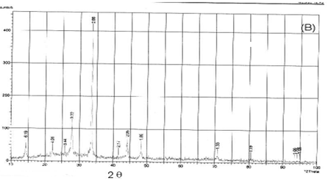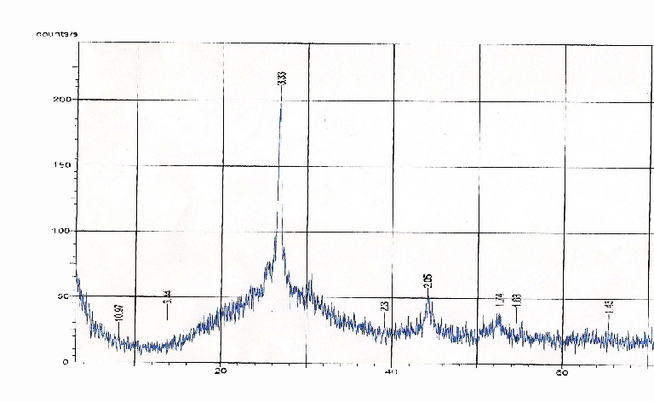
Fig 4 a.XRD of CdS thin film Fig 4 b.XRD of CdSe thin film

IV.RESULT

Cadmium sulphide belonging to the II–VI group is the most widely used material for CdS/CdTe and CdS/CuS heterojunction solar cells. It is because of the fact that CdS has intermediate energy band gap, reasonable conversion efficiency, stability and low cost.
The CdS thin films of 0.025 M molar concentration prepeary by spray pyrolysis method scanned in the visible region the energy gap was found that the band gap for CdS thins films of molar concentration 0.025M are nearly 2.4 eV It was found that the thin films samples prepared by chemical spray pyrolysis technique at constant substrate temperature were more stable.CdSthin film can be used as visibly transmitting material and buffer layer in chalcopyrite hetrojunction solar cell.The values of energy gap of CdSe are 1.7 eV can be used in IR optics, polarizers and X-Ray detector In summry CdSe is the better window layer material for solar cell and CdS are of considerable interest for their efficient use in the fabrication of solar cells .

REFERENCES
- Bhatt V.P., Gireesan K. & Desai C.F., Mat. Sci. Lett. 11, (1992) 380
- Valiukonis G., Gujeinova D.A., Krivated G., Sileika A. Phys. Stat. Solidi (B) 135, (1986) 299
- A.A. Yadav∗, M.A. Barote, E.U. Masumdar Materials Chemistry and Physics 121 (2010) 53–57
- Klausutis N. J. Electrochem 4 (1975) 625
- Pradip K.R., Sharma B.K. & Das H.L.Bull. Motor sci Vol. (23) 43 Aug 2000 313
- Heller A. and Miller B.Electrochem Acta 1980 (25) 29
- Uplane M.D. & Pawar S.H.Bull. Mat. Sci. 5, 5, (1983) 433
- Hird J P and Tembhurkar Y D Indian J. Pure and Appl. Phys., 28(1990) 583
- Shewchun J, Loferski J J, Beaulieu R, Chapmann G H and Garside BK
J. Appl. Phys., 50 (1979) 6978
- Tauc J (ed.) 1974 Amorphous and liquid semiconductors (NewYork: Plenum) p. 159
- Heavens O.S. Dover Publication Inc., Ny, (1965)
- Roy U.N., Ingle A & Rustagi K.C.Phy of Semi. Devices, Marosa publ, New Delhi 1998
- Valyormana A.G., Mathew S., Vijay Kumar K.P., Purushottaman C.
Bull. Mat. Sci, 16, 1, Feb. 1993, 55
- Pathan H.M. & Lokhande C.D.Bull. Mat. Sci. Vol 27 No. 2 April 2004, 85
- Basu, B. S. verma, T.K. Bhattacharya, M. Kar & R. Bhattacharya
Optics & Optoelectronic vol –I Narosa Publication. New Delhi.
- R. Swanepod Rev. Sci. Instr. (16) 1983 1214
- K.K. Chattopydhayay, A. Sarkar, S. chandhari & A. K. Pal Vaccume 42 (1991) 1113
- Chu T L, Chu S S, Britt J, Ferekids C, Wang C, Wu C Q and Ullal H S
IEEE Electron. Dev. Lett. EDL-13 (1992)303

