ANALYSIS OF TOOR DAL FOR ADULTERATION WITH METANIL YELLOW USING UV-VISIBLE SPECTROPHOTOMETER
R.N. Sabarinath¹ and Dr. Dorothy Pushparani²
¹ M.Sc., Department of Food Chemistry and Food Processing,
Loyola College, Chennai Dist., Tamil Nadu, India.
²Assistant Professor, Department of Food Chemistry and Food Processing,
Loyola College, Chennai Dist., Tamil Nadu, India.
E-mail Id: sabarinarayanan17@gmail.com

ABSTRACT

Food colours are generally categorized as permitted colours and non-permitted colours. Use of non-permitted food colours is known as Adulteration, this leads to loss of quality of the food. Adulteration is big concern in terms of food safety these days. Metanil yellow dye is a food colourant used extensively in various foods. It is also used as an adulterant in different spices especially in Turmeric, Sweets and regular Indian foods like pulses. Metanil yellow belongs to “non-permitted” category of food colour. The objective was to detect the presence of Metanil yellow dye in Toor dal samples collected from three zones (North, Central, South) of Chennai, using a preliminary colour test and UV-Visible Spectrophotometer Continuous consumption of this toxic food colours leads to adverse life-threatening effects in humans. Serious concern and mass awareness are needed to be raised on this issue, and use of this toxic food colour need to be abandoned completely. The used methods of detection can be used in the area of food quality control to detect such harmful and banned colours in Food products. About 6.6% of Toor dal samples collected from North Zone of Chennai tested positive for adulteration using this detection methods.

Keywords: Toor dal, food colourant, Metanil yellow, Adulteration

I.INTRODUCTION
Toor dal also known as Pigeon dal botanically names as Cajanus cajan is one of the protein rich pulses grown in India. This is widely grown in different regions of India such as Madhya Pradesh, Karnataka, Tamil Nadu, Gujarat, Uttar Pradesh. Toor dal takes place in different cuisines all over India. Toor dal is rich in Protein and fibre and is also low in calories. Mostly Toor dal is adulterated with Kesari dal (Lathyrus sativas) which is a different pulse available at subsided rated in the markets.
Adulteration in food is mainly present in its most crude form or prohibited substances are either added or partly substituted. The contamination in food is done either for financial gain or due to carelessness and lack in proper hygienic condition of processing, storing, transportation and marketing. This ultimately results that the consumer is either cheated or often became victim of disease such types of adulteration are common in developing countries and backward countries. To understand what adulteration is, one should first define the word "Adulteration" which is a legal term which denotes to a food product that fails to meet state standards and usually refers to non-compliance with health or safety standards as determined by the Food and Drug Administration (FDA 1995, 2000 and USDA/FSIS 1999).
The study of adulteration and various methods to analyse the presence of adulterants in food products was reported in most of the research papers. To study some of the food adulterants present in different food products. It is equally important for the consumer to know the common adulterants and their effect on health. The increasing number of food producers and the outstanding amount of import food stuffs enables the produces to mislead and cheat consumers.
To differentiate those who take advantage of legal rules from the ones who commit food adulteration is very difficult. The consciousness of consumer would be crucial. Ignorance and unfair market behaviour may endanger consumer health and misleading can lead to poisoning. So, we need evaluation tests for their detection. Consumption of adulterated food causes serious diseases like cancer, diarrhoea, asthma, ulcers, etc.
Adulteration in foods not only decreases our social value but morality too. The awareness of consumers plays important role in preventing food adulteration. Unawareness and unfair market behaviour might endanger consumer health and misleading can lead to poisoning. Therefore, basic screening tests should be known to common people. Foods provide nutrients to our body which play a pivotal role in body growth, development and maintenance. When the food products are impure or mixed or adulterated, they provide poor nutrition to our body and hence affect our body in many ways. The addition or mixing of inferior, harmful, substandard, useless or unnecessary substances to foods that spoils the nature and quality of food items is considered as food adulteration. There are several types of dyes used as food additives and food colorants. The use of colours for making foods aesthetically and psychologically attractive has been known for centuries. Synthetic colours are added to foods to replace natural colour lost during processing, to reduce batch-to-batch variation and to produce products with consumer appeal where no natural colour exists.
The substance Metanil yellow is vital in testing labs, mainly in quality testing, medication and food handling. Metanil yellow is a authenticated, uniform material intended for use in specified chemical and physical tests and the properties are compared with those products and possesses a high degree of purity adequate for its intended use. Metanil yellow is tannish yellow strong powder, solvent in methanol, liquor, or water. Metanil yellow has atomic weight 375,38 g/mol and sub-atomic formula C18H14N3O3SNa (Dhakal & Chao et al, 2016)
Metanil yellow is a yellow azo dye used extensively as a food colorant. It is made from diazotized metanilic acid and diphenylamine. Azo dyes are also used in laboratories as biological indicators, as pH indicators and for the purpose of research. Metanil yellow is allowed for use in industries for colouring wool, nylon, silk, paper, ink, aluminium, detergent, etc. The Metanil yellow dye is not permitted for use in food materials. It is toxic and is banned for use in foods. However, the toxic chemical azo-dye is used widely as a colouring agent in various food products as it is a cheap food colorant. Studies reveal that the dye has a toxic effect on various physiological systems. The suggestive mechanism can be that Metanil yellow gets absorbed from the intestine if consumed with food and enters the bloodstream. The toxic chemical travels in blood and reaches various organs and interferes with various cellular metabolic processes there. Earlier studies reveal that Metanil yellow generates oxidative stress in various vital organs such as heart, liver, and kidneys. (Gosh D, et al ,2017)

The Adulteration of useful food stuffs such as turmeric and honey which are considered for their medicinal values impose adverse health impacts on long‑term consumption. People consume those foods for their known medicinal values. However, unknowingly, the toxic food colorant, Metanil yellow enters their body regularly, and thus their health gets dangerously affected due to chronic exposure to Metanil yellow. Metanil yellow can induce damage in heart, liver, kidneys, nervous tissue, intestines, gastric tissue, etc., all vital organs and organ system of humans. Here, Pigeon Pea dal/Toor dal is collected from across three different zones of Chennai city in Tamil Nadu and tested for presence of Adulteration with Metanil yellow azo dye using UV-VIS Spectrophotometer. The Ministry of Health and Family Welfare is responsible for providing safe food to citizens and to assure the quality of food products, the Prevention of Food Adulteration Act, 1954 was set up that arranged the guidelines to provide pure and wholesome foods to consumers. The Act was last amended in 1986 to make punishments more stringent and to empower consumers further.
SPECIFIC OBJECTIVE
The main Aim is to analyse Toor dal samples to find adulteration with Metanil yellow dye using laboratory tests and UV-Visible Spectrophotometer.
OBJECTIVES OF THE STUDY
To determine the presence of colour adulterant Metanil yellow in Toor dal samples procured from the markets and stores from different geographical zones of Chennai (North, Central, South).
To quantify the Metanil yellow content using UV-VISIBLE spectrophotometer in the adulterated samples.

II. MATERIALS AND METHODS

ADULTERATION TEST FOR TOOR DAL TO DETECT THE PRESENCE OF METANIL YELLOW:

Metanil yellow is a synthetic dye which is not permitted to use as a food colour. However, it is extensively used to give yellow colour to dal and turmeric. It is toxic in nature and it has adverse effects on liver, intestine and brain. Presence of Metanil yellow can be tested in dal by adding a few drops of hydrochloric acid to a test sample. If the test solution turns pink in colour, it indicates presence of Metanil yellow.

IUPAC name of Metanil yellow dye is:
Sodium 3-[(4-anilinophenyl)diazenyl]benzenesulfonate

PREPARATION OF SAMPLE

The samples of Toor dal were collected from different markets present in different zones of Chennai. Geographically Chennai has three zones namely North, Central and South. Ten samples of Toor dal were collected from each zone and labelled respectively.
The samples from North Zone of Chennai were labelled as:
(N1, N2, N3, N4, N5, N6, N7, N8, N9, N10)
The samples from Central zone of Chennai were labelled as:
(C1, C2, C3, C4, C5, C6, C7, C8, C9, C10)
The samples from South zone of Chennai were labelled as:
(S1, S2, S3, S4, S5, S6, S7, S8, S9, S10).

PROCEDURE

- 0.005g of Metanil yellow dye is taken in a 100mL standard flask and made upto the mark with distilled water and marked as Concentration1
- 50 ml of the concentrated solution is taken and diluted with 100mL distilled water in a different standard flask and marked as Concentration2.
- The same process is followed till five different concentrations are made in five different standard flasks and are labelled.
- Different concentrations of Metanil yellow dye are run in UV-Visible Spectrophotometer with in a range of 200-800 nm the peak and absorbance values are recorded.
- The peak is absorbed between 400-500nm and plotted in a graph.
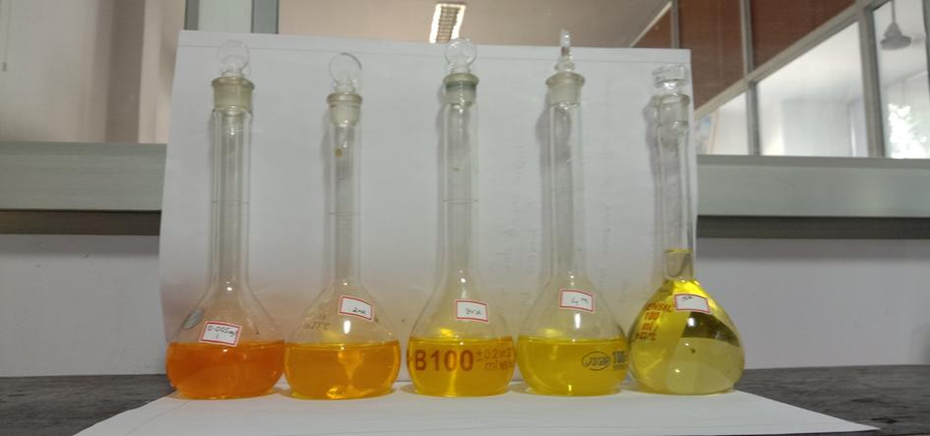
Fig.2.1

- 5g of Toor dal samples were taken in 10 different 100mL beakers
- 50mL of distilled water is added to it
- It is made to stand for 24hours
- Then, the distilled water sample is extracted from beaker
- The samples are run in a UV-VISIBLE spectrophotometer to record the peak absorbed.
- The same process is followed for all the ten different samples of Toor dal.

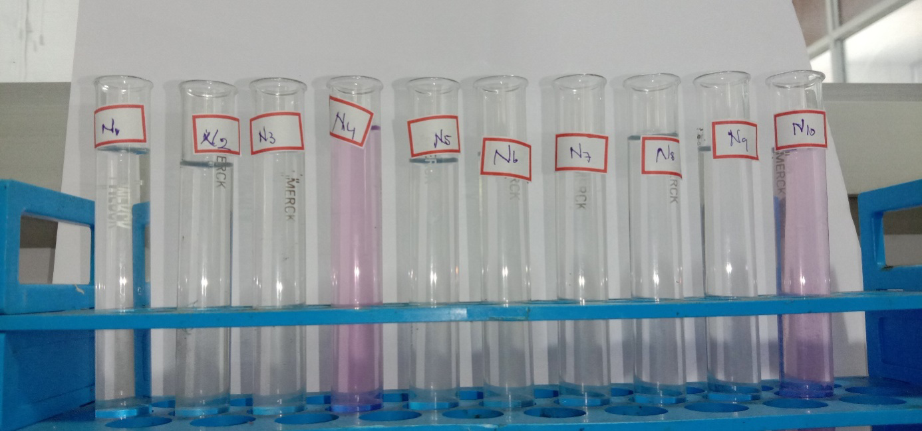

Fig.2.2. NORTH CHENNAI ZONE SAMPLES

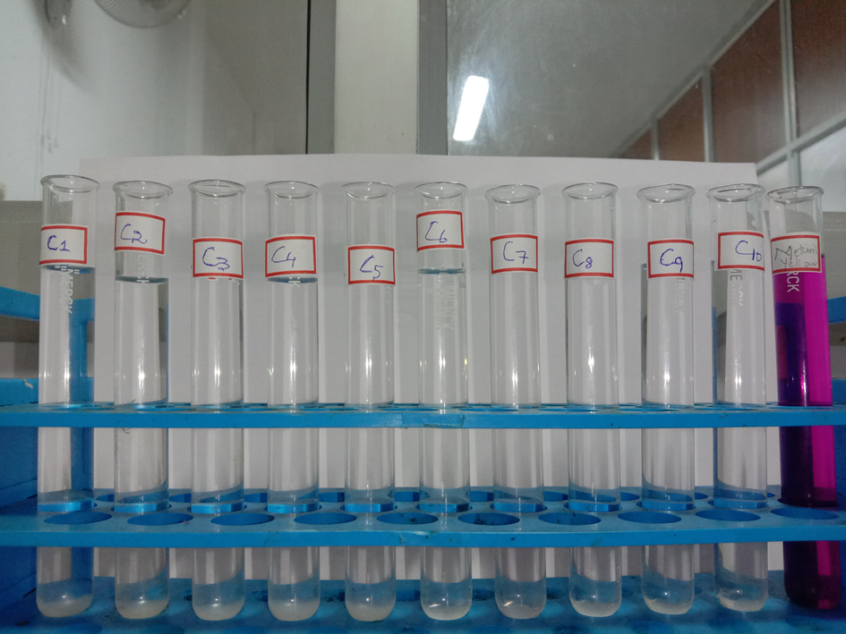
Fig.2.3. CENTRAL CHENNAI ZONE SAMPLES

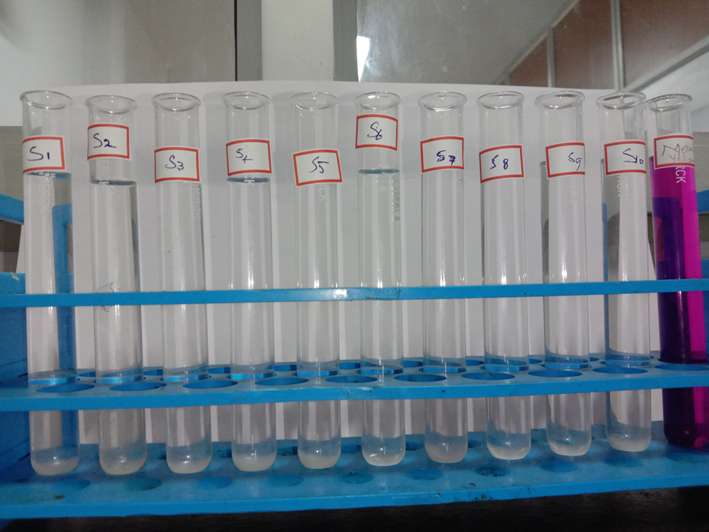
Fig.2.4. SOUTH CHENNAI ZONE SAMPLES

PROCEDURE FOR LABORATORY TEST FOR PRESENCE OF METANIL YELLOW

- 2g of Sample of Toor dal is taken in a test tube
- 2g of Con.HCL acid is added to it
- Then, 2g of Dist. Water is added to it
- It is then shaken well
- If there is the presence of Metanil yellow the solution turns into a pink colour.
- Each sample is tested using this method.

ADULTERATED | NON-ADULTERATED
6.6% | 93.4%

III. RESULT AND DISCUSSION:
Percentage of market Toor dal samples sold with Metanil Yellow is depicted below:

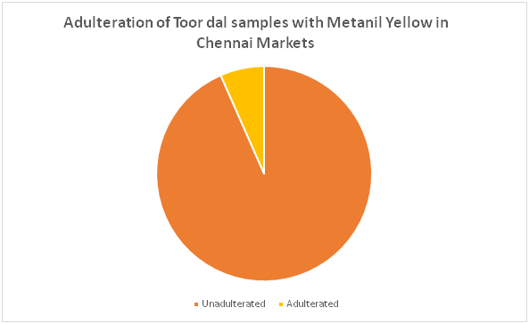
Fig.3.1 Pie Chart of Toor dal samples

The UV-Visible Spectroscopic analysis also shows the presence of Metanil yellow in samples N4 and N10. The peaks are shown in a graphical representation. Fig.3.1 represents peak of pure Metanil yellow dye. Fig 3.2,3.3 shows the presence of Metanil yellow dye in the adulterated samples.

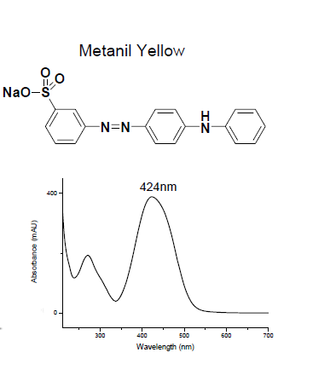
Fig.3.2 Metanil yellow peak

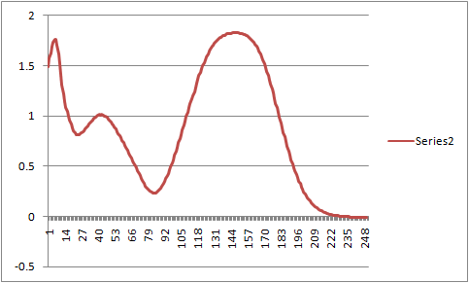

Fig.3.3.sample N4 peak

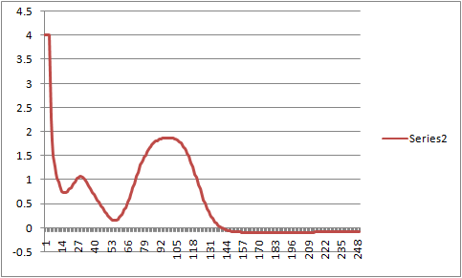
Fig.3.4.sample N10 peak

DISCUSSION
The UV-Visible spectroscopic analysis has proved the presence of Metanil yellow dye in two of the collected Toor dal samples. The Metanil yellow is an azo dye which affects the Central nervous system in humans on consumption. Out of thirty samples of Toor dal collected only two samples were adulterated using Metanil yellow dye. These two samples N4 and N10 are reportedly collected from the markets of North zone of Chennai. The Metanil yellow can also affect the Gastrointestinal tract of humans on consumption

CONCLUSION
Quantification of positive samples resulted in presence of Metanil yellow expressed as ppm:
S1 = 8.8ppm (8.8mg/Kg)
S2 = 5.99ppm (5.99mg/Kg)
On analysis for Adulteration of Toor dal sample in Chennai market reveals a very positive trend of more than 93.4% of samples being adulterated. However, 6.6% samples which were found to be adulterated with Metanil yellow dye. The adulterated range of Metanil yellow is between 5.99ppm to 8.8ppm is a cause of concern. The Food safety and Food Authority of India and Stakeholders of Food business need to create more awareness to prevent colour Adulteration in Food products. Due to the large consumption of Toor dal by a majority population and unavailability it is subjected to Adulteration. Adulteration of Toor dal with Metanil yellow increases its physical appeal in the markets. The UV-Visible spectrophotometer is effective in finding the presence of unknown compounds adulterated in foods. Only a very few samples of Toor dal present in market is subjected to Adulteration. Several studies reveal that the Metanil yellow can cause some serious damage to Human health on consumption.

FUTURE RECOMMENDATIONS

Clinical trials using animal and human models can be used to evaluate the efficacy of Metanil yellow dye on consumption. Preferred values of Metanil yellow can be added to Food products to enhance the colour of food products so that it may not affect the health.

BIBLIOGRAPHY

- Ghosh D, Singha PS, Firdaus SB, Ghosh S. Metanil yellow: The toxic food colorant. Asian Pac. J. Health Sci., 2017; 4(4):65-66.
- SagarDhakal, Kuanglin Chao, Walter Schmidt, Jianwei Qin, Moon Kim and Diane Chan. Evaluation of Turmeric Powder Adulterated with Metanil Yellow Using FT-Raman and FT-IR Spectroscopy. United States Department of Agriculture/Agricultural Research Service, Environmental Microbial and Food Safety Laboratory, 2016.
- Mara Eliza dos Santos, Ivo Mottin Demiate, Noemi N. Simultaneous determination of Tartrazine and sunset yellow in food by UV-Visible spectrophotometer and multivariate calibration methodology. Food Science and Technology, 3: 23-25, 2010.
- (FDA 1995, 2000 and USDA/FSIS 1999).
- Lakshmi V. Food Adulteration. Journal of SIT 1(2): 106-113, 2012.
- NeniIsnaeni. Metanil Yellow Reference Substance Characterization by Using Infrared and UV-Vis Spectrophotometry, TLC, and HPLC-DAD. National Quality Control Laboratory of Drug and Food (PPPOMN), Food and Drug Administration, 2020
- Ankleshwaria N. and Shah, S.R. A study on the awareness pertaining to the use of safe edible food colours amongst Indian Housewives. Applied Nutrition. 24 (2): 21-27, 1999
- Babu S, Shenolikar IS. Haeath and Nitritionalomplications of food colours. Journal of Med Res 102: 245-249, 1995
- Lancaster Frank E., Lawrence James F. Thermal decomposition of food colors amaranth, sunset yellow FCF and tartrazine in the presence of sucrose and glucose. Food Additives and contaminants, 5(4): 295-303, 1986
- MeenakshiTripathi, Subhash K. Khanna, Mukul Das. Surveillance on use of synthetic colours in eatables vis a visrevention of Foodadulterant Act of India, food Control, 211-219, 20017.
- Nital A. Zatar. Simultaneous determination of seven synthetic watersoluble food colorants by Ion-pair Reversed-phase High-performance Liquid chromatography. Journal of food technology, 5(3): 220-224, 2007.

