Biotechnology plays the key roles in the regulation of fungal secondary metabolism
¹Amit Kumar, ²Rakesh Singh Sengar, and Rajeev Kumar³
¹Department of Agriculture,
Keral Verma Subharti College of Science,
Swami Vivekanand Subharti University, Meerut – 250005(U.P)
²Department of Agriculture Biotechnology
Sardar Vallabhbhai Patel University of Agriculture and Technology
Meerut-250110(U.P)
³Department of Botany (Genetics and Plant Breeding)
C.S.S.S.(P.G.) College Machhra (Meerut) U.P. INDIA - 250106

Email-amit.agbiotech1582@gmail.com

Abstract
Fungi produce a massive array and variety of secondary metabolite. Fungal secondary metabolites are important in both fields, industry as well as in medicine. Secondary metabolites are low molecular weight compounds, which are produced from the derivative of primary metabolites. First secondary metabolite was reported in the late nineteen century. Today Fungal biotechnology is a significant player in the world economy. Microbial enzyme markets have seen a significant expansion because to recombinant DNA technology, which uses yeast and other fungi as hosts. The synthesis of enzymes, vitamins, polysaccharides, polyhydric alcohols, pigments, lipids, and glycolipids are only a few of the industrial processes that involve fungi. While some of the goods are manufactured for sale, others have potential use in biotechnology. Rapid advance in transformation methodologies has been a consequence of well defined protoplasting protocols for a large number of filamentous fungi. The molecular manipulation of filamentous fungi has resulted in some exciting developments in the area of biotechnology. Recombinant DNA technology has taken advantage of the filamentous fungal species for homologous and heterologous protein secretion on account of their ability to release high levels of secondary metabolites. In this chapter we conclude that the biotechnology plays key role for the regulation of the secondary metabolite.
Key words: Fungi, secondary metabolite, RDT, Biotechnology.

Introduction:
Fungal secondary metabolites are bioactive compounds produced by fungi that are not essential for the growth, development, or reproduction of the organism. Unlike primary metabolites, which are involved in essential cellular processes, secondary metabolites serve various ecological roles, including defense against predators and competitors, communication, and adaptation to environmental changes. Fungal secondary metabolites are chemically diverse and have a wide range of biological activities. Many of these compounds have proven to be of great interest in medicine, agriculture, and industry due to their pharmacological properties and bioactive potential. Fungal secondary metabolites continue to be an important area of research due to their potential applications in medicine, agriculture, and industry. However, it is essential to understand their biosynthesis, biological activities, and potential risks, especially in relation to food safety, to ensure their safe and responsible use.
Particularly in a resistant plant variety compared to a susceptible variety, it has frequently been found that some common phenolic compounds that are poisonous to pathogens are formed and accumulate at a higher rate following infection. Such phenolic chemicals include chlorogenic acid, caffeic acid, and ferulic acid. Chlorogenic acid is found in relatively high concentrations in peach fruit, including immature fruit and fruit from cultivars resistant to the fungus Monilinia fructicola-caused brown rot disease (Boehm et al., 1991). The fruit is resistant in both situations, but not because the acid is poisonous to the fungus that is causing it; rather, it is resistant because it prevents the synthesis of fungal enzymes that degrade host tissue. Cell wall-bound hydroxybenzoic acid and sinapic acid in the roots of date palm trees rose 11–12 times more in cultivars resistant to fusarium than they did in susceptible cultivars. When Orobanche aegyptiaca, a higher parasitic plant, infects plants like vetch (vicia sativa), resistant species appear to produce larger quantities of free and bound phenolics, lignin, and peroxidase activity in the roots than susceptible ones. Young stems of cacao infected with the witches' broom fungus Crinipellis perniciosa have 7–8 times more caffeine than healthy stems, which prevents the fungus from growing in culture. The activation of phenylalanine ammonia lyase and subsequent accumulation of phenolic chemicals were among the main defences in another polygenic disease, the black sigatoka sickness of banaqna caused by the fungus Mycosphaerella fijiensis. Additionally, it resulted in the early activation of the banana's defence mechanism against the fungus trihydroxytetralone (THT), which in resistant varieties led to necrotic microlesions and elicited defence responses that made the pathogen and the host plant incompatible (resistance) (Hoss et al., 2003). However, in susceptible types, the fungus only produced necrotizing levels of THT in the latter stages of pathogenesis, following the development of the characteristic symptoms and the establishment of a suitable relationship (Hoss et al., 2003). It should be noted that several of the common phenolics appear concurrently in the same diseased tissue, and it is possible that their combined effect—rather than the effects of each one individually—is what prevents infection in resistant varieties. This is true even though some of the common phenolics may each reach concentrations that could be toxic to the pathogen. It has even been suggested that because phenolics are present in all plant cells, regardless of location, these cells may self-sacrifice by decompartmenting and rapidly oxidising their phenolic contents, which would result in the first line of defense—cell death—or the production of a slower defence line—a peridermal defence layer.
Toxic Phenolics from Nontoxic phenolic glycosides
Toxic phenolics can be derived from nontoxic phenolic glycosides through various enzymatic or chemical processes. Phenolic glycosides are a class of secondary metabolites found in many plants, and they are typically considered nontoxic when in their glycosylated form. However, under certain conditions, these glycosides can be enzymatically or chemically converted into toxic phenolic compounds.
Phenolics are a group of compounds that are widely distributed in plants and play essential roles in their growth, development, and defense against various stresses. They can be categorized into non-toxic phenolic glycosides and toxic phenolics. Phenolic glycosides are phenolic compounds attached to a sugar molecule, and they are generally considered non-toxic. On the other hand, some phenolics in their free form can be toxic due to their ability to interact with biological molecules and disrupt cellular processes. However, it's important to note that the toxicity of phenolics can vary depending on their concentration, the specific compound, and the organism being exposed to them.
It's important to highlight that many phenolic compounds have beneficial effects on human health and are widely consumed in the form of fruits, vegetables, and herbal extracts. These compounds, such as flavonoids and polyphenols, are often associated with antioxidant and anti-inflammatory properties. However, excessive consumption or exposure to certain phenolic compounds may have adverse effects.
phenolic glycosides are generally considered non-toxic, the release of their aglycone forms or the presence of free toxic phenolics can occur through various mechanisms. Toxicity depends on factors such as concentration, metabolism, and interactions with other molecules. As with any natural compound, it is essential to understand the potential risks and benefits associated with the consumption or exposure to phenolic compounds.
Nontoxic glycosides, or molecules made of a sugar (like glucose) linked to another, frequently phenolic, molecule, are found in many plants. The enzyme glycosidase, which can hydrolyze such complex molecules and release the phenolic chemical from the complex, is known to be produced by a number of fungi and bacteria or to be liberated from plant tissue. After further oxidation, some of the liberated phenolics become extremely toxic to the pathogen and seem to be involved in the plant's defence mechanism against infection.
Role of phenol – oxidizing enzyme in disease resistance
Compared to infected susceptible varieties or healthy, uninfected plants, the activity of numerous phenol oxidising enzymes (polyphenol oxidases) is typically higher in the infected tissue of resistant kinds. The ability of polyphenol oxidase to oxidise phenolic chemicals to quinines, which are frequently more poisonous to bacteria than the original phenols, is likely the root of its significance in disease resistance (Burton et al., 1993). It is fair to predict that larger levels of hazardous oxidation products and, hence, higher levels of infection resistance will arise from enhanced polyphenol oxidase activity (Steffens et al., 2002). When a fruit ripens, a complex interaction takes place in which the amount of lipoxygenases rises and breaks down diene, a substance that is present in young, immature fruit and is harmful to fungus. The maturing fruit becomes infected as a result of these occurrences (loss of resistance). Epicatechin, a phenolic molecule that inhibits the activity of lipoxygenases, is produced in some fruit, however, as a result of elicitors from nonpathogenic fungus (Ryuichi et al., 2015). Epicatechin thus slows down the degradation of the antifungal diene, delaying the anthracnose fungi's ability to rot the maturing fruit.
Peroxidase, a different phenol oxidase enzyme, also produces hydrogen peroxide in addition to oxidising phenolics to quinines.The latter is not only antibacterial in and of itself, but it also generates highly reactive free radicals, speeding up the polymerization of phenolic compounds into molecules that resemble lignin.Once inside cell walls and papillae, these chemicals prevent the infection from developing and growing further.
Biotechnology in fungal secondary metabolism
Biotechnology plays a significant role in the study and manipulation of fungal secondary metabolism. Fungal secondary metabolites are bioactive compounds with diverse chemical structures and important biological activities. They have potential applications in various fields, including medicine, agriculture, and industry. Biotechnological approaches are employed to understand, optimize, and exploit fungal secondary metabolism for beneficial purposes. Biotechnological tools, such as next-generation sequencing and transcriptomics, are used to study the genomes and gene expression profiles of fungi. This helps identify the biosynthetic gene clusters responsible for the production of secondary metabolites and provides insights into their regulation.
By leveraging biotechnological tools and approaches, researchers can harness the diverse and valuable potential of fungal secondary metabolism. These efforts lead to the discovery of new bioactive compounds, the optimization of existing pathways for commercial production, and the development of biotechnological platforms for sustainable and environmentally friendly production of fungal secondary metabolites.
Fungal pathogens require genes that will enable them to overcome the numerous secondary metabolites that plants produce, some of which have antibacterial qualities and aid in protecting the plant from assault, in addition to the genes necessary for generating infection structures and dissolving structural barriers. In contrast to phytoalexins, which are formed in reaction to a pathogen attack, phytoanticipins are secondary metabolite molecules that are created naturally. Through genes that enable them avoid them, destroy them, change their physiology, or employ other means, pathogens react to these chemical defences of the host plant (Yu et al., 2023).
Phytoanticipins: Phytoanticipins are a class of chemical compounds produced by plants in response to the perception of potential pathogen attack or other environmental stresses. These compounds serve as part of the plant's innate immune system and act as a pre-emptive defense mechanism, ready to counteract potential threats before the pathogen or stressor can establish a successful attack. They are typically produced constitutively or induced rapidly after the plant recognizes certain signals associated with pathogen presence or stress conditions. They are different from phytoalexins, which are also defense compounds but are produced in response to pathogen infection or specific stress events. Phytoanticipins are part of the early defense response of plants and contribute to their overall resistance against various biotic and abiotic stressors. They act as a deterrent to potential attackers and can influence the outcome of the plant-pathogen interactions or protect the plant from the detrimental effects of environmental stresses.
It is important to note that the presence and composition of phytoanticipins can vary among different plant species and even among different cultivars of the same species. The production of phytoanticipins is regulated by various signaling pathways and can be influenced by environmental conditions, pathogen presence, and developmental stage of the plant. Studying phytoanticipins and their role in plant defense contributes to our understanding of plant immunity and has potential applications in crop protection and sustainable agriculture practices.
They mostly consist of tomatine and avenacin, two saponins. Glycosides having soap-like characteristics are called saponins. That might damage membranes. Unlike wheat roots, oat roots have avenacin A-1 localised in the epidermis. Oats can be infected by the fungus Gaeumannomyces graminis var. avena because it carries a gene that codes for the avenacinase enzyme, which breaks down saponin. However, avenacin-less variants of the fungus can still infect wheat, which does not produce avenaccin, even if they are unable to infect oats when the avenacinase gene is disrupted. Tomatine, a different saponin produced by tomatoes, is antifungal and possesses antimicrobial properties. the fungus that contains the avenacinase gene, which codes for the tomatinase enzyme, which breaks down the saponin tomatine. However, tomatinase gene disruption did not lessen Septoria's pathogenicity on tomato, presumably because the fungus also contains additional enzymes that can breakdown saponin. The latter occurs in the relationship between Stagonospora avenae and oat, where the fungus has three genes that can produce enzymes that can break down a specific saponin.
Cyanogenic glycosides and Glycosinolates:
Cyanogenic glycosides and glucosinolates are two classes of chemical compounds found in plants that play significant roles in plant defense and have implications for human health. The enzymes that can break down these chemicals are isolated from them in the plant. When a plant is wounded, these substances and their enzymes combine and interact to form cyanide, isocyanates, nitriles, and thiocyanates, which are all deadly to all living things as well as to fungus. However, it is unknown how they contribute to the pathogenesis of fungus and how those organisms resist themselves.
Cyanogenic glycosides are natural plant compounds that contain a sugar molecule (glycoside) linked to a cyanide-containing functional group. The most common cyanogenic glycoside is amygdalin, which is found in the seeds of various plants, including almonds, apricots, and cherries.
When the plant tissue containing cyanogenic glycosides is damaged, an enzyme called β-glucosidase is released and catalyzes the hydrolysis of the glycoside. This reaction releases cyanide, which is toxic to both animals and humans. However, the presence of cyanogenic glycosides in plants serves as a defense mechanism against herbivores. When herbivores consume these plants, the glycosides are broken down, releasing cyanide and acting as a potent deterrent.
Humans have also utilized cyanogenic glycosides for medicinal purposes, although their use requires careful processing to minimize cyanide toxicity. For example, in traditional medicine, bitter almonds (which contain amygdalin) were used in small amounts for their potential health benefits. However, the cyanide content makes them potentially hazardous if consumed in large quantities.
Glucosinolates are sulfur-containing compounds found in the Brassicaceae family of plants, which includes vegetables like broccoli, cauliflower, cabbage, and mustard. They are primarily stored in plant cells in an inactive form, as glucosinolates, and are activated upon tissue damage, such as during chopping or chewing. When glucosinolates are hydrolyzed, either by myrosinase enzymes released upon damage or by gut microbiota after consumption, they yield various breakdown products, including isothiocyanates, thiocyanates, and nitriles. These breakdown products are responsible for the characteristic pungent aroma and taste of these vegetables.
Glucosinolates have shown potential health benefits for humans. Some of their breakdown products, such as sulforaphane, have antioxidant and anti-cancer properties. Studies suggest that glucosinolates and their breakdown products may help reduce the risk of certain types of cancer and promote overall health. Additionally, glucosinolates also play a role in plant defense against herbivores and pathogens. When plant tissues are damaged, glucosinolates are released, and the breakdown products can deter herbivores and potentially protect the plant from certain pests and diseases.
Phytoalexins:
Plants that are under attack create phytoalexins, but only a few number of fungal enzymes have been discovered that can break them down when attacked by fungi (Hammerschmidt R, Dann E K. 1999). Pisatin demethylase is one such enzyme that breaks down the pea phytoalexin pisatin and is generated by the fungus Nectria haematococca (Alan P. Maloney, Hans D. VanEtten, 1994). One of the fungus' six such genes, which code for pisatin demethylase, very slightly reduced pathogenicity when the gene was disrupted (Coleman JJ, 2011). However, insertion of extra copies of the same gene in the pathogen isolates increased disease severity whereas interruption of one of the four fungal genes that detoxify the phytoalexin maakiain from chickpea reduced pathogenicity.
After the fungus has begun to grow inside the plant, several fungal genes defend it from becoming pathogenic. The efflux and influx of fungal compounds into the plant are regulated by a large number of these genes. In M. grisea, disruption of such a gene led to loss of pathogenicity (Jian-Ping Lu, 2006). The same gene may be involved in the efflux of plant compounds from the fungus because it is activated by both the rice phytoalexin sakuranetin and harmful medicines.
It is clear that nutrition levels can influence fungi's capacity to colonise plants because several fungal pathogenicity genes, when altered, produce auxotrophic strains. Adenine auxotrophs of the apple scab fungus Venturia inaequalis are nonpathogenic on apples, whereas auxotrophy is associated to a lack of pathogenicity in the maize sumut fungus Ustilago maydis (Parisi L, 2004). Similar to Stagonospora sp., auxotrophs of fusarium sp. in ornithine decaroxylase likewise lost their capacity to produce disease (Coleman JJ, 2011).
According to Ahuja et al. (2012), phytoalexins are toxic antimicrobial compounds that plants can only create in significant numbers after being stimulated by certain phytopathogenic microbes or after suffering chemical and mechanical damage. In reaction to materials diffusing from localised injured and necrotic cells, healthy cells next to those cells create phytoalexins (Jeandet et al., 2013). When there are suitable biotrophic infections, phytoalexins are not formed. Around both resistant and susceptible necrotic tissues, phytoalexins gather. Resistance happens when one or more phytoalexins accumulate to a level that prevents pathogen growth (Jeandet et al., 2013). The majority of known phytoalexins are toxic to fungi that are pathogenic to plants and impede their growth, although some are also poisonous to fungus, bacteria, and other species. From plants belonging to more than 30 families, more than 300 compounds having phytoalexinlike characteristics have been identified (Schmelz et al., 2014). In general, phytoalexins generated by members of the same plant family have chemical structures that are relatively comparable; for instance, most legume phytoalexins are isoflavonoids, while those produced by the solanaceae are terpenoids (Jeandet et al., 2010). Many fungi have been found to trigger the formation of phytoalexins, however most phytoalexins are formed in plants in response to fungal infection. Phaseollin in beans, pisatin in peas, glyceollin in soybeans, alfalfa and clover, rishitin in potatoes, gossypol in cotton and capsidiol in pepper are a few of the phytoalexins that have received the most attention (Schmelz et al., 2014; Motoyama et al., 2021).
Plant cells in good condition produce and accumulate phytoalexin. Alarm compounds created and secreted by damaged cells that diffuse into the nearby healthy cells excite nearby injured or infected cells (Wu et al., 2004). According to Wu et al. (2004), the majority of phytoalexin elicitors are typically high molecular weight compounds that are parts of the fungal cell wall, such as glucans, chitosan, glycoproteins, and polysaccharides. Enzymes from the host plant cause the elicitor molecules to break free from the fungal cell wall. The majority of elicitors are generic, meaning that they cause phytoalexin accumulation regardless of the plant cultivar and are found in both compatible and incompatible races of the pathogen. The buildup of phytoalexin they induce on some compatible and incompatible cultivars matches the accumulation caused by the pathogen races themselves, however some phytoalexin elicitors are unique. Although the majority of phytoalexin elicitors are believed to be produced by pathogens, some elicitors, such as oligomers of galacturonic acid, are thought to be produced by plant cells in response to infection or are released from plant cell walls after they have partially been broken down by the pathogen's pathogen-producing enzymes. In certain instances, suppressor molecules made by the pathogen appear to block the production of toalexins in a susceptible host after infection. The suppressors also appear to be glucans, glycoprotens, or a pathogen-produced toxin.
It is currently unclear how the connections between phytoalexin elicitors, phytoalexin producers, phytoalexin suppressors, genes for resistance or susceptibility, and the expression of resistance or susceptibility work. Many theories have been put out to explain how these components are interconnected, but much more research is required before a satisfactory explanation can be found.
A certain plant species' or race's pathogenic fungi appear to promote the formation of phytoalexins with a generally lower concentration than nanopathogens. For instance, when the pathogen Ascochyta pisi is injected into pea pods, the concentration of pisatin produced by the various pea varieties is roughly inversely correlated with the resistance of the variety to the infection. The amount of pisatin produced when the same pea variety is inoculated with various fungus strains is roughly inversely related to the virulence of each distinct fungus strain inoculated on the pea variety. Additionally, inoculations of fungal races on incompatible host cultivars led to earlier accumulations and higher concentrations of the phytoalexin glyceollin in soybean plants infected with the fungus phytophthora megasperma f. sp. glycinea than inoculations of fungal races on compatible cultivars. It has been hypothesised that the higher concentration of glyceollin in combinations of incompatible hosts and pathogens results from decreased biodegradation rather than enhanced production of the phytoalexin. However, in some host pathogen systems, such as the bean/Colletotrichum lindemuthianum and the potato/Phytophthora infestans systems, the corresponding phytoalexins, such as phaseollin and rishitin, reach equal or higher concentrations in compatible (susceptible) hosts than incompatible (resistant) ones.
However, compared to nonpathogenic fungi, pathogenic races or species appear to be less sensitive to the toxicity of the phytoalexin produced by their host plant (Jeandet et al., 2013). According to research by Jeandet et al. (2013), pathogens may have an adoptive tolerance mechanism that allows them to tolerate larger concentrations of the host phytoalexin after being exposed to lesser quantities of the substance in the past. But many pathogenic fungi have been shown to be able to metabolise the host phytoalexin into a harmless molecule, reducing its toxicity to the pathogen (Schmelz et al., 2014). Several pathogenic fungi are known to successfully cause disease while being sensitive to or unable to metabolise the host phytoalexins. In addition, some fungi that can either break down or tolerate specific phytoalexins are unable to infect the plants that make them (Browne et al., 1991).
The involvement of phytoalexins in some hosts' defence against specific pathogens appears to be decisive or auxiliary in general, but it is unknown if they have any bearing on disease resistance in the majority of host-pathogen pairings.
Pathway for secondary metabolite production
Structure obstructs that are combined in various metabolic pathways are used to biosynthesize secondary metabolites. The routes are frequently used to describe secondary metabolites and are typically called for the contained intermediates. It is surprising and fascinating how many different types of constructions these very few structural bricks can create. Because basic metabolism requires energy and essential amounts of carbon and nitrogen, the generation of secondary metabolites is tied to it.
Contrary to the several hundred primary metabolites, microbial secondary metabolites are made up of tens of thousands of figurative compounds, and their variety is expanding annually. The backbones of this diverse range of products are made just from a few important precursors generated from primary metabolism, such as amiao acid and acetyl Co A (Lei Shi and Benjamin P. Tu, 2015). This variety of products is made possible by tiny variations in the synthesis routes.
The number of known combinations in microbial auxiliary metabolites is increasing every year, in contrast to the few hundred basic metabolites. This extensive range of activity is carried out by a small number of biosynthetic pathways, but the spines begin with just two or three major precursors obtained through basic absorption, such as amiao corrosive and acetyl Co A. (Rokas et al., 2020; Lei Shi and Benjamin P. Tu, 2015)
Biosynthesis of Polyketides
The vast class of auxiliary metabolites known as polyketides is present in tiny organisms like fungus and plants. They are the most common secondary metabolites produced by fungi, and a significant number of them have biologically relevant activity. This makes them very important for microorganisms (fungi). A good example is the cholesterol-lowering chemical lovastatin, which is produced by the fungus Aspergillus terreus and Monascus ruber. It works as a catalytic HMG-CoA reductase inhibitor and was the first statin to be promoted (Dewick, 2009; Keller et al., 2005). HMG-CoA reductase is dynamic in the formation of MVA. The building blocks for polyketides, primarily malonyl-CoA (the extender unit) and acetyl-CoA (the starting unit), are poly-keto chains. Polyketide synthase (PKS), a collection of multidomain proteins or protein structures, catalyses the reactions involved in the formation of the poly-keto chain. Different life forms have different types of PKSs, but they all have the same process for creating the poly-keto chain. The starter unit and extender unit are stacked as thieves at a separate location on the PKS as the first stage. Although the extender unit is attached to an acyl carrier (ACP) domain, acetyl-CoA is connected to a ketoacyl-CoA synthase (KS) domain. A Claisen-type reaction and concurrent decarboxylation of the ACP-bound extender unit cause condensation to occur between malonyl-ACP and acetyl-KS at that moment. The resultant -ketothioester would then be able to be transferred to a KS domain and reached out by another malonyl-ACP after being bound to the ACP domain. Once the keto chain has reached the ideal length, this cycle will repeat. The chain may very easily be folded and enacted at desired points after it is complete to enable intramolecular responses. Figure 1's biosynthesis of phloracetophenone and orsellinic acid serves as an illustration of this. Similar to the anthraquinones, other progressively entangled sweet-smelling mixtures can be synthesised using the same steps but with a length of keto chain as the precursor (Dewick, 2009; Hanson, 2003; Zhang, 2021).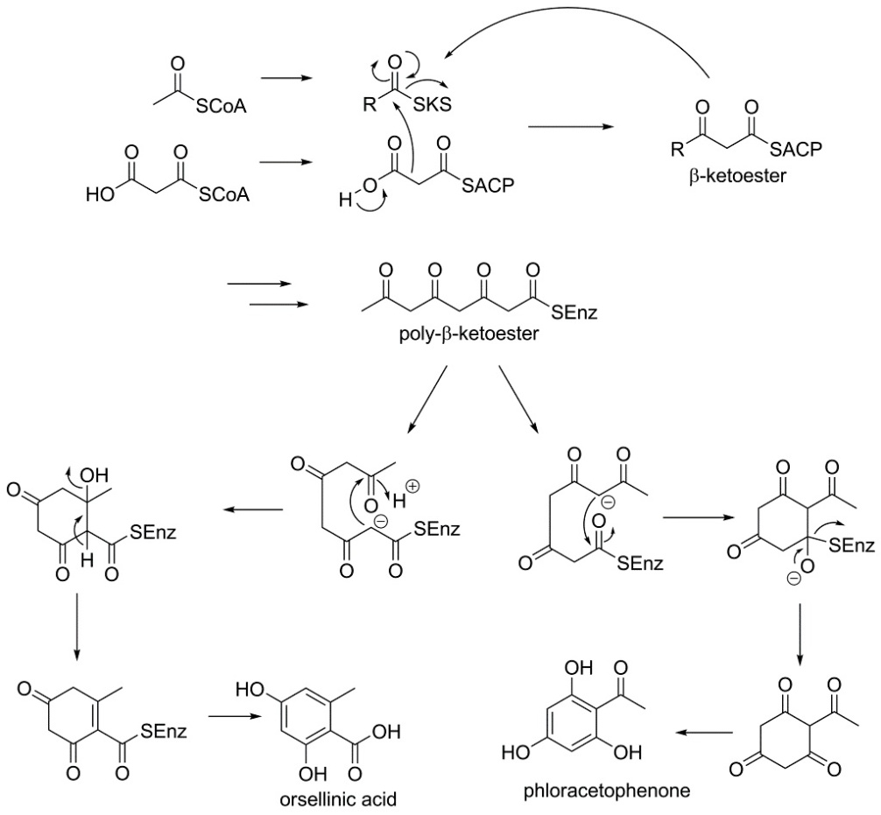
Figure1: Biosynthesis of Polykitides
Biosynthesis chorsmic acid by shikimic acid pathway
In fungus, bacteria, and other microbes, the shikimic acid route is an important metabolic pathway for the production of sweet-smelling mixtures, particularly the fragrant amino acids L-tryptophan and L-phenylalanine. However, animals do not exhibit the shikimic pathway, which is how certain amino acids are designated as essential for people. Tyrosine and phenylalanine are hence important precursors for certain alkaloids as well as phenylpropanoids, which are recognised by their C6 C3 carbon skeleton and found in a variety of fundamentally different secondary metabolites.
In the first phase of the shikimic pathway (Figure 2), erythrose 4-phosphate and phosphoenolpyruvate are built up to produce shikimic acid by two aldol-type reactions, one intramolecular and one intermolecular, which are then followed by the removal of water and a decreasing response. Shikimic acid is then phosphorylated, and the 5-hydroxy group of shikimic acid 3-phosphate receives one additional PEP atom. The synthesis of chorismic acid is the end product of the shikimic acid route, which is pursued by two subsequent phosphoric acid disposals. (Hanson, 2003; Dewick, 2009).
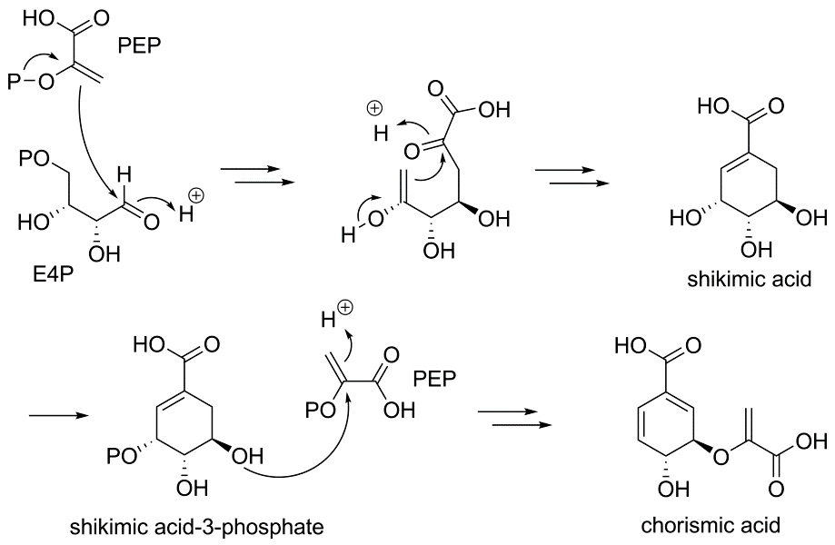
Figure-2 Biosynthesis of Chorismic acid via shikimic acid pathway
Conclusion
In this chapter, we looked at how crucial biotechnology is to the synthesis of secondary metabolites. Secondary metabolites are produced in large numbers by a range of microorganisms, including fungus and bacteria, and their complexity and diversity are occasionally surprising. In both traditional medicine and modern times, secondary metabolites have had a profound impact on society as medications, fragrances in cosmetics, flavours in beverages, agrochemicals, and other products. Low molecular weight molecules known as secondary metabolites are created from primary metabolite derivatives. In the latter part of the nineteenth century, the first secondary metabolite was described. Today, a significant player in the world economy is fungal biotechnology. Microbial enzyme markets have seen a significant expansion because to recombinant DNA technology, which uses yeast and other fungi as hosts. The synthesis of enzymes, vitamins, polysaccharides, polyhydric alcohols, pigments, lipids, and glycolipids are only a few of the industrial processes that involve fungi.
References:
- Ahuja I, Kissen R, Bones AM (2012) Phytoalexins in defense against pathogens. Trends Plant Sci. 17, 73–90.

Alan P M, Hans D V (1994) A gene from the fungal plant pathogen Nectria haematococca that encodes the phytoalexin-detoxifying enzyme pisatin demethylase defines a new cytochrome P450 family. Molecular and General Genetics MGG. 243(5):506
- Boehm E W A, Ma Z Michailides T J (2001) Species-specific detection of Monilinia fructicola from California stone fruits and flowers. Phytopathology 91, 428–439.
- Browne L M, Conn K L, Ayert W A, Tewari J P (1991) The camalexins: New phytoalexins produced in the leaves of Camelia sativa (Cruciferae). Tetrahedron 1991, 47, 3909–3914.
- Burton SG, Duncan JR, Perry T (1993) Activity of mushroom polyphenol oxidase in organic medium Biotechnol Bioeng 42(8): 938 – 944.

Coleman JJ, Wasmann CC Usami T, White GJ, Temporini ED, McCluskey K, VanEtten HD (2011) Characterization of the gene encoding pisatin demethylase (FoPDA1) in Fusarium oxysporum. Mol Plant Microbe Interact. 2011,24(12):1482-91.
- Dewick PM (2009) Medicinal natural products: a biosynthetic approach. 3rd.ed. Chichester, UK: John Wiley & Sons, Ltd. ISBN 9780470741689.

Hammerschmidt R, Dann EK (1999) The role of phytoalexins in plant protection. Novartis Found Symp. 223:175-87
- Hanson, J.R. (2003). Natural products: the secondary metabolites. Cambridge, UK: Royal society of chemistry. ISBN 0854044906.
- Hoss R, Helbig J, Bochow, Helmut (2003) Function of Host and Fungal Metabolites in Resistance Response of Banana and Plantain in the Black Sigatoka Disease Pathosystem (Musa spp. –Mycosphaerella fijiensis). Journal of Phytopathology. 148. 387 - 394.
- Jeandet P, Clément C, Courot E, Cordelier S (2013) Modulation of phytoalexin biosynthesis in engineered plants for disease resistance. Int. J. Mol. Sci. 2013, 14, 14136–14170.
- Jeandet P, Delaunois B, Conreux A, Donnez D, Nuzzo V, Cordelier S, Clément C, Courot E (2010) Biosynthesis, metabolism, molecular engineering and biological functions of stilbene phytoalexins in plants. BioFactors. 36, 331–341.
- Jian‐Ping Lu, Tong‐Bao Liu, Fu‐Cheng Lin (2006) Identification of mature appressorium‐enriched transcripts in Magnaporthe grisea, the rice blast fungus, using suppression subtractive hybridization, FEMS Microbiology Letters, 245, (1), 131-137.
- Keller N P, Turner G, Bennett J W (2005) Fungal secondary metabolism - from biochemistry to genomics. Nature Reviews Microbiology 3(12), 937- 947.

Lei Shi, Benjamin P Tu (2015) Acetyl-CoA and the Regulation of Metabolism: Mechanisms and Consequences. Curr Opin Cell Biol,33: 125–131.
- Motoyama, T.; Yun, C.-S.; Osada, H.(2021) Biosynthesis and Biological Function of Secondary Metabolites of the Rice Blast Fungus pyricularia Oryzae. J. Ind. Microbiol. Biotechnol. 2021, kuab058.
- Parisi L, Fouillet V, Schouten H J, et al.(2004) Variability of the pathogenicity of Venturia inaequalis in Europe. Acta Horticulturae.663:107–113
- Ryuichi M, Torayuki O (2015) The role of lipoxygenases in pathophysiology; new insights and future perspectives. Redox Biol. 2015 Dec; 6: 297–310.
- Schmelz E A, Huffaker A, Sims J W, Christensen S A, Lu X, Okada K, Peters R J (2014) Biosynthesis, elicitation and roles of monocot terpenoid phytoalexins. Plant J. 79, 659–678.
- Steffens JC, Li L (2002) Overexpression of polyphenol oxidase in transgenic tomato plants results in enhanced bacterial disease resistance. Planta 215: 239 – 247.

Víctor M, Luque-Almagro, Purificación Cabello, Lara P, Sáez Alfonso Olaya-Abril, Conrado Moreno-Vivián, María Dolores Roldán (2018) Exploring anaerobic environments for cyanide and cyano-derivatives microbial degradation. Appl Microbiol Biotechnol. 102(3): 1067–1074.
- Wu Q, Van Etten H D (2004) Introduction of plant and fungal genes into pea (Pisum sativum L.) hairy roots reduces their ability to produce pisatin and affects their response to a fungal pathogen. Mol. Plant-Microbe Interact. 17, 798–804.
- Yu, Wenbin & Pei, Rongqiang & Zhou, Jingyi & Zeng, Bin & Tu, Yayi & He, Bin. (2023). Molecular regulation of fungal secondary metabolism. World Journal of Microbiology and Biotechnology. 39. 10.1007/s11274-023-03649-6.
- Rokas, A.; Mead, M.E.; Steenwyk, J.L.; Raja, H.A.; Oberlies, N.H.(2020). Biosynthetic Gene Clusters and the Evolution of Fungal Chemodiversity. Nat. Prod. Rep. 2020, 37, 868–878.
- Zhang, X.; Guo, J.; Cheng, F.; Li, S. (2021) Cytochrome P450 Enzymes in Fungal Natural Product Biosynthesis. Nat. Prod. Rep., 38, 1072–1099.

