Digital Heritage of Asian Buddhist Caves Using Cultural Computing and AI: Special Reference to Ajanta Caves

Amrapali Prakash Tribhuvan
Research Scholar,
Department of Computer Science and IT
Dr. Babasaheb Ambedkar Marathwada University, Aurangabad, India
amrapaliprakash512@gmail.com

Dr. Binnaser Aziz Abdullah
Assistant Professor,
Department of Computer Science
Sir Sayyed College of Arts, Commerce & Science,
Aurangabad, India
azizbinnaser@gmail.com

ABSTRACT
UNESCO refers to 'digital heritage' as unique resources of human knowledge and expression "created digitally or converted into digital-form from existing analogue resources". Cultural Computing is emerging field for translation of culture. It uses scientific methods to represent essential aspects of culture. It includes computation of emotion, story, and culture. It is more than integrating cultural aspects into the interaction. Artificial Intelligence is another useful tool for preventing cultural heritage. Ajanta caves are universally regarded as masterpieces of Buddhist religious art. In this proposed research work author is trying to help to preserve, use and experience Ajanta Caves vast heritage in digital form. In this paper author presented the 3D reconstructed model of Cave 1 and restoration of damaged image of Bodhisattva Padmapani from cave 1 at Ajanta monastery.
Keywords— Ajanta Caves, digital heritage, cultural Computing, Artificial Intelligence.

INTRODUCTION
From India, Buddhism spread throughout Asia. Ajanta caves are universally regarded as masterpieces of Buddhist religious art. The art of Ajanta owes its inspiration to those early Buddhist bhikshus who came to western India in the wake of the spread of Buddhism under the patronage of Ashoka (273-36 B.C.). It is need of time to digitize and preserve our Ajanta caves heritage for our future generations to know about our culture and understand it.
The Ajanta Caves are approximately 30 rock-cut Buddhist cave monuments. The caves are numbered not chronologically but as a matter of convenience, starting with the one at the outmost extremity. Cave 1 is one of the finest monasteries at Ajanta, distinguished from other.
Ajanta paintings were made on a dry surface using a technique known as Tempera. Depending upon the surface a base of Mud or Husk was put which was then covered with lime, on which these paintings were then painted.
In cave 1 Jataka Tales are painted on wall. It tells the stories of Bodhisattvas painted on wall. Also, the Bodhisattvas and Buddha are also painted on the walls. The ceilings have decorative themes with animal figures. There are lot of geometrical designs on ceilings in the caves. a door inside Cave no 1 are painted with two Bodhisattvas – Bodhisattva Padmapani and Bodhisattva Vajrapani. So, Cave 1 is selected for study.
In this paper, 3D reconstructed model of Ajanta Cave1 and the restoration of world’s most famous 2200-year-old painting of Bodhisattva Padmapani from cave 1 at Ajanta monastery has demonstrated. Padmapani is extraordinary mural painting survives from early medieval India, preserved in the interior of the rock-cut Buddhist monastery of Ajanta.
The Charter on the Preservation of Digital Heritage of UNESCO defines digital heritage as embracing "cultural, educational, scientific and administrative resources, as well as technical, legal, medical and other kinds of information created digitally, or converted into digital form from existing analogue resources".
The purpose of digital heritage preservation is to ensure that it remains accessible to the public and to prevent it from disappearing. Accordingly, digital representation of heritage ensures that the essential value of its ontology is widespread and enduring. To achieve this, specified approaches are suggested for the use, research, and protection of two kinds of heritage, corresponding to its natural or cultural characteristics.
Artificial Intelligence has grown to a wide range in these years. Major branch of it is image processing. The main field in which the AI is implemented is image restoration and is mainly used in the field of security surveillance, systems in healthy department, medical diagnosis, military etc. Image processing techniques helps digital restoration but it does not alter originality of the masterpieces.

DIGITAL HERITAGE ON AJNATA CAVES
Nashik-based artist-photographer Prasad Pawar, who has been documenting, photographing, and digitally restoring the Buddhist paintings and sculptures in Ajanta for 27 years, but without touching them. The artists could not have used mashaals because they would suck the oxygen out of the room, making it difficult to work, and leave carbon deposits on the artwork.
Today technological tools like AI and automation help make the restoration process easier and more efficient. The Tech4Heritage hackathon was conducted to digitally preserve and restore the murals recovered from these heritage sites. One team comprised Arjav Jain and Aryan Prasad (all second-year students of B.Tech. Mechanical Engineering at IIT Roorkee). They have started with damaged images from the Ajanta caves, which they downloaded from the Internet, to build a unique dataset of images. This served as a foundation upon which a generative model was trained to identify the damaged areas. These images were later restored, through AI models utilizing Generative Adversarial Networks (GANs).
After reviewing some of the work on digital heritage and cultural computing, it is observed that some work is done on Ajanta Caves using digital heritage but there is no work on Ajanta Caves using the concept of cultural computing.

PROPOSED SYSTEM
The proposed system is based on primary and secondary data. Primary data will be collected directly from Ajanta Cave Cultures and secondary data is collected from books, websites etc. Real contents and objects of Ajanta caves will be collected form primary and secondary data sources. After data collection, data processing, audio video visualization, digitization will be done. Once Digital collection is done digital artifacts will be created then final cultural heritage application will be created for digital experience of Ajanta Caves.
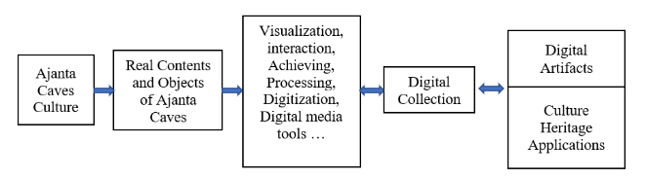
Figure 1: Proposed System Architecture

3D RECONSTRUCTION OF AJANTA CAVE 1
Caves are very dark; it is not possible to see the paintings without the help of reflectors that have been placed at the entrance of the cave. Caves authorized guides also carry some approved lighting that they briefly put on the paintings to show you the details. As you struggle with adjusting your eyes to the darkness inside. This is reason to reconstructed cave 1 in 3D. Using 3D modelling software Blender 3D model of Ajanta Cave 1 is constructed.
This cave is a vihara or residential cave or monastery. The Vihara is 64 feet square and has 20 carved pillars. Residential cells are present on all three sides of the hall. Which also has a Buddha shrine. It consists of a courtyard, porch, porch-end cells, hall, antechamber, and shrine.
Figure 2: Cave 1 Floorplan
Figure 3: Cave 1 3D Floorplan

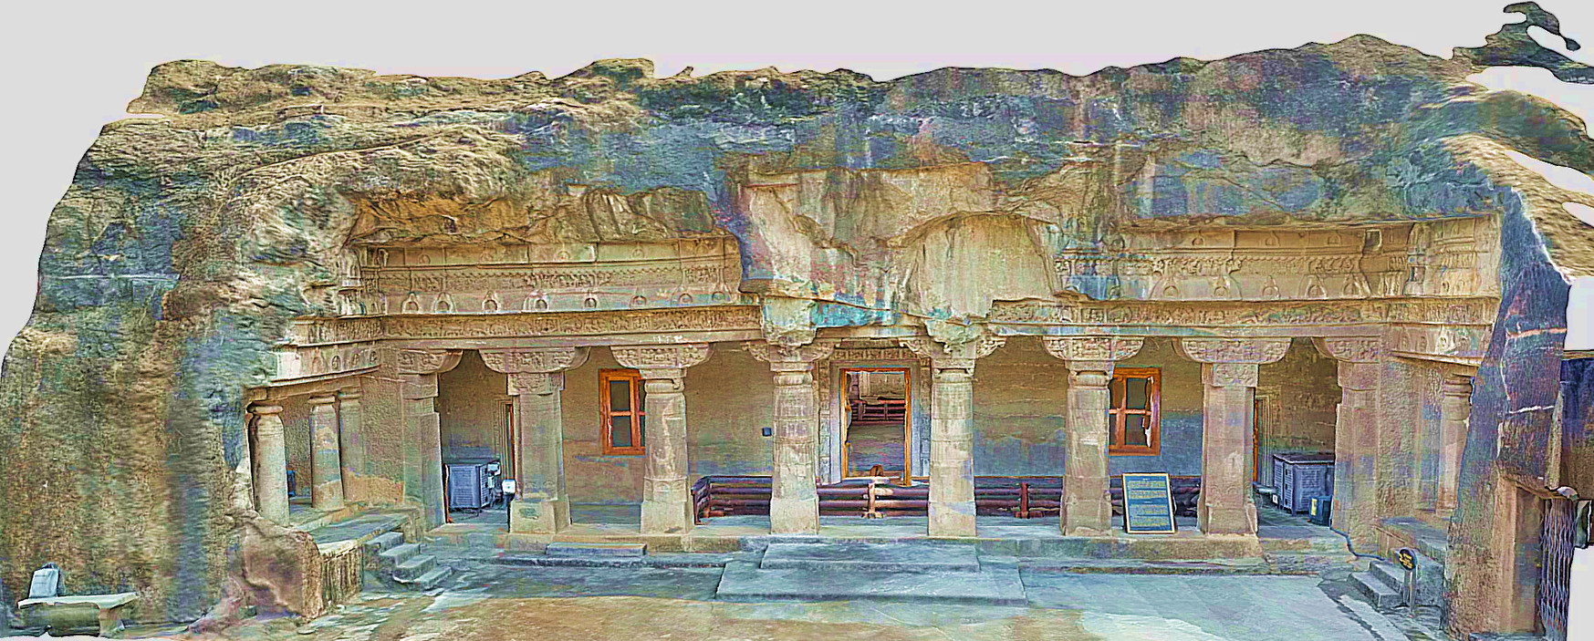
Figure 4: 3D Model of Ajanta Cave 1 – Exterior
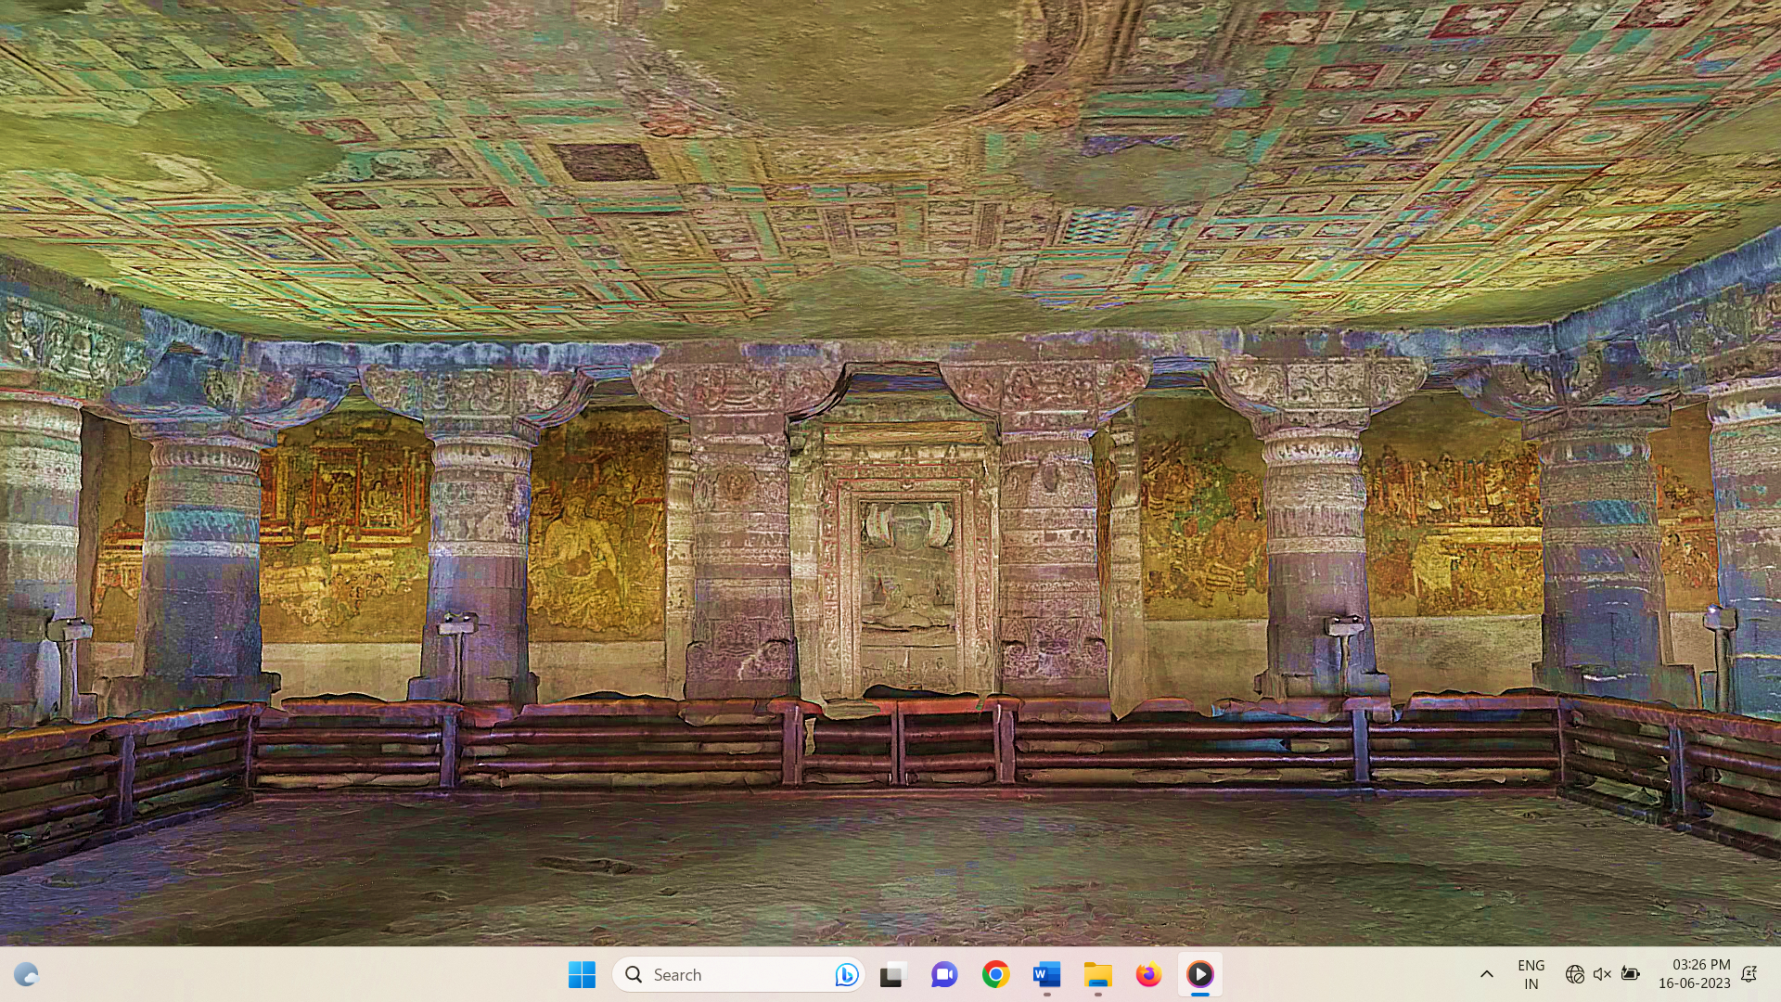
Figure 5: 3D Model of Ajanta Cave 1 – Interior

RESTORATION OF DAMAGED IMAGE OF BODHISATTVA PADMAPANI
This section describes image restoration process performed with AI programming with Python. To enhance the final output image, the damaged image is processed by Denoising it by means of Fast Means Denoising method. This reduces the coarseness of the image and makes the image smooth. In the next step, a greyscale masked image of the same damaged image is created by marking the regions which are to be repaired and is also loaded. This masked file is threshold and converted into a binary image. Thresholding is an effective way which enables us for segmentation of the image. It partitions an image by isolating into foregrounds and backgrounds, i.e., it helps in detecting the marked areas that needs to be repaired. Dilation is necessary because Thresholding reduced the thickness of the marked areas. Dilation allows us to add pixels over a region by defining a kernel value leading in making the marked lines thicker. Then this dilated masked file is saved into our machine. Final stage is applying Image Inpainting function which basically repairs the damaged areas. This technique works upon the Fast-Marching Method. The algorithm starts from the boundary of the marked area and goes on filling the areas with an average value of the pixels from a small circular neighborhood of that area. Here we have used TELEA method which is better as it integrates more seamlessly into the image. As result the output image is ready, rendered as well as restored.
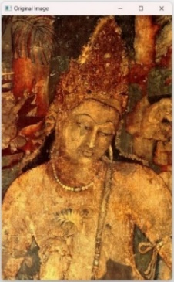
Figure 6 : Original Damaged Image of Bodhisattva Padmapani.

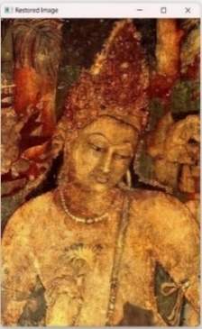
Figure 7: Restored Image of Bodhisattva Padmapani

Conclusion
In this paper architecture of proposed system is discussed. The methodology of restoration of damaged image of Bodhisattva Padmapani from cave 1 at Ajanta monastery is discussed. In this research work need of 3D reconstruction of caves is explained and presented 3D model of cave 1. In this proposed research work, author successful to digitally preserve and restore the cultural heritage site. In future work, restoration all painting of cave 1 and 3D model with restored paintings and mural will be constructed. Then Final cultural heritage application will be created for digital experience of Ajanta Caves.

References
- Ajanta Caves, India: Brief Description, UNESCO World Heritage Site. Retrieved 27 October 2006.
- Rauterberg, Matthias. "From personal to cultural computing: how to assess a cultural experience." Day IV (2006): 13-21.
- "Charter on the Preservation of Digital Heritage". UNESCO. October 15, 2003. Retrieved July 9, 2015.
- Smith, Laurajane. Uses of heritage. Routledge, 2006
- Grahman B 2002 Heritage As Knowledge : Capital Or Culture? Urban Studies , 39 , 1003 – 1017
- Rahaman, Hafizur. "A Framework for Digital Heritage Interpretation." (2012).
- Rauterberg, Matthias. Usability in the future–explicit and implicit effects in cultural computing. München: Oldenbourg Verlag, 2006.
- Digital Art: When Artistic and Cultural Muse Merges with Computer Technology" in IEEE Computer Graphics and Applications, vol.27, no. 05, pp. 98-103, 2007.
- Hao Jiang, Thomas Gonnot, Won-Jae Yi and Jafar Saniie, “Computer Vision and Text Recognition for Assisting Visually Impaired People using Android Smartphone “,2017 IEEE International Conference on Electro Information Technology (EIT).
- Kruti Goyal, Kartikey Agarwal, Rishi Kumar , “Face Detection and Tracking”, International Conference on Electronics, Communication and Aerospace Technology ICECA 2017
- Chaoxing Huang, Dan Chen ,Xusheng Tang, “Implementation of Workpiece Recognition and Location Based on Opencv”, 2015 8th International Symposium on Computational Intelligence and Design.
- Nidhi, “Image Processing and Object Detection”, International Journal of Applied Research 2015;1(9): 396-399
- Cristhian Rosales, Luis Jácome, Jorge Carrión, Carlos Jaramillo, Mario Palma, “Computer Vision for detection of body expressions of children with cerebral palsy”, 2017 IEEE Second Ecuador Technical Chapters Meeting (ETCM).
- G.D. Illeperuma, D.U.J. Sonnadara, “Computer Vision Based Object Tracking as a Teaching Aid for High School Physics Experiments”, Proc. EECSI 2017, Yogyakarta, Indonesia, 19-21 September 2017, 2017 4th International Conference on Electrical Engineering, Computer Science and Informatics (EECSI).
- Aniket V. Patil, Mrinai M. Dhanvijay, “Engraved Character Recognition Using Computer Vision To Recognize Engine And Chassis Numbers”, 2015 International Conference on Information Processing (ICIP).
- T. Arrighi, J. E. Rojas , J.C. Soto , C. A. Madrigal , J. A. Londoño, “Recognition and Classification of Numerical Labels Using Digital Image Processing Techniques “,2012 XVII Symposium of Image, Signal Processing, and Artificial Vision (STSIVA).
- Y ue Yaru, Zhu Jialin, “Algorithm of Fingerprint Extraction and Implementation Based on OpenCV”, 2017 2nd International Conference on Image, Vision and Computing,978-1-5090-6238-6/1 7©20 17 IEEE
- M. Ashok Kumar, R.R. Tewari, “Human gestures and recognizing faces in natural expressions by considering computer vision techniques on mobile devices”, Intelligent Computing and Control Systems (ICICCS), 2017 International Conference.

