FUTURISTIC TRENDS IN DENTISTRY
Artificial Intelligence --- A New Diagnostic Software in Dentistry
1)Dr.Karthik Shunmugavelu
BDS, MDS OMFP, MSC LONDON, MFDSRCS
ENGLAND, MFDSRCPS GLASGOW, FACULTY AFFILIATE RCS IRELAND,
MCIP, FIBMS USA, MASID AUSTRALIA
Senior Resident/ Consultant Dental Surgeon/ Consultant Oral and Maxillofacial Pathologist
Department of Dentistry/ Oral and Maxillofacial Pathology
PSP Medical College, Hospital and Research Institute, Tambaram, Kanchipuram main road, Oragadam Panruti, Kanchipuram District, Tamilnadu-631604
Mobile:0091-9789885622/9840023697
https://orcid.org/0000-0001-7562-8802
2) Dr.Evangeline Cynthia Dhinakaran
MBBS DMCH FUS OBG (MD PATHOLOGY)
Sree Balaji Medical College and Hospital, Chromepet, Chennai-600044, Tamilnadu
Mobile: 9952054096
Email:drevangelinedhinakaran@gmail.com
0000-0003-2194-6455

Abstract:
The pros weigh more than the cons of using Artificial Intelligence (AI), leading to speed, accuracy, economy, and error-free operation. Health care becomes very feasible with the help of Artificial Intelligence. High-quality patient care will be provided by using artificial intelligence. Along with AI, certain trends like 3D printing, Teledentistry, Machine Learning, and Smart Dental Devices are in use. These are just a few of the many ways that technology is changing dentistry. As technology continues to advance, there will be more innovative and ground-breaking developments in this field in the coming years. Albert Einstein said, "Imagination is the highest form of research," so one needs to be a National Dental Thinker providing innovative Dental solutions¹. Nanotechnology, stem cells, and gene therapy are also innovative methods that are used in dentistry². This review describes a few present and future applications of all the above trends in dentistry.
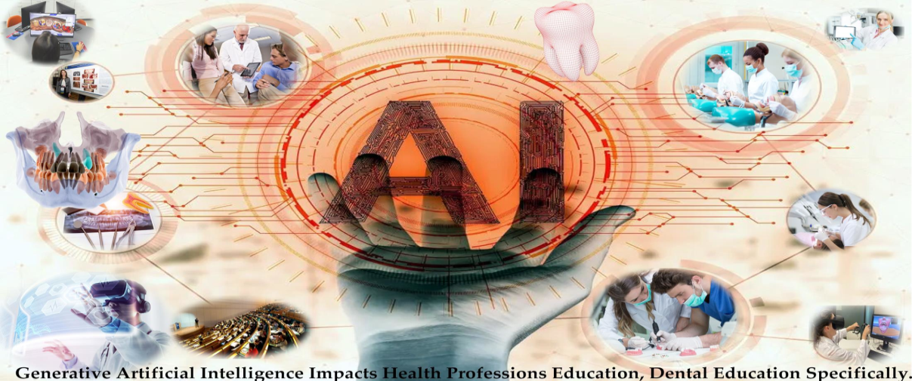
Figure1: Graphical Abstract depicting applications of AI in various specialities of dentistry such as oral maxillofacial surgery, oral maxillofacial radiology, oral maxillofacial pathology, endodontics conservative dentistry, periodontics, prosthodontics, implantology, dental materials, pedodontics and public health dentistry.
Courtesy: Thurzo A, Strunga M, Urban R, Surovková J, Afrashtehfar KI. Impact of Artificial Intelligence on Dental Education: A Review and Guide for Curriculum Update. Education Sciences. 2023; 13(2):150. https://doi.org/10.3390/educsci13020150³

Introduction:
Artificial Intelligence:
In dentistry, dental implants play a pivotal role in the replacement of teeth. The main objective is to analyze the accuracy of artificial intelligence and machine learning in the diagnosis of different dental diseases or conditions^{4,5}. "John McCarthy", a mathematician from Dartmouth University, is known as the "Father of Artificial Intelligence"⁶, and he defined the term "artificial intelligence" (AI) as "computerized synthetic human cognitive function"⁷. The definition of artificial intelligence was given by "Richard Bellman" as automated learning, problem-solving, and decision-making on par with human beings⁸. Diagnosis of oral diseases can be easily done by artificial intelligence, thereby reducing the workload of dental and health care professionals⁹. Based on the various advantages of AI-based technologies, health care, and dentistry have gained many benefits¹⁰. Artificial Intelligence played an important role during the pandemic era of severe acute respiratory syndrome (SARS)-CoV-2, where numerous people became carriers of the disease. As per Occupational Safety and Health Administration (OSHA) guidelines, the oral cavity was considered a high-risk category, which was dealt with efficiently by dental professionals^{12, 13}. Simulation of the human brain via neural networks is the blueprint of artificial intelligence. The neural network comprises neurons, which play an important role in the diagnosis of diseases. Lack of methodology, creativity, and practice is to be overcome in the future to upgrade dentistry into the field of artificial intelligence¹⁴. The main advantages of artificial intelligence in dentistry include high-quality dental care and the treatment and eradication of dental diseases. Specialties of dentistry such as oral medicine, oral radiology, oral and maxillofacial surgery, oral and maxillofacial pathology, prosthodontics, conservative dentistry, endodontics, periodontics, pediatric dentistry, oral oncology, and public health dentistry might rely on AI in the future¹⁵. In oral radiology, the interpretation of oral and maxillofacial radiological images can be improved by deep learning, algorithms, and graphic processing units^{16, 17}. The process of machine learning is significantly improving with the help of deep learning, which enables the computer to process numerous algorithms with graphic processing units¹⁸. Neural networks comprise convolutional and artificial types, which help in the diagnosis of dental caries, salivary gland pathology, oral and maxillofacial trauma, oral cancer, endodontic lesions, and dental-skeletal growth diseases¹⁹. AI enables the creation of a virtual database to assist the professionals in the treatment and also helps in follow-up and emergencies²⁰. The results showed that the accuracy and precision of the disease are about 90%–96% when the above CNN and ANN algorithms are used²¹. AI can be involved in the process of locating canals during control trials and radiographic images that show damaged or decayed teeth²². A step-wise flow chart of diagnosis, investigations, and treatment plans can be executed with the help of AI.
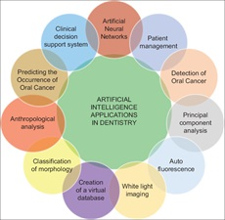
Figure 2: Graphical illustration depicting Artificial Intelligence applications in dentistry such as neural networks, patient management, oral oncology, histopathology, database, tooth morphology, and clinical support.
Courtesy: Lingam, Amara Swapna, Koppulu, Pradeep L, Akhter, Fatema, Afroz, Mohammed Malik, Tabassum, Nafeesa, Arshed, Maheen, Khan, Tahseen, E1Haddad, Sally. Future Trends of Artificial Intelligence in Dentistry. Journal of Nature and Science of Medicine 5(3):p 221-224, Jul-Sep 2022. | DOI:10.4103/jnsm.jnsm 2 22²³

The future of Artificial Intelligence:
Artificial intelligence in health care may involve activities ranging from simple to very advanced, which may include medical record review, population health analytics, radiological image interpretation, and clinical diagnosis and treatments²⁴. Clinical operational commands by dental professionals can be implemented by AI with the help of voice recognition centers²⁵. AI is a boon to the medical records department through the virtual storage of patient data. The patient’s health status can be tracked and updated. Precision in every step can be delivered with the help of cutting-edge technology²⁶. Improved Diagnostic Accuracy, Predictive Analytics, Personalized Treatment Planning, Dental Robotics, Augmented Reality, Digital Impression Scanning, and Improved Patient Communication are included, which can be done by AI models in the coming future.
Challenges of Artificial Intelligence:
Cons include errors related to the safety and quality of algorithms in Artificial Intelligence. This drawback can be overcome by "Software as a Medical Device", an innovation by the United States Food and Drug Administration (USFDA) under a new drug category that helps in the safety of patients. In the use of AI systems, the other concern is ambiguous accountability, which is very challenging for AI to get into day-to-day life²⁷.

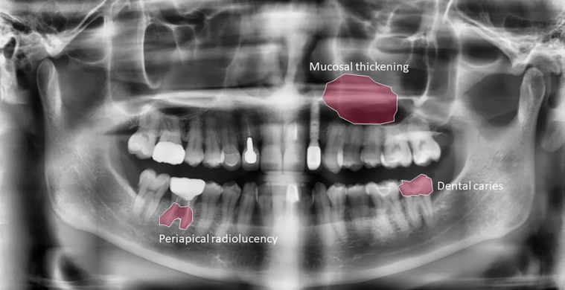
Figure 3: Artificial Intelligence dental image analysis depicting an Orthopantomogram.
Courtesy: Lee, S, Kim, D, Jeong, HG, (2022) Detecing 17 fine-grained dental anomalies from panoramic dental radiography using artificial intelligence. Research Outreach. Scientific Reports, 12, 5172. doi.org/10.1038/s41598-022-09083-2 DOI: 10.32907/RO-130-2773295876²⁸
Clinical Application of AI in Dentistry:
Osteoarthritis classification: AI has demonstrated the ability to classify 3D images of the mandibular condyle into structural degenerative changes, achieving 91% close agreement with clinician consensus and an established classification system²⁹.
Cancer Detection: In a recent study, an AI model was able to achieve an F1 score (which includes precision and recall) of 87% for the identification of images containing lesions³⁰.
Radiology: Diagnosis and treatment planning can be done effectively with the help of artificial intelligence by reproducing the radiological aspects of Intraoral Periapical Radiography (IDPA), Computer Tomography (CT), Magnetic Resonance Imaging (MRI), and Cone Beam Computed Tomography (CBCT)³¹.
Orthodontics: Developmental and functional disorders of the oral and maxillofacial apparatus can be rectified by orthodontic treatments relying on artificial intelligence (AI)³².
Periodontics: Diseases of periodontal tissues resulting in tooth mobility, tooth loss, and alveolar bone loss, combined with gingival diseases, can be managed in a better and more precise manner with the help of artificial intelligence^{33, 34}.
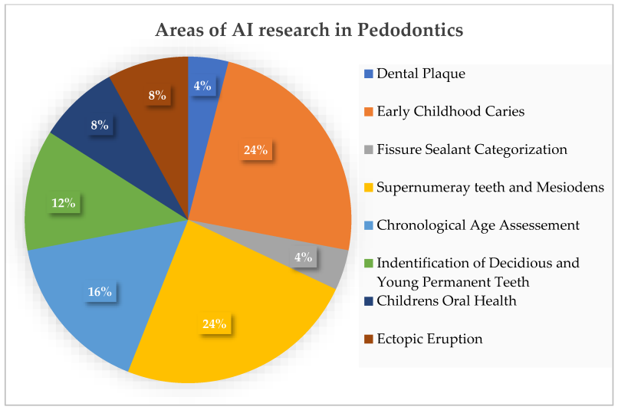
Figure 4: Areas of Artificial Intelligence research in Pedodontics such as stains calculus, dental caries, fit and fissure sealant, mesiodens, supernumerary teeth, age assessment, identification of primary and permanent teeth, oral prophylaxis, and ectopic tooth.
Courtesy: Vishwanathaiah S, Fageeh HN, Khanagar SB, Maganur PC. Artificial Intelligence- Its Uses and Application in Pediatric Dentistry: A Review. Biomedicines.2023;11(3):788. https://doi.org/10.3390/biomedicines11030788³⁵
Endodontics: Endodontology is a branch of dentistry about pulpal and periapical pathology³⁶.
Oral pathology³⁷: Implementation of Artificial intelligence helps in efficient, and accurate histopathological analysis³⁸.
Machine Learning: Large data patterns can be analyzed followed by performance of intelligent tasks devoid of human intention. Deep learning (DL) involves both patterns and compostable hierarchies of patterns³⁹.
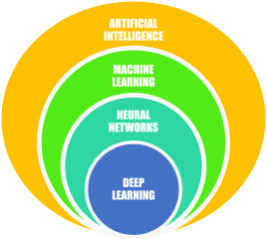
Figure 5: Depicting Artificial Intelligence followed by its key components machine learning, neural networks, and deep learning.
Courtesy: Sanjeev B. Khanagar, Ali Al-ehaideb, Prabhadevi C. Maganur, Satish Vishwanathaiah, Shankargouda Patil, Hosam A. Baeshen, Sachin C. Sarode, Shilpa Bhandi, Developments, application, and performance of artificial intelligence in dentistry-A systematic review, Journal of Dental Sciences, Volume 16, Issue 1, 2021, Pages 508-522,
ISSN 1991-7902, https://doi.org/10.1016/j.jds.2020.06.019⁴⁰.
3D printing: It is being used to create custom dental restorations such as crowns, bridges, and dentures; well, it allows dentists to create these restorations quickly and accurately. The lost anatomy of the oral and maxillofacial apparatus can be regained by 3D scans and virtual models which help in the production of aligners which in turn decides which teeth should be moved and the amount of pressure exerted based on the pressure points for each and every tooth⁴¹.
Teledentistry: Clinical information can be exchanged from remote places leading to efficient consultation and treatment planning⁴². Pros of teledentistry involve access to dental care by all categories of patients, avoidance of waiting periods, and minimization of travel⁴³. The most important application of artificial intelligence in teledentistry is a deduction of costs leading to economic status of the patient^{44, 45}.
Smart Dental Devices: The diagnosis of oral and maxillofacial conditions in a timely manner leads to correct treatment rendering good quality of life for the patient via artificial neural networks (ANNs). This is very prominent in the identification of risk groups who are more susceptible to oral cancers. It also helps in the prediction of erupted canine sizes or premolars as well as tooth surface loss.
Computer-aided design (CAD) technologies: Computer-aided design (CAD) technologies introduced in the last decade into the dental industry have signiﬁcantly facilitated achievements in dentistry⁴⁶.
Robotics in Dentistry: The word Robot was introduced by “Karel Čapek” in 1920 meaning “Robota,” similar to “labour”⁴⁸. The main advantages of robotics in the dental field include reduced operation time, accuracy of treatments, real-time navigation, surgical plan designed in relation to implant dentistry, comparative and co-relative analysis of diagnosis of oral and maxillofacial lesions followed by data collection pertaining to oral and maxillofacial imaging and finally 3-dimensional digital scanning of the implant site pertaining to prosthodontics^{47,49,50}.
Conclusion:
The above overview depicts that artificial intelligence has emerged a lot in current times and might emerge as a common tool in ultramodern dentistry in the upcoming future⁵¹. The benefits of this system are effectiveness, delicacy, better perfection, better monitoring, and time savings⁵². From the researcher’s point of view, dentistry will be a boon via artificial intelligence in the near future. Last but not least, diagnosis, management, and quality of life can be improved with the help of artificial intelligence⁵³. Clinical research pertaining to dentistry can be implemented in a systematic way with the help of artificial intelligence. The benefits of digital applications will help professionals to achieve improved and cost-efficient healthcare for patients⁵⁴. Teledentistry will help dentists to assist patients without any contact and that too in remote areas and also without adding the risks of infections⁵⁵. These are just a few of the many ways that technology is changing dentistry. In the coming future, as technology continues to advance, AI will be the best viewed as an intelligent assistant in therapeutic and diagnostic care, providing reliable data to inform clinical decision-making and ultimately this could help translate to improved protocols and health outcomes for patients. To have the full benefit of the technology, one should have a clear understanding of the concepts and models of AI. Dentists and clinicians also should ensure the collection and providing authentic data in their database to have accurate results from the models. Future research involves exploring Augmented Reality(AR) and Virtual Reality(VR) in relation to dentistry.
References:
1.Tandon, Shobha; Venkateswaran, Annapurny; Baliga, Sudhindra M1; Nayak, Ullal Anand2. Recent research trends in dentistry. Journal of Indian Society of Pedodontics and Preventive Dentistry 35(2):p 102-105, Apr-Jun 2017. Doi: 10.4103/0970-4388.206038
2.Venugopal, Chaitra; K, Shobha; Rai, Kiranmai S.; Pinnelli, Venkata B.; Kutty, Bindu M.; Dhanushkodi, Anandh. Current Gene Therapy, Volume 18, Number 5, 2018, pp. 307-323(17)Doi: https://doi.org/10.2174/1566523218666180913152615
3. Thurzo A, Strunga M, Urban R, Surovková J, Afrashtehfar KI. Impact of Artificial Intelligence on Dental Education: A Review and Guide for Curriculum Update. Education Sciences. 2023; 13(2):150. https://doi.org/10.3390/educsci13020150
4. Yu KH, Beam AL, Kohane IS. Artificial intelligence in healthcare. Nat Biomed Eng. 2018 Oct;2(10):719-731. doi: 10.1038/s41551-018-0305-z. Epub 2018 Oct 10. PMID: 31015651.
5. Topol EJ. Deep medicine: how artificial intelligence can make healthcare human again. 1st ed. New York: Basic Books; 2019.
6. Bijo Alexander and Sunil John. (2018); ARTIFICIAL INTELLIGENCE IN DENTISTRY: CURRENT CONCEPTS AND A PEEP INTO THE FUTURE. Int. J. of Adv. Res. 6 (Dec). 1105-1108] (ISSN 2320-5407). www.journalijar.com
7. Obermeyer Z, Emanuel EJ. Predicting the Future - Big Data, Machine Learning, and Clinical Medicine. N Engl J Med. 2016 Sep 29;375(13):1216-9. doi: 10.1056/NEJMp1606181. PMID: 27682033; PMCID: PMC5070532.
8. Khanagar SB, Al-Ehaideb A, Maganur PC, Vishwanathaiah S, Patil S, Baeshen HA, Sarode SC, Bhandi S. Developments, application, and performance of artificial intelligence in dentistry - A systematic review. J Dent Sci. 2021 Jan;16(1):508-522. doi: 10.1016/j.jds.2020.06.019. Epub 2020 Jun 30. PMID: 33384840; PMCID: PMC7770297.
9. Hao Ding, Jiamin Wu, Wuyuan Zhao, Jukka P. Matinlinna, Michael F. Burrow, and James K. H. Tsoi Frontier Dental Medicine, 20 February 2023. Sec. Dental Materials Volume 4 – 2023 https://doi.org/10.3389/fdmed.2023.1085251
10. Wulff A, Montag S, Steiner B, et al CADDIE2—evaluation of a clinical decision-support system for early detection of systemic inflammatory response syndrome in paediatric intensive care: study protocol for a diagnostic study BMJOpen 2019;9:e028953. doi: 10.1136/bmjopen-2019-028953
11.Prasad S, Potdar V, Cherian S, Abraham P, Basu A; ICMR-NIV NIC Team. Transmission electron microscopy imaging of SARS-CoV-2. Indian J Med Res. 2020 Feb & Mar;151(2 & 3):241-243. doi: 10.4103/ijmr.IJMR_577_20. PMID: 32362648; PMCID: PMC7224615.
12. Centers for Disease Control and Prevention, Interim Infection Prevention and Control Guidance for Dental Settings during the COVID-19 Response, Centers for Disease Control and Prevention, Atlanta, GA, USA, 2019, https://www.cdc.gov/coronavirus/2019-ncov/hcp/dental-settings.html.
13. Aminoshariae A, Kulild J, Nagendrababu V. Artificial Intelligence in Endodontics: Current Applications and Future Directions. J Endod. 2021 Sep;47(9):1352-1357. doi: 10.1016/j.joen.2021.06.003. Epub 2021 Jun 10. PMID: 34119562.Artificial intelligence in endodontics: Current applications and future directions.
14. Bhanushali, Parin & Katge, Farhin & Deshpande, Shantanu & Chimata, Vamsi & Shetty, Shilpa & Pradhan, Debapriya. (2020). COVID-19: Changing Trends and Its Impact on Future of Dentistry. International Journal of Dentistry. 2020. 1-6. 10.1155/2020/8817424. https://doi.org/10.1155/2020/8817424
15.Manne, Ravi and Kantheti, Sneha C., Application of Artificial Intelligence in Healthcare: Chances and Challenges (April 24, 2021). Current Journal of Applied Science and Technology, 40(6): 78-89, 2021, Available at SSRN: https://ssrn.com/abstract=4393347
16. Talpur S, Azim F, Rashid M, Syed SA, Talpur BA, Khan SJ. Uses of Different Machine Learning Algorithms for Diagnosis of Dental Caries. J Healthc Eng. 2022 Mar 31;2022:5032435. doi: 10.1155/2022/5032435. PMID: 35399834; PMCID: PMC8989613.
J Healthc Eng.2022 Mar 31;2022:5032435. Doi: 10.1155/2022/5032435.eCollection2022.
17. Ahmed N, Abbasi MS, Zuberi F, Qamar W, Halim MSB, Maqsood A, Alam MK. Artificial Intelligence Techniques: Analysis, Application, and Outcome in Dentistry-A Systematic Review. Biomed Res Int. 2021 Jun 22;2021:9751564. doi: 10.1155/2021/9751564. PMID: 34258283; PMCID: PMC8245240.
18. Yo-Wei chen, Kyle Stanley, Dr Med Dent, Wael Att. Current applications and future perspectives quintessens international volume 51 number 3 march 2020
19. SanjeevB. Khanagar , Ali Al-ehaideb , Prabhadevi C. Maganur , Satish Vishwanathaiah , Shankargouda Patil , Hosam A. Baeshen , Sachin C. Sarode , Shilpa Bhandi Journal of dental sciences Volume 16 Issue 1 Jan 2021 pages 508-522 https://doi.org/10.1016/j.jds.2020.06.019
20. Bas B, Ozgonenel O, Ozden B, Bekcioglu B, Bulut E, Kurt M. Use of artificial neural network in differentiation of subgroups of temporomandibular internal derangements: a preliminary study. J Oral Maxillofac Surg. 2012 Jan;70(1):51-9. doi: 10.1016/j.joms.2011.03.069. Epub 2011 Jul 29. PMID: 21802818.
21.Lim K, Moles DR, Downer MC, Speight PM. Opportunistic screening for oral cancer and precancer in general dental practice: results of a demonstration study. Br Dent J. 2003 May 10;194(9):497-502; discussion 493. doi: 10.1038/sj.bdj.4810069. PMID: 12835785.
22. Lingam, Amara Swapna; Koppolu, Pradeep1; Akhter, Fatema; Afroz, Mohammed Malik; Tabassum, Nafeesa; Arshed, Maheen; Khan, Tahseen; ElHaddad, Sally. Future Trends of Artificial Intelligence in Dentistry. Journal of Nature and Science of Medicine 5(3):p 221-224, Jul-Sep 2022. DOI: 10.4103/jnsm.jnsm _2_22
23.https://chestnutdental.com/blog/the -future-of-dentistry-how-artificial-intelligence-is-changing-oral-healthcare/
24. Agrawal P, Nikhade P (July 28, 2022) Artificial Intelligence in Dentistry: Past, Present, and Future. Cureus 14(7): e27405. doi:10.7759/cureus.27405
25. Da Costa CB, Peralta FDS, Ferreira de Mello ALS. How Has Teledentistry Been Applied in Public Dental Health Services? An Integrative Review. Telemed J E Health. 2020 Jul;26(7):945-954. doi: 10.1089/tmj.2019.0122. Epub 2019 Oct 1. PMID: 31573410
26. Mann DL. Artificial Intelligence Discusses the Role of Artificial Intelligence in Translational Medicine: A JACC: Basic to Translational Science Interview With ChatGPT. JACC Basic Transl Sci. 2023 Jan 18;8(2):221-223. doi: 10.1016/j.jacbts.2023.01.001. PMID: 36908674; PMCID: PMC9998448. July 2022 Journal of Nature and Science of Medicine 5(3):221 DOI: 10.4103/jnsm.jnsm_2_22 Licence CCBY-NC-SA 4.0
27. Thomas Nguyen, Naomie Larrivée, Alicia Lee, Olexa Bilaniuk, and Robert Durand J Canadian Dental Association 2021;87:L7
28. Lee, S, Kim, D, Jeong, HG, (2022) Detecting 17 fine-grained dental anomalies from panoramic dental radiography using artificial intelligence. Research Outreach. Scientific Reports, 12, 5172. doi.org/10.1038/s41598-022-09083-2 DOI: 10.32907/RO-130-2773295876
29,30. Strunga M, Urban R, Surovková J, Thurzo A. Artificial Intelligence Systems Assisting in the Assessment of the Course and Retention of Orthodontic Treatment. Healthcare. 2023; 11(5):683. https://doi.org/10.3390/healthcare11050683
31. Hosny A, Parmar C, Quackenbush J, Schwartz LH, Aerts HJWL. Artificial intelligence in radiology. Nature Reviews. Cancer. 2018 Aug;18(8):500-510. doi: 10.1038/s41568-018-0016-5. PMID: 29777175; PMCID: PMC6268174.

32. Tugce Gokdeniz S, Buyuksungur A, Eray Kolsuz M. Artificial Intelligence in Dentistry [Internet]. Dentistry. IntechOpen; 2023. Available from:Artificial Intelligence in Dentistry May 2023 DOI:10.5772/intechopen.111532 License CC BY 3.0 In book: Human Teeth - From Function to Esthetics [Working Title] Seyide Tugce Gokdeniz,Arda Buyuksungur and Mehmet Eray Kolsuz
33. Tonetti MS, Jepsen S, Jin L, Otomo-Corgel J. Impact of the global burden of periodontal diseases on health, nutrition and wellbeing of mankind: A call for global action. Journal of Clinical Periodontology. 2017 May;44(5):456-462. doi: 10.1111/jcpe.12732. Epub 2017 May 8. PMID: 28419559
34. Lin PL, Huang PY, Huang PW. Automatic methods for alveolar bone loss degree measurement in periodontitis periapical radiographs. Comput Methods Programs in Biomedicine. 2017 Sep;148:1-11. doi: 10.1016/j.cmpb.2017.06.012. Epub 2017 Jun 24. PMID: 28774432.
35. Vishwanathaiah S, Fageeh HN, Khanagar SB, Maganur PC. Artificial Intelligence Its Uses and Application in Pediatric Dentistry: A Review. Biomedicines. 2023; 11(3):788. https://doi.org/10.3390/biomedicines11030788
36. Joda T, Yeung AWK, Hung K, Zitzmann NU, Bornstein MM. Disruptive Innovation in Dentistry: What It Is and What Could Be Next. Journal of Dental Research. 2021 May;100(5):448-453. doi: 10.1177/0022034520978774. Epub 2020 Dec 16. PMID: 33322997.
37. Thomas T. Nguyen, Naomie Larrivée; Alicia Lee; Olexa Bilaniuk; Robert Durand, J Canadian Dental Association 2021;87:l7
38. Araújo ALD, da Silva VM, Kudo MS, de Souza ESC, Saldivia-Siracusa C, Giraldo-Roldán D, Lopes MA, Vargas PA, Khurram SA, Pearson AT, Kowalski LP, de Carvalho ACPLF, Santos-Silva AR, Moraes MC. Machine learning concepts applied to oral pathology and oral medicine: A convolutional neural networks' approach. J Oral Pathol Med. 2023 Feb;52(2):109-118. doi: 10.1111/jop.13397. Epub 2023 Jan 4. PMID: 36599081.58 Journal of oral pathology and Medicine , 04 January 2023. https://doi.org/10.1111/jop.13397
39. Nguyen TT, Larrivée N, Lee A, Bilaniuk O, Durand R. Use of Artificial Intelligence in Dentistry: Current Clinical Trends and Research Advances. J Can Dent Assoc. 2021 May;87:l7. PMID: 34343070
40. Sanjeev B. Khanagar, Ali Al-ehaideb, Prabhadevi C. Maganur, Satish Vishwanathaiah, Shankargouda Patil, Hosam A. Baeshen, Sachin C. Sarode, Shilpa Bhandi, Developments, application, and performance of artificial intelligence in dentistry-A systematic review, Journal of Dental Sciences, Volume 16, Issue 1, 2021, Pages 508-522,
ISSN 1991-7902, https://doi.org/10.1016/j.jds.2020.06.019.
41. Deshmukh, SonaliVijay(2018). Artificial intelligence in dentistry. Journal of the International Clinical Dental Research Organization. 10(2):47.10.4103/jicdro.jicdro_17_18. January 2018 Licence CCBY-NC-SA
42. Yoshinaga L. The use of teledentistry for remote learning applications. Pract Proced Aesthet Dent. 2001 May;13(4):327-8. PMID: 11402774.
43. Daniel SJ, Kumar S. Teledentistry: a key component in access to care. J Evid Based Dent Pract. 2014 Jun;14 Suppl:201-208. doi: 10.1016/j.jebdp.2014.02.008. Epub 2014 Mar 5. PMID: 24929605.
44. Susan J. Daniel, Sajeesh Kumar,Teledentistry: A Key Component in Access to Care, Journal of Evidence Based Dental Practice, Volume 14, Supplement, 2014, Pages 201-208, ISSN 1532-3382, https://doi.org/10.1016/j.jebdp.2014.02.008.
45. Duka M, Mihailović B, Miladinović M, Janković A, Vujicić B. [Evaluation of telemedicine systems for impacted third molars diagnosis]. Vojnosanit Pregl. 2009 Dec;66(12):985-91. Serbian. doi: 10.2298/vsp0912985d. PMID: 20095519.
46. Shu-Xian Zheng, Jia Li, and Qing-Feng Sun. 2011. A novel 3D morphing approach for tooth occlusal surface reconstruction. Comput. Aided Des.43,3 (March,2011), 293-302.
47. Liu L, Watanabe M, Ichikawa T. Robotics in Dentistry: A Narrative Review. Dent J (Basel). 2023 Feb 24;11(3):62. doi: 10.3390/dj11030062. PMID: 36975559; PMCID: PMC10047128.
48. Almurib Haider , Al-Qrimli Haidar & Thulasiraman Nandha. (2012). A review of application industrial robotic design. Proceedings of the 2011 Ninth International Conference on ICT and Knowledge Engineering, Bangkok, Thailand. 12-13 January 2012; pp. 105-112, 10.1109/ICTKE.2012.6152387.
49. Liu L, Watanabe M, Ichikawa T. Robotics in Dentistry: A Narrative Review. Dent J (Basel). 2023 Feb 24;11(3):62. doi: 10.3390/dj11030062. PMID: 36975559; PMCID: PMC10047128.
50. Lang T, Staufer S, Jennes B, Gaengler P. Clinical validation of robot simulation of toothbrushing--comparative plaque removal efficacy. BMC Oral Health. 2014 Jul 4;14:82. doi: 10.1186/1472-6831-14-82. PMID: 24996973; PMCID: PMC4094541.
51. Khanna, Sunali & Dhaimade, Prita. (2018). Artificial Intelligence: Transforming Dentistry Today. Indian Journal of Basic and Applied Medical Research; June 2017:Vol.-6, Issue-3, P. 161-167. www.ijbamr.com P ISSN: 2250-284X , E ISSN : 2250-285
52. Amisha, Malik P, Pathania M, Rathaur VK. Overview of artificial intelligence in medicine. J Family Med Prim Care. 2019 Jul;8(7):2328-2331. doi: 10.4103/jfmpc.jfmpc_440_19. PMID: 31463251; PMCID: PMC6691444.

53. Priyankar Roy, Lalith Vivekanand and Gurman Preet Singh GSC Advanced Research and Reviews, 2021, 07(01), 082–086. 10.30574/gscarr.2021.7.1.0078. https://doi.org/10.30574/gscarr.2021.7.1.0078
54. Ossowska A, Kusiak A, Świetlik D. Artificial Intelligence in Dentistry—Narrative Review. International Journal of Environmental Research and Public Health. 2022; 19(6):3449. https://doi.org/10.3390/ijerph19063449
55. Bhanushali, Parin & Katge, Farhin & Deshpande, Shantanu & Chimata, Vamsi & Shetty, Shilpa & Pradhan, Debapriya. (2020). COVID-19: Changing Trends and Its Impact on Future of Dentistry. International Journal of Dentistry. 2020.1-6.10.1155/2020/8817424
http://doi.org/10.1155/2020/8817424

