Fabrication of Eight-Legged Robot with Theo-Jansen’s Linkage as Foot: Handy-approach using Metallic-Strips, for Educational-Purposes

Ravi Ojha,
B.Tech. Final Year, Mechanical Engineering Department,
Madan Mohan Malaviya University of Technology,
Gorakhpur, Uttar Pradesh, India
ravirameshojha@gmail.com
Mannu Gupta,
B.Tech. Final Year, Mechanical Engineering Department,
Madan Mohan Malaviya University of Technology,
Gorakhpur, Uttar Pradesh, India

Laxmi Pandey,
B.Tech. Final Year, Mechanical Engineering Department,
Madan Mohan Malaviya University of Technology,
Gorakhpur, Uttar Pradesh, India

Piyush Tiwari,
Assistant Professor (Guest)
Mechanical Engineering Department
Madan Mohan Malaviya University of Technology,
Gorakhpur (U.P.)

ABSTRACT
Legged Robots have become popular for features like terrain-adaptability, ability to surmount complex-obstacles, high-levels of mobility, maneuverability, ability to mimic movement of living-animals, etc. Basis of such mechanisms is Walking-Linkage. Klann’s Walking-Mechanism and Theo-Jansen’s Walking-Mechanism have become most for their simplicity and single degree-of-freedom. Their principle is conversion of input rotary-motion into linear-motion of the end-effector (foot or toe). Jansen’s Linkage is modifiable in terms of link-dimensions and input-actuation, and has the capability to be more worthwhile when used in combination with other useful mechanisms like Ackermann’s. This paper presents fabrication of an 8-legged model employing Jansen’s Linkage as foot using metallic-strips and plates which a first-time approach for any walker, making this model capable of being used for educational as well as analysis and research purposes. This paper also summarizes the do’s and don'ts while fabrication of such model and basic approach while developing such models using metallic-strips which were availed from Zephyr Toymakers pvt. ltd. and motor were availed from robu.in, thus making our model very cost-efficient as far as analysis is concerned. Future-aspects of such models are also discussed at the very conclusion of this paper after listing various improvements which need to be considered on near-future.

Keywords – Mechanism, Linkage, Jansen’s Linkage, Klann’s Linkage, Walker, Robot, Fabrication, Assembly, Model, Educational-Toy

Introduction

Term ‘Robot’ is derived from Czech-word ‘Robota’ meaning ‘slave-labor’, originated in 1923 from Czech play R.U.R. (Rossum’s Universal Robot, 1921) by Karel Capek. Though there is no clear definition of ‘Robot’, it is generally believed to be designed to replace human-beings in daily household and industrial works and depicted as very-efficient and emotionless. Robot Institute of America (1969) defines a robot as “... a re-programmable, multi-functional manipulator designed to move materials, tools or specialized devices through various programmed motions for the performance of a variety of tasks”. Currently, it is used as an intelligent agent, physical or virtual, capable of doing a task autonomously or with guidance. In Basic Mechanical-Engineering, a robot is mechanical-device which imitates motions and movements of any living-organisms, preferably animals including humans.
Transporter vehicles have traditionally used wheel-mechanisms like cars and trains. Wheels are ideally suited for movement without vertical fluctuations of the body, and tires with inner rubber tubes absorb shock from a rugged road. These wheeled-vehicles are fast and efficient on nearly flat and hard surfaces, but face difficulty to traverse on certain surfaces such as uneven, obstructed, stepped, slippery, etc. In nature, legged-animals surpass obstacles and surface unevenness by varying their leg configuration in order to adapt themselves to surface irregularities. Biologically-inspired robotics learn mobile flexibility from the morphology of multiple legs and their coordination. This requires a multi-degree-of-freedom leg with many actuators, which is difficult to control and reproduce mechanically. The other option is to have a simple single degree-of-freedom leg mechanism which has certain limitations - crank driven leg mechanisms are of this type. The advantages of legged locomotion are low energy consumption, scalable design and ability in clearing obstacles. [6,9,22] The control strategy becomes complex for the leg design with several degrees of freedom, so, development of leg mechanism with one degree of freedom has drawn considerable attention from mechanisms and robotics communities. The one degree-of-freedom leg mechanisms such as Klann’s linkage, Chebyshev leg mechanism and Jansen leg mechanism are crank-based mechanisms, usually more energy efficient than the leg mechanisms requiring multiple actuators [29].
Walking-mechanisms, consisting of links and joints, are suitable for applications that require movement across rough terrains and are intended to simulate walking of humans or animals. These linkages can be planar with a single degree of freedom, or they can have a more complex motion in 3-dimensional space. Some can have multiple degrees of freedom. [31] Crank driven walking leg linkage mechanism is a planar mechanism which is driven by one input power source i.e. torque applied to the crank transmits the force to other connecting links which form a movable leg of the walking leg mechanism. A walking leg mechanism must produce a nearly straight stride-path (propelling-path). A continuously rotating actuation system that produces a closed ovoid-shaped foot path is required. Single Degree of freedom leg-mechanisms are simple and are suitable in some areas. Many such mechanisms were developed using four, six and eight links, they were straight-line mechanisms. Four link mechanisms such as Chebyshev, Grasshopper and Hoecken’s and six link mechanisms that have either Watt’s or Stephenson’s topology have been developed. Klann’s linkage uses Stephenson’s topology. The other types of linkages with eight links have different methods of operation; they are based on Peaucellier–Lipkin mechanism type behavior. Theo Jansen’s and Ghassaei’s walking leg linkage is of this type. All the above-mentioned linkages make use of coupler curves and are modified by inversion and amplification.[9] Applications of walking-robots involving these walking-linkages are as All-terrain Vehicle which can be for transportation-services or for locomotion to disables, for on-ground explorations of unreachable-places – e.g. exploration of wild, for Extraterrestrial-explorations, for Underground-explorations as Mining Excavation System and for amusement-industry – as in toy-industry and in amusement-parks.[1,2,3,4,5,6,12]
Horizontal-speed of leg-toe must be as constant as possible when touching ground and movement of leg must be as fast as possible when not touching ground. Input torque/force must be constant or at least with no extreme changes. Stride-height must be enough for clearance but not too much to conserve energy. Duration of foot touching ground must be at least for half of the cycle in case of a 2- or 4-legged mechanism and at least a third of cycle for a 3 or 6 leg mechanism. Moving-mass must be minimized as much as possible. Vertical center of mass must always lie inside the base of support and speed of each leg or group of legs must be tried to be separately controllable for steering, and for better forward and backward walking. [7,8]

KLANN’S LINKAGE

Klann-Linkage is a planar-mechanism for walking-motion with single degree of freedom, developed by Joe Klann in 1994, involving six rigid-links of which two-links are ternary, including ground-link and rest binary. All links are connected by revolute-joints which have a single degree of freedom, thus forming only lower-pairs. All joints are binary including three support-pivots. It imitates spider’s leg-movements better than others and has fewer links than other walking-mechanisms. It is also lighter than other mechanisms with higher stride. It involves one four-bar mechanism. It is one of the most widely studied leg-mechanisms besides Jansen’s leg. [9,10,14,17]

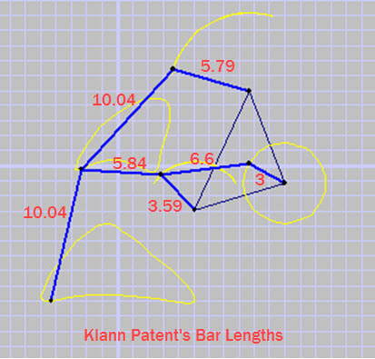
Fig. No. 1 Dimensions of original Klann’s Linkage [14]
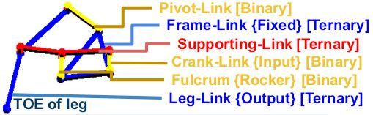
Fig. No. 2 Description of original Klann’s Linkage [14]

THEO-JANSEN’S LINKAGE

Jansen-Linkage is a walking-linkage with a single degree of freedom used as Leg or Paw of Robots. It was originally developed by Dutch-Artist Theodorus Gerardus Jozef Jansen in 1990s for his Wind-powered kinetic-sculptures “Strandbeests” (Dutch for Beach-Animals). It has been widely studied and several modifications have also been given to its dimensions for different toe-movement. Original-dimensions as described by Jansen himself have been shown here. Original Jansen’s Linkage involved twelve rigid binary-links with eight revolute-joints of which two are binary, four are ternary and two are quaternary. In most-common modified-version (fig.no.4), seven binary with one ternary i.e. total eight links are involved with seven revolute-joints of which four are binary and three are ternary. Ground-link with two support-pivots is binary. This mechanism involves two 4-bar crank-rocker mechanisms with common base{ground} link and common crank. It imitates leg movements with better strength than Klann’s and toe-velocity during stride is nearly constant unlike Klann’s. It involves only two which is a lesser number of support-pivots than others and prevents bumpy-ride, due to more linear motion when touching ground than Klann’s. [1,2,9,14] This linkage will be central to the study of this report. A comparison of Klann’s linkage with Jansen’s is shown in Table-No.1 and Fig. No.5.

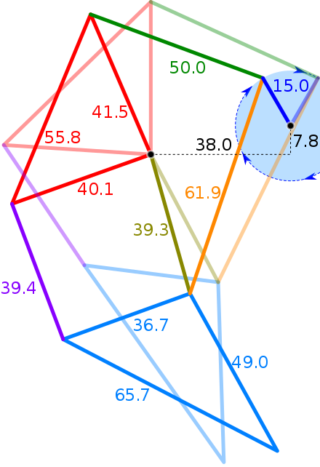
Fig. No. 3 Dimensions of original Jansen’s Linkage [14]
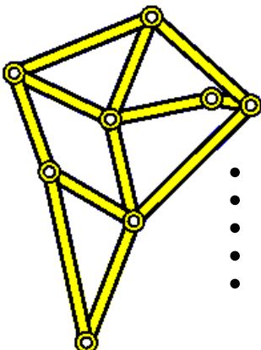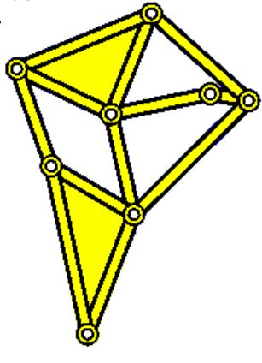
Fig. No. 4 Original Jansen’s Linkage with Modified-version on its right [14]

Tab No. 1 Comparison of Klann’s Linkage with Jansen’s Linkage [9]
CRITERIA | KLANN’S LINKAGE | JANSEN’S LINKAGE
Number of Links | 6 | 8
Number of Support-pivots | 3 | 2
Error percentage in straightness of stride path to stride length | 3.4 | 0.05
Stride-Length to Size | Medium | Medium-Large
Velocity of foot during Stride-Path | Fluctuating | Nearly Constant
Crank-Rotation w.r.t. movement of mechanism | Opposite | Same

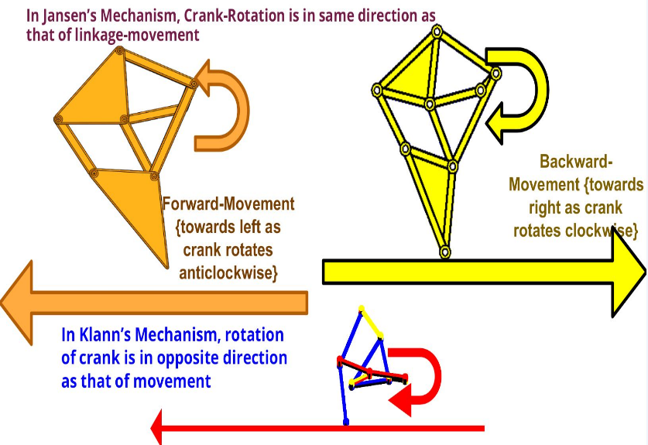
Fig. No. 5 Direction of movement of leg with respect to direction of rotation of crank for Klann’s and Jansen’s Linkages [13,14]

LITERATURE-REVIEW

V Vujošević, et al. presents analysis of walking mechanisms, advantages of walking mechanisms over wheels and effect of certain parameters on its performances and, performs locus-analysis and analysis of leg when it touches ground. [31] This paper provided us literature on velocity of foot of walking-linkage with respect to robot as well as with respect to terrain. Shortcomings of walking mechanisms are – (1) A driving member rotates in an unequal speed to obtain a unique speed of robots, or vehicles that are driven by a walking mechanism (2) The length and height of the steps are fixed (3) Inertial moments and forces cannot be balanced in a satisfied way.
Smit Panchasara, et al. proposes Modified Theo-Jansen Linkage (MTJL) consists of two ternary links & five binary links compared to Conventional Theo Jansen Linkage (CTJL) which consists of twelve binary links including a crank link to optimized step height & stride length and analyses varies dimensions of links, their foot locus trajectory. Goal is to increase step height and overcome obstacle then increment of acceleration can be neglected and MTJL should be used. [38] It gave us idea about how same mechanism can be modified and improved without any external attachments.
Table No. 2 Comparison Table for Step Height, Stride Length, and Foot Locus Trajectory [31]
Linkages Name | Step Height (mm) | Stride Length (mm) | Foot Locus Trajectory
CTJL | 22 | 67
MTJL | 34 | 66 | 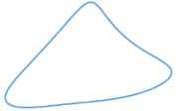

Maul Haque et al. discusses versatile robot that can run over any solid surfaces no matter the condition of surface. By adding advance technologies like Machine Learning & Artificial Intelligence these robots can handle complex tasks. [33] It provided us method to calculate torque required for knowing specifications of motor.
Mehrdad Mohsenizadeh, et al. employed loop-closure method for kinematic-analysis of Jansen mechanism by dividing it into 4-linkages to study kinematics for six points for one full cycle, using MATLAB and performed simulation using SolidWorks. Position, linear velocity & linear acceleration results for desired points obtained in SolidWorks were in good agreement with those obtained from analytical approaches in MATLAB. [3] This easy-to-understand Research-Paper inspired us to opt for opting this topic and informed us about Jansen-leg’s working. It provided us kinematic-analysis of Jansen-Linkage, of which we are here studying the position-analysis.

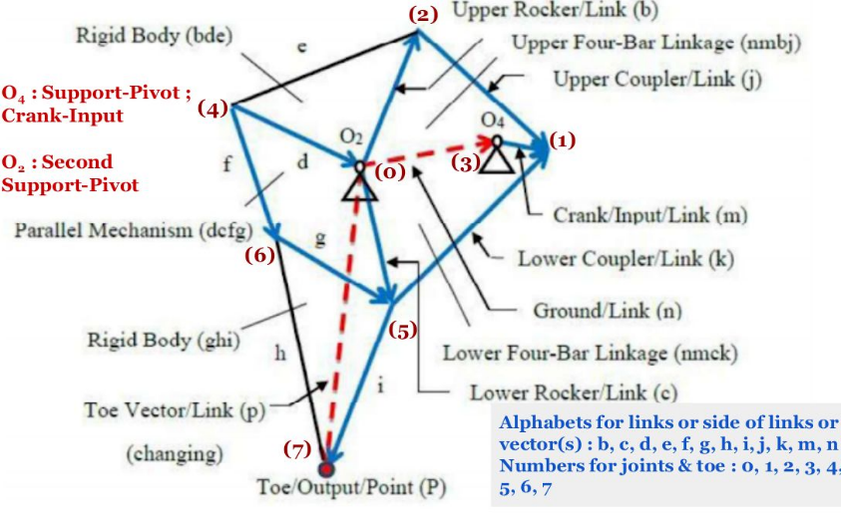

Fig. No. 6 Description of links, joints and nomenclature here used for Jansen’s Linkage [3]

Fig. No. 7 Four Movement-Phases of Toe: - AB: Stride-Phase : Ground-touch, Constant-Velocity, Linear ; BC : Lift-Phase : Towards Maximum-Height ; CA : Return-Phase: Towards Direction of Movement - its shape affects Maximum Leg-Acceleration - Ideally linear to minimize Leg-acceleration and Lower-Phase : Towards Cycle-Completion [3]

Shunsuke Nansaia et al. performed complete dynamic analysis of Jansen mechanism using projection method proposed by Blaje. Jansen link mechanism can be moved on roughly constant speed with constant input torque, accommodates for toe slipping while designing walking control system for robot platform. Further, it was also found choice of more than four legs is must to vanish an expected up & down motion. [4] Its conclusion made us realize why we should shift from 4-legged to 8-legged Robot. It also told us that link opposite to foot in triangle is prone to failure and joint other than foot and rocker-coupler joint must be taken care of seriously.
Lalit Patnaik, et al. accomplishes forward-kinematics using circle intersection method, determines trajectories of various points on mechanism in the chassis (stationary-link) reference-frame, proposes dynamic model for Jansen leg mechanism using bond graph approach with modulated multiport transformers which helps to determine motor torque profile as well as the link & joint stresses and plots trajectories of pin joints & node CoMs in the chassis reference using circle intersection method obtaining step length & height, & their variation with change in stationary link length & crank radius - step length varies linearly while the step height varies non-linearly with change in crank radius. For given ground reaction force pattern & crank angular speed profile, dynamic model determines motor torque profile &, link & joint stresses, thus aiding hardware & controller design. [34] It made us in awe of how complex studies of such simple mechanisms can be.

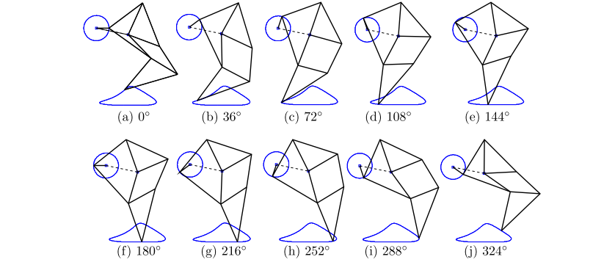
Fig. No 8 Configuration of Jansen leg mechanism at various crank angles (with respect to horizontal) in the chassis reference frame. Trajectories of the end of the crank and the foot point are also marked [34]

Florina Moldovan et al. presents classification for walking robots based on leg locomotion & main objectives that walking robots designers must achieve along with graphical results of kinematic analysis of Jansen Linkage using Pro Engineer program & SAM. [36] It tells necessity to analyze & simulate structure design using CAD facilities & to optimize proportions of legs for obtaining optimal design in order to walk smooth & stable through certain environment and informs us about classification of walkers and importance of CAD in this new-age.
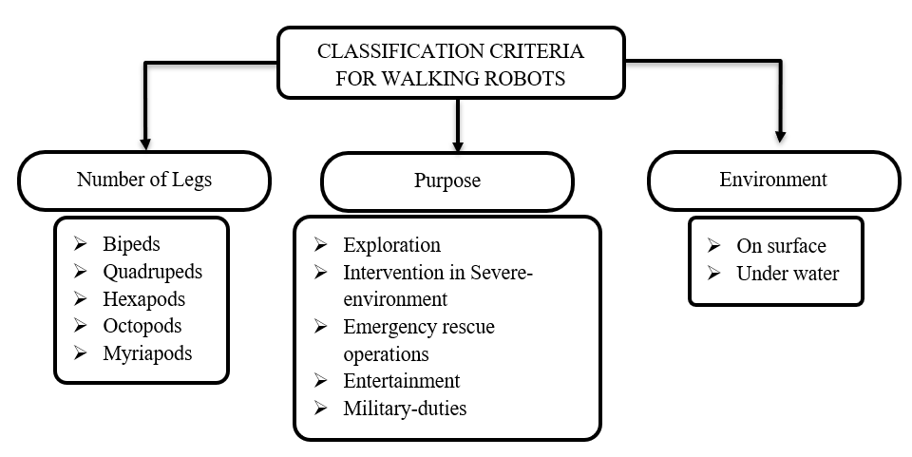
Fig. No. 9 Classification of Walking-Robots as described in [36]

Alejandra C. Hernández, et al. proposes a robotic platform based on Theo Jansen's natural gearing mechanism to help students during their school years and beyond (scientific approach, problem solving skills, creativity) and implements design with possibility to reduce complexity of building robots allowing students to design new custom pieces simply being printed and tested very quickly. Robot can be studied, modified, copied & distributed by anyone. [37] It gave us an idea how robotics and kinematic-linkages can be introduced at an early age to kids. Keval Bhasvar et al. performed design and analysis of intellectual model of autonomous surveillance robot, having 8 Jansen-Legs for surveillance in muddy or desert area or on that region where the surface is less grippy, using 360° rotating camera. After doing kinematic analysis of modified Theo Jansen Mechanism, it was found that it is jerk free and by using ternary links, it provides better stability with minor increase of input power. All the electronics are controlled by Arduino and that Arduino takes power to run itself as well as all other systems by 12 V DC battery. This is the first spider robot which is made by Polylactic Acid (PLA) material [2]. It motivated us to look for fabrication of an 8-Legged Robot and informed us about basic hardware-requirements for our model. Roslee et al. built quadrupedal robot designed for rugged terrain by using Jansen's linkage, unguided, but able to evade obstacles, change course, carry items stably. Robot's average speed is 0.02178 m/s & power consumption is 5.71 W. [5] It informed us about hardware-requirements, especially electronic-requirements and it also informed us ways to analyze Fabricated Robot. Punde et al. built mechanical robotic walker, using an eight-bar link mechanism, capable of walking towards objects according to remote-control input with detailed analysis using the software. It set basis for further investigation, optimization or extension of Jansen mechanism. Main problem faced with mechanism was the bending of leg linkages, so high stiffness should be provided. [23] It informed us how turning the direction of walking-robot takes place and how data is collected, presented about fabrication. Swadhin Patnaik studied Jansen Linkage from basics & compared its usage as part of transportation-system in Mining {in place of wheeled-ones} with wheeled-vehicles i.e., trucks. Jansen is proven to be more applicable in place of tyres after performing tyre analysis [1]. Manikanta et al. studied Klann Linkage & presented Literature-review on Ongoing-Researches on same mechanism. [10] It helped us in understanding Klann’s linkage. Ujjban Kakati, et al. intends to build a chair, based on Jansen’s Linkage that is propelled by hand using a chain and sprocket mechanism in order to make it cost effective. Fabricated model is developed in less than 10 years though still in its primitive stage. [30] It helped us to understand designing of mechanisms of larger shape & geometry and its applicability for common citizens. Samarth Jaiswal et al. implements kinematics by Jansen linkage in real life to solve problems for medium-scale farmers by decreasing time & cost of investment for farming for purposes in uneven and sticky terrain, where maneuverability of wheels of tractors also fails and prevention measure for any accident is taken by Ultrasonic sensor. It has great-capability to be developed as a product assisting the hard work of farmers. [32] It made us to wonder about scope of Jansen’s Linkage as an industrial-product in mass-scale. Gopi Krishnan Regulan et al. proposed system that can walk on both ground and water surfaces consisting two major mechanisms for its motion namely a planar eight bar Jansen mechanism as a leg & Ackermann steering mechanism as for turning and demonstrates effectiveness & performance of the system by using in-house fabricated prototype for different working conditions. It redesigns Jansen mechanism to improve drag force during walking on the water surfaces. It investigates structural stability aspects using finite element method through ANSYS software and performs kinematic analysis for proposed Jansen mechanism using the forward kinematic relations. It redesigns Jansen mechanism numerical simulations of forward kinematics in the MATLAB environment. [35] It informed us how already other mechanisms are incorporated with walking-mechanisms to increase degree-of-freedom and how vast is application of this linkage.
F Pop et al. describes mathematical model regarding synthesis, obtains results after computation and verifies them with help of 2D mechanism simulation in MATLAB then integrates Jansen mechanism into structure of 2 DOF quadruped robot with help of kinematic synthesis method trying to determine new dimensions for mechanism, based on set of initial conditions. [41] It tells the necessity to find practical solution for increasing number of DOFs to improve control of leg during walking and considers possibility to use another actuator that will be placed at hip joint. It informed us about problems of Jansen Linkage and ideas to improve them by increasing DoFs.
Komoda et al. extended & analyzed Jansen mechanism from viewpoint of number of motion points for climbing over bumps. Pivot to which rockers of 4-bar mechanisms are connected is given an up & down motion which demonstrated that lifting up of linkage center alters leg's orbit upward & combination of cycle & up-down motion provides new elliptic orbit to climb bumps with about 10 times height of original. [6] It motivated us to look for ways to give up and down motion to second-pivot in synchrony with crankshaft. Same researchers proposed extension mechanism of Jansen linkage to generate various walking patterns, hypothesized that additional cyclic motion of the linkage center-pivot alters original walking pattern into orbits systematically with various functional aspects like climbing, stepping in same place & rolling back and suggested that Jansen mechanism has capability to extend adaptive & controllable vehicle on irregular ground. [22] It gave us an idea of how Jansen-Linkage has future-scope due to its extensibility in spite of inventions of many new walking-mechanisms.

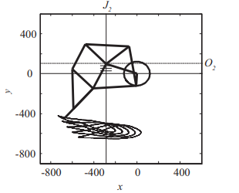
Fig. No. 10 Change of leg movements with respect to the position of joint center [6]

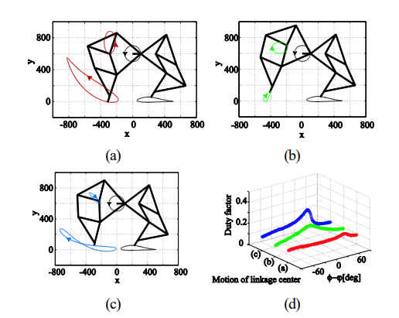
Fig. No. 11 Extended orbits generated from various cyclic motion of the linkage center (a) An orbit from a up-and-down cyclic motion, providing a climbing function (b) An orbit from a side-by-side cyclic motion, providing stepping in the same place (c) An orbit from a forward tilting and narrow width circle, providing rolling back (d) Duty factors with respect to the phase difference [22]

Chih-Hsing Liu, et al. modifies 8-bar Jansen-linkage with new link-dimensions - as per proposed path synthesis method, using commercial multibody dynamic analysis software RecurDyn, to generate foot trajectory for stair-climbing, minimizing tacking error between target & generated-trajectories and uses counterweight-slider to adjust center of gravity of robot to switch to either walking mode or stair climbing mode. Simulated & experimental results show developed 8-legged robot is capable for both walking & stair climbing robot as there are always 4 legs on ground or stairs and when robot lifts up front feet, 2 rear support-rods provide additional support [29]. It helped us to understand how any leg-mechanism, specifically Jansen’s, can be made extensible by varying link-dimensions to get different foot-trajectories and how different foot-trajectories are helpful depending on terrain of the land - specifically, stairs in this case.
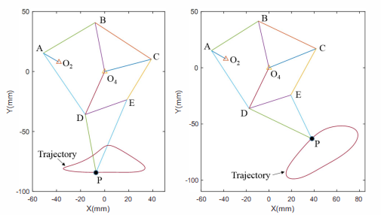
Fig. No. 12 Original and proposed leg designs for stair-climbing and their motion trajectories as described in [29]

Shunsuke Nansai, et al. presents distance-based formulation, its application to solve the position analysis problem of standard Jansen mechanism and identifies novel gait patterns of interest for a walking platform by changing configuration of a linkage. Five gait patterns of interest have been identified, analyzed & discussed in relation to potential future applications, extending capabilities of original design not only to produce novel gait patterns but also to realize behaviors beyond locomotion. It finalizes fully-functional design which enables all single-link transformations – reconfigurable linkage switches from a pin-jointed Grubler kinematic chain to a mechanism of mobility five with slider joints during reconfiguration. [39] In another paper, same researchers experiment with prototype for above suggested mechanism, validating proposed approach. In proposed reconfigurable Jansen-leg, linear actuators are added to system have to be only controlled during the transformation operation between gait patterns. It presents fully functional design of reconfigurable Jansen and reports experimental results with a working prototype discussing 4-legged robot currently being assembled. [40] It informed us of how pneumatics can be used to make links of any mechanism change its dimensions.
Shivamanappa G. Desai presents new single degree-of-freedom crank driven planar Peaucellier-Lipkin type walking leg mechanism having 8 links, performs kinematic-analysis by MATLAB & Linkage 3.0, performs optimal design using Genetic Algorithm to determine optimum lengths of links, fabricates & tests experimental model of leg mechanism to determine the practical accuracy and compares leg mechanism with Jansen’s & Klann’s walking leg mechanisms. Comparison of the experimental results of the leg mechanism with the simulation and calculated results shows that they are in good agreement. It also discusses advantages & limitations of new-linkage. [9] It gave us an idea about how new useful linkages are generated by modifying already known simple-mechanisms.
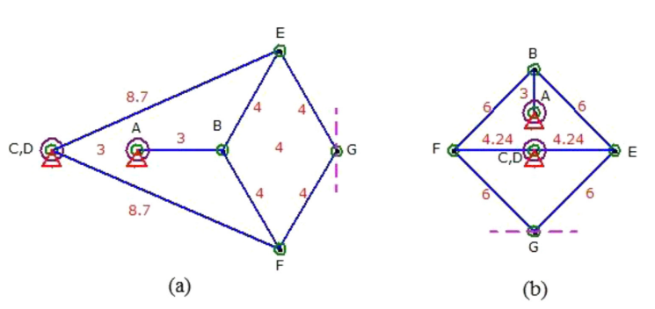
Fig. No. 13 Peaucellier–Lipkin mechanism and its inversion [9]

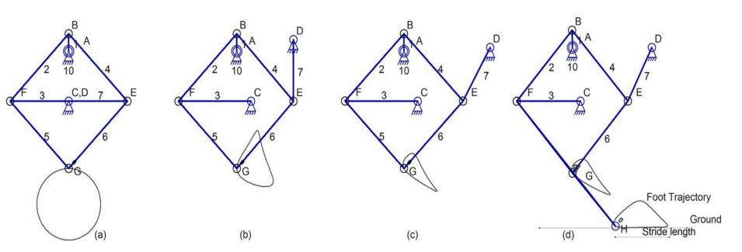
Fig. No. 14 Development stages of new walking leg mechanism as presented in [9]

FABRICATION OF MODEL

We aspired to make a wheelless moving-model whose movement was attained with help of eight Jansen-Legs that could mimic step-motion of arachnids i.e. joint-legged invertebrates and could move forward as-well-as backward. When we looked for availing the hardly-available Jansen’s Linkage from market in India along with inbuilt transmission-system for our walking-vehicle, then overall project-cost went over ₹20K/- but we wanted a model that could provide analysis on phase-difference and capability to have additional-mechanisms in future. After referring to research-papers [24], [25], [26], [27], [28] we’ve got idea to make model of metal {painted-iron} strips, which can make our project cost-efficient and analysis-based, so, analysis can be performed by changing dimensions of metal-links and phase-differences of cranks etc. Also, model can now be flexible i.e. additional-linkages can be added such that model still remains comparatively light in weight. Also, fabrication of this will provide more understanding of kinematic-linkages in real and assembling of such linkage-based machines. Also, differences from above references will be that it will have eight-legs, with more-precise dimensions, better transmission system, separated Front & Back paw and thus, preferable for phase-difference analysis.

Fig. No. 15 An example of a model using metallic strips [24], [25], [26], [27], [28]

COMPONENTS AND COST

Components include links in form of metal-bars and strips, revolute-joints in form of nut & bolt, nuts and bolts for other assembly, washers and bush-stoppers, flanges to connect cranks, shafts, motor and 12V battery and other metal-plates to form supporting-structures & chassis. Metallic strips, bars and plates availed from Zephyr Toymakers pvt. ltd. and motor were availed from robu.in. Number of components required by us, with their industrial-name and cost has been listed in table. Specification of Motor: -
- Recommended Voltage (DC): 12V
- Input Voltage-Range (DC): 6V - 12V
- Rated RPM at 12V: 10 RPM
- Rated-Torque: 680N-cm
- No-Load Current: 0.4A
- Full-Load Current: 2.047A
- D-shaft of 6mm Diameter, 27mm length
- Motor-Body 37mm diameter, 94mm length
- Mass of 0.7 kg

Table No. 3 Components and their cost
Component Name | Amount | Cost in Rupees (Rounded-Off) | Total Cost Incurred per component  (in Rupees) | Image of component if any | Used as
Electric Tape | 1 | 10 | 10 | - | Connecting Wires
Battery | 1 | 840 | 840 | - | To supply power
Motor with Cage | 1 | 999 | 999 | - | To provide rotary-motion
Pairs of Screwdriver and Spanners | 7 | 62 | 504 | - | Tools
Box of Screws - Nuts and Bolts | 19 | 90 | 1710 | 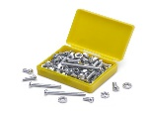 | Joints
Motor switch with frames | 1+2 frame | 233 |  | 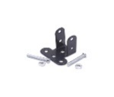 | Switch for on/off and turning direction of rotation of motor
AB4-45 | 4 | 6 | 24 |  | Mass Balancing
L-5 | 2 | 8 | 16 | 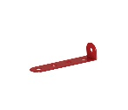 | Used in mainframe’s support-column
BT-5 | 10 | 10 | 100 |  | As crank-link, coupler and Mass Balancing
TW-1 | 20 | 1 | 20 | 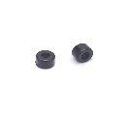 | As washer and appropriate positioning of parallel-legs
SPACER | 15 | 1.8 | 27 | 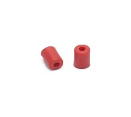 | For appropriate positioning of parallel legs
R-8 METAL BUSH | 14 | 14 | 196 | 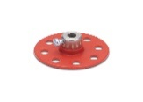 | As crank and in support-pivots
V-8 | 4 | 12 | 48 | 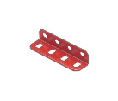 | For balancing and support frame
RT-55 | 3 | 79 | 237 | 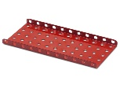 | Main-Frame
TB-20 | 1 | 52 | 52 | 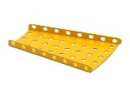 | Mass-Balancing
LRT-21 | 1 | 24 | 24 |  | Mass-Balancing
SQ-25 | 5 | 26 | 130 | 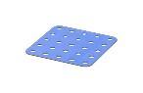 | As Support frame for shafts and motor
SQ-9 | 2 | 10 | 20 | 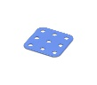 | Support frame for motor
BLR-11 | 4 | 28 | 112 | 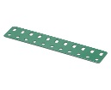 | Fixed frame for Jansen-Linkages
ALB7 2X3 | 3 | 11 | 33 | 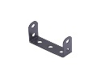 | Mass-Balancing
Washer | 10 |  | 12 | 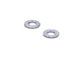 | Washer
AB-7 | 21 | 14 | 294 | 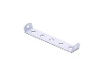 | For support-frame, links etc.
BTB-5 | 22 | 11 | 242 | 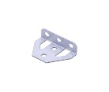 | As support frame and for mass-balancing and foot
HS-7 | 14 | 9 | 126 | 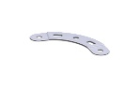 | As links and support-frame
ALB-5 | 2 | 8 | 16 |  | Motor connector
AUB-5 | 5 | 8 | 40 |  | As crank-support and foot
AB-5 | 24 | 8 | 192 |  | As link, balancing-mass, support-frame
AZS-3 | 1 | 6 | 6 |  | Motor-Coupler
AB-45, AB-2 | 28 | 4 | 112 | 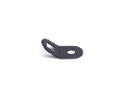 | Support-frame, foot
A-11 | 60 | 15 | 900 |  | Links and Main-Frame
A-9 | 20 | 13 | 260 | 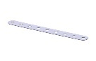 | Links and Support-frame
A-7 | 24 | 9 | 116 |  | Links
A-5 | 44 | 7 | 308 |  | Link, foot and support-frame
A-2 | 12 | 3 | 36 |  | Foot
A-4 | 12 | 5 | 60 |  | Links, Crank-link, Support-Frame
A-3 | 4 | 4 | 16 |  | Foot
80mm shaft, 4mm diameter | 3 | 9 | 27
110mm shaft, 4mm diameter | 4 | 4 | 16 | 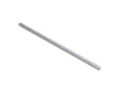
TOTAL |  |  | ₹ 8114/-

FABRICATION OF LEG

We have considered dimensions as described by Jansen himself. To get appropriate metallic-strip for link-dimensions after rounding the dimensions off to zeroth decimal-place and we took two proportions such that first-time crank-length is 2units i.e. 3hole metal-bar such that line joining two-pivots is inclined to horizontal and second time crank-length is 1unit i.e. 2hole metal-bar such that line joining two-pivots is horizontal. After a trial run by attaching motor to the crank, we found that larger-leg functioned smoother. We performed same for linkage of dimensions as described in research-paper [4] out of curiosity. This one performed smoothly but was lighter, not strong enough to hold main-frame. Its smaller-one failed as it was way smaller than before. We had to make our model such that we did not have to get into need of having more spare-components other than what was available to us. We now preferred for dimensions as described by Jansen himself. Later, we had to increase length by 1 hole as we realized that holes’ diameter were smaller than distances between them.
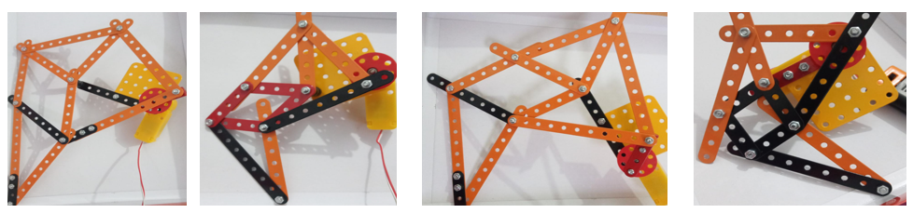
Fig. No. 16 Four tested Jansen linkage with different dimensions

FIRST-MODEL WITH GEARED-TRANSMISSION

First Model had Legs such that Front and Hind legs had cranks of their own. Two-legs are at every corner of model on single shaft, on opposites side of support frame. Within support frame, that single shaft also incorporates a gear. On one hand-side, two shafts of front and back had to be driven with such incorporated-gears. They receive their part of central rotary-power from a third-gear placed at center. Two extra gears were incorporated to fill up the distances. Basically, on one side, simultaneous rotation of two-shafts was performed. Basically 5 gears were on both left & right sides on opposite side of middle-gear, another gear received transmission from central power-drive, making a total of six gears on both sides. Drive system consisted a single shaft with two gears on both sides to transmit power to above mentioned sixth-gears. One of the two gears on this singular-shaft received power from another gear attached directly to the motor. Advantages of this model were: -
    - Crank angle could easily be adjusted as per will
    - Phase-Difference between a pair of front paw & back paw could easily be different from 0-degrees
    - Minimum possibility of collision of legs aur cranks
But we still had to reassemble the whole model as a part of second-phase due to following-reasons: -
    - Gears available could not hold up the weight of such legs and got their teeth broken
    - Metallic-gears are costly and out of budget
    - Model was quite heavy 3-4 kgs
    - Mainframe of model got bent due to heavy weight
    - Shaft-alignment of Drive-System with LHS and RHS was difficult to be maintained till submission of model
To reduce weight and number of gears we realized that front paw & back paw needs to be attached to same-crank i.e. fixed phase-difference of 0-degrees. Now, we looked for a model which had 8 legs but no gears for which no research-paper was available. We did not have any high-torque double-shaft motors, so we had to place motor on one side and align crankshafts such that power was transferred from first pair of front & back paws to last i.e. fourth pair of legs. In next model we had to compromise our model with its ability to turn.

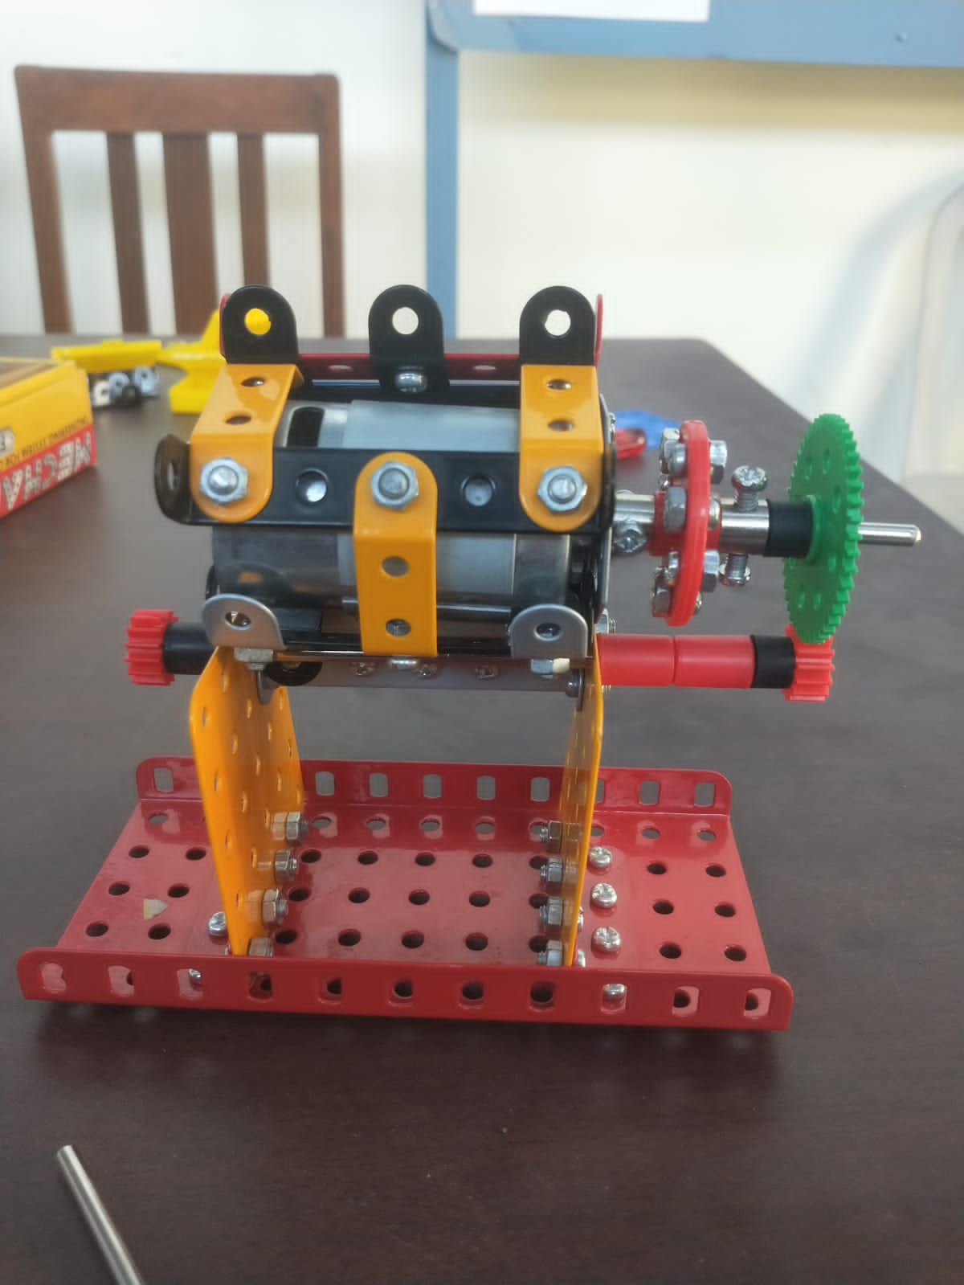
Fig. No. 17 Drive System for the first model

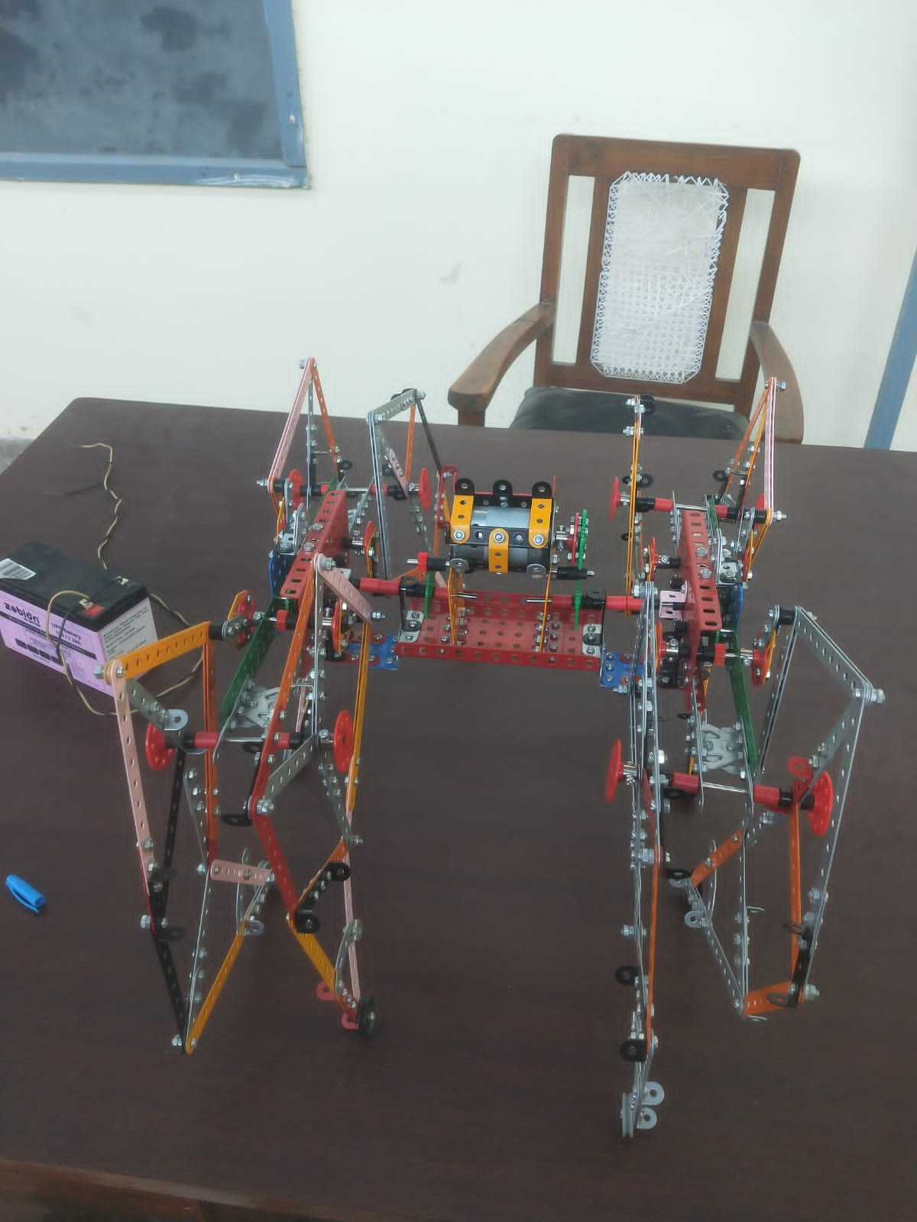
Fig. No. 18 Complete first model

SECOND-MODEL WITHOUT GEARED-TRANSMISSION

This model had a pair of front paw and back paw attached to single-crank with 0degree phase-difference. A shaft incorporates two cranks with one crank on one side of supporting-frame and one on other side. Motor is not placed centrally but on one side of whole-model to avoid gearing-system. Motor transfers power to first-pair, then, second-pair whose crank drives not only 4 connecting-rods of leg-pair but also crank parallel to it, attached to opposite collinear shaft on parallel support-frame, which also has a crank on other side to drive third collinear-shaft with two pair of legs. In this model phase-difference between four leg-pairs from left to right can still be varied, though phase-difference of a any front and back leg pair is fixed to 0degrees. Also, for dynamic balancing, it is suggested to have 180 degrees phase-difference between two cranks of single-shaft. But this model still had problem of bending of main-frame and we required motor of higher-torque

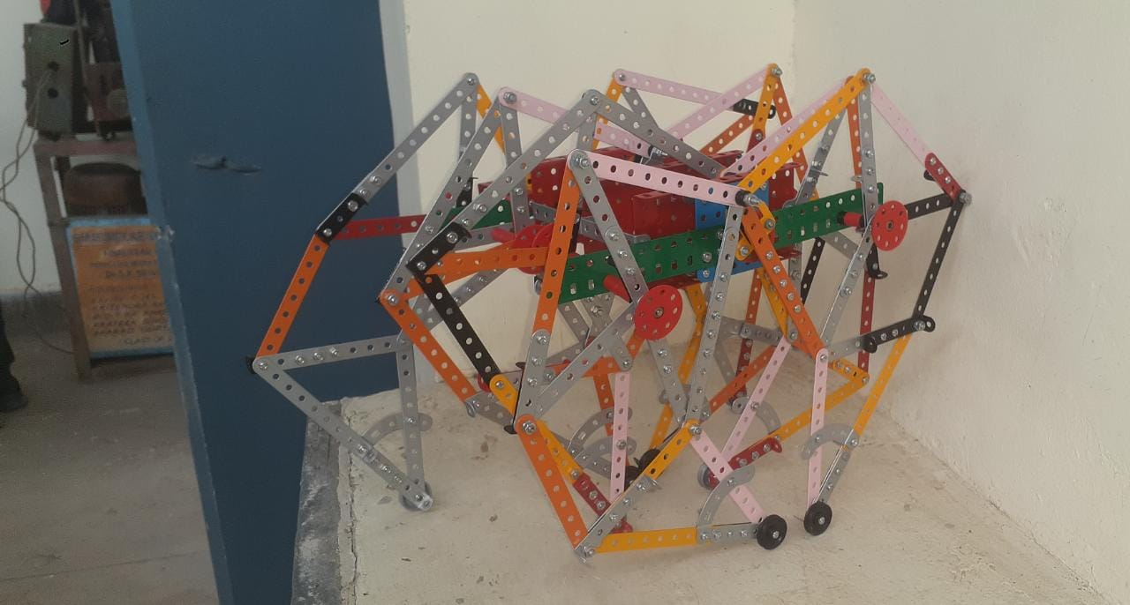
Fig. No. 19 Second model

FINAL-MODEL WITH BRIEF-DESCRIPTION OF ITS DEVELOPMENT

We not only redesigned our mainframe but also added a four-bar mechanism to toe for more stable standing.

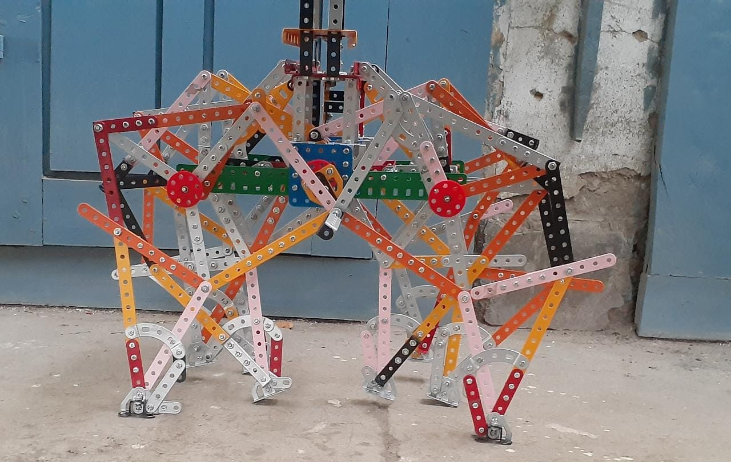
Fig. No. 20 Sideview of final model

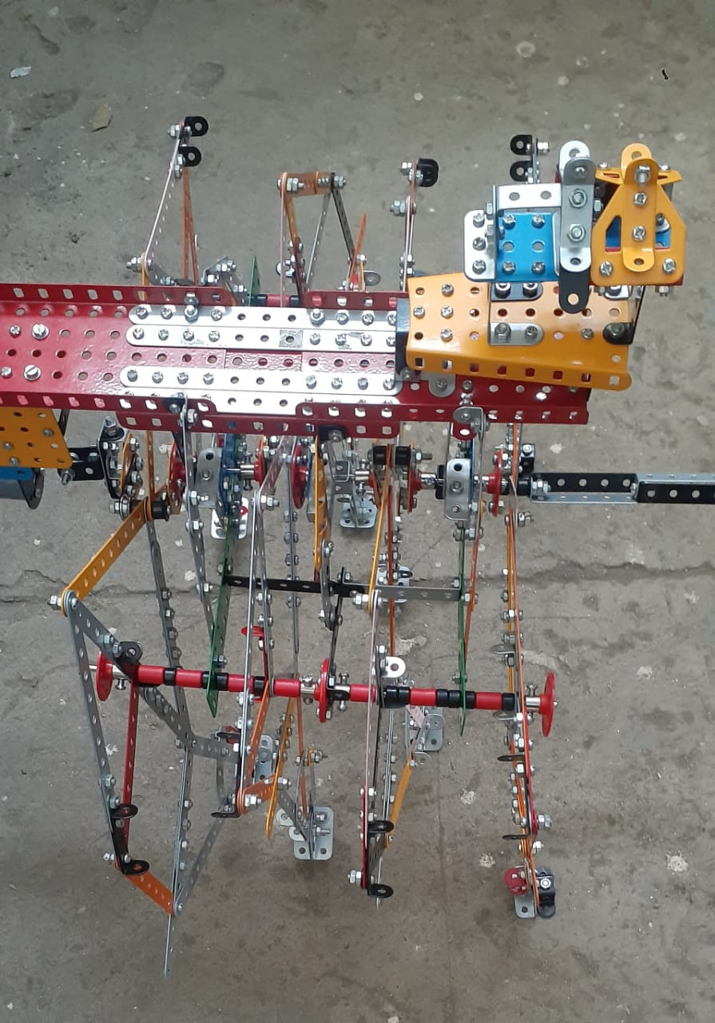
Fig. No. 21 Top-view of final model
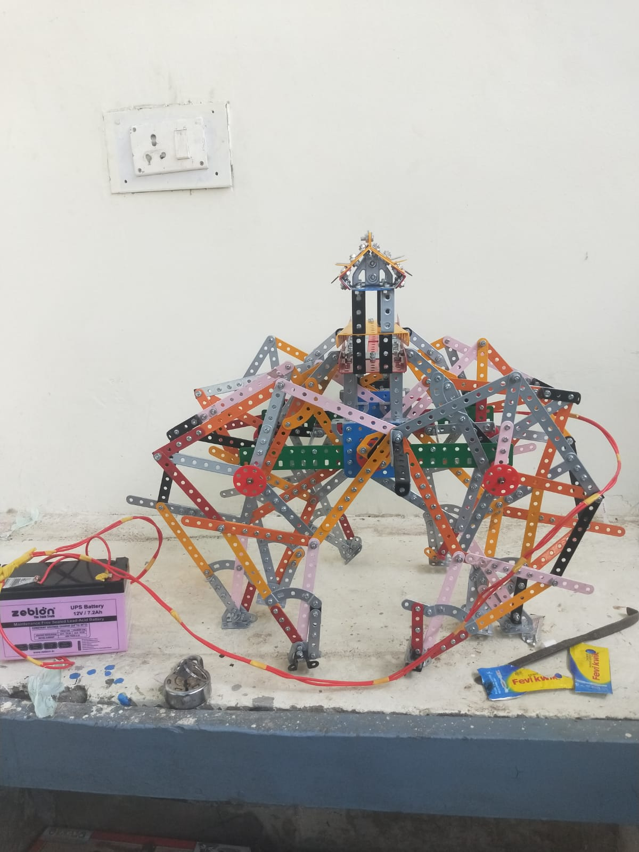
Fig. No. 22 Upright final model

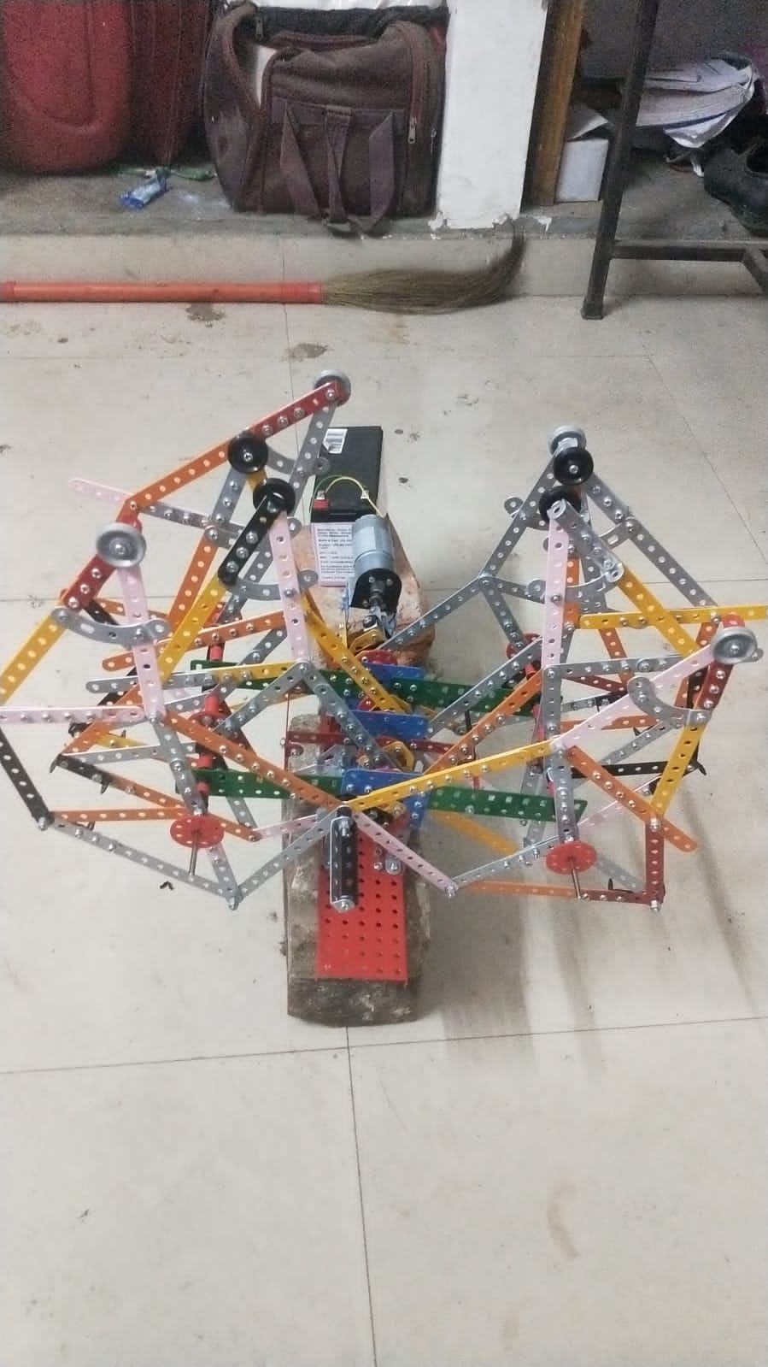
Fig. No. 23 Downside final model

From figure-no. 6 and table-no. 3, m link i.e., crank is formed with help of BT-5 and A-4 are used together along with R-8 Metal bush such that center of R-8 coincides with middle of straight-side and perpendicular to this side has A-4 placed in the middle such that hole moves out of opposite corner to which coupling-rods are attached making our crank of 4 holes. Upper coupling-rod j is made up of A-11 whereas lower coupling-rod k is made of two A-11 such that its length is of 13 holes by having 9 holes as common between both A-11. Upper-rocker b is made up of A-7, A-5 and AB-5 such that link length is 9 holes by having ending 3 holes of A-5 and A-7 as common and AB-5 has its at joint-point and end of A-7 parallel to A-5. Lower-rocker c is made up of A-7 and A-5 such that its length is 9 holes, again by having 3 holes as common. Link d and f are A-9 each of 9 holes. Link e is made up of A-11, A-5 and AB-5 such that link-length is 13 holes by having 3 holes of A-5 and A-11 as common and AB-5 has its at joint-point and end of A-11 parallel to A-5. Link g is made up of A-4, A-7 and A-11 such that its length is 9 holes by having r common holes in A-4 and A-7 with A-11 added for strength of this weakest link as described in [4]. Link i is A-11 of 11 holes. Link h is made up of A-5, A-11 and AB-7 such that its length is 13 holes such that 3 holes of A-5, A-11 and longer side of AB-7 are common. Triangle igh also incorporates HS-7 such that its first and fourth holes of it are at sixth hole from toe at h and i links respectively. Toe-mechanism is made by using A-2 attached to fifth hole of above-mentioned HS-7 and other hole with A-5 whose other end is attached to largest hole of two oppositely-coupled BTB-5 on same side. The two BTB-5 are coupled such that side with 3 holes act as foot making foot as 3×2 holes. This toe mechanism is used to have better surface-area of toe and it helps toe to readjust itself as per terrain but does not let the foot to freely rotate also. Revolute-joints are made by using bolt with two-nuts tightened with each other. Support-frame is made with help of SQ-25, two BLR-11 and AUB-5. Centers of SQ-25 and AUB-5 are used to support cranks and two holes beside it on one side and two under them, i.e., four in total are common with end four holes of BLR-11. Lower second hole of BLR-11 is used as other support pivot for Jansen-Linkage. Another support frame, which has to be placed in between those two frames, is made with the help of SQ-25, AUB-5 and two L-5. Distance between two support-frames is kept 5-holes for which AB-7 are used by attaching their ends at upper seventh hole from extreme at BLR-11 such that Theo-Jansen’s Linkage don’t get obstructed with any interfering AB-7. On one side at support pivots, proper distance between 4 pairs of legs are maintained by using two R-8 Metal-bush, 7 spacers and 10 black bushes along with two more R-8 Metal-bush to tighten the positioning of all linkages. One support frame has cranks on both sides at its center such that all three shafts are coaligned and cranks between two frames are connected to each other at crank-coupler joint, so that power is transmitted from first shaft to another. It is suggested to have 180 degrees of phase-difference on same shaft. To connect crank with couplers, black bushes are also attached to maintain proper distance. Motor is connected to first pair of legs with help of two ALB-5, two BT-5, two AB-5, two AB-2 and one AZS-3. ALB-5 is connected to motor with help of washers at its extreme U shaped end, nuts and bolts, and other two holes in same line are connected to two AB-2 whose other side lying parallel with center of ALB-5 provide base to connect with 3 holes side of BT-5 and AB-5 - which is coupled with another BT-5 at their extreme-ends having AZS-3 between them and the other BT-5 is on opposite AB-5 whose corner whole is attached to crank-coupler joint of first pair of fore paw and back paw. Motor has support-frame attached to main-frame employing two V-8, two SQ-9, two SQ-25, two BTB-5 and motor-frame. Motor-frame is attached to two BTB-5 on 3 holes’ side with its other side of two-holes attached to two SQ-9 whose other six holes are common with those of SQ-25. SQ-9 on its other end has its four-holes attached to V-8 whose other four holes are connected to main-frame. Three support-frames for shafts are attached to main frame such that SQ-25 portion are connected to two BTB-5 at their upper corners such that BTB-5 has its triangular-sides attached to vertical two holes at upper corners of SQ-25 and one BTB-5 has its 3 holes’ side attached to one extreme of AB-7 whose other extreme is attached to main-frame. BLR-11 is supported by main-frame with help of A-9, HS-7 and A-5. Support-pivots are attached to middlemost support-frame with help of AB-7 and middlemost support frame has its extreme end supported with help of triangle, HS-7 and A-4 parts. Main-frame consists of three RT-55 overlapped partially with each other with five common holes between two of them, along with four A-11 and one AB-7. To balance weight of motor we had attach more structure which acted as aesthetics also. This involved TB-20, two V-8, LRT-21, two BTB-5, two BT-5, four AB-5, four ALB7 2×3 and four AB-45.

CONCLUSION

Walking-linkages are one of the key-elements in future of Robotics and other Engineering-aspects. Theo-Jansen Linkage can be introduced to interested-kids at early-age with help of educational-toys etc. platforms to deepen their approach toward kinematics. Theo-Jansen Linkage can be a part of various Industrial-tools for machining and handling equipment as well as it can be a part of mass-scale produced industrial-product. Theo-Jansen Linkage is modifiable and several gait-patterns can be generated by various methods including varying link-dimensions as well as providing motion to second pivot which provides joint to two rockers of the duplet of 4-bar mechanisms. Theo-Jansen Linkage can easily be combined with other mechanisms like Ackermann’s etc. to make it more worth. New Walking-Linkages can also be discovered with help of already existing mechanisms and those mechanism can be a basis for future-projects.
The very-purpose of this type of fabrication was to prove that fabrication of models as such can easily be handy and performable even at home with help of such easy-to-get metallic strips and plates. Although, it should also be noted that this kind of model shall further be improved by making legs stronger with help of more metallic-strips, so that it doesn’t suffer from frequent trembling issues which it currently suffers, along with problem of bending of metallic-strips, also, cranks must be tightened to their shafts very firmly – shaft with screwed-holes for tightening can be more helpful. Such models, as developed by us can be used for educational as well as analysis purposes. Such analysis can involve addition of other mechanisms in integration with Jansen’s with help of similar-types of components, analysis with different-dimensions and styles of same linkage and analysis with different phase-differences or analysis with provision of cyclic-motion to one of support-pivots. This model can help in inspiring similar models acting as prototype and/or test-models of required larger-models. This model is not just inspiration for Jansen’s Leg based walkers but also for other walking-linkages such as Klann’s and others including new-ones. These models with fabrication can help to educate children about mechanisms and their working along with application at very early-stage as a part of practical-education.

REFERENCES

[1] Swadhin Patnaik; “Analysis Of Theo Jansen Mechanism (Strandbeest) And Its Comparative Advantages Over Wheel Based Mine Escavation System” ; IOSR Journal of Engineering (http://robotix.ah-oui.org/user_docs/dos08/jansen-mechnism-analysis.pdf)
[2] “Kinematic Analysis of Theo Jansen Mechanism-Based Eight-Leg Robot” – Keval Bhavsar, Dharmik Gohel, Pranav Darji, Jitendra Modi & Umang Parmar – Proceedings of the 63rd Congress of ISTAM 2018 – Advances in Fluid Mechanics and Solid Mechanics – Springer (https://doi.org/10.1007/978-981-15-0772-4)
[3] Mehrdad Mohsenizadeh & Jenny Zhou; “Kinematic Analysis and Simulation of Theo Jansen Mechanism” ; ACADEMIA (https://www.academia.edu/download/60226964/KinematicAnalysisandSimulationofTheoJansenMechanism20190807-107874-ahz70t.pdf)
[4] Shunsuke Nansaia, Mohan Rajesh Elarab & Masami Iwasea; “Dynamic Analysis and Modeling of Jansen Mechanism” ; ELSEVIER (https://doi.org/10.1016/j.proeng.2013.09.238)
[5] H H Roslee, J C Tew, M A U Ismail, A A A Adli, W A F W Othman, A A A Wahab & S S N Alhady ; “Development of Theo Jansen inspired all-terrain quadruped mini mobile robot” ; IOP Publishing (https://iopscience.iop.org/article/10.1088/1742-6596/1969/1/012009/pdf)
[6] Kazuma Komoda (PY), and Hiroaki Wagatsuma; “A study of availability and extensibility of Theo Jansen mechanism toward climbing over bumps” ; ACADEMIA (https://www.academia.edu/download/55774831/P3-28.pdf)
[7] “The Design and Optimization of a Crank-Based Leg Mechanism” – Amanda Ghassaei, Professors Phil Choi and Dwight Whitaker, Pomona College Department of Physics and Astronomy – April 20, 2011
[8] Shigley, Joseph E. (September 1960). “The Mechanics of Walking Vehicles: A Feasibility Study”. University of Michigan Department of Mechanical Engineering
[9] Shivamanappa G. Desai, Anandkumar R. Annigeri, A. TimmanaGouda; “Analysis of a new single degree-of-freedom eight link leg mechanism for walking machine” ; ELSEVIER (https://doi.org/10.1016/j.mechmachtheory.2019.06.002)
[10] Komma Siva Manikanta, Dr. Vinodh & Mr. John Silvister Raju ; “Klann Mechanism” ; IOP Publishing (https://iopscience.iop.org/article/10.1088/1757-899X/981/4/042091/pdf)
[11] Walking strandbeest dynamics – Sander Huisman, University of Twente (https://community.wolfram.com/groups/-/m/t/863933)
[12] Interactive Kinetic Horse Sculpture with Jansen's linkage, Kevin Gao (https://grabcad.com/library/interactive-kinetic-horse-sculpture-with-jansen-s-linkage-1)
[13] Jansen Linkage, Rachit Goyal (https://grabcad.com/library/jansen-mechanism-1)
[14] Wikimedia Commons
[15] The Strandbeest (https://www.mapleprimes.com/posts/213110-The-Strandbeest)
[16] https://www.behance.net/gallery/57344463/Theo-Jansens-Strandbeests?tracking_source=search_projects_recommended%7CImke+Jansen
[17] Klann’s Linkage dimensions (https://www.diywalkers.com/klanns-linkage-plans.html)
[18] Theo Jansen step machine (https://community.ptc.com/t5/PTC-Mathcad/Theo-Jansen-step-machine/td-p/493755
[19] Strandbeest (https://dribbble.com/shots/2452100-Strandbeest)
[20] Spyder Generation 700 (https://itch.io/post/418561)
[21] Comparison of crank based leg mechanism/Jansen linkage Modifications
(https://en.m.wikibooks.org/wiki/Comparison_of_crank_based_leg_mechanism/Jansen_linkage_Modifications)
[22] Kazuma Komoda and Hiroaki Wagatsuma; “A proposal of the extended mechanism for Theo Jansen linkage to modify the walking elliptic orbit and a study of cyclic base function” (https://www.ihmc.us/dwc2012files/Komoda.pdf)
[23] Yash Punde, Yugandhar Dhande, Amit Chopde, Sumedh Bagade; “Design and Linkage Analysis of Theo Jansen Mechanism” ; IJERT (http://dx.doi.org/10.17577/IJERTV9IS090170)
[24] “Jansen Mechanism Walker Made with EDISON Science Box” ; Hoik Jang, Hyeongbeom Lee and Junghyeok Lee; Dept. of Mechanical Engineering, Chung-Ang University
[25] “A Research about optimum design of the walking robot using Jansen mechanism” ; JIN YONGZHU, Hyoung Geun Chi; Dept. of Mechanical Engineering, Yonsei University
[26] “Walking Apparatus Design through Jansen Mechanism” ; Ungsig Nam; Department of Mechanical Engineering, KAIST
[27] “Optimization on Working Trajectory of a Quadruped Robot Based on Jansen Mechanism” ; JoonSeok Bae, SeongMin Yu, MinJun Kim, EunSik Jeong, SangMin Han, WooJung Hwang, JaeNeung Choi, ChoonYeol Lee; Dept. of Mechanical Engineering, Yeungnam Univ.
[28] “Designing walking robot using Theo Jansen Mechanism” ; Byeongcheol Lee; Dept. of Mechanical Engineering, KAIST
[29] Chih-Hsing Liu, Meng-Hsien Lin, Ying-Chia Huang, Tzu-Yang Pai, Chiu-Min Wang; “The Development of a Multi-legged Robot Using Eight-bar Linkages as Leg Mechanisms with Switchable Modes for Walking and Stair Climbing” ; 2017 3rd International Conference on Control, Automation and Robotics
[30] Ujjiban Kakati, Mohammed Rameez, Partha Sankar Medhi, Sourav Mondal, Madhava Moorthy; “Design and Fabrication of a Walking Chair using Linkage Mechanism” ; IJERT (https://www.ijert.org/research/design-and-fabrication-of-a-walking-chair-using-linkage-mechanism-IJERTV4IS080193.pdf)
[31] V Vujošević, M Mumović, A Tomović, R Tomović; “Robot based on walking Jansen mechanism” ; IOP Conf. Series: Materials Science and Engineering (https://iopscience.iop.org/article/10.1088/1757-899X/393/1/012109/meta)
[32] Samarth Jaiswal, Harshil Patel, Ayush Patel, Rutvik Parmar, Parth A Shah; “Development and Implementation of Jansen’s Linkage in Bioinspired Robot for Farming” ; International Research Journal of Modernization in Engineering Technology and Science (https://www.researchgate.net/publication/339973053_DEVELOPMENT_AND_IMPLEMENTATION_OF_JANSEN'S_LINKAGE_IN_BIOINSPIRED_ROBOT_FOR_FARMING)
[33] Maul Haque, Akash Nandi, Arun Kumar Nandi; “The Jansen Walking Robot; Journal of Intelligent Mechanics and Automation” (https://doi.org/10.55571/jima.2022.04024)
[34] Lalit Patnaik, Loganathan Umanand; “Kinematics and dynamics of Jansen leg mechanism: A bond graph approach” ; ELSEVIER (https://doi.org/10.1016/j.simpat.2015.10.003)
[35] Gopi Krishnan Regulan, Ganesan Kaliappan, M. Santhakumar; “Development of an Amphibian Legged Robot Based on Jansen Mechanism for Exploration Tasks” ; Advancements in Automation, Robotics and Sensing (pp.74-91) (http://dx.doi.org/10.1007/978-981-10-2845-8_7)
[36] Florina Moldovan, Valer Dolga; “Analysis of Jansen walking mechanism using CAD” ; Solid State Phenomena Vols. 166-167 (2010) pp 297-302 (https://www.researchgate.net/publication/261189627_Analysis_of_Jansen_Walking_Mechanism_Using_CAD)
[37] Alejandra C. Hernández, Clara Gómez, Jonathan Crespo, Ramón Barber; “A Home-Made Robotic Platform Based on Theo Jansen Mechanism For Teaching Robotics” ; 10th International Technology, Education and Development Conference (https://doi.org/10.21125/inted.2016.0579)
[38] Smit Panchasara, Neel Bharadia, Jyotin Gajjar, Pratik Barot, Keval Bhavsar, Rushil Shah, Umang Parmar, Pina Bhatt; “Kinematic Analysis based Comparative Study and Development of Modified Theo Jansen Linkage (MTJL)” (https://istam.iitkgp.ac.in/resources/2022/proceedings/Full_paper/PA0145.pdf)
[39] Shunsuke Nansai, Nicolas Rojas, Mohan Rajesh Elara, Ricardo Sosa; “Exploration of Adaptive Gait Patterns with a Reconfigurable Linkage Mechanism” ; IEEE/RSJ International Conference on Intelligent Robots and Systems (https://doi.org/10.1109/IROS.2013.6697027)
[40] Shunsuke Nansai, Nicolas Rojas, Mohan Rajesh Elara, Ricardo Sosa, Masami Iwase; “On a Jansen leg with multiple gait patterns for reconfigurable walking platforms” ; Advances in Mechanical Engineering 1–18 (https://doi.org/10.1177/1687814015573824)
[41] F Pop, E-Ch Lovasz, C Pop, V Dolga; Dimensional synthesis of a leg mechanism; IOP Conf. Series: Materials Science and Engineering 147 (http://dx.doi.org/10.1088/1757-899X/147/1/012083)

