Future Trends of AI in Food Science & Technology and Agriculture

Authors Name: Rahul Dnyanesh Gunjal, Dr. Sheetal Sonawdekar.
Affiliation Name: D Y Patil University School of Biotechnology and Bioinformatics-Navi Mumbai, India
Email: rah.gun.bt21@dypatil.edu

ABSTRACT
Artificial Intelligence (AI) falls under the domain of computer science and aims to replicate human cognitive processes, learning abilities, and knowledge retention. AI can be categorized into strong AI and weak AI. Weak AI focuses on creating machines that imitate human intelligence and judgment, while strong AI asserts that machines can replicate human thought processes. A variety of sectors, including gaming, weather prediction, heavy industry, process industry, food production, medicine, data analysis, stem cell research, and knowledge representation, have adopted AI techniques for their specific purposes. AI encompasses a diverse range of algorithms like Support Vector Machine (SVM), K-nearest neighbour (KNN), Random Forest, Reinforcement Learning, and Artificial Neural Network (ANN), among others. AI's impressive performance has made it increasingly popular in various industries, particularly for decision-making and process estimation, with the main objectives of cost reduction, improved quality, and enhanced profitability.
Keywords: AI in food industry; AI driven agriculture; Machine Learning; Food Sensors; Sustainable food supply

- INTRODUCTION

Artificial Intelligence (AI) represents a branch of computer science dedicated to replicating human cognitive functions, learning capabilities, and knowledge retention. It can be categorized as strong AI or weak AI. Weak AI involves creating machines that mimic human intelligence and judgment, while strong AI contends that machines can replicate human thought processes. Various sectors, including gaming, weather forecasting, heavy and process industries, healthcare, data mining, and more, have adopted AI for their specific applications. AI encompasses a range of algorithms like Support Vector Machine (SVM), K-nearest neighbour (KNN), Random Forest, Reinforcement Learning, and Artificial Neural Network (ANN). Its exceptional performance has made it a favoured tool for decision-making and process estimation, aiming to reduce costs, improve quality, and enhance profitability [1].
Recent discussions have revolved around food production and factors influencing commodity markets in the supply-demand chain. These insights have raised concerns about meeting the food demands of a growing population sustainably. Addressing whether this challenge can be met without harming the environment and overexploiting resources is crucial. Factors include population growth, rising income levels in developing nations, global warming, and environmental hazards stemming from human activities. The food industry has evolved with modern innovations, especially in functional foods promoting a healthy lifestyle. To meet demands, the industry has adopted advanced processing techniques, transitioning from traditional machinery to intelligent machines and production lines. The question remains if these innovations can cater to the growing population while averting potential challenges. Hope for a solution lies in increased demand paralleled by advancements in technical innovations. The past decade has witnessed the rise of 4IR technologies like AI and computer vision robotics, altering business models and investments. These technologies hold promise in addressing future sustainable food supply demands [2].
The application of AI in food science and technology has yielded positive outcomes, improving production methods and personalized nutrition approaches. As AI continues to progress, its impact on the food industry is expected to grow significantly. In this chapter, we will explore upcoming developments of AI in food science and technology that are poised to revolutionize food manufacturing, distribution, and consumption practices.

- EARLY INNOVATIONS IN FOOD INDUSTRY

Many ages ago, the beginnings of progress in the realm of food production can be historically identified. In the beginning, simple implements were employed, but gradually, these transformed into the application of expansive mechanized systems. The domains of agriculture and food processing presently rank among the most lucrative fields, accountable for the creation and refinement of roughly 64% of the global food supply utilizing diverse technological breakthroughs. With the passage of time, each facet of the food sector has embraced inventive techniques to amplify effectiveness and curtail squander. Furthermore, these inventive approaches harbor the capacity to invigorate economic expansion and furnish enhanced prospects for generating income.

- FOOD PROCESSING PERSPECTIVE

Within the realm of the culinary sector, beyond the realms of food processing and administration, a pivotal segment exists that holds the power to profoundly affect the food economy. According to statistical information, the food processing domain is impacted by various variables, including the control of quality, the array of food categories, prevalent patterns, consumer psychology, and human welfare. These variables impose specific limitations on the food processing sphere, thereby necessitating the integration of technologies to amplify production efficiency, manage waste, and fulfil market requirements. As mentioned previously, the advancement of food processing technologies is significantly molded by shifts in market tendencies, which subsequently mold the entirety of the food industry. Essentially, market trends are hinged upon consumer viewpoints concerning food items, and these viewpoints can be altered through methodologies or marketing tactics.
Global reports on food technology indicate that certain occurrences such as time limitations, social circumstances, stress mitigation, and indulgence have led to an upsurge in the desire for modular foodstuffs within the marketplace. Similarly, the escalating proclivity toward health awareness and well-being has considerably spurred the acceptance of functional edibles. Expressions like "Embrace the Global, Support the Local," "Where Organic Meets Wholesome," and "Gluten-Free, Catering to Prominent Asian Markets" vividly exemplify the profound sway of health consciousness and well-being on market drifts [10]

- AI REVOLUTION

Artificial Intelligence (AI) embodies a fusion of various techniques and phenomena, yet its notable advancements can be largely attributed to two pivotal technological breakthroughs known as Neural Networks (NN) and Deep Learning (DL). This progress, once deemed unattainable, has now become feasible due to the contemporary high computational capacity of Graphics Processing Units (GPUs). The computational prowess of GPUs has empowered neural networks to emulate the intricate operations of the human brain, facilitating AI in acquiring proficiency in intricate tasks by leveraging extensive sets of training data. This profusion of data has resulted in remarkable discoveries, with prominent technology companies such as Google, Microsoft, Amazon, Facebook, and Apple actively participating in AI investigations, accumulating substantial data through their services. Nonetheless, these recent advancements in Artificial Intelligence have spurred contemplation within the human community regarding the potential of machine learning and the boundless prospects that AI could achieve in the times ahead [5].

- AI IN FOOD INDUSTRY

The expansion of artificial intelligence (AI) usage within the food sector has seen substantial growth over time, driven by several factors such as food categorization, parameter identification and forecasting, quality assurance, and food safety protocols. A range of widely utilized methodologies, including expert systems, fuzzy logic, artificial neural networks (ANN), adaptive neuro-fuzzy inference system (ANFIS), and machine learning, have found application in the food domain. Prior to the integration of AI, extensive research had already been conducted on topics related to food, aimed at both public awareness and improvements in food characteristics and production outcomes. The integration of AI into the food industry has been an ongoing process spanning decades, and its implementation continues to broaden, yielding a multitude of advantages [3], [12].

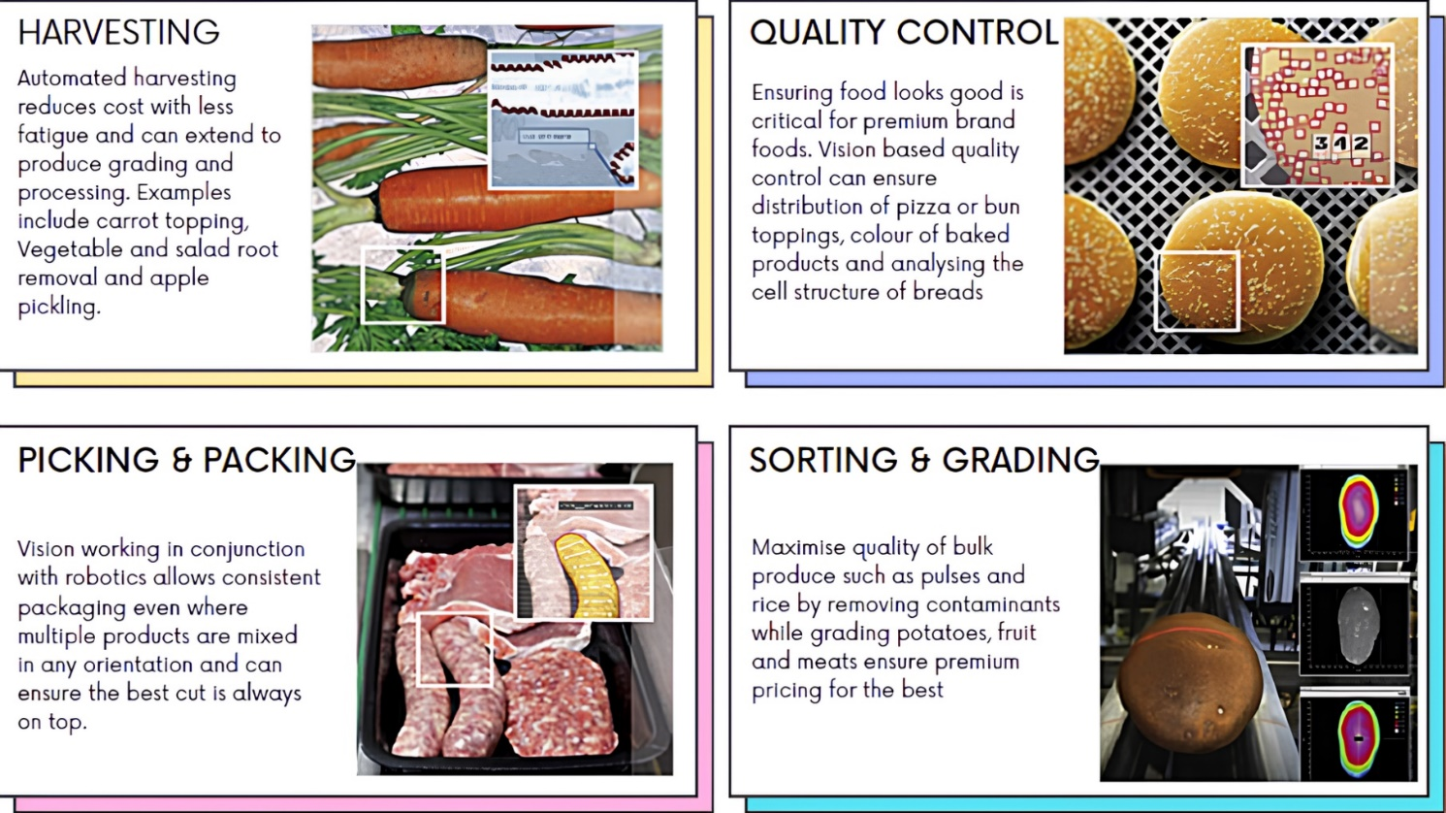
Fig.1 AI driven food industry, Harvesting, Quality Control (QC), Pickling and Sorting using AI algorithm [25]

- AREAS OF AI IN FOOD INDUSTRY

- Precision Agriculture and Smart Farming
AI-driven technologies will play a crucial role in transforming traditional agriculture into precision agriculture and smart farming systems. Drones and autonomous robots equipped with AI algorithms will be deployed to monitor and manage crops efficiently. These devices will gather data on soil conditions, plant health, and weather patterns, allowing farmers to make data-driven decisions for irrigation, fertilization, and pest control. The result will be increased crop yields, reduced resource consumption, and minimized environmental impact.

- Personalized Nutrition and Health Monitoring
AI will revolutionize the way we approach nutrition and health. Personalized nutrition will become a reality through AI-powered applications that analyse an individual's genetic data, lifestyle, and dietary preferences to recommend optimal meal plans. Moreover, wearable devices and smartphone apps will use AI to track and interpret health metrics, providing real-time insights into a person's nutritional needs and health status. This personalized approach will not only prevent diet-related diseases but also improve overall well-being.

- Food Quality and Safety Assurance
AI will enhance food quality and safety assurance by revolutionizing the way we detect and prevent contamination and spoilage. Intelligent sensors and AI algorithms will be deployed across the food supply chain to monitor factors like temperature, humidity, and chemical composition, enabling real-time tracking and early detection of potential hazards. This proactive approach will minimize foodborne illnesses and food waste, ensuring a safer and more sustainable food system.

- Culinary Creativity and Recipe Generation
AI will empower chefs and home cooks with creative culinary solutions. AI-driven recipe generation systems will analyse vast databases of ingredients, Flavors, and cooking techniques to propose innovative and delectable recipes. Moreover, AI-powered robotic kitchen assistants will become more prevalent, helping to prepare complex dishes, and reducing the workload in professional kitchens.

- Sustainable Food Production
AI will be instrumental in promoting sustainable food production practices. By leveraging machine learning and data analytics, AI can optimize resource utilization, minimize food waste, and reduce the carbon footprint of food production processes. Additionally, AI will drive advancements in alternative protein sources, such as plant-based and lab-grown meat, making them more accessible and palatable to a broader audience.

- Enhanced Food Packaging and Labelling
AI will revolutionize food packaging and labelling to ensure consumer safety and improve transparency. Smart packaging integrated with AI sensors will monitor product freshness and integrity, providing consumers with accurate information about the product's condition. AI-powered apps will also enable real-time scanning of product labels, helping consumers make informed choices based on their dietary preferences and allergens.

- AI-Enabled Food Delivery and Logistics
With the surge in online food delivery, artificial intelligence will have a pivotal role in optimizing delivery routes, forecasting demand patterns, and minimizing delivery durations. Advanced algorithms will guarantee that customers receive food when it's at its freshest and highest quality. Additionally, self-driving delivery vehicles and AI-equipped drones will further enhance the efficiency of logistics, streamlining the entire process and making it more economically viable, among other things.
The future of AI in the realm of food science and technology appears extremely promising, offering potential advantages across various facets of the food industry. From sustainable production methods to personalized nutrition and enhanced food safety systems, AI is set to transform how we manufacture, distribute, and savor our food. Nevertheless, as these technologies progress, it is crucial to address ethical concerns, safeguard data privacy, and ensure accessibility to ensure that the benefits of AI in the food sector are widely accessible and implemented responsibly. By harnessing AI's complete potential, we have the opportunity to construct a more resilient, efficient, and nourishing food ecosystem for future generations [4], [8].

- AI based food processing strategies
The existence of data related to food has sparked interest among researchers in the field of artificial intelligence, leading them to delve into the domain of culinary exploration. By 2015, computers had achieved a level of intelligence that allowed them to recognize food items depicted in images. In the early months of 2016, the Massachusetts Institute of Technology (MIT) engineered an AI system with the capacity to anticipate the constituents and nutritional composition of visually presented food. This innovation swiftly transitioned to the public domain, accessible as a mobile application within a matter of months. These strides in AI have yielded significant advantages for the food industry, facilitating efficient product promotion based on global culinary trends and strategic decision-making. Moreover, food processing has become more versatile, with machines demonstrating the ability to differentiate not only between basic tasks like distinguishing apples from oranges but also tackling more intricate challenges such as discerning between low-saturated fats and high unsaturated fats. Figure 1 showcases the food monitoring methodologies employed for diverse applications at "Stemmer Imaging".

- AI DRIVEN AGRICULTURE

Developed nations swiftly embrace novel advancements in technology, discarding outdated machinery in favor of more effective solutions. An intriguing advancement in agriculture involves the merger of computer vision and robotics, which has completely transformed the methods employed for land surveys and data inspections. A recent remarkable achievement in this field involves the utilization of drones and unmanned aerial systems equipped with multi-spectral sensors. This technological integration empowers farmers to oversee their crops meticulously, aiding them in making well-informed decisions related to irrigation and soil fertility.
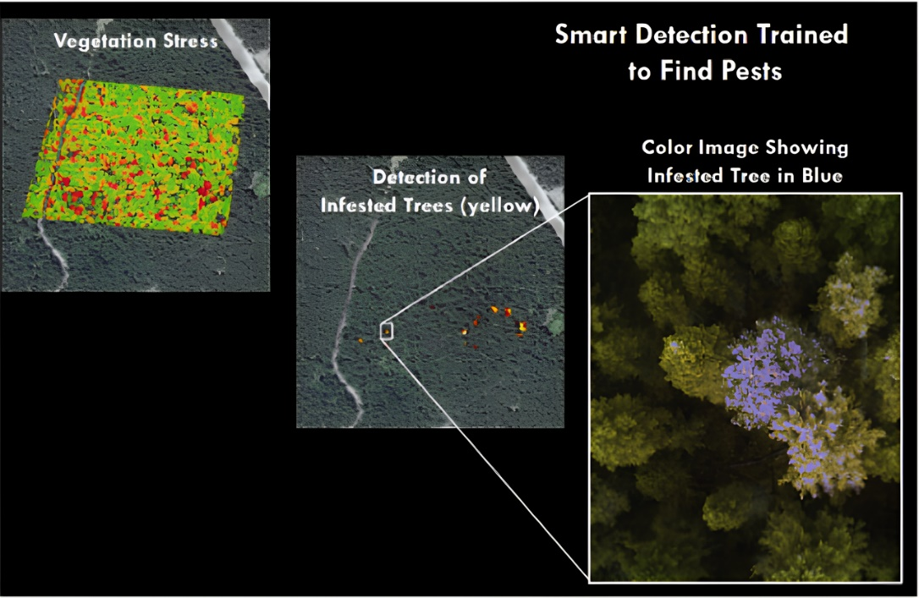
Soil, an intricate ecosystem teeming with countless cells, bacteria, and fungi, requires a conducive environment to foster plant growth. Cultivating fertile soil involves promoting beneficial microorganisms while simultaneously managing detrimental nematodes and pests. Conventional techniques for diagnosing soil pathogens are limited; however, Trace Genomics has introduced a more holistic approach that addresses multiple pathogens concurrently. By scrutinizing the soil's microbiome, Trace Genomics compiles critical data as its primary input. The genetic profiles of the soil are harnessed to anticipate diverse factors, encompassing sustainable yield, crop caliber, and susceptibility to diseases. Given the intricate interplay of variables such as environmental circumstances, nutrient compositions, and fertilization methods, this issue exhibits inherent nonlinearity. Machine Learning plays a pivotal role for enterprises like Trace Genomics in processing extensive data samples and constructing empirical models capable of predicting elements that contribute to elevated crop yields [15].
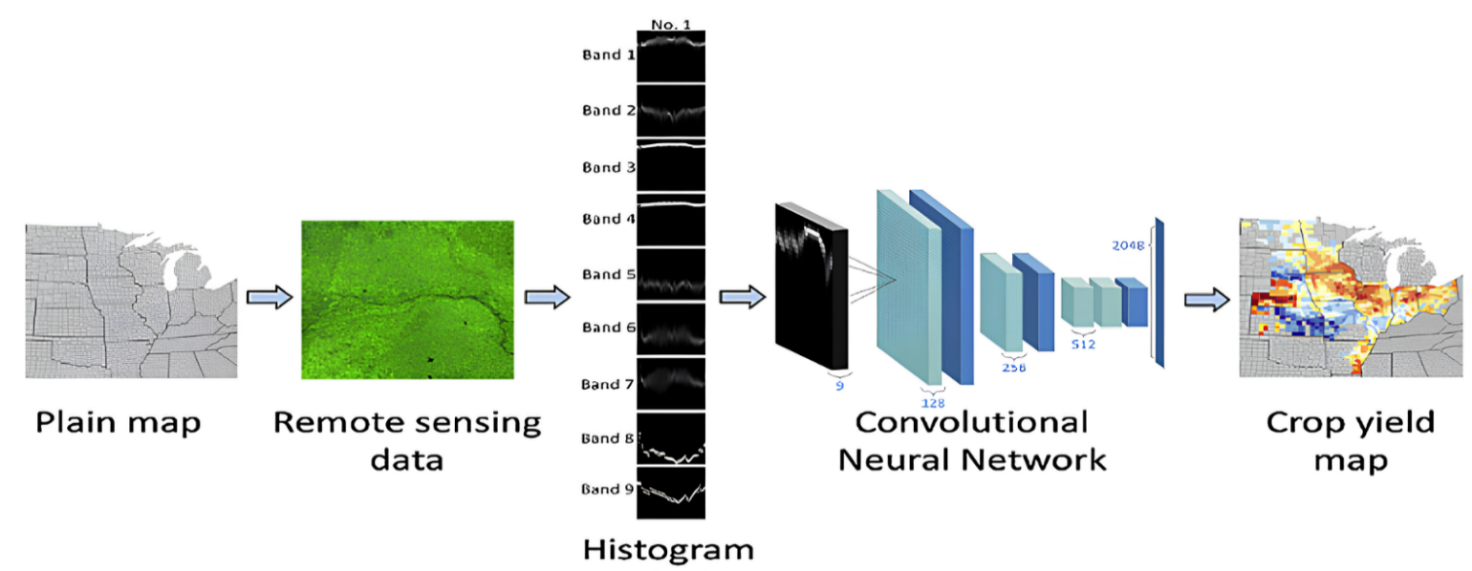
Fig.2.Smart Detection trained to find pests using machine intelligence algorithms by SLANTRANGE [24]
Fig.3. Smart Detection of crop yielding map using machine intelligence algorithms by SLANTRANGE [23]
On a global level, the increasing population has a significant impact on various aspects, including government policies and services. A major concern related to this issue is finding a balance between food demand and supply in developing countries with a growing population. The progress in technology has opened opportunities for improving a country's economic status. Governments and private investors are now focusing on incorporating AI and computer vision technologies in sectors like the food industry and agriculture to address specific problems and enhance productivity.
AgTech startups are actively selecting AI and computer vision solutions tailored to specific tasks to improve agricultural yields and achieve the goal of sustainable food supply by 2050. Companies like Ceres Imaging, SkySquirrel Technologies, and Blue River Technologies are utilizing computer vision technologies, employing drones and robotics for image acquisition and spectral image analysis. Sensor data plays a crucial role in analysing various factors on farms, and startups such as Centaur Analytics, Spensa Technologies, and Sencrop are using different sensor data to detect anomalies in crop yields and irregularities in resource supply. For a comprehensive overview of AgTech startups utilizing AI and computer vision technologies, refer to Table 1.

Table.1 AgTech startups using AI: Robotics, Sensors, precision agriculture, smart irrigation, Next generation farms.
Serial Number | Technology | Entity | Details | Use-Case | Investors | References
1 | Robotics, Drones | Ceres Imaging | Founded in 2014, Oakland, California, USA | Identify nutrient deficiencies, establish management zones, enable variable rate applications, and water stress imaging | ImagineH20, Lemnos Labs, Silicon Badia | [18]
2 | Sensors | Spensa Technologies | Founded in 2009, Great Lakes, USA | Smart sensors for weed detection, prediction of pests | Emerging Innovations | [19]
3 | Precision Agriculture and Predictive Analysis | Agrilyst | Founded in 2015, Brooklyn, New York, USA | Forecasting harvest periods and guided sowing cycles. Using data-driven systems that leads to good yields | Brooklyn Bridge Ventures, Metamorphic Ventures | [20]
4 | Smart Irrigation | AquaSpy | Founded in 1998, Adelaide, South Australia, Australia | Tracking crop behaviour of both water and nutrients through profiling modelled using predicted parameters of soil moisture | Alpina Partners, Centre for Energy and Greenhouse Technologies | [21]
5 | Next Generation Farms | Aero Farms | Founded in 2004, Newark, New Jersey, USA | Growing fresh leafy greens, herbs without sunlight and soil. Providing controlled environment through data driven modelling | 21Ventures, GSR Ventures, Middleland Capital | [22]

- BASICS OF MACHINE LEARNING

If you have ever engaged in a conversation with a data scientist about supervised, unsupervised, or reinforcement learning, you are essentially delving into discussions about the optimal approaches for addressing issues based on the data available to them. This segment will delve into the fundamental distinctions between supervised, unsupervised, and reinforcement learning within the domain of machine learning (ML), which itself falls under the umbrella of Artificial Intelligence. Prior to exploring the various types of ML, let us first clarify the concept of learning. At its core, ML revolves around crafting programs through the use of examples – specifically, data. While traditional programs rely on established rules and human intuition, data scientists generate fresh insights by implementing machine learning algorithms on short-term observed data.

- Supervised Learning
Supervised Learning is a data science approach that constructs a predictive model using labelled data. In simpler terms, labelled data includes various characteristics (features) of the data along with a specific outcome we aim to predict. To illustrate, if we want an AI model to distinguish between apples and bananas, the label would be either "apple" or "banana," while the features could encompass measurements like weight, length, and width of the fruits.
Now, let us delve into a more pertinent business example: customer attrition. To comprehend customer churn, you must first identify potential signs that a customer might leave. For this type of model, your dataset would contain indicators such as days since last purchase and average purchase amount, along with the labelled target variable indicating if the individual is still a customer. Given the historical data on customer status, constructing a model using this dataset aligns well with the concept of supervised learning.
Indicators of discussing supervised learning techniques might include terms such as:
  - Linear regression
  - Logistic regression
  - Support vector machines (SVM)
  - Decision trees
  - Random forest
Key Aspects of Supervised Learning: In supervised learning, the underlying assumption is that forthcoming data will resemble past data. Algorithms "learn" from a provided dataset, meaning they create a model based on historical patterns and labels. However, sometimes these models may not perform optimally when faced with new data. This phenomenon, known as "overfitting," indicates that the model is overly tailored to historical data. In simpler words, an overfit model lacks the ability to generalize.
When a model's performance declines, data experts must strike a balance between model accuracy and adaptability as the foundational dataset evolves. The process of retraining and adjusting the model to accommodate these changes typically unfolds gradually during the model's utilization. This constitutes a recurring stage in the data science lifecycle and underscores the importance of consistent model monitoring to ensure continued relevance [14].

- Unsupervised Learning
Unsupervised Learning involves a methodology aimed at discovering patterns and connections within data that lacks labels. This approach is commonly utilized to establish groupings and clusters.
To illustrate, consider the scenario of an email marketing campaign. Suppose you possess a dataset containing information about recipients, including their past purchasing behaviours, most recent website visits, and average expenditure on transactions. Since there are no predefined categories for grouping specific customers, you can utilize unsupervised learning to potentially create your own categories. By employing unsupervised learning, you can analyse this behavioural data and arrange your customers into distinct clusters. The remarkable advantage of this machine learning technique is that you do not need to possess prior knowledge of the inherent groupings – the clusters naturally form based on data patterns. Subsequently, these clusters can be associated with business terms. As a result, you can make informed decisions about which subset of customers to target in your email campaign.
Unsupervised learning is frequently employed for exploratory analysis and anomaly detection, aiding in the comprehension of relationships between different segments of data and the identification of potential trends. Such techniques can also serve as preprocessing steps before applying supervised learning algorithms or other artificial intelligence methodologies. Notable examples of unsupervised learning techniques encompass:
- K-Means Clustering
- Principal Component Analysis (PCA)
- Autoencoding
Often, unlabelled data is subjected to unsupervised learning methods due to the absence of desired output during application. Evaluating the accuracy of an unsupervised model becomes intricate in the absence of corresponding labels that signify the intended outcome. The validation of a model's effectiveness requires either manual examination of the results obtained or the formulation of precise rules. These challenges can sometimes be alleviated by combining unsupervised learning algorithms with other techniques, a process occasionally referred to as "stacking" [14].

- Reinforcement Learning
Reinforcement Learning, a methodology centered around a reward-based mechanism, involves training through iterative interactions. It employs a machine or an Agent to engage with an environment, experimenting with diverse approaches to achieve specific outcomes. This Agent receives rewards or penalties upon attaining favourable or unfavourable states, consequently discerning the paths leading to positive results and those resulting in negative consequences. Progress is gauged by a score (referred to as Q-Value, giving rise to the alternate term Q-learning), enabling the Agent to progressively enhance its performance. The concept finds application in scenarios such as guiding a car along a curving road. In this case, the Agent monitors its present status by measuring variables like speed, alignment with the road, and proximity to road edges. The Agent can execute actions that alter its state, like steering, accelerating, or braking. Rewards are bestowed upon desired behaviours such as staying centered on the road and successfully completing the route, while penalties are incurred for collisions or sluggish movement.
A proficient execution of Reinforcement Learning harmonizes immediate and future rewards, facilitating optimization. For instance, the car must learn to avoid crashes while advancing toward the destination. Unlike supervised learning, which necessitates labelled data, and unsupervised learning, which employs unlabelled datasets, reinforcement learning operates without these prerequisites. It continually refines its performance by adapting from past experiences and crafting new ones. In essence, it generates fresh datasets and outcomes with each attempt.
Reinforcement Learning finds application across domains such as:
- Robotics
- Self-driving systems
- Gaming
These algorithms are often leveraged to tackle intricate challenges. Although they excel in gaming scenarios, their collaboration in team-based activities remains a developing area. Additionally, reinforcement algorithms are under assessment in recommendation engines, alongside supervised and unsupervised methods, to ascertain their optimal use in specific contexts [14].
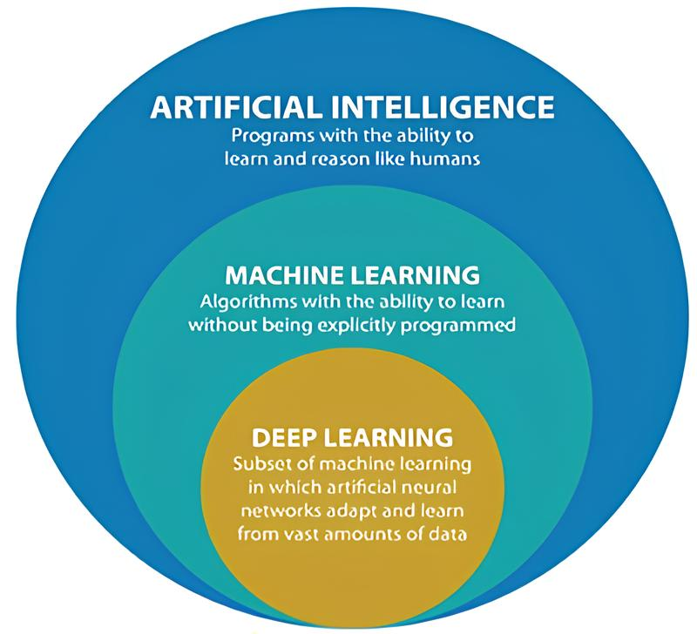
- SUB-TYPES OF AI
Fig. 4 AI & its Sub Types [26]

- Machine Learning (ML)
Machine Learning (ML) is known to be the subset of AI. It is a computer algorithm that advances automatically with experiences. ML can be classified into three broad categories which are supervised learning, unsupervised learning, and reinforcement learning. Supervised learning aims to predict the desired target or output by applying the given set of inputs. On the other hand, unsupervised learning does not have any outputs to be predicted and this method is utilized to classify the given data and determine the naturally occurring patterns. Reinforcement learning is when there is an interaction between the program and the environment in reaching certain goals. Among the known models in machine learning are, decision trees (DT), Random Forest (RF), Support Vector Machines (SVM), regression analysis, Bayesian networks, genetic algorithm, kernel machines, and federated learning. ML has been commonly used for handling complex tasks and huge amount of data as well as variety of variables where no pre-formula or existing formula is available for the problem. Other than that, ML models have the additional ability to learn from examples instead of being programmed with rules [1], [2], [4], [17].

- Random Forest (RF)
The Random Forest (RF) technique is a supervised approach extensively employed for classification and regression tasks. It operates on an ensemble learning principle, wherein during training, RF amalgamates numerous decision trees. These trees collectively determine the output class by utilizing the class mode from each individual tree. Comprising decision trees, RF boasts simplicity in construction, utilization, and interpretation. While decision trees perform well with their training data, they lack adaptability when applied to classify novel samples. The noteworthy aspect is that random forest harmonizes simplicity with a substantial enhancement in precision. RF offers multiple benefits, with one of its key strengths lying in versatility. It aptly serves both classification and regression objectives, while also enabling a clear assessment of the significance it attributes to input features.
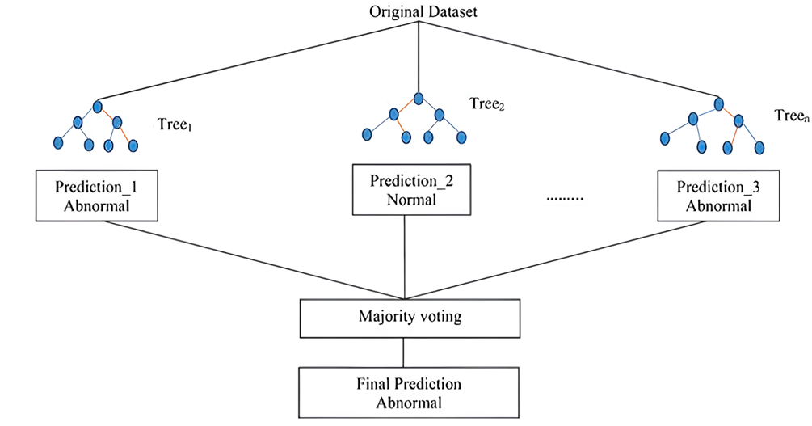
Fig.5 A common RF architecture for prediction [17]

- Deep learning (DL)
Deep learning, a subset of artificial intelligence, has experienced significant advancements in the realm of identifying impurities and flaws in recent times. This particular field focuses on the depth of layers within a neural network. A neural network containing more than three layers, encompassing both inputs and outputs, qualifies as a deep learning algorithm. The inception of convolutional neural networks (CNN) in the latter part of the 1990s marked the initiation of progressive developments in deep learning models. Subsequently, profound efforts have been invested in enhancing deep neural networks through various theoretical and practical enhancements. Presently, CNNs have emerged as the cutting-edge solution for image pattern recognition [1], [2], [4], [17].

- Artificial neural networks (ANNs)
Artificial neural networks (ANNs) are designed to resemble how the human brain functions. They are based on the model of biological neurons. ANN contains an activation function, weights, and threshold which is composed of several interconnected neurons comprised of input, hidden, and output layers. ANNs are well-known for their adaptability, generalization ability, and noise tolerance. Recently, ANNs have been used with fluorescence sensors in the adulteration detection of extra virgin olive oil with hyperspectral images with Raman microscopy and some other agriculture and food quality related applications.

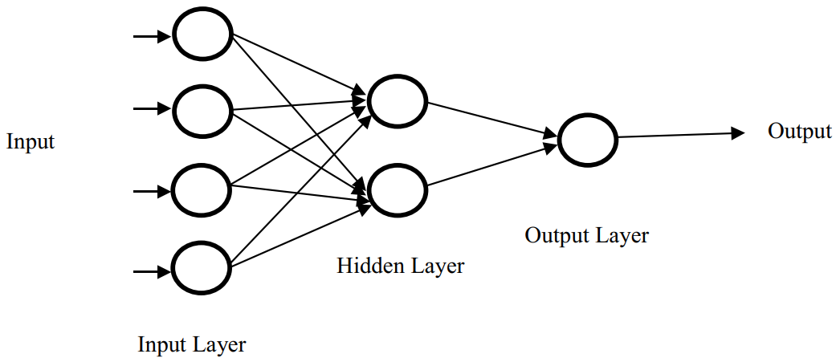

Fig.6 ANN structure in general [17]

- Convolutional Neural Networks (CNN)
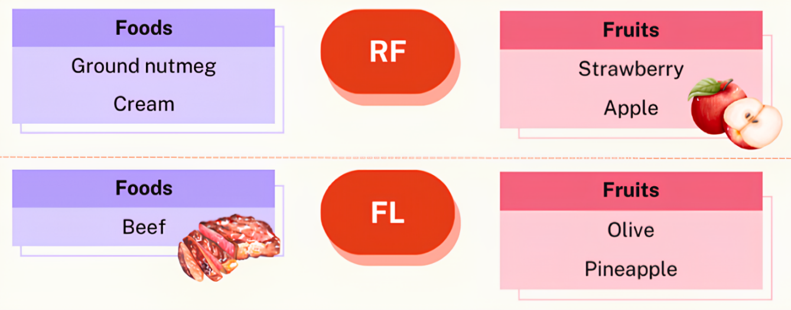
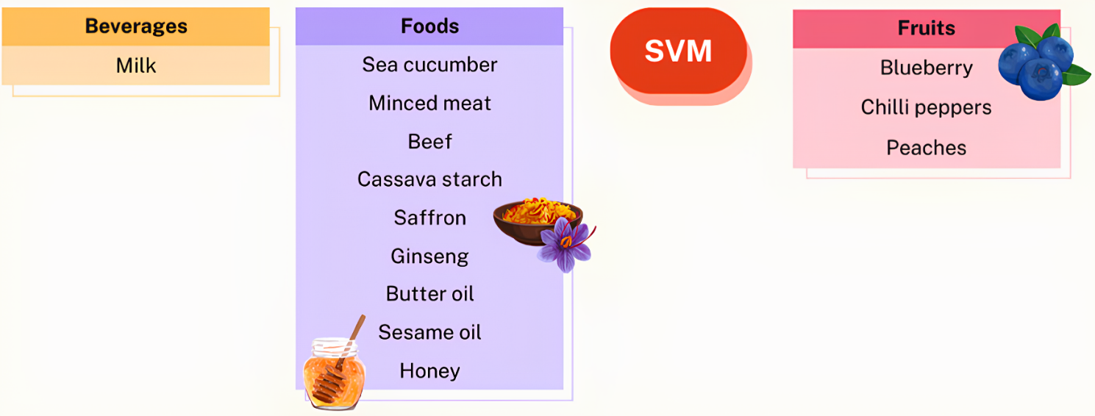
Convolutional Neural Networks CNN has been proven as one of the major methods in learning deep features of input digital information in solving classification and regression related tasks. The picture below Fig. 8 indicates a CNN architecture that includes an input layer, convolution layer, pooling layer, fully connected layer, and output layer. There are various available CNN architectures that are widely used for food and agriculture image classification including VGG, AlexNet, LeNet, ResNet, DenseNet and Inception. CNN has been successfully used for the adulteration detection in food and quality evaluation of agricultural products.
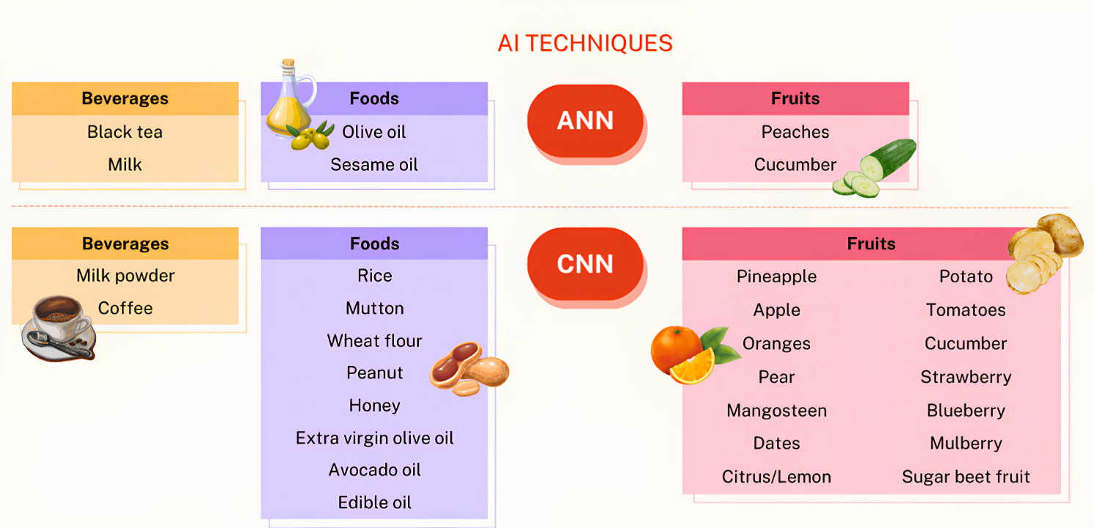
Fig.7 Overview of AI techniques used in food and beverages adulteration and fruit defect detection [16]

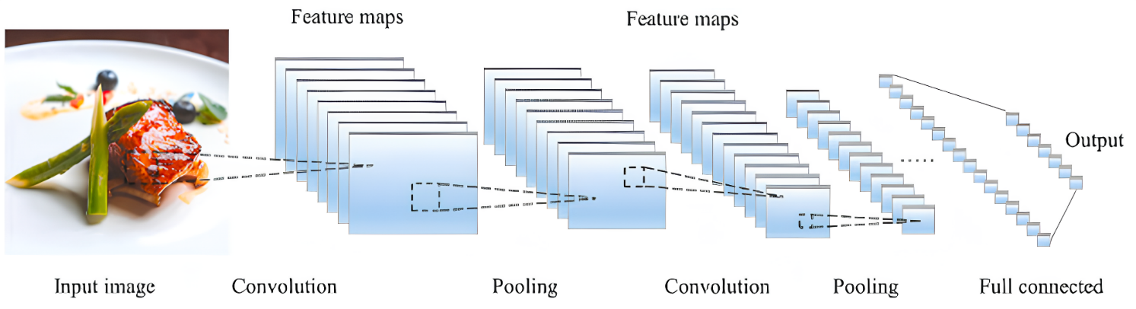
Fig.8 A common CNN architecture for food detection and analysis, consisting of convolutional layers, a pooling layer, and a fully connected layer [25]

- Fuzzy Logic (FL)
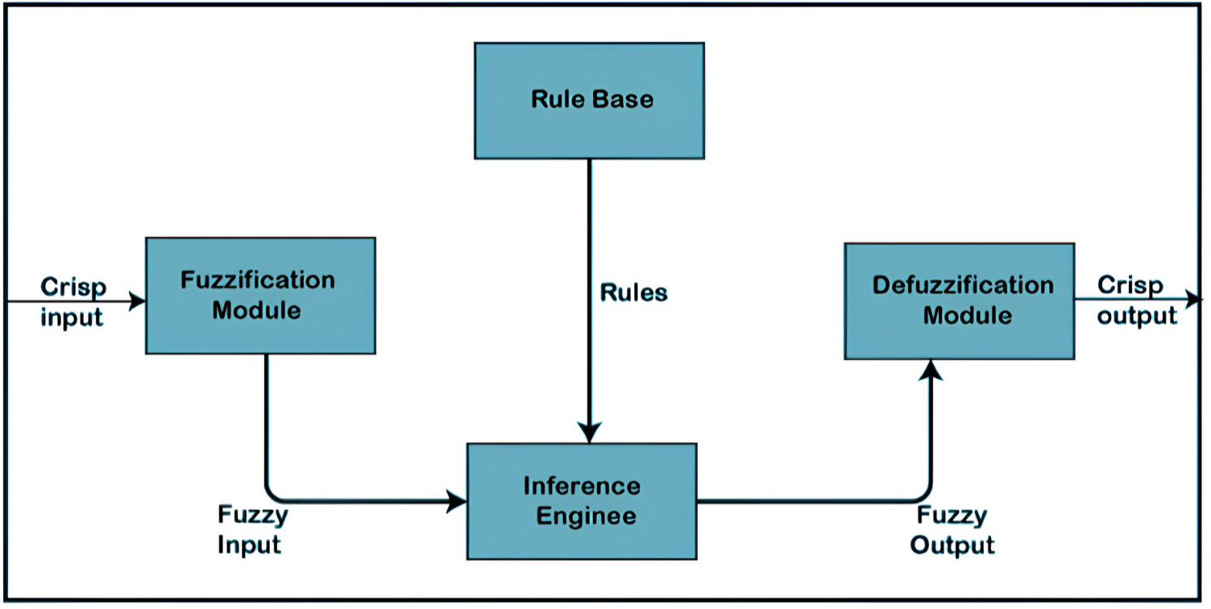
Fuzzy Logic (FL) models how humans make complex decisions when presented with ambiguous and uncertain information. It has been shown to be an effective tool for resolving classification problems involving incomplete and/or ambiguous information. However, fuzzy requires tuning for better performance which may cause problems when dealing with large amounts of data or high dimensional data. Fuzzy systems allow for the use of more straightforward algorithmic formulations and linguistic variables. A typical FL architecture is based on four main parts which are rule base, fuzzification inference engine, and defuzzification shown in Fig. 9. Some applications of fuzzy logic in food quality included pineapple quality classification, prediction of poultry egg production, sunflower oil frying rate determination, wine quality classification, extraction ranking of Flixweed (Descurainia sophia) seeds quality and external defects detection of olive.
Fig.9 A typical FL architecture is based on four main parts which are rule base, fuzzification interference engine and defuzzification [17]

- Knowledge based Expert System (ES)
The knowledge-based system is a computer program that utilizes knowledge from different sources, information, and data to solve complicated problems. It can be classified into three categories which are expert systems, knowledge-based artificial intelligence, and knowledge-based engineering. The breakdown of the knowledge-based system is presented in Fig. 10. The knowledge-based expert system which is widely used in the industries is a decisive and collective computer system that can imitate the decision-making ability of human expert. It is a type of knowledge-based system that is known as among the first successful AI models. This system depends on experts for solving the complicated issues in a particular domain. It has two sub-systems, which are knowledge base and inference engine. The facts about the world are stored in the knowledge base, and the inference engine represents the rules and conditions regarding the world which are usually expressed in terms of the IF–THEN rules. Normally, it can resolve complicated issues by the aid of a human expert. This system is based on the knowledge from the experts. The main components of the expert system (ES) are human expert, knowledge engineer, knowledge base, inference engine, user interface, and the user. The flow of the expert system is shown in Fig. 11 [1], [2], [4], [17].
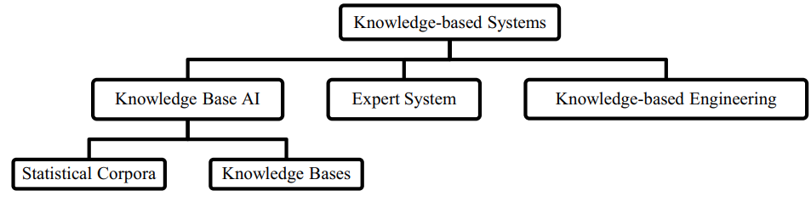
The food industry has been utilizing ES for various objectives as this system is proven to be useful especially in the decision-making process. The knowledge-based expert system has been applied in white winemaking during the fermentation process for the supervision, intelligent control, and data recovery. Apart from that, a web-based application was developed by implementing the ES to calculate the nutritional value of the food for the user.
Fig .10 Knowledge based system [17]
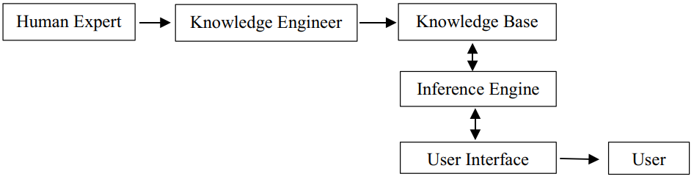

Fig. 11 Expert System [17]

- PRACTICAL USE OF AI BASED TECHNIQUES FOR ADULTERATION AND DEFECT DETECTION ON FOOD AND AGRICULTURE INDUSTRY

Food quality, safety, and authenticity are critical concerns throughout the food industry, not just for consumers and the government sector. Food authenticity has become crucial since associated fraud can potentially have serious public health implications. Global food fraud is estimated to cost around $US49 billion, per year. When food is tainted, the global food supply chain has extensive consequences, as demonstrated by the 2008 Chinese milk scandal and the 2013 horse-meat scandal. These outrages have refocused efforts on improving actions to guarantee the reliability of the food supply, with an increased demand for vigilant, quick, and credible food tracking to secure the food supply chain. Artificial intelligence (AI) can rapidly and accurately analyse large volumes of data of any complexity.
AI has emerged with high-implementation computation and big data technologies to unlock, quantify, and interpret complicated data pat­ terns. They have been employed to tackle complex technical challenges and have gained in popularity over the last few years. AI is increasingly applied in a wide range of food and agricultural systems from production, to disease detection weed detection phenology livestock production integrated crop-livestock system, aquaculture, yield prediction, harvesting processing to packaging and distribution to consumer. There are currently some reviews available on AI applications in the food industry in general and agriculture in general. Whereas others have focused only on certain AI algorithms for example ANN in drying technology and ANN in food process and CNN in agriculture.
AI has been increasingly used to tackle the issue of food adulteration in recent years. Using AI in food adulteration detection involves training algorithms by managing data sets of authentic and counterfeit products to spot detailed compositional differences. These differences are then utilized to create models that, by sensing a food product, can precisely determine whether it has been tampered with or not. This approach shows great potential for non-destructive identifying adulteration that may not be detectable by human inspection or conventional laboratory methods. Moreover, the use of AI in food adulteration detection can be a cost-effective and efficient way to screen large amounts of products for possible adulterants, which is particularly important for food producers and retailers who need to ensure the quality and safety of their products. Furthermore, the ability of AI to learn and adapt from new data can improve its accuracy over time as it processes more examples of authentic and counterfeit products [12], [15].

- ADVANTAGES AND LIMITATIONS OF AI

- Advantages:

- Reduction in Human Error
A major benefit of Artificial Intelligence is its ability to markedly decrease mistakes while enhancing precision and exactness. AI's decisions at each stage are guided by prior data collection and specific algorithms. When correctly programmed, these errors can be eliminated entirely.
Illustration:
An instance showcasing the diminishment of human errors through AI can be seen in the application of robotic surgical systems. These systems execute intricate procedures with accuracy and precision, thereby diminishing the likelihood of human errors and advancing patient safety within the healthcare sector.

- Zero Risks
An additional significant benefit of artificial intelligence involves humans being able to mitigate numerous risks by delegating tasks to AI-driven robots. These tasks encompass activities such as bomb defusal, space travel, and deep-sea exploration. Machines composed of metal materials possess inherent durability, allowing them to thrive in inhospitable conditions and adverse surroundings. Furthermore, they exhibit precision and heightened accountability, enduring prolonged periods of operation without succumbing to fatigue.
Illustratively, a case in point highlighting the eradication of risks can be observed in the implementation of a fully automated production line within a manufacturing facility. In this scenario, robots assume all responsibilities, eradicating the potential for human errors and injuries, especially in hazardous settings.

- 24x7 Availability
Numerous research studies indicate that humans typically maintain peak productivity for only around 3 to 4 hours each day. It's also widely recognized that humans necessitate regular breaks and time off to strike a balance between their professional and personal lives. Conversely, artificial intelligence (AI) possesses the capacity to operate tirelessly without the need for intervals. AI systems exhibit significantly swifter cognitive processing compared to humans, enabling them to multitask proficiently and achieve precise outcomes across various activities concurrently. Moreover, AI algorithms empower these systems to effortlessly handle monotonous and repetitive tasks. An illustrative instance of this phenomenon can be observed in online customer support chatbots, which leverage AI and natural language processing to provide instantaneous assistance to customers anytime and anywhere. These chatbots adeptly address common inquiries, resolve issues, and if necessary, escalate intricate matters to human agents, thereby ensuring continuous and seamless customer service.

- Faster Decision-making
AI offers the advantage of expediting decision-making processes. Through the automation of specific tasks and the provision of immediate insights, AI aids in accelerating and enhancing the decision-making capabilities of entities. This proves especially advantageous in critical situations where swift and precise choices are imperative to avert costly mistakes or preserve lives.
Illustration:
A case in point demonstrating accelerated decision-making is the utilization of AI-driven predictive analytics within the realm of financial trading. In this scenario, algorithms possess the capacity to swiftly analyse extensive datasets in real time, enabling them to arrive at well-informed investment decisions more rapidly than human traders. The outcome is an enhancement in returns on investments and a reduction in associated risks.

- Pattern Identification
AI demonstrates exceptional performance in recognizing patterns, showcasing its prowess in the field. Its capacity to scrutinize extensive datasets and discern patterns, as well as trends, equips AI to facilitate enhanced comprehension of customer actions, market inclinations, and other pivotal elements for enterprises and establishments. This knowledge proves invaluable for making informed choices and enhancing business results.
For instance, AI's role in pattern identification is evident in its application within fraud detection. Through machine learning algorithms, AI discerns patterns and irregularities within transactional data, thereby enhancing security measures and curbing financial losses for both individuals and entities. This exemplifies how AI's pattern recognition capability can elevate safeguards and bolster fiscal integrity.

- Perform Repetitive Jobs
In our daily job responsibilities, we will engage in various routine activities like inspecting documents for errors and sending out expressions of gratitude. These mundane tasks could potentially be streamlined and made more efficient through the implementation of artificial intelligence. By leveraging AI, we can free up individuals from monotonous duties, enabling them to channel their energy into more innovative endeavors. This parallels the utilization of robots in manufacturing assembly lines, where tasks like welding, painting, and packaging are executed precisely and rapidly, resulting in cost savings and enhanced productivity [13].

- Limitations:

- High Initial Costs
Generating a machine capable of emulating human intelligence is a significant accomplishment, demanding substantial time, resources, and financial investment. Additionally, artificial intelligence necessitates up-to-date hardware and software for ongoing enhancements and compliance with current standards, contributing to its considerable expenses.

- No Creativity
One major drawback associated with artificial intelligence is its limitation in thinking innovatively. While AI can accumulate knowledge through pre-existing data and past occurrences, it falls short in displaying creativity. An illustrative case is exemplified by the bot named Quill, which generates earning reports for Forbes. These reports solely rely on information and figures previously input into the bot. Although the bot's ability to autonomously compose articles is noteworthy, it lacks the distinctive human element found in other articles featured in Forbes.

- Unemployment
A particular utilization of artificial intelligence involves robots, which are supplanting jobs and potentially causing a rise in joblessness in certain instances. This has led to assertions that the substitution of humans by chatbots and robots could potentially lead to ongoing unemployment. Take, for example, the widespread use of robots to take over tasks previously handled by human workers in technologically advanced countries like Japan. Nevertheless, this does not apply universally, as it simultaneously opens up new avenues for human employment while also serving to enhance efficiency by substituting certain human roles.

- Make Humans Lazy
AI technology automates the bulk of monotonous and recurring activities. As a result, the need for manual memorization or puzzle-solving diminishes, leading to a decreasing reliance on our cognitive capacities. This overreliance on AI has the potential to create challenges for upcoming generations.

- Emotionless
From a young age, we have been educated those machines, including computers, lack emotions. Human collaboration is integral to success, requiring proficient team administration. Although it is undeniable that robots outperform humans in efficient performance, the irreplaceable aspect of human interactions, fundamental to teamwork, remains evident.

- No Improvement
Creating artificial intelligence is beyond human capabilities as it relies on pre-existing information and knowledge. AI excels at repetitive tasks, but any modifications or enhancements necessitate manual code adjustments. While AI can store vast amounts of data, it lacks the adaptability of human intelligence. Machines are restricted to performing tasks they have been specifically designed or programmed for; any deviation often leads to failures or irrelevant outcomes, potentially causing substantial harm. Consequently, achieving conventional outcomes remains elusive [13]

- GUIDELINES ON CHOOSING THE APPROPRIATE AI METHOD

AI has been used widely in the industry as it offers a lot of advantages compared to the traditional method. All the algorithms are known to be accurate and reliable, but careful selection should be made by considering the advantages and limitations of the algorithms. The different algorithms have their own strengths and weakness, hence choosing them for a particular application in the food industry needs to be looked on a case-to-case basis. The guideline to choose the most appropriate method is given below:
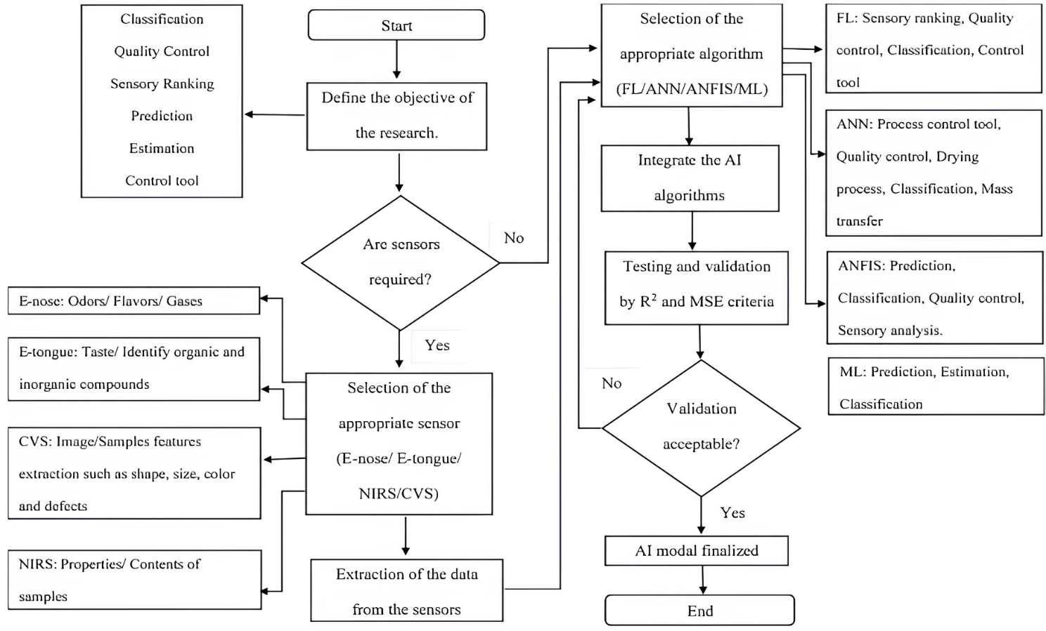
Selecting the appropriate algorithm is important when developing the AI model as it can aid the user to attain an accurate, rapid, and cost-saving results. Therefore, a guide - line given in Fig. 12 is an important asset prior to achieving best performances in a case study. The primary step in the selection process is that users should define and finalize the objective of using AI in their research or implementation. Prediction, classification, quality control, detection of adulterants, and estimation are among the common objectives of AI applications in the food industries. Next, decision should be made whether sensors such as E-tongue, E-nose, CVS, and NIRS are required to collect the sampling data or not for collecting the data from the samples. Normally, integration with those sensors is conducted to obtain the parameters and characteristics of the samples to be included in the AI algorithms for sample testing purposes. Upon deciding the necessity of the sensors, users should compare and choose the fitting algorithm with respect to their study. Among the most common AI algorithms that have been employed include the FL, ANN, ANFIS, and ML methods. ANFIS has shown to have a higher accuracy, but the complexity of the model makes it less favourable compared to the other algorithms. It is advisable for the users to determine the complexity of the research in selecting the most appropriate algorithm for their studies. Once the selection of the algorithm has been confirmed, the data available are integrated with the AI algorithms [11], [17].
Fig.12 Flowchart for developing AI model [17]
Finally, the testing and validation are done to analyze the performance of the established model. The AI model has been created successfully once the validation is accepted; otherwise, users should return to the previous step and reselect the algorithm. Figure 12 shows the guideline in choosing and development of the AI model in food industry application.

- TRENDS ON THE APPLICATION OF AI IN THE FOOD INDUSTRY IN THE FUTURE

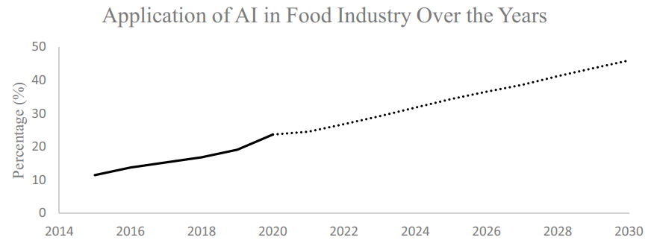
The overall trend on the application of AI in the food industry is shown in Fig. 13. From the studies within the past few years, the usage of the AI methods has been observed to increase from 2015 to 2020 and is predicted to rise for the next 10 years based on the current trends. Among the rising factors for the application of AI in the food industry is the introduction of Industrial Revolution 4.0 (IR 4.0). The merging of technologies or intelligent systems into conventional industry is what is known as IR 4.0 and can also be called smart factory. AI which is categorized under the IR 4.0 technologies focuses on the development of intelligent machines that functions like the humans. IR 4.0 makes a great impact in the product recalls due to the inspections or complains in the food industries. The implementation of the AI integrated in the sensors able to detect the errors during the manufacturing process and rectify the problems efficiently. Apart from that, IR 4.0 also plays a big role in the human behaviour as consumers in the twenty-first century often discover information regarding the foods in the internet. The rising concerns on the food quality allow more usage of AI as they can enhance the quality of the food and aids during the production process. The highest amount of application of AI in the food industry was seen in the year 2020 as more researchers are carrying out studies using the AI method, and it is believed to continue rising for the upcoming years due to increasing in food demand and the concern on the safety of the foods which are being produced [5], [6].
Fig.13 Application of AI in the Food Industry [17]

- CONCLUSION AND FUTURE OUTLOOK

In conclusion, AI has been playing a major role in the food industry for various intents such as for modelling, prediction, control tool, food drying, sensory evaluation, quality control, and solving complex problems in the food processing. Apart from that, AI can enhance the business strategies due to its ability in conducting the sales prediction and allowing the yield increment. AI is recognized widely due to its simplicity, accuracy, and cost-saving method in the food industry. The applications of AI, its advantages, and limitations as well as the integration of the algorithms with different sensors in the food industry are critically summarized. Moreover, a guideline has been proposed as a step-by-step procedure in developing the appropriate algorithm prior to using the AI model in the food industry–related field, all of which will aid and encourage researchers and industrial players to venture into the current technology that has been proven to provide better outcome.

REFERENCES

- Borana J, Jodhpur NU (2016) Applications of artifcial intelligence & associated technologies. Proceeding of International Conference on Emerging Technologies in Engineering, Biomedical, Management and Science [ETEBMS-2016], March,
- Iqbal J, Khan ZH, Khalid A (2017) Prospects of robotics in food industry. Food Science and Technology 37(2):
- Ramakrishna RR, Hamid ZA, Zaki WMDW, Huddin AB, Mathialagan R (2020) Stem cell imaging through convolutional neural networks: current issues and future directions in artifcial intelligence e technology PeerJ 8
- Corney D (2002) Food bytes: intelligent systems in the food industry. British Food Journal 104(10):
- Stăncioiu A (2017) The Fourth Industrial Revolution “Industry 4.0.” Fiabilitate Şi Durabilitate 1, 74–78.pdf/2017-01/11_Alin STĂNCIOIU - THE FOURTH INDUSTRIAL REVOLUTION INDUSTRY 4.0”.pdf
- Bai C, Dallasega P, Orzes G, & Sarkis J (2020) Industry 4.0 technologies assessment: a sustainability perspective. Int J Prod Econ 229, 107776.
- P. Bairoch, M. Grindrod, Agriculture and the Industrial Revolution, 1969 (Collins).
- N.P. Mahalik, A.N. Nambiar, Trends in food packaging and manufacturing systems and technology, Trends Food SciTechnol. 21 (2010)
- N. Perrot, I.C. Trelea, C. Baudrit, G. Trystram, P. Bourgine, Modelling and analysis of complex food systems: state of the art and new trends, Trends Food Sci. Technol. 22 (2011).
- Senauer, E. Asp, J. Kinsey, et al., Food Trends and the Changing Consumer, Eagan Press, 1991.
- N.R. Mavani, J.M. Ali, S. Othman, M.A. Hussain, H. Hashim, N.A. Rahman, Application of artificial intelligence in food industry—a guideline, Springer, Food Eng. Rev. 14 (1) (2022)
- P. Li, S. Tang, S. Chen, X. Tian, N. Zhong, Hyperspectral imaging combined with convolutional neural network for accurately detecting adulteration in Atlantic salmon, Food Control 147 (May 2023), 109573,
- Nikita Duggal, Advantages and Disadvantages of Artificial Intelligence [2023 Edition]
- Christina Bernard, Supervised vs. Unsupervised vs. Reinforcement Learning: What’s the Difference? December 21, 2021
- Journal of Agriculture and Food Research Volume 2, December 2020, 100033
- S. Othman et al. Journal of Agriculture and Food Research 12 (2023) 100590
- Application of Artificial Intelligence in Food Industry—a Guideline. Food Engineering Reviews (2022) 14:134–175
- P. Shah, Image Processing Aerial Thermal Images to Determine Water Stress on Crops (2014)
- S. Caplan, B. Tilt, G. Hoheisel, T.A. Baugher, Specialty crop growers' perspectives on adopting new technologies HortTechnology, 24 (2014), pp. 81-87
- N.N. Prescott, Agroterrorism, resilience, and indoor farming Anim. Law, 23 (2016), p. 103
- D.H. Sloane, Aquaspy-a revolutionary new soil moisture sensor Proceedings of the Beltwide Cotton Conferences, National Cotton Council of America, Memphis, TN (2007)
- K. Januszkiewicz, M. Jarmusz, Envisioning urban farming for food security during the climate change era. vertical farm within highly urbanized areas IOP Conference Series: Materials Science and Engineering, IOP Publishing. (2017), Article 052094
- J. You, X. Li, M. Low, D. Lobell, S. Ermon, Crop yield analysis
- M. Barre, Slantrange & dronedeploy part i: flight planning
- Stemmer, Vision technology for the food and beverage industry
- Natalie Yelton, Dallin Porter. What is artificial intelligence (AI?)

