DESIGNING SMART CAR USING IOT TO PREVENT THE AUTOMATIC LOCKING OF DOOR FOR THE SAFETY OF CHILDREN

Dr. Madhura K^{1*} Dr. Manjula H M²
Assistant Professor-Senior Scale Assistant Professor
School of CSE & IS School of CSE & IS
Presidency University, Bangalore Presidency University, Bangalore
madhura@presidencyuniversity.in manjulahm@presidencyuniversity.in

ABSTRACT
The expanding way of life of substantial responsibility and quick existence of people has made them to fail to remember some fundamental things in their day to day existence or here and there flighty, either purposely or accidentally. The occupied and quick life has made them to forget even their own children and older guardians who will need support on some crisis circumstances. One such circumstance of ongoing years is getting caught inside the programmed locking framework vehicles lastly it prompts demise because of suffocation from absence of oxygen and abundance heat called as death because of hotness stroke. They would attempt to call for help however at times it will be undetected and even they would go after opening the vehicle entryway, yet because of absence of information how to open it they will be caught inside. This undertaking is with respect to the security of youngsters' or older individual who gets secured a programmed vehicles and the wards are unconscious of it.
The proposed structure utilizes IOT smart devices with the relationship of gadgets like gesture measuring device, oxygen device and Raspberry Pi. The gadget improvement instrument which is utilized to see headway inside the vehicle and an oxygen device to gauge the oxygen level. These two device contraptions related with one another so oxygen device will be connected with advancement device and thus it is connected with Raspberry Pi. The oxygen devices will have a relationship with vehicle's modified focal locking framework also so when vehicle gets locked it begins evaluating the oxygen level. In the Raspberry Pi memory some crisis number will be selected. After the vehicle gets locked the oxygen device checks the degree of oxygen for at standard stretches. Right when the oxygen level decreases under the 80%, the oxygen device gives message to improvement device. Right when any improvement is recognized by the advancement device, it organizations Raspberry Pi and the security ready device. The Raspberry Pi gives a caution call to one of the crisis number and meanwhile vehicle utters an alarm sound.
KEYWORDS: IOT, Sensor, Raspberry Pi, Heat Stroke.

- INTRODUCTION

The introduction section of the chapter gives a deep insight into the different existing and underlying technologies used. The chapter is organized in the order of introduction, literature survey, draw backs of existing system, proposed system, components used in the proposed system and at last the block diagram of the proposed idea.
There are some promptly accessible items for this reason like Smart vehicle seats which works dependent on the expansion in the temperature in the seat where the kid will be locked in and Wireless closeness sensors which makes an alert if the distance among youngster and ward builds a specific cutoff. Yet, both are not a good one on the grounds that for keen vehicle seat the newborn child ought to be situated in the seat and for remote vicinity sensors the gadget ought to be attached to baby yet the comparable circumstances might occur for youngsters and older people likewise whom won't remain at one spot inside the vehicle. So a gadget is needed to detect the movement. The circumstance spans to outrageous point in view of absence of oxygen supply, there is need of sensor to gauge the degree of oxygen accessibility.
There are many existing safety products are available such as Smart car seats, Wireless proximity sensors but still somewhere lacking in safety measurement when the kids are locked inside the car during car ignition is off. For this purpose, to enhance the existing smart gadgets, additional sensors are added such as oxygen sensor and motion sensor. Oxygen sensor will be activated when the oxygen level goes down the threshold value. The motion sensor will trigger when car ignition is off. Both motion and oxygen sensors are interconnected so that the entire circuit should work in both the cases; that is car is on or off. By interconnecting the sensors, the proposed work is expected to achieve better result than the existing.
In the existing systems sensors such as heat sensor and CO2 sensors are used. But this will work only when the car is standing under sun. Moreover, the current system doesn’t blow any alarm so that passer by people will be alerted. The proposed system beeps a security alarm so that passer by people will be alerted. Even car’s door lock will be signaled to open by the sensors and kids can be saved by the passer by or the police.

- REVIEW OF LITERATURE
The domestic automatic locking system cars will have the safety measures for accident like seat belt, air bags and if any intruder tries to harm or tries to open the locked car means it makes an alarm so that passerby can identify. The existing safety measure exists only for infants which doesn’t help teenagers or elderly people if they accidently get locked inside automatic locking system car.

2.1. EXISTING SAFETY MEASURES
2.1.1. Smart car seats
An organization called TOMY International created one potential arrangement. In 2013, it started selling a "keen vehicle seat" with iAlert innovation that imparts between one of TOMY's First Years Brand vehicle seats and your cell phone. The vehicle seat, accessible through Amazon for $284, has temperature, point, and movement sensors. In the event that the seat gets too hot, the organization says it will send a caution to your telephone. The framework additionally cautions you if the seat is introduced inappropriately or on the other hand if the youngster has unfastened themselves while the vehicle is moving.
Amazon clients gave it blended audits. However, the seat's solaces and non-electronic provisions appeared all good, a couple of analysts tracked down that the ready framework was untrustworthy. For instance, client "Jackie D" said on July 24, 2013: "When the unit was associated, the cautions would come through 9 out of multiple times yet the issue is that they should come through 10 out of multiple times. When setting up optional contacts to get message notifications, the ready disappointment rate was considerably higher, possibly 2 out of 10 went through and when these went through they actually required something like 10 minutes to get. "Client "CRP Ag" remarked on October 17, 2013: "Regardless of my reservations, if you view the cautions as one more apparatus in your toolbox as a parent attempting to guard your youngster, this is a great development. When the crimps are worked out, this will be an extraordinary gadget."
TOMY reacted on the Amazon client audit site to Jackie D's remark, promising to work with her to resolve the issues she raised. CBS News reached the organization's advertising firm however couldn't get an assertion at press time.

2.1.2. Wireless proximity sensors
One more kind of innovation that could help in these circumstances is a vicinity sensor. Nearness two or three two gadgets: one section is actuated when the youngster is in their vehicle seat and the other is with the guardian. An alert sound when the two gadgets become isolated.
Child Alert's Child Minder Soft Clip System Digital Wireless Technology Monitor replaces the plastic chest cut on the child's vehicle seat security outfit. You convey the other part with you as a key coxcomb. When the child's chest gadget is cut together, it interfaces carefully to the overseer's gadget. If the two gadgets are isolated by in excess of 15 feet for over 6 minutes, an alert goes off. It sells for $79.99 on Amazon.
Child Alert additionally sells one more form of the framework, The ChildMinder Infant-Toddler ElitePad System, where the youngster's essence is recognized by a strain cushion put under the vehicle seat pad rather than through the bridle cut. The issue with this kind of framework, as indicated by security master Arbogast, is that most passings happen when there is an adjustment of schedule. For instance, the individual who as a rule drops the youngster off to childcare doesn't do it that day. "In case you are depending on a key coxcomb, you wanted to make sure to move the vital dandy to another person. It is not difficult to break the chain".

2.2 PROBLEMS WITH THE EXISTING DEVICES:
By and large, 37 youngsters bite the dust from heat-related passing’s in the wake of being caught inside vehicles. Indeed, even awesome of guardians or parental figures can accidentally leave a resting child in a vehicle; and the final product can be injury or even demise.
As demonstrated by the security affiliation Kids and Cars, an ordinary of 37 children fail miserably consistently in hot vehicles. These fuse models where an adolescent has been forgotten in a vehicle, unintentionally gets themselves a vehicle or trunk, or, in couple of cases, when a child has been purposely left in a vehicle.
NoHeatStroke.org, a data site run by a meteorology and case ace, has been gathering data on these scenes beginning around 1998. Since that time, the greatest number of spending's every year was in 2010, with 49 passing's. 2015 had minimal speed of events, with 24.

Figure 1: Rate of death of children from 1998 to 2017
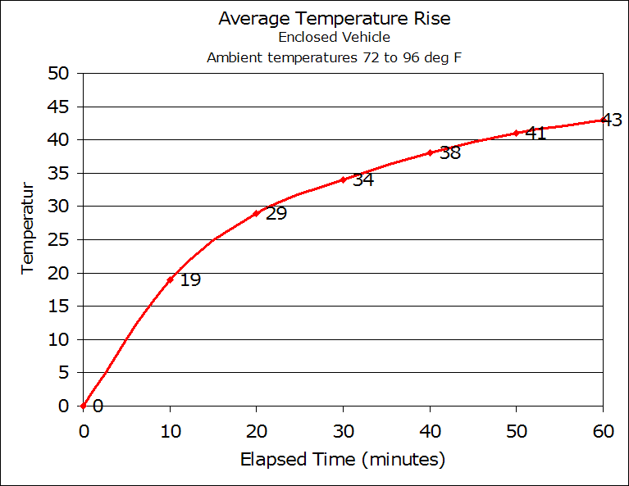
Figure 2: The graph below shows temperature rise which will cause a heat stroke

III. PROPOSED SYSTEM

The proposition framework incorporates an organization of IOT gadgets like:
• A Motion sensor used to detect any development inside the vehicle,
• An Oxygen sensor to quantify the oxygen level occasionally for like clockwork and
• A Raspberry Pi; in the memory of Raspberry Pi some crisis PDA numbers will be put away.
• The Raspberry Pi will be even associated with vehicle's security caution framework for contact.

3.1. WORKING OF COMPONENTS

• When the vehicle gets locked consequently and the oxygen sensor gets actuated and gauges the oxygen level. If the degree of oxygen is underneath 80% and it conveys a message to movement sensor.
• The movement sensor looks for developments inside the vehicle and if any development is detected by the movement sensor, it conveys a message to Raspberry pi.
• When the Raspberry Pi gets actuated, it gives a call to the put away numbers in its memory and conveys a message to the vehicle's locking framework for contact and simultaneously vehicle makes an alert sound.
• The oxygen sensor will be customized such a way that it should gauge the oxygen level intermittently with a deferral.

The sensors are planned such a way that oxygen sensor will be associated with movement sensor and thusly oxygen sensor will be associated with Raspberry Pi. Raspberry Pi thusly it will be associated with programmed locking arrangement of the vehicle, which is now intended to make the alert sound on touch.

3.2. COMPONENTS OF THE PROPOSED SYSTEM
i) Hardware Components
➢ The different hardware components of the system are listed below:
1) Oxygen sensor
2) Motion sensor
3) Raspberry pi
1) Oxygen sensor
An oxygen sensor (or lambda sensor) is an electronic gadget that actions the extent of oxygen in the gas or fluid being broke down.
All vehicles that were made post 1980 component an oxygen sensor. It is situated inside the emanations control framework. When working, the O2 sensor sends information to the administration PC situated inside the motor. In your vehicle, a working O2 sensor guarantees that your motor is running at top execution. Moreover, this sensor holds your emanations within proper limits and alarms you to when discharges are excessively unreasonable. For states that have vehicle assessment projects to manage outflows, the utilization of the CEL and O2 light will make authorities aware of any inordinate emanations. Thus, if at least one of your oxygen sensors is defective during a discharges review for your vehicle, you will doubtlessly not pass the assessment.
At the point when a gas controlled motor consumes fuel there is oxygen present. Oxygen in a motor is the consequence of various components including the air temperature, height, motor temperature, load on the motor, and barometric strain.
For the proposed framework, the oxygen sensor will be associated with the programmed vehicle locking framework. At the point when vehicle gets locked it begins estimating the oxygen level occasionally with some deferral (say for like clockwork). At the point when it recognizes oxygen level falls underneath 80%, it conveys a message to movement sensor. The most recent variants of vehicles are four oxygen sensors. Assuming the vehicle is worked with proposed model, five oxygen sensors will be available.
➢ Images of oxygen sensor
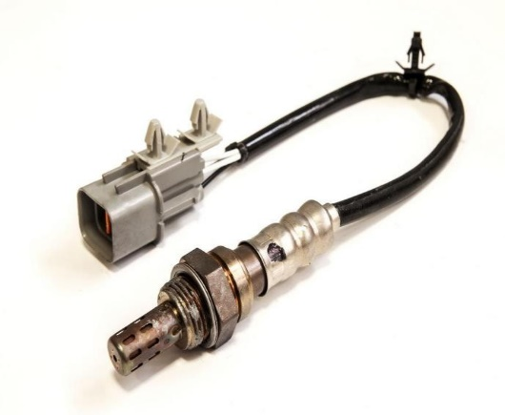
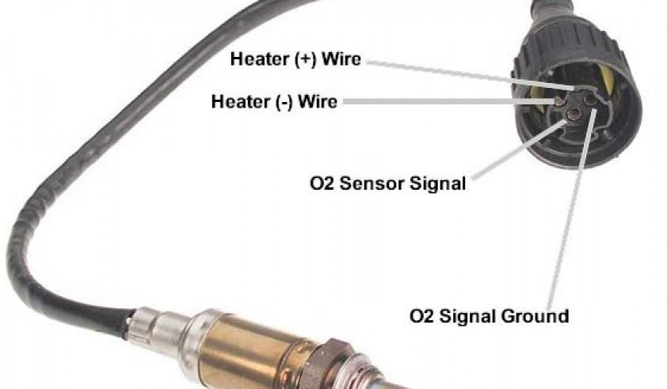

2) Motion sensor
A movement sensor is a gadget that identifies moving articles, especially individuals. Such a gadget is frequently coordinated as a part of a framework that consequently plays out an undertaking or alarms a client of movement in a space.
Movement sensors are usually utilized in security frameworks. They work dependent on a wide assortment of standards and are utilized in a wide assortment of uses. Normal utilization could be in the outside entryways or windows of a structure for observing the region around the structure. After recognizing movement, they produce an electrical sign dependent on which a few moves are made.
In the proposed framework, the movement sensor will be associated with Raspberry Pi which will be thusly associated with programmed locking framework sensor of the vehicle. At the point when the movement sensor gets initiated from the sign sent by oxygen sensor, it looks for development inside vehicle. When it identifies the development, it estimates the hotness produced by the item and conveys message to oxygen sensor, which thusly will gauge the oxygen level. When level of oxygen falls underneath 80% conveys message to Raspberry Pi.

3) Raspberry Pi
The last and the most important device of the entire network is “Raspberry Pi” which is called as “mini- computer”. Image of Raspberry pi is shown below:
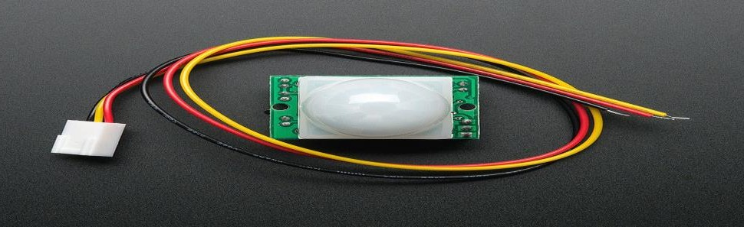

IV. WORKING OF THE SYSTEM
Raspberry Pi acts because the coronary heart of the whole community of gadgets as it elements vital energy required for the sensors used within side the system. For Raspberry Pi there a connection from automobile battery so that once the auto is in ON nation or jogging mode it receives charged. This rate is furnished to the sensors. All the gadgets are stored in among AC wind and steering. When the auto stops, the mechanically it receives locked inside mins. The automated lock button turns on oxygen sensor as a way to degree the oxygen stage periodically with a while put off of five minutes most effective whilst it unearths the auto is locked. When the oxygen stage is under the edge of 80% it sends sign to movement sensor. After the movement sensor turns on it searches for human motion in the variety of 6 meters. If it unearths any motion, sends sign to Raspberry Pi which in flip offers name to the registered numbers and turns on automobile alarm for touch.

The entire circuit diagram to depicted below:
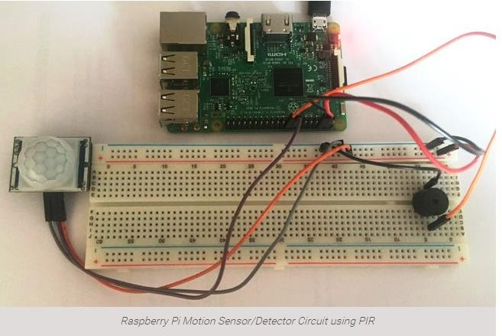

Block Diagram of the above circuit diagram is shown below:
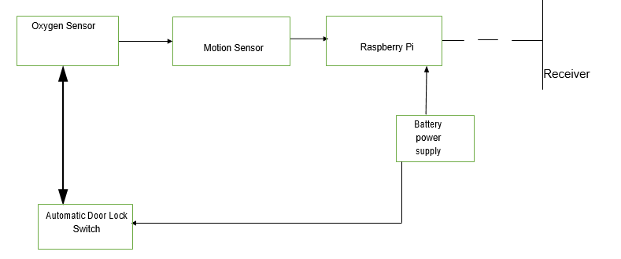

V. CONCLUSION
Yearly, many kids get locked inside the car with or without the knowledge of guardians and lead to losing their life either by due to lack of oxygen or excess heat. Using a smart technology, it is possible
prevent such situation to some extent. By adding a IOT device to the automatic door locking and by identifying motion inside the car along with lack oxygen level, it is possible to alert their guardian or by passers. Thus by saving them. The proposed work contains addition of some sensors to carry out this task and it is cost effective.

VI. REFERENCES
[1] C.P.Shimpi, N.P.Kadam, N.M.Mali, “VEHICLE ACTIVE SAFETY SYSTEM: FOR CHILDREN HYPERTHERMIA IN PARKED VEHICLE”, at International Journal of Advanced Engineering Research and Studies, Sept 2014.
[2] Venkatesh PL, Vivek C, “Safety Locking System of Car Door Using Sensors”, at International Journal of Science and Research (IJSR), Volume 5 Issue 3, March 2016.
[3] Chanda Nikhil Kumar, Madhavi Soni, Dr.R.Dineshkumar, “ANTI-SUFFOCATION IN VEHICLES:ELECTRONIC MESSAGE ALERT”, at Indian J.Sci.Res. 17(2): 325-328,2018.
[4] Mallikappa DN Dodderi1, Rao Sukesh Raghavendra, Narayana Hegde, Navaneeth Rao I,Mohammed Asif, “A Mechatronic System to Prevent Death due to Suffocation in a Locked Car”, at IRA-International Journal of Technology & Engineering (ISSN 2455-4480), 4(3), 126-134.
[5] https://en.wikipedia.org/wiki/Oxygen_sensor
[6] https://www.meineke.com/blog/oxygen-sensor/
[7] https://www.google.co.in/search?q=oxygen+sensors+for+cars&dcr=0&source=lnms&tbm=isch&sa=X&ved=0ahUKEwi0wszszJrZAhWLI5QKHceABpIQ_AUICygC&bi w=1366&bih=662#imgrc=WzewEGgmlXsXeM:
[8] https://www.edgefx.in/types-of-motion-sensors- working-and-applications/
[9] https://learn.adafruit.com/pir-passive-infrared- proximity-motion-sensor?view=all
[10] https://www.kidsandcars.org/how-kids-get-hurt/heat- stroke/
[11] https://edition.cnn.com/2016/08/05/health/hot-car- deaths-charts-trnd/index.html

