Tooth Separation And Matricing: Past, Present And Future
Dr Sunpreet Khurana¹,Dr Ishita kapur¹,Tanya Arora²
1Reader,Department of conservative dentistry and endodontics,Maharishi Markandeshwar College of Dental Sciences & Research, Maharishi Markandeshwar (Deemed to be University)Ambala, Haryana, India
2PG student,Department of conservative dentistry and endodontics,Maharishi Markandeshwar College of Dental Sciences & Research, Maharishi Markandeshwar (Deemed to be University)Ambala, Haryana, India

ABSTRACT
Tooth separation and matricing are essential techniques in modern dentistry, aimed at achieving optimal outcomes in various restorative and cosmetic procedures. Tooth separation involves carefully widening the spaces between teeth to enable the proper placement of matrices during restorative treatments. These matrices act as precise guides, helping dentists create accurate tooth contours and facilitating the precise application of dental materials. Through the combined use of tooth separation and matricing, dental professionals can achieve superior results in restorations, leading to improved aesthetics and functional benefits for patients.
INTRODUCTION
Maintaining the health and functionality of the stomatognathic system necessitates proper tooth contacts and proximal restorations. Food impaction, tooth movement, and periodontal problems can result from the failure to restore proximate areas.
Tooth separation during restorative procedures is necessary to prevent damage. Matrix systems are used to create accurate tooth contour and proper proximal contacts.
While objective evaluation methods exist, dentistry relies on a tripartite approach to restoration, focusing on tooth shape enhancement, minimal interference with dental tissue, and use of tooth-colored materials. Meeting these criteria ensures proper function and protection of the oral complex.
TOOTH SEPARATION
Tooth separation refers to separating the adjacent teeth during different clinical situations using one device or the other. The devices used are known as tooth separators.
INDICATIONS FOR TOOTH SEPARATION
The situations where tooth separation is required are as follows:
- For examination of the proximal surfaces of teeth if caries is questionable, especially in cases where contact areas are very tight and it is not possible to examine otherwise.
- For removal of the foreign bodies (e.g., fruit seeds) that get stuck in between the teeth and are difficult to remove otherwise.
- For insertion of the matrix band, in cases where the contacts are very tight.
- For cavity preparation on the proximal surface of a tooth so that the bur does not accidentally injure the proximal surface of the adjacent healthy tooth.
METHODS OF TOOTH SEPARATION
There are two techniques of achieving tooth separation, namely slow and rapid.
Slow Separation or Delayed Separation
This refers to the slow movement of the teeth to achieve the required separation by placing certain materials in between two adjacent teeth, such as gutta-percha sticks and orthodontic wires.
Rapid Separation or Immediate Separation
This refers to the rapid movement of the teeth to achieve the required separation by placing certain devices in between two adjacent teeth by following either the ‘wedge principle’ or the ‘traction principle’.
- Rapid separation by the wedge principle: Separation is accomplished by insertion of a pointed wedge-shaped device between the teeth in order to create separation at that point or closure on the opposite proximal side of the involved teeth. The more the wedge moves facially or lingually, the greater will be the separation. The following are examples of these types of separators:
- Elliot separator: It is indicated for short duration separation that does not necessitate stabilization. It is useful in examining proximal surfaces or in final polishing of restored contacts.
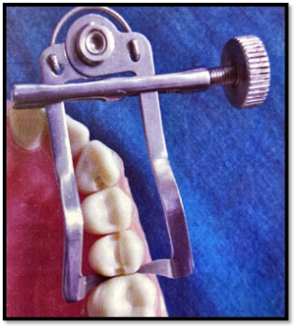
Fig.1
Elliot’s separator
- Wood or plastic wedges: These are triangular shaped wedges, usually made of medicated wood or synthetic resin. In cross-section the base of the triangle will be in contact with the interdental papillae, gingival to the gingival margin of the proximal cavity.
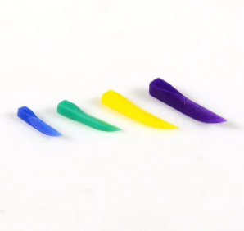
Fig.2 Fig.3
Wooden wedges Plastic wedges
Light-transmitting wedges are special plastic wedges which are transparent and have a light reflecting core. They are used with transparent matrices while placing Class II composite restorations.
With the invention of newer sectional matrices, ‘flexible wedges’ are now available, which can adapt flexibly according to the space available in the interdental region.
There are different wedging techniques:
- Single wedging: The pointed end of a wedge is placed from buccal or lingual embrasure whichever is bigger. The band of the retainer is thus tightly wedged against the tooth.
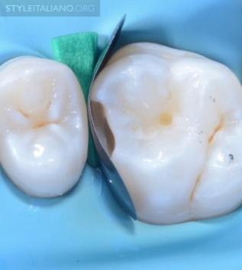
Fig.4
Single wedging technique

- Piggyback wedging: In situations where there is gingival recession and the proximal box is shallow gingivally, a single wedge maybe very much apical to the gingival margin. In such cases, a second usually smaller wedge is “piggy backed” over the first wedge. This will ensure proper contour of the matrix band.
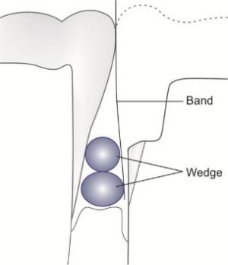
Fig.5
Piggyback wedging
- Double wedging: This refers to the technique of using two wedges, one from the buccal aspect and another from the lingual aspect to provide close adaptation of the matrix band at the cervical aspect of the tooth.
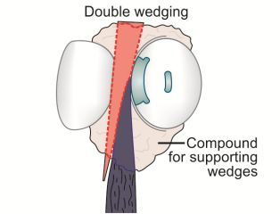
Fig.6
Double wedging technique
- Wedge-wedging: This technique is employed primarily on the mesial aspect of the maxillary first premolars. Since these teeth have fluted areas (concave areas) in the root near the gingival margin, placing a single wedge may still leave an open margin gingivally. Therefore, a second wedge can be inserted between the first wedge and the band so that this opening is eliminated and the matrix band is well adapted to the gingival margin of the prepared cavity.
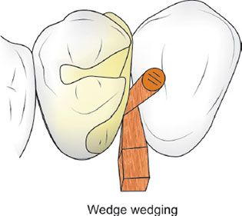
Fig.7
Wedge-wedging technique
- Rapid separation by the traction principle: In this technique, a specially designed instrument is placed on the two teeth to be separated. This instrument engages the proximal surfaces of the two teeth and then moves them apart. Examples of separators which work on traction principle are:
- Non-interfering true separator
- Ferrier double bow separator
- Ivory adjustable separator

MATRICING
A matrix is a device that is applied to a prepared tooth before the insertion of the restorative material to assist in the development of the appropriate axial tooth contours and in order to confine the restorative material excess.
Ideal requirements of a matrix:
- Rigidity
- Establishment of proper anatomic contour
- Restoration of correct proximal contact relation
- Prevention of gingival excess
- Convenient application
- Ease of removal
Matrix System
Band: It is a piece of metal or polymeric material, intended to give support and form to the restoration during its insertion and setting.
Retainer: It holds the band in desired position and shape. The retainer could be a mechanical device, a wire, dental floss or impression compound.
CLASSIFICATION OF MATRICES
- Based on mode of retention
- With retainer e.g., Tofflemire matrix
- Without retainer e.g., Automatrix
- Based on type of band
- Metallic nontransparent matrix
- Nonmetallic transparent matrix
- Based on type of cavity for which it used
- Matrix for class I cavity preparation
- Double banded Tofflemire (Barton matrix)
- Matrix for class II cavity preparation
- Single banded Tofflemire matrix
- Rigid material supported sectional matrix
- Ivory matrix no.1
- Ivory matrix no.8
- Copper band matrix
- Anatomical matrix
- Automatrix
- Matrix for class III cavity preparation
- Mylar strip matrix
- S-shaped matrix
- Matrix for class IV cavity preparation
- Custom lingual matrix
- Mylar strip matrix
- Transparent crown form matrix
- Modified S-shaped band matrix
- Matrix for class V cavity preparation
- Window matrix
- Cervical matrix
DESCRIPTION OF VARIOUS MATRICES
Tofflemire Universal Matrix Band Retainer
A Tofflemire matrix system results in which a temporary wall is constructed on the opposite side of the axial partitions to build up the tooth structure around the missing portions during preparations. It is a metallic circumferential type of matrix that provides a good barrier in class II restorations.
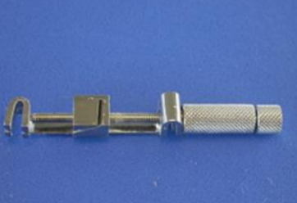
Fig.8
Tofflemire universal matrix system
Auto Matrix
The auto matrix technology enables matrix positioning and maintenance without the usage of bulky retainers, resulting in easier placement, improved access, a clearer perspective on the operative field and increased patient satisfaction.
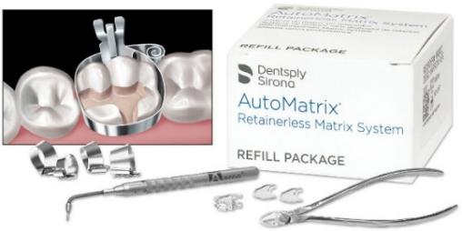
Fig.9
Auto matrix system
Ivory Matrix No.1
Ivory Matrix No.1 retainer is most commonly used for unilateral Class II cavity preparations. It has a claw at one end with two flat semicircle arms having a pointed projection at the end. On the other hand of the retainer there is a screw which when rotated clockwise brings ends of both claws closer to each other.
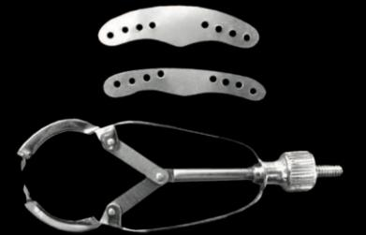
Fig.10
Ivory No.1 matrix retainer and band
Ivory Matrix No.8
Ivory matrix retainer holds the matrix band that encircles the tooth to provide missing walls on both proximal sides. The matrix band is made up of thin sheet of metal so that it can pass through the contact area of the unprepared proximal side of the tooth. Circumference of the band can be adjusted using the screw present in the matrix band retainer.
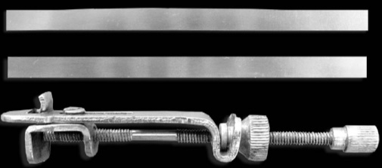
Fig.11
Ivory No.8 matrix retainer and band
Copper Bands
A continuous band is recommended for MOD restorations. It can be retained till the restorations are completed.
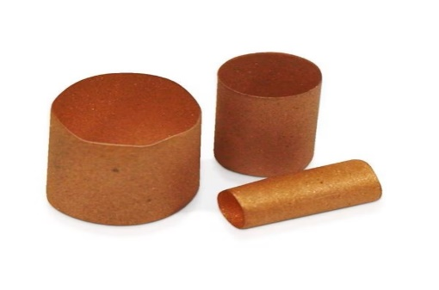
Fig.12
Copper band matrices
RECENT ADVANCEMENTS OF MATRICES
Over the years, the field of dentistry has witnessed significant advancements in matrix system technology, leading to improved techniques for tooth separation and matricing during restorative procedures. These advancements have allowed dentists to establish better proximal contact surfaces and anatomically correct contours, crucial for the optimal form and function of the dentition and the protection of the periodontal complex.
Several innovative sectional matrix systems have emerged, each designed to meet specific clinical needs. Some of these include the ConveXi-T S2 and Palodent Sectional Matrix System, Bioclear Matrix System.
Advancements have not been limited to posterior restorations, as there have also been significant developments in anterior matrix systems for composite restorations. Some of the notable innovations in this area are the Unica Anterior, Unica Minideep, Fusion Anterior Matrix System, and the Blue View VariStrip.
These advancements in matrix technology have led to precise interproximal restorations, ensuring proper marginal adaptation and reducing the risk of poor contours, overhangs, or weak restorative material condensation. The improved contact tightness and better anatomical shaping have resulted in enhanced patient comfort and restoration aesthetics.
CONCLUSION
Tooth separation and matricing have been crucial techniques in restorative dentistry, allowing for proper contours and contacts in composite resin restorations. The introduction of sectional matrix systems in the 1980s revolutionized the process, and modern advancements have further improved efficiency and effectiveness. Future developments, such as personalized 3D-printed matrices and new materials, hold promise for even better outcomes. Overall, tooth separation and matricing continue to play a vital role in dental restorations, ensuring optimal results for patients.
REFERENCES
- Sikri VK. Textbook of Operative Dentistry.4th ed. CBS publishers and distributors; 2017
- Garg N, Garg A. Textbook of Operative Dentistry.3rd ed. New Delhi: Jaypee Brothers Medical Publishers; 2015
- Raghu R, Srinivasan R. Clinical Operative Dentistry: Principles and Practices.2nd ed. Emmess Medical Publishers; 2011
- Bjarnason S. Temporary tooth separation in the treatment of approximal carious lesions. Quintessence International. 1996 Apr 1;27(4).
- Owens BM, Phebus JG. An evidence-based review of dental matrix systems. Gen Dent. 2016 Sep 1;64(5):64-70.
- Ahmad MZ, Gaikwad RN, Arjumand B. Comparison of two different matrix band systems in restoring two surface cavities in posterior teeth done by senior undergraduate students at Qassim University, Saudi Arabia: A randomized controlled clinical trial. Indian Journal of Dental Research. 2018 Jul 1;29(4):459.
- Patekar VR, Mankar N, Burde K, Achanta A. Choice of Matrix System in Dentistry, J Res Med Dent Sci, 2022, 10 (11): 120-126.
- Singh H. Essentials of Preclinical Conservative Dentistry 2/e. Wolters kluwer india Pvt Ltd; 2020 Jun 1.
- Marzouk MA, Simonton AL, Gross RD. Operative dentistry. Modern theory and practice, 1st ed. St Louise-Tokyo, Ishiyahu Euro America Inc. 1985.
- Urkande NK, Mankar N, Nikhade PP, Chandak M, Ikhar A, Patel A. Anterior Matrix Systems for Composite Restorations: A Review. Cureus. 2023 Apr 4;15(4):1-9.

