Significance of Artificial Intelligence in Critical Care Medicine

Author- Dr Abhimanyu Bhatia, MD (Head and Consultant, Department of Critical Care Medicine, Saroj Hospital ,New Delhi)
Dr Pulkit Bansal, MBBS
Dr Aneesha Bhardwaj, MBBS
Dr Chinmaya Manchanda, MBBS

Introduction
Critical care is medical care for people with life threatening injuries who are admitted in intensive care unit. It comprises of life-threatening injuries which range from diseases like sepsis, heart conditions, burns, trauma and various other problems.
Artificial intelligence (AI) is systems or machines that mimic intelligence to perform tasks and can
iteratively improve themselves based on the information they collect¹.
In general, AI is referred to as the “field of science” as well as engineering and deals with the computational understanding of intelligence or intelligent behavior with the formation of artefacts that impart such behaviors. (Alsheibani et.al. 2018); (Guan, 2019).¹

“As AI is an interdisciplinary concept embracing fundamentals and equipment of diversified areas like computation, mathematics, logic, and biology, it is used to deal with issues of understanding imitating intelligence and performing cognitive tasks with minimum human arbitrations” (Guan 2019). AI systems in health care are successful because of the advanced algorithms for learning numerous characteristics from a huge amount of health care data that helps in problem-solving and achieves results at a rate and magnitude futile for humans.¹
There are many potential applications in the intensive care unit (ICU) particularly, given the large amounts of data collected routinely.² With growing science and technology, there has been rapid advancement in timely diagnosis and treatments employed in healthcare. Since AI has evolved, it can transform the face of medicine in a remarkable manner.

Types of A.I.
AI is a combination of various technologies which are integrated together and hence helps? the user to reach a calculated decision.
The various types of technologies available are detailed as follows:
- Machine Learning: neural networks and deep learning
One of the most commonly used types of AI is machine learning which is a statistical method. The most prevalent utilization of conventional machine learning is in precision medicine. It is beneficial for assessing the exact condition of the patient based on the peculiarities and medical background and it estimates the procedure for the treatment of patients.^{1,3,4}

- Natural Language Processing or NLP¹
NLP utilizes unstructured healthcare data which is locked in electronic health record systems. NLP is utilized for converting data into a usable and analyzable form. NLP studies patients’ records and extricates important information such as prescriptions, medication plans and medical issues. AI is employed to develop NLP algorithms for the assimilation and assortment of clinical papers.

- Rule-based expert systems
These are a set of rules which are provided by numerous electronic health records (EHR). The rule-based expert system involves data scientists, and it attempts to reason in a manner similar to human beings.^{1,4,5}

- Artificial Neural Networking
The computation of simulations galvanized by the human brain is known as Artificial Neural Networks (ANN). In ANN, AI developments include voice recognition, images and robotics recognition. The main objectives of ANN are to reflect the activities of human brain nerve cells utilizing neural networks of algorithms and maintaining a correlation between sets of data like the human brain.^{1,5,6}

- Clinical Decision Support System (CDSS)
The main motive of CDSS is to diagnose the disease accurately by making use of previous patient data through application of web applications or integration with electronic health records (EHR) and computerized provider order data (CPOE) systems.^{1,5,7}

Advantages & Disadvantages of AI

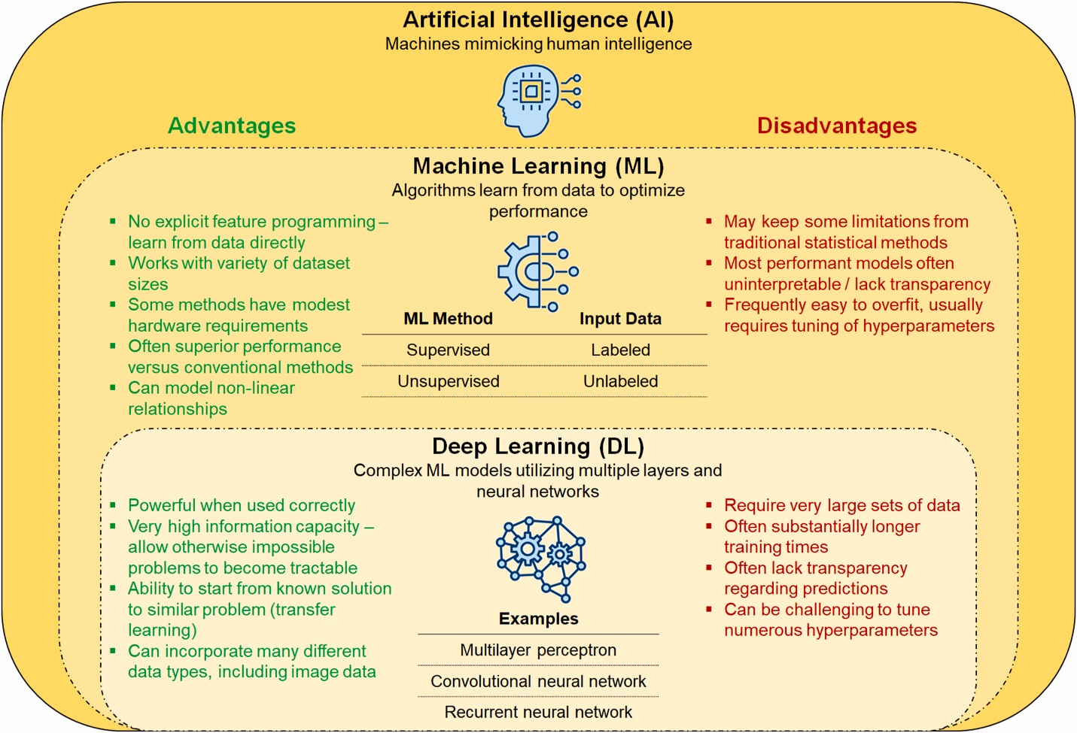

Jacob C. Jentzer, Anthony H. Kashou, Dennis H. Murphree, Clinical applications of artificial intelligence and machine learning in the modern cardiac intensive care unit, Intelligence-Based Medicine, Volume 7,2023,100089,ISSN 2666-5212.

AI Applications in Critical Care Medicine

AI could reduce the inter-clinician variability and offer other benefits. AI excels at finding complex relationships in large volumes of data and can simultaneously and rapidly analyze many variables to predict outcomes of interest, such as sepsis or mortality.
The modern ICU environment is data-rich, providing fertile soil for the development of more accurate predictive models, better decision support tools, and greater personalization of care.⁹

Although the introduction of machine learning to the ICU is in its infancy, several studies have already been published describing the application of this technology in the management of the critically ill patient. Some have used large population datasets to predict length of stay, ICU readmission and mortality rates, and the risks of developing medical complications or conditions such as sepsis and ARDS. Other studies have dealt with smaller datasets of clinical and physiological data to aid in the monitoring of patients undergoing ventilatory support.¹⁰

Prediction of Length of Stay
Houthooft et al inferred that for predicting patient mortality and a prolonged stay, the best performing model is a support vector machine (SVM) with GA,D=65.9% (area under the curve (AUC) of 0.77) and GS,L=73.2% (AUC of 0.82). In terms of LOS regression, the best performing model is support vector regression, achieving a mean absolute error of 1.79 days and a median absolute error of 1.22 days for those patients surviving a non-prolonged stay thus reaching the conclusion that Using a classification grid based on the predicted patient mortality and prolonged stay, allows more accurate modeling of the patient length of stay. The detailed models allow to support the decisions made by physicians in an ICU setting.¹¹

Yu-wei lin et al addressed the unplanned ICU readmission prediction by utilizing chart events, demographics, and ICD-9 embeddings features. Their machine learning solution for prediction of ICU readmission offers higher accuracy and sensitivity compared to existing solution. In addition, since the model can have multiple operating points, its sensitivity and specificity can be tuned to match requirements for specific clinical settings, such as high sensitivity for critical care.¹²

A hidden Markov model framework applied to physiological measurements taken during the first 48 h of ICU admission also predicted ICU length of stay with reasonable accuracy.¹³
Sepsis Prediction
Early sepsis prediction can drastically reduce the mortality and length of stay in ICU.
Desautels et al. found that, in 22,853 ICU stays, systemic inflammatory response syndrome (SIRS), Simplified Acute Physiology Score II (SAPS II) and sequential organ failure assessment (SOFA) had AUCs of 0.609, 0.700 and 0.725 respectively for identifying sepsis at the time of Onset.¹⁴

Nemati et al by using a set of 65 features (variables), calculated on hourly basis and passed to the Artificial Intelligence Sepsis Expert algorithm to predict onset of sepsis in the proceeding T hours (where T = 12, 8, 6, or 4). Artificial Intelligence Sepsis Expert was used to predict onset of sepsis in the proceeding T hours and to produce a list of the most significant contributing factors. They concluded that Artificial Intelligence Sepsis Expert can accurately predict the onset of sepsis in an ICU patient 4-12 hours prior to clinical recognition.¹⁵

Kamaleswaran et al used artificial intelligence to develop a novel algorithm using physiomarkers to predict the onset of severe sepsis in critically ill children. They inferred that Artificial intelligence can be used to predict the onset of severe sepsis using physiomarkers in critically ill children. Further, it may detect severe sepsis as early as 8 hours prior to a real-time electronic severe sepsis screening algorithm.^{16.}

Severity scoring and prediction of mortality

Decisions about which patients to admit to intensive care and how long to keep them there are difficult.
Dybowski created an artificial neural network or ANN, which was optimized by genetic algorithms, trained, and evaluated the performance in the clinical setting of systemic inflammatory response syndrome and hemodynamic shock in a set of 258 patients. They interpreted that ANNs have lent themselves particularly well to modelling a complex clinical situation suggested that this relates to their inherently flexible nature which accommodates interactions between the clinical input fields. In addition, they demonstrated the value of a second computational technique (genetic algorithms) in "tuning" ANN performance. These techniques can potentially be implemented in individual intensive care units; the outcome models which they will generate will be sensitive to local practice. Analysis of such accurate clinical outcome models may empower clinicians with a hitherto unappreciated degree of insight into those elements of their clinical practice which are most relevant to their patients' outcome.¹⁷

Pirrachio et al worked on The Super ICU Learner Algorithm (SICULA), an ensemble machine learning technique that uses multiple learning algorithms to obtain better prediction performance and interpreted that compared with conventional severity scores, Super Learner offers improved performance for predicting hospital mortality in patients in intensive care units.¹⁸

Mechanical Ventilation

Mechanical ventilation is the backbone of any critical care setup and even though modern high-end ventilators are extremely well-functioning and complicated, an autonomous ventilator is highly desirable.
Prasad et al worked on A Reinforcement Learning Approach to Weaning of Mechanical Ventilation in Intensive Care Units and concluded that AI algorithm used to advise when to wean, outperformed clinical practice in terms of number of re-intubations.¹⁹
Parreco worked on using artificial intelligence to predict prolonged mechanical ventilation and tracheostomy placement and demonstrated the use of artificial intelligence through machine-learning classifiers for the early identification of patients at risk for prolonged mechanical ventilation and tracheostomy and application of these identification techniques could lead to improved outcomes by allowing for early intervention.²⁰

Chen et al. developed an algorithm to identify ineffective efforts from the maximum deflection of the expiratory portion of airway pressure and flow. Ineffective effort was present in 58% of the 24 patients enrolled in their study. Analysis of 5899 breaths yielded sensitivity and specificity for the detection of ineffective efforts >90%.²¹
Rhem et al. and Adams et al. developed a set of algorithms to detect two types of asynchronies associated with dynamic hyperinflation, double triggering, and flow asynchrony. Based on a learning database of 5075 breaths from 16 patients, they developed logical operators to recognize double triggering based on bedside clinical rules.^{22,23}

Patient Monitoring

AI and deep machine learning in conjugation with different sensors and devices is being used for better patient monitoring and better care nowadays in critical care setting.
Davoudi et al. explored the use of wearable sensors, light and sound sensors, and a camera to collect data on ICU patients and their environments to improve detection of delirium and enable real-time interventions to improve sleep hygiene.²⁴
AI is also taking advantage of the move towards higher-resolution continuous data capture. For example, deep learning analysis of electrocardiogram data, measured continuously in ICU patients, can detect ST changes.²⁵

Risk factors

The various risk factors with the use of AI in ICU is that it is prone to cyber-attacks, system bias and mismatch of data.
Cyber-attacks can hinder a machine’s effective use and may even threaten the patient’s life as these attacks could range from a pacemaker malfunction to ventilator disruption.
System bias can creep in due to deep machine learning from physicians’ decisions which are biased towards certain aspects of decision making.
Even the best-performing AI systems impose a critical challenge known as a mismatch. AI systems are inadequately conscious towards the cause and may endorse a course of action that does not correlate with the previous condition of the patient. This could result in great harm to the patient.^{26,1}

Conclusion

In recent years, there has been massive progress in artificial intelligence (AI) with the development of deep neural networks, natural language processing, computer vision and robotics.²⁶
Rapid advancement of AI from both private and public sector means that it is the fastest evolving technology which will be used for the next generation of healthcare technology. It can be a double-edged sword which in the right hands can prove to be a boon especially in the field of critical care where life altering decisions are taken in split seconds. AI can augment the quality of life as well as play a role in prolonging it.

REFERENCES

1. kaur, ekampreet, bans, akash, eze, U.O. and singh, jaskaran (2023). ARTIFICIAL INTELLIGENCE IN HEALTHCARE: A PROSPECTIVE APPROACH. Anveshan: Multidisciplinary Journal of Geeta University, 1(1).

2. Lovejoy, C.A., Buch, V. & Maruthappu, M. Artificial intelligence in the intensive care unit. Crit Care 23, 7 (2019).
3. Reddy, S., Fox, J., & Purohit, M. P. (2018). Artificial intelligence-enabled healthcare delivery. Journal of the Royal Society of Medicine, 112(1),22-28.

4. Davenport, T., & Kalakota, R. (2019). The potential for artificial intelligence in healthcare. Future Healthcare Journal, 6(2), 94-98.

5. Kourou, K., Exarchos, K. P., Papaloukas, C., Sakaloglou, P., Exarchos, T., & Fotiadis, D. I. (2021). Applied machine learning in cancer research: A systematic review for patient diagnosis,classification and prognosis. Computational and Structural Biotechnology Journal, 19, 5546-5555.
6. Alsheibani, S., Cheung, Y., & Messom, C. (2018). Artificial intelligence adoption: AIreadiness at firm-level. In M. Tanabu, & D. Senoo (Eds.), Proceedings of PACIS2018: Pacific Asia Conference in Information Systems (PACIS).
7. Amann, J., Blasimme, A., Vayena, E., Frey, D., & Madai, V. I. (2020). Explainability for artificial intelligence in healthcare: A multidisciplinary perspective. BMC Medical Informatics and Decision Making, 20(1).

8. Jacob C. Jentzer, Anthony H. Kashou, Dennis H. Murphree,Clinical applications of artificial intelligence and machine learning in the modern cardiac intensive care unit,Intelligence-Based Medicine,Volume 7,2023,100089,ISSN 2666-5212,https://doi.org/10.1016/j.ibmed.2023.100089. (https://www.sciencedirect.com/science/article/pii/S2666521223000030)
9. Lovejoy et al. Critical Care (2019) 23:7 https://doi.org/10.1186/s13054-018-2301-9
10. Gutierrez Critical Care (2020) 24:101 https://doi.org/10.1186/s13054-020-2785-y
11. Houthooft R, Ruyssinck J, van der Herten J, et al. Predictive modelling of survival and length of stay in critically ill patients using sequential organ failure scores. Artif Intell Med. 2015;63:191–207.
12. Lin YW, Zhou Y, Faghri F, Shaw MJ, Campbell RH. Analysis and prediction of unplanned intensive care unit readmission using recurrent neural networks with lon short term memory. PLoS One. 2019;14: e0218942.
13. Sotoodeh M, Ho JC. Improving length of stay prediction using a hidden Markov model. AMIA Jt Summits Transl Sci Proc. 2019;2019:425–34.
14. Desautels T, Calvert J, Hoffman J, Jay M, Kerem Y, Shieh L, et al. Prediction of Sepsis in the Intensive Care Unit With Minimal Electronic Health Record Data: A Machine Learning Approach. JMIR Med Inform. 2016;4:e28.
15. Nemati S, Holder A, Razmi F, Stanley MD, Clifford GD, Buchman TG. An Interpretable Machine Learning Model for Accurate Prediction of Sepsis in the ICU. Crit Care Med. 2018;46:547–53.
16. Kamaleswaran R, Akbilgic O, Hallman MA, West AN, Davis RL, Shah SH. Applying Artificial Intelligence to Identify Physiomarkers Predicting Severe Sepsis in the PICU. Pediatr Crit Care Med. 2018;19:e495–503.
17. Dybowski R, Gant V, Weller P, Chang R. Prediction of outcome in critically ill patients using artificial neural network synthesised by genetic algorithm. Lancet. 1996;347:1146–50.
18. Pirracchio R, Petersen ML, Carone M, Rigon MR, Chevret S, van der Laan MJ. Mortality prediction in intensive care units with the Super ICU Learner Algorithm (SICULA): a population-based study. Lancet Respir Med. 2015;3:42–52.
19. Prasad N, Cheng L-F, Chivers C, Draugelis M, Engelhardt BE. A Reinforcement Learning Approach to Weaning of Mechanical Ventilation in Intensive Care Units. ArXiv170406300 Cs. 2017 Apr 20; Available from: http://arxiv.org/abs/1704.06300.
20. Parreco J, Hidalgo A, Parks JJ, Kozol R, Rattan R. Using artificial intelligence to predict prolonged mechanical ventilation and tracheostomy placement. J Surg Res. 2018;228:179–87.
21. Chen CW, Lin WC, Hsu CH, Cheng KS, Lo CS. Detecting ineffective triggering in the expiratory phase in mechanically ventilated patients based on airway flow and pressure deflection: feasibility of using a computer algorithm. Crit Care Med. 2008;36:455–61.
22. Rehm GB, Han J, Kuhn B, et al. Creation of a robust and generalizable machine learning classifier for patient ventilator asynchrony. Methods Inf Med. 2018;57:208–19.
23. Adams JY, Lieng MK, Kuhn BT, et al. Development and validation of a multialgorithm analytic platform to detect off-target mechanical ventilation. Sci Rep. 2017;7:14980.
24. Davoudi A, Malhotra KR, Shickel B, Siegel S, Williams S, Ruppert M, et al. The Intelligent ICU Pilot Study: Using Artificial Intelligence Technology for Autonomous Patient Monitoring. ArXiv180410201 Cs Eess. 2018 Apr 25;
25. Afsar FA, Arif M, Yang J. Detection of ST segment deviation episodes in ECG using KLT with an ensemble neural classifier. Physiol Meas. 2008;29:747–60.
26. Reddy, S., Fox, J., & Purohit, M. P. (2018). Artificial intelligence-enabled healthcare delivery. Journal of the Royal Society of Medicine, 112(1), 22-28. https://doi.org/10.1177/0141076818815510.

