PHARMACEUTICAL DOSAGE FORMS

Dosage forms are the means by which drug molecules are delivered to sites of action within the body.
Need For Dosage Forms:
- Provide safe and convenient delivery of accurate dose. Example- tablets, capsules, syrups
- Protection of a drug substances from atmospheric oxygen or moisture. Example –coated capsules,seald ampoules.
- Protection from gastric juice after oral administration. Example- Enteric coated tablet
- Masking bitter taste and odour of a drug substances. Example-Capsules, coated tablets, flavored syrups
- Provide liquid preparation of drug that insoluble or unstable in the desired vehicle . Example- Suspension .
- Provide liquid dosage forms of substances soluble in desired vehicle . Example-Solution.
- Optimal drug action.
- Insertion of drugs into body cavities (rectal, vaginal) 10- Use of desired vehicle for insoluble drugs.
- Provide optional drug action from topical administration sites. Example –ointment ,cream, ear and nasal preparations.
- Controlled release mechanisms.
- Placement of drugs within body tissues.

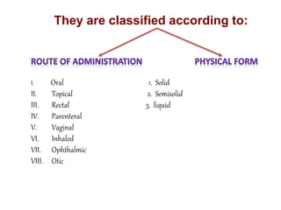
DOSAGE FORME

Patient Safety/Benefit

Drug Safety/Benefit

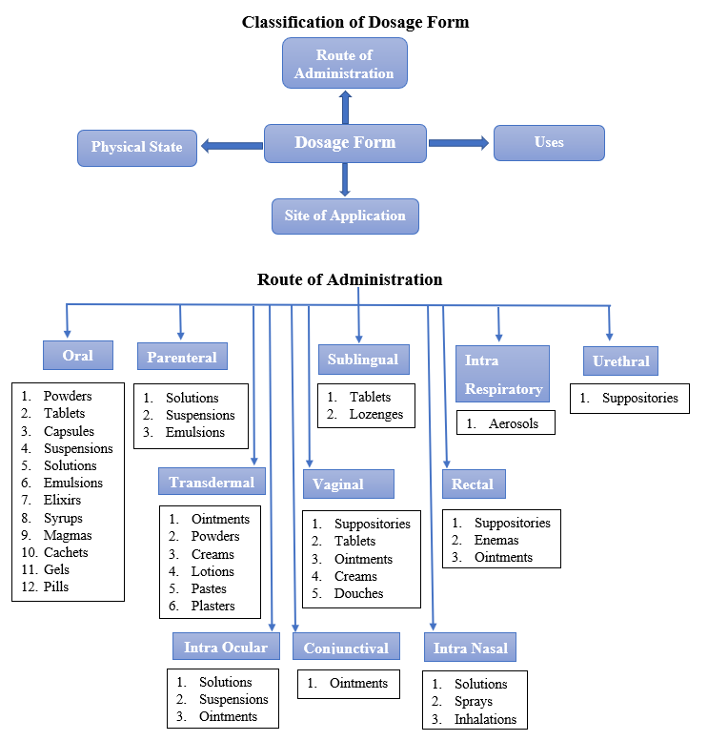
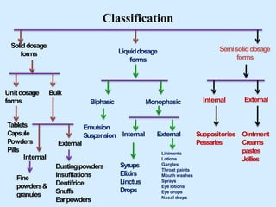

CHAPTER -1

Solids Dosage Forms Development
Solid dosage forms are the most important dosage forms for pharmaceuticals, which contain a unit dose of one or more drugs. Commonly used solid dosage forms are powders, granules, tablets, capsules, etc., accounting for about 70% of the pharmaceutical preparations. Compared with liquid dosage forms, solid dosage forms have good physical and chemical stability, lower manufacturing costs, and are easy to take and carry, the pretreatment of the preparation process undergoes the same unit operation to ensure uniform mixing and accurate dosage of the drug, and there is a close relationship between the dosage forms.

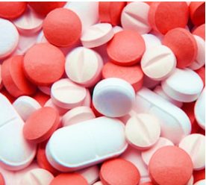
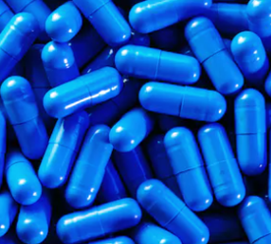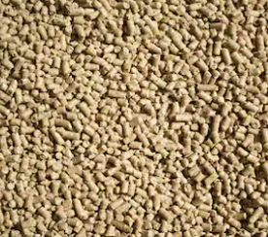 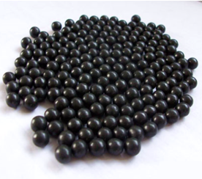
Tablet Capsule Granules Pellets
The pharmaceutical tablet can be defined as a solid oral dosage form or solid unit dosage form. It contains a mix of active substances with pharmaceutical excipients. Any substance apart from the active ingredient can be classified as an excipient. The excipients that are used in tablets are diluents, binders, glidants and lubricants. The most popular form of a tablet is the compressed form. A tablet can be designed to accurately deliver targeted cavities of the body. Tablets can be administered orally, buccally, intravaginally or rectally. The tablets may differ in size, shape, weight, thickness, dissolution and hardness depending on the use and manufacturing method.
Tablets
Pharmaceutical Properties of Tablets
After the table definition, we will see the properties of tablets
It should be hard and strong enough to withstand mechanical shocks through the manufacturing, packing, and shipping stages.
The tablet produced must also be physically and chemically stable.
The drug entity in the tablet should be bioavailable. This means that the tablet should release the content it consists of in a predictable and reproducible way.
It should not have any sort of defects such as cracks, chips, or contamination. It also should have an elegant product identity.
The tablets for a particular targeted body part should be uniform in terms of weight and drug content.

Pharmaceutical Tablet Uses
- They give an accurate dosage of the API or medicaments in a convenient package
- The different colors and markings help distinguish the tablets doe different uses
- It is used to disguise unstable medications and unpalatable entities.
- Tablets are medicines that are easy to swallow
- They provide relief to many diseases and ailments
- They can be conveniently carried even when traveling

TYPES
- Oral Tablets for Ingestion
1) Standard Compressed Tablets
2) Multiple Compressed Tablets
Compression Coated Tablets – a) sugar coated,
b) film coated tablets,
c) gelatin coated tablets,
d) enteric coated tablets Layered tablet
Inlay tablet
3) Targeted Tablets – a) Floating Tablet,
b) Colon Targeting Tablet
4) Chewable tablets
5) Dispersible tablets

Tablets used in the Oral Cavity
1) Lozenges and troches
2) Sublingual tables
3) Buccal tablet
4) Dental cones
5) Mouth dissolved / rapidly dissolving tablets

Tablets Administered by other Routes
1. Vaginal tablet
2. Rectal tablet
3. Implants

Tablets used to prepare Solution
1) Effervescent tablets
2) Molded tablets
Hypodermic tablet
Dispensing /soluble tablet
3) Tablet Triturate.

Structure Wise
1) Divisible Tablets
2) Aperture Tablet
3) Concave Convex Tablets
4) Core Tablet

Action Wise
1) Modified Release Tablet

ORAL TABLET FOR INGESTION
Over 90% of tablets manufactured are ingested orally. These are designed to swallow intact, with exception of chewable tablets.
1) Standard Compressed Tablets: These are standard uncoated tablets made by compression using wet granulation, direct compression or double compression. It provides rapid disintegration and drug release. They are mostly intended to exert local
action in GIT. It typically includes water insoluble drugs such as antacid and adsorbents. In addition to medicinal agents compressed tables usually contains a number of pharmaceutical adjuvants such as diluents, binders, disintegrants, etc.
2) Multiple Compressed Tablets:
Multiple compressed tablets are prepared by more than one compression cycle. This process is best suited when separation of active ingredient is needed for stabilitypurposes, or if the mixing process is inadequate to guarantee uniform distribution of two or more active ingredients. There are three categories under this class: Compression coated tablets, Layered tablets and Inlay tablets.
Compression Coated tablets: This tablet readily lends itself into a repeat action. Outer layer provides the initial dose while the inner core releases the drug later on. Hence, it is useful for releases of two active pharmaceutical ingredients (APIs), one immediate release formulation which is entrapped in coat and the other sustained release formulation entrapped in the core. It is also possible to provide loading dose and maintenance dose for one drug
using this concept. Colton 232, Stock 538 and Manesty Drycota 900 are
equipment’s utilized for preparingcompression coated tablets [7].

a) Sugar Coated Tablets: The sugar coat protect the enclosed drug from the environment and provide a barrier to objectionable taste or odour. It also produces an elegant, glossy appearance. The patient acceptability also increases due to the sweet taste of tablet. Widely utilized in preparing multivitamin and multivitamin mineral combination.
b) Film Coated Tablets: It is the type of coated tablets in which drug is not required to coating. In case to provide more strength to the tablet, film coating is used as alternative to sugar coating. The polymers such as HPC (Hydroxypropyl cellulose), HPMC (Hydroxypropyl methyl cellulose), and Ethyl cellulose are used for this technique. It is also a fast process than the sugar coating technique. It has the advantages over sugar coating in that it is more durable, less bulky and less time consuming to apply, but it is less attractive and elegant in physical appearance than sugar coating. The coating is designed to rupture and expose the core tablet at the desire location in the gastrointestinal tract.
c) Gelatin Coated Tablets: The innovator product, the gel cap is a capsule–shaped compressed tablet that allows the coated product to be about one–third smaller than a capsule filled with an equivalent amount of powder. The gelatin coating facilities swallowing, and gelatin–coated tablets are more tamper evident than unsealed capsule.
d) Enteric Coated Tablets: The enteric coated tablets are coated with the material resistant to acidic medium (stomach environment) and hence are not able to release drug in stomach. Whereas, it easily releases drug in intestine (alkaline) media. Hence, drugs have to pass through stomach and the time of release of drug is delayed and hence called delayed action tablet [8].
i Layered Tablets: Layered tablets are composed of two or three layers of granulation compressed together. Theyhave the appearance of a sandwich because the edges of each layer are exposed. When two or more active pharmaceutical ingredients are needed to be administered simultaneously and they are incompatible, the best option for the formulation pharmacist would be to formulate multilayered tablet. A single tablet composed of two or more layers and usually each layer is of different color to produce a distinctive looking tablet Equipment-Versa press [7].
Inlay Tablets: A variation of the compression coated tablet is the inlay, dot, or bull's-eye tablet. Instead of the core tablet being completely surrounded by the coating, its top surface is completely exposed. This form can be useful in sustained release preparations to reduce the size and weight of the tablet. Two drugs are incorporated in tablet, one in core and one in coat. Release of both drugs starts immediately but coating is responsible for slow release and core is responsible for immediate release of incorporated drugs. Inlay tablet are prepared with the Stokes, Colton, or Kilian machines. No alterations in equipment are needed only the feed frame and hopper, which normally provide the top coating, are not installed .
3) Targeted Tablets: Under this category there are two types of tablets.
a. Floating tablets: These are designed to prolong the residence time of the dosage form within the GI tract. This not only prolongs GI residence time but also does so in an area of the GI tract that would maximize drug reaching its absorption site in solution and hence, ready for absorption. These are low density tablets. It can expand in gastric environment. Floating in diarrhoea to keep the drug in floaticondition in stomach to get a relatively better response. Controlled delivery of drugs. It minimizes the mucosal irritation by releasing drug slowly. Used in treatment of gastrointestinal disorders such as gastro esophageal reflux. Ease of administration and better patient compliance.
b. Colon Targeting Tablets: It provides a desired drug concentration in the body by delivering a therapeutic amount of drug to a target site i.e. colon. It is suitable and required for the drugs having instability, low solubility, and short half-life, a large volume of distribution, poor absorption, low specificity, and therapeutic index. The pH in this region (colon) varies from 6.4-7 and presence of microbial flora plays an important role in drug release. Various mechanisms adopted for drug release in this area are: Coating with pH sensitive polymer e.g., Eudragit S100 and L100; Biodegradable polymer which are sensitive to colonic bacteria; Bio- adhesive polymer e.g., poly carbophils. Redox sensitive polymers. It provides delivery of drugs accurately into the lower GI tract (by avoiding the drug release in upper GIT), which occurs primarily in the large intestine (i.e. colon) [10].
4) Chewable Tablets: Chewable tablets which are required to be broken and chewed in between the teeth before ingestion. These tablets are given to the children who have difficulty in swallowing and to the adults who dislike swallowing. These tablets are intended to disintegrate smoothly in mouth at a moderate rate either with or without actual chewing. Chewable tablet are often employed when the active ingredient is intended to act in a localized manner rather than systemically the composition of chewable tablet consists of gum core which may or may not be coated. The core is composed of an insoluble gum base like fillers, waxes, antioxidants, sweeteners, flavoring agents. The percentage of gum base varies from 30-60%. Mannitol is widely used as an excipient in chewable tablet for its non-hygroscopic nature for moisture sensitive drugs [11, 12 ]
5) Dispersible Tablets: Dispersible tablets as defined in European Pharmacopoeia are uncoated or film coated tablets intended to be dispersed in water before administration giving a homogeneous dispersion. Typically a dispersible tablet is dispersed in about 5 to 15 ml of water (e.g. in a tablespoonful or a glass of water) and the resulting dispersion is administered to the patient. Dispersible tablets are required to disintegrate within 3 min in water at 15 to 25. Also the dispersion produced from a dispersible tablet should pass through a sieve screen with a nominal mesh aperture of 710 µm [13].
B) TABLETS USED IN ORAL CAVITY
1) Lozenges and Torches: Lozenges are flavored medicated dosage forms intended to be sucked and held in mouth or pharynx. Two lozenge forms include hard (or boiled) candy lozenges and compressed tablet lozenges (TROUCHES). Lozenges may be used for; Local medications in the mouth or throat, Systemic drug uptake. Soft variety of lozenge, called a pastille, consists of medicament in a gelatin or glycero- gelatin or in a base of acacia, sucrose and water. No disintegrant is included in compressed lozenges composition. Other additives (binder and filler) must have pleasant taste or feeling during dissolution. Common binder used in compressed lozenges is gelatin; common fillers are (Sorbitol, mannitol and glucose) [1].
2) Sublingual Tablets: They are to be placed under the tongue and produce immediate systemic effect by enabling the drug absorbed directly through mucosal lining of the mouth beneath the tongue. The tablets are usually small and flat, compressed lightly to keep them soft. The tablet must dissolve quickly allowing the drugs to be absorbed quickly It is designed to dissolve in small quantity of saliva. Sublingual, meaning literally 'under the tongue' refers to a method of administering substances via the mouth in such a way that the substances are rapidly absorbed via the blood vessels under the tongue rather than via the digestive tract [16].
3) Buccal Tablets: These drugs are intended to be dissolved in buccal pouch. Tablets are designed not to disintegrate. It is placed near the opening of parotid duct to provide the medium to dissolve the tablet. Buccal tablets are most often used when replacement hormonal therapy is the goal. Long–Acting Buccal Tablets include use of viscous natural or synthetic gums or mixtures of gums can be compressed to form a hydrated surface layer from which the medicament slowly diffuses and is available for absorption through buccal mucosa. Mucoadhesive polymers like PANA and carbopol 934 are used [1, 2].
4) Dental Cones: These tables are designed to be loosely packed in the empty socket remaining following a tooth extraction. Main purpose behind the use of this tablet is either to prevent multiplication of bacteria in the socket by employing a slow releasing antibacterial compound or to reduce bleeding by an astringent or coagulant containing tablet. It’s formulated to dissolve or erode slowly in presence of 20-40 minutes period. Usually used vehicles are sodium chloride, sodium bicarbonate or amino acid. [1,2 ]
5) Mouth Dissolved or Rapid Dissolving Tablets: Mouth dissolving tablets can define as "A solid dosage form containing medicinal substances, which disintegrates rapidly, usually within a matter of seconds, when placed under the tongue. Mouth Dissolving Tablet has a pleasing mouth feel, and it not required water to swallow. MDT easily dissolved or disintegrates in saliva within a few seconds (15 s to 3 min). .Some MDT tablets are designed to dissolve in saliva remarkably fast, within a few seconds, and are called true fast-dissolving tablets. Others contain agents to enhance the rate of tablet disintegration in the oral cavity and are more appropriately termed as fast-disintegrating tablets, as they may take about one minute to disintegrate completely. Having good hardness, dose uniformity, easy administration and serves as the first choice of dosage form for pediatrics, geriatrics and travelling patients [14].
C) Tablets Administered by Other Routes
1) Vaginal Tablets: Designed for vaginal administration in treatment of local vaginal infections, for systemic absorption and absorption into vaginal tissue can be inserted with aid of an applicator. In the treatment of localized vaginal infections such as, Candida albicans, yeast and Haemophilus vaginalis. These are uncoated bullet shape or ovoid tablets. Designed to under go slow dissolution and drug release in vaginal cavity. Pleased in an upper region of vaginal tract by plastic tube inserter. Itmay contain antibacterial, antiseptic, or astringents [1, 2].
2) Rectal tables: It is old and acceptable means of treatment. The volume and nature of rectal fluid, its buffer capacity, pH and surface tension play a large part in this but are subject to wide variation, even within single subject, resulting in variability of absorption by this route. Rectal tables not required refrigeration. Better product stability even at room temperature.
3) Implants: These tablets are implanted in the body cavities for a prolonged effect from several days to months up to year. These tablets are small in size and cylinder like in shape. They are designed for subcutaneous implantation by surgical procedure where they are slowly absorbed over a period of month or a year. Special injector with a hollow needle and plunger is used to administer the rod shaped tablet. For other shapes surgery is used. They are sterile formulations without excipients. Mainly these tablets are prepared to deliver growth hormones to food producing animals. Ear is preferred site for administration of drug [1,8].
D) TABLETS USED TO PREAPER SOLUTION
1) Effervescent Tablets: Effervescent tablets are designed to break in contact with liquid such as water or juice, often causing the tablet to dissolve into a solution the benefit of effervescent tablets is that they dissolve completely and evenly meaning that localized concentrations of the ingredients cannot occur. This means not only a better taste but also less chance of irritation and a more efficient means of ingesting the ingredients. Effervescence consists of a soluble organic acid and an alkali metal carbonate salt, one of which is often the API. Carbon dioxide is formed if thismixture comes into contact with water. They have good stomach and intestinal tolerance [15].
2) Molded Tablets
a. Hypodermic Tablets: These are one type of sterile preparations. In these, tablets are dissolved in the WFI or sterile water to inject before the actual injection in the hypodermic cavity. They are intended to be added in WFI of sterile water to form a clear solution which is to be injected parentally. They are widely used by rural physician due to its portability. It can be used for medicaments whose stability in water is very poor. Their use in this manner should be discouraged, since the resulting solutions are not sterile [1,8].
b. Dispensing or Soluble Tablets: They are to be added to water or other solvents to make a solution containing a fixed concentration of API. Should contain no insoluble materials (including Glidants, binders etc.), since they will be made into clear solution. A material incorporated in dispensing tablets includes mild silver proteinate, bichloride of mercury and quaternary ammonium compounds. These tablets are highly toxic if taken orally by mistake. These tablets provide a convenient quantity of potent drug [1].
3) Tablet Triturate: Tablet triturates are small, usually cylindrical, Molded or compressed tablets. The drugs employed in such products were usually quite potent and were mixed with lactose and possibly a bonder, such as powder acacia. Tablet triturates are usually soft and friable. Many of the drugs employed in these tables were highly potent and drug migration could occur as the alcohol evaporated. Only a minimal pressure is applied during their manufacturing, since they must be readily and completely soluble in water [1]

Structure Wise
1) Divisible Tablet: It is sometimes necessary to administer one-half or one-fourth of a tablet and under such circumstances tablets are generally scored once in the middle or twice with lines perpendicular to one another. V-shaped double layer tablets with scoring in the center have been designed.
2) Aperture Tablets: Designed with a view to achieve constancy in the surface area during disintegration & dissolution.
3) Concave-convex Tablets: These tablets have been designed with a view to keep surface area of the structure relatively constant during the dissolution process. Area is lost on the convex surfaces and gained at the concavities.
4) Core Tablets: These tablets have a central core over which another layer of material is compressed and are generally made by two successive compressions. Separate incompatible ingredients.
ACTION WISE
Modified Release Tablet: Release the medicament slowly for long time duration after administration of a single tablet. Used to target the site specific releases. Comparison of blood concentration vs. time any adjuvant that can alter water uptake rate, swelling, and gelling characteristics can alter the release rate of API. The drug release can be modified by providing suitable micro environment pH in the tablet .Inclusion of alkaline polymers results in desirable drug release of acidic drugs.

CAPSULES
Capsules are solid dosage forms in which medicinal agents and inert substances are enclosed in a small shell of gelatin. Gelatin capsule shells may be hard or soft, depending on their composition. The shells may be composed of two pieces, a body and a cap, or they may be composed of a single piece. Two piece capsules are commonly referred to as hard-shell capsules, and one-piece capsules are often referred to as soft-shell capsules.
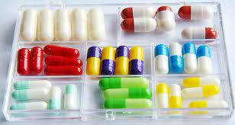
Fig.capsules
Hard Gelatin Capsules (HGC) The empty capsule shells are made of gelatin, sugar, and water. As such, they can be clear, colorless, and essentially tasteless. They may be colored with various FD&C and D&C dyes and made opaque by adding agents such as titanium dioxide. Most commercially available medicated capsules contain combinations of colorants and opaquants to make them distinctive, many with caps and bodies of different colors.
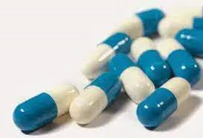
Fig. hard gelatin capsule
Soft gelatin capsules are made of gelatin to which glycerin or sorbitol has been added. Soft gelatin capsules, which contain more moisture than hard capsules, may have a preservative, such as methylparaben and/or propylparaben, to retard microbial growth. Soft gelatin capsules may be oblong, oval, or round.
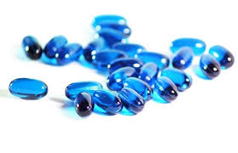
Fig. Soft gelatin capsules
Granules is a kind of drug, which is made of raw materials after extraction, and then added with certain excipients to make a dry preparation with granules, or a single dose of granules to make a block, and it is also called granules. Granules is a kind of oral solid dosage form commonly used in drug, especially in traditional Chinese drug, it is also one of the commonly used dosage forms for children. Granules can be swallowed directly or washed into the water for drinking, the distribution of granules in water is different. Granules can be divided into soluble granules, suspension granules, effervescent granules and other forms.
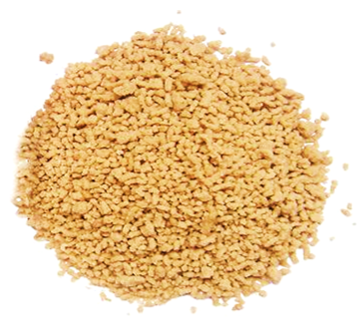
Fig.1 Granules.
The team of CD Formulation is leading experts in all aspects of pharmaceutical formulation development and dosage form optimization, we can accord the characteristics of the API and the development goals of the customers to design the formulation of granules. CD Formulation can provide you with one-stop services to meet your needs of granules.
PELLETS
Small free flowing spherical units ranging in size, prepared by agglomeration of fine powders called pellets. • Their size and shape allow their administration as injections and also for oral drug delivery. • Pellets range in size, typically, between 0.5 – 1.5 mm, though other sizes could be prepared.
Taste masking: Micropellets are ideal for products where perfect abatement of taste is required. pellets proivide the masking of unpleasant taste without lowering of bioavailability especially for oral products. • Immediate release: Administering drugs in pellet form leads to an increased surface area as compared to traditional compressed tablets and capsules. This would considerably reduce the time required for disintegration and have the potential for use in rapidly dispersible tablets. • Sustained release: Pellets are being increasingly used in the manufacture of sustained release dosage form of drugs. The advantages of the dosage form is well known and some examples are given below : • Extend day time and night time activity of the drugs, • Reduced dosage frequency of dosage forms, • Increased patient compliance

CHAPTER -2

Liquids Dosage Forms
Liquid dosage forms is pourable pharmaceutical preparations，it is also one of the oldest dosage form used in the treatment of patients and affords rapid and high absorption of medicinal products. Liquid dosage form contains a mixture of active pharmaceutical ingredients and non-pharmaceutical ingredients (excipients) dissolved or suspended in a suitable solvent or mixtures of solvents. They are administered by oral and parenteral (injection, inhalation, ophthalmology, ear canal, nasal cavity and topical) routes. Oral liquids are non-sterile, while liquids administered by parenteral routes are available in sterile and non-sterile formulations.
Pharmaceutical liquid dosage forms are those preparations that contains a combination of active drugs and excipients (emulsifying, dispersing, solubilizing, stabilising, suspending, wetting, thickening agent, preservative, sweetening agent, flavoring agent, and colouring agent) that are dissolved or suspended in appropriate solvents and used as a drug or medication .
Monophasic liquid dosage forms are the liquid solutions that comprise two or more components in a single phase. True solutions, which are homogeneous mixtures created by dissolving solute in long-term solvents, are also known as true solutions.
Solutions
Solid materials are dissolved in an appropriate solvent, which are homogeneous mixture containing one or more chemical compounds. Solutions are one of the oldest dosage forms and are made by dissolving a solid, liquid, or gas into a solvent in which the solute molecules are dissolved into a solvent such as water, alcohol or carbonated beverages [3].
Syrup
Syrup is a sugar-in-water saturated aqueous solution with or without medicinal, ingredients. Syrups have a high percentage of sucrose (66.7% w/w I.P. and 85% w/v USP). Prepare sucrose 66.7% w/w syrup in filtered water, stirring constantly while heating. It’s crucial not to let the temperature climb above 1600°C while heating [4]. After cooling, it’s kept in a cool, dry area in a tightly sealed container to keep moisture and foreign particles out. Vitamins, sedatives, saline medicines, and antibiotics all use syrups in their composition.
Linctus
Linctus is a viscous, monophasic liquid solution with a high syrup concentration that is used to treat cough and sore throat. It’s made by dissolving citric acid in chloroform, adding peppermint water, amaranth solution, and syrup (as a carrier) to reach the desired volume [6]. However, the majority of linctus comprises chemicals that have expectorant, sedative, and antibacterial properties [7].
Elixirs
An elixir is a sweet fragrant liquid mixture that is administered orally for medical purposes. It contains a variety of active substances, including ethyl alcohol, propylene glycol, water, glycerin, and flavoring agents, all of which are necessary for elixir manufacture. Medicated elixirs and non-medicated elixirs are the two types of elixirs available [8]. Non-medicated elixirs are used as vehicles or solvents for medicated elixirs, which include potent medications as antihistaminic, antibiotics, hypnotics, and sedatives, and should be kept in a light-resistant, firmly closed container away from sunlight [9].
Gargles
Gargles are aqueous concentrated solutions that are used to treat throat infections by coming into touch with the mucus membrane in the buccal cavity. Gargles are delivered in a concentrated form, but when used, they are diluted with warm water. Gargles are kept in an airtight jar with a plastic screw cover [10].
Mouthwash
Mouthwashes are aqueous solutions with a pleasant taste and odour that are used to keep the buccal cavity clean and deodorised. Alcohol, glycerin, antimicrobial, colouring, and flavoring agents are all found in mouthwashes. Food particles caught deep inside the throat and mucous in the mouth can be eliminated with the help of mouthwashes with strong flavors and alcohol, which function by producing cough. Mouthwashes come in a variety of flavors, including antibacterial and anti-plaque mouthwashes, anti-cavity mouth rinses, and more. The antiseptic mouthwashes eliminate the bacterial plaque that causes bad breath, caries, and gingivitis, while the fluoride-containing mouthwashes protect against tooth decay [11]. It’s primarily used for dental hygiene. In general, some firms suggest that when mouthwash is used, you should not drink water right away. However, mouthwashes are ineffective in removing plaque and bad breath, thus brushing and flossing are required.
Lotions
Lotions are liquid preparations for application to the skin’s surface. Lotions are applied to the skin’s surface with cotton wool for purposes of protection, such as cooling and relaxing. Antiseptic, antibacterial, antifungal, moisturising, and protective substances are prescribed by dermatologists to treat or prevent skin problems [13].
Liniment
Liniment is a liquid dose form of medication that is applied to the affected area with friction or rubbing action. Liniments are a blend of substances with qualities such as analgesic, relaxing or stimulating. These should only be used on the outside of the body and should not be used on broken skin.
Nasal drops
Nasal drops are liquid or greasy solutions that are sprayed into the nostrils with a dropper. Antiseptics, local analgesics, and vasoconstrictors are all present in these solutions. The droplets are usually watery rather than greasy [14]. Nasal drops are isotonic because they have a neutral pH and a viscosity that is similar to nasal secretions, thanks to the usage of methyl alcohol [15].
Ear drop
Ear drops are solutions made from water, glycerin, or propylene glycol that are infused into the ear using a dropper. They are used to clean the ear canal, soften wax, and treat minor infections. When viewed under a microscope under suitable conditions of visibility, ear drops are clear solutions that do not include any particles [16]. Ear drops are also available as suspensions, which generate sediment that disperses widely when the container is shaken and stays disseminated for a long time [17].
Throat paints
Throat paints are the viscous liquid dosage form of medicaments which are used for the purpose of mouth and throat infections. Glycerin is typically used as a base in significant amounts to ensure that the medicine stays in contact with the mucous membrane for a long time and has a pleasant flavour [18].
Eye drops
Eye drops are ocular dosage forms of medications with drawbacks such as limited availability, frequent administration, pharmaceutical outflow through tears, unpredictability of dosages, and lacrimal fluid. The inherent physiology of the eye continues to make ocular drug distribution difficult [19]. The efficient removal mechanism at the site of action (rapid tear turnover, blinking) and low corneal permeability combine to diminish the efficacy of ophthalmic formulations and restrict drug bioavailability to less than 5%.
Biphasic liquid dosage forms
Biphasic liquid dosage forms are ones that have two phases in them. This comprises the medicine that has been dissolved as well as the solvent (vehicle). There are two types of biphasic liquid dosage forms.
• Suspension
• Emulsion
Suspension
Suspensions are biphasic liquid dosage forms of medication in which the internal phase is uniformly distributed with finely divided solid particles in a liquid dispersion medium over a period of 0.5 to 5 minutes. In pharmaceutical solutions, solid particles act as a disperse phase, while liquid vehicles act as a continuous phase. The external phase, also known as the suspending medium, [20]. Pharmaceutical suspension formulations are done for the following reasons. • To improve the drug stability of the suspensions. • To reduce the bitterness. • The medication is insoluble in the delivery medium in this formulation. • To achieve long term medication release (sustained release).
Classification of suspension: Suspensions are categorised using the following framework: • Determined by administration route
• Oral
• Parenteral
• Topical
• Based on the nature of solid particles electro kinetics
• Flocculated suspension
Deflocculated suspension
Oral suspensions
For oral administration, an oral suspension consists of undissolved particles and active substances suspended in sweetening, flavoring, or viscous vehicles with therapeutic agents. Oral suspensions are commonly used to treat oral fungal infections. “Oral suspensions allow for dose flexibility and are cost-effective when a patient requires dose titration, however many pharmaceutical medications are not available as oral suspensions [22]. Insoluble components are suspended in a dispersion media with suspending agents to create oral suspensions. Suspending agents are used to help disperse powders evenly throughout the preparation and avoid particle flocculation [23].
Parenteral suspensions
Parenteral suspensions are sterile preparations that are intended to be administered directly into the systemic circulation of people [24]. Parenteral suspensions are insoluble medication particles dispersed in a heterogeneous system that must be resuspended in an aqueous or vegetable oil vehicle before being administered to patients.
Emulsion
A biphasic liquid dosage form of a drug is an emulsion, which ismade up of two immiscible liquids, one of which is the dispersed phase and the other the continuous phase. Emulsions are a thermodynamically unstable system that must be stabilised by adding a third component called an emulsifier. Emulsifiers stabilise the system by forming a thin film around the dispersed phase globules, which range in size from 0.1 to 100 micrometers in diameter.
Types of emulsion The two basic types of emulsions such as • O/W (oil dispersed in water) • W/O (water dispersed in oil).
Oil-in-water emulsions (O/W)
Pharmaceutical emulsions are made up of a mixture of oil drop. lets scattered throughout the aqueous phase. Fats and oils for oral administration are always manufactured as oil-in-water (O/W) emulsions shows in figure 2, whether as carriers for oil-soluble medications or as medicines in their own right. They’re non-greasy and easy to wipe away from the skin’s surface [30]. They are applied physically to provide a cooling effect and internally to maskthe oil’s unpleasant taste.
Water-in-oil emulsions (W/O)
W/O emulsions (water-in-oil emulsions) are medicinal emulsions in which water is scattered as globules in oil continuous phase shows in figure 3. Water-in-oil emulsions have an occlusive action, which hydrates the stratum corneum and prevents the evaporation of eccrine secretions. They’re oily but not watersoluble, and they’re used to maintain moisture from evaporatinfrom the skin’s surface while cleansing it of oil-soluble dirt [31]. Example: Cold cream

CHAPTER -3

Semi-solids Dosage
Semi-solids constitute a large proportion of the drug formulation. They are used as carriers for drugs that are topically delivered by way of the skin, rectal tissue, vagina, cornea, urethral membrane, nasal mucosa, and so on. Semi-solids dosage forms are advantageous for a wide variety of drug molecules in terms of their ease of use, rapid preparation and local delivery capabilities. There are a variety of dosage forms for semi-solid, each with unique characteristics, they can be applied on the affected area directly and the administration of this dosage form to be readily administered to patients of any age. Semi-solids dosage forms usually presented in the form of ointments, gels, creams and suppositories, and these dosage forms consist of one or more active ingredients that dissolved or uniformly dispersed in a suitable base and any suitable excipients.
Types of Semi-Solid Dosage Forms
Semi-solid dosages for topical and transdermal use come in a number of different forms. The following are the most common: Ointments
Ointments are SSD forms that are designed for external use. They are typically made with a combination of oil and water, as well as other ingredients like pharmaceutical-grade waxes, emulsifiers, and preservatives. Ointments are thicker than creams and lotions, making them ideal for treating conditions like eczema, as they also provide a layer of protection for the skin.
powder and ointment. They may be designed for both topical and transdermal use. They can be difficult to apply evenly and to large areas; as such, pastes are most often used to treat localized conditions, like athlete's foot.

Gels
Gels are semi-solid dosage forms that can be either topical or transdermal. They are aqueous colloidal suspensions with a liquid phase that is entrapped in a polymeric matrix. Gels tend to be clear or translucent, and their smooth consistency makes them easy to apply evenly over large areas of skin. In addition to being used as a medication, they can also be used as lubrication.

Jellies
Jellies have a similar consistency to gels, but are designed for topical use only. They are typically made with a combination of water, an active ingredient, and other ingredients like gelling agents, emulsifiers, and preservatives. Jellies are used to treat conditions like vaginal dryness.

Poultices
Poultices, or cataplasms, are an SSD form that is meant for topical use only. A medication is applied to a cloth or dressing, then this dressing is placed on the area being treated. Poultices are often used to treat skin conditions like boils or sunburn, although they are also used to alleviate soreness and inflammation.
Suppositories
Suppositories are a transdermal semi-solid dosage form. They have an external membrane that melts, dissolves, or softens at body temperature, which releases the active ingredient so it can be absorbed into the bloodstream. Suppositories are inserted into a body cavity, such as the vagina or rectum.
Plasters
Medicated plaster is typically made with a combination of plaster, water, and an active ingredient. The plaster is applied to the skin where it hardens and provides a slow, steady release of medication over time. Salicylic acid can be applied via medicated plaster for the treatment of skin and plantar warts.
Rigid Foams
Medicated foams are a unique drug delivery system. Gas bubbles are distributed in a liquid, which contains the active pharmaceutical ingredient (API) and excipients. Topical foams are used to deliver a variety of active ingredients, including corticosteroids, antimicrobials, and chemical sunscreens.
Glycerogelatins
Glycerogelatins are a semi-solid dosage form that can be used for sustained release. They are typically made with a combination of glycerin and gelatin, along with the active ingredient.
Novel drug delivery system
Inhalation Dosage Forms: Inhalers and nasal sprays are examples of dosage forms used for delivering medications directly to the respiratory system. They are commonly used for the treatment of asthma, chronic obstructive pulmonary disease (COPD), and other respiratory conditions.
Transdermal Dosage Forms: Transdermal patches or gels are applied to the skin, allowing the medication to be absorbed into the bloodstream over a period of time. They are commonly used for long-term drug delivery, such as hormone replacement therapy or pain management.
Parenteral Dosage Forms: These include injections, infusions, and implants. Parenteral dosage forms are administered directly into the bloodstream or other tissues through routes like intravenous, intramuscular, or subcutaneous injection.
Oral Strip/Oral Film: Oral films, as mentioned earlier, are thin, flexible strips that rapidly dissolve in the mouth, delivering the medication directly into the bloodstream.

In the pharmaceutical industry, pellets can be defined as
small, free-flowing, spherical particulates manufactured by
the agglomeration of fine powders or granules of drug
substances and excipients using appropriate processing
equipmen

