The Evolution of the Automated Car Dashboard

Danish V
Mechanical Engineering
Faculty of Engineering and Technology – Jain (Deemed-to-be University)
Bengaluru India
danishjain005@gmail.com

ABSTRACT
This chapter explores the progression of automotive dashboards into automated interfaces, from basic information panels to interactive platforms. It describes the historical backdrop of classic dashboards, which delivered critical vehicle data via conventional gauges and dials. With the growth of automation and connection came an era of change, bringing in information technology systems with entertainment, navigation, and communication options. Touchscreens and smartphone connectivity improved the driving experience even further. The chapter then goes into today's scenario, where automation has taken centre stage. Dashboards were asked to display real-time data on adaptive cruise control and parking assistance by Advanced Driver Assistance Systems (ADAS). These interfaces promote collaboration between drivers and AI systems, highlighting the importance of a hybrid connection. The user experience is increasingly prioritised in modern automotive dashboards, which have multifunctional touchscreens, voice recognition, and personalised AI-driven layouts. Distraction mitigation and cyber security are highlighted, emphasising the need for smart design. In the future, the chapter recognises augmented reality displays projecting crucial information onto the driver's field of vision, enhancing situational awareness. As prospective possibilities, biometric sensors and integration with smart city infrastructure are being investigated. The growth of autonomous car dashboards combines wider transportation technology innovations and promises to transform the driving experience. The chapter finishes by emphasising the importance of these dashboards in the road towards self-driving and networked vehicles, emphasising the importance of balancing innovation, safety, and user-centric design.
Keywords – Automotive dashboards, Automated interfaces, Information technology systems, Touchscreens, Advanced Driver Assistance Systems (ADAS), User experience, Hybrid connection, Augmented reality displays, Biometric sensors, Autonomous car dashboards.

INTRODUCTION
The modest vehicle dashboard has experienced one of the most significant transformations in the history of the automobile. The automobile dashboard has developed into a sophisticated digital interface that seamlessly combines information, entertainment, and interactivity from what was once a utilitarian array of analogue gauges and knobs. This chapter sets off on a historical trip, charting the advancement of the automated automobile dashboard from its humble origins to the present. It examines the crucial impact that connection and automation have had on altering this core element of vehicle design and provides a look into the bright future that lies ahead. The development of the current automated automobile dashboard is evidence of the unrelenting march of technology and of the mutually beneficial link between invention and human intellect. It is essential to first look back to the early years of motoring, when the dashboard was a long way from the interactive wonders we know today, in order to fully appreciate the significance of this progression [1-2].
- The Early Days: Basic Information Displays
Imagine, if you will, an era when the vehicle was a brand-new innovation, an engineering marvel that was at once thrilling and mysterious. During those early years, the automobile dashboard was a functional symphony of analogue gauges and dials that conveyed crucial information to the driver about the condition of their vehicle. The fuel gauge displayed the car's requirement for petrol, the engine temperature gauge alerted the driver to potential overheating, and the speedometer gracefully conveyed pace with a sweeping needle. These modest tools served as the drivers' interfaces with their vehicles, creating a shaky connection between people and cars. The dashboard evolved along with car technology. The development of digital displays, which added LED indications and numeric readouts to the conventional analogue gauges, was a turning point. These little improvements prepared the dashboard for its transformation into a comprehensive information hub that went beyond its initial function [2-3].

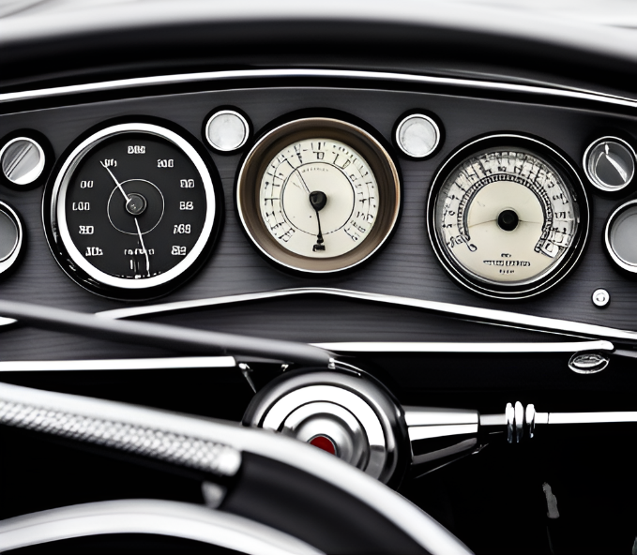

Figure 01: Example of Early Days Car Dashboards

- The Technological Leap: Infotainment and Connectivity
The automotive sector experienced a seismic transformation at the beginning of the 21st century. A new age of in-car experiences, one that extended beyond simple vehicle operation, was brought in with the development of infotainment systems. The dashboard of the automobile suddenly became more than just a place to display important information; it also served as a platform for communication, entertainment, and navigation [4]. Touchscreen screens, resembling portable gadgets, took the stage and provided drivers and passengers with simple access to a variety of capabilities. Until now, the separate domains of driving and digital contact have come together in a technological symphony, with cellphones serving as bridges for communication between the online and in-vehicle interfaces.
This fusion of connectivity and mobility was a significant turning point that fundamentally altered how drivers engaged with their cars. They had access to music and amusement, were guided by navigational aids over unfamiliar terrain, and could safely and easily speak hands-free. Driving had improved in previously unimaginable ways because of the dashboard's evolution from a static tableau to a dynamic gateway that connected the physical and digital worlds[5].

ADAS REVOLUTIONIZES CAR DASHBOARDS
In this section, Automation Takes Centre Stage, we will explore how the evolution of the car dashboard parallels the rise of automation and advanced driver assistance systems (ADAS), propelling it into new realms of functionality and significance.
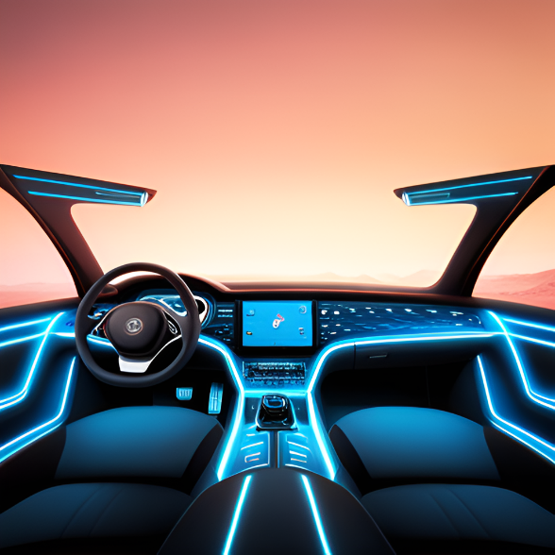
Figure 02: Example of Futuristic Car Dashboard
- Automation Takes Centre Stage
With the introduction of automation and advanced driver assistance systems (ADAS), the course of the automobile dashboard's history was significantly changed. The dashboard became a crucial intersection where human and machine collaboration converged as cars developed the ability to carry out duties independently. It changed from being a one-way source of information to a two-way interface, encouraging cooperation between the driver and the car's intelligent systems [6].
- The Rise of Advanced Driver Assistance Systems (ADAS)
The concept of the dashboard changed when automation was gradually incorporated. Real-time information about the surroundings, the road, and any risks started to take precedence. Intricate sensors and algorithms are used by ADAS systems, which include functions like adaptive cruise control, lane departure alerts, and automated parking, to analyse the surroundings and support the driver in making judgements [7]. The dashboard of cars developed into a display medium for these dynamic insights, serving as a link between the computing power of the automobile and the driver.
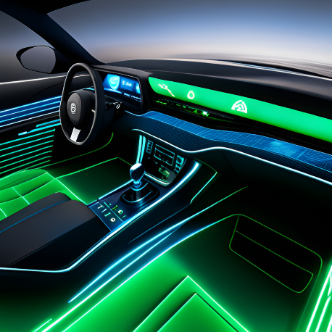

Figure 03: Concept Picture of ADAS Car Dashboard

- Dashboard as a Collaboration Hub
A new type of human-machine collaboration was facilitated by the union of automation with the dashboard of an automobile. The dashboard gave the driver the ability to actively interact with the vehicle's capabilities rather than relegating them to a passive position. The driver was given real-time feedback on the dashboard while the vehicle used adaptive cruise control to keep a constant distance from other vehicles or automatic parking assistance to manoeuvre into small parking spaces. The dashboard was transformed into a communication centre that promoted understanding and trust between the driver and the car's artificial intelligence as a result of this interactive feedback loop.
Additionally, the appearance of the dashboard was seamlessly updated to include automatic safety systems. The conspicuous display of warnings for impending lane changes, potential crashes, and traffic sign recognition improved driver awareness and safety [8]. The dashboard, which was before only an instrument cluster, now had to actively aid in the driving job, symbolising the changing dynamic between human intuition and mechanical accuracy.
- User Experience and Interface Design
User experience and interface design gained importance in this era of greater cooperation. The dashboard needed to convey data in a way that supported human intellect and attention duration; it could no longer just display statistics. Design guidelines were created to make sure that information was presented in a quiet, transparent manner, minimising distraction [9]. Graphical user interfaces were carefully designed to prioritise important information while accommodating the natural inclinations of the human eye.
The emergence of touchscreens, speech recognition technology, and even motion controls simultaneously provided a variety of engagement modalities, enabling drivers to select the most user-friendly method of interacting with the dashboard's functions. Artificial intelligence systems analyse the behaviour and preferences of the driver, personalising the dashboard's design and information to suit each user's requirements. As a result of the customization, usefulness and safety were both enhanced. Drivers could now access information with little interference to their concentration on the road [8-9].

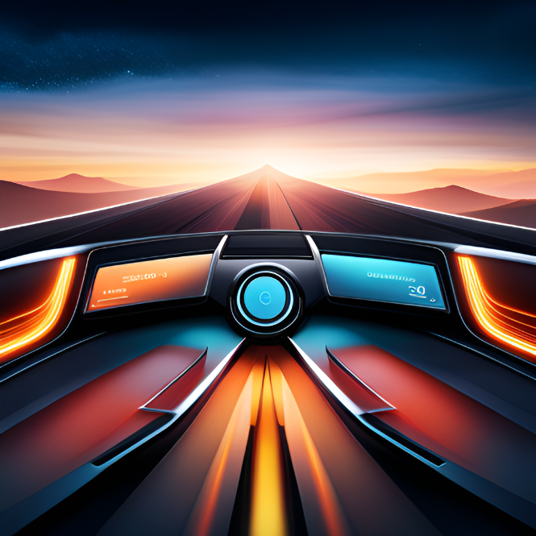

Figure 04: An Interface Design of Car Dashboard for User Experience

- CONCLUSION
The remarkable journey of technical development within the automobile industry is reflected in the growth of the car dashboard from its primitive beginnings to its present condition as a dynamic and interactive interface. Automation, connectivity, and advanced driver assistance systems (ADAS) have all come together to change not just the functions of the dashboard but also the experience of driving. The modern automobile dashboard serves as a centre for communication between intelligent machines and human drivers and is no longer restricted to providing basic information. Driver decision-making is aided by real-time data from ADAS features that easily integrate into the dashboard, providing for safer and more productive travel. This change highlights how human intuition and artificial intelligence are collaborating more and more, with the dashboard serving as a bridge for communication.
In this shift, user experience and interface design have taken centre stage. In addition to providing information, the dashboard now regulates a seamless interplay between people and technology. The way that drivers interact with their vehicles has been completely reimagined thanks to touchscreens, voice recognition, and AI-driven customization, improving both usability and safety. Future prospects indicate even more creative opportunities. Autonomous vehicles may be able to react to the emotions and physical circumstances of the driver thanks to augmented reality displays and biometric sensors. Real-time traffic information and reminders for preventative maintenance might result from deeper integration with smart cities, elevating the dashboard to a key position within a larger linked ecosystem.
In conclusion, the development of the automated vehicle dashboard reflects the constant change in the automotive industry. It started out as a group of mechanical gauges but has now developed into an intelligent interface that captures the interaction between people and machines. The dashboard is a representation of innovation, human intelligence, and the limitless possibilities of integrating technology with the human experience as it continues to improve and transform transportation. The automated car dashboard will likely continue to be at the centre of this change, offering chances to build safer, more practical, and more engaging driving experiences.
- REFERENCES

- "The Role of AI in Shaping the Future of Car Dashboards" Rodriguez, M., Patel, S., Gupta, R. AI & Society, 2022.
- "User- Centered Design of Autonomous Vehicle Interfaces: Past, Present, and Future" Thompson, G., Davis, M., Garcia, F. Human Factors, 2020.
- "Designing Multi-Modal Interfaces for Autonomous Vehicle Dashboards" Wilson, D., Turner, H., Collins, P. International Conference on Automotive User Interfaces and Interactive Vehicular Applications, 2019.
- "A Cognitive Ergonomics Approach to Designing Autonomous Car Dashboards" - Garcia, C., Smith, A., Wilson, B. (Ergonomics in Design, 2022)
- "From Buttons to Gestures: A Study on Gesture-Based Interfaces in Autonomous Vehicle Dashboards" - Smith, R., Davis, L., Miller, K. (Proceedings of the ACM Conference on Interactive Experiences for Television and Online Video, 2017)
- "Innovations in Automotive Dashboards: A Survey of Emerging Technologies" - Patel, A., Williams, R., Jackson, M. (IEEE Transactions on Intelligent Vehicles, 2019)
- "Human-Machine Interaction Design for Next-Generation Autonomous Vehicle Dashboards" - Chen, L., Kim, H., Patel, S. (IEEE Intelligent Transportation Systems Magazine, 2023)
- Gowda, N., Ju, W., & Kohler, K. (2014, September). Dashboard design for an autonomous car. In Adjunct proceedings of the 6th international conference on automotive user interfaces and interactive vehicular applications (pp. 1-4).
- Padagannavar, P. (2016). Automotive product design and development of car dashboard using Quality Function Deployment. International Journal of Industrial Engineering Research and Development (IJIERD), 7(1), 10-23.

