Recombinant DNA Technology

Dr.Ramesh.D^{1*},Dr.Kumara Wodeyar D.S², Dr.Ananth Krishna.L.R³, Dr.Yathish.H.M⁴, Dr.Anil Gattani⁵

^{1*}Assistant Professor Department of Veterinary Physiology and Biochemistry, Veterinary College Hassan, KVAFSU, Karnataka-573202, India.

²Assistant Professor, Department of Veterinary Physiology and Biochemistry, Veterinary College Gadag, KVAFSU, Karnataka, India

³Associate Professor and Head Department of Veterinary Physiology and Biochemistry, Veterinary College Gadag, KVAFSU, Karnataka, India.

⁴Assistant Professor Department of Animal Genetics and Breeding, Veterinary College Bengaluru, KVAFSU, Karnataka, India

⁵Associate Professor Department of Veterinary Biochemistry, College of veterinary Science and Animal Husbandry, Jabalpur India.

*Corresponding Author

Assistant Professor Department of Veterinary Physiology and Biochemistry, Veterinary College Hassan, KVAFSU, Karnataka-573202, India. Email-drrameshd@gmail.com Mobile-8277522429.

Learning Objectives
- Comprehend the importance of recombinant DNA technology.
- Gain knowledge of isolation of DNA and its separation on agarose gel.
- Understand restriction enzyme digestion and ligase enzymes and their application in rDNA Technology.
- Understand the different vectors and their application in gene cloning and expression.
- Safety concern of rDNA Technology
- Applications of rDNA Technology

Abbreviations Used
SL No | Abbreviations used | Expansion
1 | DNA | Deoxy ribonucleic acids
2 | dsDNA | Double stranded Deoxy ribonucleic acids
3 | gDNA | Genomic DNA
4 | rDNA | Recombinant DNA
5 | E. coli | Escherichia coli
6 | PCR | Polymerase Chain Reaction
7 | GMOs | Genetically modified organisms
8 | YACs | Yeast Artificial Chromosomes
9 | BACs | Bacterial Artificial Chromosomes
- Introduction
Recombinant DNA technology has resulted in step forwards in crop and animal biotechnology. The rDNA technology comes from our ability to study and change gene functions by manipulating genes and transforms them into cells of plant and animals. There are several tools of molecular biology are used including, DNA isolation and analysis, molecular cloning, determination of gene copy number, quantification of gene expression, transformation of the appropriate host for replication or transfer into crop and analyses of transgenic organisms etc.
- Definition and background
Recombinant rDNA technology involves procedures for analyzing or combining DNA fragments from one or several organisms sources including the introduction of the rDNA of interest into a host cell for replication, or integration into the genome of the target cell (Figure 1).
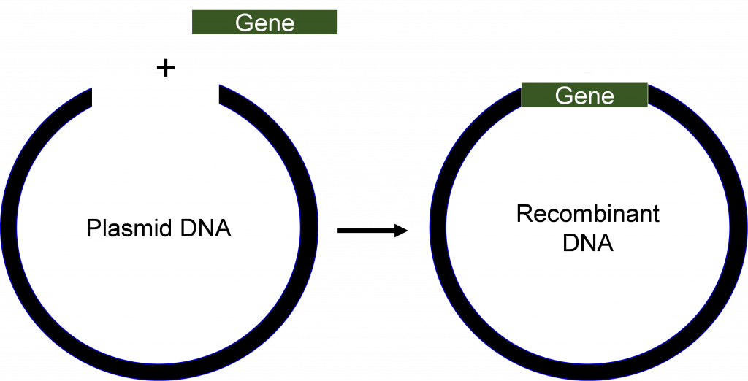

Figure 1. Recombinant DNA is made from combining DNA from two or more different sources [1].
Advances in molecular biology in the early 1970s, including the success in creating, and transferring DNA molecules into cells, revolutionized both science and industry.
The first GMOs were bacteria that synthesize the simple proteins of pharmaceutical interest, (Ex: insulin). As the technologies improved day by day, the other organisms including plants became amenable for improvement by rDNA technology.

Table 1 provides important milestones in the development and application of rDNA technology.
Table 1.Events related to the development and application of recombinant DNA technology.
Event | Year
Mendel’s experiments published | 1866
DNA discovered in cell | 1869
Mutation of genes by x-rays | 1927
One gene-one enzyme hypothesis | 1941
DNA is identified as the genetic material | 1944
Structure of DNA determined | 1953
Ribosomes synthesize protein | 1954
Function of mRNA proposed | 1961
Genetic code determined | 1961-64
Isolation of a restriction enzyme | 1970
Recombinant DNA techniques developed | Early 1970s
Isolation of a single copy gene from higher eukaryote | 1977
Rapid method of DNA sequencing developed | 1977
Plant transformation | 1983
Field testing of transformed plants | ca. 1986
Release of engineered plants to general public in the US | 1995-96
Transformation of cells with rDNA produces organisms called bioengineered or genetically modified organisms (GMOs). The GMOs contain new traits from another organism. The first GMOs were Escherichia coli cells that were transformed with genes from human to produce various proteins for pharmaceutical purposes.
- Isolation of DNA, restriction digestions and its separation on an agarose gel Electrophoresis
- Preparation of gDNA
Isolating the pure DNA is the prime criteria in rDNA technology, the challenge is that plant cell and animal cells produce numerous other compounds that often act as contaminants and may inhibit cloning or sequencing of the DNA. Also, tissues as well as organs from the same plant, or different plants frequently contain various compositions of metabolites, like proteins, lipids, and carbohydrates. These compounds must be separated from the DNA during isolation. To achieve this, scientists take advantage of the physicochemical Properties of different molecules inside the cell. For example, negatively charged DNA is, making it soluble in aqueous solution. However, the polar sugar phosphate groups of the DNA are repelled by non-polar solutions. Therefore, the last step in many DNA purifications protocols involves precipitation using alcohol. Other compounds, for example, proteins can also be easily separated from DNA by altering the concentration of salt in the extraction buffer (Figure.2).
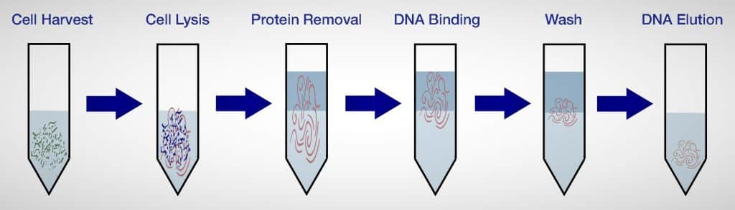
Fig.2 Genomic DNA isolation procedure
- Digestion of gDNA using restriction endonucleases
Restriction endonucleases are a group of enzymes derived (primarily) from bacteria. Although there are different types of restriction enzymes, those most useful for rDNA technology would recognize the specific short sequences (4-6bp) in DNA and cleave the dsDNA at that site to produce cohesive (sticky) or blunt-ended fragments (Figure 3).
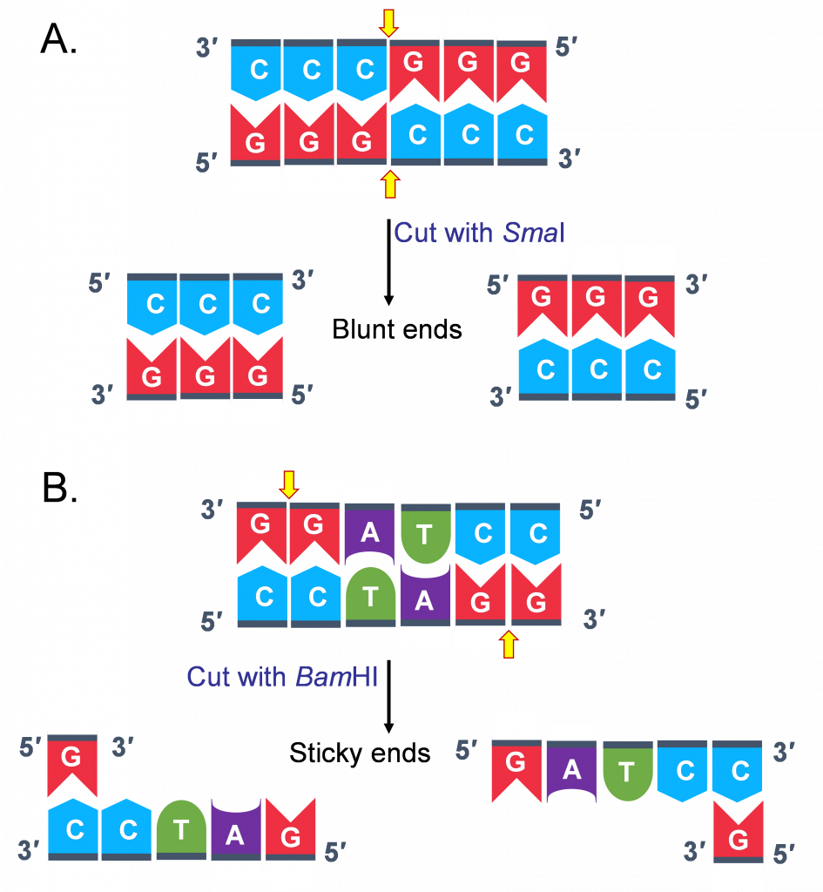

Figure 3. Example of how restriction enzymes cut DNA. (A) Treating the DNA with SmaI results in fragments with blunt ends. (B) Whereas treatment with BamHI produces fragments with “cohesive” or “sticky” ends [1].
More than 500 different restriction enzymes have been identified and can be purchased commercially. Thus, one may ask the question, how often does a restriction enzyme cut within a genomic sequence? It is not possible to give an exact answer for this question. However, let us assume that there are 4 bases on any strand of DNA. This means the probability of detecting an A (adenine) at a particular location is 1/4. Now, since most restriction enzymes recognize sequences of 6 bases long specifically, the probability of finding such a site is (1/4)6 = 1 site in every 4,096 base pairs (bp). Assuming you have isolated genomic DNA from maize, and you want to digest it with a restriction enzyme that cuts every 4,096 (4,100) bp, how many fragments will you obtain? To answer this question, you need to have knowledge of the size of the genome of the plant you are working with. For example the approximate size of genome of the maize is 2,500,000,000 bp. Thus, using an enzyme that cuts every 4,100 nucleotides one would expect to obtain 2,500,000,000 bp/4,100 bp, approximately 610, 000 fragments. Note that nucleotide distribution is not always random and thus frequency may be different for given DNA. Also, methylation of specific bases in genomic DNA can prevent cleavage at some site.
- Separation of digested genomic DNA on Agarose gel
The only physical features of nucleic acid fragments that are routinely used for their characterization are their size and nucleotide sequence. DNA Molecular weight is most conveniently evaluated by electrophoresis in agarose gels. Agarose solidified into gel by forming hydrogen bonding when cooled from the melted state. This gel, interwoven network of agarose chains, interferes with the running of DNA through the gel. Pore size, which affects rate of movement of DNA fragments of a given size, depends on the agarose concentration. The gel is submerged in electrolyte solution; sample is loaded into wells on one end and current is subjected to facilitate movement of DNA fragments. Since the charge of the DNA is negative it will migrate in the electrical field. Fragments separate according to size. The distance of the migration in each time is proportional to 1/log MW. Following gel electrophoresis DNA can be visualized by staining with ethidium bromide or other DNA stains (Figure.4).

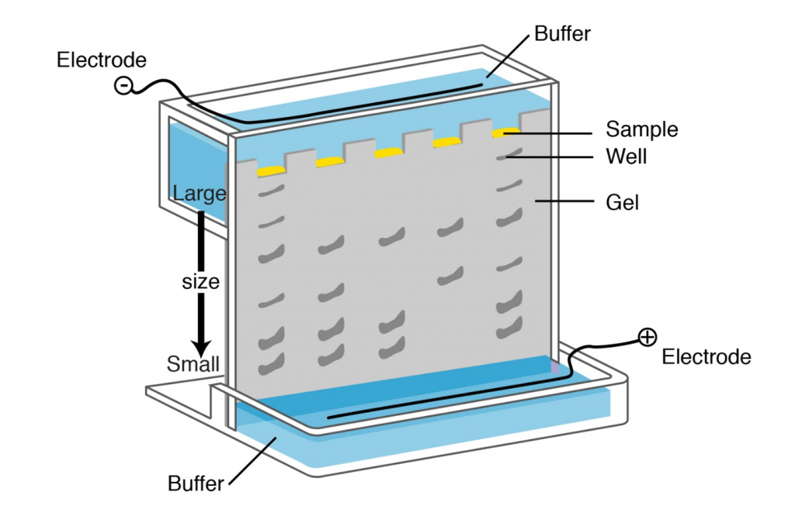

Figure 4. Gel electrophoresis is used to separate nucleic acid (DNA and RNA) or protein molecules by their size. For DNA, the sample is placed in an electric field and the negatively charged DNA will migrate to the positive electrode. Migration speed depends on the size of the DNA fragment. Use of semisolid matrix such as agarose or polyacrylamide gel facilitates separation of the DNA molecules.[2]

Table.2.Enzymes Used in Recombinant DNA Technology [4]
SL | Enzyme(s) | Function
1 | Type II restriction endonucleases | Cleave DNAs at specific base sequences DNA ligase Joins two DNA molecules or fragments
2 | DNA polymerase I (E. coli) | Fills gaps in duplexes by stepwise addition of nucleotides to 3’ ends
3 | Reverse transcriptase | Makes a DNA copy of an RNA molecule
4 | Polynucleotide kinase | Adds a phosphate to the 5’ OH ends of a linear duplex
5 | Terminal transferase | Adds homopolymer tails to the 3’-OH ends of a linear duplex
6 | Exonuclease III | Removes nucleotide residues from the 3’ends of a DNA strand
7 | Bacteriophage λ exonuclease | Removes nucleotides from the 5’ ends of a duplex to expose single-stranded 3’ ends
8 | Alkaline phosphatase | Removes terminal phosphates from either the 5’ or 3’ end (or both

- Polymerase Chain Reaction (PCR)
Polymerase chain reaction (PCR) is a method by which millions of copies of a single DNA fragment are produced in a test tube within few hours. The basic steps in PCR reaction were discussed in the Lesson on PCR and Gel Electrophoresis. Once the sequence of a particular gene is known, it becomes possible to use PCR to isolate that gene from any DNA sample, at the genomic level a gene consist of regulatory sequences, coding, and non-coding sequences. Thus, if the goal is to use PCR to isolate both regulatory and non-regulatory sequences of a gene, the approach would be to use DNA as the starting material.
In cloning genes by PCR, restriction enzyme sites are incorporated at the 5′-end of the primers to facilitate cloning of PCR fragments. A few additional nucleotides (~6 nucleotides) added at the 5′-end of the restriction sites to facilitate restriction digestion of PCR products prior to cloning in a plasmid vector. Alternatively, PCR products can be cloned directly into a T-A cloning vector without restriction digestions in E. coli because the PCR product obtained from the PCR reactions using Taq polymerase includes A overhangs.
After cloning into E. coli, the fragment is analyzed by sequencing and then sub-cloned into suitable vectors for expression studies. Like all other biochemical processes, DNA synthesis by PCR is not a perfect process, and occasionally the polymerase enzyme will add an incorrect base to the growing DNA strand. In the context of DNA replication in a cell, the errors are corrected by the different DNA polymerase; this is called “proofreading”. Commercially available DNA polymerases may or may not possess the proofreading capability. But in order to achieve the proof reading in the PCR reactions we need to use the high fidelity DNA polymerase like Pfu, vent polymerase if the PCR product is used for the Expression analysis.
Important consideration in PCR analysis is contamination.
Minor contamination of the starting material can have serious consequences. Recall that minute amounts of starting DNA can be amplified to millions of copies through PCR. If one accidentally mixed DNA from different sources, the results will be confounding making it impossible to distinguish lines in this regard ensures that proper procedures are followed in preparing PCR assays. One common contamination source in plant biology is the products from previous amplification processes. A completed PCR reaction will contain millions of copies of amplified fragments so that even a minute droplet or aerosol from a pipette tip will contain an enormous number of amplifiable molecules. It is always essential to run negative controls which will reveal the presence of contaminating DNA in your PCR assays.
- mRNA as starting material for rDNA Technology
The synthesis of RNA from DNA through the process of transcription. Transcription is an important step in gene expression. The mRNA produced can be isolated and “copied” back to DNA by a process called reverse-transcription (Figure 5). The first step of reverse transcription mimics a strategy used by retroviruses that have RNA genomes. As part of their gene-transmission package, retroviruses contain an enzyme called RNA-dependent DNA Polymerases, referred to as reverse transcriptase. After infecting a host cell the retrovirus uses its reverse transcriptase to copy its single stranded RNA genome into a strand of complementary DNA (cDNA). The reverse transcriptase then synthesizes the second DNA strand from the first strand of cDNA to make a double stranded-DNA copy which can then integrates into the host genome.
If only a gene’s coding sequence is required, isolating the gene from cDNAs would be the strategy. It is important that cDNAs are synthesized from tissues expressing the gene of interest. Thus, prior knowledge of where the gene is functional is important in constructing the cDNA molecules for cloning the gene of interest.
The cDNAs produced in vitro (Figure 5) can be used for PCR analysis, similar to chromosomal DNA. The combination of reverse-transcription and PCR (RT-PCR) is a valuable tool in gene cloning and quantification of mRNA.
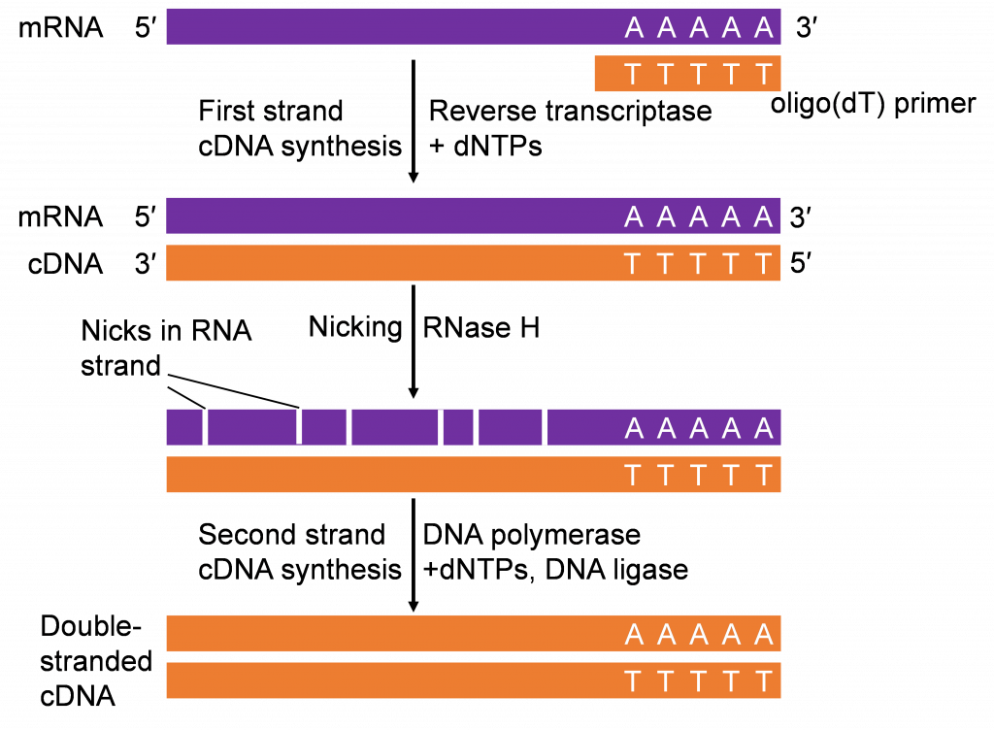Figure 5. A population of mRNA isolated from plant/animal tissues is combined with oligo(dT) primers that anneal to the poly(A) tail of the mRNAs to initiate the reverse transcription of cDNA from mRNA template with dNTPs. The result is hybrid molecules (mRNA-DNA). Treatment with RNAse H causes degradation of the mRNA leaving an intact single stranded DNA (first strand). DNA polymerase synthesizes the second strand by adding complementary dNTPs to the growing chain. The reagents for RT usually come in pre-mixed kits making such an assay easy to carry out routinely in most laboratories. Most mRNAs from cells in tissues analyzed are converted to cDNAs. Thus, using primers specific to a sequence, that double stranded cDNA can be amplified by PCR for various purposes for example, gene cloning. [1]

- Cloning vector definition and requirements
A cloning vector is a specialized DNA sequence that can enter a living cell and provide means for detection of its presence to a researcher by conferring a selectable property on the host cell (e.g., resistance to antibiotics), and possess means for self-replication. A vector must also have simply distinguishable physical traits, such as size, or shape, to allow purification away from the host cell’s genome without any contamination.
- Types of cloning vectors
An example of a cloning vector is a plasmid (Figure 6), defined as an autonomously replicating extra chromosomal circular DNA which is faithfully passed on to progeny. Plasmids are double stranded circular DNA and range in size from about 1 kb – 200 kb. The most useful for cloning are 2 – 10 kb because smaller plasmids are easier to manipulate and usually produce higher copy numbers when grown in bacterial host cells.
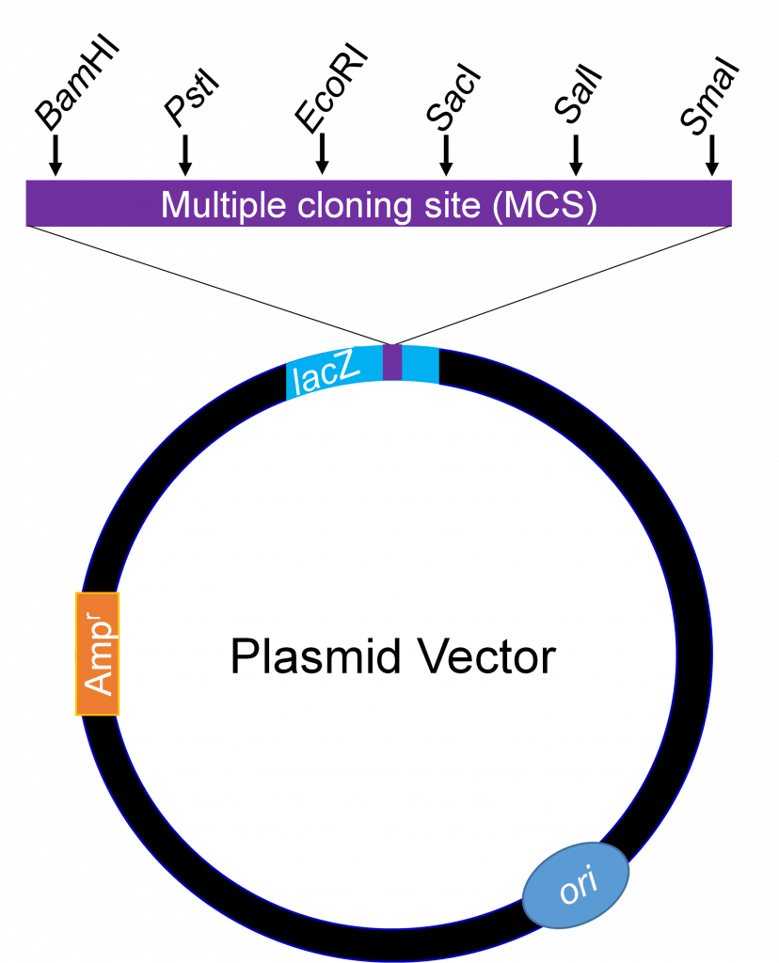

Figure 6. Basic map of a plasmid vector. The MCS contains several restriction enzymes sites and few are shown here as example [1].
Generally, no more than 10 kb is cloned into plasmids. For cloning large DNA fragments with high efficiency, a vector called bacteriophage lambda is used. Large chromosomal DNA fragments close to 23 kb are stable when introduced into a lambda phage vector.
Bacterial Artificial Chromosomes (BACs)
Bacterial artificial chromosomes are simply plasmids designed for the cloning of very long segments ( 100,000 to 300,000 bp) of DNA. They generally they include selectable markers such as resistance to the antibiotic chloramphenicol (CmR ), as well as a very stable origin of replication (ori) that maintains the plasmid at one or two copies per cell. DNA fragments of several hundred thousand base pairs are cloned into the BAC vector. The large circular DNAs are then introduced into host bacteria by electroporation. These procedures use host bacteria with mutations that compromise the structure of their cell wall, permitting the uptake of the large DNA molecules [4].
Yeast Artificial Chromosomes (YACs)
- coli cells are by no means the only hosts for genetic engineering. Yeasts are particularly convenient eukaryotic organisms for this work. As with E. coli, yeast genetics is a well-developed discipline. The genome of the most commonly used yeast, Saccharomyces cerevisiae, contains only 14x10⁶ bp (a simple genome by eukaryotic standards, less than four times the size of the E. coli chromosome), and its entire sequence is known. Yeast is also very easy to maintain and grow on a large scale in the laboratory. Plasmid vectors have been constructed for yeast, adopting the same principles that follow the use of E. coli vectors described above.
Convenient methods are now available for moving DNA into and out of yeast cells, facilitating the study of many aspects of eukaryotic cell biochemistry. Some recombinant plasmids incorporate multiple replication origins and other elements that allow them to be used in more than one species (for example, yeast or E. coli). Plasmids that can be amplified in cells of two or more different species are called shuttle vectors. large genomes and the associated need for high-capacity cloning vectors led to the development of yeast artificial chromosomes.YAC vectors contains all the essential elements needed to maintain the eukaryotic chromosome in the yeast cell nucleus: a yeast origin of replication, two or more selectable markers, and specialized sequences needed for stability and proper segregation of the chromosomes at cell division [4].
- Ligation Transformation and Screening for rDNA
Cutting and joining together of vector and DNA fragments from different origins results in rDNA. Recall that restriction endonucleases (table-2) are used to cut dsDNA further to join dsDNA molecules together, an enzyme called DNA ligase is used. The enzyme DNA ligase is used to ligate together restriction fragments by forming new phosphodiester bonds. The ligated vector and DNA fragment can now be transformed into the host cell for replication and expression.
The transformation of E. coli takes several steps. First, a gene of interest is inserted into a plasmid that contains a selectable marker usually encoding for resistance to an antibiotic. Second, the plasmid construct containing the gene of interest is transformed into bacterial cells by briefly exposing the mixture of ligated plasmid-DNA fragment (rDNA molecule) and bacterial cells to cold (0ºC) and heat (37-42ºC).
The next step is to grow the transformed cells on selection media incorporated with selective antibiotic (KAN-Kanamycin). Only the cells that have been transformed with the plasmid containing the gene of interest and the marker for resistance (KAN-kanamycin) to the antibiotic will survive. In addition to using an antibiotic, plasmid vector systems that contain the lacZ gene encoding β-galactosidase allow for easier selection of positive colonies that may harbor the rDNA molecule of interest must be selected using the BLUE-white Screening method as depicted in the Figure.7.

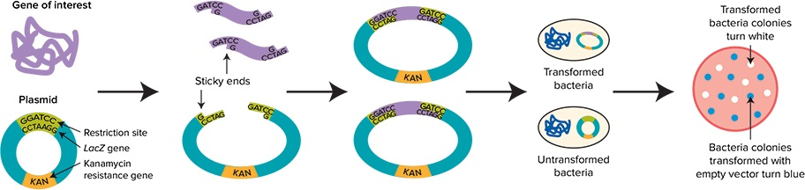
BLUE-White Screening of recombinant Transformed bacteria

Figure 7: Schematic representation of a typical blue-white screening procedure. Blue-white screening of bacterial colonies involves cloning of gene inserted into a plasmid vector with an antibiotic resistance and LacZ reporter gene. The ligation of the insert into the multiple cloning site of the vector inactivates the LacZ gene. The transformation of competent E. coli with the ligated mixture in the presence of X-gal in culture media results in the formation of blue and white colonies [3].
- Applications of rDNA Technology
Today, rDNA plays a significant role for countless patients as well as in questions of how to provide sufficient food supply in developing countries like India and for environmental related issues.Major Application areas of rDNA technology includes Food industry, Agriculture, Environmental use, Medicine Research, Both in Animal and plant Biotechnology etc. Some of the examples are
- Insulin production with recombinant DNA technology
- Recombinant DNA for human growth hormone production
- Recombinant Vaccines
- Gene therapies and recombinant DNA
- Enzyme production with recombinant DNA technology
- Recombinant DNA technology for protein production.

- Safety concern of rDNA technology
Considering the safety of recombinant DNA, rDNA and protein molecules are not observed as dangerous. The apprehensions remain about few organisms that express rDNA, particularly when they outside the laboratory invivio conditions and are introduced into the environment or food chain. The safety issues comprise antibiotic resistance and adverse immune reactions, in addition to the health sector includes the potential of gene pollution of the environment but also deleterious health effects of foods from genetically modified organisms. On the other hand, to make sure the greatest degree of safety possible, all rDNA work needs to be accommodating with high standards and guidelines set out by the respective regulatory institutions of the country. Despite safety issues, there is the ethical issue of genetically modified organisms, human genome editing as well as around genetic information in common.
- The future prospects in rDNA technology
Recent days, recombinant DNA technology plays a very important role in improving health conditions by developing new gene therapy and vaccines products but also in dealing with several plant disorders, especially viral, bacterial and fungal resistance. With the rising incidences of chronic diseases being one of the main driving factors, the size of the global rDNA technology market is anticipated to reach $223 billion by 2028, with an annual growth rate of 7.7% .
Lesson Summary
Recombinant DNA technology has contributed significantly to development of agricultural biotechnology. Transformation of cells with rDNA produces organisms called bioengineered or genetically modified organisms. The tools for plant rDNA technology include, vectors, restriction enzyme, ligation enzymes, bacterial hosts, methods to isolate and multiply nucleic acids, methods to quantify nucleic acids, Agrobacterium as a vector to insert foreign DNA into plants.
Reference:
- WALTER SUZA; DONALD LEE; MARJORIE HANNEMAN; AND PATRICIA HAIN, https://iastate.pressbooks.pub/genagbiotech/chapter/recombinant-dna-technology/
- Electrophoresis (genome.gov)
- https://www.moleculardevices.com/en/assets/app-note/bpd/automated-colorimetric-colony-selection-blue-white-colony-screening-with-qpix-400-series .
- Lehninger Principles of Biochemistry 4th Ed, 2004

