SOLAR TREE
*Anuradha¹
Aayush Chauhan²
*Rishabh Kumar³
¹singhanuradha99@gmail.com
³46.rishabhkumar@gmail.com
^{1,3}Uttarakhand Technical University, Dehradun Uttarakhand
2IIMT University Meerut
INDIA
ABSTRACT
Solar energy, which is regarded as the most abundant and necessary energy source, may be captured and converted into electricity with the use of solar panels. However, solar power panels have concerns with prisoner efficacy and public perception and require a big space to be built (in municipal areas it's impossible to find such a large area). Solar tree is a novel idea that can effectively address these issues in these circumstances. Innovative building called a "solar tree" uses photovoltaic technology on a single pillar that resembles a tree. Maximum power point tracking (MPPT), which modifies the angle of the solar panels in response to variations in decreasing irradiance angle, is used to maximise conversion of power from solar panels. A MPPT solar hybrid inverter is used in this study to help produce the most solar energy, which will be stored in the fast-charging solar battery. In order to minimise the shadowing effect, 50 watt 10 solar PV panels are used to build a tree-like structure. Each panel is inclined at an angle of 22.5o towards the south-east direction. The Internet of Things (IoT) is used in the research to record panellist data for research purposes. A temperature of 65 degrees Celsius may be reached by solar panels, which will reduce the functionality of solar cells. Temperature has an impact on the efficiency of the panels, Therefore sprinkler system will be used to cool solar panels. This system will be managed by IOT. We will use the Internet of Things to measure the temperature of the solar PV panels because we are aware that high temperatures reduce the efficiency of the solar panel. We built this research with the idea that solar tree power plants might be a component of the plan for smart cities because there hasn't been much work reported on enhancing the design of solar trees and making them easier to operate and more efficient.
- INTRODUCTION
Renewable energy is produced by ongoing processes or sources. These energy sources include hydropower, geothermal energy, wind energy, and solar energy. Although green and clean energies are frequently connected with renewable energy sources, there are small distinctions between these three categories of energy. If renewable energy originates from recyclable sources, then clean energy is defined as energy that emits no pollutants, such as carbon dioxide, and green energy is defined as energy derived from renewable sources. Although there is much overlap between these different energy sources, not all renewable energy sources are genuinely 100 percent green or clean.
- Solar energy
Solar energy is that which is obtained by the sun's rays. The world is constantly and abundantly supplied with solar energy. Solar power is a free resource. It does not produce any feasts, thus it cannot be a source of pollution. It's price is reasonable. Its cost of conservation is modest. The solar system's one drawback is that it cannot generate power during periods of heavy rains. But compared to other energy sources, its effectiveness is lower. Only the first investment is required. It has a low emigration rate and a lengthy lifespan. without pollution.
- Advantages of Solar Energy
Humanity has never been treated cruelly by nature. In actuality, it is bringing him many kinds of resources and supplies to meet the various demands of mankind. This also applies to solar energy. The sun is a huge nuclear reactor that continuously burns hydrogen gas at high temperatures to produce energy.
Here are several examples:
1. Solar energy is a potent replacement for nuclear and fossil fuels.
2. The sun offers a perfect energy source that is cheap, infinite, and doesn't pollute the air or the water.
3. Energy source that is more and more competitive.
4. Lessens the need for reliance on the natural gas or electrical grid.
5. Financial aid for self-supply.
6. Important countermeasure to climate change.
7. Produces wealth and local jobs.
8. Ability to generate enough electricity to run a home/building.
- A Sight on Solar Geometry:
The seasonal and hourly variations in the sun's location must be taken into account when constructing any kind of system that depends on solar radiation. It is important to have a system that can adapt to the position of the sun because this directly affects the incident angle of sunlight. When selecting where to place a building's windows, it is also beneficial to take the position of the sun into account.
Two alternative angles can be used to characterise the sun's location. The first angle is the solar azimuth (denoted by, alpha), which is the angle formed by the sun and the cardinal directions of true north when seen in a clockwise direction It is calculated up to the point at which the sun's location is horizontally projected onto the surface of the Earth. The second angle, the solar altitude or elevation, denotes the sun's angle with respect to the horizontal and is represented by the Greek letter phi (Figure 1). The amount of radiation incident on a vertical surface is measured by the angle of incidence, not the position of the sun. Following is a relationship between the angle of incidence and the solar altitude:
θ = 90° – Φ
The orientation of incoming sunlight on a structure or item can be determined by combining the two angles. Knowing this, it is recommended to install solar collectors and other equipment so that they are 20 degrees either side of perpendicular to the sun. We can further manage the angle incident on the surface of the collector by including a device that adapts to the incidence angle of the sun [3].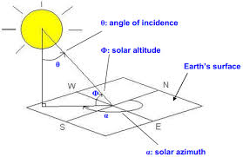
Figure 1 Solar Geometry
In relation to the horizontal plane of its orbit, the Earth is tilted on its pole to pole axis by around 23.5°. As a result, there is a 47° difference in the peak solar altitude angle, which accounts for the seasonal differences between summer and winter. The sun rises and sets throughout the day in the northern hemisphere on the south-facing (equator-facing) side of the building
- SOLAR PV TREE
The idea of a "Solar PV Tree" is a distinctive fusion of science and art to create a solar PV sculpture. This innovative concept was viewed as an effort to combine artistic beauty with new solar power technologies. A solar tree is essentially a decorative way to generate clean energy. Panels are organised as leaves on the limbs of the energy tree, which resembles a tree. It resembles a natural tree exactly, except instead of leaves, it has solar panels [1].
A self-sufficient photovoltaic installation is the solar tree. It is outfitted with a number of solar panels that, so long as they are illuminated by sunlight, generate voltage at their respective ends. The voltage can then be used to charge batteries after that. Subsequently, a variety of uses are made of the energy that was previously stored in the batteries. The electric energy provided by this device is completely free, save for the occasional battery replacement. The charging and discharging procedures of the batteries can be further automatically controlled to extend their lifespan. ‘TREE’ stands for
T = Tree generating
R = Renewable
E = Energy and
E = Electricity
The solar tree is a steel framework on top of which solar panels are installed to capture solar energy for use in recharging cell phones, laptops, and other tiny electronic devices. Street lights can also be charged with it. A solar PV tree may gather incident sunlight throughout the day regardless of the Sun's location because the panels are set up at various angles. The solar tree's three-dimensional structure can increase the overall surface area for sunlight absorption.
- Objective of building solar tree:
1. Since there were just a few solar tree plants with standard structural designs, we tried to build a better one.
2. To increase the effectiveness of the power plant, we tested it with a sprinkler system.
Additionally, solar trees have benefits for both urban and rural areas, golf courses, and resorts. applicable in public parks, recreational parks, private gardens, balconies, verandas, and penthouses; Highways are affected. In areas that have been cleared of trees, it is utilised for street lighting, home power supply, industrial power supply, and continuous power supply.
It is used in batteries charging of mobile phones, laptops, tablets; Wireless data transmission.
- Basic components of a solar tree
- Solar PV Panels
- Cables for connecting modules
- Inverter
- Batteries
- Structure
- MPPT Energy Charge Controller

These are the basic components of solar tree but for its advancement we can also use Solar Trackers and other similar devices such as Solar Concentrator.
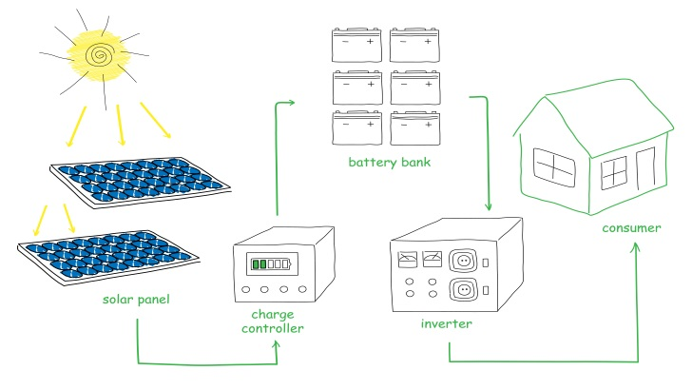

Figure 2. Solar PV System
- Designing of Solar Tree
Solar energy, which is regarded as the most plentiful and significant unavoidable source of energy, can be converted into electrical energy by use of solar panels. Solar power panels, however, have concerns with prisoner efficacy and public impression and require a huge space to be built (in civic areas it is impossible to find such a large area). In a similar circumstance, Solar Tree is the fashionable idea capable of solving these issues. A solar tree is a building or piece of art that uses photovoltaic technology on a single pillar to resemble a tree. The use of maximum power point tracking (MPPT), which entails adjusting the angle of the panels in accordance with changes in the angle of irradiance, can result in the best possible conversion of power from solar panels.. In order to minimise the shadowing effect, 50 watt 10 solar PV panels are used to form a tree-like structure. Each panel is tilted 22.5 degrees towards the south-east, and an MPPT solar hybrid inverter is then used to produce the most solar energy, which is then stored in the fast-charging solar battery. Additionally, the Internet of Things (IoT) will be used in the project, which will help with two things: first, recording panel data for research purposes; and second, monitoring the sprinkler system that will be installed on the solar tree to increase panel efficiency because we know that temperature affects panel efficiency. An automated sprinkler system will be used since high temperatures reduce the panel's effectiveness.
Each panel on the solar tree is constructed to operate as efficiently and as long as possible. Their primary goal was to get rid of the shadow effect.
Following fundamentals are kept in mind :
• The branches should be 120 degrees apart from one another, and the branch above them should be conjugate with them. Thus, the rays of the panels below it are not blocked by the shade of the panel above.
.
- The branches should be inclined at an angle of 22.5º with respect to the pole(structure).
- Further the panel should be kept South-East direction (as per Indian standards).
3-D design of solar tree, prepared by Tinkercad software is shown in fig.2

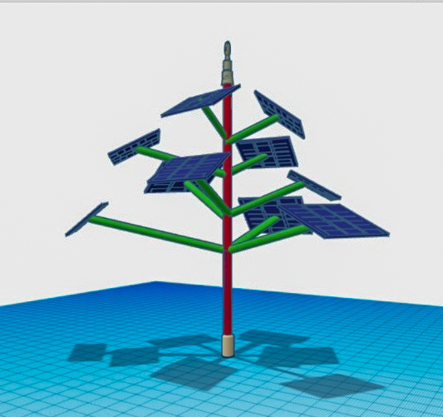
Figure 2 Design by Tinkercad
- Schematic and Circuit Diagram of the Solar tree: Schematic and circuit diagrams are shown in fig.3 and 4 respectively

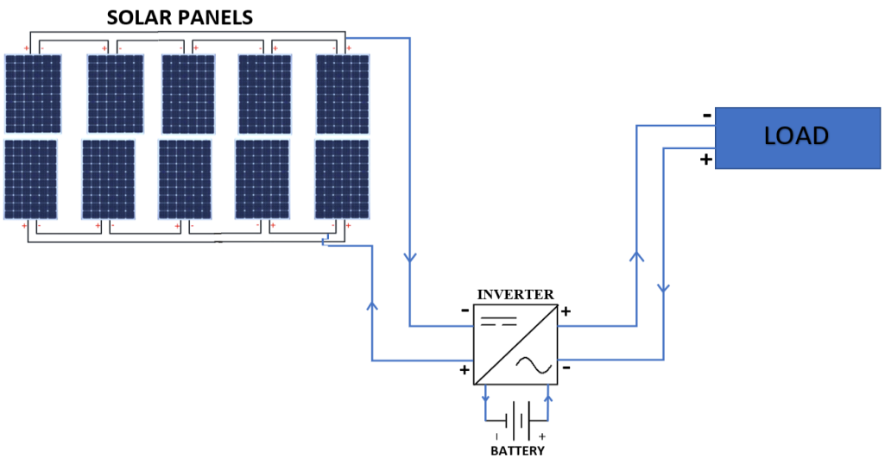
Figure 3 Schematic Diagram

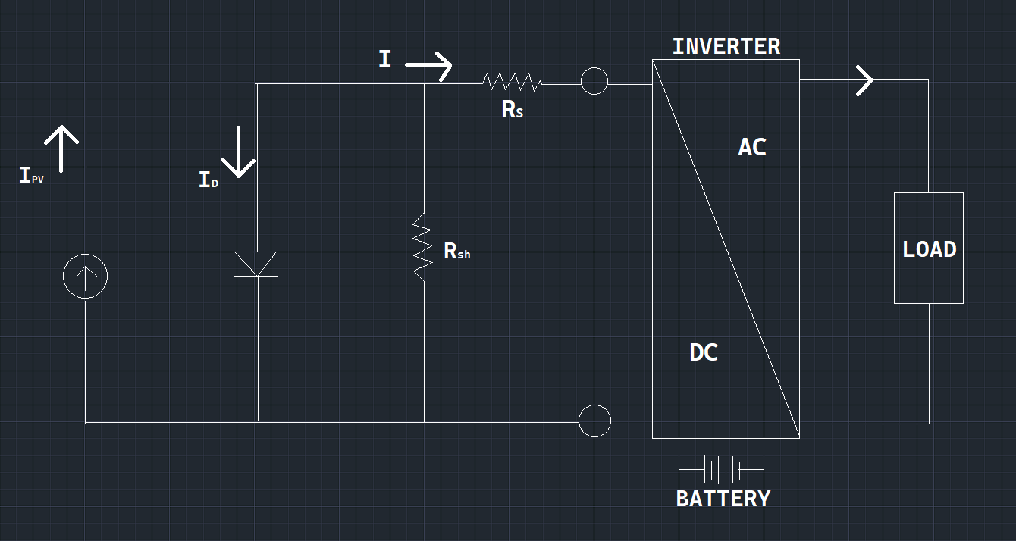
Figure 4 Circuit Diagram

- Block Diagram of the Project:

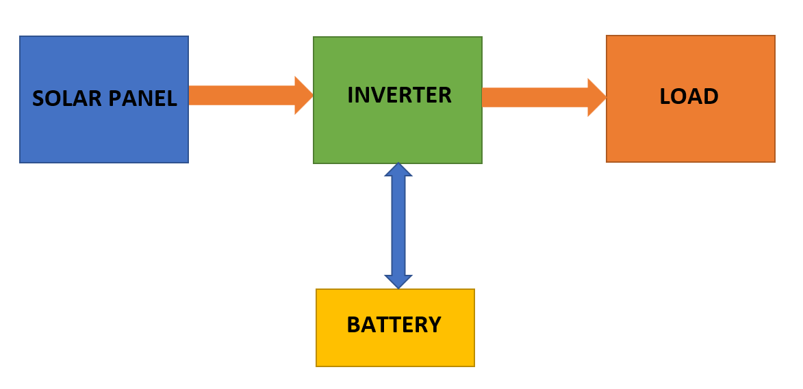
Figure 5 Block Diagram

- CONSTRUCTION OF SOLAR TREE

The promotion of knowledge, comprehension, and adoption of renewable energy is one goal of many solar tree installations. They are not commonly employed as a building's main energy source; rooftop solar systems serve that purpose. In addition to rooftop solar panels or other eco-friendly building practises, solar trees serve as a symbol of these more significant financial commitments and their positive environmental impact. Solar trees can increase people's knowledge of and enthusiasm for solar energy while also offering shade and gathering spaces. A solar tree can accomplish a wide range of goals, some of which are described below.Some of the general objectives of the solar tree are:
1. Agricultural field
- They are also used to power tillers, pumps, etc.
2. Commercial Buildings
- In various companies, factories, offices, schools, etc; Solar trees can be installed with proper land management.
3. Residential Sites
- Residential areas like colonies can be benefitted from the solar trees.
- They are also used in green or net-zero energy buildings.
- They can also be easily installed/placed at verandahs, private gardens (see Figure 8).
4. Highways
- Solar trees can be installed across highways to power lighting systems and surveillance cameras.
5. Coastlines
- They can be used on coastlines as on highways.
6. Public Places
- They can be installed at public places like parks, gardens, tourist spots, etc to power lightings as well as to increase aesthetic appearance..
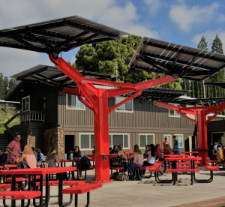
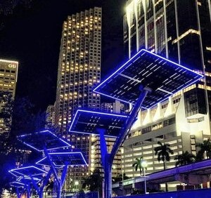

- CONCLUSION
In conclusion, the idea of a solar tree is an original and environmentally friendly approach to the production of renewable energy sources and urban planning. These buildings incorporate solar panels into their architecture to efficiently harness solar energy and also offer aesthetic value to urban surroundings by emulating the shape and function of a tree.
Solar trees have a number of important benefits. They are especially well suited for urban locations with limited available land since they first optimise space utilisation. As a result of their design, solar panels may be oriented more effectively, maximising energy capture throughout the day. Solar trees can also be used as charging stations, giving electric automobiles and other devices easy access to clean energy.
Solar tree installation can considerably lower carbon emissions, lessen reliance on fossil fuels, and promote sustainable energy practises. For wider implementation, nevertheless, issues including high setup costs, upkeep, and guaranteeing interoperability with regional infrastructure must be resolved.
Solar trees may become even more efficient and economical as technology develops, giving them more and more appeal as a mainstream energy producing choice. They are a potential invention on the path to a greener and more sustainable future because of their capacity to combine utility with beauty and environmental advantages.

REFERANCE
[1] Mr. A P R Srinivas, “Design and Development of a SOLAR TREE”, International Journal of Scientific & Engineering Research, Volume 7, Issue 10, October-2016 ISSN 2229-5518.
[2] https://www1.eere.energy.gov › solar_timeline.
[3] Holck, O. and Rosenfeld, J.L.J. (2005). Estimation of Exposure to Sunlight of the Liner Under a Tiled Roof Solar Energy. Vol 78 No. 2. pp. 199–209.

[4] Jenny Nelson, The Physics of Solar Cells, Imperial College Press, 2003.

[5] Mr. A P R Srinivas, “Design and Development of a SOLAR TREE”, International Journal of Scientific & Engineering Research, Volume 7, Issue 10, October-2016 ISSN 2229-5518.

[6] Notton. G, Cristofari. C, Mattei. M. and Poggi. P. (2005). Modelling of a double-glass photovoltaic module using finite differences, Appl. Therm.Eng, 25, 2854–2877.
[7] Kumar, S., Tiwari, P. & Zymbler, M. Internet of Things is a revolutionary approach for future technology enhancement: a review. J Big Data 6, 111 (2019).
[8] Manish Dhone, Kishor Sonwane, Denis Farkase, Jayantsingh Baghel “A Review on Solar Tree” International Journal of Scientific and Research Publications, Volume 4, Issue 2, December 2018 IJARIIE-ISSN(O)-2395-4396
[9] G. S. Karlekar Asst. Professor, Department of Electrical Engineering. Ballarpur Institute of Tech., Ballarpur, India. International Journal of Engineering Applied Sciences and Technology, 2020 Vol. 4, Issue 10, ISSN No. 2455-2143

