ECO MATERIALS
INTRODUCTION
Eco materials are referred to as "environmentally friendly materials" or "environmentally preferable". These are the materials that promote environmental betterment across their whole life cycle while preserving reliable performance. Eco-materials reduce negative effects on the environment and increase the recyclability of materials and efficiency.
PROPERTIES
Eco-materials are considered superior to conventional materials as they poses the following properties:
- Reusability, which enables the reuse of collected goods for similar purposes.
- Recyclability, which enables the use of collected waste as a raw resource.
- Structural dependability will be based on its dependable mechanical attributes.
- Long-term usage without chemical deterioration due to chemical stability.
- The ability of biological safety to be employed without harming the ecological system.
- The ability to substitute other materials for "bad" ones.
- A perk that makes the workplace comfortable

Eco-Material: Need for the material
- Non-renewable resources are necessary for the building industry's extraordinary growth.
- The production of construction materials has harmful and lasting environmental effects. The distribution of urban growth has significant effects on the need for resources, the state of the environment, the advancement of technology, and world trade in construction.
- Transferring resource management programmes and low-pollution production techniques to emerging nations like India is one of the most crucial steps towards lowering the worldwide environmental effect of the production and use of construction materials.

Eco-Material: Classification
- Cyclic materials
- Materials for ecology and environmental protection
- Materials for social justice, society and human health
- Energy – Producing materials based on their origins and functions
These four main categories are further classified to ten sub-categories (Table 1):

Sub Categories | Examples
Recyled Material | Eco-cement. Coal ash concrete, glass ceramics from wastes, recycled plastics, silica fertilizer, marine block.
Renewable Material | Wood ceramics, wood based materials, soil ceramics, biodegradable plastic made of vegetable  base
Material for efficeincy | Waste reduction materials, wear resistant metals and alloys, pre-paint steel and alloy.
Material for waste treatment | Membranes for exhausted gas separation, ion-exchange resins, microbial enzymes, absorbement materials for oil and grease removal.
Material for reduction of environmental load | Catalysts and biological membrane materials for fuel cells, carbon-fiber composites, photo- catalyst coating materials for construction.
Material for easy disposal | Biodegradable plastics, functionally graded material, colorbetos which replace asbestos, TSOP
Hazaradous free material | Lead-free solder, halogen flame retardant-free plastics, chromium-free steel VOCs-free adhesive. heavy metals free polyesters
Materials for reducing human health impacts | Vibration damping steel sheet, sound proof panels, anti-bacteria coating materials, bone-cream for orthopedic surgery and brain surgery.
Material for energy efficiency | Ultra-ligh steel Al-Mg lightweight alloys, heat resistant alooy for turbines, high magnetic induction steel sheets, highly endothermic steel chromo phobic fibers heat mirror fom for household energy saving
Material for green energy | High grade silicon for solar cells, thermoelectric conversion materials, selectve transparent glass highly durable sesing sheets for solar batteries
Table 1 Category of Eco-Materials

Benefits of Eco-Friendly Materials:

Saves Energy

Energy is saved because environmentally friendly items like solar panels harness energy from the sun. They act as a substitute for fossil fuels in the generation of power. They don't use resources like coal, gas, or oil because they are non-renewable.

Low-Maintainance
Eco-friendly structures require less upkeep since they operate more efficiently. For instance, a green building makes extensive use of windows to encourage natural illumination.It leads to energy conservation and a decline in the use of artificial lighting.

Saves Water
By utilising these resources, green construction fosters water conservation, ensures that future generations will continue to have access to plentiful and clean water, as well as allows alternative water sources like rainwater and promotes water recycling.

Costs Less
Water and energy can be saved by adopting eco-friendly materials in green buildings.Construction may be more expensive up front, but it will save money on operations and upkeep in the long run.

Improves Environment

The indoor environment is improved by eco-friendly items. Going for architectural designs that allow for natural lighting, ventilation, and air quality is becoming more and more popular today.The atmosphere is made bright and inviting by these elements.

Decrease Carbon Footprint
Environmental protection is the benefit of eco-friendly packaging that is most obvious. Eco-friendly packaging typically uses recycled and biodegradable materials, reducing the waste of raw materials in the manufacturing process.Additionally, the manufacturing process is typically more effective, using less precious resources overall and lowering the environmental harm that enterprises cause.

Bio-Degradable

Green packaging provides positive long-term impacts even after it has been used for transportation, in addition to lowering carbon footprint and environmental impact.These sustainable alternatives materials have a minimum environmental impact because they are recyclable and biodegradable.

Eco-Friendly Materials:

Bamboo

The best environmentally friendly alternative to wood is bamboo, member of the grass family. Depending on the variety and region, bamboo can grow up to 3 feet every day, making it one of the planet's fastest-growing plants. More than only its quick growth, bamboo is sustainable. Bamboo is becoming more and more popular, which will help forests regenerate. Bamboo is used in a wide range of products, including tiles, trim and flooring, wood, countertops, and decks.

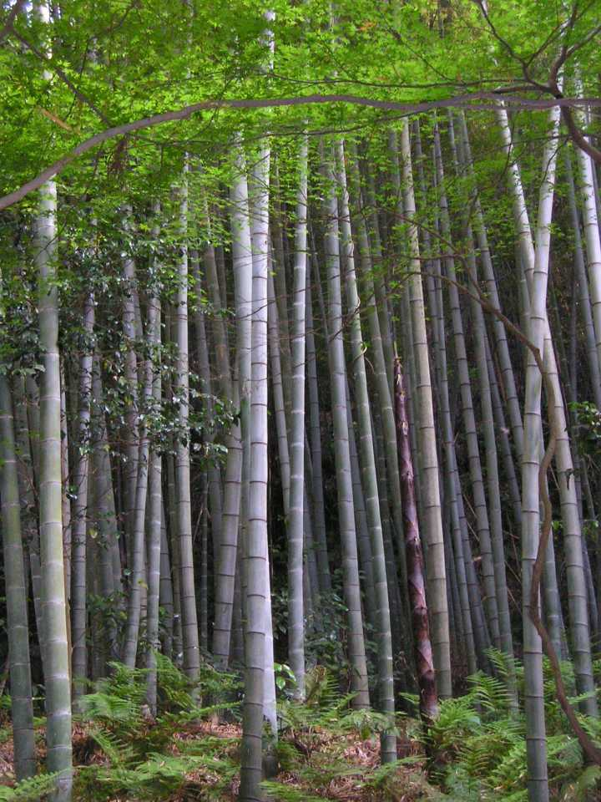 Fig 1: Bamboo

Recycled Metal

Mining, heating, and shaping steel need a lot of energy, but properly and effectively reusing or recycling it into new goods lowers the energy needed and increases the sustainability of the material. The recycled metal is strong and does not require regular replacement. It does not burn or wrap, making it perfect for roofing, building facades, and structural support. Recycled steel resists insects and moisture.

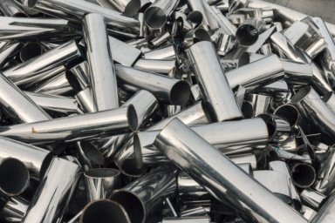 Fig 2: Recycled Metal

Sheep's Wool Insulation:
Sheep's wool is a great alternative to chemical-filled insulation. It is produced with less energy and insulates the home just as effectively as conventional insulation. Your building can be made more energy efficient and soundproof with sheep's wool. Compared to straw and some natural insulators like cotton, sheep's wool is more common, simpler to collect, and regenerates more quickly. Additionally, it does not decompose as quickly as those substances, like straw.Unfortunately, it is not the cheapest insulator. It also needs to be treated to deter flies and prevent the growth of fungi. Such treatment may make sheep's wool less environmentally friendly, depending on the chemicals used.

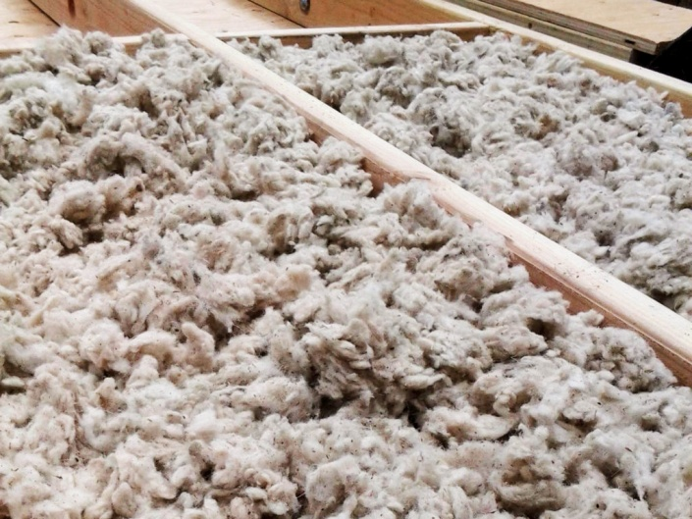 Fig 3: Sheep's Wool Insulation

AAC Blocks
Traditional bricks are quickly being replaced in the construction sector by AAC blocks, also known as autoclaved aerated concrete blocks. As a result of being up to three times more lightweight than normal bricks, AAC is very simple to handle and work with.
One of these AAC blocks' major benefits is thermal efficiency. They lessen the need for heating and cooling while keeping the residence comfortable year-round. When compared to regular blocks, the blocks are more fireproof. When compared to traditional clay or cement blocks, the weight of these blocks is up to three times lower. As a result, the construction is finished sooner.
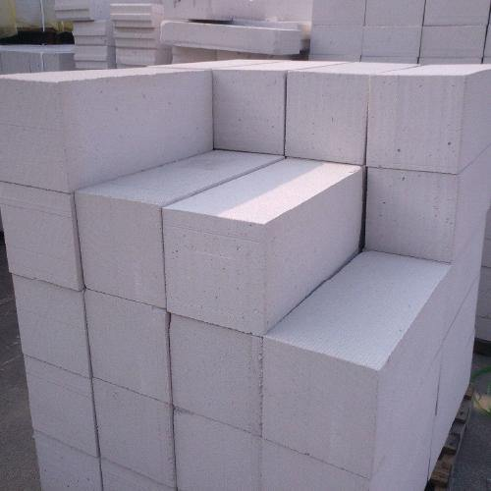 Fig 4: AAC Blocks

Timber Crete

Construction is done with this unusual building material, which is made of concrete and sawdust. It is lighter than concrete and produces fewer transportation emissions.

Sawdust also recycles waste and replaces some of the labour- and energy-intensive components of traditional concrete. Concrete made from wood can be moulded into typical shapes like pavers, bricks, and blocks. It is more effective in insulating than brick, clay, or concrete and is also incredibly robust and fire-resistant.

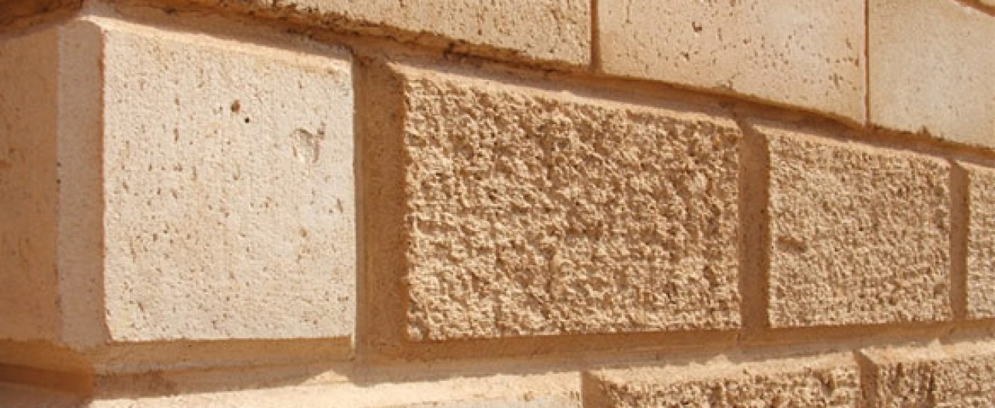 Fig 5: Timber Crete

Straw Bales

Another eco-friendly building material that can be used for framing is this one. They have good insulating properties and can be used as soundproofing materials. Because it prevents air from passing through, which may have some properties that make it fire-resistant, it can also be utilized as fill material between columns and in beam frameworks.

Straws can be easily harvested and replanted without harming the environment. Straw baling also has a negligible effect. In order to keep the house warmer in the winter and cooler in the summer, they can also be hung from walls, ceilings and attics.

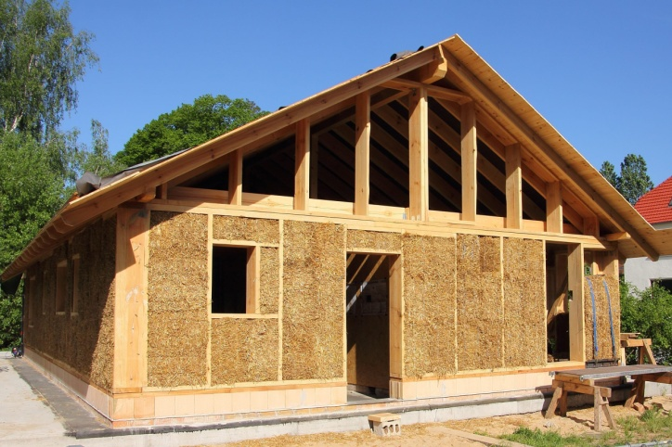 Fig 6 : Straw Bales

Cork
Similar to bamboo, cork expands quite quickly. It can be extracted from a living tree that is still generating new cork and growing. Even after being sustained under pressure, the cork maintains its flexibility and toughness and resumes its former shape. It is often used in floor tiles because of its durability and toughness.
Additionally, because of its exceptional shock absorption qualities, it is perfect for insulating sheets and subflooring. It is also excellent at absorbing sound.
It is also a valuable thermal insulator because it resists fire, especially if left untreated, and does not release any toxic gases as it burns. Since cork is almost impermeable, it does not absorb water or rot.

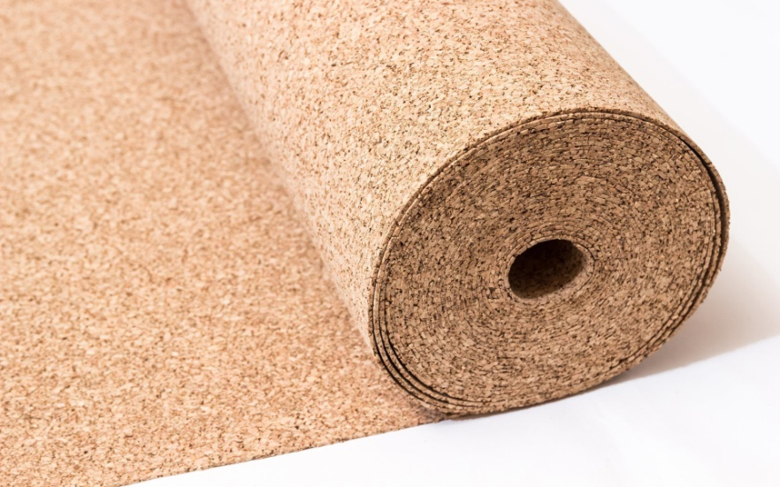 Fig 7 : Cork

Stabilized Mud Blocks
On earth, soil is fairly prevalent. Additionally, dirt has strong, good thermal insulating qualities. In order to provide chipper construction and increase building strength, the earth is used as a construction material. Additionally, enhance building thermal control and offer users excellent efficiency. The issue, though, is where soil is used in building. Therefore, soil is used in mud blocks thanks to science.
This stabilised mud wall is used to simulate the space between a reinforced beam and column. This block is used in a variety of ways. Mud brick is another name for this stabilised mud block.

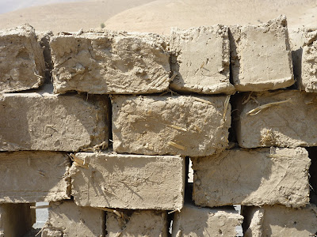 Fig 8 : Stabilized Mud Blocks

Plant-Based Polyurethane Rigid Foam

In construction, rigid foam is frequently used as insulation material. It is constructed of kelp, hemp, and bamboo. It can be used as insulation since it is stiff and essentially immovable. It offers heat resistance, sound insulation, and protection from pests and mould.
Hempcrete
In order to create a strong, environmentally friendly building material, lime or mud cement is combined with hemp shives, which are tiny fragments of wood from the plant's stalk. Hempcrete can be integrated with conventional building construction methods while being lightweight and non-structural. Similar to conventional concrete, it can be prefabricated into building materials .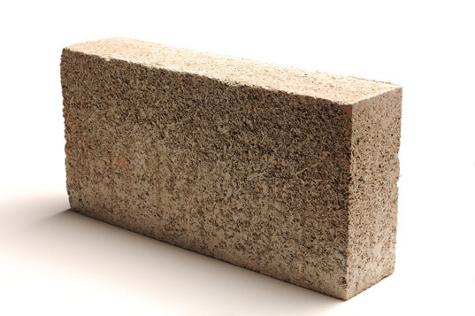 Fig 9 : Hempcrete

Conclusion
Building with environmentally friendly materials benefits both the environment and human health. I truly hope that the information on this list has been enlightening and helpful in guiding future environmentally responsible decision-making.

