Nanotechnology in Animal Husbandry: Pioneering Advancements in Dairying

Somveer  PhD Research Scholar  Dairy Engineering Division  National Dairy Research Institute  Karnal, Haryana, India  somveer.berwal20@gmail.com | Amrita Pramanik  PhD Research Scholar  Animal Biotechnology Division  National Dairy Research Institute  Karnal, Haryana, India  amritapramanik2020@gmail.com | Manisha Kumari  Teaching Associate  Dairy Engineering Division  College of Dairy Science and Technology, RAJUVAS  Bikaner, Rajasthan, India  mishameena7@gmail.com

Abstract
The livestock production industry is at a tremendous pressure to generate enough food to the exponentially increasing population on Earth. The encounter with advanced infections, diseases as well as climate change has increased the pressure on the livestock production system. Nanotechnology, an emerging application of particles at the nano scale size, opens gate to increase animal production, growth and health by providing enhanced diagnostics, medicines, vaccines, therapeutics, adjuvants, animal fodder and others feed additives, and helping in reproduction of animals. The implementation of nanotechnology in the dairy industry holds the potential for a forthcoming revolution. Current chapter explores captivating instances of the novel application of nanotechnology in animal husbandry and dairy processing industry to familiarize the benefits and potential challenges of emerging nanotools that helps in increasing the food production from cattle and shelf-life extension for dairy products in a sustainable manner. Moreover, reducing size of particles through nanotechnology can enhance the properties of bioactive ingredients in dairy products.

Keywords: Nanotechnology, Agriculture, Dairying, Animal Husbandry and Farm animals.

- INTRODUCTION
The word ‘nano’ is adopted from the Greek-language word which means ‘the dwarf’ and is commonly used in combination with other words like nanometre, nanobots, nanotechnology (NT), etc. [1,24]. NT is defined as the science and technology of small things with new changes in their chemical composition, physical structure and also higher reactivity as well as solubility [1,25]. Nanomaterials differs from their counterparts with respect to their unique physical, chemical, and biological properties. Due to the smaller size, molecules are more biologically active, having more stable structure and are less affected by other underlying factors like oxidative inactivation etc. The main objective of NT is to generate materials on a nanoscale, having at least one dimension ranging from 1 to 100 nanometers [1], concerning various sizes of biological structures (Fig. 1). These ultrastructure materials having higher surface-area ratio, called nanoparticles (NPs). Nanoparticles (NPs) can be readily synthesized from a range of substances, encompassing metals, flowers, leaves, and chemicals [21]. At the ultramicroscopic scale, NPs attain distinct physical, chemical, and biological attributes, opening novel avenues for investigating the cellular, structural, and molecular mechanisms within mammalian cells [2].
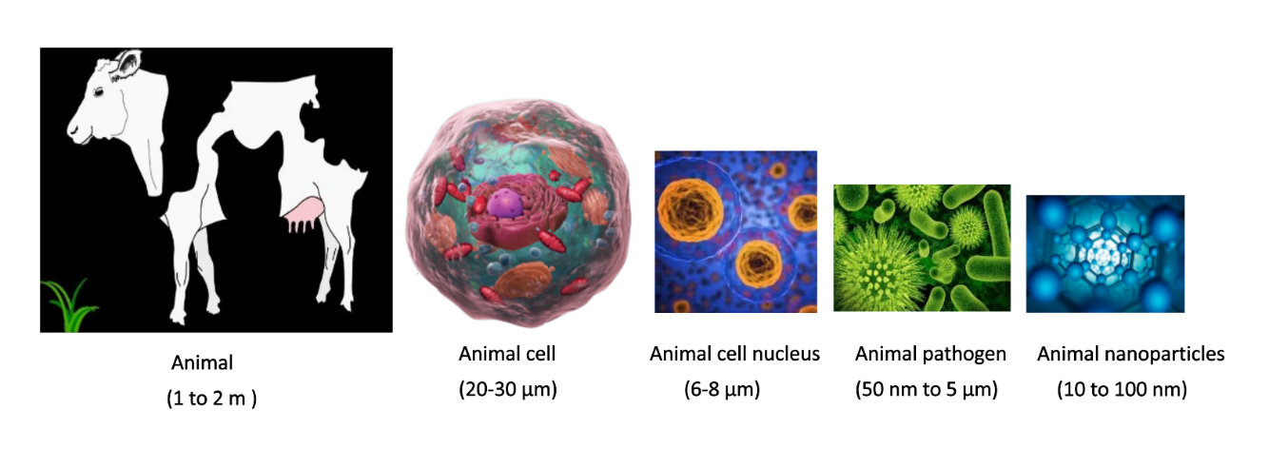
Fig. 1: Different biological structures with varying size in farm animals [21]

NT, the manipulation of matter at the nanoscale, has emerged as a game-changing technology with a broad range of applications in numerous industries. NT has made their mark on agriculture, changing animal husbandry practices and dairy farming methods over the past years. This chapter explores the various applications of NT in enhancing animal health, nutrition, and overall productivity in the milieu of modern agricultural practices. NT having numerous applications in veterinary medicine including disease diagnosis, treatment, animal breeding, drug delivery, and improving and boosting animal origin food product. It offers a wide range of new nanomaterials and NPs including Nano chips, nanosenser, gold NPs, liopsoms, quantum dot, magnetic Nanoparticles etc for disease diagnosis, vaccination, pathogen detection, animal breeding and provide polymeric NPs, carbon nanotube, Nano shell dendrites, etc for delivering antimicrobial NPs and nano medicine for treatment of disease.
Numerous domains within agricultural animal production hold promise for the application of nanotechnology (NT) to enhance both animal well-being and food yield. Over an extended span, domesticated animals including cattle, goats, sheep, pigs, buffalo, and poultry have functioned as vital food sources, contributing meat, milk, and related items for human dietary needs. Projections indicate a global human population of around 9 billion by 2050, necessitating a substantial increase, possibly two to threefold, in global agricultural output to meet the escalating demands of the expanding populace. It is assumed that the human population will reach closely 9 billion by 2050, requiring a doubling or even tripling of global agricultural production to adequately cater to the perpetually expanding human populace's food demands [3]. Hence, it is required to adopt the modern technologies, like Nanotechnology in the field of the Animal Husbandry, to enhance the productivity of domestic animals. Over recent years, there has been a growing enthusiasm to investigate the potential of NT in enhancing animal health and production. In this context, our attention is directed towards several NT applications within the realms of Animal Husbandry and Dairying (Fig. 2).

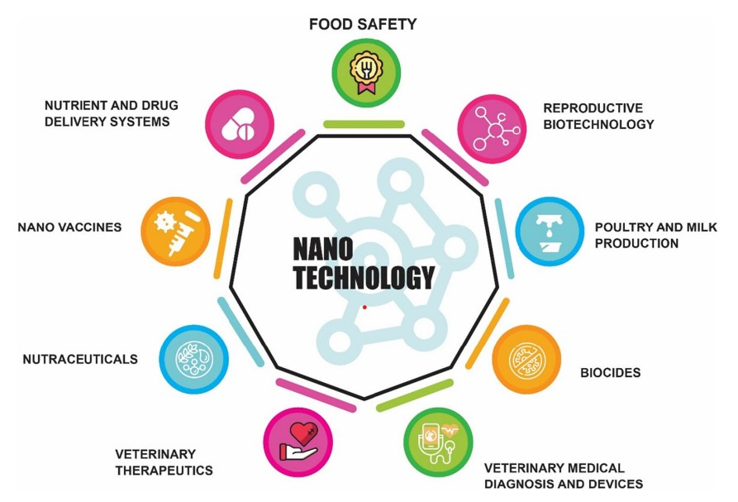

Fig. 2: Applications of nanotechnology for animal production and veterinary medicine [26]

- IMPROVEMENT IN ANIMAL HEALTH
Animals at livestock farm which are in good health contribute to increased animal productivity, ensuring a consistent and quality food supply, reduced reliance on antibiotics and vaccines, and steady trade of animal products. Consequently, prioritizing effective healthcare and disease prevention can lead to substantial cost savings by eliminating the need for treatment and eradication of disease. One of the generally observed examples is an outbreak of the foot and mouth disease (FMD), a catastrophic viral illness that effects cattle, buffalo, sheep, goats, pigs, which costs around 11 billion US dollars to the outbreak countries, primarily India and China [4]. Additionally, animal products such as milk, meat, and dairy products, inclusion of items like hides are not permitted by the disease-free importing nations like the USA and Europe, this restriction also leads to substantial losses in the animal trade industry. Notably, these nanoparticles (NPs) share a similar size scale with disease-causing viruses (nanometres in size) and similarity offers the potential to create efficient diagnostic and therapeutic approaches for specific diseases [2]. Therefore, Nanotechnology is considered as a striking option to improve veterinary medicine, animal health, and drug delivery. The utilization of nanominerals and nanoemulsion technologies brings numerous advantages to the production and application of cattle and poultry feed, such as reduced expenses, decreased reliance on additives, and the incorporation of growth promoting and immunomodulating charecteristics [27]. Nanominerals can also inhibit the harmful microorganisms in feed, which regulate the rumen fermentation process, even defines the reproductive problems faced by cattle and sheep herd industry. Nanominerals have also been used to treat the several animal diseases. For instance, nanozinc oxide has the potential to increase the growth rate, immunity, and reproductive activity of farm animals and birds, as well as lower the occurrence of diarrhoea in non-rumen animals [28]. Studies have revealed that nanozinc has the ability to enhance milk yield and decrease the count of somatic cells in cattle affected by recessive mastitis.
- VETERINARY DIAGNOSTICS
Establishing the fast, accurate, and highly responsive detection of disease-causing pathogens that is fundamental to effectively treating and eradicating those diseases In recent times, the progress in nanotechnology (NT) has brought about a transformative shift in veterinary diagnostics. For example, nanoparticles (NPs) based on iron oxide can now be employed to track the dispersion of a medication within the body by utilizing magnetic resonance imaging (MRI) [5]. Also, a specific drug can be labelled with fluorescent Nanoparticles to identify where it is located within the target cells [6]. Moreover, NP-based diagnostic chips are made available to rapidly analyse a large number of samples [7]. Nanoparticle based diagnostic chips (NP-chips) require less time, a minute quantity of initial material (like blood or serum), fewer consumables, and yield more precise outcomes in contrast to conventional laboratory techniques like PCR (polymerase chain reactions) and ELISAs (enzyme-linked immunosorbent assays) [22]. Several examples of Nanoparticle based veterinary diagnostics are outlined in Table 1.

Table 1: Applications of nanoparticles for veterinary diagnostics [22]

Animal Species | Nanoparticle utilizing diagnostic tool | References
Chicken | Detection of the avian influenza virus (H7N9) by 3D-printed immunoassay using quantum dots | Xiao et al. (2019) [31]
Pig | Detection of for porcine diarrhoea virus using nano-polymerase chain reaction assay | Wanzhe et al. (2015) [32]
Chicken | To examine avian flu antibodies in serum, use a polyvinylidene difluoride membrane coated with gold NPs | Emami et al. (2012) [33]
Cow | To detect volatile organic chemicals connected to bovine tuberculosis in breath, NPs-based array of sensors (NA-NOSE) | Peled et al. (2012)  [34]
Both domestic and wild animals | NPs-based Biosensor incorporated with NPs to identify the faecal samples with Johne's disease which is caused by Mycobacterium avium subsp. paratuberculosis (MAP) | Kumanan et al. (2009) [35]
Chicken and Goat | A fluoro-immunoassay based on quantum dots to identify Chicken Newcastle and goat pox virus antibodies in blood serum | Yuan et al. (2009)  [36]

- VETERINARY THERAPEUTICS AND VACCINE ADMINISTRE
Investment in veterinary medical research and development will increase access to the best medicines and vaccinations for treating diseases. NT has opened up new opportunities in veterinary medicine through the creation of a smart drug delivery system that assures the efficient administration of pharmaceuticals to the target tissues or organ [2]. The smart medication delivery method guarantees optimal therapeutic efficacy for a sufficient amount of time, as well as little irritation and maximum absorption at the target site [8]. Many NPs, including polymeric nanoparticles, nanoshells, carbon nanotubes, dendrimers, liposomes and nanopores, as well as magnetic NPs, have been employed in recent years for the targeted administration of medications to treat veterinary disorders [9]. In veterinary medicine, a wide variety of antibiotics, including penicillin, streptomycin, amoxicillin, tetracycline, and gentamycin, are regularly used medications. Antibiotics are utilised in farm animals, particularly in chickens and pigs, not only to eradicate harmful bacteria but also as growth boosters [10]. Antibiotic resistance may become more common in humans after they consume milk and meat products that have been treated with antibiotics [11]. To combat the overuse of antibiotics in farm animals, NT can be important in the development of potent, nontoxic antibacterial drugs. Antigenic parts of pathogens called vaccines are frequently utilised to shield animals from contracting disease states. The vaccination prompts the body to create particular antibodies against a particular infection [12]. Type of antigen, delivery method, and vaccine formulation all have a significant impact on vaccine effectiveness. Adjuvants (immunological agents) are frequently given with vaccinations to boost the body's immune response, which results in better and more durable immunity to a certain disease [13]. Synthetic peptides and recombinant proteins, which are common candidates for vaccines but are susceptible to early breakdown, cannot be shielded from this by adjuvants based on aluminium [14]. NPs can be used to modify the adjuvants so that vaccinations have increased bioactivity at a lower dose and can elicit a particular immune response. The adjuvants can be created using a variety of NPs, including liposomes, polystyrene nanobeads, and ISCOMs (immune-stimulating complexes) [14]. Several examples of Nanoparticle-based therapeutics in veterinary are summarized in Table 2. By utilising NT, a variety of nutrients, biological molecules, and drugs can acquire novel physicochemical properties. These properties include increased mucoadhesive properties, improved enzymatic actions, higher cellular uptake and mobility, and controlled sustained drug delivery at the target site [29].

Table 2: Applications of NP-active vaccines and therapeutics in animals medicine [29]

Types of Animals | Nanoparticle-based therapeutic and vaccine
Cow | Using liposomes to deliver streptomycin for the treatment of brucellosis
 | Ring-shaped nanoparticles (NPs) delivered intra-nasally for the treatment of respiratory syncytial virus
 | Diclofenac liposome-based transdermal administration as an analgesic and anti-inflammatory medication
Sheep | Delivering the vaccine for foot and mouth disease with polystyrene nanobeads
 | Delivering the vaccination for Newcastle disease with DNA-chitosan nanospheres
 | Staphylococcal mastitis vaccine delivered via liposomes
 | Bovine leukaemia virus vaccination delivered by liposomes
Horse | Treatment of babesiosis with diamidine delivered via liposomes
 | Ivermectin administration by micelles to treat Strongylus vulgaris
 | Rhodococcus equi pneumonia water-based NPs adjuvant vaccination
 | Vaccination against Toxoplasma gondii delivered by liposomes
Pig | Delivery of the FMD (foot and mouth disease) vaccination using dendrimers
 | E. coli Fimbriae Polymeric Vaccine

- IMPROVEMENT IN ANIMAL PRODUCTION
Reproductive efficiency plays a pivotal role in livestock farming systems, significantly impacting farms' productivity, profitability, and long-term sustainability. The ability of farm animals to reproduce effectively directly influences the efficiency of milk and meat production. Farm animals are raised with the aim of producing large quantities of milk, meat, eggs, fiber, and hide productin while minimizing expenses. Achieving efficient farm production requires the implementation of sound management practices that include sufficient nutrition and maintaining good health, as well as adaptation of animals to specific production conditions. The farm animal production system has undergone significant change in the last few decades due to the rapidly expanding demand for food of animal origin, which is supported by the mechanisation of agriculture and technical advancements. Nanotechnologies can also be used to boost farm animals' capacity for reproduction. For instance, NP-coated feed supplementation, also known as nanofeed, is used to increase animal productivity and growth as well as to enrich dairy, meat, and egg products [7]. Currently, nanotecnology in animal production systems is in its very early stage, but there is great potential in coming years that Nanotechnology will be extensively used to enhance the farm animal production.
- ANIMAL NUTRITION
The animal feed causes approximate 40-50% of operating costs in livestock production system [23]. The objective of feed industry is to increase the efficiency of feed and its additives. Nutritional deficiency causes drastic decreases in the production potential of animals, and nutrient-deficient animals are more prone to occurrence of disease [23]. The production of animal products (milk, eggs, and meat) should be increased as well as their quality, and the animal feed industry should use NPs to formulate feed with the following goals in mind: (a) improving overall feed efficiency; (b) increasing levels and quality of animal products (milk, eggs, and meat); (c) using NPs with immune-modulating and antioxidant properties to improve health; (d) reducing the need for antibiotics as growth promoters, as these may have detrimental effects on human health and (e) removing boar taint of animals products, particularly in pig’s meat [15]. Numerous research claimed that feed in nanoform might be used to increase its nutritional value and foster animal growth [15]. Some of the examples of nanofeed additives are summarized in Table 3.

Table 3: Nanoparticle additives-added farm animal feeds [8]

Nanoparticles | Animal Species | Application
Selenium | Sheep, goat, poultry | Inducing stimulation of enzyme activity and rumen microbial flora
 |  | Enhancement of semen quality
 |  | Enhancing immune response
Zinc | Ruminants, pig, poultry | Improvement in feed conversion ratio that endorses animal’s growth
 |  | Enhancement of immune response
Chromium | Pig | Anti-diarrheal activity
 |  | Improvement in the carcass quality, specifically lean meat production
 |  | Enhanced the immune response
Copper | Poultry | Metabolic rate inducing stimulation in broilers during their embryonic development
 |  | Strengthening the biocompatibility of immune system
Montmorillonite-Composite | Poultry | Reduction in aflatoxin toxicity
Nano-polystyrene with polyethylene-glycol linkers and mannose targeting biomolecules | Farm animals, including poultry | Binding and removal of foodborne pathogens in animal feed

- ANIMAL REPRODUCTION
Reproduction, in which germ cells (sperm and oocyte) are combined to create an embryo that grows into a new generation of animals, is a natural mechanism to increase the population of cattle. Since many years ago, people have been breeding next-generation animals to produce more food (meat and milk) for human consumption by taking advantage of the best genotype and phenotypic parent animals. The most popular technique for assisting faster and more widespread replication of superior animal production qualities in farm animal reproduction is artificial insemination (AI) with frozen semen. In order to comprehend the physiology of the fertilisation process, NPs have recently been utilised to research the biological interaction between sperm and egg [16, 17]. Utilization of Nanoparticles (NPs) to evaluate the physical and physiological traits of sperm such as motility, direction, and acrosome integrity, can be helpful in predicting the semen’s suitability for use in assisted reproductive techniques (ART) and as a result, ensuring successful fertilization. Furthermore, Nanoparticle-based magnetic purification method of bull semen has shown efficacy in separating damaged and defective sperm, consequently enhancing fertilization potential both in both vitro and in vivo settings [18, 19]. Recently, the potential applications of NPs as antioxidants and protective agents were investigated as supplement in semen extender to protect sperm during cryopreservation stress [20]. NT can be used in conjunction with techniques for semen cryopreservation and gamete biology to improve an animal's capacity for reproduction. A promising tool in the management of reproduction, nano-biosensors are being validated and used for illness detection, estrus management, and hormone level detection [30].

- NANOTECHNOLOGY FOR DAIRY PROCESSING
Nanotechnology offers a wide range of usage in the dairy industry, providing opportunities to improve various aspects of dairy production, processing, and product quality. The advantages of using nanomaterials in the dairy industry are discussed (Fig. 3). Nanomaterials can be used as encapsulating agents for vitamins, antioxidants, flavours, minerals, and other nutrients, which are important for fortifying milk and milk products [37]. They also have a role in developing novel packaging materials and biosensors to protect against disease-causing microorganisms. Nanomaterials can be beneficial for various other applications such as protecting milk and milk products from oxidation and spoilage [38].
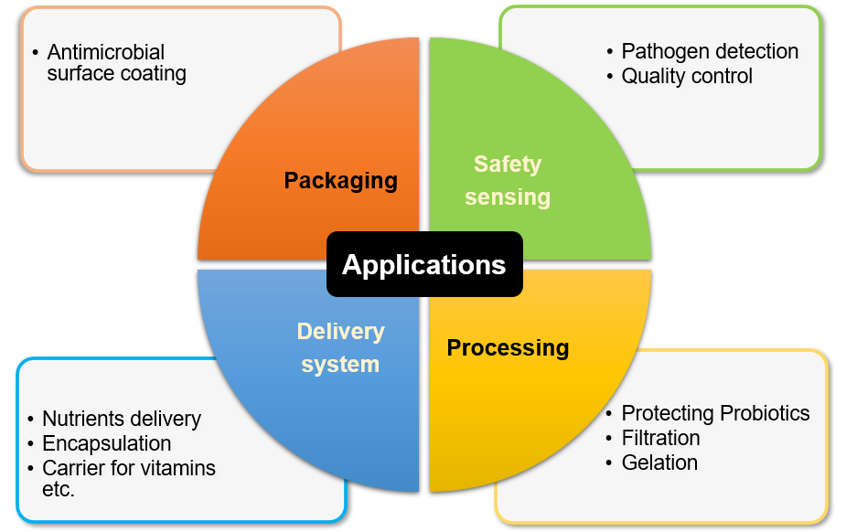
Fig. 3 Applications of nanotechnology in dairy industry [38]

By integrating nanotechnology into the dairy industry, producers can enhance product quality, safety, and processing efficiency, contributing to the advancement of the dairy sector in a sustainable and responsible manner. Some of the key applications include:

- Nutrient Delivery and Fortification
Nanotechnology enables the nanoencapsulation of nutrients and bioactive compounds, enhancing their stability during processing and digestion. This allows for the development of fortified dairy products with improved nutritional value, such as nano-encapsulated vitamins, minerals, or antioxidants in milk, yogurt, or cheese. Nano-emulsions can be utilized to create stable and homogenous mixtures of immiscible liquids, which can enhance the texture and sensory attributes of dairy products. For example, nano-emulsions can be employed in ice cream to provide a smoother and creamier mouthfeel [39]. Nanotechnology can be utilized to reduce the fat content in dairy products without compromising taste and texture. Nanostructured fat substitutes can mimic the mouthfeel of fats, providing healthier alternatives to consumers. The delivery system functions as a conduit for conveying the functional ingredient to the target object of action. It is imperative for the delivery system to safeguard the functional ingredient against chemical or biological degradation throughout processing, storage, and utilization [40].

- Food Safety and Quality
Nano-sensors and nanomaterials play an important role in detecting contaminants, pathogens, or spoilage indicators in dairy products [38]. This ensures better food safety and quality throughout the dairy supply chain, reducing the risk of foodborne illnesses and spoilage. Nanosensors demonstrate the capacity to monitor temporal variations in temperature and humidity, detect gases emanating from oxidative food spoilage and pathogenic microorganism contamination within packages, while also enabling colour changes in the package as a means to convey pertinent information regarding these alterations [41].

- Extended Shelf Life & Smart Packaging
Nanotechnology can extend the shelf life of dairy products by inhibiting the growth of spoilage causing microorganisms and maintaining product freshness for a longer duration. Nanotechnology offers opportunities for advanced dairy product packaging. Nanocomposite materials can provide better barrier properties, reducing oxygen and moisture permeability, thus extending the shelf life and preserving the quality of dairy products. Nano-packaging in dairy products aims to safeguard the contents and extend the shelf life of such products. Commonly investigated nanoparticles used in this context encompass copper, titanium dioxide, zinc oxide, and silver all of which demonstrate notable antimicrobial properties when employed in dairy product packaging (Table 17.3) [38].

Table 4: Nanoparticles incorporated packaging for dairy products [37]

Product | Nanoparticle | Target microorganisms | References
Butter | Zinc NPs coated-packaging film | - | Contreras et al. (2010) [42]
Soft white cheese | Titanium NPs/Poly vinyl alcohol (PVA) CS/ Chitosan/TiO₂ nanocomposite | Escherichia coli Staphylococcus aureus, Candida albicans, and Pseudomonas aeruginosa | Youssef et al. (2015) [43]
Dairy products | Copper NPs | Pseudomonas spp. | Longano et al. (2012) [44]
Soft ripened cheese | TiO₂ coated HDPE-based food packaging | Reduction in activity of organic materials | Gumiero et al. (2013) [45]
Soft cheese and milk powder | Combination of nano-silver (1%) and TiO₂ (0.1%) | Enterobacter spp. | Metak and Ajaal (2013) [46]

- Improved Dairy Processing
Nanotechnology can optimize dairy processing techniques. For instance, the use of nanofiltration or ceramic nanomembranes facilitates more efficient separation of components from milk, leading to improved processing efficiency and higher-quality dairy products. Nanotechnology can be employed to create unique nanoscale tags or markers for dairy products, enhancing their traceability and authentication to prevent counterfeiting and ensure product integrity [47]. Furthermore, the ongoing development of smart packaging employing nanotechnology has introduced innovative functionalities for food preservation. This smart packaging incorporates diverse nanosensors and nanodevices, enabling consumers to access real-time information regarding the condition of the food enclosed within. Equipped with nanosensors, the packaging is designed to monitor both internal and external factors affecting food products, pellets, and containers across the entire supply chain [48].
- POTENTIAL CHALLENGES ASSOCIATED WITH NANOPARTICLES
The safety aspect of nanoparticles is a significant concern due to the increased contact surface area resulting from the nanoscale materials, leading to potential toxic effects in the body. However, the regulation and knowledge surrounding these nanomaterials are currently lacking. While some researchers and research committees acknowledge the usefulness of this technology, further investigations are necessary to ensure the safety of these nanomaterials [49]. The human body may be exposed to nanoparticles through various systems such as the respiratory, digestive, and skin systems, as shown in figure 4. Ingestion of nanoparticles has been linked to heightened oxidative stress, free radical production, DNA mutations, and potential harm to human health [50].
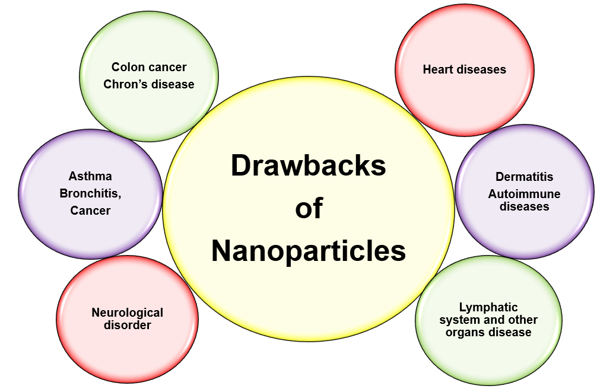
Fig. 4 Potential challenges associated with nanoparticles [49]

- CONCLUSION
Nanotechnology is having vast potential to enhance the production and health of agricultural farm animal. Existing conducted researches have concluded that the application of nanotechnology in enhancement of feed efficiency, precise diagnostic tools, targeted drug delivery, enhanced vaccine response, and increased fertility in agricultural animals. Individuals within the nanotechnology field, encompassing scientists, engineers, and biologists, should sustain their ongoing initiatives. Additionally, securing substantial financial resources for research and development is imperative for their progress. A multitude of uses exist for these inventive nanoparticles within the animal sector, and the current examination aimed to aid in directing attention toward scientific methodologies while also identifying potential applications for these technologies. Nanotechnology has reformed scientific research in the disciplines of animal and veterinary sciences. This chapter aimed to emphasize these purposes and pinpoint potential prospects for forthcoming applications.

Nanotechnology is assuming a crucial function in areas like ensuring food safety, disease diagnosis, medical treatment, vaccine manufacturing, efficient nutrient and drug delivery mechanisms as alternatives to antibiotics, reproductive biotechnology, and the poultry industry. The significant expansion of the contact surface area in nanoparticles gives rise to significant safety apprehensions. Nanoparticles can enter the human body through various routes such as inhalation, ingestion, and skin contact. Consequently, it is essential to establish a suitable regulatory body to tackle these concerns and supervise the secure usage, implementation of nanoparticles and oversee the safe utilization and uses of nanoparticles.

REFERENCES

[1] Roco, M. C. (2003). Nanotechnology: convergence with modern biology and medicine. Current Opinion in Biotechnology, 14(3), 337-346.
[2] Scott, N. R. (2005). Nanotechnology and animal health. Revue Scientifique Et Technique-Office International Des Epizooties, 24(1), 425.
[3] Sekhon, B. S. (2014). Nanotechnology in agri-food production: an overview. Nanotechnology, Science and Applications, 31-53.
[4] Knight-Jones, T. J., and Rushton, J. (2013). The economic impacts of foot and mouth disease-What are they, how big are they and where do they occur? Preventive Veterinary Medicine, 112(3-4), 161-173.
[5] Soenen, S. J., Himmelreich, U., Nuytten, N., Pisanic, T. R., Ferrari, A., and De Cuyper, M. (2010). Intracellular nanoparticle coating stability determines nanoparticle diagnostics efficacy and cell functionality. Small, 6(19), 2136-2145.
[6] Ajmal, M., Yunus, U., Matin, A., and Haq, N. U. (2015). Synthesis, characterization and in vitro evaluation of methotrexate conjugated fluorescent carbon nanoparticles as drug delivery system for human lung cancer targeting. Journal of Photochemistry and Photobiology B: Biology, 153, 111-120.
[7] Craighead, H. (2006). Future lab-on-a-chip technologies for interrogating individual molecules. Nature, 442(7101), 387-393.
[8] El Sabry, M. I., McMillin, K. W., and Sabliov, C. M. (2018). Nanotechnology considerations for poultry and livestock production systems-A review. Annals of Animal Science, 18(2), 319.
[9] Muktar, Y., Bikila, T., and Keffale, M. (2015). Application of nanotechnology for animal health and production improvement: a review. World Appl Sci J, 33(10), 1588-1596.
[10] Selokar, N. L., Dua, S., Kumar, D., Sharma, B., and Saini, M. (2020). Application of Nanotechnology in Agricultural Farm Animals. Biogenic Nano-Particles and their Use in Agro-ecosystems, 1-8.
[11] Bartlett, J. G., Gilbert, D. N., and Spellberg, B. (2013). Seven ways to preserve the miracle of antibiotics. Clinical Infectious Diseases, 56(10), 1445-1450.
[12] Pulendran, B., and Ahmed, R. (2011). Immunological mechanisms of vaccination. Nature Immunology, 12(6), 509-517.
[13] Awate, S., Babiuk, L. A., and Mutwiri, G. (2013). Mechanisms of action of adjuvants. Frontiers In Immunology, 4, 114.
[14] Underwood, C., and Van Eps, A. W. (2012). Nanomedicine and veterinary science: The reality and the practicality. The Veterinary Journal, 193(1), 12-23.
[15] Hill, E. K., and Li, J. (2017). Current and future prospects for nanotechnology in animal production. Journal Of Animal Science And Biotechnology, 8(1),1-13.
[16] Vasquez, E. S., Feugang, J. M., Willard, S. T., Ryan, P. L., and Walters, K. B. (2016). Bioluminescent magnetic nanoparticles as potential imaging agents for mammalian spermatozoa. Journal Of Nanobiotechnology, 14, 1-9.
[17] Feugang, J. M., Youngblood, R. C., Greene, J. M., Willard, S. T., and Ryan, P. L. (2015). Self-illuminating quantum dots for non-invasive bioluminescence imaging of mammalian gametes. Journal of Nanobiotechnology, 13, 1-16.
[18] Odhiambo, J. F., DeJarnette, J. M., Geary, T. W., Kennedy, C. E., Suarez, S. S., Sutovsky, M., and Sutovsky, P. (2014). Increased conception rates in beef cattle inseminated with nanopurified bull semen. Biology Of Reproduction, 91(4), 97-1.
[19] Durfey, C. L., Swistek, S. E., Liao, S. F., Crenshaw, M. A., Clemente, H. J., Thirumalai, R. V., Steadman, C. S., Ryan, P. L., Willard, S. T., and Feugang, J. M. (2019). Nanotechnology-based approach for safer enrichment of semen with best spermatozoa. Journal Of Animal Science And Biotechnology, 10(1), 1-12.
[20] Falchi, L., Khalil, W. A., Hassan, M., and Marei, W. F. (2018). Perspectives of nanotechnology in male fertility and sperm function. International Journal of Veterinary Science and Medicine, 6(2), 265-269.
[21] Charitidis, C. A., Georgiou, P., Koklioti, M. A., Trompeta, A. F., and Markakis, V. (2014). Manufacturing nanomaterials: from research to industry. Manufacturing Review, 1, 11.
[22] Bai, D. P., Lin, X. Y., Huang, Y. F., and Zhang, X. F. (2018). Theranostics aspects of various nanoparticles in veterinary medicine. International Journal Of Molecular Sciences, 19(11), 3299.
[23] Wanapat, M., Cherdthong, A., Phesatcha, K., and Kang, S. (2015). Dietary sources and their effects on animal production and environmental sustainability. Animal Nutrition, 1(3), 96-103.
[24] Chakravarthi, V. P., and Balaji, N. (2010). Applications of nanotechnology in veterinary medicine. Veterinary World, 3(10), 477.
[25] Troncarelli, M. Z., Brandão, H. M., Gern, J. C., Guimarães, A. S., and Langoni, H. (2013). Nanotechnology and antimicrobials in veterinary medicine. Formatex, 13, 543-556.
[26] Ali, A., Ijaz, M., Khan, Y. R., Sajid, H. A., Hussain, K., Rabbani, A. H., Shahid, M., Nasser, O., Ghaffar, A., Naeem, M. A., Zafar, M. Z., Malik, A. I., and Ahmed, I. (2021). Role of nanotechnology in animal production and veterinary medicine. Tropical Animal Health and Production, 53, 1-14.
[27] El-Sayed, A., and Kamel, M. (2020). Advanced applications of nanotechnology in veterinary medicine. Environmental Science and Pollution Research, 27, 19073-19086.
[28] Hassan, A. A., El-Ahl, R. M. S., Oraby, N. H., El-Hamaky, A. M., and Mansour, M. K. (2021). Zinc nanomaterials: Toxicological effects and veterinary applications. In Zinc-Based Nanostructures for Environmental and Agricultural Applications (pp. 509-541). Elsevier.
[29] Osama, E., El-Sheikh, S. M., Khairy, M. H., and Galal, A. A. (2020). Nanoparticles and their potential applications in veterinary medicine. Journal of Advanced Veterinary Research, 10(4), 268-273.
[30] Monerris, M. J., Arévalo, F. J., Fernández, H., Zon, M. A., and Molina, P. G. (2012). Integrated electrochemical immunosensor with gold nanoparticles for the determination of progesterone. Sensors and Actuators B: Chemical, 166, 586-592.
[31] Xiao, M., Huang, L., Dong, X., Xie, K., Shen, H., Huang, C., and Tang, Y. (2019). Integration of a 3D-printed read-out platform with a quantum dot-based immunoassay for detection of the avian influenza A (H7N9) virus. Analyst, 144(8), 2594-2603.
[32] Yuan, W., Li, Y., Li, P., Song, Q., Li, L., and Sun, J. (2015). Development of a nanoparticle-assisted PCR assay for detection of porcine epidemic diarrhea virus. Journal of Virological Methods, 220, 18-20.
[33] Emami, T., Madani, R., Rezayat, S. M., Golchinfar, F., and Sarkar, S. (2012). Applying of gold nanoparticle to avoid diffusion of the conserved peptide of avian influenza nonstructural protein from membrane in Western blot. Journal of Applied Poultry Research, 21(3), 563-566.
[34] Peled, N., Ionescu, R., Nol, P., Barash, O., McCollum, M., VerCauteren, K., and Haick, H. (2012). Detection of volatile organic compounds in cattle naturally infected with Mycobacterium bovis. Sensors and Actuators B: Chemical, 171, 588-594.
[35] Kumanan, V., Nugen, S. R., Baeumner, A. J., and Chang, Y. F. (2009). A biosensor assay for the detection of Mycobacterium avium subsp. paratuberculosis in fecal samples. Journal of Veterinary Science, 10(1), 35-42.
[36] Yuan, P., Ma, Q., Meng, R., Wang, C., Dou, W., Wang, G., and Su, X. (2009). Multicolor quantum dot-encoded microspheres for the fluoroimmunoassays of chicken newcastle disease and goat pox virus. Journal of Nanoscience and Nanotechnology, 9(5), 3092-3098.
[37] Smykov, I. T. (2020). Nanotechnology in the Dairy Industry: Benefits and Risks. The ELSI Handbook of Nanotechnology: Risk, Safety, ELSI and Commercialization, 223-275.
[38] Poonia, A. (2019). Recent trends in nanomaterials used in dairy industry. Nanoscience for Sustainable Agriculture, 375-396.
[39] Silva, H. D., Cerqueira, M. Â., and Vicente, A. A. (2012). Nanoemulsions for food applications: development and characterization. Food and Bioprocess Technology, 5, 854-867.
[40] Weiss, J., Takhistov, P., and McClements, D. J. (2006). Functional materials in food nanotechnology. Journal of Food Science, 71(9), R107-R116.
[41] Syed, M. A. (2014). Advances in nanodiagnostic techniques for microbial agents. Biosensors and Bioelectronics, 51, 391-400.
[42] Contreras, M. P., Avula, R. Y., and Singh, R. K. (2010). Evaluation of nano zinc (ZnO) for surface enhancement of ATR–FTIR spectra of butter and spread. Food and Bioprocess Technology, 3, 629-635.
[43] Youssef, A. M., El-Sayed, S. M., Salama, H. H., El-Sayed, H. S., and Dufresne, A. (2015). Evaluation of bionanocomposites as packaging material on properties of soft white cheese during storage period. Carbohydrate Polymers, 132, 274-285.
[44] Longano, D., Ditaranto, N., Cioffi, N., Di Niso, F., Sibillano, T., Ancona, A., Conte, A., Nobile, M. A., and Torsi, L. (2012). Analytical characterization of laser-generated copper nanoparticles for antibacterial composite food packaging. Analytical And bioanalytical Chemistry, 403, 1179-1186.
[45] Gumiero, M., Peressini, D., Pizzariello, A., Sensidoni, A., Iacumin, L., Comi, G., and Toniolo, R. (2013). Effect of TiO2 photocatalytic activity in a HDPE-based food packaging on the structural and microbiological stability of a short-ripened cheese. Food Chemistry, 138(2-3), 1633-1640.
[46] Metak, A. M., and Ajaal, T. T. (2013). Investigation on polymer based nano-silver as food packaging materials. International Journal of Chemical and Molecular Engineering, 7(12), 1103-1109.
[47] Kuswandi, B. (2017). Environmental friendly food nano-packaging. Environmental Chemistry Letters, 15(2), 205-221.
[48] Biji, K. B., Ravishankar, C. N., Mohan, C. O., and Srinivasa Gopal, T. K. (2015). Smart packaging systems for food applications: a review. Journal of Food Science and Technology, 52, 6125-6135.
[49] Cockburn, A., Bradford, R., Buck, N., Constable, A., Edwards, G., Haber, B., hepbur, P., Howlett, J., Kampers, F., Klein, C., Radomski, M., Stamm, H., Wijnhoven, S., and Wildemann, T. (2012). Approaches to the safety assessment of engineered nanomaterials (ENM) in food. Food and Chemical Toxicology, 50(6), 2224-2242.
[50] Handford, C. E., Dean, M., Spence, M., Henchion, M., Elliott, C. T., and Campbell, K. (2015). Awareness and attitudes towards the emerging use of nanotechnology in the agri-food sector. Food Control, 57, 24-34.

