Soil Spectral Signatures Analysis for soil Property Estimation and Prediction
Prajakta Babasaheb Labade¹, Komal Gangaram Rokade², Dr. Atul Arvind Atre³
¹ Ph.D Scholar at Dept of Soil and Water Conservation Engineering Dr.BSCAET, Dr. Balasaheb Sawant Konkan Krishi Vidyapeeth, Dapoli-415712 Maharashtra, India.
² Ph.D Scholar at Deptt of Soil and Water Conservation Engineering Dr.ASCAET , Mahtma Phule Krishi Vidyapeeth, Rahuri-413722, Maharashtra, India.
³Professor and Head of Deptt of Soil and Water Conservation Engineering Dr. ASCAET, Mahtma Phule Krishi Vidyapeeth, Rahuri-413722 Maharashtra, India.
Corresponding email: prajaktalabade98@gmail.com
Abstract:
A crucial and fundamental part of the global ecosystem are the soils. Soil is the loosely packed organic or mineral material that covers the immediate surface of the earth and serves as a natural growing medium for land plants. The growing human population puts strain on the earth's resources, especially the soil. Since the beginning of civilization, humans have relied on the soil as a means of maintaining their existence. Therefore, thorough knowledge of soil resources is necessary for a number of efforts, such as command area development and catchment area development, including their potential, capabilities, and limitations. Features of soil that are physical, biological, or chemical in nature are all significant. Basic indicators of a soil's effectiveness are its physicochemical characteristics, which are comparable to agronomic outcomes in the form of crop output. Understanding the changes that take place in environmental systems depends on knowing the characteristics of the soil. Using remote sensing technology, many soil properties have been successfully studied in the spatial and temporal domains. Understanding the spectral reflectance characteristics of soils is aided by a variety of remote sensing applications in soils. Certain soil qualities can be mapped and measured using spectral imaging. Identifying soil types and future planning that includes conservation measures in catchment area treatments will be made easier with an understanding of soil spectral signatures.
Keywords: Spectral Signature, Soil, Reflectance, Spectroradiometer
Introduction:
1. Spectral Reflectance and Spectral Signature of soil
The term "signature" refers to any remotely observed parameter that, either directly or indirectly, defines the type or state of the item being studied. The amount of EMR, typically intensity of reflected radiation or reflectance in percentage, emitted by the material is plotted against wavelengths by combining the points to form a spectral response curve or spectral fingerprints. The spectral signature of an object is determined by the incident EMR and the region of the electromagnetic (EM) spectrum with which it interacts. The spectral reflectance curves depict the spectral response in a specific wavelength region of the electromagnetic spectrum, which is influenced by a variety of elements including the target's composition, the sun's position in the sky, and its chemical and physical properties.
Soil reflectance can also aid in soil identification, chemical composition, and mapping. Soil texture (% of sand, silt, and clay), soil moisture (dry, moist, saturated), organic matter content, iron-oxide content, and surface roughness all affect soil reflectance (Jensen, 1983). The term "chromophores" refers to soil properties that influence spectral reflectance. Soil chromophores can be classified as chemical or physical chromophores based on how they alter the soil spectrum (Bhise et al.,2019). At specified wavebands, the chemical chromophores discretely absorb the entering EMR. Physical chromophores, on the other hand, have an effect on the entire EMR spectrum (Bhise et al., 2019). As a result, the development or disappearance of chemical chromophores may result in significant reflection and/or absorption peaks. The physical chromophores alter the shape of the reflectance spectra. The principal chemical chromophores that might influence the reflection and absorption peaks of soil spectra include iron oxides, clay minerals, soil moisture, and organic matter. As a result, physical chromophores such as sand, silt, clay, and geometry have the greatest influence on the shape of reflectance spectra (Swain et al.,2021).
2. Factors or soil properties affect on Spectral reflectance
  - Soil Moisture:
The moisture content of the soil reflects the amount of water present. Surface reflectance is reduced by soil moisture at all visible wavelengths (Jensen, 1983). This cycle is repeated until the soil becomes saturated, at which point further precipitation has no influence on reflection. Reflectance at NIR wavelengths is also negatively connected to soil moisture due to water (H2O) and hydroxyl (OH) absorption qualities; an increase in soil moisture produces a particularly rapid decline in reflectance at 0.9 m, 1.4 m, 1.9 m, 2.2 m, and 2.7m. The effect of water and hydroxyl absorption is more pronounced in clay soils due to the high concentration of bound water and hydroxyl absorption.
  - Soil Texture:
The texture of a soil is determined by its percentage of sand, silt, and clay. The texture of soil is a key factor that determines its reflectance. When ploughed, a clay soil has a rough surface due to its robust structure; clay soils also have a high moisture content, resulting in a low diffuse reflectance.A sandy soil, on the other hand, has a weak structure and produces a relatively flat surface when ploughed. It is worth noting that the impacts of soil structure interact with other factors such as low moisture and organic matter content to increase the degree of reflection in sandy soil.

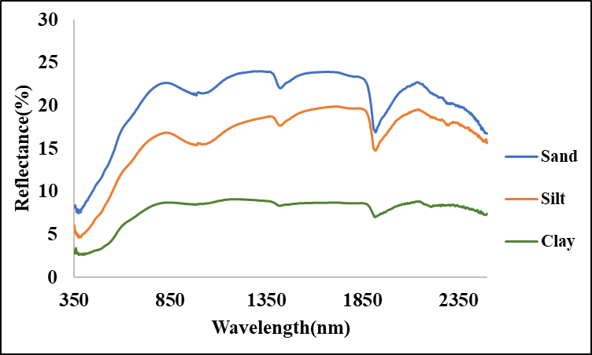

Fig no1. Variation in the spectral reflectance characteristics of soil according to moisture content and Soil Texture

  - Soil organic carbon and Organic matter Content:
Soil organic carbon is a quantifiable component of organic matter in the soil. Organic matter in soil has a dark color and reduces reflectance up to a 4-5% organic matter level. When the organic matter content of the soil exceeds 5%, it appears black, and any additional increase in organic matter has no effect on reflectance (Curran, 1985).
  - Iron oxide:
Many soils have a 'rusty' red color due to iron oxide, which covers or coats individual soil particles. Red light (0.6-0.7m) is largely reflected by iron oxide. Researchers used a red-to-green bi-directional reflectance ratio to calculate iron ore concentrations from satellite altitudes.
- Details About Spectroradiometer SVC HR1024i
3.1 Spectroradiometer:
A spectroradiometer is a light measurement instrument that can determine the wavelength as well as the amplitude of light emitted by a light source. Spectrometers distinguish wavelengths based on where light strikes the detector array, allowing the entire spectrum to be collected in a single collection.
The spectroradiometer monitors spectral response in the UV, visible, and near infrared wavelength ranges between 350 and 2500 nm. A white 12.5 cm12.5 cm spectralon plate that can reflect practically all incident light is used as a reference. A spectroradiometer was used to obtain the reflectance reading on that target. Before taking the reflectance reading of the actual target, the spectroradiometer was used to obtain the reflectance of the spectralon plate. The reflectance of the target soil was calculated using the provided formula.
R (%)=$\frac{L(λ)}{S(λ)}$
Where, R (%) = Reflectance
L(λ) =Target radiance
S(λ) = Reference radiance
The Specifications of Spectroradiometer SVC HR 1024i model are as follows;
Table No 1. Specifications of Spectro-radiometer SVC-HR 1024i
Spectro-radiometer SVC-HR 1024i
Spectral Range | 350 nm – 2500 nm
Internal Memory | 1000 Scans
Channels | 1024
Bandwidth | ≤ 1.5 nm, 350 – 1000 nm
Wavelength reproducibility | 0.1 nm
Internal Digital Camera | Yes
Internal GPS | Yes
Reference Material | Spectralon
Software for spectral analysis | SVC HR-1024i
FOV (Optical Fibre) | 25⁰
Diameter of Scene | 44 cm for height 1m above surface
Height of Spectral measurement | 50 cm (Scene Dia. – 22 cm)

Fig No 2. Spectroradiometer SVC HR 1024i
3.2 Operating Procedure:
- 1. Plug in the Bluetooth antenna and insert a fully charged battery into the spectroradiometer.
- If a cable connection is used, the cable must be put into both the spectroradiometer and the PDA.
- Turn on the instrument for around 15 minutes (warm-up period) before using it for the first time.
- Run the PDA data capture software, go to the 'File' menu, and choose the 'AutoSave' option. This permits measurements to be stored to file automatically after each target acquisition.
- Choose radiation graph type from the 'graph' menu.
- Choose 'Connect' from the 'Instrument' menu. There is a list of COM ports that can be used to connect the PDA to the spectroradiometer. As the connection port, 'COM8' was chosen. Using Bluetooth, navigate to the 'Setting' menu and select optic to lens 4 to use four optic drums. Usually, the integration settings are left at factory default.
- Place the spectroradiometer in the center of the spectralon panel and press the 'Reference' button. Software button to start the reference scan. This reading will be used as a reference for all subsequent readings up until the following Reference scan.
- After completing the reference scan, simply click the 'Target' button for each future scan.
- When the experiment is complete, remove the gadget from the PDA.
  - Processing of Data
- Get the SVC HR 1024i program and install it.
- 2. Begin the SVC HR-1024i software. SELECT 'Open' from the 'File' option to open the sig format files obtained from the spectroradiometer.
- SIG File Merge: Select 'SIG File Merge' from the 'Tool' menu to combine numerous SIG files into a single comma-delimited text data file. In the dialogue box, click the 'Browse' option to select the SIG format files to merge. Choose the combined format as the 'SIG Format Output File' and then press the 'Process All Files' button.
- SIG files Overlap/Matching: From the 'Tool' menu, select 'SIG files Overlap/Matching' to apply the current overlap and matching parameters to a set of input SIG format files.There is no overlapping data in the SIG data files acquired by the PDA software, and no matching process has been done. Use this tool to eliminate overlap and, if necessary, to run the detecter matching algorithm.
- In the dialogue box, click the Browse button to select the SIG format input files to process. Begin by reading and processing each SIG file individually, then writing the updated data to an output file with the string "_moc" (Matching Overlay Correction) appended to the original name. For example, if the input SIG file name is "gr062606_001.sig", the output SIG file name is "gr062606_001_moc.sig".
6. Resample spectrum data: From the 'Tool' menu, select 'Resample spectral data' to resample the input SIG format data files and copy the resampled data to new output SIG format data files. In the dialogue box, pick either all wavelengths present in the input SIG file or a specific range of interest.
Using the Browse button, select the SIG format input files to process. Begin processing the SIG files one at a time; each SIG file is read and linearly re- sampled at the Resampling Interval of choice, and the new data is written to an output file with the string "_resamp" appended to the original name.
6. Open these resample files in notepad, then copy them to an excel spreadsheet. It offers reflectance readings based on observation.
  - The stepwise procedure for obtaining the spectral response in laboratory condition:
1) Collect a field soil sample.
2) The spectroradiometer can be fixed in a single location using a retaining platform.
3) Soil samples were put in a layer 2 cm deep in 9 cm diameter petri dishes.
4) Scanning was carried out after a spectralon reference reading was taken.
5) Use the SVC HR1024i spectroradiometer to examine soil samples.
6) At the height, the sensor's distance from the earth's surface was kept constant.
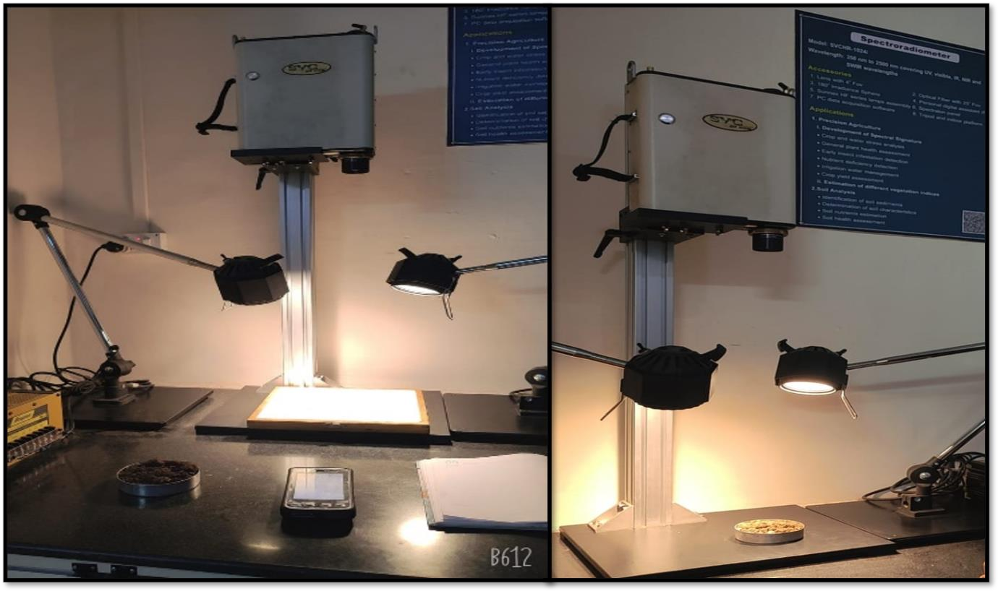
7) After the observation was finished, the next soil sample was placed on the petri plate and observations were repeated.

Fig 3. Experimental setup for recording reflectance of soil

Conclusion:
Soil spectral signatures differ and can be used to differentiate soil series. It is also beneficial for analyzing soil properties and planning future conservation measures in watershed area treatments. Understanding the different types of soil in their area might help policymakers.
References:
Anonymous.2014. SVC HR-1024i / SVC HR-768i / SVC HR-640i / SVC HR-768si/SVC HR-512i User Manual Revision 1.12.29 Firemens Way, Poughkeepsie, New York 12603.
Bhise. P.R., Kulkarni S.B and Borole V.Y. 2019. Acquisition of Soil Spectral Signatures and Creation of Database for Vaijapur Taluka Using Spectroradiometer 4. International Conference on Adaptive Science & Technology.
Curran, P. J. (1985), Principles of Remote Sensing, Longman, 282p.
Hoffer, R.M. (1978), Biological and physical considerations in applying computer-aided analysis techniques to remote sensor data, in Remote Sensing: The Quantitative Approach, P.H.
Jensen J. R., (1983), Biophysical Remote Sensing – Review Article. Annals of the Associations of American Geographers, 73(1), 111-132p
Kaleita A. L., L. F. Tian, and M. C. Hirschi.2005. Relationship Between Soil Moisture Content and Soil Surface Reflectance. American Society of Agricultural Engineers. ISSN 0001−2351. 48(5):979−1986.
Lobell. D.B and G. P. Asner.2002. Moisture Effects on Soil Reflectance. Soil Science Society of American Journal. 66:722-727.
Mammadov.E., M. Denk, F.Riedel , K. Lewinska, C. Kazmierowski and C. Glaesser . Visible and Near-Infrared Reflectance Spectroscopy for Assessment of Soil Properties in the Caucasus Mountains, Azerbaijan. Communications in soil science and plant analysis. 51(16):2111–2136.
Mendes W. D., A.M. Dematte, N.A.Rosin , F.S. Terra, R .R. Poppiel , D.F. Urbina-Salazar , C.L.Boechat, E.B.Silva , N.Curi, S .G. Silva , U. J. Santos and G.S. Valladares.2022. The Brazilian soil Mid-infrared Spectral Library: The Power of the Fundamental Range. Geoderma .41(5):115-772.

Sahwan W., B. Lucke, T. Sprafke, K.Vanselow and R.Baumler.2020.Relationships between spectral features, iron oxides and colours of surface soils in northern Jordan. European Journal Soil Science.72: 80–97.
Sakin.E.2011.Organic carbon organic matter and bulk density relationships in arid-semi arid soils in Southeast Anatolia region. African Journal of Biotechnology.11(6):1373-1377
Sinha.A.K.1986.Spectral reflectance characteristics of soils and its correlation with soil properties and surface conditions. Journal of the Indian Society of Remote Sensing .14(1):1-9
Stoner E.R. and M.F. Baumgardner. 1981.Characteristic variations in reflectance of surface soils.Soil Science Society of American Journal.45:1161-1165.
Streck N. A., D. Rundquist and J. Connot.2003. Spectral signature of selected soils. ISSN 0104-1347, 11(1):181-184.
Swain. S.R., P. Chakraborty, N. Panigrahi, H. B. Vasava, N. N. Reddy, S. Roy, I. Majeed and B. S. Das .2021. Estimation of soil texture using Sentinel-2 multispectral imaging data: An ensemble modelling approach Soil & Tillage Research .21(3):105-134.
http://speclab.cr.usgs.gov/
http://theindoorbonsaitree.com

