Book chapter
Biosurfactants: Need of A New Pharmaceutical Additive for Solubility Enhancement in Pharmaceutical, Food and Cosmetic Industry

Mr. Sandeep Singh Bhadoriya1*, Dr. Sachin Kumar Jain², Dr. Prashant Wadagbalkar ³

- Malwanchal University,Indore Madhya Pradesh, India
- Oriental University, Indore, Madhya Pradesh, India
- Amaltas Medical College, Dewas, Madhya Pradesh, India

Introduction

Surfactants are amphiphilic molecules that aggregate at interfaces, reducing crosslinking and forming cluster structures like micelles [1]. Many synthetic and mostly petroleum-based surfactants are now available to meet the current surfactant needs of the market. Only 32% of the world's surfactant production is devoted to industry, and about 54% of this is used in household/laundry detergents [2]. Surfactants come in many forms and are generally divided into four groups based on their charge: anionic, nonionic, cationic, and amphoteric. Most chemical antibiotics are cationic surfactants that are also effective against Gram-positive bacteria.Anionic and nonionic surfactants are non-toxic and effective against Gram-negative bacteria. There are many important surfactants such as fatty alcohol ethoxylates (FAEO), linear alkylbenzene sulfonates (LAS), and lauryl ether sulfates (LES) [3]. Increasing awareness of the use of renewable resources and "green products" has encouraged the development of alternatives to surfactants. Biosurfactants (BS) are an example of environmentally friendly options [4]. Biosurfactants can be produced biologically from continuous materials by microbial fermentation or enzymatic synthesis [5].The main feature of biosurfactants is their low micelle concentrations (CMC). This suggests that biosurfactants are more effective at low concentrations than many chemically produced surfactants. Bio-surfactants are good choices for "green" detergents and surfactants because they are known to be biodegradable and only need a minimal amount to fix the problem. Important Components in Pharmaceuticals: Surfactants Surfactants, substances that reduce the surface energy of liquid, solid and/or gas phase interactions, have many functions in medicine [6,7]. Surfactants are amphiphilic in addition to having both hydrophilic and lipophilic domains in their chemical structure.Their main role in medicine is to make drugs more soluble, especially poorly water-soluble, including new and improved bioactive drugs (such as small molecule drugs, peptides, proteins, vitamins, vaccines and oligonucleotides). they are shipping in vivo. In addition, they increase the thermodynamic performance and diffusion rate as well as the stability of the encapsulated drug. They are particularly important for drug use in cell walls, membranes, skin, and other biological interfaces. Surfactants are also important plasticizers required to improve the flow and in vivo solubility of semisolid delivery vehicles and viscous excipients, such as those used in suppositories. For example, sucrose fatty acid esters are important lubricants for tablets [8].They can also be used as a wetting agent to mix chemicals into powder, granule and nanoparticulate carrier vehicles and dispersions. The most common use of surfactants is in the form of self-assembly for drug delivery vehicles. Self-mixing structures based on surfactant monolayers are emulsions, oil-in-water dispersions (O/W-) or vice versa (W/O-). Emulsions are relatively large, usually micron to millimeter in size, and are thermodynamically unstable and often require agitation for long-term stability. Both aerosol and microencapsulated media are prepared using emulsions.High-pressure homogenization can be used to prepare nanoemulsions (also called "microemulsions") with an average size of 0.05-1.0 ¬µm, which, due to their small size, can be sterilized by microfiltration and again easily prevent physiological clearance. to enter. in vivo interfaces. Nanoemulsions are generally used for parenteral administration (Figure 1). Water-oil-surfactant mixtures often form thermodynamically stable microemulsions with nanoscale structures [9,10].Hydrophilic and lipophilic surfactant systems form O-W- and W/O-microemulsions, often composed of spherical nanodroplets. Layered or bicontinuous microemulsions are dynamically mixed networks of oil and water separated by surfactant monolayers, formed by a surfactant system with balanced hydrophilicity and lipophilicity. Mixing water with ingredients that self-microemulsify (emulsify) on contact with water is one way to create microemulsions (and emulsions) in vivo. Surfactants are also used as therapeutic agents. Examples of antimicrobial agents include glycolipid biosurfactants, amino acid-based surfactants, and sugar fatty acid esters [11,12].Glycolipid biosurfactants and polyunsaturated fatty acid monoacylglycerol (MAG) have anti-inflammatory properties [12,13]. Sophorolipid biosurfactants are anti-inflammatory agents [8]. Many cosmetics, lotions, and personal care products often contain surfactants. Figure 2 [10, 11] lists the chemical composition of conventional surfactants used in drug formulations. Standard surfactants are non-ionic and highly biocompatible.Oligonucleotide separation requires the use of cationic surfactants. Recent studies have shown that bio-based cationic arginine derivatives can act as biocompatible carriers [12]. Phospholipids are a different class of surfactants. In addition to synthetic pulmonary surfactants used in the treatment of acute and neonatal depression [14,15], they are an important part of carriers called liposomes, which can consist of one or more mixed phospholipid layers (single or multilayer) [16]. -18].

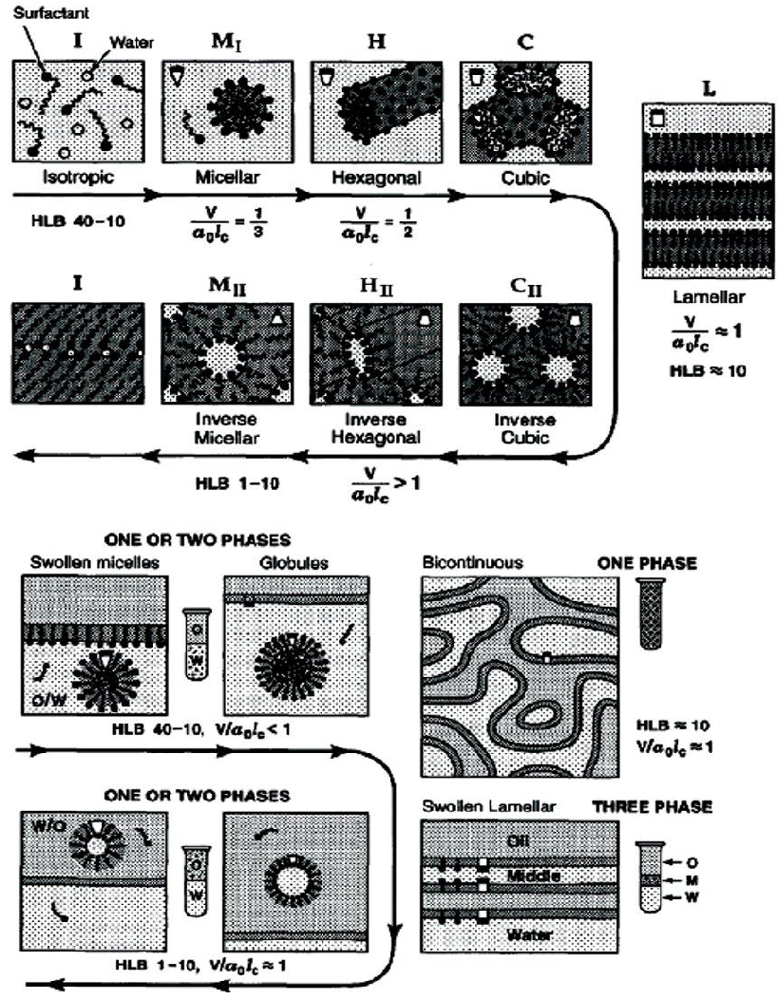

Figure 1: Surfactant self-assembly structures formed in: a) water surfactant and b) water-surfactant-oil systems as a function of the surfactant’s hydrophilic-lipophilic balance.

Advantages of Biosurfactants

Biosurfactants have many advantages in their chemical composition, some of which are: Biodegradability - Bacteria can rapidly degrade biosurfactants [6]. Less Toxic - Biosurfactants are less toxic than synthetic surfactants. Also, studies have shown that biosurfactants offer a higher EC50 value [7] (effective concentration to reduce 50% of those tested) than synthetic products. Availability of Raw Materials - Biosurfactants can be made from simple, inexpensive materials. The three carbon sources mentioned above - hydrocarbons, carbohydrates and/or lipids - can be used alone or in combination [8].Physical factors - Many biosurfactants are unaffected by environmental factors such as temperature, pH and ionic strength tolerance. Lichen produced by Bacillus licheniformis species is not affected by temperature up to 50°C, pH range 4.5-9.0, NaCl concentration 50g/l and Ca concentration 25g/l [9]. Surface and Interface Activity - Sagalowicz et al.[10] stated that a good surfactant can reduce the tension of water from 75 to 35 mN/m and the interface between water/hexadecane from 40 to 1 mN/m. Surfactin can reduce the surface tension of water to 25 mN/m, water/hexadecane to 25 mN/m, and water/hexadecane to <1mN/m [9].

Other advantages
Biocompatibility and digestibility - It allows their application in cosmetic, pharmaceuticals and as functional food additives [8].

Surfactants Employed in Pharmaceuticals are Primarily Biobased
The development of "bio-based" surfactants is increasing mainly due to the increase in the price of petroleum raw materials compared to oleochemical raw materials (due to increased international demand and loss of production and availability) and greater sustainability of the use of renewable resources. [19] . In addition, dwindling oil supply prospects, exacerbated by global demand, have been associated with environmental disasters, including the 2010 Deepwater Horizon oil spill in the Gulf, where the greatest destruction took place. American history - and carbon dioxide production and their impact on climate change. These products make consumers want more environmentally friendly products. In general, the cost of producing bio-based surfactants is comparable to the cost of producing petroleum surfactants. Therefore, the market share of bio-based surfactants has increased recently and this trend should continue.Most of the surfactants mentioned in the previous section are made from some continuous materials [19,20]. Sugar esters, polysorbates, MAGs and fatty acid ethoxylates all provide fatty acyl components from oleochemicals, with fatty acid methyl or ethyl esters (which make up the majority of biodiesel) as raw materials. The development and expansion of oleochemical biorefineries has been successful, as oil, chemical intermediates and bio-based products are all produced from oilseed crops [19,20]. Sources rich in the C10-C16 saturated fatty acyl group include olive oil, coconut oil (especially palm stearin, products derived from the palmitoyl-rich portion of palm oil), coconut oil, and calyx oil. Inexpensive sources of 16:0, 18:0, 18:1 and 18:2 fatty acids include cooking oil, waste oil, seaweed oil, jatropha oil, sapinberry oil and soap.Castor oil, produced in Brazil, India and many countries around the world, is a source of ricinoleic acid. Medium-chain fatty alcohols - the lipophilic group of APG (alkyl polyglycosides) - can be produced from gasoline or from fatty acid methyl esters by heterogeneous catalyzed reactions. Gums, soaps and other products from the oleochemical industry can be used directly to make phospholipids [21].

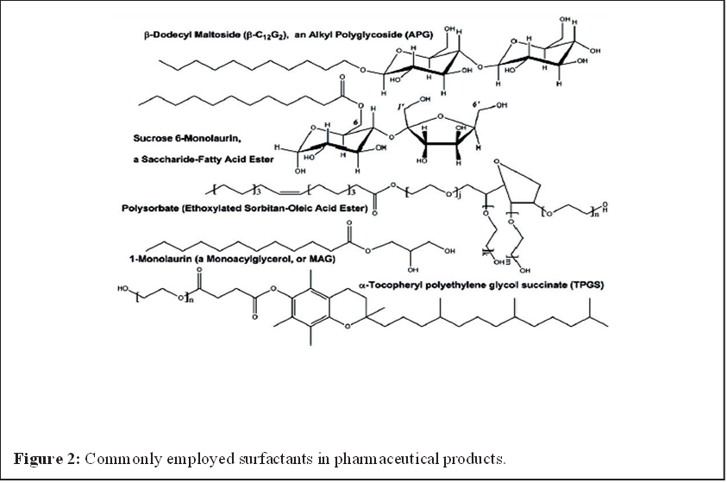
Advantages of Bioprocessing to Prepare Surfactants for Pharmaceuticals
Many bio-based surfactants can be produced with the aid of enzymes [19]. Bioprocessing has many advantages over chemical processing, including sustainability, lower energy consumption (due to lower temperatures), less waste and by-product production, trouble-free metal catalysts or acids/bases, and safe operation. The disadvantage of using enzymes compared to chemical catalysts is the limited charge (although this problem is reduced when enzymes are immobilized to allow reuse) and the slow reaction usually with enzymatic reactions. In addition, the starting material must first be purified due to the need to reduce inhibitors; For example, fatty acyl containing materials should not contain phospholipids, aldehydes/ketones, peroxides and other harmful substances. However, enzymatic bioprocessing is expected to become cost competitive due to increased energy costs (as expected), increased safety benefits (due to government regulations and/or needed user products), and enzymes and their enzymes being active and attractive. Rise of production machinery (due to advances in biotechnology).Enzymatic bioprocessing is expected to become cost competitive and attractive.

Application of Biosurfactant in Pharmaceutical and Cosmetic Industry
Biosurfactants are recommended as an alternative to surfactant production in the cosmetic industry, as they affect viscosity and consistency well through emulsification, foaming, water-binding capacity, spreading and wetting (Table 1). These surfactants are used as emulsifiers in insecticides, disinfectants, bath products, acne, dandruff products, antibacterial products, baby products, mascaras, lipsticks, toothpastes, whitening agents and other products, foaming agents, solvents, wetting agents, cleaning agents. agent, anti-inflammatory agent and enzyme activity medium [22,23].

Table 1: Relevance of glycolipid biosurfactants to the pharmaceutical/cosmetic industry [23].

Glycolipid Type | Producing Organism | Activity | Pharmaceutical/Cosmetic Applications
Sophorolipids | Candida bombicola, Candida apicola | Antibacterial, Antioxidant, Moisturizing, Wetting, Foaming, Emulsifying, Stimulates dermal fibroblasts | Lotions, body washes, hair products, lip color, eye shadow, acne treatment, deodorants, skin smoothing, anti-wrinkle products
Rhamnolipids | Pseudomonas aeruginosa | Antimicrobial, Emulsifying agent | Anti-wrinkle and anti-aging products
Mannosylerythritol lipids | Candida antarctica | Antimicrobial, Emulsifying agent, Dispersant | Skin smoothing and anti-wrinkle products

Discussion
Biosurfactants can increase the bioavailability of high molecular weight hydrophobic drugs, which is thought to be by increasing their surface area, desorbing from the surface, and making apparent solubility. These properties of biosurfactants can be used in the formulation of drugs to increase bioavailability. Although the technology is still in its infancy, bioprocess techniques have shown great potential in the production of bio-based surfactants for pharmaceuticals. Biocatalytic production is particularly attractive due to its strong sustainability, increased selectivity for desired products and reduced waste. To do this, biotechnology needs to develop stronger enzymes at lower cost. As interest and availability in renewable materials increase, scientists and engineers will continue to refine enzymatic bioprocess design and the ability to create new biobased surfactants for pharmaceutical use.

References

1. Van Hamme JD, Singh A, Ward OP (2006) Physiological aspects. Part 1 in a series of papers devoted to surfactants in microbiology and biotechnology. Biotechnol Adv 24: 604-620.
2. Banat IM, Makkar RS, Cameotra SS (2000) Potential commercial applications of microbial surfactants. Appl Microbiol Biotechnol 53: 495-508.
3. Develter DWG, Lauryssen LML (2010) Properties and industrial applications of sophorolipids. Eur J Lipid Sci Technol 112: 628-638.
4. Vaz DA, Gudiña EJ, Alameda EJ, Teixeira JA, Rodrigues LR (2012) Performance of a biosurfactant produced by a Bacillus subtilis strain isolated from crude oil samples as compared to commercial chemical surfactants. Colloids Surf B Biointerfaces 89: 167-174.
5. Syldatk C, Hausmann R (2010) Microbial Biosurfactants. Eur J Lipid Sci Technol 112: 615-616.
6. Chesko JR, Anderson C, Fox L, Kalvodova T, Dutil S, et al. (2009) Nonionic surfactants formulated into drug and vaccine delivery systems, in Non-Ionic Surfactants, edited by P.L. Wendt and D.S. Hoysted, Nova Science Publishers, Hauppauge NY USA 177-197.
7. Mishra M, Muthuprasanna P, Surya Prabha K, Sobhita Rani P, Satish Babu IA, et al. (2009) Basics and potential applications of surfactants-a review, Int J PharmTech Res 1:1354-1365.
8. Otomo N (2009) Biobased Surfactants and Detergents: Synthesis, Properties, and Applications, Hayes DG, Kitamoto D, Solaiman DKY, Ashby RD, (eds.). AOCS Press, Champaign, IL 275-298.
9. Garti N (2003) Microemulsions as microreactors for food applications. Curr Opin Colloid Interface Sci 8: 197-211.
10. Sagalowicz L, Leser ME, Watzke HJ, Michel M (2006) Monoglyceride SelfAssembly Structures as Delivery Vehicles. Trends in Food Science & Technology 17: 204-214.
11. Infante MR, Perez L, Moran C, Pons R, Pinazo A (2009) Synthesis, aggregation properties, and applications of biosurfactants derived from arginine. In: Biobased Surfactants and Detergents Synthesis, Properties, and Applications, Hayes DG, Kitamoto D, Solaiman DKY, Ashby RD, (eds.). AOCS Press, Champaign, IL USA 351-387.
12. Kitamoto D, Morita T, Fukuoka T, Imura T, Konishi M (2009) Self-assembling properties of glycolipid biosurfactants and their potential applications Curr Opin Colloid Interface Sci 14: 315-328.
13. Fortin S (2010) Polyunsaturated fatty acid monoglycerides, derivatives, and uses thereof. USA Patent 2009-535048, 20100160261.
14. Savić S, Tamburić S, Savić MM (2010) From conventional towards new-natural surfactants in drug delivery systems design: current status and perspectives. Expert Opin Drug Deliv 7: 353-369.
15. Müllertz A, Ogbonna A, Ren S, Rades T (2010) New perspectives on lipid and surfactant based drug delivery systems for oral delivery of poorly soluble drugs. J Pharm Pharmacol 62: 1622-1636.
16. Acosta EJ, Saad SMI, Kang N, Policova Z, Hair ML, et al. (2009) Lung surfactants: formulation, evaluation, and polymeric additives. In: Biobased Surfactants and Detergents: Synthesis, Properties, and Applications, Hayes DG, Kitamoto D, Solaiman DKY, Ashby RD, (eds.). American Oil Chemists’ Society Press, Champaign, IL USA 191-229.
17. Shailesh S, Neelam S, Sandeep K, Gupta GD (2009) Liposomes: a review. Journal of Pharmacy Research 2: 1163-1167.
18. Immordino ML, Dosio F, Cattel L (2006) Stealth liposomes: review of the basic science, rationale, and clinical applications, existing and potential. Int J Nanomedicine 1: 297-315.
19. Hayes DG (2009) Biobased Surfactants and Detergents: Synthesis, Properties, and Applications. D.G. Hayes DG, Kitamoto D, Solaiman DKY, Ashby RD. American Oil Chemists’ Society Press, Champaign, IL 3-25.
20. Giraldo L, Camargo G, Tirano J, Moreno-Pirajan JC (2010) Synthesis of fatty alcohols from oil palm using a catalyst of Ni-Cu supported onto zeolite. E-Journal of Chemistry 7: 1138-1147.
21. Gielen D, Newman J, Patel MK (2008) Reducing industrial energy use and CO2 emissions: the role of materials science. MRS Bulletin 33: 471-477.
22. Gharaei-Fathabad E (2011) Biosurfactants in pharmaceutical industry: A Mini Review. Am J Drug Discov Dev 1-11. 23. Williams K (2009) Biosurfactants for cosmetic application: Overcoming production challenges. MMG 445 Basic Biotechnology 5: 78.

