IoT based Pre-indication for accident avoidance system in vehicles
¹Dr.A.Sathish Kumar,
¹Professor, Department of ECE, Erode Sengunthar Engineering College, Erode

Abstract
Drunk driving is a very dangerous behavior because excessive consumption of alcohol causes distortion in thought pattern of drivers. The investigation conducted by the World Health Organization in 2008 shows that about 50% – 60% of traffic accidents are related to drunk driving. In present times, the cases of traffic accident caused by drunk driving has increased rapidly. It has therefore become evident that drunk driving does great harm to public security. Different technologies and techniques have been adopted to reduce the incidence of road accidents due to drunk driving by motorists. The alcohol detector in is made up of the MQ-6 sensor.
Keywords: IoT, MQ 6, Vehicle, Accident Avoidance, Node MCU

Introduction
This device displays the results of the alcohol sensor as it senses the alcohol molecules in air present around it shown in fig.1.1, and displays a warning text when it crosses the fixed threshold set by the code. Also, the micro- controller which was acting as a comparator in the circuit in relay, had no response such as an alarm to warn that the threshold has been crossed. This system was required two contents with alcohol and non-alcohol i.e., one person to carry out the testing and note when the threshold is crossed and the other as the person being tested. This system was nowhere close to proving a means of inhibiting a driver if he/she were drunk not to mention real time implementation.
The aim of this project is to reduce road accidents related to drunk driving to the barest minimum by using Internet of Things (IoT) technology. With the help of this system, drivers under the influence of alcohol can be detected, monitored, and tracked by relevant law enforcement agency in the smart city.
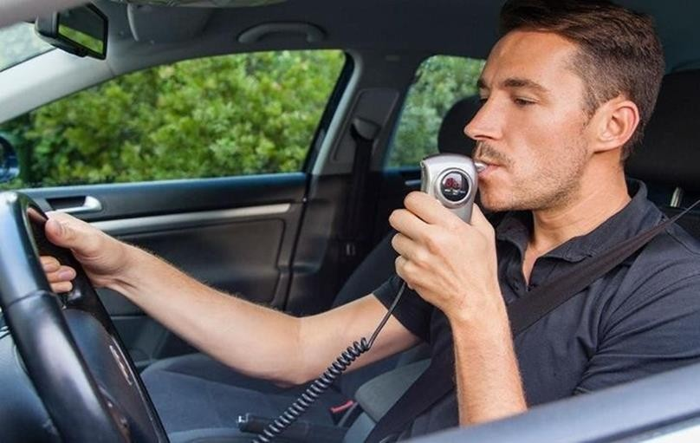
Fig. 1.1 Alcohol Detector (Non - Contactless)

Driving a vehicle implies the acceptance of a certain number of risks. The careful driver will always be aware of the risks but also ensure that the level of risk never rises to an unacceptable level. Alcohol not only impairs one’s ability to drive, but it also alters a driver’s subjective assessment of risk so that he or she drives more recklessly shown in Fig.1.1. Irrespective of the amount of alcohol consumed, the maximum concentration of alcohol in the body is reached. This project use PIC16F877A, LCD display, MQ-3 alcohol sensor and buzzer. The output of the sensor is directly proportional to the content of alcohol consumed. We try to develop this project to make it available for everyone. This project won’t cost much, but it will bring much for it concentrate to humans safety. This project has a preventative effect which can stop accident from the beginning. In this project, initially we check whether the person id drunk or not by using the MQ-3 alcohol sensor
- Literature Survey
Fatality Analysis Reporting System (FARS). 2009 One of the primary objectives of the National Highway Traffic Safety Administration (NHTSA) is to reduce the staggering human toll and property damage that motor vehicle traffic crashes impose on our society. Crashes each year result in thousands of lives lost, hundreds of thousands of injured victims, and billions of dollars in property damage. Accurate data are required to support the development, implementation, and assessment of highway safety programs aimed at reducing this toll. NHTSA uses data from many sources, including the Fatality Analysis Reporting System (FARS) which began operation in 1975. Cahalan, D. American Drinking Practices: A National Study of Driving Behavior and Attitudes. 1969, Rutgers University Press: New Brunswick, NJ Questions about drinking problems in early drinking surveys were often phrased in terms of lifetime occurrence “did this ever” occur? Phrasing the question in such terms obviously has the greatest chance of picking up positive responses. Babor, AUDIT: The alcohol use disorders identification Test: Guidelines for use in primary health care. 1992, Geneva, Switzerland: World Health Organization.How to Calculate the Content of Alcohol in a Drink The alcohol content of a drink depends on the strength of the beverage and the volume of the container.

Existing Method
Driving a vehicle implies the acceptance of a certain number of risks. The careful driver will always be aware of the risks but also ensure that the level of risk never rises to an unacceptable level. After half an hour when taken on an empty stomach. After an hour when taken with a meal. On the other hand, it takes the body a long time to eliminate alcohol. An individual in good health eliminates alcohol at a rate that reduces blood alcohol concentration by 0.1 to 0.15 gram/litre/hour. Thus, one’s driving ability remains impaired long after he or she has stopped drinking. Alcohol abuse has both short- and long- term neurological and psychiatric consequences that can endanger road safety. The IR sensor has a receiver that detects the reflected IR light. The receiver is designed to detect changes in the amount of reflected light and is able to distinguish between the reflected light and ambient light. This signal is then sent to a microcontroller or other processing unit that interprets the signal and makes a decision based on the presence or absence of an object.IR sensors can be used in various types of object detection applications, including proximity sensors, reflective sensors, and interrupter sensors. In a proximity sensor, the sensor emits a beam of IR light and detects the reflected light to determine the presence or absence of an object within its sensing range.
- Vehicle Control
The IoT drunk driving monitoring system is a groundbreaking system with huge application the field of smart cities and smart transportation. To make this possible, the hardware section of the system positioned in the vehicle makes use of the MQ3 sensor (Alcohol sensor) which senses the alcohol molecules in the air around the driver to determine if the driver is drunk or sober. A microcontroller is used for controlling entire circuits and to maintain timing. There a microcontroller named PIC16F877A from Microchip Corporation is used for this purpose. It is a 16 bit microcontroller and has 40 pins arranged in five ports (Port A-E), the port B is used here for connecting LCD module and port A is used to interface with the input from the MQ- 3 sensor.

Implementation of Vehicle Control

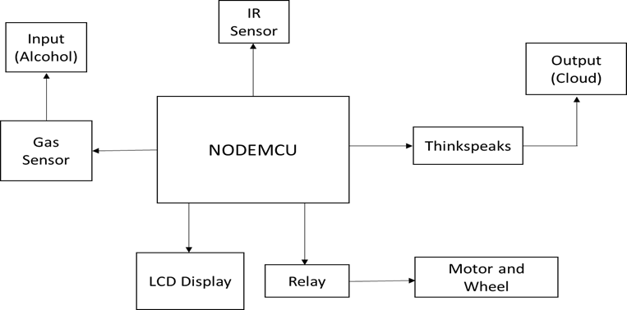
Fig.2 Implementation of vehicle control

Flow Chart

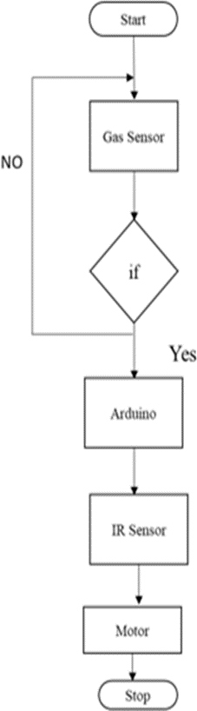
Fig.2 Flow chart

The simple gas sensor - MQ3 is appropriate for recognizing liquor, this sensor can be utilized as a part of a breathalyzer. It has a high affectability to liquor and little affectability to Benzene. The affectabilitycan be balanced by the potentiometer. Tin oxide (SnO2) is Sensitive material of MQ-3 gas sensor is, which has a lower conductivity in clean air. Gas spill identification is the method involved with distinguishing possibly dangerous gas spills by sensors. Node MCU is a low-cost open source IoT platform. It initiallyincluded firmware which runs on the ESP8266 Wi-Fi SoC from EspressifSystems, and hardware which was based on the ESP-12 module. NodeMCU was created shortly after the ESP8266 came out. On December 30, 2013, Espressif Systems began production of the ESP8266. NodeMCU started on 13 Oct 2014, when Hong committed the first file of nodemcu-firmware to GitHub.

Thingspeak Cloud

ThingSpeak is an IoT analytics platform service that allows you to aggregate, visualize, and analyze live data streams in the cloud. You can send data to ThingSpeak™ from your devices, create instant visualizations of live data, and send alerts using web services like Twitter® and Twili0N.

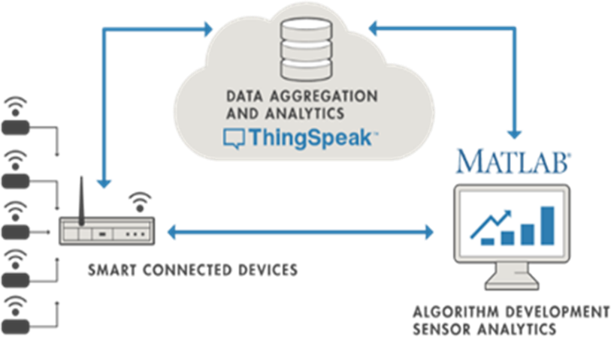

Fig.3 Thingspeak Website

ThingSpeak allows you to aggregate, visualize and analyze live data streams in the cloud. With ThingSpeak, your data is stored in channels.
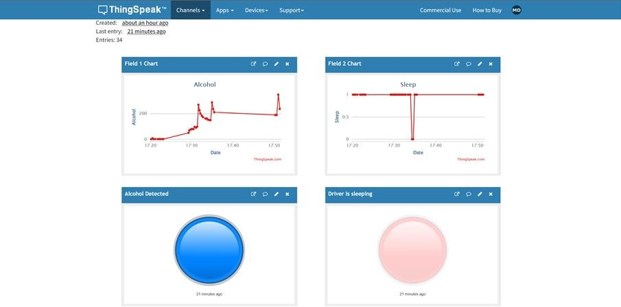
Fig.4 Cloud Monitoring
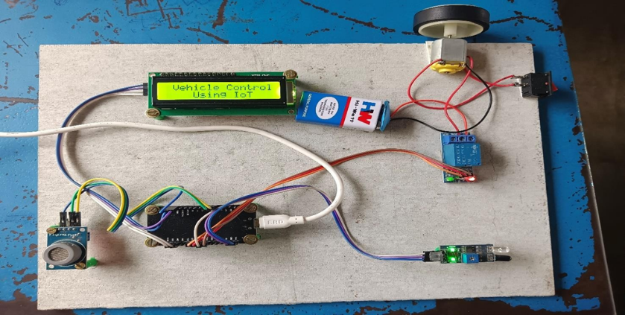
Fig 5. Hardware Implemented

Future Scope

    - Here we have made the relationship of alcohol sensor with Arduino UNO and Uploaded the normal code to the Arduino using the Arduino IDE.
    - We can screen the degree of alcohol ate up by the individual and we find whether he is in a common state or crushed state.
    - Next, we use Thing Speak to send the SMS cautioning to the different people who needs to screen that person.
    - We furthermore make a LCD show to ponder the individual’s state at that moment.

Application

    - Smart alcohol detector locks the engine when the person had alcohol and tried to start the vehicle.
    - To detect the alcoholic persons the policemen can use this smart IoT alcohol detector to store the data.
    - Data can be captured based on time stamps and can be monitored after some days or months.

Conclusion
The project mainly helps in alcohol detection system that was developed for road Transportation safety in smart city using Internet of Things (IoT) technology. This system not only curbs drunk driving by automatically shutting down the vehicle that contains the drunk driver but also allows for traffic authorities to easily locate the shutdown vehicles using the coordinates of the vehicle sent to web server. The technologies which are used in the proposed system are good enough to ensure the perfect shut down and pick up of the drunk driven vehicle. There are no projects that cannot be improved. One of the improvements that could be made on this system in the future is that it should be made smaller. The smaller the system, the more convenient the alcohol system is, the more likely drivers will accept it.

References

- Abid khan and Ravi Mishra (2021), ‘Drivers Fatigue Detection Using Efficient Det In Advanced Driver Assistance Systems’ International Journal of Engineering Trends and Technology Vol.02, pp.9-13.
- Arunvijay, D. and Yuvraj, E. (2020) ‘In-vehicle alcohol detection using low-cost sensors and genetic algorithms to aid in the drinking and driving detection’, International journal of student’s research in technology &management Vol.2, pp. 321-543.
- Azhagumurugan, R. and Karthik, A. (2017) ‘Detection of functional state after alcohol consumption by classification and machine learning technics’ International Conference on Computation of Power, Energy Information and Communication (ICCPEIC), pp. 108- 111.
- Divyabharathi,P. and JeyaSingh,Y. (2016) ‘Design Using TM4C123 Microcontroller with Motion Detection Application’, International Journal of Engineering Research & Technology (IJERT), Vol.05, pp.9-21.
- Jim Isaac (2019) ‘Analysis of Road Accidents Using Machine Learning Techniques’, International Research Journal of Engineering and Technology (IRJET), Vol.01, pp. 84- 91.
- Jacob Varghese (2022) ‘Vehicle alcohol detection system based on internet of things technology’ International Conference on Inventive Computation Technologies (ICICT), pp. 533-538.
- Karuppasamy,K. (2017) ‘A study of classification for driver conditions using driving behaviors’, International Research Journal of Engineering and Technology (IRJET), Vol.04, pp.1904- 1907.
- Karthikeyan, R. and Dhandapani, A. (2021) ‘Future smart cities requirements, emerging technologies, applications, challenges’, Journal of Computer Applications, Vol.05, pp.56- 87.

