Minor cosmetic procedures depend on the patient's aesthetic sensibility and medical necessity. When it comes to analyzing a patient's smile in orthodontics today, several factors are typically taken into account. These include the vertical position of the front teeth in relation to the upper lip both at rest and during a smile, ensuring an adequate display of the incisors without excessive gumminess. Additionally, the transverse dimension of the smile and the presence of buccal corridors, as well as the arc of the smile and the vertical alignment of the gum margins, are all important considerations.^{[1]}
Botulinum toxin (BTX) and dermal fillers have become increasingly popular in recent years because they offer a less invasive alternative to surgical procedures for achieving regenerative and aesthetic enhancements. Patients can benefit from these treatments at a lower cost and with minimal or no downtime required for recovery, which has contributed to their widespread use.Due to the encouraging results obtained in restoring a beautiful smile and improving facial aesthetics, dentists have recognised the benefits of Botox and dermal fillers and have integrated them into clinical dentistry.^{[2]}
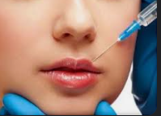
Fig. 10.1- Lip Fillers
Botulinum toxin (BTX) is a commonly used treatment to address the effects of muscular contraction in the lower and middle regions of the face and neck, including cases of excessive gum exposure during smiling, also known as a "gummy smile." This treatment is often the preferred approach for addressing wrinkles on the upper portion of the face. However, finding a solution for a gummy smile can be challenging as there is no single straightforward approach. Over-contraction of the levator labii superioris alaeque nasi muscle, which is responsible for lifting the upper lip, is often the underlying cause of this condition..^{[3]}
The Rubenstein, Miskinyar, Kostianovsky, , and LaTrenta and Rees surgical procedures, among others, have been described in the literature for the repair of hyperfunctional elevator muscles of upper lip, but they are not frequently utilised to cure a gummy smile. Nonsurgical alternatives to osteotomies would be preferable for minimising excessive gingival show brought on by muscle hyperfunction.^{[3]}
In essence, fillers are substances that can provide volume to the skin that has largely lost its natural volume. There are essentially two sorts of fillers: synthetic and biodegradable. The biodegradable ones are transient and are eventually reabsorbed by the body, whilst the synthetic ones are more durable and are not capable of being reabsorbed. The ability to induce antigenicity and the source of the dermal fillers allow for differentiation between them.^{[3]}
Fillers should not be put into muscles like Botox is. Orthognathic or orthodontic treatment may not be sufficient to address all modest lip asymmetry. To make the lower border or the vermillion border on both sides symmetrical, fillers could be needed. Additionally, it can be utilised to compensate for minor defects in the skeletal element that affect the soft tissues that cover it. Dermal fillers, for instance, can be used to improve modest jaw asymmetry brought on by differences in ramal height.^{[4]} For those who are not interested in a genioplasty, fillers may be an option to amplify the chin. Though not a long-term fix, similar results can still be obtained. Botulinum Toxin A can be utilised to anesthetise the elevator muscles of upper lip in people who have gummy smiles to lessen the display of gums when they smile.
The advancements in cosmetic procedures and surgeries are being brought in practice to help attain the utmost aesthetics possible for a lot of patients without much of the invasions.
- SOFT TISSUE FILLERS
Botulinum toxin type A (BTX-A) is the most potent neurotoxin among the different types of botulinum toxin. To produce the toxin, a strain of Clostridium botulinum is stimulated to release the toxin, which is then collected from the culture medium after being dissolved. The toxin is subsequently filtered, accelerated, purified, and crystallized using ammonium sulfate. BTX-A must be refrigerated but not frozen in this form, and after reconstitution, it should be diluted with saline and used within four hours. ^{[3]}
MECHANISM OF ACTION
Botulinum toxin is absorbed into the bloodstream through the gastrointestinal tract after ingestion. The toxin works by blocking the release of acetylcholine (ACH), which is a neurotransmitter responsible for muscle contraction and glandular secretion. By inhibiting the release of ACH, the toxin causes a loss of muscle tone in the injected area. However, the toxin does not affect all nerve terminals, allowing the dystonic muscle to contract with less force. This results in an improvement in the posture and function of the hypertonic muscle. The muscle weakness induced by the toxin usually lasts for about 3-4 months. ^{[5]}

TYPES
Botulinum toxin (BTX) is classified into seven different serogroups: A, B, C, D, E, F, and G. There are six distinct formulations of BTX available on the market, including BTA (Dysport, Botox, Xeomin, PurTox, and Prosigne) and BTX-B (Neuroblocs/Myobloc). Unlike Dysport and Botox, which are in the form of a white powder that requires dilution, Myobloc is available as a solution. Since the formulation and potency of each brand of BTX may differ, the appropriate dosage of BTX needed for a particular treatment is determined based on the brand or practitioner's recommendations..^{[6]}

APPLICATION IN ORTHODONTICS
Botulinum toxin (BTX) is often used for the treatment of facial pain and temporomandibular joint (TMJ) disorders in the oral and maxillofacial area. It is also utilized for dental therapeutic and aesthetic purposes.
- TEMPOROMANDIBULAR DISORDERS
Temporomandibular disease (TMD) often involves the presence of one or more muscle trigger points. Palpation of these trigger points can elicit pain that is transmitted along the associated muscle or nerve pathways. Injections of sterile saline and local anesthetic are typically administered directly to these trigger points to achieve short-term relief by disrupting the muscle contraction. However, the effects of saline or anesthetic injections are limited and typically only last a few minutes to a few days. In contrast, BTX injections at these trigger points have been shown to be highly effective in reducing muscle contraction strength, with the effects lasting up to three months..^{[7]}
- FACIAL PAIN
Neurotoxins are commonly used to treat TMD and facial pain by targeting various muscles involved in chewing, including the temporalis, masseter, medial and lateral pterygoid muscles, as well as facial muscles such as orbicularis oculi, sternocleidomastoid, orbicularis oris, depressor anguli oris, mentalis, trapezius, splenius capitus, frontalis, procerus, and corrugator muscles. Even if only one side of the temporalis and masseter muscles is affected, neurotoxins can be administered to both sides of the face.
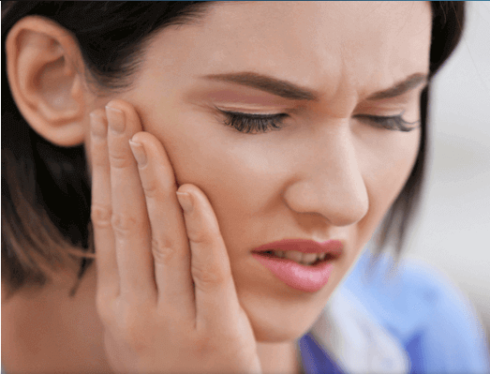
Fig.10.2- Facial Pain
- BRUXISM
Bruxism refers to the habit of clenching or grinding teeth, which can lead to TMD, headaches, facial pain, and deterioration of dental health, as well as exacerbation of periodontal disease. In patients with bruxism and TMD, injections of neurotoxins are administered bilaterally into the masseter and temporalis muscles. The appropriate amount of injection can reduce the strength of muscle contractions during mastication while also improving the ability to chew and speak. The use of neurotoxins can help treat periodontal diseases by reducing facial pain and TMD symptoms and eliminating the bruxism component.
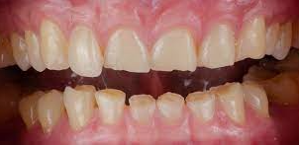
Fig. 10.3- Bruxism
- MASSETERIC HYPERTROPHY
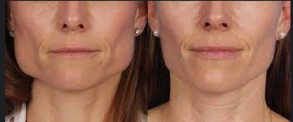
Fig. 10.4- Bilateral Masseteric Hypertrophy
Masseteric hypertrophy is characterized by the enlargement of the masseter muscles that commonly leads to clenching and bruxism. Injecting neurotoxins into the masseter muscle belly is an effective treatment for masseteric hypertrophy. This procedure results in a reduction in the intensity of masseter muscle contractions and a proximal reduction in the face. As with all botulinum treatments, repeated injections are required in monthly intervals..^{[7]}
- GUMMY SMILE
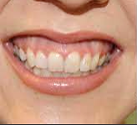
Fig. 10.5- Gummy Smile
A gummy smile is a cosmetic issue where excessive gingival tissue is visible while smiling. To treat this, Hwang et al. suggested the Yonsei point, which is located at the center of the triangle formed by the zygomaticus minor, levator labii superioris alaeque nasi, and levator labii superioris muscles. For each injection site, a recommended dose of 3 U is suggested..^{[8]}
- RELAPSE AFTER ORTHODONTIC TREATMENT
After orthodontic treatment, individuals with excessive muscular activity may have recessed teeth. In such cases, Botox can be used to reduce the strength of the muscles, thereby directing them towards a more normal movement during treatment.
- TRISMUS
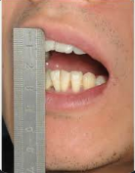
Fig. 10.6- Trismus
Patients who suffer from TMD may experience difficulty in opening their mouths due to inflammation and tension in the masticatory muscles. BTA injections can effectively reduce muscle inflammation and relax the neighboring masticatory muscles, resulting in increased jaw mobility and easier mouth opening. Injecting BTA into the muscles of mastication has shown positive therapeutic effects in treating TMD patients. ^{[9]}
DRUG INTERACTION
d-Penicillamine, cyclosporine, aminoglycosides, aminoquinolones, muscle relaxants. Lincosamide and quinidine are all pills that affect the outcomes of neurotoxin management.^{[10]}
CONTRAINDICATIONS
- Psychologically ill patients
- patients suffering from a neuromuscular condition
- individuals with asthma and arrythmia
- individuals who are allergic to BTX and fillers
- Pregnant and lactating women who have to keep away from the usage of BTA
COMPLICATIONS
As therapeutic doses of BTA are typically higher than those used for cosmetic purposes, complications are more common when it is used for therapeutic purposes. Studies show that around 7% of BTA patients develop resistance, which has led researchers to investigate alternative BTX treatments. Common adverse effects include palpitations, fever, tingling sensations, and nausea, which usually subside after 2 days. Other potential complications of BTA therapy include pain, ecchymosis, and erythema at the injection site, facial asymmetry, ptosis, drooping of the mouth, lip edema, muscle weakness, dysphagia, aspiration, xerostomia, and hepatitis..^{[10]}

DERMAL FILLERS

Dermal fillers are substances that are used to restore volume to skin that has lost some of its natural fullness. These fillers are classified based on their source and their potential to cause an immune reaction, or antigenicity..^{[1]}
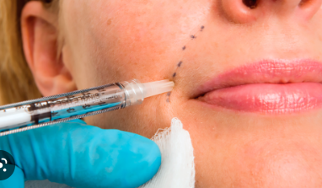
Fig.10.7- Dermal Fillers

CLASSIFICATION^{[11]}
1. Classification based on the characteristics of materials:
• Autologous: Materials obtained from the patient's own body
• Heterologous: Materials derived from multiple species
• Alloplastic: Materials such as plastic, metal, or ceramic that are not biological in nature.

2. Classification based on biodegradability:
• Biodegradable: Fillers that can be broken down into non-hazardous substances.
• Non-biodegradable: Fillers that do not degrade in the natural environment.

3. Classification based on the duration of the filler's action:
• Temporary: Fillers with effects lasting less than 6 months.
• Long-lasting: Fillers with effects lasting 6 months to 2 years.
• Semi-permanent: Fillers with effects lasting 2-5 years.
• Permanent: Fillers with effects that do not disappear over time.

INJECTION PLANES
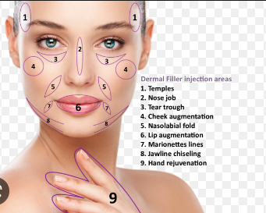
Fig. 10.8- Injection Sites
Fillers and Botox differ in the way they are injected. While Botox is injected into the muscles, fillers should not be injected into the muscles. Instead, it is recommended to inject dermal fillers into the fat region. This is because the fat acts as a natural filler. The fat on the face is divided into two planes: the superficial and deep fat. The superficial fat runs parallel to the skin, while the deep fat runs parallel to the muscular layer. Injecting fillers into the superficial fat at a depth of 3mm ensures that the effects of the filler last longer and the volume of filler deposited is lower..^{[12]}
HYALURONIC ACID
Hyaluronic acid (HA) is a significant component of the extracellular matrix and is found in various parts of the body such as the skin, synovium, and eyes. In a previous study, De Maio described the effectiveness of HA fillers in modifying muscle activity. He suggested that HA fillers could potentially impact muscular contraction either by aiding or inhibiting it.
COLLAGEN
Collagen is the primary structural component of the skin. Bovine collagen and bioengineered human collagen dermal fillers are both FDA-approved and are less painful for patients during injection, eliminating the need for anesthesia or nerve blocks..^{[13]}
CALCIUM HYDROXYLAPATITE (CAHA)
Calcium hydroxylapatite (CaHA) is a synthetic microparticle that is enclosed in a carrier gel and has been approved by the FDA for treating facial wrinkles and atrophy in HIV patients since 2006. CaHA comprises about 30% of the gel, while the remaining 70% is the carrier gel. Compared to other fillers, injections of CaHA result in faster visible improvements due to the long-lasting collagen accumulation around the microparticles, which can last up to 15 months.
POLY-L-LACTIC ACID
PLLA is a synthetic, polymeric, and biodegradable polymer that is safe for use in the body. When injected, it stimulates the growth of collagen by activating fibroblasts, leading to increased facial volume. The process of soft tissue augmentation involves inducing an inflammatory response in the tissue, which then leads to the deposition of collagen.
POLY (METHYL METHACRYLATE)
Poly (methyl methacrylate) (PMMA) is composed of 80% bovine collagen and 20% PMMA microparticles. After collagen degradation in about three months, the microspheres remain encapsulated by a fine fibrous capsule. Silikon, which is non-biodegradable, is also used in people and stimulates collagen production around the silicone particles. However, its application can cause many difficult-to-treat problems. In dentistry, fillers are applied to treat gummy smile, gingivectomy, periodontal and implant surgeries, and to enhance lip and perioral volume.. ^{[15]}
- INJECTION TECHNIQUES-
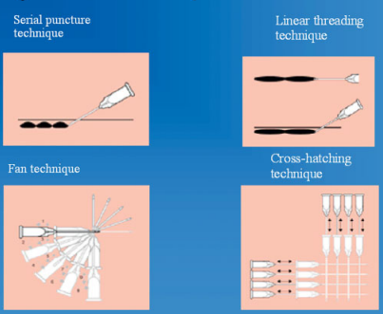
Fig. 10.9- Injection Techniques
LINEAR THREADING TECHNIQUE:
During injection, the needle's length should correspond to the wrinkle's length, and the substance is injected while pulling the needle slowly backward to position the threads of the gel lengthwise in the wrinkle..^{[16]}
SERIAL PUNCTURE TECHNIQUE:
Multiple injections are placed in a row along the length of the wrinkle or fold to be treated. They are made close together so that they merge into a smooth, continuous line that lifts the wrinkle. ^{[16]}.
FAN TECHNIQUE:
The periphery of the treatment area is targeted by inserting the needle, similar to the linear threading method. Once a line has been injected, the direction of the needle is adjusted and a new line is treated in the same way..^{[16]}
CROSS HATCHING TECHNIQUE:
The linear threading technique is used to inject the filler, where the needle is inserted at the outer edge of the area to be augmented and injected. The needle is then withdrawn and inserted 5-10 mm adjacent to the initial puncture site and injected in the same manner. This process can be repeated at right angles to the original lines.
TOWER TECHNIQUE:
The perpendicular injection technique is an innovative approach used to administer hyaluronic acid fillers. This method involves depositing the filler at a perpendicular angle to the deep tissue plane, with gradual reduction of product deposition as the needle is withdrawn. As a result, a series of struts or towers are created, which provide support to the overlying soft tissue, resulting in a more youthful appearance. This technique is particularly effective for treating areas such as the lateral brow, nasolabial folds, marionette lines, prejowl sulcus, and mental region..^{[16]}
INTRAORAL APPROACH:
Before the procedure, the skin on the targeted area is cleaned with an antiseptic. The patient is then positioned upright and the treatment area is marked using the Hinderer's method.
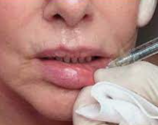
Fig. 10.10- Intraoral Approach
To identify the site for volume augmentation, two intersecting lines are drawn. One line runs from the tragus to the alar cartilage of the nose, and the other from the outer canthus of the eye to the labial commissure. The upper outer quadrant of the intersection is chosen for the implant placement. Before the procedure, the skin over the treatment area is cleansed with a topical antiseptic and the patient is positioned upright. The Hinderer's method is used to mark the areas for treatment.
COMPLICATIONS OF DERMA FILLERS
Early side effects of dermal filler injections may include redness, swelling, and bruising. To minimize pain, small amounts of local anesthetics are delivered gradually during the injection. Topical creams containing arnica, aloe vera, or naphthoquinone may help to alleviate bruises. In rare cases, patients with previous sensitization may experience allergic reactions shortly after the injection. If a filler is injected improperly, lumps and bumps may develop.
Both botulinum toxin (BTX) and dermal fillers have been approved for both diagnostic and therapeutic purposes. In 2014, the Michigan Board of Dentistry and the New Jersey State Board of Dentistry also approved the use of BTX and dermal fillers for dental applications..^{[17]}

Polo conducted a study where he administered 0.25 U of Botox to five patients who had excessive gingival display caused by the overactivity of upper lip elevator muscle. Freund et al. also used dermal fillers in combination with Botox injections to treat patients with gummy smiles, which resulted in both cosmetic and functional benefits. This combination was also used to treat lipstick lines by modifying the contraction of the orbicularis oris muscle. Daines and Williams filled black triangles using interdental soft tissue fillers and Botox injections, which resulted in a 3-4 month long-lasting outcome.
Early side effects of these procedures include erythema, edema, and bruising, but can be limited by slow injection and small-volume delivery of local anesthetics. Arnica, aloe vera, and naphthoquinone creams have been reported to help with bruises. In cases where the patient has been sensitized previously, allergies may develop within hours. If an incorrect filler is injected superficially or in the wrong areas, lumps and bumps may also develop. The Michigan Board of Dentistry and the New Jersey State Board of Dentistry approved the use of BTX and dermal fillers in 2014 to treat both diagnostic and therapeutic issues..^{[18]}
Studies conducted by Freund et al. found that administering BTXA into the temporalis and masseter muscles in TMD-related complications led to symptom relief lasting 2-4 months. In addition, BTX has anti-inflammatory properties as reported by Erdal et al. and Cersosimo et al. Injecting into the masticatory musculature reduces hyperfunctional or spastic muscles. Elcio reported that Botox injections also alleviated the throbbing pain associated with trigeminal neuralgia of the face..^{[19]}

- LIP AUGMENTATION
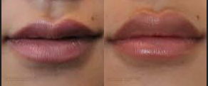
Fig. 10.11- Lip Augmentation
Lip augmentation is a cosmetic procedure that can enhance thin lips and give them a more youthful appearance. Different methods are available such as lip fillers, implants, fat transfers, and lip lifts. Each method has varying recovery time, effects, and potential risks. This in-office procedure offers different options to suit individual needs, including non-surgical procedures that use temporary fillers to plump up the lips or surgical procedures that involve small incisions for longer-lasting results..^{[20]}
TYPES OF LIP AUGMENTATION^{[20]}
- FAT GRAFTING (autologous fats injections or fat transfer): A plastic health care professional takes fat from some other area of your frame — commonly your belly — purifies it and injects it into your lips.
- LIP FILLERS: A healthcare company injects lip filler, also known as a dermal filler, into your lips or around your mouth.
- LIP IMPLANTS: A plastic general practitioner makes a small incision in every nook of your mouth and inserts an implant into your lips.
- LIP LIFT: A plastic health practitioner eliminates excess pores and skin among your nostril and upper lip (or the corners of your mouth) to pull up your lips.
TYPES OF LIP FILLERS: Healthcare providers specially use lip fillers that include hyaluronic acid, a natural substance discovered to your frame. commonplace hyaluronic acid fillers include Restylane and Juvéderm. some fillers also include lidocaine, which numbs your pores and skin to save you pain or pain from the process.
DURATION OF LIP AUGMENTATION-
Lip fillers final six months to a year; fat grafting lasts at the least 5 years. A lip raise is permanent. Lip implants are permanent but may be removed at any time.
The quality lip augmentation manner is unique for each person. The right system for you depends for your dreams and lip shape and length. for instance, lip implants or a lip raise may be best in case you choose everlasting outcomes.^{[20]}
However, implants may not be appropriate for razor-thin or asymmetrical lips. collectively along with your healthcare issuer, you can decide the exceptional method for you.
INDICATIONS FOR LIP AUGMENTATION-
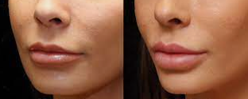
Fig.10.12- Lip Augmentation
- Patients who are in proper fitness.
- Don’t smoke or can give up smoking before the process.
- Don’t have an lively contamination like a chilly sore.
- Don’t have a persistent situation like diabetes or lupus.
- Have practical expectations approximately your results.
Lip fillersnwhile getting lip injections, the doctor uses a pleasant needle to inject the filler into your lips. The injections commonly take 10 to half-hour.^{[20]}
- FAT TRANSFER
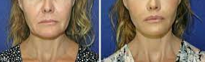
Fig. 10.13- Fat Transfer
If the injected substance incorporates fats out of your frame, you’ll have liposuction to put off the fats, normally from your belly place. After the fat is purified, your plastic health care professional injects it into your lips. The whole procedure takes approximately 60 to 90 minutes to complete.^{[21]}

- LIP IMPLANT^{[22]}
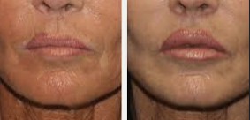
Fig. 10.14 - Lip Implant
This manner typically lasts approximately half-hour. throughout lip implant surgical treatment, your plastic health care provider:
- Local anesthesia administered on the lip
- Makes a tiny incision in each corner of the mouth.
- Creates a tunnel via inserting a clamp through one incision and threading it to the opposite aspect.
- Pulls the implant via the tunnel the use of the clamp.
- Closes the incisions with stitches.

- LIP LIFT^{[22]}
This method commonly takes approximately an hour. throughout a lip carry, your plastic health care professional:
- Anaesthetize the vicinity.
- Makes an incision below the nose.
- eliminates a small strip of pores and skin.
- Lift the upper lip.
- Closes the incision with stitches.
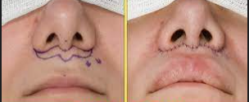
Fig. 10.15- Lip Lift Procedure
Possible risks and complications include:
- Allergic reactions like redness and itching.
- Bleeding.
- Bruising.
- Infection.
- Lip stiffening.
- Scarring.
- Swelling.
- Uneven lips.
The ultimate goal in a complete plan is to offer the most feasible options to the patient and have a treatment plan individualized for the patient. Any experienced expert in the area of Maxillofacial surgical procedure might vouch that many times just Orthognathic surgical operation/Orthodontics or a combination of each are simply no longer enough to attain the exceptional results but one should be willing to incorporate adjuvant tactics to attain the nice effects.

REFERENCES
  - Sinha A, Hurakadli M, Yadav P. Botox and derma fillers: The twin-face of cosmetic dentistry. International Journal of Contemporary Dental and Medical Reviews. 2015 Feb;2015:131214.
  - Patel D, Mehta F, Trivedi R, Thakkar S, Suthar J. Botulinum toxin and gummy smile-a review. IOSR J Dent Med Sci. 2013 Jan;4(1):1-5.
  - Dalati MH, Koussayer LT. An introduction to botulinum toxin and dermal fillers for dentists: Part 1. EC Dental Science. 2020;19(8):142-57.
  - Garber DA, Salama MA. The aesthetic smile: diagnosis and treatment. Periodontology 2000. 1996 Jun;11(1):18-28.
  - Meunier FA, Schiavo G, Molgó J. Botulinum neurotoxins: from paralysis to recovery of functional neuromuscular transmission. Journal of Physiology-Paris. 2002 Jan 1;96(1-2):105-13.
  - AlAhmary AW, Alqhtani SM, Alshahrani BA, Alkaram WA, Alhadad BS, Elmarakby AM. Clinical Applications of Botulinum Toxin in Oral and Maxillofacial Surgery: Clinical Applications of Botulinum Toxin in Oral and Maxillofacial Surgery. Open Access Macedonian Journal of Medical Sciences. 2020 Oct 5;8(F):260-71.
  - Kurtoglu C, Gur OH, Kurkcu M, Sertdemir Y, Guler-Uysal F, Uysal H. Effect of botulinum toxin-A in myofascial pain patients with or without functional disc displacement. Journal of Oral and Maxillofacial Surgery. 2008 Aug 1;66(8):1644-51.
  - Hwang WS, Hur MS, Hu KS, Song WC, Koh KS, Baik HS, Kim ST, Kim HJ, Lee KJ. Surface anatomy of the lip elevator muscles for the treatment of gummy smile using botulinum toxin. The Angle Orthodontist. 2009 Jan;79(1):70-7.
  - Bhat PR, Janiani P, Trasad VA. Botox: An advancement in dentistry: An overview. AOHDR. 2018;1:1-5.
  - Food U. Administration D. Information for healthcare professionals: OnabotulinumtoxinA (marketed as Botox/Botox Cosmetic), AbobotulinumtoxinA (marketed as Dysport) and RimabotulinumtoxinB (marketed as Myobloc). FDA Alert Rockville, MD: FDA. 2009.
  - Dastoor SF, Misch CE, Wang HL. Botulinum toxin (Botox) to enhance facial macroesthetics: a literature review. Journal of Oral Implantology. 2007 Jun;33(3):164-71.
  - Ashok D, Gnanashanmugam SK. Dermal fillers in orthodontics. Eur J Mol Clin Med. 2020;7:1626-9.
  - Zielke H, Wölber L, Wiest L, Rzany B. Risk profiles of different injectable fillers: results from the Injectable Filler Safety Study (IFS Study). Dermatologic surgery. 2008 Mar;34(3):326-35.
  - Fitzgerald R, Vleggaar D. Facial volume restoration of the aging face with poly‐l‐lactic acid. Dermatologic therapy. 2011 Jan;24(1):2-7.
  - Pallua N, Wolter TP. A 5-year assessment of safety and aesthetic results after facial soft-tissue augmentation with polyacrylamide hydrogel (Aquamid): a prospective multicenter study of 251 patients. Plastic and reconstructive surgery. 2010 Jun 1;125(6):1797-804.
  - Vedamurthy M. Soft tissue augmentation-Use of hyaluronic acid as dermal filler. Indian Journal of Dermatology, Venereology and Leprology. 2004 Nov 1;70:383.
  - Haneke E. Managing complications of fillers: rare and not-so-rare. Journal of cutaneous and aesthetic surgery. 2015 Oct;8(4):198.
  - Polo M. Botulinum toxin type A in the treatment of excessive gingival display. American journal of orthodontics and dentofacial orthopedics. 2005 Feb 1;127(2):214-8.
  - Cersósimo MG, Bertoti A, Roca CU, Micheli F. Botulinum toxin in a case of hemimasticatory spasm with severe worsening during pregnancy. Clinical neuropharmacology. 2004 Jan 1;27(1):6-8.
  - Byrne PJ, Hilger PA. Lip augmentation. Facial plastic surgery. 2004 Feb;20(01):31-8.
  - Groen JW, Krastev TK, Hommes J, Wilschut JA, Ritt MJ, Van Der Hulst RR. Autologous fat transfer for facial rejuvenation: a systematic review on technique, efficacy, and satisfaction. Plastic and Reconstructive Surgery Global Open. 2017 Dec;5(12).
  - Brody-Camp S, Raggio BS. Lip Implants.

