FORMS OF MOTION
Dr.BhanuPratap and Dr.Rajan Bhatia
FORMS OF MOTION
Most human movement is general motion, a complex combination of linear and angular motion components. Since linear and angular motion are “pure” forms of motion, it is sometimes useful to break complex movements down into their Linear and Angular components when performing an analysis.
Types:
1.Linear motion / Translation
(i) Rectilinear
(ii) Curvilinear
2. Angular motion / Rotation
3. General motion
LINEAR MOTION/TRANSLATION
All points on the body show the same trajectory (motion along a line)
When all parts of an object move the same
distance, in the same direction and time.
Pure linear motion includes the motion of the respective system in which all system components move at the same speed and in the same direction. Linear motion is also called translational motion or translation. When a body receives a translation it moves completely and parts of the body do not move towards each other. For example, a sleeping passenger is transferred into the air while the plane is in motion. However, if the driver stands up and reaches for the newspaper, naive interpretation no longer takes place, as the position of the arm relative to the body changes.
Linear motion can also be thought of as motion along a line. If the line is straight, the motion is linear; If the line is curved, the motion is curvilinear. A cyclist holding a parking spot is moving in a straight line while a motorcycle is traveling on a straight road. If a cyclist jumps on a bike and the bike's frame isn't spinning, both the rider and the bike (unless the wheels are spinning) will bend while airborne. Similarly, a Scandinavian skier travels in a straight line as he slides down a short hill in a locked, static position.
If a skier jumps over a ditch and the whole body moves along the bend in the same direction and at the same speed, the motion is curved. When a cyclist or skier rolls downhill, the motion is non linear aa the upper body moves faster than the lower body.
Figure 2-1 displays a gymnast in rectilinear, curvilinear, and rotational motion.
Rectilinear: straight path Curvilinear: curved path
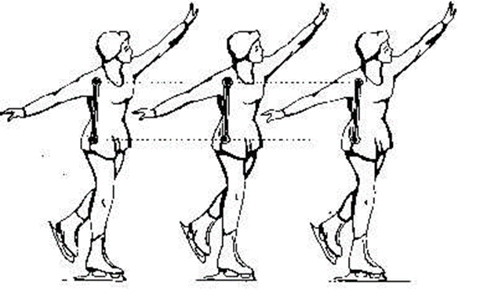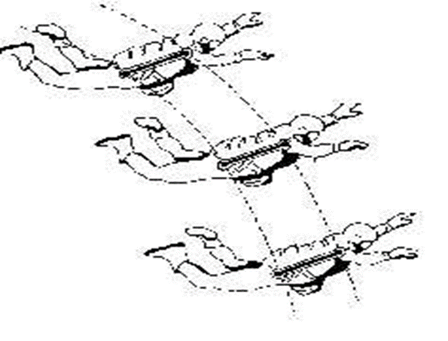

Angular motion / Rotation
Rotation around an axis of rotation When an object moves on a circular path around an axis, and all parts move through the same angle, direction, and time.
The line of rotation/Axis/centre of rotation may be within or out-side the body, retains its position and lies at right angles to the plane of the motion of the body.
e.g. - Horizontal bar, Hammer throw, floor exercises- somersault, rolls, forward and backward etc.
Angular motion is rotation around a central imaginary line known as the axis of rotation, which is oriented perpendicular to the plane in which the rotation occurs. When a gymnast performs a giant circle onRotation of a body segment at a joint occurs around an imaginary line known as the axis of rotation that passes through the joint centrea bar, the entire body rotates, with the axis of rotation passing through the centre of the bar. When a springboard diver executes a somersault in mid-air, the entire body is again rotating, this time around an imaginary axis of rotation that moves along with the body. Almost all volitional human movement involves rotation of a body segment around an imaginary axis of rotation that passes through the centre of the joint to which the segment attaches. When angular motion or rotation occurs, portions of the body in motion are constantly moving relative to other portions of the body.
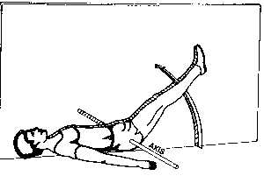
General Motion
It is a combination of motion and angle, or it can be different, eg kinematics. Walk, run, jump. The legs make angular movements around the hip joint and C.G.
Other examples of body movements are cycling, wheelchair, pole vault etc. When flip and rotation are combined motion is motion. While the scorer ball rotates etc.When flip and rotation are combined, motion is motion. While the soccer ball around the central axis at the same time, it also rotates in the air (Figure 2.2). The runner is defined by the movement of the body in the hips, knees and ankles. Most human movements are general movements rather than angular or angular movements.
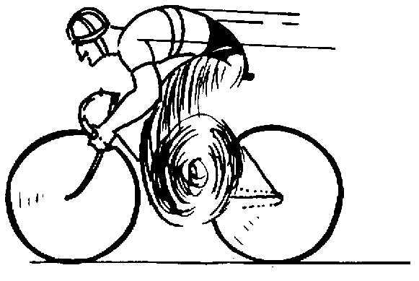

Mechanical Systems
Before determining the nature of the movement, the relevant mechanism should be defined. Generally, the entire human body is chosen as the system to be analyzed. In other cases, however, the system can be described as righthanded and perhaps even prepared by the right arm. During impact, the body shows a general movement , the arm is mostly angular and the sound of the ball swing is linear. The machine to be analyzed is selected by the motion analyst based on the desired point of interest.
REFERENCES:
Bartlett, R. (2016). Introduction to Sports Biomechanics: Analysing Human Movement Patterns. Routledge.
Knudson, D. (2013). Fundamentals of Biomechanics (3rd ed.). Springer.
Winter, D. A. (2009). Biomechanics and Motor Control of Human Movement. John Wiley & Sons.
Winter, D. A. (2009). Biomechanics and Motor Control of Human Movement. John Wiley & Sons.
Nigg, B. M., & Herzog, W. (2007). Biomechanics of the Musculo-Skeletal System (4th ed.). John Wiley & Sons.
Hay, J. G. (1993). The Biomechanics of Sports Techniques. Prentice Hall.
Robertson, G. E., Caldwell, G. E., Hamill, J., Kamen, G., & Whittlesey, S. N. (Eds.). (2004). Research Methods in Biomechanics (2nd ed.). Human Kinetics.
Zatsiorsky, V. M., &Seluyanov, V. N. (2002). The Biomechanics of the Human Musculoskeletal System. Human Kinetics.
Winter, D. A. (1990). Biomechanics and Motor Control of Human Movement. John Wiley & Sons.
Nordin, M., & Frankel, V. H. (2012). Basic Biomechanics of the Musculoskeletal System (4th ed.). Lippincott Williams & Wilkins.

