ABSTRACT

The area of biopharmaceutics studies the effects of a drug's physical/chemical characteristics, dose form (drug product), and route of administration on the rate and degree of systemic drug absorption. The sequence of events which take place before a drug's therapeutic effect is elicited is how the scientists explain the significance of the drug substance and the drug formulation on absorption and in vivo distribution of the medication to the site of action.

KEYWORDS- Biopharmaceutics, Pharmacokinetics ,drug

- Biopharmaceutics

A key area of the pharmaceutical sciences known as biopharmaceutics studies the relationship between a drug's physicochemical qualities in dose form and the pharmacology, toxicological, or clinical response that is seen after it is administered [2]. The dosing regimen affects both the safety and effectiveness of a drug. For many medications, there can be significant variations in the ideal dosage and dosing intervals. Additionally, the ideal dosage for a particular medicine can vary greatly amongst patients. [3].

Knowing what the medicine does to the body is vital, however it is also necessary to understand what the body does to the drug. Understanding a medicine's varying effects on different species and changing its dosing depend on recognizing its pharmacodynamic and pharmacokinetic characteristics in humans and animals. [4, 5].

The core concept of pharmacokinetics is the drug's plasma concentration. The volume of available drug present in circulation has a significant impact on dose estimations based on the drug's protein binding. Some body tissues and the medicine concentration in plasma are in balance. [6]
- Pharmadynamics
Pharmacodynamics is the study of how a drug's concentration at the site of action affects the outcome, including the duration and strength of both its beneficial and harmful effects. All main and secondary effects associated with the desired therapeutic benefits, expansions of the therapeutic effect that might result in toxicity at higher doses, and effects associated with drug interactions are all the subject of studies
- Pharmacokinetics
In addition to the process of the drug's absorption, distribution, metabolism, and excretion (ADME) pattern, pharmacokinetics is the study of the time course of a drug within the body (amount and duration of systemic exposure to the drug). Typically, drug concentrations in blood or plasma are measured to obtain pharmacokinetic parameters. [1].

Absorption
In order to figure out the rate and extent of absorption,, Despite absorption studies often include multiple measurements of concentration of drug in blood and the urine following dosage.
Drug absorption allude to the movement of the drug molecules from their site of administration straight into the circulation. of blood Drugs need to get across one or more of layers of cells and the cell membranes in order to be absorbed.
The drug's structure mostly affects solubility. The quantity and type of lipophilic functionalities a molecule contains, as well as how tightly it is packed into crystals, all affect how soluble a molecule is. Increases in lipophilicity or crystal packing promote a decrease in solubility.
The following factors affect drug absorption when taken orally:
- Biological factors:Site specificity, GI transit, first-pass metabolism, liver metabolism, excretion of bile , bladder excretion, and also protein binding of pharmaceuticals are all examples of drug transport mechanisms.
- Pharmaceutical factors:Excipients, dosage form type, manufacturing procedure, testing of stability, and instructions for storage
- Miscellaneous factors:salt formation, crystallinity, polymorphism, crystal size, volume,shape and the distribution, dissociation properties, prodrugs along with dissociation characteristics and the creation of stereotypes [3, 7, 8]

Drug absorption
Drugs could be weak bases or acids that can endure in the body in both of ionized and the non-ionized states. Drugs can penetrate cell membranes in their non-ionized form because the molecules are sufficiently soluble in membrane lipids. The ratio of two forms at a specific place affects rate of the absorption, which additionally impacts distribution and the elimination. In contrast a weak base's protonated formation is ionized, the weak acid's protonated formation is non-ionized.The negative log of the ionization constant is the pKa of each acidic or basic drug.Protonated form predominates when pH is less than pKa; nonprotonated form predominates when pH is greater than pKa.. [9].
There are a total of two ways how absorption occurs across the cellular membrane. Lipid substances are absorbed by a transcellular method in which a drug diffuses and entering the lipid core of a membrane of cell before reaching opposite edge. Additionally, the solute can also diffuse through cellular membrane then reach blood stream. Paracellular absorption is an additional process. Drug absorption is aided by the pores between the cells that have been filled with water. Water-soluble drugs are quickly absorbed, however each particle's molecular size has pushed up an immense effect. [10, 11].
Figure 1 depicts the mechanisms for transcellular and paracellular absorption..
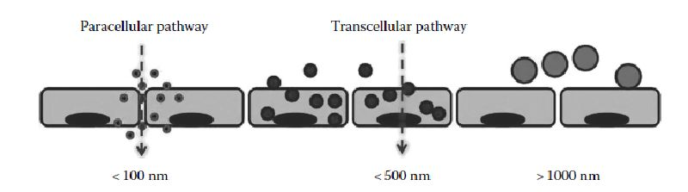

Fig 1.
Transcellular and paracellular routes for drug absorption

- Transportation across cellular membranes

Passive diffusion

A drug is transported beyond the membrane utilising energy from the gradient of concentration, and the extent of drug absorbed is determined by how the drug is split in favor of the membrane of lipids. The unionized drugs permeates much more readily than the ionized variant. Fick's first law, thereby separates diffusive flux to the concentrations undergo assuming of gradual state, can be a means of clarifying passive diffusion.According to this theory, the flux shifts along a concentration gradient from high-concentration locations to low-concentration ones, with an order of extent that is in proportion to gradient. To settle it another way, it postulates that a solute will migrate from a densely concentration area to a sparsely concentration one.

Active transportation

Moving against a lower concentration area in the GIT towards a region of higher concentration in the plasma is a live instance of active transport, which refers tothe transport of molecules against a concentration gradient through the lipid membrane of a cell. The GIT embraces the absorption sites in one particular area. Massive quantities of substances so the cell necessitate ion, glucose, and amino acids are a few examples, frequently link with active transport. The Chemical energy is involved in this active transport mechanism, which form adenosine triphosphate (ATP). They are these energy molecules operating as a ferry service, activating up molecules from the GIT, ferrying them over, dropping in the cytoplasm, and returning. They are location-specific, as drugs are movement at a specific location in GIT, exclusive in quantity, and site-specific.

Endocytosis

It is an energy-intensive procedure through that cells take in molecules via encapsulating these, including proteins. The big polar molecules that can't fit through the hydrophobic cell membrane or plasma membrane use it. Exocytosis is the opposite process. In contrast to other types of endocytosis, like the vesicular uptake of different liquids called as pinocytosis, phagocytosis is a specialized type of endocytosis that entails vascular uptake of solids by an organism, such as bacteria. Some cells be involved with phagocytosis for purposes to obtain nutrients. Pinocytosis is type of endocytosis in that microscopic particles adequately taken inside the cell, raising an introversion, and subsequently suspended inside tiny vesicles. It is also referred to as cell drinking, cell eating, and bulk-phase pinocytosis. [8, 12-17]

In Figure 2, various endocytosis types are depicted.

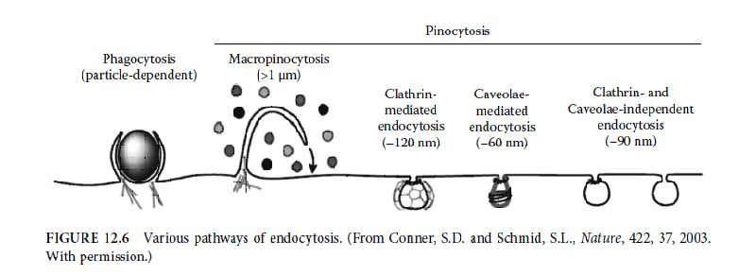

Figure 2.
Various endocytosis pathways

Distribution
Distribution reveals details regarding the amount and timing of drug and/or metabolite accumulation in tissues as well as their removal.
The composition of the medicine determines how it is disposed of through circulation, into the organs and tissues. The distribution of medicine into organs and tissues will be better the more lipophilic it is. Hydrophilic drugs are known as ion trapping because they are typically concentrated in cells.
- Volume of distribution

The (Vd), also called as the apparent Distribution volume,It is a theoretical volume in pharmacology that whole volume of drug delivered might need to anticipate to offer exactly the same concentration as blood plasma.

The (Vd) can be determined utilizing the concise equations: X =VdC, where X is the Volumeof drug in the body ,Vd is the volume of distribution, C is the concentration in plasma, if amount of drug (X) and the consequent concentration (C) are well known.

Most lipid-insoluble drugs do not penetrate the brain after an vital dose; they are largely restricted to plasma and interjacent fluid. Drugs which are lipid soluble penetrate all tissues and may build up in fat. Vd may be more than the entire amount of the volume of the body for medicines that assemble outside the plasma compartment.

The following factors are involved in drug diffusion and distribution through the blood-tissue barrier.

- Flow of blood

- Permeability via blood tissue barrier

- Solubility in tissues

- Partition of pH

- Binding of proteins within a compartment

Figure 3 depicts numerous drug distribution routes in the blood 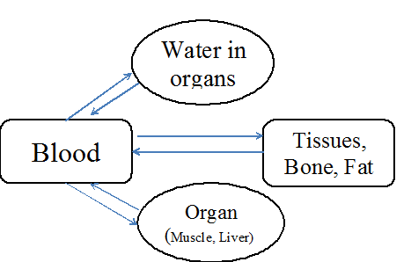

Figure 3.

Several paths for drug absorption into the blood

- Compartment models in drug distribution kinetics

The Compartment models are fictitious constructs that are given to explain how a medicine behaves in a biological system after it has been given to the body. Pharmacokinetic compartment models include:
One-compartment model: The body frame is seen as a kinetically identical unit after drug administration.

Two- compartment type : body is separated into two compartments: a peripheral compartment and a central compartment.

Multi compartment model: A drug is distributed throughout multiple compartments in this model, and the concentration-time profile displays multiple exponentials. [4, 9, 18-21].

Table 1 displays the drug's distribution throughout several body compartments..

Table 1.
Body compartment and the drug distribution

Compartments of Body (L/kg body weight) | Drug distribution in body compartments
Extracellular and intracellular total body water = 0.6 | Relatively Small water-soluble drugs
Water outside of cells = 0.2 | Greater water-soluble drugs
The blood = 0.08  The Plasma = 0.04 | Plasma protein-bound greater drugs
The body's fat = 0.2 – 0.35 | Lipid-soluble drugs
Bones = 0.07 | Particular ions

Biotransformation/Metabolism
An enzyme-catalyzed transformation of drug to their metabolites is known as biotransformation or drug metabolism. A drug becomes less polar through metabolism; a lipid -soluble molecule increases its polarity and water solubility, improving kidney elimination. A drug may not be metabolized and may instead be excreted if it is already extremely polar and water soluble. The liver serves as the primary organ for the biotransformation of the majority of drugs, although other tissues, such as the gut, kidneys, brain, lungs, and skin, also contain enzymes that help pharmaceuticals be metabolized. Drugs which are lipophilic are abundantly metabolized inside the liver to become hydrophilic drugs.
Phase I and II processes are generally used to carry out drug metabolism..
The cytochrome P450 system is crucial to phase I drug clearance and plays a significant role in it.
Phase I: The production of a product that is amenable to a phase II conjugative reaction is the first stage in biotransformation. Uncovering an OH, NH2, or SH functional group during phase I also entails converting it into more polar products, some of which may have altered or reduced activity.
Phase II:Combining a drug or oxidized metabolite of it with an endogenous conjugating agent generated from sources of carbohydrates, proteins, or sulfur; typically, the resulting compounds are more soluble in and easier to excrete by the urine or by bile. Phase II entails conjugation reactions involving amino acids, acetic acid, sulfuric acid, and glucuronic acid.
Enzymes that break down drugs are divided into two categories:
- Nonmicrosomal (non-inducible)
- Microsomal (inducible)

Clearance (Elimination)
The amount of plasma in vascular compartment which is eliminated of drugs (just unbound, unbound to proteins) per unit of time through the procedure of metabolism and elimination is known as drug clearance (CL).The drug's concentrations that remain inside the blood thereafter administration affect clearance. Blood flow to the extracted organs facilitates drug clearance. Extraction is a percentage of clearing process (E) that refers to an amount of a drug that leaves an organ permanently (excreted) or changes into a different chemical form (metabolism).
The method of eliminating drugs from the body typically involves hepatic clearance (ClH) and renal excretion (ClR). Systemic clearance (CIS) can be computed as a whole by
ClS=ClH+ClRClS=ClH+ClR
The kel constant for elimination can be assessed for the volume of distribution and the amount of drug in circulation are acquainted.
kel=Cl/Vd���=��/��
If drug is removed by using first-order kinetics, clearance is constant.
Half-life (t1/2)- It is an amount of time necessary to achieve a plasma concentration reduction to 50% of the starting point.
Zero-order reaction:Regardless of drug concentration in body, reaction moves along at a consistent rate.
First-order reaction: The rate at which the reaction happens depends on the amount of drug inside the body.
The Excretory organs:
Major routes: the liver, lungs, the kidneys.
Minor routes: the saliva, breast milk, perspiration, and tears
- Urine: This is the most significantnonvolatile drugs and their metabolites excretory pathway (drugs not associated with plasma proteins) passive tubular reabsorption and proximal tubular active secretion It also aids in quantifying the amount of drug expelled.
- Renal excretion:Glomerular filtration causes tiny molecules with lower molecular weight to end up in urine. To be excreted in urine, a drug can be deliveredfrom the blood capillaries through tubular carrier systems (tubular secretion) to the nephron lumen.
- Renal clearance: Filtration will be used to remove the unbound drug, and as the protein-bound drugs dissociates over time, it will be gradually removed from the body. Drugs with higher lipophilicity have increased plasma protein binding, which reduces renal clearance
- In drugs design, renal clearance : Tiny compounds (molecular weights under 350) with relatively basic structures may effectively combine renal clearance with paracellular absorption.
- Biliary and liver excretion: The liver is an organ with the highest rate of metabolism. Drugs that are not absorbed and those that have undergone metabolized are expelled through fecal waste. In a majority oxidation reactions, involving alcohol oxidation, N-oxidation, S-oxidation, and hydroxylation of aromatic and aliphatic compounds, the enzyme cytochrome plays an critical part in the clearance of drugs.
Figure 4 depicts the hepatic and renal clearance mechanism.
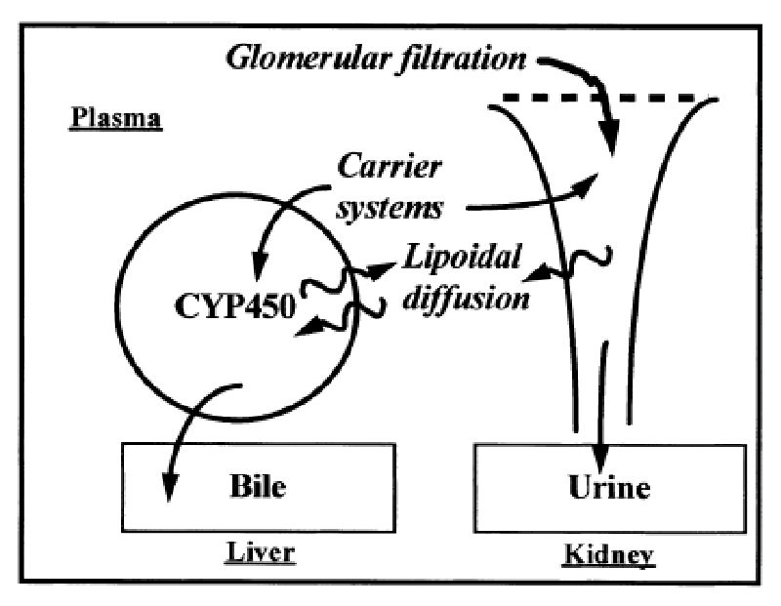

Figure 4.
Renal and hepatic clearance mechanisms
- The Lungs: Alcohol, iodine, iodates, and gaseous anesthetics can all be excreted through the lungs..
- Other excretion pathways include perspiration, saliva, and tears, which often depend on pH and facilitate drug excretion by passive lipophilic drug diffusion.
- Milk:Due to ionic trapping, basic drugs tend to collect in milk since it is more acidic than plasma, but acidic pharmaceuticals have a lower concentration than in plasma.No of the pH, nonelectrolytes like ethanol and urea can enter milk.
- Skin and hair: Excreting the hazardous metal result in homicide or suicide [3, 8, 21, 22-26].

- Conclusion
The study of pharmacokinetics, which includes the absorption, distribution, metabolism, and excretion procedure (ADME), examine temporal the physiological course of a drug. The pharmacokinetic notion that is based on concentration of drug in biological matrix is simplest. The the drug concentration in the biological matrix needs to be quantified using a sensitive and selective bioanalytical approach. The majority of drugs may absorbed through passive diffusion. Solubility of the drug in lipids and the surface area that is available for absorption determine the drug diffusion rate in passive processes. Molecular size, lipid solubility, plasma protein binding all play a role in how the drug is distributed. The drug transformed after distribution in a metabolite that is either active or inactive pharmacologically. Metabolism of drugs depends heavily on the liver. Drugs that have been metabolized are mostly eliminated through the liver and kidney. For quick screening, choice, and development of new compounds, drug research and development process needed lot of clinical data. The pharmacokinetic parameters are evaluated using a variety of mathematical models. Results from preliminary pharmacokinetic studies are particularly helpful for characterizing drug metabolism, disposition profile, and absorption, all of which are crucial for finding and creating new therapeutics for unmet medical needs.

References
- Lakshmana Prabu S, Thirumurugan R, Suriyaprakash TNK. (2014). The role of the drug discovery, clinical, and regulatory affairs teams in turning a potent agent into a registered product. In: Elsevier Reference Module in Chemistry, Molecular Sciences and Chemical Engineering, Reedijk J (Ed.) Elsevier, Waltham, MA. 23-May-14 doi: 10.1016/B978-0-12-409547-2.11400-3.
- Gibaldi M. (1991). Preface. In: Biopharmaceutics and Clinical Pharmacokinetics. Lea, Febiger, 7, Malvern, PA.
- 3.Panchagnula R, Thomas NS. (2000). Biopharmaceutics and pharmacokinetics in drug research. International Journal of Pharmaceutics, 201, 131–150.
- Lin JH, Lu AY. (1997). Role of pharmacokinetics and metabolism in drug discovery and development. Pharmacology Review, 49, 403–449.
- Phytochemistry. (2012). In: Pharmacokinetics and Metabolism in Drug Design, Smith DA, Allerton C, Kalgutkar, Waterbeemed H and Walker DK, 1–17, Wiley-VCH Verlag & Co, Weinheim, Germany.
- Pharmacokinetic. (2012). In: Pharmacokinetics and Metabolism in Drug Design. Smith DA, van de Waterbeemd H, Walker DK, Mannhold R, Kubinyi H, Timmerman H, 19–40, Wiley-VCH Verlag GmbH, Weinheim, Germany.
- Absorption. (2012). In: Pharmacokinetics and Metabolism in Drug Design. Smith DA, van de Waterbeemd H, Walker DK, Mannhold R, Kubinyi H, Timmerman H, 41–59, Wiley-VCH Verlag GmbH, Weinheim, Germany
- General pharmacology. (1993). In: Pharmacology and Pharmacotherapeutics. Satoskar RS, 1–50, Popular Prakashan Private Ltd, Mumbai.
- http://www.us.elsevierhealth.com/media/us/samplechapters/9781416066279/Chapter%2002.pdf [Accessed on 10.10.2014]
- Gunaratna C. (2000). Drug metabolism and pharmacokinetics in drug discovery: a primer for bioanalytical chemists, part I. Current Separation, 19, 17–23.
- Lakshmana Prabu S, Suriya Prakash TNK. (2012). Extraction of drug from the biological matrix: a review. In: Applied Biological Engineering Principles and Practice, Naik GR, 479–506, InTech, Croatia.
- http://ocw.mit.edu/courses/health-sciences-and-technology/hst-151-principles-of-pharmacology-spring-2005/lecture-notes/ln34hms3275.pdf
- Birkett DJ. (2002). Pharmacokinetics Made Easy, 2nd ed. McGraw-Hill, Roseville, Australia.
- Levine RR. (2000). Pharmacology: Drug Actions and Reactions, 6th ed. Parthenon, New York.
- Clark B, Smith DA. (1986). In: An Introduction to Pharmacokinetics, 2nd ed. Blackwell Scientific, Oxford.
- Jegadeesan D, Eswaramoorthy M. (2011). Nanomaterials for therapeutic drug delivery. In: Nanobiomaterials Hand Book. Balaji S, 12.1–12.22, CRC Press, Taylor & Francis, UK.
- Absorption of drugs. (1995). In: Biopharmaceutics and Pharmacokinetics a Treatise. Brahmankar DM, Jaiswal SB, 5–75, Vallabh Prakashan, New Delhi.
- Distribution. (2012). In: Pharmacokinetics and Metabolism in Drug Design. Smith DA, van de Waterbeemd H, Walker DK, Mannhold R, Kubinyi H, Timmerman H, 61–79, Wiley-VCH Verlag GmbH, Weinheim, Germany.
- Distribution of drugs. (1995). In: Biopharmaceutics and Pharmacokinetics a Treatise. Brahmankar DM, Jaiswal SB, 76–90, Vallabh Prakashan, New Delhi.
- Urso R, Blardi P, Giorgi G. (2002). A short introduction to pharmacokinetics. European Review for Medical and Pharmacological Sciences, 6, 33–44.
- Compartment modeling. (1995). In: Biopharmaceutics and Pharmacokinetics a Treatise. Brahmankar DM, Jaiswal SB, 230–272, Vallabh Prakashan, New Delhi.
- Clearance. (2012). In: Pharmacokinetics and Metabolism in Drug Design. Smith DA, van de Waterbeemd H, Walker DK, Mannhold R, Kubinyi H, Timmerman H, 81–102, Wiley-VCH Verlag GmbH, Weinheim, Germany.
- Renal clearance.. (2012). In: Pharmacokinetics and Metabolism in Drug Design. Smith DA, van de Waterbeemd H, Walker DK, Mannhold R, Kubinyi H, Timmerman H, 103–110, Wiley-VCH Verlag GmbH, Weinheim, Germany.
- Excretion of drugs. (1995). In: Biopharmaceutics and Pharmacokinetics a Treatise. Brahmankar DM, Jaiswal SB, 178–203, Vallabh Prakashan, New Delhi.
- Pharmacokinetic basic considerations. (1995). In: Biopharmaceutics and Pharmacokinetics a Treatise. Brahmankar DM, Jaiswal SB, 212–229, Vallabh Prakashan, New Delhi.
- http://pharmaquest.weebly.com/uploads/9/9/4/2/9942916/pkinetic_parameter.pdf [Accessed on 10.10.2014]

