Adapting the traditional guide model to visually impaired

¹Dr. Geetha. A, ²Dr. Keerthika. V ³ Dr.Priyasumitha VS

1 Assistant Professor, Alliance College of Engineering and Design, Alliance University,Bangalore
geetha.a@alliance.edu.in
2 Associate Professor, Alliance College of Engineering and Design, Alliance University, keerthika.v@alliance.edu.in,Bangalore
3 Assistant professor, KG College of Arts &Science, priyasumitha123@gmail.com
Coimbatore

ABSTRACT

The same information needs apply to persons who are blind or visually impaired as they do to those who are seeing. Like sighted individuals, those who are blind or partly sighted want to be able to travel, make purchases, and simply relax in a park. Additionally, they want to have access to relevant data in the format that is most convenient for them. It is crucial to provide a productive library service for those who are print-impaired since there are much fewer commercially available books in accessible formats than there are available.Due to illness or injury to the area of the eye or brain that processes visual information, a person with visual impairment loses their capacity to see. A visual impairment is an eye disorder that cannot be treated with glasses or contact lenses. The iris regulates the amount of light that may pass through the pupil of the eye. It also has a cornea that focuses light and a retina that transforms light impulses into nerve signals that are sent to the brain to create images. Vision becomes impossible when the retina or optic nerve, which sends light signals to the brain, are injured. Congenital blindness is the term used to describe infants who have vision problems from birth. In order to assist the blind, we created technology that makes moving easier.

1.INTRODUCTION

One of the most common problems that people who are blind or visually impaired deal with on a daily basis is unsafe movement. They experience emotional discomfort, jeopardize their independence, and put themselves in risk by failing to recognize and avoid obstructions in their path. There are around 253 million visually impaired persons in the globe, according to the most current World Health Organization (WHO) figures. There are 36 million blind persons and 217 million people who are visually impaired worldwide. As the population continues to grow at a pace of 2 million every 10 years, visual impairment has become a serious problem. There will likely be twice as many blind people by the year 2020. For those with illnesses and visual impairment, assistance is needed for daily chores like walking in strange places.
Routine tasks, notably navigation, need assistance for those with visual problems. People with visual impairments must be able to recognize obstacles and other distractions in order to move safely in new or unfamiliar environments. In order to provide assistive technology or help for persons who have visual impairment, this topic is being investigated. The same information needs apply to persons who are blind or visually impaired as they do to those who are seeing. Just like sighted individuals, those who are blind or partially sighted want to be able to move about, make purchases, and even unwind in a park. Additionally, they want to have access to relevant data in the format that is most convenient for them. It is crucial to provide a productive library service for persons who are print-impaired since there are much fewer commercially available resources than there are accessible items.
- Types of Visual Impairments
A spectrum of visual impairments exist. When a person has total blindness, also known as complete vision loss, they cannot perceive any light and only perceive total darkness.People may suffer from various kinds of vision loss. For instance, even with a prescription, a person may still be extremely nearsighted or farsighted. Field loss would be regarded as a form of visual impairment. Retinitis pigmentosa patients experience vision loss in areas that may not be related to their visual acuities.
2.2 Mobile Apps for Visual Impaired Students
There are accessibility apps for iOS and Android devices. Many students with visual impairments may find it easier to adjust to college life with their assistance.
Dragon Speech Recognition:With the help of this free speech-to-text app, users can quickly produce text documents by taking oral instructions.
KNFB Reader: KNFB Reader can give users quick access to printed text by speaking out loud typed text.
Talking Scientific Calculator: This calculator app offers an accessible digital calculator through the use of VoiceOver, a screen reader included with iOS devices.
Seeing AI: In order to provide audible descriptions of text and objects, such as documents, product labels, handwriting, and even colours, seeing AI uses the camera.
AccessNote: AccessNote is a VoiceOver-compatible note-taking app that works with a conventional keyboard or a refreshable Braille display.
BlindSquare: Created with screen readers in mind, BlindSquare is a GPS app for travellers with visual impairments.
Be My Eyes: With the help of volunteers who can virtually assist students with visual impairments, Be My Eyes users can ask questions or describe the environment around them.
A person must meet the federal definition of legal blindness in order to be eligible for government assistance like Social Security disability payments or vocational rehabilitation. You might be considered legally blind if your vision cannot be corrected past 20/200 acuity or if your field of vision is restricted to 20 degrees or less.
3.Related Innovation Fields
The blind and visually handicapped already have access to certain navigating aids and systems. The most crucial instruments are white canes and seeing-eye dogs. Their performance is limited in terms of speed, coverage, and ability compared to what people with real eyes can see. Obstacles above the head cannot be detected by a cane; they can only be detected below the knee. Furthermore, it can only identify barriers that are immediately next to it. Despite being an excellent navigational aid, seeing-eye dogs need extensive training that is time-consuming for persons who are blind or visually handicapped and they are unable to detect overhanging objects. Additionally, compared to other aids, seeing-eye dogs are somewhat pricey.

Based on survey done we have identified following problems
- Problem in colliding to objects.
- Families not able to know the location of impaired.
- Accidents with moving vehicles

3.1 Designing The Solution
System detects objects and pre-informs the used about upcoming object.It provides user location to families, can also be used as assistance for blind.Uses ultra-sonic sensors to measure the distance for nearby objects.The receptors receive the reflecting waves and based on its distance is calculated.The device is compact and parable can be carried on easily.Can also be put on to baby cradles to alarm parents, when infant is about to collide.The system informs hospital when an accident occurs.

4. Equipment of Visually impaired
This system focuses on the welfare of visually impaired individuals. The system is called Guider, it is named so because it serves as an object detector and alarmer for impaired. When the user comes reasonably nearer to any object the system rings, hence preventing collapse. It also provides user location to families and hospital when user gets hurt. The following subheadings will be elaborating about development process and methodology.

Arduino Uno R3:

A microcontroller board called Arduino UNO is based on the ATmega328P. It has 6 analogue inputs, a 16 MHz ceramic resonator, 14 digital input/output pins (six of which can be used as PWM outputs), a USB port, a power jack, an ICSP header, and a reset button. It comes with everything needed to support the microcontroller; to get started, just plug in a USB cable, an AC-to-DC adapter, or a battery. You can experiment with your UNO without being overly concerned that you'll make a mistake; in the worst case, you can replace the chip for a few dollars and start over.

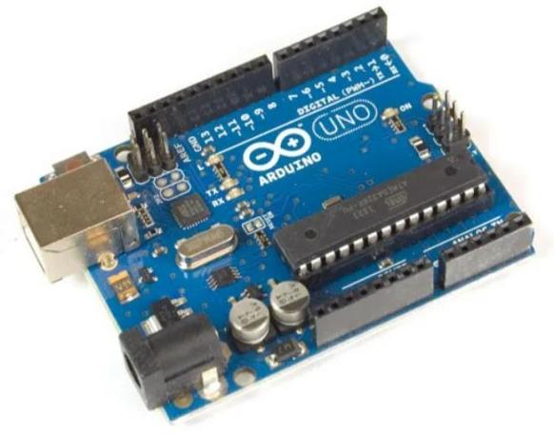
Fig:4.1 Arduino Uno R3

Ultrasonic Sensor HCSR-04

Sonar is used by the HC-SR04 ultrasonic sensor to calculate a distance to an object. This sensor's accuracy of 0.3 cm (0.1 inches) and reading range of 2 cm to 400 cm (0.8 inch to 157 inch) make it suitable for the majority of hobbyist projects. This specific module also includes ultrasonic transmitter and receiver modules.

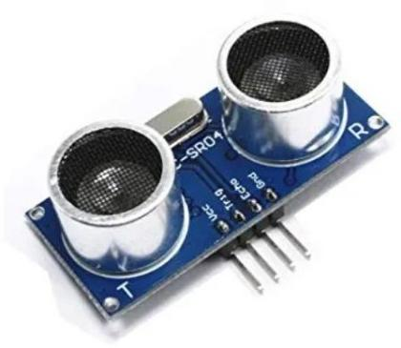

Fig: 4.2 Ultrasonic Sensor HCSR-04
Bluetooth Module
To calculate the distance to an object, the HC-SR04 ultrasonic sensor uses sonar. For the majority of DIY projects, this sensor's range of readings—2 cm to 400 cm (0.8 in. to 157 in.)—and accuracy of 0.3 cm (0.1 in. Ultrasonic transmitter and receiver modules are also included with this specific module.

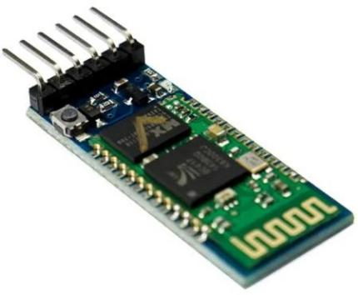
Fig:4.3 Bluetooth Module
Buzzer 12V
A beeper or buzzer, for example, could be electromechanical, piezoelectric, or mechanical in design. The signal is converted from audio to sound as its primary function. It is typically powered by DC voltage and used in timers, alarm clocks, printers, computers, and other electronic devices. It can produce a variety of sounds, including alarm, music, bell, and siren,depending on the different designs.

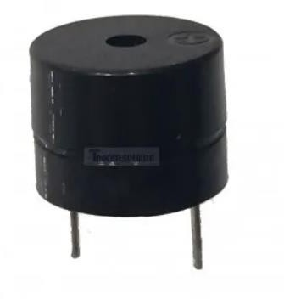
Fig:4.4 Buzzer 12V

9V Battery Snap Cap with DC Jack
A simple connection from a 9V battery to a power device or circuit that has a dc connector is made possible by 9V snap connectors that are stronger and longer-lasting. With an outside diameter of 5.5mm and an interior diameter of 2.1mm, this plug is a very popular barrel type. The heart is upbeat. This item is also referred to by the names 9V Battery Snap Cap with Male DC Connector, 9V Battery Snap Connector With Male DC Jack, Battery Snapper With DC Pin, 9V Battery, Battery Connector, DC Jack, Battery Snap Connector, and Battery Snapper Connector 9V DC.

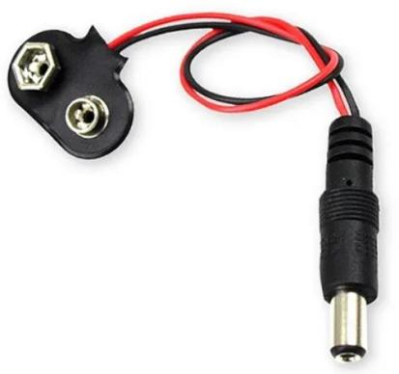

Fig:4.5 9V Battery Snap Cap with DC Jack
Male to Female Jumper Wires
A jump wire is an electrical wire, or group of them in a cable, with a connector or pin at each end , which is normally used to interconnect the components of a breadboard or other prototype or test circuit, internally or with other equipment or components, without soldering.Individual jump wires are fitted by inserting their end connectors into the slots provided in a breadboard, the header connector of a circuit board, or a piece of test equipment.

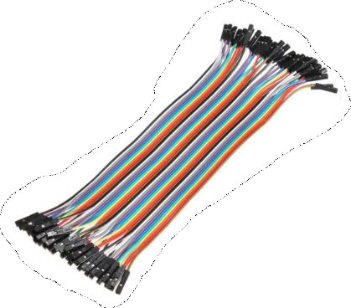
Fig:4.6 Male to Female Jumper Wires

5.Development of Processing Methodology
Step 1: The Arduino code is written in C language as it is closer to hardware.
Step 2: Software Serial Library is included so that our Arduino is able to communicate with Bluetooth devices.
Step 3: We have declared Transmitting and Receiving pins of Bluetooth module as 9 and 8 respectively.
Step 4: Global variables are declared.
Step 5: Setup() function has void return type and is executed once only when our software system initializes.
Step 6: Hence in setup() we declare pinMode(), which tells Arduino type of usage of each pin.
Step 7: Here we declare transmitting and receiving pins of ultrasonic sensor and buzzer pins.
Step 8: Initialization of Bluetooth is also done in this function.
Step 9: Loop() function runs repeatedly in an Arduino device hence we write here all the code functionalities of Arduino.
Step 10: We turn on the ultrasonic sensor by digitalWrite() function then.
Step 11: By this the transmitter of ultrasonic sensor starts emitting ultrasonic waves. 1
Step 12: Waves are transmitted for 10 milliseconds, since we have put a delay of 10
milliseconds.
Step 13: Then we turn off the transmitter using digitalWrite() function. 14.pulseIn() function returns float value which is the time waves took to reflect back and reach back to the receiving end of ultrasonic sensor.
Step 14: With this time er calculate distance of object which was the cause of ultrasonic waves to reflect.
Step 15: If the distance of the object is less than 10cm we inform the bluetooth module to send SMS to family.
Step 16: If distance is less than 100cm but greater than 10cm we just ring the alarm for the blind person to get notified about the obstacle in front.

Model of the Guider

The following image shows the final model of our software system. The user has to connect their mobile phone through Bluetooth with our Guider.  The stick can be used as a support for the impaired with an alarm which pre-informs the user about an upcoming object with the help of a buzzer.  If the user is under 10cm of an object then the system informs the concerned contact phone numbers about the incident with an SMS. Hence, serving as an absolute guider for the user. | 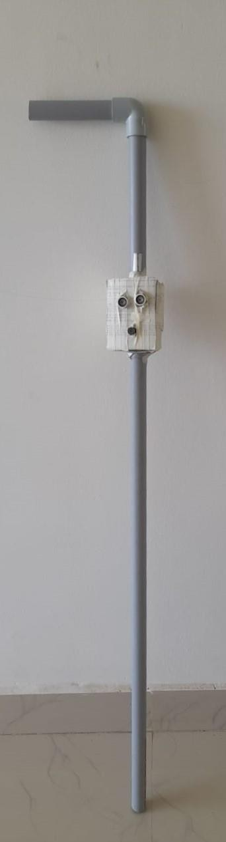

CONCLUSION
In conclusion, my research on persons with visual impairments has taught me a lot. The most essential subjects I've read about are the challenges that those with visual impairments face. It's amazing how their lives have changed and how they've had to adjust to losing their vision. I've come to understand, however, that living with a visual impairment comes with a lot of challenges that individuals must deal with on a daily basis, such as concerns about money, psychological issues, medication side effects, and other issues. Every day is a struggle for them. The human being is the most beautiful creation in the universe, and technology has considerably helped to close the gap between society and people who are blind or visually impaired. Every day, science-based discoveries produce new technology that improve the quality of life for everyone, including healthy people and those with disabilities. As genuine members of society who shouldn't be treated differently than other people, persons with vision impairments and other disabilities should also be accommodated, the designers should bear in mind. Although people with visual impairments may work in the same variety of occupations as those with normal eyesight, their unemployment rate is much greater. Although the employment rate for those who are blind or visually impaired has been rising gradually, more job options are needed for these highly talented and qualified people. I was able to pinpoint their problem and the strategy and procedure for coming up with answers thanks to my investigation.The device can be extended to add on the future functionalities, The device can be used to order cabs, to ease mobility on visually impaired.The user would be able to voice call with the system.The device can read out the text which user hovers on.The model can be updated to be able to be handier to the visually impaired.The device can be extended to translate sign language to speech.The device can also act as a virtual friend to the user.The device can have an emergency button which makes a call to their guardian when pressed.

REFERENCES

- A. Carullo, M. Parvis, “An ultrasonic sensor for distance measurement in automotive applications”, IEEE, 2001
- W. Yang, X. Zhao, A. S. Reddy M, Vyshnavi, C. R. Kumar, Saumya, “Virtual Assistant Using Artificial Intelligence ”, JETIR, 2020.
- M. J. Samual, “Implementation of GPS Based Object Location and Route Tracking on Android Device”, IJISE, 2015.
- “Research on Realization of Python Professional English Translator”, ISAEECE, 2021

