SATELLITE AND SPACE COMMUNICATION

Dr.Shalini S Sheela S
Dept. Computer Science and Engineering Dept.Computer Science and Engineering
DSATM,Bangalore Bangalore, India
shalini.siddamallappa@gmail.com Sheela.s@gat.ac.in
Prathyusha S Syed Mezan Naimuddin
Dept. Aeronautical Engineering Dept. Aeronautical Engineering
Global Academy of Technology Global Academy of Technology
Bangalore, India Bangalore, India
prathyushas354@gmail.com mezan990@gmail.com

Akshay D Vivek N
Dept. Computer Science and Engineering Dept. Aeronautical Engineering
Global Academy of Technology Global Academy of Technology Bangalore, India Bangalore, India
akshay70224@gmail.com viveknanjundaiah2003@gmail.com

ABSTRACT
Satellite and space communication plays a vital role in revolutionizing how we connect and communicate globally. This paper presents an overview of satellite technology and its profound impact on modern society. With an ever-increasing demand for faster and more reliable communication. It explores the essential components of a satellite system, such as the satellite itself, ground stations, and user terminals. The paper highlights the various orbits utilized by satellites, including geostationary, medium Earth orbit (MEO), and low Earth orbit (LEO). The differences in advantages and limitations emphasize their application in different communication scenarios. Satellites act as essential relays, facilitating long-distance communication between remote regions and providing internet access to underserved or hard-to-reach areas. This has led to incredible advancements in education, healthcare, disaster management, etc... Furthermore, the abstract outlines satellite technology, including high-throughput satellites (HTS), software-defined radios (SDR), and improved signal-processing techniques. The abstract concludes by addressing the emerging trends in space communication, such as the integration of satellite constellations and the rise of private space companies. The introduction of mega-constellations of small satellites in LEO can revolutionize global connectivity and further drive innovation in space technology. Satellite and space communication represents a transformative force in the modern world, enhancing connectivity all over the world and catalyzing socioeconomic progress. As technological advancements continue to soar, satellite-based communication is poised to play an even more critical role in shaping the future of our interconnected world.
keywords:- satellite, space, communication

I. INTRODUCTION
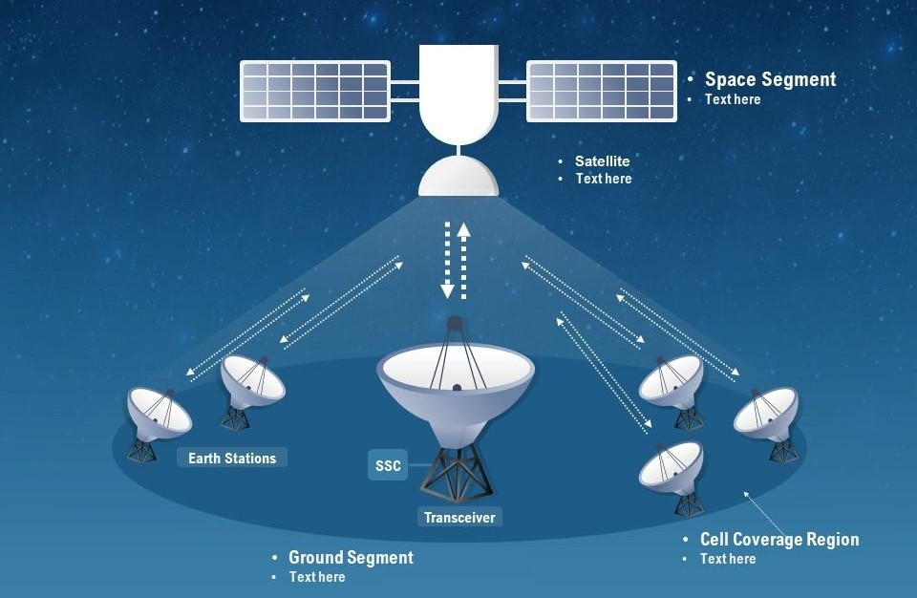
A communication satellite is nothing but a microwave repeater station in space. It is helpful in telecommunications, radio, television, and internet applications. A repeater is a circuit, which increases the strength of the received signal and then transmits it. But, this repeater works as a transponder. A satellite is a moon, planet, or machine that orbits a planet or star. A space communication system requires the use of at least one ground station on Earth (the ground segment) and at least one spacecraft (the space segment ). A satellite communications system can be broadly divided into two segments—a ground segment and a space segment.

SATELLITE
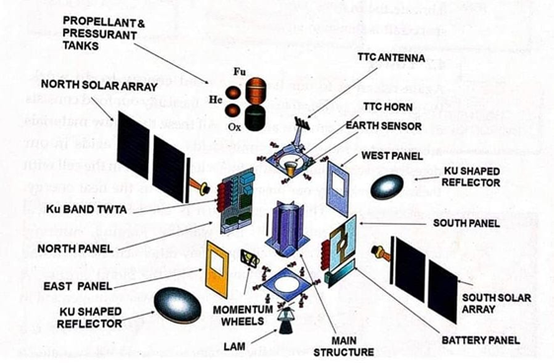
A satellite is an object that moves around a larger object. Earth is a satellite because it moves around the sun. The moon is a satellite because it moves around Earth. Earth and the moon are called "natural" satellites. But usually when someone says "satellite," they are talking about a "man-made" satellite. Man-made satellites are machines made by people.[1] These machines are launched into space and orbit Earth or another body in space. There are thousands of man-made satellites. Some take pictures of our planet. Some take pictures of other planets, the sun, and other objects. These pictures help scientists learn about Earth, the solar system, and the universe. Other satellites send TV signals and phone calls around the world. Satellites come in many shapes and sizes. But most have at least two parts in common - an antenna and a power source. The antenna is used to send and receive information. The power source can be a solar panel or battery. Solar panels make power by turning sunlight into electricity.
SATELLITE COMMUNICATION
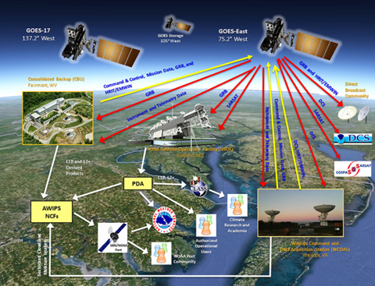
A communications satellite is an artificial satellite that relays and amplifies radio telecommunication signals via a transponder; it creates a communication channel between a source transmitter and a receiver at different locations on Earth.[2] Communications satellites are used for television, telephone, radio, internet, and military applications. Many communications satellites are in geostationary satellite, 22,300 miles (35,900 km) above the equator, so that the satellite appears stationary at the same point in the sky; therefore the satellite dish antennas of ground stations can be aimed permanently at that spot and do not have to move to track the satellite. Others form satellite constellations in low Earth orbit, where antennas on the ground have to follow the position of the satellites and switch between satellites frequently. The high-frequency radio waves used for telecommunications links travel by line of sight and so are obstructed by the curve of the Earth. The purpose of communications satellites is to relay the signal around the curve of the Earth allowing communication between widely separated geographical points. Communications satellites use a wide range of radio and microwave frequencies To avoid signal interference, international organizations have regulations for which frequency ranges or "bands" certain organizations are allowed to use. This allocation of bands minimizes the risk of signal interference.
SPACE COMMUNICATIONS
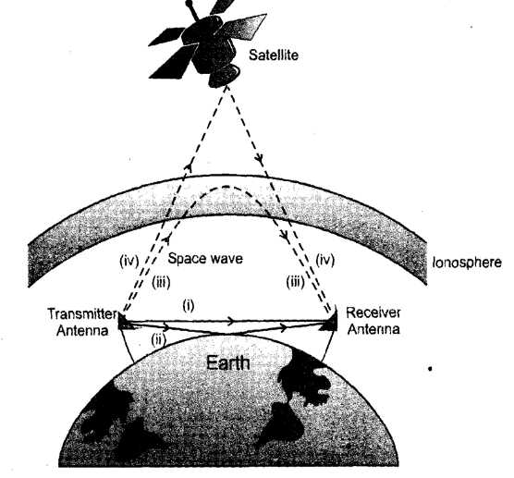
Space communication is the exchange of data between Earth and Space or between 2 points in Space. Since Space communication requires sending and receiving messages across great distances, such as from the Earth ground to satellites in Earth orbit or a spacecraft into deep space, it involves the employment of cutting-edge technologies. A space communication system requires the use of at least one ground station on Earth (the ground segment) and at least one spacecraft (the space segment).[3] Their tasks are receiving orders from Earth (uplink), sending data to Earth (downlink), and sending or receiving information from another satellite.
CHALLENGES OF SPACE COMMUNICATION
1. The Basics
Space communications rely on two things: a transmitter and a receiver. A transmitter encodes a message onto electromagnetic waves through modulation, which changes the properties of the wave to represent the data.[4] These waves flow through space toward the receiver. The receiver collects the electromagnetic waves and demodulates them, decoding the sender’s message.
2. Ground Networks
Communicating from space involves more than pointing a spacecraft’s antenna at the Earth. NASA has an extensive network of antennas around the globe — over all seven continents — to receive transmissions from spacecraft. Network engineers carefully plan communications between ground stations and missions, ensuring that antennas are ready to receive data as spacecraft pass overhead.
3. Space Relays
In addition to direct-to-Earth communications, many NASA missions rely on relay satellites to get their data to the ground. For example, the space station communicates through Tracking and Data Relay Satellites (TDRS), which transmit data to ground stations in New Mexico and Guam. The recently launched Mars 2020 Perseverance rover will send data through orbiters around Mars, which forward the data to Earth.
4. Bandwidth
NASA encodes data on various bands of electromagnetic frequencies. These bandwidths — ranges of frequencies — have different capabilities. Higher bandwidths can carry more data per second, allowing spacecraft to downlink data more quickly. Currently, NASA relies primarily on radio waves for communications, but the agency is developing ways to communicate with infrared lasers. This type of transmission — dubbed optical communications.
5. Data Rates
Higher bandwidths can mean higher data rates for missions. Apollo radios sent a grainy black-and-white video from the Moon.[9] An upcoming optical terminal on the Artemis II mission will send 4K, ultra-high definition video from lunar orbit.
6 . Latency
Latency can become a challenge. At Mars’ closest approach — about 35 million miles away — the delay is about four minutes. When the planets are at their greatest distance — about 250 million miles away — the delay is around 24 minutes. This means that astronauts would need to wait between four and 24 minutes for their messages to reach mission control, and another four to 24 minutes to receive a response.
7 Interference
communications transmissions travel over long distances or through the atmosphere, the quality of their data can deteriorate, garbling the message. Radiation from other missions, the Sun, or other celestial bodies can also interfere with the quality of transmissions.
PROPAGATION OF WAVES IN THE EARTH'S ATMOSPHERE
The earth's atmosphere affects the propagation of electromagnetic waves from one place to another on the surface of the earth. [5]You may like to begin by explaining about the earth's atmosphere to understand how it affects the communication process. Based on the variation of temperature, air density, and electrical conductivity with altitude, the atmosphere may be thought of as made up of several layers [8]. Troposphere is the lowest region near the earth. It is characterized by a negative temperature gradient (6 K km-') leading to temperatures between 290K (at the equator) to 220K (at high altitudes) at the tropopause. The air density is maximum but electrical conductivity is the least compared to other layers.
SPACE WAVE PROPAGATION
The space wave is the VHF F radio wave (30 MHz to 300 MHz). The two types of space e-waves are shown in Fig. They are the direct wave and ground reflected wave [6]. The direct wave is by far the most widely used mode of antenna communication. The propagated wave is direct from transmitting to receiving antenna and d does not travel along the ground. The earth's surface, therefore, does not attenuate it.
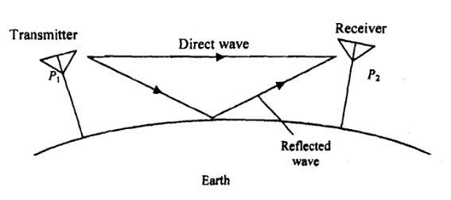
Abbreviations
EOS – EARTH OBSERVING SYSTEM
LEO – LOW EARTH ORBIT
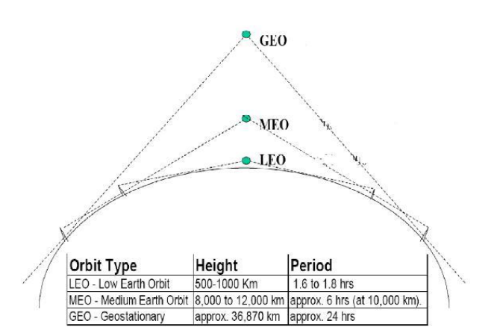
NEO – NEAR-EARTH OBJECT
SATELLITE SYSTEM
1. LEO:
Low Earth Orbit satellites have a small area of coverage. They are positioned in an orbit approximately 3000km from the surface of the earth. They complete one orbit every 90 minutes. The large majority of satellites are in low earth orbit. The Iridium system utilizes LEO satellites (780km high). The satellite in LEO orbit is visible to a point on the earth for a very short time.
2. MEO:
Medium Earth Orbit satellites have orbital altitudes between 3,000 and 30,000 km.
They are commonly used in navigation systems such as GPS
3. GEO:
Geosynchronous (Geostationary) Earth Orbit satellites are positioned over the equator. The orbital altitude is around 30,000-40,000 km
There is only one geostationary orbit possible around the earth
Lying on the earth’s equatorial plane.
The satellite orbits at the same speed as the rotational speed of the earth on its axis.
They complete one orbit every 24 hours. This causes the satellite to appear stationary concerning a point on the Earth, allowing one satellite to provide continual coverage to a given area on the Earth's surface
One GEO satellite can cover approximately 1/3 of the world

They are commonly used in communication systems
Advantages
Simple ground station tracking
Nearly constant range
Very small frequency shift
Disadvantages
Transmission delay of the order of 250 msec.
Large free space loss.
No polar coverage
Satellite orbits in terms of the orbital height:
According to distance from Earth:
Geosynchronous Earth Orbit (GEO),
Medium Earth Orbit (MEO),
Low Earth Orbit (LEO)

Satellite uplink and downlink Analysis and Design
1. Equivalent Isotropic Radiated Power
A key parameter in link-budget calculations is the equivalent isotropic radiated power, conventionally denoted EIRP. From Eqs, [7] the maximum power flux density at some distance r from transmitting antenna of gain G i
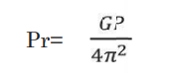
An isotropic radiator with an input power equal to GPS would produce the same flux density. Hence, this product is referred to as the EIRP, or EIRP is often expressed in decibels relative to 1 W, or dBW. Let PS be in watts; then [EIRP] = [PS] x [G] dB, where [PS] is also in dBW and [G] is in dB.
2. Transmission Losses
The [EIRP] may be thought of as the power input to one end of the transmission link, and the problem is to find the power received at the other end. Losses will occur along the way, some of which are constant.
3. The Link-Power Budget Equation
Now that the losses for the link have been identified, the power at the receiver, which is the power output of the link, may be calculated simply as [EIRP] [LOSSES] [GR], where the last quantity is the receiver antenna gain. Note carefully that decibel addition must be used. The major source of loss in any ground-satellite link is the free-space spreading loss [FSL], the basic link-power budget equation taking into account this loss only. However, the other losses also must be taken into account, and these are simply added to [FSL]. The losses for clear-sky conditions are
[LOSSES] = [FSL] + [RFL] + [AML] + [AA] - [PL] equation for the received power is then
[PR] = [EIRP] x [GR] - [LOSSES]
where [PR] received power, Dbw
[EIRP] - equivalent isotropic radiated power, dBW [FSL] free-space spreading loss, dB
[RFL] - receiver feeder loss, dB
[AML] - antenna misalignment loss, dB
[AA] - atmospheric absorption loss, dB
[PL] polarization mismatch loss, dB
4. The Uplink
The uplink of a satellite circuit is the one in which the earth station is transmitting the signal and the satellite is receiving it specifically that the uplink is being considered

Authors
Dr.Shalini.S
Sheela. S
Prathyusha. S
Syed Mezan Naimuddin
Akshay. D
Vivek. N
Affiliations
Dr. Shalini .S | Dept. Computer Science and Engineering
Sheela .S | Dept. Computer Science and Engineering
Prathyusha. S | Dept. Aeronautical Engineering
Syed Mezan Naimuddin | Dept. Aeronautical Engineering
Akshay. D | Dept. Computer Science and Engineering
Vivek. N | Dept. Aeronautical Engineering

Conclusion
In conclusion, satellite and space communication have revolutionized the way we interact with the world and understand the universe. These technologies have ushered in an era of global connectivity, enabling seamless communication and data exchange across vast distances. From telecommunications to disaster management, navigation to scientific research, and national security to environmental monitoring, satellites play a pivotal role in shaping various aspects of our modern lives. Satellite communication has connected people, businesses, and nations, transcending geographical barriers and fostering global collaboration. It has empowered remote and underserved regions with access to essential services, driving economic growth and improving livelihoods. Additionally, satellites have become indispensable in disaster management, providing timely information and aiding humanitarian efforts during natural calamities.

REFERENCES

[1]. Wilbur L. Pritchard, Hendri G. Suyderhoud, Robert A. Nelson, “Satellite Communication Systems Engineering”, Prentice Hall/Pearson, 2007.
[2]. N. Agarwal, “Design of Geosynchronous Space Craft”, Prentice Hall, 1986.
[3]. Bruce R. Elbert, “Satellite Communication Applications”, Hand Book, Artech House Boston London,1997
[4]. Tri T. Ha, “Digital Satellite Communication”, II nd edition, 1990
[5]. Robert G. Winch, “Telecommunication Transmission Systems”, Mc Graw-Hill Book Co., 1983
[6]. Brian Ackroyd, “World Satellite Communication and earth station Design”, BSP Professional Books, 1990.
[7]. G.B.Bleazard, “Introducing Satellite communications“, NCC Publication, 1985.
[8]. M.Richharia, “Satellite Communication Systems-Design Principles”, Macmillan 2003.
[9]. Emanuel Fthenakis, “Manual of Satellite Communications”, Mc Graw Hill Book Co., 1984

