APPLICATIONS OF INTERNET OF THINGS ON REMOTE HEALTH MONITORING SYSTEM

R.Sushmitha V.Ramana Babu Md Asim Iqbal
Faculty in CSE Dept Faculty in CSE Dept Asst Prof. in Dept. of ECE
KUCE & T KUCE & T KUCE & T
sushmacse511@gmail.com ramana.vrb@gmail.com mdasimiqbal605@gmail.com

Abstract
Research into health-related demands is a permanent fixture among the many IoT requests. The rising popularity of Internet of Things (IoT) approaches in the healthcare sector can be attributed to their potential to reduce expenses, improve clarity of communication, and restore patients' sense of satisfaction with their care. This study provides inspiration for visualising the potential of IoT in intricate medical operations. One of the most important Internet of Things (IoT) apps that connects mobile sensors, people, clinicians, networks, and other linked devices is the "Mobile Healthcare Management System (HMS)". The overarching goal of this work is to design a simple and inexpensive health monitoring system for people living in areas where access to specialised medical care is limited. This setup is easily transportable. Cost-effective and simple enough that even those with no special training can use it successfully. Moreover, Internet of Things (IoT) technology is used in the development of this idea so that information can be transmitted to a distant server and retrieved by physicians. This project makes use of a NODE MCU, an LM35 temperature sensor, a pulse sensor, and a 16x2 LCD display. Create an account with one of the IoT platforms that supports ThingTalk. The Username, Device-Id, Asset-Id, Secret key, etc., for the IoT account must be written down and entered into the Arduino code. All of these credentials, together with individual pin numbers for assets (Parameters), are added to the Arduino application. The NODE MCU has an internal ESP8266 Wi-Fi interface, so it may send the parameters read in the preceding operation to the IoT account together with the corresponding pin numbers.
- Introduction
A patient's vital body status can be monitored remotely through the use of a remote health monitoring system, which is an extension of a hospital medical system. Detection systems used to be only found in medical facilities; they were large, complicated, and power hungry. The constant development of semiconductor technology has resulted in sensors and microcontrollers that are more compact, run more quickly, use less power, and are less expensive. According to the IoT European Research Cluster (IECR) project idea, "Internet of Things" (IoT) refers to a variety of concepts that can be organised into a unified whole by use of a set of standardised collaborative communication agreements. The Internet of Things (IoT) is a network infrastructure that allows for adaptable communication and data exchange between any number of devices located anywhere in the world and any number of fixed or mobile infrastructure nodes. It's a game-changer, and it's become better and better through the years. The Internet of Things was a game-changing concept that was introduced into a high-tech, information-driven society by means of enlightened, resource-conserving engineering. Health, energy, the environment, public protection, food and water access, connection, manufacturing, and many more spheres of social usage have all shifted their attention to the Internet of Things in recent years. According to projections, the global total of connected devices will increase from the current estimate of 20.35 billion to 75.44 billion by 2025. Previously, it was not possible for doctors to keep tabs on patients in critical situations when they were located in far-flung places. As a result, we built a system that keeps tabs on the health of the patient and automatically uploads the results to a server, where the doctor can always find them. The only way to keep tabs on a patient in the past was a collection of specialised devices, one for each measurable trait. Therefore, we assembled various equipment into a single module to monitor the necessary patient conditions. In today's world, IoT is the norm. Internet connectivity has expanded greatly, allowing for previously unimaginable expansion in the number of devices it can link. The Internet of Things is a global, pervasive network in which every gadget is connected to every other device using a wide variety of smart technologies (IoT). Each sensor's readings were recorded and then sent to the server. We looked at the information on numerous computers and mobile devices under password protection.
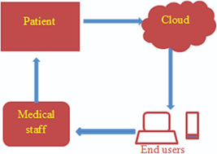
Fig 1. Monitoring System
In-home physiological monitoring is a promising area of research for remote health monitoring. Patients who are elderly or have a chronic illness and hope to avoid a lengthy hospital stay can benefit from this monitoring. Signals of interest are collected and transmitted by wireless sensors, which are then received by a processor and processed automatically. This project requires you to select suitable sensors for your intended detection and then develop algorithms to make that detection a reality. Some applications include monitoring heart signals and the ability to detect a fall.
- Existing Work
In-home physiological monitoring is a promising area of research for remote health monitoring. Patients who are elderly or have a chronic illness and hope to avoid a lengthy hospital stay can benefit from this monitoring. Signals of interest are collected and transmitted by wireless sensors, which are then received by a processor and processed automatically. This project requires you to select suitable sensors for your intended detection and then develop algorithms to make that detection a reality. Some applications include monitoring heart signals and the ability to detect a fall. An approach to a remote health monitoring system was developed using a single parameter monitoring system, bringing medical care outside of the typical clinic or hospital and into the patient's own home. Data from a heartbeat detection system, a fall detection system, the ambient temperature, and a few other factors were to be gathered by the system. In this way, remote detection could make use of the information gathered by systems designed to track just one characteristic.
We already employ active normal technology to connect a wide variety of sensors to an Arduino UNO in the existing system. Constantly measured physical values are used to keep track of a patient's vital signs, which are then relayed to the on-site medical staff in the event of an emergency. The patients' bodies are scanned continuously while the sensors are attached to them. The Arduino UNO was used in the development process. This prototype board features a pulse sensor and a temperature sensor, both of which record their readings. Embedded C code is utilised in the Arduino UNO software for dumping. We can use a dedicated WIFI module to make this an IoT device. We had network problems, maybe because of a slow connection or because we were still using wired connections. We cannot guarantee a flawless connection while using two independent WIFI modules. For this reason, not all values are successfully submitted. To circumvent this, we choose for NODE MCUs with an integrated WIFI module and simple circuitry.
- Proposed Work
With the advent of 'IoT,' we can now differentiate between 'health data' in a doctor's analysing and diagnostics following the implementation of physical sensor systems. The major advantage of the "IoT in healthcare" is a lighter maintenance load, followed by better healthcare outcomes. Insightful lessons were learned from the expansion of the personal and online health care network, and it was speculated that the rise of cloud health services would be a result of the proliferation of mobile information and other applications that would render dated technology obsolete. The Internet of Things (IoT) is already available as a main platform for tracking the state of mind. Due to the lack of reliable monitoring tools, numerous additional dangers can be taken. The Internet of Things and similar technologies are used here. Careful consideration is in the patient's best interest. Information on a patient is gathered through a number of different sensors. The patient can rely on the caregiver for sound health advice. Disabled patients often rely on Internet of Things devices, which necessitates extra surveillance. Strategies for monitoring patients with the aid of sensors to ensure continuous material mobility for their caretakers have been compiled.
We propose using NodeMCU and the relevant sensors to create a patient monitoring system. These sensors are used to remotely monitor a patient's vital signs in the intensive care unit (ICU) and to regulate medication administration. By using this method, doctors can keep tabs on patients' vital signs, like temperature and heart rate, from anywhere in the hospital—even when they're not physically present. If any of the monitored values go outside of the normal range, the system will either trigger a pop-up warning for the attending medical staff or sound an alarm. The website is the sole medium for conveying this information and facilitating dialogue between the doctor and patient. The Node MCU acts as a server, compiling data collected by Arduinos and uploading it to a custom webpage. With this system, the doctor can get real-time updates. This means fewer lives lost and more people saved.
A. Hardware Requirements:
• Node MCU
• Temperature Sensor
• Heart Beat Sensor
• LCD DISPLAY
B. Software Requirements:
• Embedded C
• Arduino software
NODE MCU: IoT (Internet of Things) applications are the focus of NodeMCU, an open-source firmware and development board. The ESP8266 Wi-Fi SOC from Espress if Systems is used for the firmware, and the ESP-12 module provides the hardware foundation.
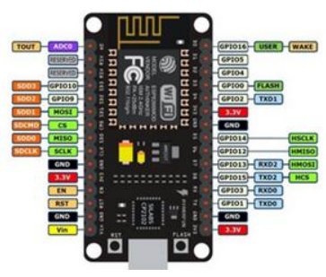
Fig 2. Node MCU
Temperature Sensor: Depending on the ambient temperature, the LM35 precession IC's output voltage will change. It's a tiny, low-cost IC that can measure temperatures from -55 degrees Celsius to 150 degrees Celsius. It can be easily connected to any microcontroller with analog-to-digital converter (ADC) support or any development board.
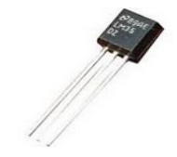
Fig 3. Temperature Sensor
Pulse Sensor : There is a light on the pulse sensor module that can be used to get a more accurate reading. The amount of blood flowing through the capillaries is proportional to the amount of light reflected when we place a finger on the pulse sensor.
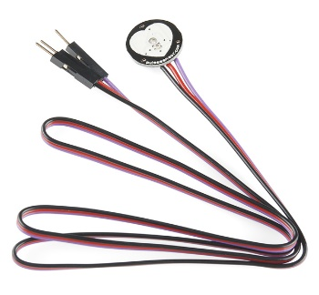
Fig 4. Pulse sensor
Working steps
Step-1: Attached to the microcontroller permanently is the pulse sensor. We obtain a pulse from that sensor with each pump. The LCD receives data from the sensor.
Step-2: When measuring temperature, LM35 is what's needed. The output of this temperature sensor shifts as the temperature changes.
Step-5: Data is processed by Arduino and sent to the NODE MCU after being gathered from various sensors.
Step-6: The NODE MCU is an internet-connected WiFi module that receives data from an Arduino and sends it to a remote server.
Step-7: Thing Speak is used to access data stored on a server.
Step-8: The doctor is given log-in credentials to the site so that he or she can monitor the patient's condition remotely.
Block Diagram
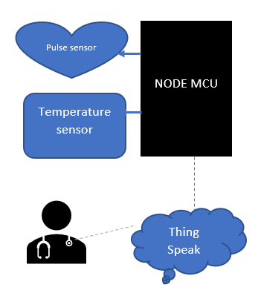
Fig 5.Block diagram
ADVANTAGES
• Better patient experience
• Improved disease management
• Homecare
• Decreased costs
• Reduced Errors

- Results
Our preliminary research has yielded the following findings for our planned project. Data is shown on an LCD screen. Data will be shown on the Thing Speak website later.
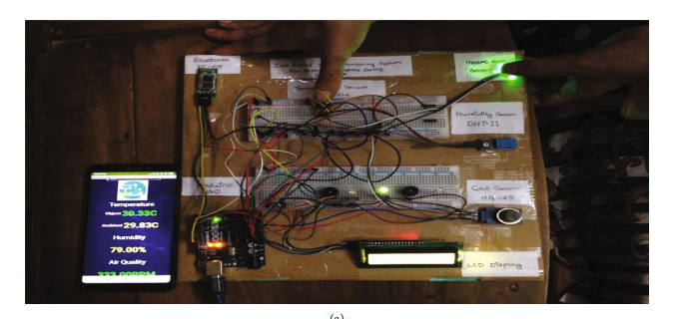
Fig 6. LCD Displaying output
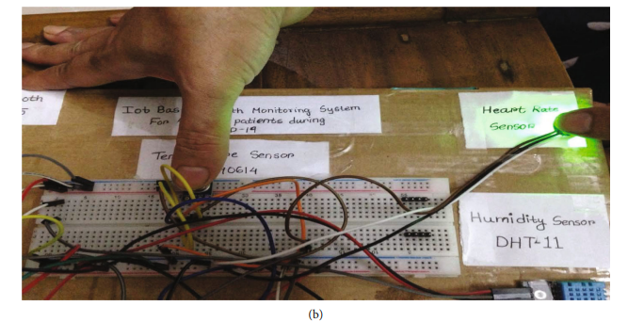
Fig 7. Over all System
Conclusion
With daily monitoring, recording, and storage as a database, the suggested system of patient health monitoring utilising IOT can be highly useful in any emergency scenarios. The doctor may check on patients in far-flung corners of the hospital, or even when he's not there at all, by using this device to measure vitals like temperature and pulse. In the future, this IoT gadget may also be combined with cloud computing, allowing the database to be shared throughout all hospitals for intense care and treatment, and sending alerts (Popup messages) to doctors if any parameters go to abnormal. Most importantly, the user may take this system with them wherever they go. Every household could have just one of these instead of two separate thermometers and oximeters.
References
[1] Saranya. E, Maheswaran. T, “IoT Based Disease Prediction and Diagnosis System for Healthcare”, International Journal of Engineering Development and Research (IJEDR) | Volume 7, Issue 2 | ISSN: 2321-9939, pp.232-237, 2019.
[2] M.M. Dhanvijay and S.C. Patil, “Internet of Things: a survey of enabling technologies in healthcare and its applications,, Computer Networks, vol. 153, pp. 113–131, 2019.
[3] K. Hung, Y. T. Zhang, and B. Tai. Wearable medical devices for telehome healthcare.In Procs.26th Annual International Conference on the IEEE EMBS, 2004.
[4] Fang, Xiang et al: An extensible embedded terminal platform for wireless telemonitoring, Information and Automation (ICIA), 2012 International Conference on Digital Object Identifier: 10.1109/ICInfA.2012.6246761 Publication Year: 2012 , Page(s): 668 - 673.
[5] Majer, L., Stopjaková, V., Vavrinský, E.: Sensitive and Accurate Measurement Environment for Continuous Biomedical Monitoring using Microelectrodes. In: Measurement Science Review. - ISSN 1335- 8871. - Vol. 7, Section 2, No. 2 (2007), s. 20-24.
[6] Dr.T. Poongodi, Dr. Balamurugan Balusamy, Dr.P. Sanjeevikumar, Dr. Jens Bo HolmNielsen, “Internet of Things and E-Healthcare system-A Short review on challenges”, IEEE India info.vol.14 No. 2, pp. 143-147, 2019
[7] Smiju Sudevan, Mani Joseph, “Internet of Things: Incorporation into Healthcare Monitoring”, IEEE, 2019.
[8] M.M. Dhanvijay and S. C. Patil, “Internet of Things: A survey of enabling technologies in healthcare and its applications,’ Computer Networks, vol.153, pp. 113-131, 2019.
[9] M.M.E. Mahmoud et al., “Enabling technologies on a cloud of things for smart healthcare,” IEEE Access, vol. 6, no. c, pp. 31950-31967, 2018.
[10] R Sangeetha, Dr.R. Jegadeesan, M P Ramya and G Vennila, “Health Monitoring System Using Internet of Things”, International Journal of Engineering Research and Advanced Technology (IJERAT), E-ISSN: 2454-6135, Volume.4, Issue 3 March-2018.
[11] Dziak, D., Jachimczyk, B., &Kulesza, W.J., “IoT-based information system for healthcare application: design methodology approach”, Applied Sciences,7(6), 596, (2017).
[12] J. Qi, P. Yang, G. Min, O. Amft, F. Dong, and L. Xu, “Advanced internet, of things for personalized healthcare systems: A survey,” Pervasive Mob. Computer. vol. 41, pp. 132-149, 2017.
[13] S.B. Baker, W. Xiang, and I. Atkinson, “Internet of Things for Smart Healthcare: Technologies, Challenges, and Opportunities,” IEEE Access, vol. 5, no. c, pp. 26521-26544, 2017.
[14] Yuehong, Y.I.N., Zeng, Y., Chen, X.,& Fan, Y., “The internet of things in healthcare: An overview”, Journal of Industrial Information Integration,1, 3-13, (2016).
[15] Ejaz, W., Anpalagan, A., Imran, M.A., Jo, M., Naeem, M., Qaisar, S.B. and Wang, W., “Internet of Things (IoT) in 5G wireless communications”, IEEE Access, vol.4, pp.10310-10314, 2016.

